ShopEZ.API
Technical Documentation
E-Commerce Backend System
Version 1.0.0 | April 2026

1. Project Overview
ShopEZ.API is a scalable RESTful backend built using ASP.NET Core Web API. It supports product management, order processing, authentication, and role-based access control.

2. Architecture
The system follows layered architecture:
Controller → Service → Repository → DbContext

3. Technology Stack
Component | Technology
Backend | ASP.NET Core Web API (.NET 8)
ORM | Entity Framework Core
Database | SQL Server
Authentication | JWT
Security | BCrypt
Testing | Postman
Documentation | Swagger

4. Authentication & Authorization
JWT-based authentication is implemented. Token must be passed in header:
Authorization: Bearer <token>
Role | Access
Admin | Manage products, view orders
User | Place orders, view products
Default Admin Credentials:
Email: admin@gmail.com
Password: Admin@123

5. API Endpoints

5.1 Auth APIs
Method | Endpoint
POST | /api/auth/register
POST | /api/auth/login

5.2 Product APIs
Method | Endpoint | Access
GET | /api/products | Public
GET | /api/products/{id} | Public
GET | /api/products/search | Public
POST | /api/products | Admin
PUT | /api/products/{id} | Admin
DELETE | /api/products/{id} | Admin

5.3 Order APIs
Method | Endpoint | Access
GET | /api/orders | Authenticated
GET | /api/orders/{id} | Authenticated
POST | /api/orders | Authenticated

6. Features
• Pagination using Skip & Take
• Search using query parameters
• Price filtering
• Transaction handling with rollback
• Stock validation

7. API Testing
APIs were tested using Postman.
Steps:
1. Register user
2. Login to get JWT token
3. Add token in Authorization header
4. Test secured endpoints
Note: Add screenshots here before submission (Login, Products, Orders).
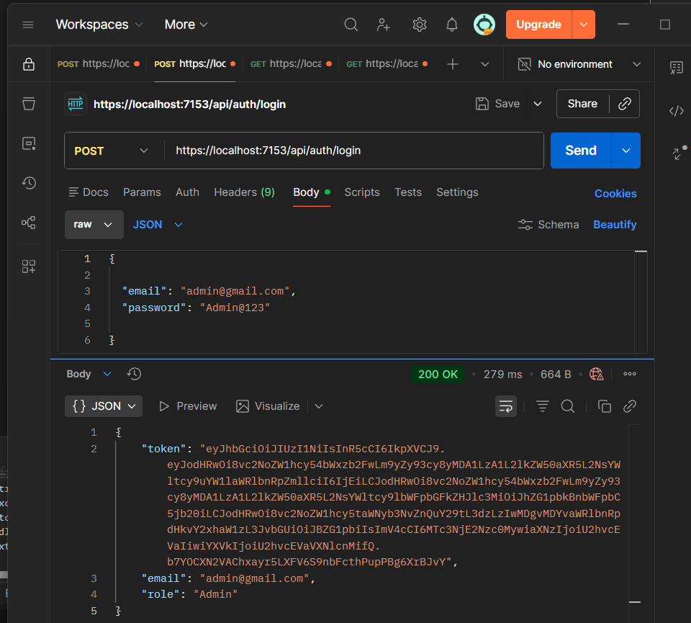
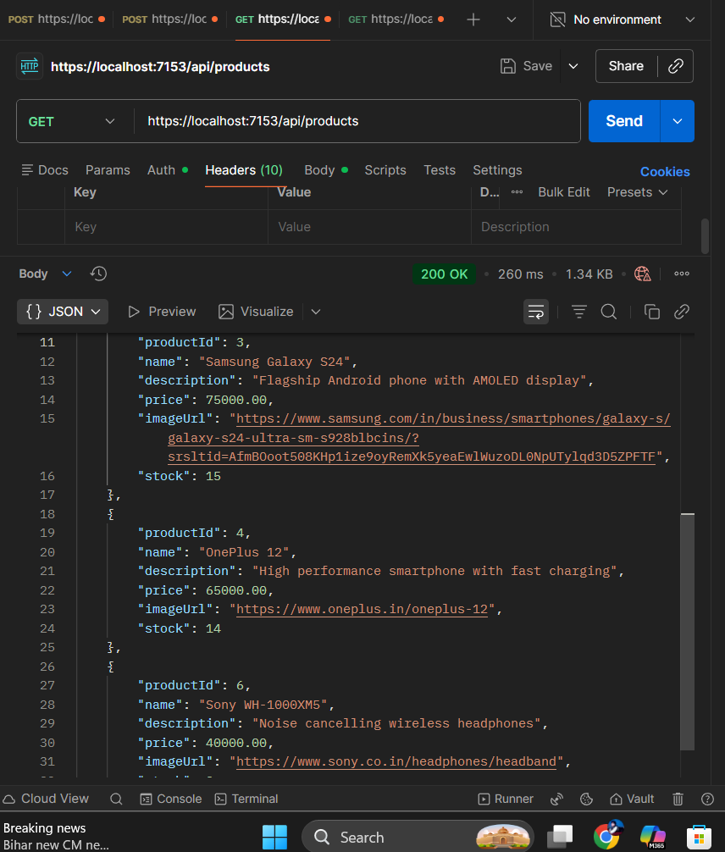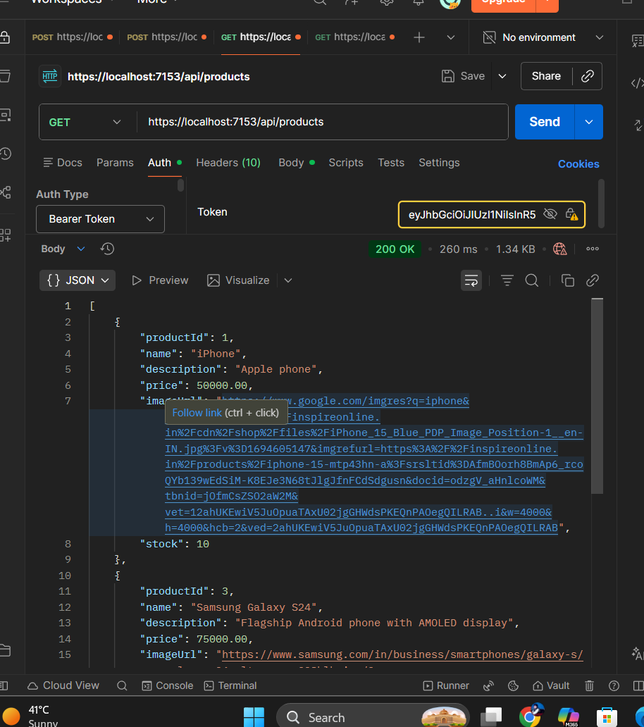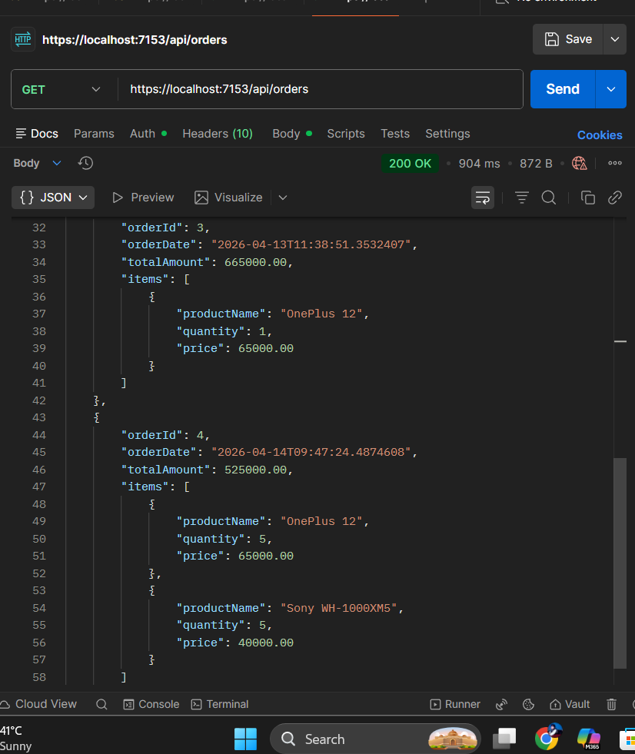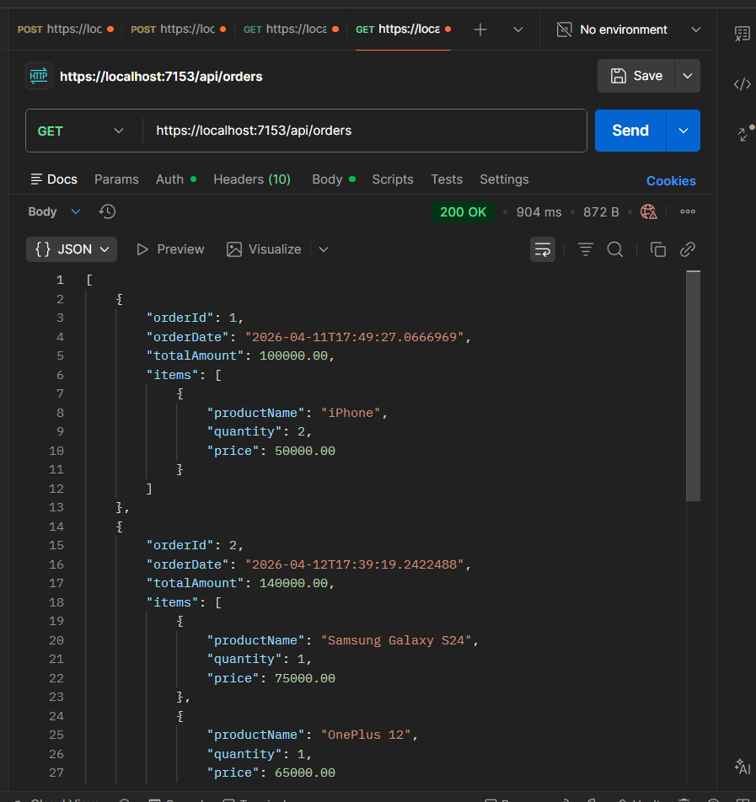

8. Error Handling
Code | Description
200 | Success
201 | Created
400 | Bad Request
401 | Unauthorized
403 | Forbidden
404 | Not Found
500 | Internal Server Error

