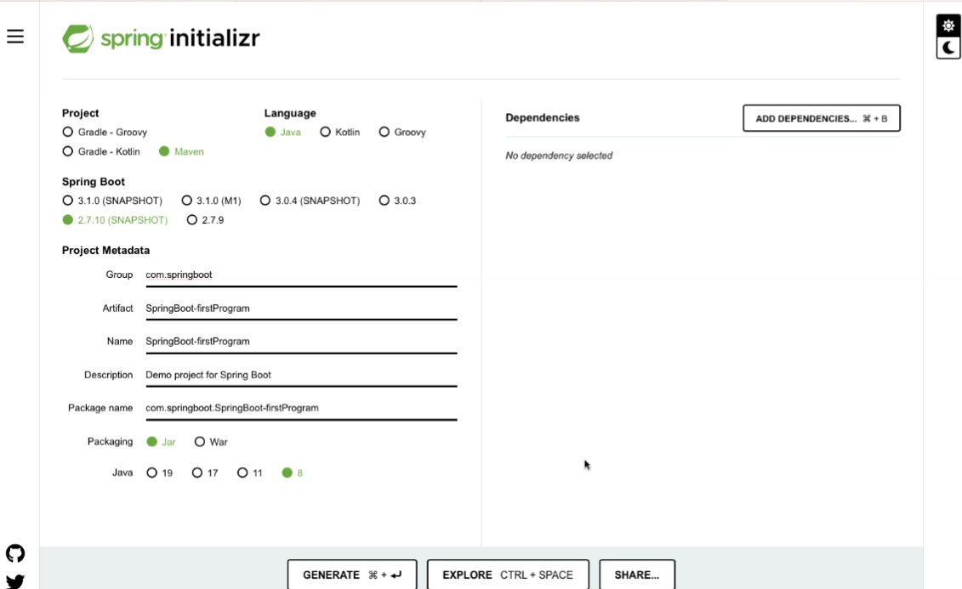

import org.springframework.boot.SpringApplication;

import org.springframework.boot.autoconfigure.SpringBootApplication;

import org.springframework.context.annotation.ComponentScan;

@SpringBootApplication

@ComponentScan({"com.springboot.controller"})

public class SpringBootFirstProgramApplication {

public static void main(String[] args) {

SpringApplication.run(SpringBootFirstProgramApplication.class, args);

}

}

import org.springframework.stereotype.Controller;

import org.springframework.web.bind.annotation.RequestMapping;

import org.springframework.web.bind.annotation.RestController;

@RestController

public class HelloController {

@RequestMapping("/")

public String display() {

return "my First SpringBoot Program";

}

}

pom.xml

<?xml version="1.0" encoding="UTF-8"?>

<project xmlns="http://maven.apache.org/POM/4.0.0" xmlns:xsi="http://www.w3.org/2001/XMLSchema-instance"

xsi:schemaLocation="http://maven.apache.org/POM/4.0.0 https://maven.apache.org/xsd/maven-4.0.0.xsd">

<modelVersion>4.0.0</modelVersion>

<parent>

<groupId>org.springframework.boot</groupId>

<artifactId>spring-boot-starter-parent</artifactId>

<version>2.7.10-SNAPSHOT</version>

<relativePath/> <!-- lookup parent from repository -->

</parent>

<groupId>com.springboot</groupId>

<artifactId>SpringBoot-firstProgram</artifactId>

<version>0.0.1-SNAPSHOT</version>

<name>SpringBoot-firstProgram</name>

<description>Demo project for Spring Boot</description>

<properties>

<java.version>1.8</java.version>

</properties>

<dependencies>

<dependency>

<groupId>org.springframework.boot</groupId>

<artifactId>spring-boot-starter-web</artifactId>

</dependency>

<dependency>

<groupId>org.springframework.boot</groupId>

<artifactId>spring-boot-starter-test</artifactId>

<scope>test</scope>

</dependency>

</dependencies>

<build>

<plugins>

<plugin>

<groupId>org.springframework.boot</groupId>

<artifactId>spring-boot-maven-plugin</artifactId>

</plugin>

</plugins>

</build>

<repositories>

<repository>

<id>spring-milestones</id>

<name>Spring Milestones</name>

<url>https://repo.spring.io/milestone</url>

<snapshots>

<enabled>false</enabled>

</snapshots>

</repository>

<repository>

<id>spring-snapshots</id>

<name>Spring Snapshots</name>

<url>https://repo.spring.io/snapshot</url>

<releases>

<enabled>false</enabled>

</releases>

</repository>

</repositories>

<pluginRepositories>

<pluginRepository>

<id>spring-milestones</id>

<name>Spring Milestones</name>

<url>https://repo.spring.io/milestone</url>

<snapshots>

<enabled>false</enabled>

</snapshots>

</pluginRepository>

<pluginRepository>

<id>spring-snapshots</id>

<name>Spring Snapshots</name>

<url>https://repo.spring.io/snapshot</url>

<releases>

<enabled>false</enabled>

</releases>

</pluginRepository>

</pluginRepositories>

</project>

OUTPUT

/\\ / ___'_ __ _ _(_)_ __ __ _ \ \ \ \

( ( )\___ | '_ | '_| | '_ \/ _` | \ \ \ \

\\/ ___)| |_)| | | | | || (_| | ) ) ) )

' |____| .__|_| |_|_| |_\__, | / / / /

=========|_|==============|___/=/_/_/_/

:: Spring Boot :: (v2.7.10-SNAPSHOT)

2023-02-26 11:27:03.423 INFO 24968 --- [ main] c.s.S.SpringBootFirstProgramApplication : Starting SpringBootFirstProgramApplication using Java 18.0.1.1 on LAPTOP-IO0A0RUD with PID 24968 (C:\Users\aj709\Downloads\SpringBoot-firstProgram\SpringBoot-firstProgram\target\classes started by aj709 in C:\Users\aj709\Downloads\SpringBoot-firstProgram\SpringBoot-firstProgram)

2023-02-26 11:27:03.426 INFO 24968 --- [ main] c.s.S.SpringBootFirstProgramApplication : No active profile set, falling back to 1 default profile: "default"

2023-02-26 11:27:04.767 INFO 24968 --- [ main] o.s.b.w.embedded.tomcat.TomcatWebServer : Tomcat initialized with port(s): 3007 (http)

2023-02-26 11:27:04.786 INFO 24968 --- [ main] o.apache.catalina.core.StandardService : Starting service [Tomcat]

2023-02-26 11:27:04.786 INFO 24968 --- [ main] org.apache.catalina.core.StandardEngine : Starting Servlet engine: [Apache Tomcat/9.0.71]

2023-02-26 11:27:04.939 INFO 24968 --- [ main] o.a.c.c.C.[Tomcat].[localhost].[/] : Initializing Spring embedded WebApplicationContext

2023-02-26 11:27:04.940 INFO 24968 --- [ main] w.s.c.ServletWebServerApplicationContext : Root WebApplicationContext: initialization completed in 1433 ms

2023-02-26 11:27:05.424 INFO 24968 --- [ main] o.s.b.w.embedded.tomcat.TomcatWebServer : Tomcat started on port(s): 3007 (http) with context path ''

2023-02-26 11:27:05.436 INFO 24968 --- [ main] c.s.S.SpringBootFirstProgramApplication : Started SpringBootFirstProgramApplication in 2.648 seconds (JVM running for 3.338)

http://localhost:3007/

my First SpringBoot Program