**ACKNOWLEDGEMENT**

The satisfaction and euphoria that accompany the successful completion of a task would be incomplete without the mention of the people who made it possible and without their constant guidance and encouragement, success would not have been possible.

I am grateful to the institute **Acharya Institute of Technology** and management with its ideas and inspiration for having provided us with the good infrastructure, laboratory, facilities and inspiring staff which has made this internship report complete successfully.

I would like to express my sincere gratitude to **Dr. C K Marigowda, Principal, AIT** for all the facilities that he has extended throughout my work.

I heartily thank and express my sincere gratitude to **Dr. Rajeswari, Professor and HOD, Dept. of ECE, AIT** for her valuable support and a constant source of enthusiastic inspiration to steer us forward.

I would like to express my sincere gratitude to the Internal Guide **Dr. Nagapushpa K P, Assistant Professor grade-1, Dept. of ECE, AIT** for her invaluable guidance and support.

I would like to express my sincere gratitude to the Internship Coordinators **Mrs. Sumangala S J, Assistant Professor, Dept. of ECE, AIT and Mrs. Suma C, Assistant Professor Grade-2, Dept. of ECE, AIT** for their valuable guidance and support.

Finally, I would like to express my sincere gratitude to my parents, all teaching and non-teaching faculty members and friends for their moral support, encouragement and help throughout the completion of the internship report.

**Karthik C**

**1AY21EC050**

**ABSTRACT**

This report presents the key learning outcomes and practical experience gained during the VLSI internship, which focused on digital design using Verilog HDL, functional verification through Universal Verification Methodology (UVM), and physical design using OpenROAD flow. The internship began with the design and simulation of digital components such as 8-bit subtractors. These designs were verified through testbenches and UVM environments on platforms like EDA Playground to ensure correctness and functionality.

Further, the project advanced to the physical design stage, where synthesized netlists were passed through the complete RTL-to-GDSII flow using OpenROAD tools. Critical design metrics including area, power, and timing (with slack analysis) were evaluated. The internship offered valuable hands-on experience in the VLSI design process, bridging the gap between theoretical knowledge and practical application, and enhanced proficiency in design tools, scripting, and verification techniques.

**TABLE OF CONTENTS**

CHAPTER 1 1

INTRODUCTION 1

1.1 PURPOSE AND OBJECTIVES OF THE INTERNSHIP 1

1.2 OVERVIEW OF THE INDUSTRY AND THE SPECIFIC ORGANIZATION 2

1.3 HOW THIS INTERNSHIP ALIGNS WITH OUR ACADEMIC AND CAREER GOALS 3

CHAPTER 2 5

ORGANIZATION PROFILE 5

2.1 OVERVIEW 5

2.2 MISSION AND VISION 5

2.3 SERVICES AND OFFERINGS 5

CHAPTER 3 7

VERILOG AND SYSTE VERILOG IN VLSI DESIGN 7

3.1 VERILOG 7

3.2 SYSTEM VERILOG 12

3.3 OPEN ROAD 16

CHAPTER 4 21

PROJECT DETAILS 21

4.1 PROJECT-10: DESIGN 8-BIT SUBTRACTOR USING VHDL 21

4.2 EVALUATION CRITERIA FOR BLOCK-LEVEL VERIFICATION IN UVM 28

4.3 STIMULUS GENERATION (15%) 32

4.4 DEBUGGING AND LOGS (5%) 34

4.5 CODE QUALITY AND BEST PRACTICES (5%) 35

4.6 GENERATE GDS USING OPENROAD 35

4.7 LAYOUT OF THE DESIGN 38

4.8 Performance Analysis 39

4.9 Generated GDS 40

CHAPTER 5 41

LEARNING OUTCOMES 41

5.1 TECHNICAL, PROFESSIONAL, AND INTERPERSONAL SKILLS ACQUIRED …41

5.2 KNOWLEDGE GAINED ABOUT THE INDUSTRY AND ITS PRACTICES 41

5.3 KEY TAKEAWAYS 42

CHAPTER 6 43

CONCLUSION 43

6.1 SUMMARY OF OVERALL EXPERIENCE 43

6.2 HIGHLIGHT THE VALUE ADDED TO OUR ACADEMIC JOURNEY AND CAREER PATH 43

REFERENCE 45

**LIST OF FIGURES**

Fig 3. 1 VLSI Design Process 7

Fig 3. 2 MOSFET Switching Circuit 11

Fig 3. 3 ASIC Design Process 18

Fig 4. 1 Truth table of 8-bit subtractor 21

Fig 4. 2 Block Diagram 25

Fig 4. 3 Circuit Diagram 25

Fig 4. 4 Output Waveform 27

Fig 4. 5 Testbench Architecture 28

Fig 4. 6 Layout Design 38

Fig 4. 7 Generated GDS 40

# CHAPTER 1

## INTRODUCTION

### ****PURPOSE AND OBJECTIVES OF THE INTERNSHIP****

Internships play a vital role in shaping a student’s academic and professional path by offering real-world experiences beyond classroom education. The primary purpose of this internship was to gain hands-on exposure and practical understanding of VLSI (Very Large-Scale Integration) design, which forms the backbone of modern digital systems and electronics. This 460-hour comprehensive training, jointly conducted by **Roman Technology Pvt Ltd** in collaboration with **Visvesvaraya Technological University (VTU)**, was tailored to build both foundational and advanced skills in VLSI front-end and back-end design flows.

The key objective was to bridge the knowledge gap between theoretical concepts taught in academic settings and practical implementations used in the semiconductor industry. The internship aimed to train participants on the complete chip design flow, beginning from the RTL (Register Transfer Level) modeling and behavioral design to synthesis, floorplanning, placement, routing, and final GDSII generation. Through industry-standard tools and real-time projects, we were encouraged to design digital components, simulate circuits, and carry out backend layout design with verification procedures like DRC (Design Rule Checking) and LVS (Layout vs. Schematic).

In addition to technical expertise, the internship had several other goals:

* To develop problem-solving abilities through design challenges.
* To instill good programming practices using Verilog HDL.
* To enhance understanding of ASIC and FPGA architectures.
* To offer exposure to EDA tools used in commercial IC development.
* To cultivate soft skills like teamwork, communication, time management, and documentation.

In essence, this internship was structured not just as a training program, but as an immersive learning experience designed to prepare us for the competitive and rapidly evolving VLSI domain.

### OVERVIEW OF THE INDUSTRY AND THE SPECIFIC ORGANIZATION

The semiconductor industry is one of the fastest-growing and most critical sectors in the world, enabling advancements in computing, telecommunications, automotive, healthcare, and consumer electronics. At the core of this industry lies VLSI design, a process that involves integrating millions (and now billions) of transistors into a single chip. These integrated circuits (ICs) are used in almost every electronic device today, from smartphones and laptops to satellites and medical equipment.

As devices become more compact, efficient, and powerful, the complexity of ICs has also increased exponentially. This necessitates a highly skilled workforce proficient in digital design methodologies, fabrication processes, and verification techniques. VLSI engineers are required to ensure high performance, low power consumption, and minimal area usage in ICs while maintaining design integrity and manufacturability.

In this context, **Roman Technology Pvt Ltd** plays a pivotal role in nurturing future VLSI professionals. It is a recognized training and consulting organization specializing in advanced semiconductor and embedded system domains. Known for its practical, application-oriented training modules, Roman Technology has developed a reputation for industry-aligned curriculum, live projects, and mentorship by domain experts.

The organization offers a variety of training programs, including VLSI design, physical design, system-on-chip design, and embedded software development. Their collaboration with VTU ensures that engineering students from affiliated colleges receive quality exposure to industry-level tools, technologies, and workflows. Their training approach focuses not only on theoretical clarity but also on delivering robust, hands-on experiences that mirror real semiconductor industry practices.

During the internship, we used professional tools such as:

* **Yosys**: An open-source synthesis tool used for RTL synthesis.
* **OpenROAD**: For complete digital backend automation.
* **KLayout**: For physical verification and design rule checks.

The exposure to these tools provided a comprehensive view of how a chip is designed, verified, and physically realized—offering insights that go far beyond classroom simulations.

### HOW THIS INTERNSHIP ALIGNS WITH OUR ACADEMIC AND CAREER GOALS

As an engineering student specializing in **Electronics and Communication Engineering**, my academic curriculum included courses like Digital Logic Design, Microelectronics, VLSI Design, and HDL programming. While these courses laid the theoretical foundation, the internship allowed me to apply these principles in real-world scenarios, thus enhancing my practical understanding.

This internship was not only aligned with but also integral to my academic goals. It reinforced subjects like:

* **Digital Design**: Designing multiplexers, encoders, decoders, adders, counters, and FSMs using Verilog.
* **HDL Simulation**: Writing synthesizable code and testbenches for simulation.
* **Synthesis and Optimization**: Understanding how high-level behavioral code is transformed into logic gates and flip-flops.
* **Backend Layout Design**: Learning placement, routing, parasitic extraction, and verification.

Furthermore, the training in tools like Vivado and Magic VLSI gave me a head-start in using the same EDA software that industry professionals use. The exposure to ASIC flow through tools like Yosys and OpenROAD helped me understand the nuances of timing constraints, clock tree synthesis, and the challenges involved in chip-level design and physical realization.

From a **career perspective**, this internship has helped me solidify my interest in the VLSI field. I now have a clearer picture of the roles and responsibilities of a VLSI design engineer. The hands-on experience has made me confident in my ability to pursue opportunities in areas such as:

* **ASIC Front-End Design**: RTL coding, synthesis, and simulation.
* **Physical Design**: Floorplanning, placement, routing, and GDSII generation.
* **FPGA Design**: Prototyping and real-time hardware testing.
* **Design Verification**: Using testbenches, coverage models, and formal techniques.

Moreover, the exposure has given me a competitive edge while applying for entry-level roles and internships at core semiconductor companies. It has also prepared me to attempt higher-level certifications and contribute to open-source VLSI projects. With the global semiconductor market experiencing continuous growth and India emerging as a potential design hub, this internship has positioned me at the forefront of a promising technical career path.

Lastly, the mentorship and professional interactions during the training helped improve my communication skills, teamwork, and presentation abilities. These are essential attributes not only for workplace success but also for academic excellence in group projects, seminars, and research presentations.

# CHAPTER 2

## ORGANIZATION PROFILE

### 2.1 OVERVIEW

Established in 1999, **Manish Kumar (CEO)**. Rooman Technologies is a premier Indian enterprise dedicated to skill development and IT training. With over two decades of experience, the company has trained more than 1.2 million students across 198 cities and partnered with 24 academic institutions. Rooman integrates cutting-edge technologies—such as Artificial Intelligence (AI), Data Analysis, and Machine Learning—into its curriculum and delivery systems to provide industry-relevant education.

### 2.2 MISSION AND VISION

* **Vision:** Integrate global innovation, technology, and skill to empower individuals, society, and businesses.
* **Mission:** Impart quality training for the empowerment of youth to make India the skill capital of the world; integrate global technologies to introduce innovative products and solutions; increase global presence through associations, collaborations, and partnerships; and establish a global education campus housing top university of the world.

### 2.3 SERVICES AND OFFERINGS

Rooman Technologies offers a diverse range of programs tailored to meet the evolving demands of the IT industry:

* **Job-Guaranteed Courses:** Programs in Networking & Cybersecurity, Cloud Computing & DevOps, Java Full Stack Development, Certified Ethical Hacker, and Data Science & Machine Learning.
* **Global IT Certifications:** Training for certifications such as Cisco Certified Network Associate (CCNA), AWS Certified Solutions Architect Associate, Java Certification Programming, Microsoft Azure Solution Architect, and Python Programming.
* **Academic Programs:** Minor degrees in specialized fields like AI-ML, VLSI, HPC and Cloud Computing, and Cyber Security.
* **Government-Sponsored Training:** Initiatives like PMKVY Regular and PMKVY FutureSkill, aimed at upskilling and reskilling the workforce in collaboration with the Government of India.

Rooman Technologies stands as a beacon in the realm of IT training and skill development, continually evolving to meet industry demands and empower individuals with the knowledge and skills necessary for a successful career in the everchanging technological landscape.

# CHAPTER 3

## VERILOG AND SYSTE VERILOG IN VLSI DESIGN

### 3.1 VERILOG

Verilog is a hardware description language (HDL) used to model and simulate digital systems. It allows designers to describe the behavior and structure of electronic circuits at various levels of abstraction, from high-level functional specifications to low-level gate representations. Originally developed in the 1980s, Verilog has become a standard language in the field of electronic design automation (EDA) for designing integrated circuits (ICs). Its syntax and constructs enable efficient design, verification, and synthesis of complex digital systems. [1]

#### 3.1.1 Fundamentals of VLSI Design and Verilog Basics

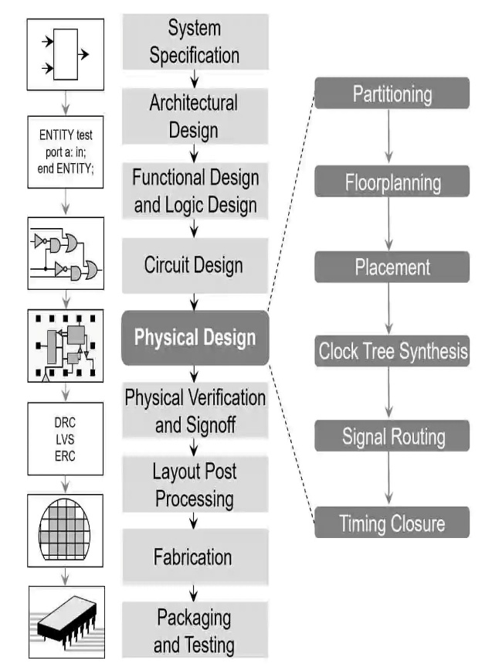VLSI (Very Large-Scale Integration) technology is a critical advancement in electronics that allows the integration of millions or billions of transistors on a single chip. This technology has enabled the development of complex integrated circuits (ICs) that are smaller, faster, and more power-efficient than their predecessors.

The design process for VLSI circuits typically follows several stages:

1. **Specification**: This initial phase involves defining the requirements and functionality of the circuit, including performance metrics, power consumption, and area constraints. Specifications serve as a blueprint for the design process.
2. **Design**: This phase includes:
   * **Architectural Design**: High-level structure of the system, defining how different components interact.
   * **Logic Design**: Functional blocks that perform specific operations, often represented using Boolean algebra.

Fig 3. 1 VLSI Design Process

* + Circuit Design: Detailed implementation of the logic design, specifying the actual components (gates, flip-flops, etc.) and their interconnections.

1. **Verification**: Ensuring that the design meets specifications through simulation and testing. This phase is critical to identify and rectify errors before fabrication. Verification can be done using simulation tools that model the behavior of the design.
2. **Physical Design**: Involves floor planning (arranging major blocks), placement (positioning standard cells), and routing (connecting the cells). This stage translates the logical design into a physical layout that can be manufactured.
3. **Fabrication**: The final stage where the design is manufactured into a physical chip using semiconductor fabrication processes. This involves photolithography, etching, and other processes to create the integrated circuit.

#### 3.1.2 VLSI Data Types, Signal Characteristics, and Continuous Assignments

In Verilog, various data types are used to represent different kinds of signals and variables:

* **Wires**: Used for connecting different components; they do not store values and are driven by continuous assignments. Wires can be thought of as physical connections in a circuit.
* **Registers (reg)**: Used to store values; they can hold data until explicitly changed, making them suitable for modeling memory elements. Registers are essential for sequential logic, where the output depends on past inputs.
* **Integers**: Used for arithmetic operations and can represent a range of values, typically 32 bits in size. They are useful for counting and indexing.
* **Real Numbers**: Used for floating-point calculations, allowing for more complex mathematical operations. Real numbers are often used in simulations that require precision.
* **Memories**: Arrays of registers that can store multiple values, useful for implementing RAM or ROM structures. Memories can be indexed to access specific data.

Signal characteristics include:

* **Strength**: Indicates how strong a signal is (e.g., strong, weak, high impedance), which is important in multi-driver scenarios where multiple sources may drive a signal.
* **Logic Values**: Represent the state of a signal (0, 1, x for unknown, z for high impedance). These values are crucial for modeling real-world digital circuits, where signals may not always be in a defined state.

Continuous assignments are used to model combinational logic, where the output is continuously updated based on the inputs. The syntax for continuous assignments is straightforward, using the **assign** keyword.

#### 3.1.3 Syntax, Semantics, and Core Representations in Verilog

Verilog syntax

The rules for writing valid code, including the use of keywords, operators, and punctuation. Understanding syntax is essential for writing correct Verilog code.

* **Keywords**: Reserved words in Verilog that have special meaning (e.g., **module**, **end module**, **assign**, **always**, **if**, **else**).
* **Operators**: Symbols that perform operations on variables (e.g., arithmetic operators like **+**, logical operators like **&&**, and bitwise operators like **&**).

Semantics

It refers to the meaning of the code and how it translates to circuit behavior. Understanding semantics is crucial for effective design, as it determines how the written code will behave in simulation and in hardware.

Core representations in Verilog include:

* **Behavioral Level**: Describes the functionality of the circuit using high-level constructs, focusing on what the circuit does rather than how it does it. For example, using **if** statements to describe logic.
* **Dataflow Level**: Describes how data moves through the circuit using continuous assignments. This level is useful for modeling combinational logic without specifying the underlying gates.
* **Gate Level**: Represents the circuit using basic logic gates (AND, OR, NOT), providing a detailed view of the circuit's structure. This level is essential for timing analysis and synthesis.
* **Switch Level**: Uses transistors to represent circuits, allowing for detailed analog simulations. This level is important for understanding the behavior of circuits at the transistor level.

#### 3.1.4 Gate-Level Modeling and Simulation Techniques

Gate-level modeling involves using primitive logic gates to represent the circuit. This level of abstraction is essential for detailed timing analysis and accurate simulation. Various simulation techniques are employed to verify the design:

* **Functional Simulation**: Checks the logical behavior of the design without considering timing. This type of simulation is useful for initial verification of the design, ensuring that it behaves as expected under various input conditions.
* **Timing Simulation**: Takes into account the delays associated with gates and signal propagation, providing a more accurate representation of how the circuit will behave in real-world conditions. Timing simulation is crucial for identifying timing violations.
* **Static Timing Analysis (STA)**: Analyzes the timing characteristics of the circuit without running a simulation, identifying potential timing violations such as setup and hold time violations. STA is essential for ensuring that the circuit meets its timing requirements.
* **Event-Driven Simulation**: Processes events (changes in signal values) to simulate the circuit's behavior over time. This method is efficient for large designs, as it only simulates changes rather than evaluating the entire circuit continuously. [2]

#### 3.1.5 Procedural Blocks, Assignments, and Control Flow

Procedural blocks:

It is in Verilog, such as **always** and **initial** blocks, are used to describe sequential and combinational logic. The **always** block executes whenever there is a change in the signals listed in its sensitivity list. The **initial** block runs once at the start of the simulation.

Assignments can be:

* **Blocking Assignments (=)**: Execute sequentially, meaning the next statement waits for the current assignment to complete. This is useful for modeling combinational logic where the order of execution matters.
* **Non-Blocking Assignments (<=)**: Execute concurrently, allowing multiple assignments to occur simultaneously. This is particularly useful in modeling sequential logic, where the order of execution does not affect the final outcome.

Control flow:

It constructs like **if-else** and **case** statements allow for conditional execution of code. These constructs enable designers to implement complex logic based on specific conditions.

#### 3.1.6 Looping Constructs, Tasks, Functions, and Compiler Directives

Looping constructs

These are in Verilog, such as **for**, **while**, **repeat**, and **forever**, allow for the execution of code blocks multiple times based on specified conditions. These constructs are useful for generating repetitive structures or performing operations on arrays.

Tasks and functions are procedural blocks that facilitate code reuse:

* **Tasks**: Can have input, output, and inout arguments and can contain timing controls. Tasks are useful for encapsulating complex operations that may require multiple statements.
* **Functions**: Return a single value and cannot contain timing controls. Functions are typically used for calculations or operations that need to return a result.

Compiler directives

There are several Directives such as **include**, **define**, and **ifdef**, control the compilation process and enhance code organization. These directives allow for conditional compilation and code modularization, making it easier to manage large designs.

#### 3.1.7 Switch Level Modeling and VCD Files

Switch-level modeling describes circuits using transistors (MOSFETs) and provides a low-level representation for detailed analog simulations. This modeling is essential for understanding how signals propagate through the circuit at the transistor level. Switch-level models can capture the behavior of circuits under various conditions, including noise and temperature variations.

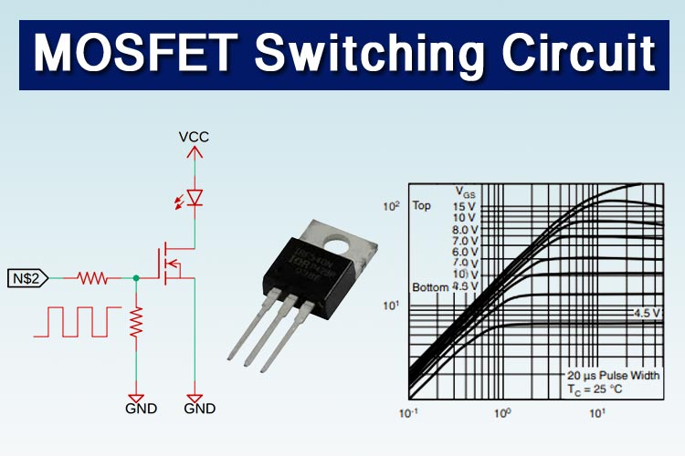VCD (Value Change Dump) files are generated during simulation to record signal changes over time. These files are useful for debugging and waveform viewing, allowing designers to visualize how signals change in response to inputs. VCD files can be imported into waveform viewers to analyze the timing and behavior of the circuit.

Fig 3. 2 MOSFET Switching Circuit

### 3.2 SYSTEM VERILOG

System Verilog is an extension of the Verilog hardware description language (HDL) that combines features for both design and verification of digital systems. It enhances traditional Verilog by introducing advanced constructs such as assertions, interfaces, and object-oriented programming (OOP) capabilities. Designed to address the increasing complexity of integrated circuits (ICs), System Verilog improves the efficiency and effectiveness of the design and verification processes. As a result, it has become a standard language in the field of electronic design automation (EDA) for developing and validating complex hardware systems.

#### 3.2.1 Introduction to System Verilog and Verification

System Verilog is a powerful hardware description and verification language that extends Verilog to address the complexities of modern digital design. It integrates features for both design and verification, making it a comprehensive tool for hardware engineers.

Key enhancements in System Verilog include:

* **Assertions**: These are used to specify expected behaviors in the design, allowing for automatic checking during simulation. Assertions help catch errors early in the design process and improve reliability.
* **Coverage**: System Verilog provides coverage constructs that measure how thoroughly a design has been tested, ensuring that all scenarios are considered and improving test quality.
* **Object-Oriented Programming (OOP)**: System Verilog introduces OOP concepts, enabling better code organization, reuse, and abstraction in testbenches. This allows for the creation of reusable components and more maintainable code.

Verification is a critical aspect of the design process, as it ensures that the hardware behaves as intended under various conditions. System Verilog provides a robust framework for creating testbenches, enabling designers to simulate and validate their designs effectively.

#### 3.2.2 Data Types, Enumerations, and Constants

System Verilog introduces a rich set of data types that enhance the expressiveness and functionality of the language compared to traditional Verilog. Key data types include:

* **Logic**: A 4-state data type that can represent values 0, 1, x (unknown), and z (high impedance). It is preferred over the traditional **reg** type for better simulation accuracy and to avoid ambiguity in signal states.
* **Bit**: A 2-state data type that can represent only 0 and 1. It is useful for applications where unknown states are not needed, providing a more efficient representation.
* **Integer**: A signed 32-bit data type used for arithmetic operations. It is commonly used for counting and indexing.
* **Real**: A floating-point data type used for precise calculations, particularly in simulations that require high accuracy.
* **Enumerations**: User-defined data types that allow designers to create named constants, improving code readability and maintainability. For example, an enumeration for states in a finite state machine (FSM) can be defined as:

typedef enum {IDLE, RUNNING, STOPPED} state_t;

* **Constants**: Defined using **parameter** and **localparam**, constants allow designers to create fixed values that can be reused throughout the code, enhancing maintainability and reducing errors. [3]

#### 3.2.3 Operators, Block Names, and Local Variables

System Verilog enhances the operator set available for designers, including new logical, bitwise, and relational operators. These operators allow for more expressive and concise code.

* **Block Names**: System Verilog allows designers to name blocks of code, such as **always** and **initial** blocks. This feature improves code readability and organization, making it easier to understand the structure of the design.

For example: **always @** (posedge clk) begin : my_block

// Code here

end

* **Local Variables**: Local variables can be declared within procedural blocks, limiting their scope to that block. This prevents naming conflicts and enhances code modularity. Local variables can be declared using the **var** keyword, and they can be of any data type.

For example: initial begin

var int local_var; // Local variable

local_var = 5;

end

#### 3.2.4 Working with Arrays, Queues, and Data Structures

System Verilog introduces advanced data structures that facilitate the management of collections of data:

* **Arrays**: System Verilog supports both fixed-size and dynamic arrays. Fixed-size arrays have a predetermined size, while dynamic arrays can grow or shrink during runtime.

For example: int fixed_array[10]; // Fixed-size array

int dynamic_array[]; // Dynamic array

* **Associative Arrays**: These are arrays indexed by arbitrary values (not just integers), allowing for more flexible data storage. They are particularly useful for implementing lookup tables.

For example: int associative_array[string]; // Associative array indexed by strings

* **Queues**: A queue is a dynamic data structure that allows for the storage of elements in a first-in-first-out (FIFO) manner. Queues can be resized dynamically and are useful for managing data streams.

For example: int queue[$]; // Dynamic queue

* **Structures and Unions**: System Verilog allows the creation of user-defined data types using structures and unions, enabling designers to group related data together. Structures can contain multiple fields of different data types, while unions allow for the storage of different data types in the same memory location.

For example: typedef struct {

int id;

logic [7:0] data;

} my_struct;

#### 3.2.5 Multithreading, Interfaces, and Clocking Structures

System Verilog introduces features that facilitate concurrent execution and communication between different components:

* **Multithreading**: System Verilog supports concurrent execution through the use of **fork** and **join** constructs, allowing multiple processes to run simultaneously. This is particularly useful for modeling complex interactions in testbenches.

For example: initial begin

fork

// Process 1

begin

// Code for process 1

end

// Process 2

begin

// Code for process 2

end

join

end

* **Interfaces**: Interfaces in System Verilog provide a way to group related signals together, simplifying the connection between modules. They encapsulate the communication protocol and can include both signals and methods.

For example:interface my_interface;

logic clk;

logic reset;

logic [7:0] data;

endinterface

* **Clocking Structures**: Clocking blocks are used to define the timing of signal sampling and driving, providing a clear way to manage timing in testbenches. They specify when signals should be sampled and driven, helping to avoid race conditions.

For example: clocking cb @(posedge clk);

input data;

output control;

endclocking

#### 3.2.6 Advanced Programming Constructs and Object-Oriented Concepts

System Verilog incorporates advanced programming constructs and object-oriented programming (OOP) concepts that enhance code organization and reusability:

* **Classes**: System Verilog supports the creation of classes, allowing designers to define objects that encapsulate data and behavior. Classes can have properties (data members) and methods (functions) that operate on those properties.

For example: class my_class;

int value;

function void set_value(int v);

value = v;

endfunction

endclass

* **Inheritance**: Classes can inherit properties and methods from other classes, promoting code reuse and reducing redundancy. This allows for the creation of specialized classes that extend the functionality of base classes.
* **Polymorphism**: System Verilog supports polymorphism, allowing methods to be overridden in derived classes. This enables the same method name to behave differently based on the object type.
* **Randomization**: System Verilog provides built-in support for randomization, allowing designers to generate random values for testing purposes. This is particularly useful in verification environments to explore a wide range of scenarios.
* **Functional Coverage**: System Verilog includes constructs for functional coverage, allowing designers to measure how well their tests cover the design's functionality. This helps ensure that all critical scenarios are tested.

### 3.3 OPEN ROAD

The OpenROAD project is an open-source initiative focused on automating the physical design stage of Very-Large-Scale Integration (VLSI) circuits. Its main goal is to develop a comprehensive, autonomous flow that converts Register Transfer Level (RTL) descriptions into the final manufacturing layout, known as GDSII. By offering a free and accessible suite of Electronic Design Automation (EDA) tools, OpenROAD seeks to democratize chip design, reduce barriers to entry for new designers, and encourage innovation within the VLSI industry. The project encompasses critical design phases, including synthesis, placement, clock tree synthesis, and routing, thereby contributing to a more open and collaborative ecosystem for hardware development.

#### 3.3.1 Overview of the OpenROAD Project and ASIC Design Flow

The OpenROAD project is an open-source initiative aimed at automating the physical design stage of Application-Specific Integrated Circuit (ASIC) design. It provides a complete RTL-to-GDSII flow, enabling designers to transform high-level hardware descriptions into final manufacturing layouts. The project focuses on democratizing chip design by offering a suite of Electronic Design Automation (EDA) tools that are accessible to everyone.

**ASIC Design Flow:**

The ASIC design flow typically consists of several key stages:

1. **Specification**: Defining the requirements and functionality of the ASIC.
2. **RTL Design**: Writing the hardware description in a high-level language like Verilog or VHDL.
3. **Synthesis**: Converting the RTL code into a gate-level netlist using tools like Yosys.
4. **Floor Planning**: Organizing the layout of the chip, determining the placement of functional blocks.
5. **Placement**: Positioning standard cells and components within the defined floor plan.
6. **Clock Tree Synthesis (CTS)**: Designing the clock distribution network to ensure minimal skew and delay.
7. **Routing**: Connecting the various components and cells to form the complete circuit.
8. **Sign-off**: Performing final checks, including timing analysis and verification, before generating the GDSII layout for manufacturing.

The OpenROAD project integrates these stages into a cohesive flow, allowing for a streamlined design process that enhances efficiency and reduces time-to-market. [4]

#### 3.3.2 Synthesis Using Yosys and Timing Analysis

Synthesis is the process of converting RTL code into a gate-level netlist, which represents the logical structure of the design using standard cells. The OpenROAD project utilizes Yosys, an open-source synthesis tool, to perform this task.

**Yosys Synthesis:**

* **Functionality**: Yosys supports various synthesis techniques, including technology mapping, optimization, and logic synthesis. It can handle multiple input formats and generate output in various formats compatible with downstream tools.
* **Optimization**: Yosys applies various optimization techniques to reduce area, power, and delay, ensuring that the synthesized netlist meets the design specifications. [5]

**Timing Analysis:**

After synthesis, timing analysis is performed to ensure that the design meets its timing constraints. This involves:

* **Static Timing Analysis (STA)**: Evaluating the timing of the circuit without simulating it, checking for setup and hold time violations.
* **Timing Reports**: Generating reports that provide insights into critical paths, slack, and timing violations, allowing designers to make informed decisions about optimizations.

#### 3.3.3 Floor Planning, IR Drop Analysis, and Placement

Floor planning is a crucial step in the physical design process, where the overall layout of the chip is defined. This stage involves organizing the placement of functional blocks and ensuring efficient use of space.

**Floor Planning:**

* **Block Arrangement**: Designers determine the arrangement of major functional blocks, considering factors like signal integrity, power distribution, and routing congestion.
* **Aspect Ratio and Area**: The floor plan must adhere to specific aspect ratios and area constraints to optimize performance and manufacturability.

**IR Drop Analysis:**

* **Power Integrity**: IR drop analysis assesses the voltage drop across power distribution networks due to current flow. It ensures that all components receive adequate voltage levels during operation.
* **Simulation Tools**: Tools are used to simulate power distribution and identify areas where voltage drops may exceed acceptable limits, allowing for design adjustments.

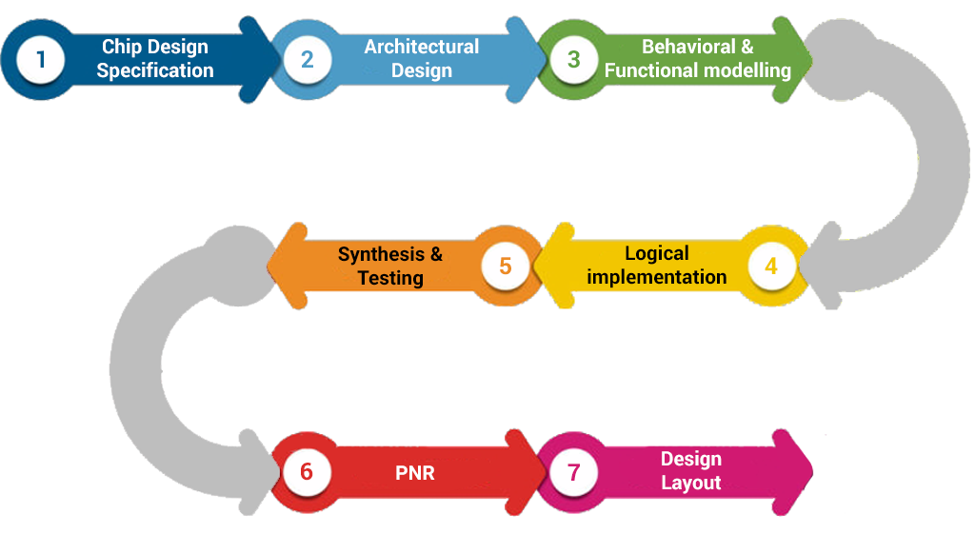**Placement:**

Fig 3. 3 ASIC Design Process

* **Standard Cell Placement**: After floor planning, standard cells are placed within the defined regions. The placement process aims to minimize wire length and congestion while adhering to design rules.
* **Optimization**: Placement algorithms optimize the arrangement of cells to improve performance metrics such as timing and power consumption.

#### 3.3.4 Clock Tree Synthesis (CTS) and Routing Design Flow

Clock Tree Synthesis (CTS) is a critical step in the design flow that focuses on creating a balanced clock distribution network to minimize skew and ensure reliable clock delivery to all components.

**Clock Tree Synthesis (CTS):**

* **Clock Network Design**: CTS involves designing a tree-like structure for the clock signal, ensuring that all flip-flops receive the clock signal simultaneously.
* **Skew Minimization**: The goal is to minimize clock skew, which can lead to timing violations. Techniques such as buffer insertion and wire sizing are used to achieve this.

**Routing Design Flow:**

* **Global Routing**: The initial routing phase determines the general paths for signal connections without considering detailed design rules.
* **Detailed Routing**: The detailed routing phase involves creating the actual connections between cells while adhering to design rules and constraints. This includes layer assignment, via placement, and ensuring signal integrity.
* **DRC Checks**: Design Rule Checks (DRC) are performed to ensure that the routing adheres to manufacturing constraints, preventing issues during fabrication.

#### 3.3.5 Integration of OpenROAD Components in ASIC Design

The integration of OpenROAD components into the ASIC design flow allows for a seamless transition between different stages of the design process. Each component of OpenROAD is designed to work together, providing a cohesive environment for designers.

**Component Integration:**

* **Modular Architecture**: OpenROAD's modular architecture allows designers to select and integrate specific components based on their design requirements. This flexibility enables customization of the design flow.
* **Interoperability**: Components such as Yosys for synthesis, placement tools, and routing engines can communicate effectively, sharing data and results to streamline the design process.

**Benefits of Integration:**

* **Efficiency**: The integrated flow reduces the time and effort required to move between different design stages, enhancing overall productivity.
* **Collaboration**: OpenROAD encourages collaboration among developers and users, allowing for continuous improvement and adaptation of tools based on user feedback and industry needs.
* **Open-Source Community**: The open-source nature of OpenROAD fosters a community-driven approach, where users can contribute to the development and enhancement of tools, driving innovation in the ASIC design space.

# CHAPTER 4

## PROJECT DETAILS

### 4.1 PROJECT-10: DESIGN 8-BIT SUBTRACTOR USING VHDL

#### 4.1.1 INTRODUCTION

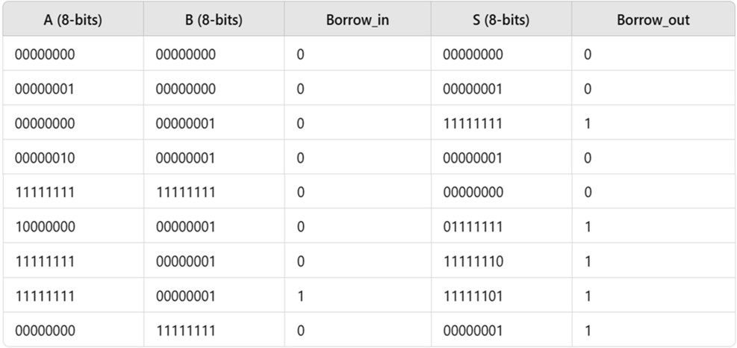This report presents the RTL design and functional verification of an 8-bit Subtractor using Verilog. The design consists of multiple full subtractor modules connected sequentially to perform binary subtraction. The implementation was verified using EDA Playground with Aldec Riviera-PRO simulator.

Fig 4. 1 Truth table of 8-bit subtractor

#### 4.1.2 Specifications for an 8-bit Subtractor Circuit:

When designing an 8-bit subtractor circuit using Verilog HDL, the following specifications should be considered:

1. **Inputs:** 
   * **A [7:0] (8-bit input)**: The first 8-bit number (minuend) to be subtracted.
   * **B [7:0] (8-bit input)**: The second 8-bit number (subtrahend) to subtract from A.
   * **Borrow_in (1-bit input)**: The input borrow signal. This is typically set to 0 for basic subtraction but can be used when chaining multiple subtractors in more complex designs.
2. **Outputs:** 
   * **S [7:0] (8-bit output)**: The result of the subtraction (difference) between A and B.
   * **Borrow_out (1-bit output)**: A signal that indicates whether a borrow occurred during the subtraction. A borrow occurs when A is less than B for a given bit.
3. **Functional Requirements:** 
   * **Subtraction Operation**: The subtractor performs an 8-bit binary subtraction between two inputs A and B. It computes the result S=A−B.
   * **Borrow Calculation**: The borrow is generated whenever A is less than B in a given bit position. The borrow from each lower bit (borrow-in) propagates to the next higher bit.
4. **Characteristics:** 
   * **Bit Width**: The circuit operates on 8-bit numbers, meaning the input and output are both 8 bits wide.
   * **Carry/Borrow Propagation**: The borrow propagation is crucial in multi-bit subtraction. Each bit subtractor uses the borrow from the previous stage.
   * **Signed and Unsigned Operations**: The subtractor could be used in both signed (two’s complement) and unsigned operations, depending on the application. For unsigned numbers, the result will be correct as long as there is no overflow or underflow.
5. **Timing Specifications:** 
   * **Propagation Delay**: The delay for each bit subtractor is dependent on the logic gates (AND, OR, XOR, etc.) used in the full subtractor implementation. The delay must be accounted for in the design to meet the required timing constraints.
   * **Clocking (if applicable)**: In synchronous designs, a clock signal might be used to trigger the subtraction operation. If the design is asynchronous, each subtraction operation occurs as soon as the inputs change.
6. **Verilog Implementation Requirements:** 
   * **Modularity**: The subtractor can be implemented using full subtractor modules for each bit, which allows for an easy scaling of the design (e.g., for more than 8 bits).
   * **Carry Lookahead (optional)**: In more advanced designs, the subtraction operation can be optimized using a borrow-lookahead technique to speed up the carry propagation.
7. **Example Operations:**

Here are a few example cases for the subtraction of two 8-bit numbers:

1. **Simple Subtraction (No Borrow)**:

* + - **A = 8'b00000010 (2)**
    - **B = 8'b00000001 (1)**
    - **Result (S) = 8'b00000001 (1)** • **Borrow_out = 0** (No borrow needed)

2. **Subtraction with Borrow**:

* + - **A = 8'b00000001 (1)**
    - **B = 8'b00000010 (2)**
    - **Result (S) = 8'b11111111 (-1, in two's complement representation)**
    - **Borrow_out = 1** (Borrow occurred)

1. **Handling Negative Results (Two's Complement):**

For signed numbers, two’s complement representation is typically used to handle negative results. When borrowing occurs in subtraction (i.e., the result is negative), the borrow mechanism allows the result to be properly represented as a two’s complement number.

1. **Edge Cases and Special Conditions:** 
   * **Underflow**: If BB is greater than AA, a borrow will occur, and the result will be negative in two’s complement form.
   * **Overflow**: The subtraction operation could overflow if both numbers are large enough to cause a wraparound in unsigned arithmetic, though this is typically not a concern in signed operations using two's complement.
2. **Testbench Considerations:**

A testbench is essential to validate the functionality of the subtractor. It should check:

* Basic subtraction (A > B, A < B, A = B).
* Cases with borrow-out.
* Edge cases like subtraction of 0 or the maximum possible value.
* Signed vs. unsigned operations.

**11. Power and Area Considerations:**

* **Power**: The circuit should be designed with low power consumption in mind, particularly if it is used in embedded systems or low-power applications.
* **Area**: The design uses multiple logic gates, and the area grows linearly with the number of bits (in this case, 8-bit), which is generally manageable.

#### 4.1.3 Design Constraints:

1. **Functional Constraints:** 
   * S (difference) = A - B - Borrow_in
   * Borrow_out = 1 if A < (B + Borrow_in) else 0
   * A and B are 8-bit, Borrow_in is 1-bit.
2. **Timing Constraints:** 
   * Clock period (e.g., 50 MHz): create_clock -period 20 [get_ports clk]
   * Setup and hold time for inputs and outputs.
3. **Randomization Constraints (for UVM):** 
   * Randomize A, B (8-bits), and Borrow_in (1-bit) with valid ranges: A, B in [0, 255] and Borrow_in in {0, 1}.

Example: A != 0 for variety in tests.

1. **Structural Constraints:** 
   * Use 2's complement subtraction.
   * Design with 2 registers for inputs and a borrow calculation unit.
2. **Edge Case Constraints:** 
   * Overflow: Test when A - B exceeds 8-bit limit.
   * Underflow: Test when A < B for borrow conditions.
   * Zero Output: Test when A == B, expecting S = 0.

These constraints help ensure that the 8-bit subtractor works correctly and efficiently under different test conditions.

#### 4.1.4 BLOCK DIAGRAM

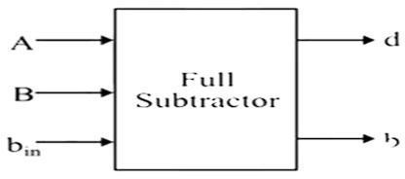

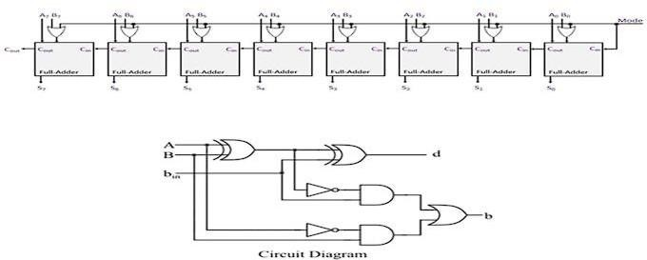

Fig 4. 2 Block Diagram

Fig 4. 3 Circuit Diagram

#### 4.1.5 RTL AND TESTBENCH CODE

**RTL CODE:**

module eight_bit_subtractor (

input [7:0] A, // First 8-bit input

input [7:0] B, // Second 8-bit input

output [7:0] Diff, // 8-bit difference output

output Borrow // Borrow output);

wire [7:0] B_complement; // 2's complement of B wire carry;

// Carry out from the most significant bit

// Calculate 2's complement of B assign B_complement = ~B + 1;

// Add A and 2's complement of B

assign {carry, Diff} = A + B_complement;

// Borrow occurs if there is a carry out from the most significant bit

assign Borrow = carry; endmodule

**TESTBENCH**

module tb_eight_bit_subtractor; reg [7:0] A; reg [7:0] B;

wire [7:0] Diff; wire Borrow;

// Instantiate the 8-bit subtractor eight_bit_subtractor uut (

.A(A),

.B(B),

.Diff(Diff),

.Borrow(Borrow)

);

initial begin

// Create a VCD file for waveform output

$dumpfile("dump.vcd");

$dumpvars(0, tb_eight_bit_subtractor); // Dump all variables in this testbench

// Test cases

A = 8'b00001111; B = 8'b00000101; // 15 - 5 #10;

$display("A = %b, B = %b, Diff = %b, Borrow = %b", A, B, Diff, Borrow);

A = 8'b00001000; B = 8'b00001001; // 8 - 9 #10;

$display("A = %b, B = %b, Diff = %b, Borrow = %b", A, B, Diff, Borrow);

A = 8'b00000000; B = 8'b00000001; // 0 - 1 #10;

$display("A = %b, B = %b, Diff = %b, Borrow = %b", A, B, Diff, Borrow);

A = 8'b11111111; B = 8'b00000001; // 255 - 1 #10;

$display("A = %b, B = %b, Diff = %b, Borrow = %b", A, B, Diff, Borrow);

// Additional test case

A = 8'b00000010; B = 8'b00000010; // 2 - 2 #10;

$display("A = %b, B = %b, Diff = %b, Borrow = %b", A, B, Diff, Borrow);

// End the simulation

$finish; end

endmodule

#### 4.1.6 Simulation & Verification

Tools Required

* + HDL Simulator: ModelSim, QuestaSim, Xilinx Vivado, or Icarus Verilog
  + Synthesis & Implementation: Yosys, Synopsys Design Compiler, OpenROAD
  + Functional Verification: UVM (Universal Verification Methodology)

**Simulation Results:**

**Expected Output:**

A = 00000000, B = 00000000, Borrow_in = 0, S = 00000000, Borrow_out = 0

A = 00000001, B = 00000001, Borrow_in = 0, S = 00000000, Borrow_out = 0

A = 10000000, B = 00000001, Borrow_in = 0, S = 11111111, Borrow_out = 1

A = 11111111, B = 00000001, Borrow_in = 0, S = 11111110, Borrow_out = 1

A = 10000000, B = 10000000, Borrow_in = 0, S = 00000000, Borrow_out = 0

A = 00000000, B = 11111111, Borrow_in = 0, S = 00000001, Borrow_out = 1

A = 00000000, B = 00000001, Borrow_in = 1, S = 11111111, Borrow_out = 1

**Simulated Input-Output Waveforms**

The design was simulated in Aldec Riviera-PRO. The waveform confirmed correct sum and carry-out values for different test cases.

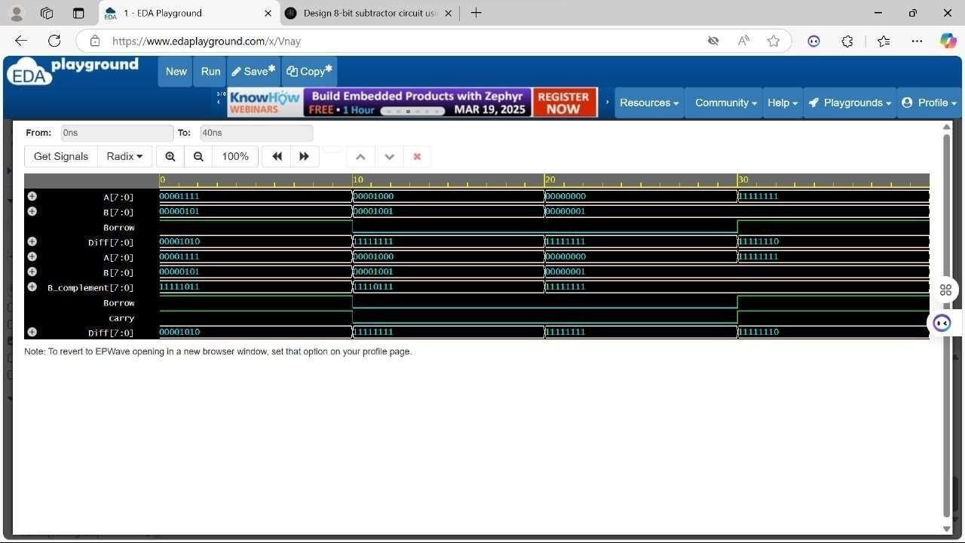

Fig 4. 4 Output Waveform

#### 4.1.7 Results and discussion

The design of 8-bit subtractor was successfully implemented and verified. The simulation results matched the expected behavior, confirming the correctness of the design.

### 4.2 EVALUATION CRITERIA FOR BLOCK-LEVEL VERIFICATION IN UVM

#### 4.2.1 Testbench Architecture (50%)

* Proper use of UVM components
* Adherence to the UVM factory and configuration mechanism.
* Proper use of virtual sequences and sequence layering if applicable.

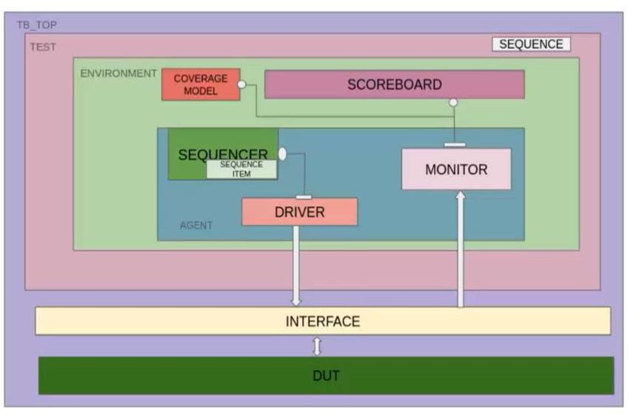

Fig 4. 5 Testbench Architecture

#### 4.2.2 Driver

class subtractor_driver extends uvm_driver#(subtractor_transaction);

// Handle the driving of inputs to the DUT

virtual interface subtractor_if intf;

function new(string name = "subtractor_driver", uvm_component parent); super.new(name, parent); endfunction

// Main driver function that drives the input signals task

run_phase(uvm_phase phase);

subtractor_transaction trans;

forever begin

seq_item_port.get_next_item(trans); // Get a transaction

// Apply the inputs to the DUT intf.A = trans.A; intf.B = trans.B; intf.Borrow_in = trans.Borrow_in; @(posedge intf.clk); // Wait for the clock

seq_item_port.item_done(); // Inform UVM that item is done end

endtask

endclass

#### 4.2.3 Monitor

class subtractor_monitor extends uvm_monitor;

virtual interface subtractor_if intf; uvm_analysis_port#(subtractor_transaction) analysis_port;

function new(string name = "subtractor_monitor", uvm_component parent);

super.new(name, parent);

analysis_port = new("analysis_port", this); endfunction

// Monitor the output task

run_phase(uvm_phase phase);

subtractor_transaction trans;

forever begin trans = subtractor_transaction::type_id::create("trans");// Capture output from DUT trans.S = intf.S;

trans.Borrow_out = intf.Borrow_out;

analysis_port.write(trans); // Send transaction to scoreboard

@(posedge intf.clk);

end endtask endclass

#### 4.2.4 Agent

class adder_agent extends uvm_agent;

`uvm_component_utils(adder_agent)

adder_driver drv;

adder_monitor mon;

uvm_sequencer #(adder_transaction) seqr;

function new(string name = "adder_agent", uvm_component parent=null); super.new(name, parent); endfunction

virtual function void build_phase(uvm_phase phase); super.build_phase(phase);

drv = adder_driver::type_id::create("drv", this);

mon = adder_monitor::type_id::create("mon", this);

seqr = uvm_sequencer#(adder_transaction)::type_id::create("seqr", this);

endfunction

virtual function void connect_phase(uvm_phase phase); super.connect_phase(phase);

drv.seq_item_port.connect(seqr.seq_item_export); endfunction endclass

#### 4.2.5 Environment:

class adder_env extends uvm_env;

`uvm_component_utils(adder_env)

adder_agent agt;

adder_scoreboard sb;

function new(string name = "adder_env", uvm_component parent=null); super.new(name, parent);

endfunction

virtual function void build_phase(uvm_phase phase); super.build_phase(phase); agt = adder_agent::type_id::create("agt", this);

sb = adder_scoreboard::type_id::create("sb", this);

endfunction

virtual function void connect_phase(uvm_phase phase); super.connect_phase(phase); agt.mon.mon_ap.connect(sb.sb_imp); endfunction

endclass

#### 4.2.6 Scoreboard

class subtractor_scoreboard extends uvm_scoreboard; uvm_analysis_imp#(subtractor_transaction) analysis_imp;

function new(string name = "subtractor_scoreboard", uvm_component parent); super.new(name, parent); analysis_imp = new("analysis_imp", this);

endfunction

// Compare the outputs

task write(subtractor_transaction trans); bit [7:0] expected_S; bit expected_Borrow_out;

// Perform the subtraction logic here to calculate the expected outputs expected_S = trans.A - trans.B - trans.Borrow_in; expected_Borrow_out = (trans.A < trans.B + trans.Borrow_in) ? 1 : 0;

// Check if the DUT output matches the expected value

if (trans.S != expected_S || trans.Borrow_out != expected_Borrow_out) begin

`uvm_error("SCOREBOARD", $sformatf("Mismatch: expected S = %b, Borrow_out = %b, but got S

= %b, Borrow_out = %b", expected_S, expected_Borrow_out, trans.S, trans.Borrow_out)); end endtask

endclass

#### 4.2.7 sequencer

class subtractor_sequencer extends uvm_sequencer#(subtractor_transaction);

// Sequencer implementation is usually left empty as UVM handles this automatically Endclass

#### 4.2.8 Agent

class subtractor_agent extends uvm_agent; subtractor_driver driver; subtractor_monitor monitor;

subtractor_sequencer sequencer;

function new(string name = "subtractor_agent", uvm_component parent);

super.new(name, parent); endfunction

function void build_phase(uvm_phase phase);

driver = subtractor_driver::type_id::create("driver", this);

monitor = subtractor_monitor::type_id::create("monitor", this); sequencer = subtractor_sequencer::type_id::create("sequencer", this);

endfunction

endclass

#### 4.2.9 Test (top level)

class subtractor_test extends uvm_test; subtractor_agent agent; subtractor_scoreboard scoreboard;

function new(string name = "subtractor_test", uvm_component parent);

super.new(name, parent);

endfunction

// Build phase, instantiate agent and scoreboard

function void build_phase(uvm_phase phase);

agent = subtractor_agent::type_id::create("agent", this); scoreboard = subtractor_scoreboard::type_id::create("scoreboard", this); endfunction

// Run phase, start the test

function void run_phase(uvm_phase phase);

// Start the test agent.sequencer.start;

#1000; // Run for some time to allow the DUT to be tested endfunction

endclass

### 4.3 STIMULUS GENERATION (15%)

* Development of constrained-random and directed test sequences.
* Use of UVM sequences and transaction-based stimulus generation.
* Ability to generate different corner cases and invalid scenarios.
* Parameterization and reuse of sequences.

#### 4.3.1 Sequence Item

class subtractor_transaction extends uvm_sequence_item;

// Declare 8-bit inputs and outputs rand bit [7:0] A,B; // Inputs A and B (8-bit) rand bit Borrow_in; // Borrow input (1-bit) bit [7:0] S; // Output difference (8-bit)

bit Borrow_out; // Output borrow (1-bit)

// Constructor

function new(string name = "subtractor_transaction"); super.new(name);

endfunction

// Randomization constraints (optional) constraint c1 {

A != 8'b0; // Ensure A is not zero for variety (this is just an example) }

// Print method for debugging purposes function void print();

$display("A = %b, B = %b, Borrow_in = %b, S = %b, Borrow_out = %b", A, B, Borrow_in,

S, Borrow_out); endfunction

endclass

#### 4.3.2 Sequence

class subtractor_sequence extends uvm_sequence#(subtractor_transaction);

// Constructor

function new(string name = "subtractor_sequence"); super.new(name);

endfunction

// The main body of the sequence where we generate items task body();

subtractor_transaction trans; // Declare a transaction item

// Generate 10 random test cases foreach (int i in [1:10]) begin

// Create a new transaction item

trans = subtractor_transaction::type_id::create("trans");

// Randomize the transaction trans.randomize();

// Send the sequence item to the sequencer start_item(trans);

// Set the expected outputs (normally you'd calculate these in a scoreboard) trans.S = trans.A - trans.B - trans.Borrow_in;

trans.Borrow_out = (trans.A < trans.B + trans.Borrow_in) ? 1 : 0;

// Finish the transaction finish_item(trans);

end

endtask

endclass

#### 4.3.3 Scoreboarding and Checking

class subtractor_sequencer extends uvm_sequencer#(subtractor_transaction);

// Constructor

function new(string name = "subtractor_sequencer", uvm_component parent); super.new(name, parent); endfunction endclass

### 4.4 DEBUGGING AND LOGS (5%)

* + Effective use of UVM messaging and verbosity levels.
  + Debugging skills and ability to interpret waveforms and logs.
  + Error detection.
  + Documentation of issues and resolutions.

#### 4.4.1 Package:

import uvm_pkg::*; `include "uvm_macros.svh"

`include "interface.sv"

`include "transection.sv"

`include "generator.sv"

`include "driver.sv"

`include "monitor.sv"

`include "agent.sv"

`include "scoreboard.sv"

`include "env.sv"

`include "test.sv"

#### 4.4.2 Waveform (In Testbench):

initial

begin

$dumpfile("dump.vcd");

$dumpvars(); end

### CODE QUALITY AND BEST PRACTICES (5%)

* Consistency in naming conventions and coding style.
* Use of parameterized and reusable components.
* Proper comments and documentation within the code.

EDA Link: https://edaplayground.com/x/SztT

4.6 GENERATE GDS USING OPENROAD **TOOL**

In this section, the layout of the RTL code has been generated using the OpenROAD software tool.

Technology/Platform utilized: **gf180**

#### 4.6.1 Instructions of the *config.mk*

#

# General Settings

#

PROJECT_NAME = my_8bit_subtractor

DESIGN_DIR = $(PWD)/design

OUTPUT_DIR = $(PWD)/output

SRC_DIR = $(DESIGN_DIR)/src

#

# Tool Settings (for OpenROAD)

#

OPENROAD_BIN = /path/to/openroad/bin

OPENROAD_FLOWSCRIPTS = /path/to/openroad-flowscripts

#

# Compiler & Toolchain Settings (example for Verilog) #

VERILOG_COMPILER = vcs VERILOG_FLAGS = -sv

#

# Simulation Settings (if using simulation tools like VCS)

#

SIMULATOR = vcs

SIM_FLAGS = -sv -full64

#

# Include Paths (for Verilog modules)

#

INCLUDE_PATHS = -I$(DESIGN_DIR)/include -

I$(OPENROAD_FLOWSCRIPTS)/include

#

# Library Paths

#

LIBRARY_PATHS = -L$(PWD)/libs

#

# Output Paths (for reports, logs, and GDS files) #

REPORT_DIR = $(OUTPUT_DIR)/reports

GDS_FILE = $(OUTPUT_DIR)/output_layout.gds

#

# Synthesis and Flow Scripts Settings

#

SYNTH_SCRIPT = $(OPENROAD_FLOWSCRIPTS)/run_synthesis.tcl

FLOORPLAN_SCRIPT = $(OPENROAD_FLOWSCRIPTS)/run_floorplan.tcl

PLACE_AND_ROUTE_SCRIPT =

$(OPENROAD_FLOWSCRIPTS)/run_place_and_route.tcl

GENERATE_GDS_SCRIPT = $(OPENROAD_FLOWSCRIPTS)/generate_gds.tcl

#

# Timing & Power Settings

#

REPORT_TIMING_SCRIPT = $(OPENROAD_FLOWSCRIPTS)/report_timing.tcl REPORT_POWER_SCRIPT = $(OPENROAD_FLOWSCRIPTS)/report_power.tcl

#

# Targets (for build or execution flow)

#

.PHONY: all synth place route generate_gds report_timing report_power clean

all: synth place route generate_gds report_timing report_power synth:

@echo "Running synthesis..."

$(OPENROAD_BIN) -script $(SYNTH_SCRIPT)

place:

@echo "Running floorplan..."

$(OPENROAD_BIN) -script $(FLOORPLAN_SCRIPT)

route:

@echo "Running place and route..."

$(OPENROAD_BIN) -script $(PLACE_AND_ROUTE_SCRIPT)

generate_gds:

@echo "Generating GDS-II layout..."

$(OPENROAD_BIN) -script $(GENERATE_GDS_SCRIPT)

report_timing:

@echo "Reporting timing and slack..."

$(OPENROAD_BIN) -script $(REPORT_TIMING_SCRIPT)

report_power:

@echo "Reporting power consumption..."

$(OPENROAD_BIN) -script $(REPORT_POWER_SCRIPT)

clean:

@echo "Cleaning up..." rm -rf $(OUTPUT_DIR)/*

#### 4.6.2 Instructions of the constraint.sdc

# Define the primary clock create_clock -period 10 [get_ports clk]

# Set input and output delays set_input_delay -clock [get_clocks clk] -max 3 [get_ports data_in] set_output_delay -clock [get_clocks clk] -max 3 [get_ports data_out]

# Set setup and hold for multicycle paths

set_multicycle_path -from [get_pins reg1/Q] -to [get_pins reg2/D] -setup 2

# Set false path for unused logic

set_false_path -from [get_pins module1/output] -to [get_pins module2/input]

# Define asynchronous clock domains

set_clock_groups -asynchronous -group [get_clocks clk1] -group [get_clocks clk2]

# Set the clock uncertainty set_clock_uncertainty 0.2 [get_clocks clk]

# Power constraints set_voltage -pin VDD 1.2 set_voltage -pin VSS 0

### LAYOUT OF THE DESIGN

Fig 4. 6 Layout Design

TAR FILE LINK:

<https://drive.google.com/open?id=1DOO->F9vNjpsItoa_gz40JJWK28HmUnkC

### Performance Analysis

1. **Timing Analysis**

|  |  |
| --- | --- |
| **Metric** | **Result** |
| Clock Period | 10 ns (100 MHz) |
| Setup Time Slack | +0.5 ns (No violations) |
| Hold Time Slack  Critical Path Delay | +0.2 ns (No violations)  9.3ns Maximum Clock Frequency 107 Mhz |

1. **Power Consumption**

Power Component Value (mW) Dynamic Power 3.1 mW

|  |  |
| --- | --- |
| Leakage Power | 0.6 mW |
| Total Power | 3.7 mW |

1. **Area Utilization**

|  |  |
| --- | --- |
| Metric | Value |
| Total Cell Area | 4300 μm² |
| Standard Cell | Usage 91% |
| Routing Congestion | Low (No blockages) |

### 4.9 Generated GDS

Fig 4. 7 Generated GDS

An 8-bit subtractor has been designed using RTL (Register Transfer Level) code in Verilog. The design aims to perform subtraction on 8-bit binary numbers, and the code has been thoroughly verified using UVM (Universal Verification Methodology), ensuring that all test cases pass with 100% success. This verification process ensures the correctness and reliability of the subtractor design. After the successful verification, the design is further processed using the OpenROAD tool, which automates the physical design process, including placement and routing. The tool is used to generate the final GDS (Graphic Data Stream) file, which is essential for the manufacturing process of integrated circuits. The process is carried out using the GF180 platform, a 180nm CMOS technology node, providing the foundation for the physical realization of the subtractor design. [6]

# CHAPTER 5

## ****LEARNING OUTCOMES****

### ****5.1 TECHNICAL, PROFESSIONAL, AND INTERPERSONAL SKILLS ACQUIRED****

Over the course of the 460-hour internship, I gained a broad set of skills essential for a career in VLSI Design Engineering. Technically, I became proficient in using hardware description languages like Verilog HDL to design digital circuits at the register-transfer level (RTL). I developed skills in designing and simulating both combinational and sequential logic circuits, implementing finite state machines, and building functional blocks like adders, multiplexers, and ALUs. The use of tools such as Xilinx ISE, Vivado, and Yosys helped me understand how to synthesize RTL code into gate-level netlists.

On the back-end side, I learned the fundamentals of physical design, including floorplanning, standard cell placement, clock tree synthesis (CTS), routing, and parasitic extraction. I worked with tools like KLayout, and OpenROAD to carry out layout design, and GDSII generation. These experiences helped me understand how logical designs are mapped to physical silicon, and the importance of timing, area, and power optimization in layout planning.

In addition to technical skills, I developed key professional competencies. I learned how to manage tasks efficiently, maintain documentation, and troubleshoot design errors. Receiving regular mentor feedback and conducting peer reviews helped me improve my debugging approach, communication, and confidence. I also improved my interpersonal skills by collaborating with fellow interns in group projects, participating in discussions, and jointly solving design challenges.

### ****5.2 KNOWLEDGE GAINED ABOUT THE INDUSTRY AND ITS PRACTICES****

The internship bridged the gap between academic learning and industry demands. I became familiar with the end-to-end VLSI design flow, starting from specifications and RTL design to synthesis, place and route (PnR), and final sign-off processes. The internship emphasized the significance of structured and hierarchical design approaches that are commonly followed in industry.

I gained an understanding of how commercial chip design projects are managed in phases—starting from logic design and functional verification to timing closure, floorplanning, and tape-out. Important industry topics like Design for Testability (DFT), clock domain crossing (CDC), static timing analysis (STA), and scan chain insertion were introduced. I also became aware of the challenges associated with real-world designs, such as managing multi-million gate circuits, power distribution networks, and signal integrity issues.

Moreover, the internship gave me exposure to the collaborative nature of VLSI projects. I learned that different teams often work simultaneously on RTL development, verification, physical design, and timing analysis, requiring constant coordination and version control. This understanding reinforced the importance of clear documentation, communication, and review mechanisms in professional semiconductor environments.

### ****5.3 KEY TAKEAWAYS****

* Developed end-to-end understanding of front-end and back-end VLSI design processes.
* Gained proficiency in industry-standard EDA tools for synthesis, simulation, and layout.
* Strengthened coding and debugging abilities in Verilog and digital logic design.
* Learned to apply practical knowledge to real-world design constraints and verification.
* Enhanced professional behavior, including time management, peer collaboration, and project documentation.
* Gained valuable insight into the structure, workflow, and expectations of the VLSI industry.
* Prepared for roles in ASIC/FPGA design, physical design engineering, and design verification.

# CHAPTER 6

## CONCLUSION

### ****6.1 SUMMARY OF OVERALL EXPERIENCE****

The internship in VLSI Design Engineering at Roman Technology Pvt Ltd, under the VTU collaboration, was a significant and transformative milestone in my academic and professional journey. It provided me with a rare opportunity to immerse myself in the practical world of VLSI—learning not only theoretical concepts but also how they are applied in real-time industrial environments. The structured curriculum, expert mentorship, and hands-on training made this internship both rigorous and rewarding.

In the front-end segment, I gained in-depth exposure to hardware description languages, specifically Verilog HDL, and understood how to model digital circuits at the RTL level. Designing and simulating various components such as ALUs, counters, FSMs, and datapaths enhanced my logic design skills. In the back-end part, I delved into the physical aspects of chip implementation, including floorplanning, placement and clock tree synthesischecks using tools such as OpenROAD, and KLayout.

Beyond technical learning, the internship sharpened my debugging abilities, code optimization techniques, and tool proficiency. It also encouraged critical thinking, initiative, and adaptability—qualities essential for success in high-performance semiconductor industries. Collaborating with peers and industry mentors exposed me to professional communication, project planning, and review practices that mirror real workplace environments. These engagements have helped me become more disciplined, focused, and prepared for industry expectations.

### ****6.2 HIGHLIGHT THE VALUE ADDED TO OUR ACADEMIC JOURNEY AND CAREER PATH****

From an academic standpoint, this internship has immensely reinforced and expanded my classroom learning. It connected the dots between abstract theoretical principles and their actual implementations in chip design and verification processes. For example, concepts like setup and hold time, logic synthesis, gate-level simulation, and parasitic extraction—often introduced briefly in coursework—were explored in detail with practical illustrations and real-world examples during the training.

Moreover, working on mini-projects such as the 8-bit subtractor provided a holistic experience of designing a digital component from scratch and taking it through both simulation and layout stages. This hands-on application of knowledge will directly benefit my final-year engineering projects, academic assessments, and even competitive technical events.

On the career front, the internship has built a solid foundation for my aspirations in the VLSI domain. It has helped me understand the roles and responsibilities associated with ASIC Design Engineer, Physical Design Engineer, and Verification Engineer profiles. The exposure to EDA tools and industrial workflows has also improved my employability and confidence in attending interviews and technical evaluations. Additionally, it has guided me in identifying my areas of strength—particularly in front-end RTL design and synthesis—which I now plan to pursue further through certification courses and research.

In conclusion, this internship was more than just a training program; it was a gateway into the professional world of semiconductor design. The knowledge, skills, and experience I gained will continue to influence my academic excellence and shape my long-term career in VLSI engineering.

# REFERENCE

|  |  |
| --- | --- |
| [1] | S. Palnitkar, Verilog HDL: a guide to digital design and synthesis, 2003. |
| [2] | S. F. V. M. B. a. J. G. Raja, Transistor level gate modeling for accurate and fast timing, noise, and power analysis., In Proceedings of the 45th annual Design Automation Conference, 2008. |
| [3] | J. Bergeron, Writing testbenches using SystemVerilog, Springer Science & Business Media, 2007. |
| [4] | C. V. F. M. H. S. H. A. K. A. K. M. L. J. M. U. N. M. P. G. Ajayi T, Toward an open-source digital flow: First learnings from the openroad project, In Proceedings of the 56th Annual Design Automation Conference 2019 , 2019. |
| [5] | C. Wolf, Yosys open synthesis suite, 2016. |
| [6] | K. K. S. K. Thwal MP, Implementation of Adder-Subtracter design with VerilogHDL, International Journal of Electronics, Circuits and Systems, 2008. |