# PROBLEM SOLVING

# (solving various problems with c language)

*Summer Internship Report Submitted in partial fulfillment*

*of the requirement for under graduate degree of*

**Bachelor of Technology**

In

**Computer science Engineering**

By

**B.Hemanth**

**221710313006**

*Under the Guidance of*

**Mr. M. Venkateswarlu**

Assistant Professor



Department Of Computer science Engineering

GITAM School of Technology

GITAM (Deemed to be University)

Hyderabad-502329 July 2020

**DECLARATION**

### I submit this industrial training work entitled **“**solving various problems with c language” to GITAM (Deemed To Be University), Hyderabad in partial fulfillment of the requirements for the award of the degree of “**Bachelor of Technology**” in “ **Computer science Engineering**”. I declare that it was carried out independently by me under the guidance of **Mr. M. Venkateswarlu**, Asst. Professor, GITAM (Deemed To Be University), Hyderabad, India.

The results embodied in this report have not been submitted to any other University or Institute for the award of any degree or diploma.

Place: HYDERABAD B.HEMANTH

Date: 221710313006

GITAM (DEEMED TO BE UNIVERSITY)

Hyderabad-502329, India Dated:

**CERTIFICATE**

This is to certify that the Industrial Training Report entitled **“**solving various problems with c language **”** is being submitted by B.HEMANTH (221710313006) in partial fulfillment of the requirement for the award of **Bachelor of Technology** **in computer science Engineering** at GITAM (Deemed To Be University), Hyderabad during the academic year 2018-19

It is faithful record work carried out by her at the Computer science **Engineering Department**, GITAM University Hyderabad Campus under my guidance and supervision.

**Mr. M. Venkateswarlu Dr.K.Manjunathachari** Assistant Professor Professor and HOD

Department of CSE Department of CSE

iv

**ACKNOWLEDGEMENT**

Apart from my effort, the success of this internship largely depends on the encouragement and guidance of many others. I take this opportunity to express my gratitude to the people who have helped me in the successful competition of this internship.

I would like to thank respected **Dr. N. Siva Prasad,** Pro Vice Chancellor, GITAM Hyderabad and **Dr. CH. Sanjay,** Principal, GITAM Hyderabad

I would like to thank respected **Dr. K. Manjunathachari,** Head of the Department of computer science Engineering for giving me such a wonderful opportunity to expand my knowledge for my own branch and giving me guidelines to present a internship report. It helped me a lot to realize of what we study for.

I would like to thank the respected faculties **Mr. M. Venkateswarlu** who helped me to make this internship a successful accomplishment.

I would also like to thank my friends who helped me to make my work more organized and well-stacked till the end.

B.HEMANTH

221710313006

**TABLE OF CONTENTS**

**[1 Introduction to the project 2](https://docs.google.com/document/d/1tjcjW_gBxLXJJ8lcM_zoOmIZgnojR5jVKL0I-zXZKt8/edit" \l "heading=h.gjdgxs)**

**[2  Problem 1 3](https://docs.google.com/document/d/1tjcjW_gBxLXJJ8lcM_zoOmIZgnojR5jVKL0I-zXZKt8/edit" \l "heading=h.30j0zll)**

[2.1 Problem Statement:-](https://docs.google.com/document/d/1tjcjW_gBxLXJJ8lcM_zoOmIZgnojR5jVKL0I-zXZKt8/edit" \l "heading=h.1fob9te) 3

[2.2 Coding](https://docs.google.com/document/d/1tjcjW_gBxLXJJ8lcM_zoOmIZgnojR5jVKL0I-zXZKt8/edit" \l "heading=h.3znysh7) 6

[2.3 Output](https://docs.google.com/document/d/1tjcjW_gBxLXJJ8lcM_zoOmIZgnojR5jVKL0I-zXZKt8/edit" \l "heading=h.2et92p0) 8

**[3  Problem 2 11](https://docs.google.com/document/d/1tjcjW_gBxLXJJ8lcM_zoOmIZgnojR5jVKL0I-zXZKt8/edit" \l "heading=h.tyjcwt)**

[3.1 Problem Statement:-](https://docs.google.com/document/d/1tjcjW_gBxLXJJ8lcM_zoOmIZgnojR5jVKL0I-zXZKt8/edit" \l "heading=h.3dy6vkm) 11

[3.2 Coding](https://docs.google.com/document/d/1tjcjW_gBxLXJJ8lcM_zoOmIZgnojR5jVKL0I-zXZKt8/edit" \l "heading=h.1t3h5sf) 14

[3.3 Output](https://docs.google.com/document/d/1tjcjW_gBxLXJJ8lcM_zoOmIZgnojR5jVKL0I-zXZKt8/edit" \l "heading=h.4d34og8) 15

**[4  Problem 3](https://docs.google.com/document/d/1tjcjW_gBxLXJJ8lcM_zoOmIZgnojR5jVKL0I-zXZKt8/edit" \l "heading=h.2s8eyo1) 16**

[4.1 Problem Statement:-](https://docs.google.com/document/d/1tjcjW_gBxLXJJ8lcM_zoOmIZgnojR5jVKL0I-zXZKt8/edit" \l "heading=h.17dp8vu) 16

[4.2 Coding](https://docs.google.com/document/d/1tjcjW_gBxLXJJ8lcM_zoOmIZgnojR5jVKL0I-zXZKt8/edit" \l "heading=h.3rdcrjn) 18

[4.3 Output](https://docs.google.com/document/d/1tjcjW_gBxLXJJ8lcM_zoOmIZgnojR5jVKL0I-zXZKt8/edit" \l "heading=h.26in1rg) 19

**[5  Problem 4](https://docs.google.com/document/d/1tjcjW_gBxLXJJ8lcM_zoOmIZgnojR5jVKL0I-zXZKt8/edit" \l "heading=h.lnxbz9) 20**

[5.1 Problem Statement:-](https://docs.google.com/document/d/1tjcjW_gBxLXJJ8lcM_zoOmIZgnojR5jVKL0I-zXZKt8/edit" \l "heading=h.35nkun2) 20

[5.2 Coding](https://docs.google.com/document/d/1tjcjW_gBxLXJJ8lcM_zoOmIZgnojR5jVKL0I-zXZKt8/edit" \l "heading=h.1ksv4uv) 22

[5.3 Output 2](https://docs.google.com/document/d/1tjcjW_gBxLXJJ8lcM_zoOmIZgnojR5jVKL0I-zXZKt8/edit" \l "heading=h.44sinio)3

1. **Software Requirements 24**

6.1 Hardware Requirements 24

## 6.2 Software Requirements 24

1. **References 25**

# **1 Introduction to the project**

Problem Solving is the Process of Designing and carrying out certain steps to reach a Solution. 5 problems which are listed below are of different complexity and require different approach and logics in order to achieve desired Output/ Solution.

1. **Library management system -**In this problem we add book information about the books such as author name,book name and finally we will display the information about books.
2. **Milk Man and His Bottles -**In this problem we find out the minimum number of bottles required to supply the given demand of milk.

**3 .FACTORS -** In this problem we are going to print the factors for  the numberwhich is equivalent to the product of the given numbers.

**4 .MAXIMUM ROW SUM-** In this problem we are going to find the row with the maximum sum.

1. **PROBLEM-1**

**C PROGRAM ON LIBRARY MANAGEMENT SYSTEM.**

**2.1 Explanation:**

Program to perform following actions :

1. Add book information.

2. Display book information.

3. List all books of given author.

4. List the title of specified book.

5. List the count of books in the library.

**Concepts used for solving the problem :**

Structures:

A structure is a user defined data type in C/C++. A structure creates a data type that can be used to group items of possibly different types into a single type.

Creation of structures:

‘struct’ keyword is used to create a structure. Following is an example.

**struct** address

{

**char** name[50];

**char** street[100];

**char** city[50];

**char** state[20];

**int** pin;

};

Declaration of structures:

A structure variable can either be declared with structure declaration or as a separate declaration like basic types.

// A variable declaration with structure declaration.

**struct** Point

{

**int** x, y;

} p1;  // The variable p1 is declared with 'Point'

// A variable declaration like basic data types

**struct** Point

{

**int** x, y;

};

**int** main()

{

**struct** Point p1;  // The variable p1 is declared like a normal variable

}

Initialization of structure members:

Structure members **cannot be** initialized with declaration. For example the following C program fails in compilation.

**struct** Point

{

**int** x = 0;  // COMPILER ERROR:  cannot initialize members here

**int** y = 0;  // COMPILER ERROR:  cannot initialize members here

};

The reason for above error is simple, when a datatype is declared, no memory is allocated for it. Memory is allocated only when variables are created.

Structure members **can be** initialized using curly braces ‘{}’. For example, following is a valid initialization.

**struct** Point

{

**int** x, y;

};

**int** main()

{

   // A valid initialization. member x gets value 0 and y

   // gets value 1.  The order of declaration is followed.

**struct** Point p1 = {0, 1};

}

Accessing structure elements:

Structure members are accessed using dot (.) operator.

#include<stdio.h>

**struct** Point

{

**int** x, y;

};

**int** main()

{

**struct** Point p1 = {0, 1};

    // Accessing members of point p1

    p1.x = 20;

**printf** ("x = %d, y = %d", p1.x, p1.y);

**return** 0;

}

**Output:**

x = 20, y = 1

Arrays:

An array in C or C++ is a collection of items stored at contiguous memory locations and elements can be accessed randomly using indices of an array. They are used to store similar type of elements as in the data type must be the same for all elements. They can be used to store collection of primitive data types such as int, float, double, char, etc of any particular type. To add to it, an array in C or C++ can store derived data types such as the structures, pointers etc. Given below is the picturesque representation of an array.

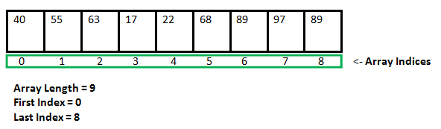Fig 2.1.1

**2.2 Coding:**

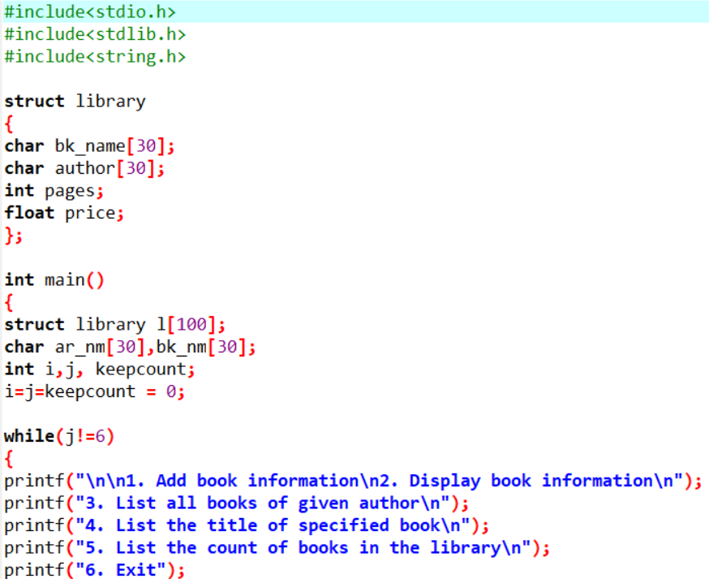

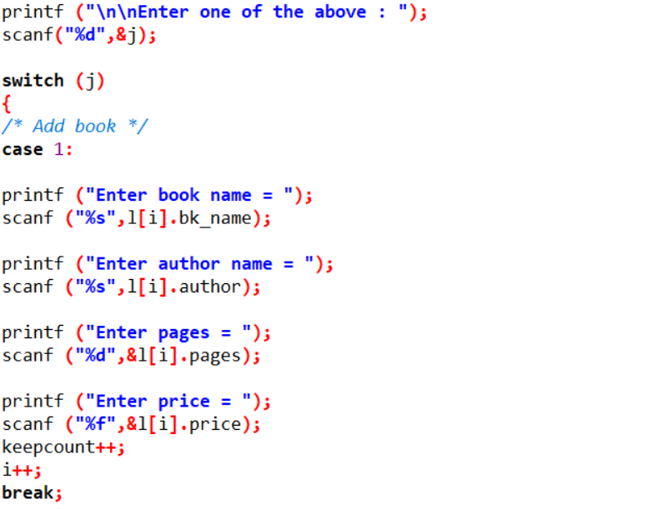

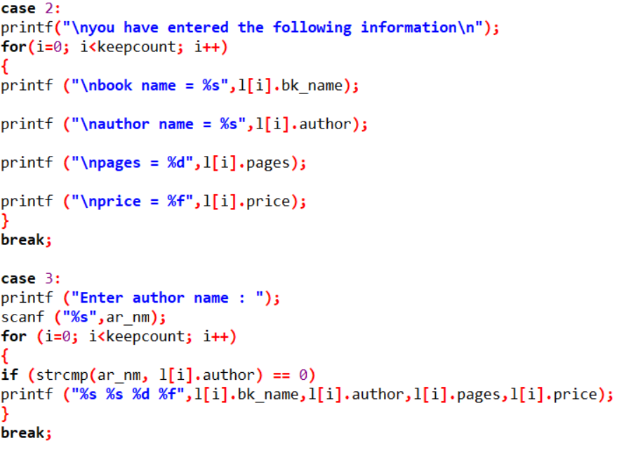

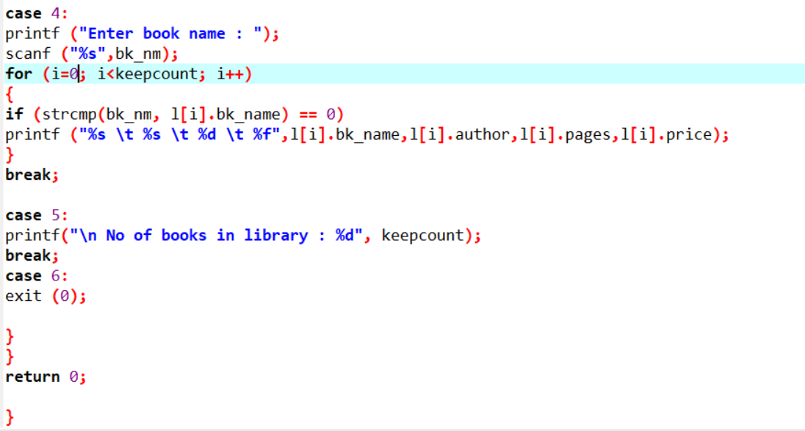

**2.3 OUTPUT:**

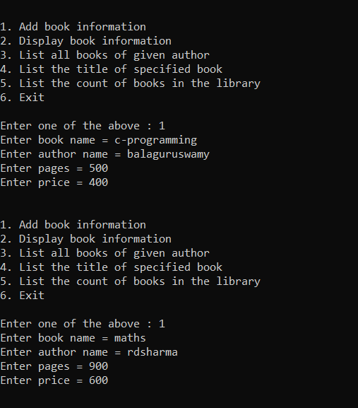

Fig.2.3.1

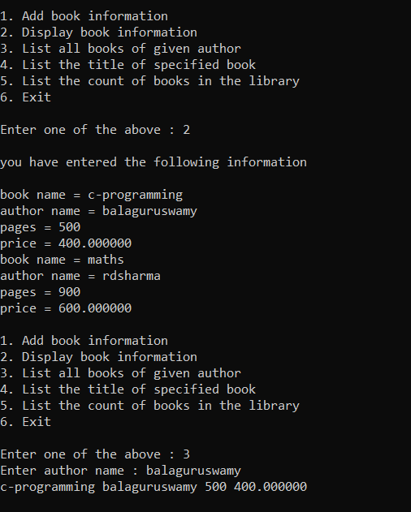

Fig 2.3.2

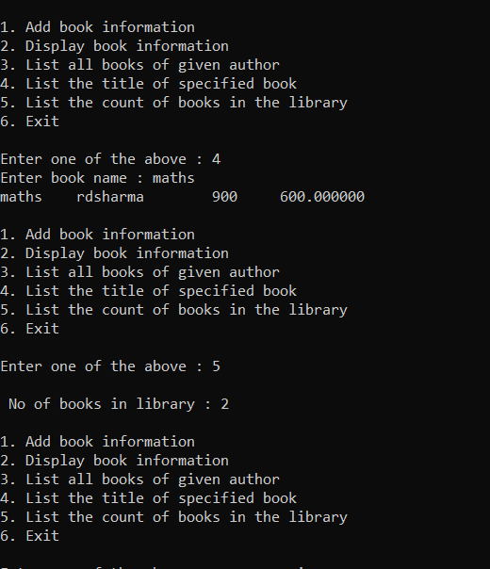

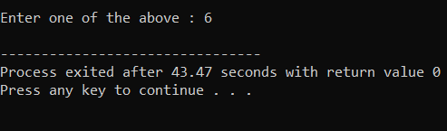

Fig2.3.3

1. **PROBLEM-2**

**3.1 Milk Man and His Bottles**

A Milkman serves milk in packaged bottles of varied sizes. The possible size of the bottles are {1, 5, 7 and 10} litres. He wants to supply desired quantity using as less bottles as possible irrespective of the size. Your objective is to help him find the minimum number of bottles required to supply the given demand of milk.

Input Format:

First line contains number of test cases N  
Next N lines, each contain a positive integer Li which corresponds to the demand of milk.

Output Format:

For each input Li, print the minimum number of bottles required to fulfill the demand.

Constraints:

1 <= N <= 1000  
Li > 0  
1 <= i <= N

**Sample Input and Output :**

|  |  |  |
| --- | --- | --- |
| **SNo.** | **Input** | **Output** |
| 1 | 2  17  65 | 2  7 |

Explanation:

Number of test cases is 2  
1. In first test case, demand of milk is 17 litres which can be supplied using minimum of 2 bottles as follows :

* 1 x 10 litres and
* 1 x 7 litres

2. In second test case, demand of milk is 65 litres which can be supplied using minimum of 7 bottles as follows :

* 6 x 10 litres and
* 1 x 5 litres.

3**.2 CODING :**

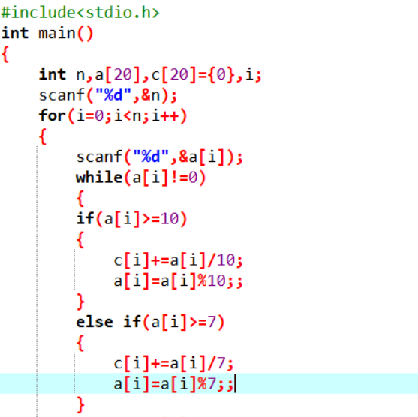

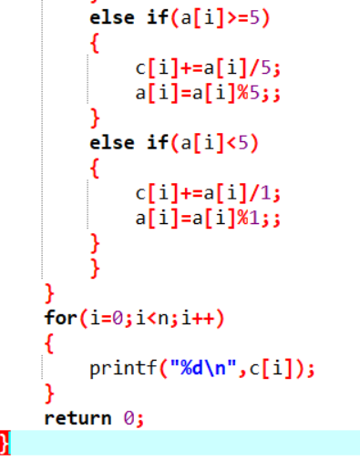

**3.3 OUTPUT :**

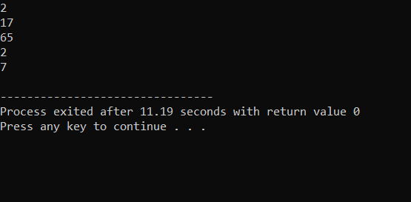

Fig 3.3.1

#### PROBLEM 3

#### FACTORS

In this problem we are going to print the factors for  the number which is equivalent to the product of the given numbers.

4.1 Problem Statement:Factors

Alice has learnt factorization recently. Bob doesn't think she has learnt it properly and hence he has decided to quiz her. Bob gives Alice a very large number and asks her to find out the number of factors of that number. To make it a little easier for her, he represents the number as a product of N numbers. Alice is frightened of big numbers and hence is asking you for help.Your task is simple. Given N numbers, you need to tell the number of distinct factors of the product of these N numbers.

Input:

3

3

3 5 7

3

2 4 6

2

5 5

Output:

8

10

3

4.2 CODING:-

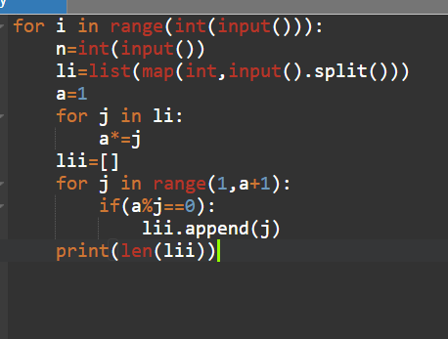

 Fig4.4.2

4.3 OUTPUT:-

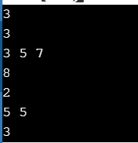

Fig4.4.3

### 5 PROBLEM 4

#### THE MAXIMUM ROW SUM

In this problem we are going to find the row with the maximum sum.

5.1 Problem Statement:-

Find row with maximum sum in a Matrix

Given an N*N matrix. The task is to find the index of a row with the maximum sum. That is the row whose sum of elements is maximum.

Examples:

Input : mat[][] =

{ { 1, 2, 3, 4, 5 },

 { 5, 3, 1, 4, 2 },

 { 5, 6, 7, 8, 9 },

{ 0, 6, 3, 4, 12 },

 { 9, 7, 12, 4, 3 }, };

Output : Row with maximum sum is 3 with sum=35

5.2 CODING:-

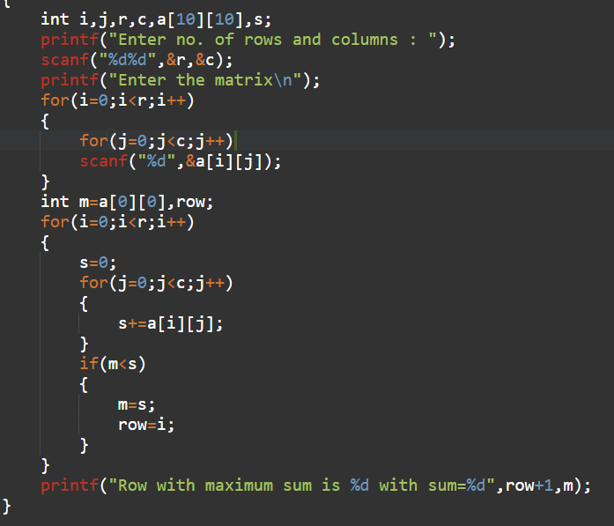

 Fig5.5.2

5.3 OUTPUT:-

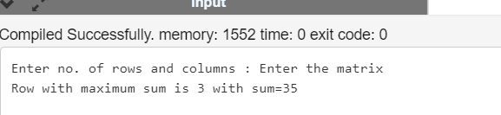

**6. Software Requirements**

## **6.1 Hardware Requirements**

This project can be executed in any system or an android phone without prior to any platform.

We can use any online compiler and interpreter.

## **6.2 Software Requirements**

There are two ways to execute this projects

1.Online compilers

2.Softwares for execution (DEV C++, ANACONDA…..)

Online Compilers require only internet connection. We have many free compilers with which we can code.

Softwares for execution need to be installed based on the user’s system specification. These help us to completely execute the project. These softwares are based on the platforms

**REFERENCES**

* <https://www.faceprep.in/tcs/tcs-codevita-questions/>
* <https://prepinsta.com/tcs-codevita/practice-questions-with-answers/>