SOFTWARE ENGINEERING PROJECT

RMS

STRUCTURAL DIAGRAM:-

Class Diagram:-

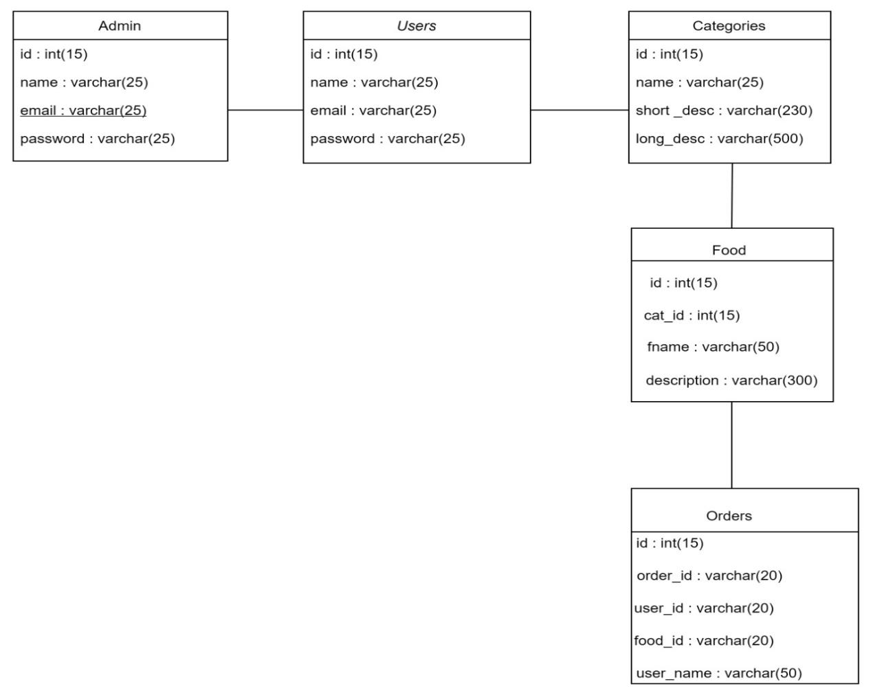

Object Diagram:-

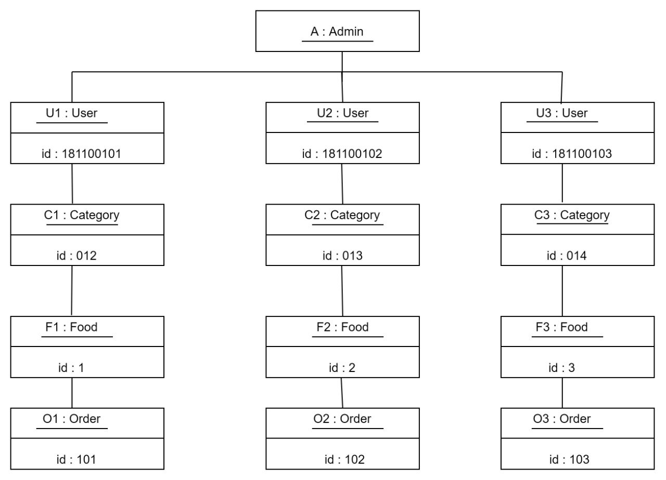

BEHAVIORAL VIEW DIAGRAM:-

Sequence Diagram:-

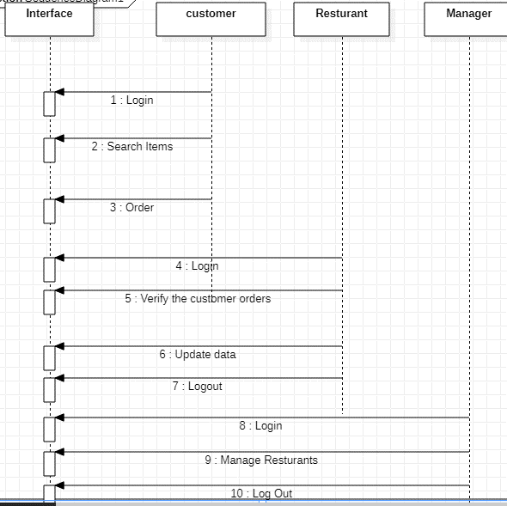
Collaboration Diagram:-

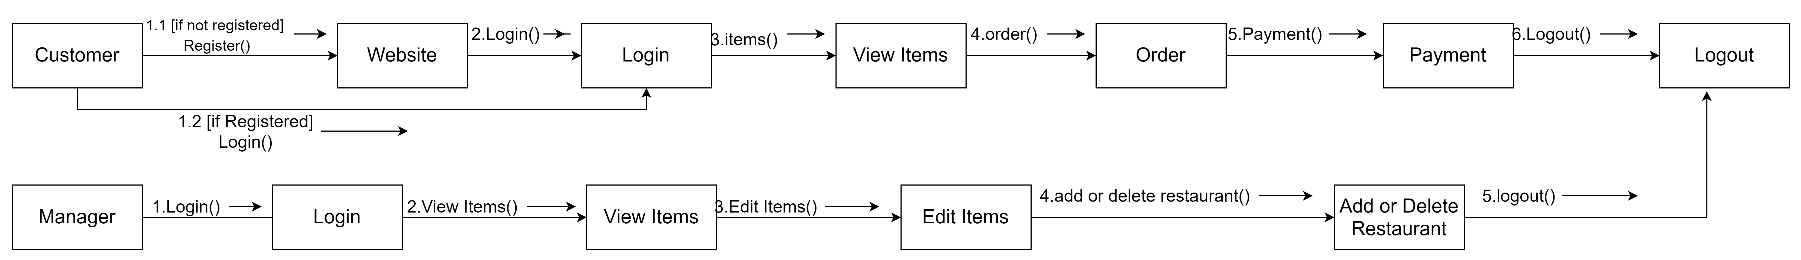

State - chart Diagram:-

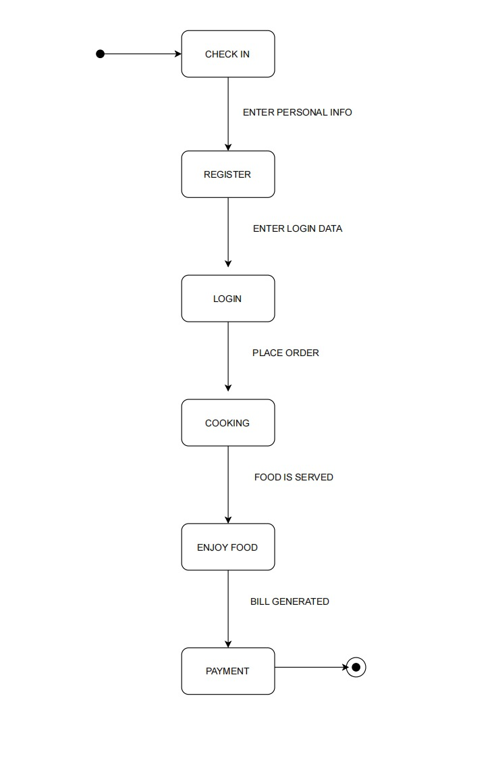

Activity Diagram:-

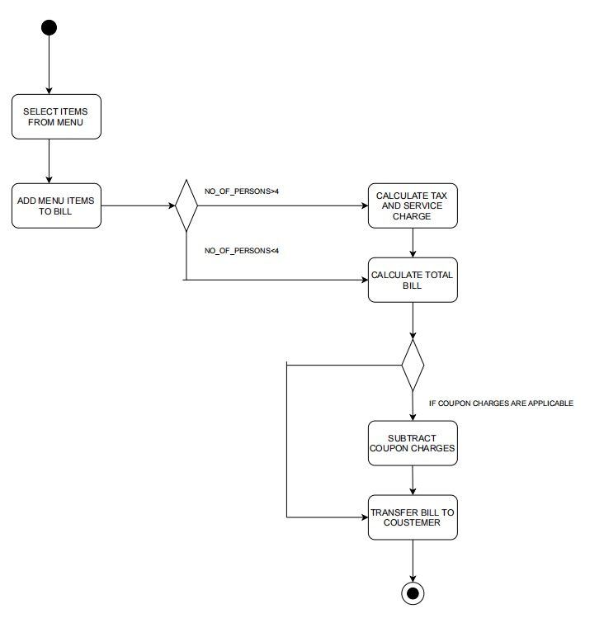

GROUP MEMBERS(CSE - I):-

- Shashank M - AP18110010528

- Hemanth M - AP18110010535

- Manikanta K - AP18110010558

