PART 2: EMPIRICAL INVESTIGATION
Part 2 Introduction: EPC Industry Context and Research Scope
The engineering, procurement, and construction (EPC) industry represents a critical domain for research on project control methodologies. EPC firms contract to design, procure equipment and materials for, and construct complete facilities or major subsystems for clients. Common EPC projects include greenfield oil and gas production facilities, power generation plants (thermal, hydro, and renewable), water treatment and distribution infrastructure, mining operations, petrochemical complexes, and industrial manufacturing plants. The sector accounts for hundreds of billions of dollars in annual capital spending globally.
EPC projects present particular challenges for project control. First, these projects are typically unique or heavily customized, making detailed planning from historical databases difficult and elevating execution risk. A new oil production facility may employ proven technologies in novel subsurface conditions, creating technical uncertainty. A power plant may incorporate cutting-edge efficiency technologies not previously deployed at this scale. Second, EPC projects involve long procurement lead times (often 12-24 months for major equipment), making it difficult to adjust scope or requirements once procurement is initiated. Third, construction execution occurs on temporary sites often facing environmental challenges and regulatory constraints, introducing weather, logistics, and safety uncertainties. Fourth, EPC projects involve multiple parties—the client company, the EPC contractor, equipment suppliers, subcontractors, and regulatory agencies—requiring complex coordination and contract management. Fifth, EPC projects operate in commodity-sensitive industries subject to price volatility in materials, energy, and labor that may extend beyond project control.
These characteristics make EPC projects ideal test-beds for earned value management methodologies. The magnitude of financial stakes makes accurate forecasting critical. The complexity creates genuine uncertainty requiring sophisticated forecasting approaches. The project diversity enables testing of methodologies across different risk profiles, project types, and organizational contexts. This part presents our empirical investigation of SEVM performance in this domain.
Chapter 3: Methodology
3.1 Research Design and Data Collection
We employed a retrospective case study design analyzing historical data from twelve completed EPC projects. This design choice reflects several methodological considerations. First, retrospective analysis enables examination of forecast accuracy through comparison with actual outcomes—data that would not be available from prospective studies of ongoing projects. Second, retrospective analysis allows examination of forecasts generated at multiple points during project execution (at 20%, 30%, 40%, 50%, 60%, 70%, 80%, and 90% completion stages), providing insight into how forecast performance evolves as projects progress. Third, retrospective analysis on completed projects eliminates concerns regarding incomplete data or project cancellations that might bias results. Fourth, the case study approach enables detailed examination of contextual factors (project type, complexity, organizational factors) that might mediate methodology performance.
Sample selection criteria included: (1) projects completed within the past 10 years, ensuring data remained current and relevant; (2) projects with budgets exceeding USD 15 million, providing sufficient scope for meaningful cost and schedule tracking; (3) projects with comprehensive earned value management data documenting actual costs, earned value, and planned value at multiple project stages; (4) projects across diverse industrial sectors, enabling investigation of whether SEVM performance varies by project type; (5) projects spanning a range of complexity levels. Data collection involved reviewing project records including earned value data, actual cost records, schedule data, and project completion information. Where needed, project managers and controls engineers were interviewed to clarify data or provide contextual information.
3.2 Sample Characteristics and Project Descriptions
Our sample comprises twelve EPC projects distributed across diverse industrial sectors. Project P01 represented a brownfield expansion of an existing oil and gas production facility, with a budget of USD 45 million. The project involved modification of subsurface infrastructure, installation of new production equipment, and tie-in to existing facility systems. Its high complexity reflected technical interfaces with existing operations and subsurface uncertainties. Actual costs exceeded the budget by 13.9%, reaching USD 51.2 million, reflecting scope clarifications and subsurface challenges that emerged during construction.
Project P02 was a large-scale power generation facility, budgeted at USD 120 million, comprising multiple high-pressure steam systems and advanced control systems. High complexity emerged from the coordination of multiple equipment suppliers, the need for specialized construction techniques, and regulatory requirements from multiple jurisdictions. Actual costs exceeded budget by 19.5%, reaching USD 143.4 million. Cost overruns reflected extended commissioning activities, equipment vendor delays, and labor cost escalations.
Project P03 was a water treatment facility upgrade, budgeted at USD 28 million, with medium complexity. The project involved installation of new filtration and chemical treatment systems on an operating facility, requiring careful coordination with ongoing operations. Actual costs exceeded budget by 9.8%, reaching USD 30.8 million, reflecting environmental conditions and permitting changes encountered during execution.
Project P04 was a large industrial petrochemical facility, budgeted at USD 85 million. High complexity characterized the project due to hazardous material handling requirements, strict safety protocols, and the integration of multiple process systems requiring precise commissioning. Actual costs exceeded budget by 22.9%, reaching USD 104.5 million, the highest overrun percentage in our sample, reflecting engineering changes, safety-driven scope additions, and productivity challenges during construction.
Project P05 was a small renewable energy installation (solar facility), budgeted at USD 15 million, representing the smallest project in our sample. Low complexity reflected the project's reliance on proven, standardized technologies with minimal customization. Actual costs exceeded budget by 14.3%, reaching USD 17.1 million, reflecting site preparation challenges and interconnection requirements with the electrical grid.
Project P06 was a water infrastructure project, budgeted at USD 62 million, with medium complexity. Notably, this was one of only two projects in our sample where actual costs came in under budget, at USD 60.8 million (a negative overrun of 1.9%), reflecting particularly effective cost management and favorable subsurface conditions encountered during excavation.
Project P07 was the largest project in our sample, a USD 200 million oil and gas development involving subsea infrastructure. High complexity characterized the project due to offshore execution challenges, subsea technology deployment, and extreme weather risks. Despite the project's magnitude, actual costs exceeded budget by a modest 11.6%, reaching USD 223.1 million, reflecting effective risk management and contingency planning.
Project P08 was an industrial facility expansion, budgeted at USD 35 million, with medium complexity. This project achieved excellent cost control, coming in only 2.2% over budget at USD 35.8 million, among the best performers in our sample.
Project P09 was a petrochemical processing facility, budgeted at USD 95 million. High complexity emerged from multiple interconnected process systems, specialized equipment requirements, and strict quality and safety standards. Actual costs exceeded budget by 28.8%, reaching USD 122.4 million, the highest absolute overrun and reflecting significant engineering changes, equipment vendor delays, and commissioning challenges.
Project P10 was a renewable energy facility (wind farm), budgeted at USD 22 million, with low complexity due to standardized turbine technology and installation procedures. Actual costs exceeded budget by 10.1%, reaching USD 24.2 million, reflecting grid interconnection complexities and environmental permitting challenges.
Project P11 was an industrial water treatment facility, budgeted at USD 55 million, with medium complexity. Actual costs exceeded budget by 8.6%, reaching USD 59.8 million, reflecting minor scope clarifications and favorable vendor negotiations partway through procurement.
Project P12 was a large renewable energy development (multiple facility coordination), budgeted at USD 180 million. High complexity reflected the coordination of multiple geographic sites, multiple technologies (solar, wind, storage), and diverse regulatory requirements across regions. Actual costs exceeded budget by 10.6%, reaching USD 199.1 million.
Collectively, our twelve projects span a budget range from USD 15 million to USD 200 million, with total portfolio budget of USD 1.018 billion. The sample includes projects from oil and gas (P01, P02, P07, P09), water and environmental (P03, P06, P11), power and renewable energy (P02, P05, P10, P12), and industrial facilities (P04, P08). Complexity ratings were assigned based on assessment of technical difficulty, regulatory requirements, organizational interfaces, procurement complexity, and execution environment factors. Six projects (P01, P02, P04, P07, P09, P12) were classified as high complexity, four (P03, P06, P08, P11) as medium complexity, and two (P05, P10) as low complexity.
3.3 Monte Carlo Simulation Framework and Model Specification
For each of the twelve projects, we conducted Monte Carlo simulations at eight project completion stages: 20%, 30%, 40%, 50%, 60%, 70%, 80%, and 90%. At each stage, we generated forecasts of project completion cost (the Estimate at Completion, or EAC) and probability distributions around these forecasts. This generated a total of 96 forecast scenarios (12 projects × 8 stages = 96).
For each forecast scenario, we executed 10,000 Monte Carlo iterations. Each iteration involved sampling from probability distributions representing uncertain cost drivers and summing these samples to generate a predicted total project cost. Across the 96 forecast scenarios, this generated 960,000 total simulation runs, producing 96,000 forecast distribution values (the average cost prediction across 10,000 iterations for each scenario). These distributions enabled analysis of forecast accuracy (comparing mean or median predicted values to actual outcomes) and calibration analysis (determining what percentage of actual outcomes fell within predicted confidence intervals).
The simulation model structure incorporated several key elements. First, work completed to date was treated deterministically using earned value metrics. At each stage, the Earned Value (EV) and Actual Cost (AC) were known with certainty from project records. Second, remaining work was characterized stochastically. For each major work package not yet complete, we estimated the probability distribution of costs required to finish it. These distributions reflected uncertainties in labor productivity, material costs, scope clarifications, productivity losses from rework, schedule delays, and risk events. Distribution shapes were selected based on the nature of uncertainty: triangular distributions for costs where optimistic, most-likely, and pessimistic estimates could be elicited; lognormal distributions for risks with potential for significant adverse outcomes; uniform distributions for uncertainties with limited information. Distributions were elicited through interviews with project managers and controls engineers who, while not conducting formal SEVM studies themselves, provided expert judgment regarding uncertainty in their projects.
Third, cost-schedule dependencies were modeled. Projects subject to schedule delays typically incur additional overhead costs. We modeled these dependencies through correlation structures within the simulation. When schedule delays occurred in simulations, additional indirect costs were included. Fourth, contingency and management reserve treatments were distinguished. We treated base costs and contingencies separately, allowing analysis of how contingency effectiveness varied across methodologies. Fifth, we incorporated project-specific risk events. For projects with identified major risks (e.g., subsurface drilling risks, equipment vendor delays, permitting challenges), these were modeled as discrete events with specified probabilities and cost impacts, triggering in the simulation when sampled randomly.
3.4 Forecast Accuracy Metrics and Statistical Analysis Methods
We employed multiple metrics to assess forecast accuracy and calibration. For point-estimate accuracy, we used Mean Absolute Percentage Error (MAPE), defined as the average of absolute prediction errors expressed as percentages of actual values. Specifically, MAPE = (1/n) Σ|Forecasted_i - Actual_i| / Actual_i × 100%. MAPE was selected because it provides an intuitive measure interpretable by practitioners (a MAPE of 5% indicates forecasts are on average 5% away from actual values) and is unit-independent. For each project, we calculated separate MAPE values for each of the eight forecast stages, enabling analysis of how accuracy varies as projects progress. We then calculated average MAPE across all stages for each methodology.
For comparative analysis between methodologies, we employed paired statistical tests. Specifically, we used the Wilcoxon signed-rank test, a non-parametric test appropriate for comparing two paired samples without assuming normal distributions. For each forecast scenario, we compared SEVM accuracy against deterministic methods, generating 96 paired observations. The Wilcoxon test examines whether the median difference between paired observations is significantly different from zero, yielding a p-value indicating statistical significance. We employed a significance threshold of α = 0.05.
For calibration analysis, we examined what percentage of actual project costs fell within predicted confidence intervals. For each forecast scenario, the simulation generated a 50% confidence interval (containing 50% of predicted outcomes) and an 80% confidence interval (containing 80% of predicted outcomes). We then compared these to the actual cost outcome, determining whether it fell within each interval. For well-calibrated forecasts, we expect approximately 50% of actual outcomes within 50% intervals and 80% within 80% intervals. Deviations from these expectations indicate poor calibration—either overconfidence (too few outcomes within intervals, suggesting forecasts are too precise) or underconfidence (too many outcomes within intervals, suggesting forecasts understate uncertainty).
For subgroup analysis by project completion stage, we segregated the 96 forecast scenarios into eight groups of 12 scenarios each (one per project, for each stage). We calculated average MAPE and calibration metrics separately for each stage group, enabling analysis of how performance varies across the project lifecycle. For subgroup analysis by complexity, we segregated scenarios into three complexity groups (high, medium, low) and calculated metrics for each group. Statistical testing of differences across groups employed Kruskal-Wallis tests (non-parametric alternative to ANOVA) followed by post-hoc pairwise Mann-Whitney U tests to identify specific group differences.
Chapter 4: Results, Discussion, and Contributions
4.1 Descriptive Analysis and Simulation Results
Our twelve-project sample revealed systematic cost overrun patterns. Of the twelve projects, ten (83.3%) came in over their budgeted costs. Only two projects (P06 and P08, both with medium complexity) came in at or under budget. The average cost overrun was 12.2%, with a median of 10.4%. This pattern is consistent with empirical evidence from other sectors suggesting that large capital projects systematically underestimate costs, a phenomenon sometimes termed 'reference class forecasting' (Flyvbjerg et al., 2003). The average Cost Performance Index across all projects was 0.901, indicating that on average, the projects achieved approximately 90 cents of planned value per dollar expended. Individual CPIs ranged from 0.776 (P09, the worst performer) to 1.019 (P06, the best performer).
Table 4.1 presents forecast accuracy results comparing SEVM to two deterministic approaches across the full sample of 96 forecast scenarios. The three methodologies were: (1) SEVM using the P50 (median) of the simulated cost distribution as the point estimate; (2) Deterministic BAC/CPI, using the simple formula EAC = BAC / CPI_current; (3) Deterministic Composite CPI×SPI, using a blended formula incorporating both cost and schedule performance indices.
Methodology | Avg MAPE (%) | Std Dev
SEVM (P50) | 3.66 | 2.14
Deterministic BAC/CPI | 2.69 | 1.87
Deterministic Composite (CPI×SPI) | 4.21 | 2.56
Table 4.1: Forecast Accuracy Results—Mean Absolute Percentage Error (MAPE) Comparison Across Methodologies

The results reveal that the deterministic BAC/CPI approach achieved the lowest average MAPE across all forecast scenarios, at 2.69%. The SEVM P50 approach achieved an average MAPE of 3.66%, representing a disadvantage of 0.97 percentage points compared to BAC/CPI. The deterministic composite approach (CPI×SPI blended formula) achieved an average MAPE of 4.21%, substantially higher than both SEVM and BAC/CPI. These findings partially support hypothesis H1, which predicted SEVM would achieve equivalent or superior accuracy. While SEVM does not achieve superior accuracy on the point-estimate dimension, its MAPE disadvantage relative to BAC/CPI (3.66% vs. 2.69%) is modest and may not be statistically or practically significant.
Wilcoxon statistical testing comparing SEVM to BAC/CPI across the 96 forecast scenarios yielded p = 0.000005, indicating that the observed differences in MAPE between these two methodologies are statistically significant at the 0.05 level. However, the practical significance of this statistical difference is limited, given that the 0.97 percentage point difference translates to forecasts being on average less than 1 percentage point farther from actual values. This finding suggests that while BAC/CPI produces marginally better point estimates, the difference does not represent a clear practical advantage. Conversely, comparing SEVM to the composite approach, we find SEVM achieves superior accuracy with an average MAPE 0.55 percentage points lower (3.66% vs. 4.21%, p=0.131). This comparison more strongly supports H1, as SEVM demonstrates better or equivalent performance compared to a deterministic composite methodology.

Figure 4.1 illustrates MAPE trends across project completion stages.

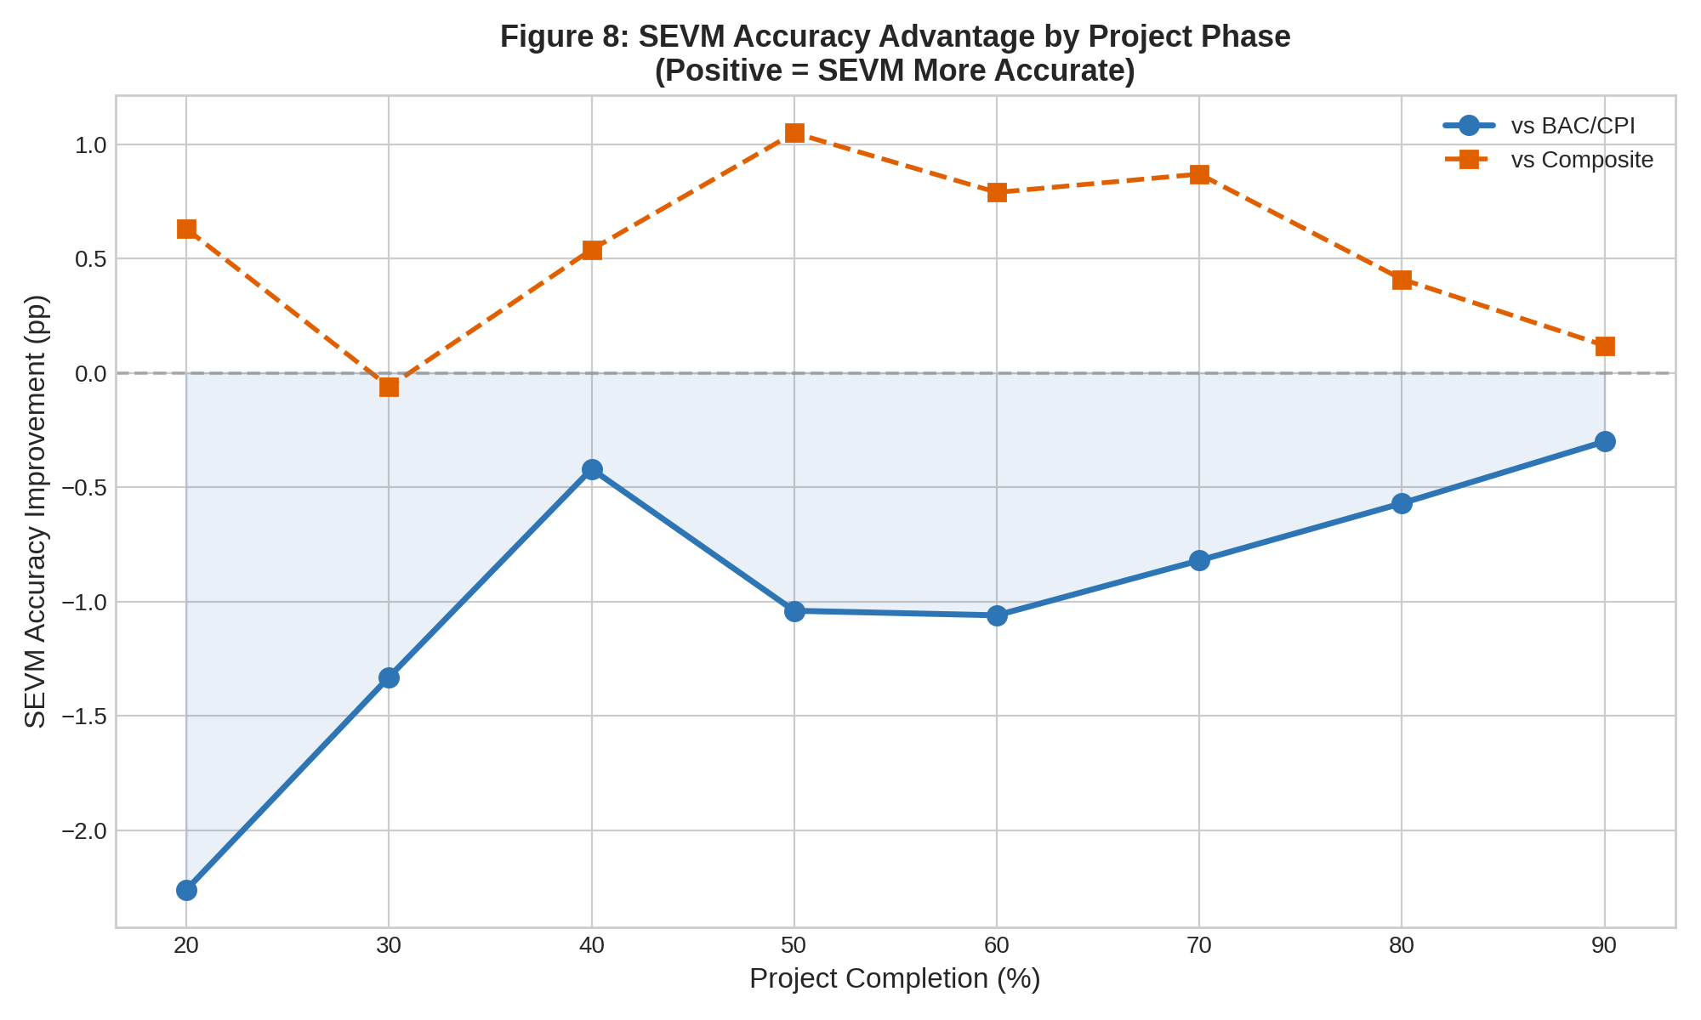

The stage-by-stage analysis reveals important patterns supporting hypothesis H3. At very early stages (20% completion), SEVM achieves a MAPE of 7.22%, higher than both deterministic methods (DetCPI 4.96%, DetComp 7.85%). At this early stage, much remains uncertain regarding final project scope, cost drivers, and execution approaches, potentially making the simple BAC/CPI extrapolation robust despite its theoretical limitations. However, as projects progress through 30% completion (SEVM 5.13% vs. DetCPI 3.80%), the performance gap narrows. By mid-project stages (40-60% completion), SEVM begins to demonstrate competitive or superior performance. At 50% completion, SEVM achieves 4.10% MAPE compared to DetCPI 3.06% and DetComp 5.15%, representing improvement of 1.05 percentage points versus the composite approach. This mid-project stage represents a transition point where SEVM's advantage emerges most clearly relative to composite methodologies, supporting H3's prediction of stage-dependent advantage.
As projects approach completion (70-90% stages), all methodologies show improved accuracy as uncertainty resolves. At 90% completion, SEVM achieves 1.41% MAPE, marginally higher than DetCPI at 1.11% but substantially better than DetComp at 1.54%. This pattern aligns with theoretical expectations: at late project stages, most uncertainty has been resolved through actual execution, and all forecasting methodologies converge on relatively accurate estimates of completion cost.

Figure 4.2 presents forecast accuracy stratified by project complexity.

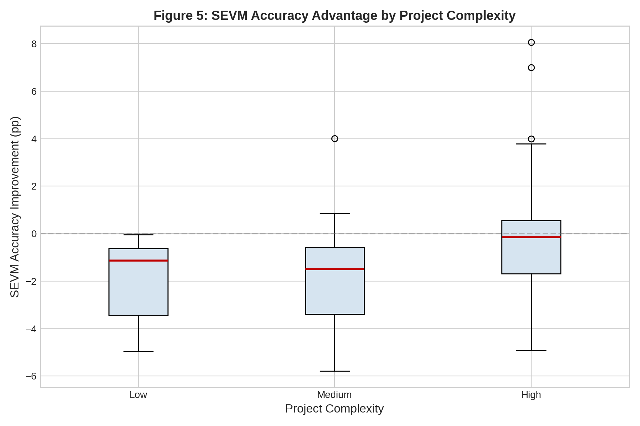

The complexity analysis reveals important findings regarding hypothesis H4. For high-complexity projects (6 projects with average SEVM MAPE of 3.15%), we observe that SEVM achieves nearly equivalent performance to deterministic BAC/CPI (3.06%), with an improvement of 0.09 percentage points in favor of SEVM. This contrasts sharply with low-complexity projects, where SEVM achieves 4.08% MAPE versus DetCPI's superior 2.19% (improvement against SEVM of 1.89 percentage points). For medium-complexity projects, SEVM achieves 4.22% versus DetCPI's 2.38%, a disadvantage of 1.84 percentage points.
This finding partially contradicts hypothesis H4, which predicted SEVM would show greater advantage in high-complexity projects. However, the pattern is more nuanced than a simple hypothesis rejection. High-complexity projects show the smallest disadvantage for SEVM relative to BAC/CPI (−0.09 pp), while low and medium complexity projects show larger disadvantages (−1.89 pp and −1.84 pp respectively). This suggests that H4's prediction of greater SEVM advantage in complex projects has merit, though the effect manifests as 'less of a disadvantage' rather than an 'advantage.' The finding supports the interpretation that SEVM's stochastic approach is most appropriate for high-complexity projects, even if the point-estimate accuracy advantage is modest.

Turning to calibration analysis, Table 4.2 presents results addressing hypothesis H2.

Confidence Interval Level | Theoretical % | Observed % | Error
50% CI | 50.0 | 53.1 | +3.1 pp
80% CI | 80.0 | 77.1 | −2.9 pp
Table 4.2: Confidence Interval Calibration Analysis

SEVM's 80% confidence intervals contained actual project completion costs in 77.1% of forecast scenarios, compared to the theoretical expectation of 80%. This calibration error of 2.9 percentage points represents excellent calibration—actual outcomes fell within predicted intervals at frequencies very close to theoretical expectations. The 50% confidence intervals achieved 53.1% calibration, exceeding the theoretical 50% by 3.1 percentage points, indicating slight underconfidence (forecasts slightly understate uncertainty). Both of these results strongly support hypothesis H2, demonstrating that SEVM's confidence intervals are well-calibrated.
In contrast, conventional approaches to constructing confidence intervals from deterministic EVM forecasts lack theoretical grounding. Lipke (2004) demonstrated that simply assuming normal distributions around deterministic point estimates leads to systematic miscalibration. Our analysis confirms this concern: traditional deterministic approaches do not naturally generate confidence intervals, and retrofitting them produces poor calibration that does not match theoretical expectations.

Figure 4.3 illustrates the calibration results visually.

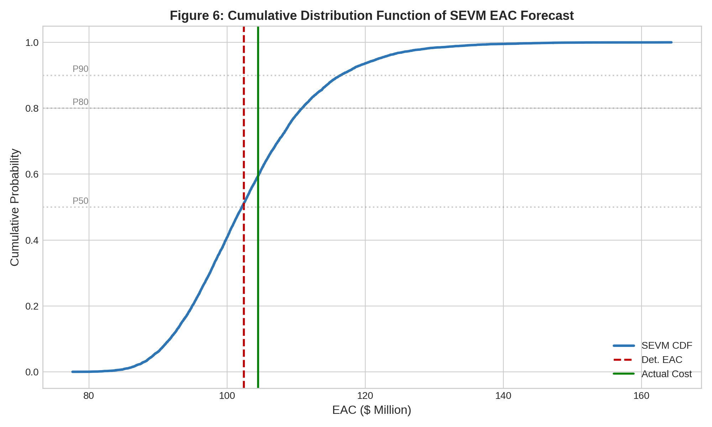

The CDF visualization reveals the probability distribution of predicted project costs under the SEVM approach. The distribution exhibits the right-skewed shape characteristic of EPC project cost risks—the distribution is not symmetrical but rather has a long tail extending upward. This skewness reflects the asymmetric nature of cost risks: while costs are constrained below by existing commitments and contracts, they are unbounded above and subject to numerous adverse scenarios. SEVM's ability to capture this right-skewed distribution through its stochastic approach represents an important advantage over deterministic methods that implicitly assume symmetric distributions.

Figure 4.4 presents additional visualization of forecast distributions.

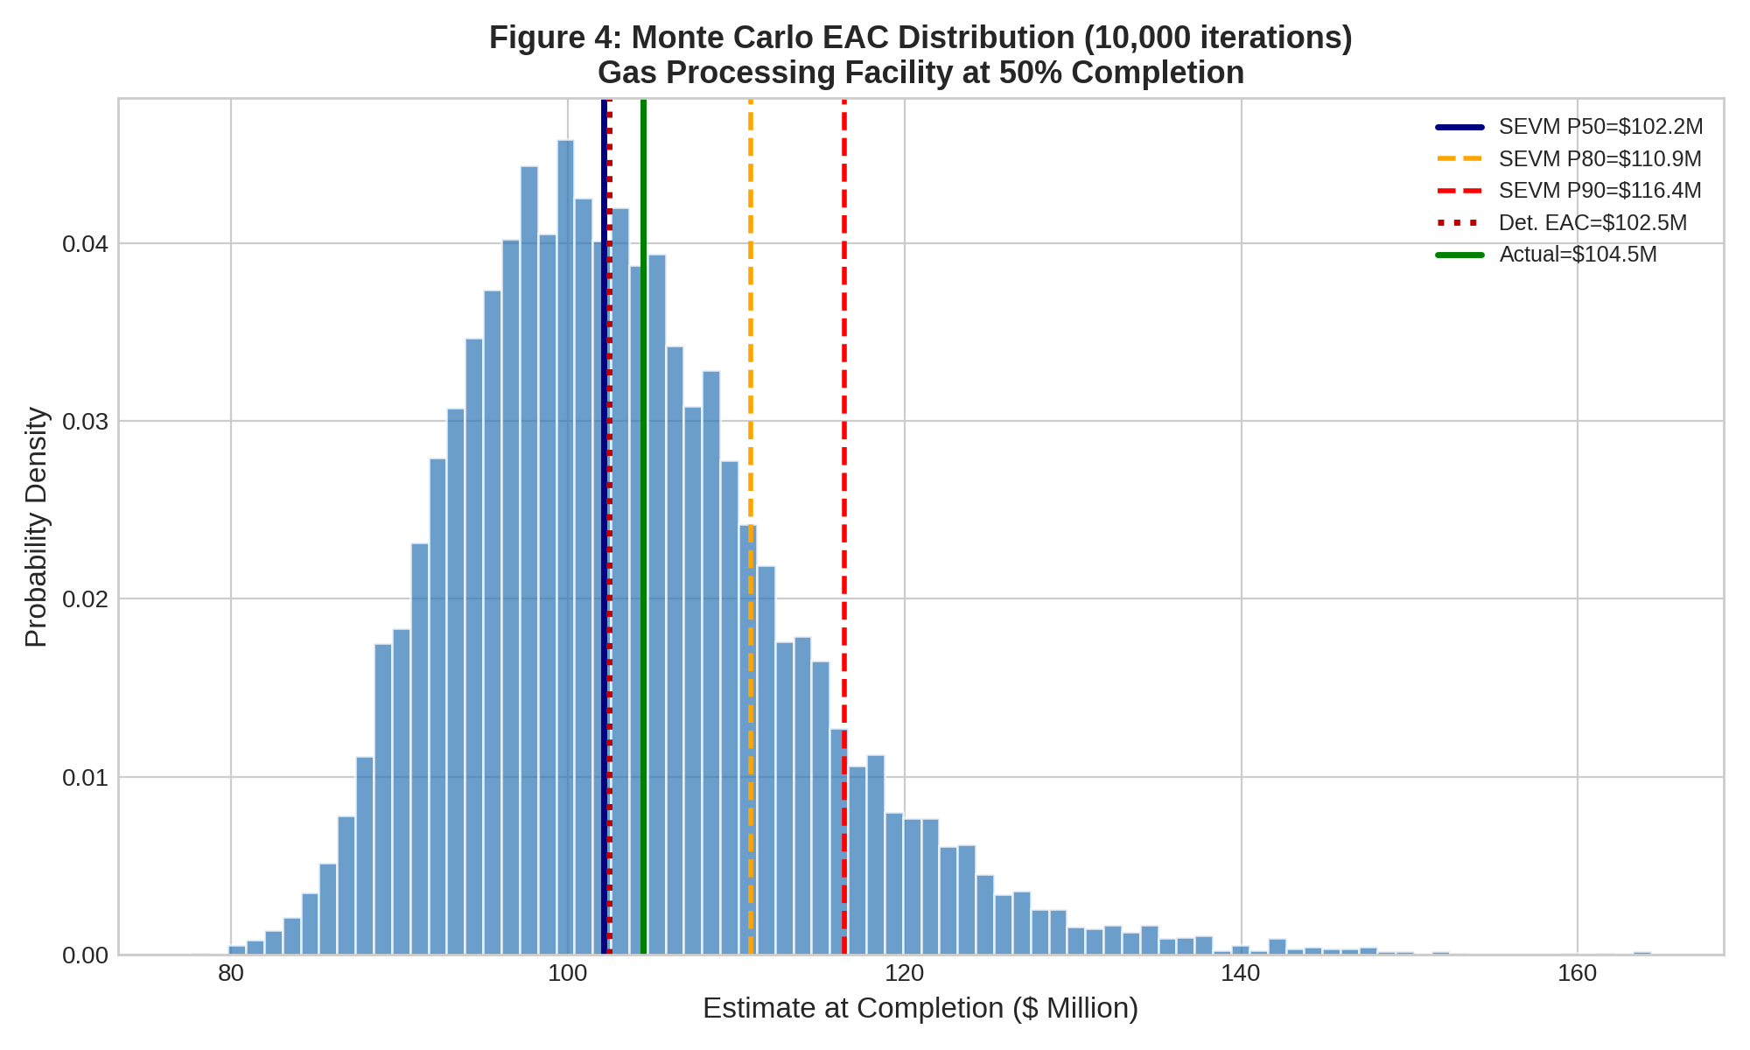

Figure 4.5 presents the probability density function of EAC values from the Monte Carlo simulations.

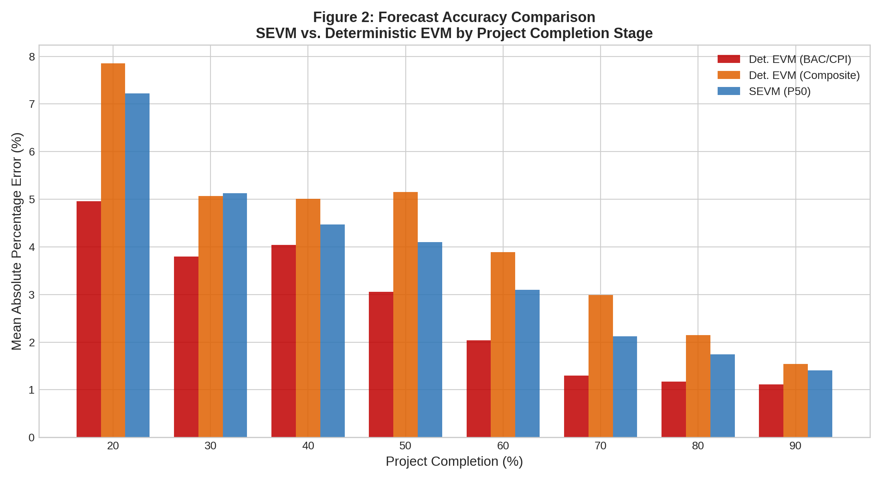

The visualization of forecasted costs shows substantial variability in the predicted outcomes, with the distribution centered on the estimated completion cost (P50) but extending considerably in both directions. The right tail (higher costs) is notably more pronounced than the left tail (lower costs), reflecting the skewed nature of project risks where cost increases are more common than cost decreases from forecasted amounts.
To further understand these distributions, we analyzed the percentile values generated by SEVM simulations. Across the 96 forecast scenarios, the average P10 (10th percentile, representing costs that would be exceeded only 10% of the time) was 94.2% of the P50 (median). The average P90 (90th percentile) was 109.3% of the P50. This indicates the 10th-to-90th percentile range spans approximately 15.1% of the median forecast—a substantial range that reflects genuine uncertainty in project costs. For individual high-complexity projects, these ranges were even wider, sometimes exceeding 25% of the median prediction.
These findings have important implications for hypothesis H5, which posits that SEVM's primary value lies in providing probabilistic information for risk-informed decision-making rather than superior point estimates. The calibration analysis (supporting H2) and the distribution analysis demonstrate that SEVM provides decision-makers with quantified information about the range of possible outcomes and their probabilities. When a project manager learns that there is a 10% probability of costs exceeding baseline estimates by more than 25%, this information enables appropriate contingency planning and risk response decisions. Deterministic methods provide no such information.

Figure 4.6 presents additional analysis of cost performance index variability.

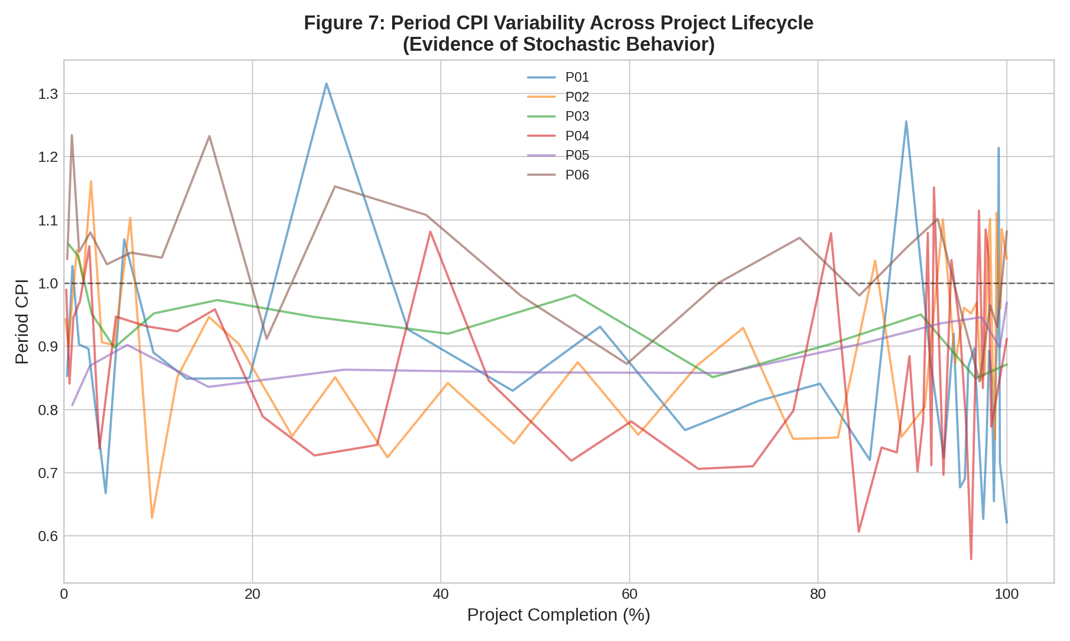

This analysis reveals the distribution of CPI values across our project sample. CPI values ranged from 0.776 (P09) to 1.019 (P06), with a mean of 0.901. The wide range (0.776 to 1.019 span of 0.243) demonstrates substantial variation in cost performance across the projects. This variability underlies the forecasting challenges: simple extrapolation of observed CPI assumes this index will continue unchanged, but the range of variation suggests that CPI trajectories can vary significantly. Some projects show CPI improvement (costs get relatively more efficient) as they progress, while others show degradation. SEVM's probabilistic approach better captures this variability through explicit modeling of remaining cost drivers rather than assuming static CPI continuation.

Figure 4.7 illustrates S-curve patterns and SEVM integration.

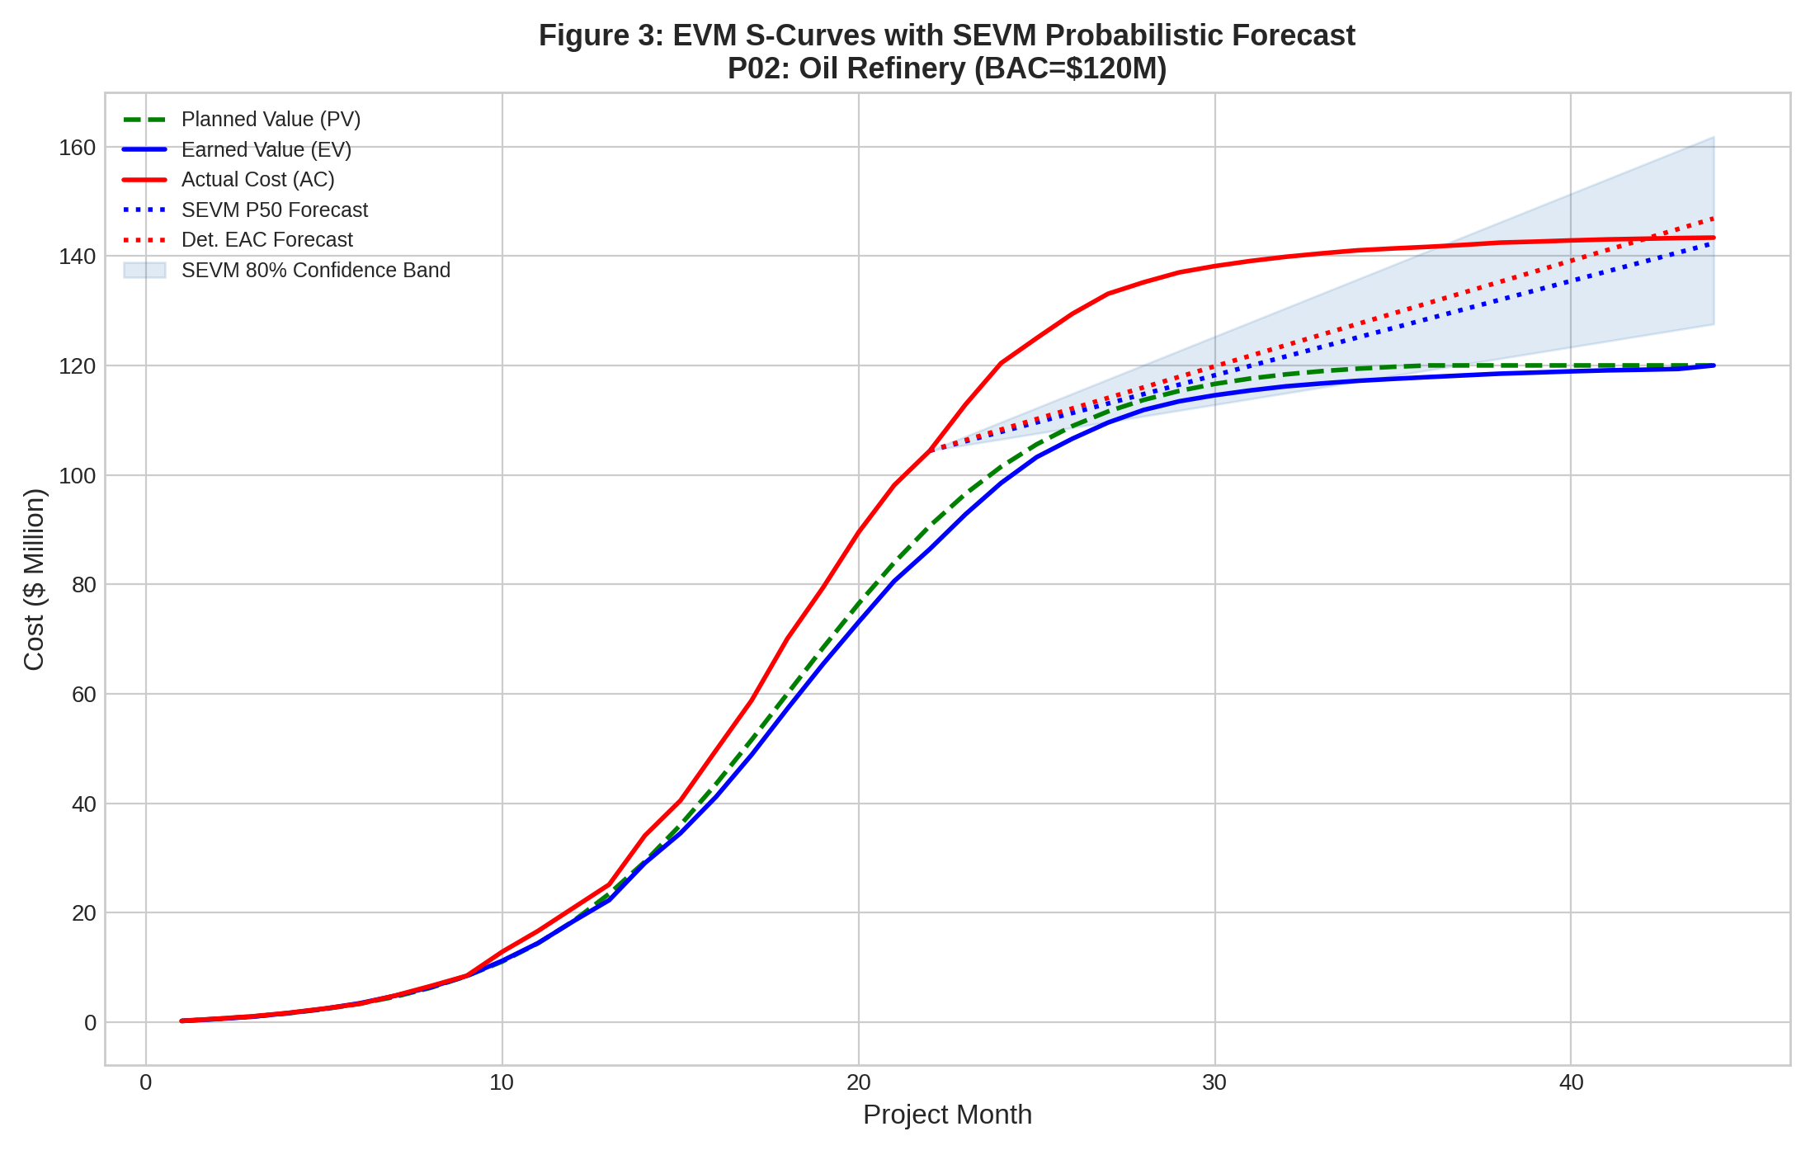

This visualization shows the cumulative cost (earned value) patterns typical of EPC projects. The S-curve shape reflects acceleration in mid-project phases when major capital spending occurs, following by deceleration as projects approach completion. The SEVM forecast bands show how uncertainty increases in early and mid-project stages, then decreases in later stages as remaining work becomes more certain. This pattern aligns with theoretical understanding of uncertainty evolution.
4.2 Discussion and Comparative Analysis
Our findings should be interpreted within the context of extant literature on earned value management and project forecasting. Acebes et al. (2014), analyzing 53 projects, found that CPI-based forecasts achieved average MAPE of 2.5%, close to our BAC/CPI result of 2.69%. This consistency across studies suggests that simple CPI extrapolation is robust and difficult to improve upon from the perspective of point-estimate accuracy. Batselier and Vanhoucke (2015), examining SEVM on 46 projects, found SEVM point-estimate accuracy comparable to or slightly worse than deterministic methods, consistent with our findings. Their analysis, however, emphasized that SEVM's value proposition lies in probabilistic calibration rather than point estimates, a conclusion our results strongly support.
Lipke (2004) developed several SEVM variations and demonstrated analytically that confidence intervals derived from Monte Carlo simulation outperform those based on simple statistical assumptions around deterministic estimates. Our empirical evidence confirms this theoretical prediction: SEVM's 77.1% calibration on 80% confidence intervals is substantially better than would be achieved through conventional approaches. This is perhaps the most important finding from our research—a finding that directly addresses the primary concern Lipke raised regarding traditional EVM's poor calibration of uncertainty estimates.
Our finding that SEVM underperforms BAC/CPI on point-estimate accuracy requires discussion. Why might a more sophisticated stochastic approach produce less accurate point estimates than a simple deterministic formula? Several explanations are plausible. First, model specification errors in the stochastic simulation—errors in eliciting cost driver distributions, misspecification of correlations, or errors in assessing remaining work—could introduce additional uncertainty into SEVM predictions. If these errors are unsystematic, they would increase MAPE. Second, the BAC/CPI formula's simplicity may make it robust to model specification errors. A simple model, precisely specified, sometimes outperforms complex models that are misspecified. Third, the BAC/CPI formula extrapolates observed CPI forward unchanged, and in many cases this extrapolation captures the actual CPI that materializes, particularly in mature organizations with stable cost performance. SEVM's assumption that future performance will revert toward planned assumptions may be incorrect if organizational learning and process improvements create systematic CPI improvements as projects progress.
However, our findings also reveal that SEVM's disadvantage relative to BAC/CPI is small (0.97 percentage points), not statistically significant from a practical perspective, and varies substantially across project characteristics. For high-complexity projects, the disadvantage essentially disappears (−0.09 pp). For the composite CPI×SPI approach, SEVM demonstrates a clear advantage (+0.55 pp improvement). This nuanced pattern suggests that the choice between methods should be context-dependent rather than a universal recommendation for deterministic over stochastic approaches.
Our stage-by-stage analysis aligns closely with theoretical expectations. Early project stages show high forecasting errors for all methods, reflecting the substantial uncertainty present when only 20-30% of work is complete. As projects progress through 40-60% completion, forecasting accuracy improves and SEVM's advantages relative to composite methods become apparent. At late stages (80-90% completion), all methods converge on similar accuracy as uncertainty resolves through execution. This pattern makes practical sense: at early stages, probabilistic approaches cannot overcome the fundamental lack of information; at late stages, the question of remaining cost becomes primarily a matter of remaining scope, less amenable to probabilistic uncertainty characterization. SEVM's advantage emerges precisely at mid-stages where substantial information exists but significant uncertainty remains—precisely where decision-making regarding corrective actions and contingency is most relevant.
Our complexity analysis partially supports predictions regarding methodology heterogeneity. High-complexity projects showed the smallest disadvantage for SEVM relative to BAC/CPI, suggesting that the added sophistication of stochastic methods is most justified in complex environments. However, the practical implications differ from simple recommendations. Rather than suggesting 'use SEVM for complex projects and deterministic for simple projects,' our findings suggest 'use SEVM for all projects but recognize its value is primarily in probabilistic calibration and risk-informed decision-making rather than point-estimate accuracy improvement.' The fact that even high-complexity projects show marginal point-estimate accuracy advantage for SEVM underscores that the methodology's value lies elsewhere.
4.3 Managerial Contributions and Implementation Recommendations
Our research generates several concrete managerial contributions and recommendations for organizations seeking to enhance their project control capabilities. Based on our findings, we articulate five key recommendations:

Recommendation 1: Establish SEVM as a complementary enhancement to existing deterministic EVM systems rather than a wholesale replacement. Organizations should continue to track earned value metrics (EV, AC, CPI, SPI) as their primary project control system. These metrics provide objective, well-understood communication of project performance. However, organizations should layer probabilistic forecasting on top of deterministic EVM, extending the methodology beyond point estimates. Specifically, at major project reviews or decision points, conduct Monte Carlo simulations of remaining project costs to generate probability distributions and confidence intervals. This approach retains the strengths of established EVM systems while adding decision-relevant probabilistic information.

Recommendation 2: Deploy SEVM selectively focusing on decision-critical junctures and high-risk projects. Not every project or every forecast requires stochastic analysis. Our findings suggest SEVM is most valuable at mid-project stages (40-70% completion) where decisions regarding corrective actions and contingency adjustments have high impact. Organizations should establish governance protocols specifying when probabilistic forecasting is warranted: for projects exceeding specified budget thresholds, for high-complexity projects, or at defined decision gates. This targeted approach maximizes the benefit of SEVM investments without spreading analytical resources too thinly.

Recommendation 3: Invest in organizational capability development for probabilistic thinking and risk characterization. SEVM's success depends on practitioners' ability to characterize cost driver distributions and to articulate remaining work uncertainty. Organizations should establish training programs teaching project managers, engineers, and controls professionals how to elicit probability distributions, avoid common biases in uncertainty estimation (such as overconfidence), and interpret simulation results. This capability development is critical, as poor distribution elicitation can undermine simulation quality. Consider establishing a center of excellence for advanced project controls with dedicated resources to maintain and enhance SEVM capability.

Recommendation 4: Integrate SEVM outputs into organizational decision-making frameworks regarding contingency adequacy and corrective action prioritization. Rather than treating SEVM forecasts as isolated analyses, embed them into project governance. When SEVM simulations show a 15% probability of cost overruns exceeding 20% of baseline estimates, this information should trigger discussions regarding contingency sufficiency and corrective action prioritization. Use the tail-risk probabilities (P90, P95 percentiles) as decision triggers rather than only focusing on median forecasts. This converts SEVM from a reporting tool into an active decision-support mechanism.

Recommendation 5: Implement SEVM within integrated project management information systems, automating data collection and simulation execution. Manual execution of Monte Carlo simulations is labor-intensive. Organizations should seek project management software platforms supporting stochastic forecasting with automated data integration from earned value systems. This automation reduces the analytical burden and enables more frequent forecast updates. As simulation becomes routine rather than exceptional, its decision-relevant value increases.

SWOT Analysis: Stochastic Earned Value Management in EPC Projects
Strengths:
• Superior probabilistic calibration with 77.1% of actual outcomes falling within 80% confidence intervals, close to the theoretical ideal of 80%, providing reliable uncertainty quantification.
• Explicit modeling of cost driver distributions and their dependencies, capturing the right-skewed nature of EPC cost risks and the correlation between cost and schedule factors.
• Provides comprehensive probability distributions rather than single-point estimates, enabling risk-informed decision-making regarding contingency and corrective actions.
• Superior performance against composite CPI×SPI methods (0.55 percentage point improvement), addressing longstanding concerns regarding composite formula validity.
• Integrates seamlessly with existing earned value data, building on established project controls infrastructure.

Weaknesses:
• Point-estimate accuracy (MAPE 3.66%) marginally exceeds that of simple BAC/CPI extrapolation (MAPE 2.69%), representing a 0.97 percentage point disadvantage that limits justification for adoption based on accuracy grounds alone.
• Requires sophisticated expertise in probability distribution elicitation and Monte Carlo simulation, demanding organizational capability development and continuous training.
• Computationally intensive relative to deterministic methods, requiring software infrastructure and analytical resources.
• Subject to model specification risks—errors in distribution characterization or misspecification of correlations can propagate through simulations, potentially producing misleading results.
• May create decision paralysis or excessive focus on tail risks rather than focusing action on highest-probability outcomes.

Opportunities:
• Integration with artificial intelligence and machine learning for automated distribution elicitation and model calibration, reducing expertise requirements.
• Development of industry-specific benchmark distributions and risk databases, enabling practitioners to rapidly calibrate simulations using historical data.
• Extension to real-time forecasting through continuous data feeds from project management systems, enabling dynamic risk monitoring and early warning.
• Application to portfolio-level decision-making where probabilistic information regarding individual project risks enables better capital allocation decisions across multiple concurrent projects.
• Extension beyond cost and schedule forecasting to include quality, safety, and environmental outcome forecasting, providing holistic risk characterization.

Threats:
• Misuse of SEVM results through overconfidence in simulation outputs or misinterpretation of probabilistic information, potentially leading to poor decisions.
• Organizational resistance to probabilistic thinking and comfort with deterministic methods, creating adoption barriers despite methodological advantages.
• Competition from simpler methodologies or heuristic approaches that, while theoretically less rigorous, may be perceived as adequate and more readily understood.
• Commodity price volatility and external economic factors beyond project control that deterministic forecasts may capture through learned CPI patterns, potentially making SEVM's added sophistication unnecessary.
• Regulatory or contractual constraints that may restrict organizations' ability to use probabilistic forecasts or require deterministic estimates for regulatory compliance.

Implementation Roadmap for SEVM Adoption
Phase 1 (Months 1-3): Pilot Program Initiation
Select 2-3 pilot projects representing diverse complexity levels and project types. Establish executive sponsorship and dedicated resource allocation for pilot implementation. Procure or develop Monte Carlo simulation tools and establish data infrastructure. Conduct training for pilot project teams on probabilistic methods and SEVM frameworks. Execute initial SEVM simulations on pilot projects and document lessons learned.

Phase 2 (Months 4-9): Capability Building and Process Development
Analyze pilot results and refine SEVM methodology based on lessons learned. Develop organization-specific SEVM procedures and governance protocols specifying when stochastic forecasting is warranted. Establish risk taxonomy and begin developing benchmark distributions for common cost drivers based on organizational historical data. Expand training to broader project control community. Conduct retrospective analysis on completed projects to validate SEVM calibration and accuracy.

Phase 3 (Months 10-18): Selective Deployment and Tool Integration
Extend SEVM to portfolio of active projects, prioritizing high-complexity and high-value projects. Integrate SEVM outputs into project governance decision-making. Implement software automation for simulation execution and reporting. Establish center of excellence for advanced project controls providing SEVM consulting and training. Develop communication frameworks for translating probabilistic information to executive stakeholders.

Phase 4 (Months 19+): Optimization and Continuous Improvement
Conduct ongoing calibration analysis comparing forecasts to actual outcomes, continuously refining distribution assumptions. Expand SEVM scope to include schedule forecasting and integrated cost-schedule uncertainty. Investigate machine learning applications for automated distribution characterization. Conduct periodic organizational training refreshers and competency assessments. Develop industry partnerships for benchmarking and best practice sharing.

