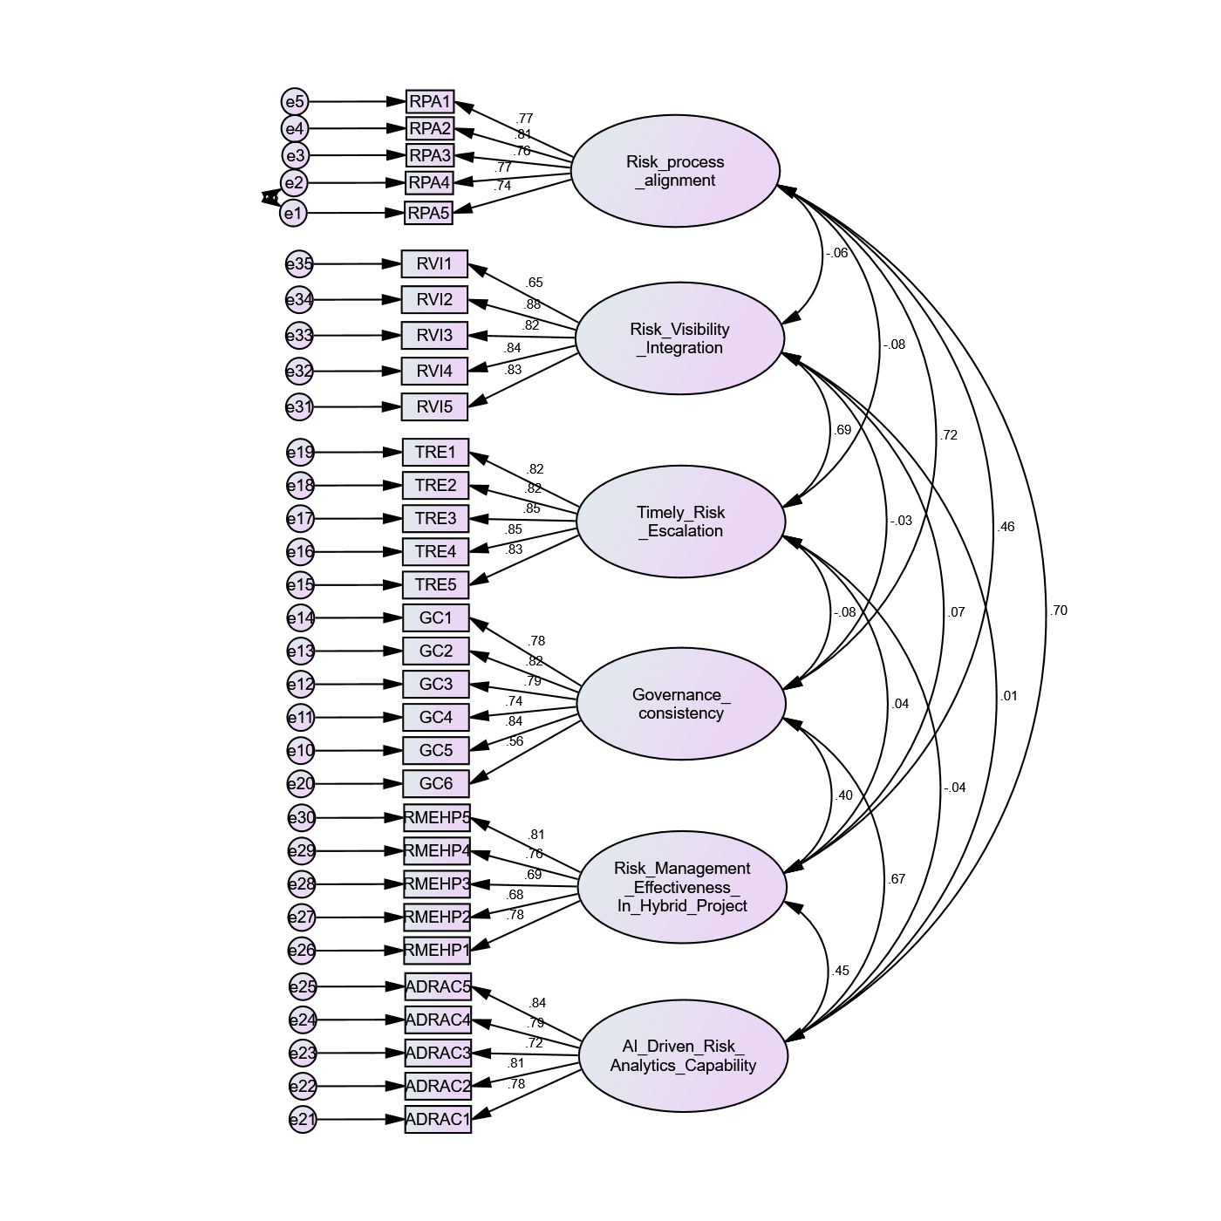

Path |  |  | Standardized Estimate | S.E. | C.R. | P
RPA5 | <--- | Risk process alignment | 0.741
RPA4 | <--- | Risk process alignment | 0.775 | 0.056 | 17.291 | ***
RPA3 | <--- | Risk process alignment | 0.76 | 0.068 | 14.343 | ***
RPA2 | <--- | Risk process alignment | 0.805 | 0.064 | 15.185 | ***
RPA1 | <--- | Risk process alignment | 0.768 | 0.077 | 14.487 | ***
GC5 | <--- | Governance consistency | 0.839
GC4 | <--- | Governance consistency | 0.739 | 0.052 | 16.39 | ***
GC3 | <--- | Governance consistency | 0.794 | 0.054 | 18.167 | ***
GC2 | <--- | Governance consistency | 0.822 | 0.052 | 19.123 | ***
GC1 | <--- | Governance consistency | 0.78 | 0.055 | 17.711 | ***
TRE5 | <--- | Timely Risk Escalation | 0.83
TRE4 | <--- | Timely Risk Escalation | 0.85 | 0.052 | 20.095 | ***
TRE3 | <--- | Timely Risk Escalation | 0.853 | 0.057 | 20.2 | ***
TRE2 | <--- | Timely Risk Escalation | 0.823 | 0.054 | 19.141 | ***
TRE1 | <--- | Timely Risk Escalation | 0.816 | 0.052 | 18.916 | ***
GC6 | <--- | Governance consistency | 0.565 | 0.06 | 11.602 | ***
ADRAC1 | <--- | AI Driven Risk Analytics Capability | 0.776
ADRAC2 | <--- | AI Driven Risk Analytics Capability | 0.808 | 0.064 | 16.645 | ***
ADRAC3 | <--- | AI Driven Risk Analytics Capability | 0.72 | 0.065 | 14.531 | ***
ADRAC4 | <--- | AI Driven Risk Analytics Capability | 0.792 | 0.062 | 16.261 | ***
ADRAC5 | <--- | AI Driven Risk Analytics Capability | 0.842 | 0.063 | 17.487 | ***
RMEHP1 | <--- | Risk Management Effectiveness In Hybrid Project | 0.775
RMEHP2 | <--- | Risk Management Effectiveness In Hybrid Project | 0.684 | 0.063 | 13.201 | ***
RMEHP3 | <--- | Risk Management Effectiveness In Hybrid Project | 0.688 | 0.06 | 13.282 | ***
RMEHP4 | <--- | Risk Management Effectiveness In Hybrid Project | 0.756 | 0.062 | 14.727 | ***
RMEHP5 | <--- | Risk Management Effectiveness In Hybrid Project | 0.81 | 0.063 | 15.796 | ***
RVI5 | <--- | Risk Visibility Integration | 0.83
RVI4 | <--- | Risk Visibility Integration | 0.841 | 0.054 | 19.657 | ***
RVI3 | <--- | Risk Visibility Integration | 0.823 | 0.051 | 19.042 | ***
RVI2 | <--- | Risk Visibility Integration | 0.878 | 0.052 | 20.963 | ***
RVI1 | <--- | Risk Visibility Integration | 0.648 | 0.063 | 13.738 | ***

Kaiser-Meyer-Olkin Measure of Sampling Adequacy. |  | .927
Bartlett's Test of Sphericity | Approx. Chi-Square | 7646.378
 | df | 465
 | Sig. | .000

Fit Index | Value
Chi-square (χ²) | 78.092
Degrees of Freedom (df) | 33
CMIN/DF | 2.366
P-value | 0
GFI | 0.958
RMR | 0.027
NFI | 0.959
RFI | 0.945
IFI | 0.976
CFI | 0.976
RMSEA | 0.06

H1

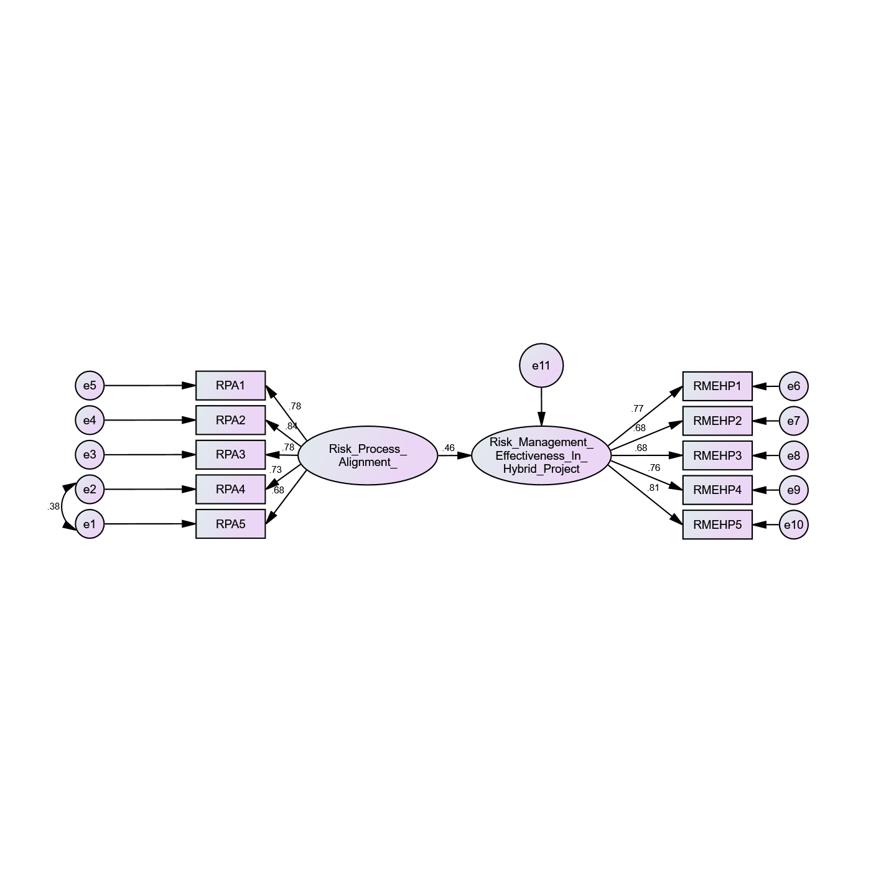

Path |  |  | Standardized Estimate | S.E. | C.R. | P
Risk_Management__Effectiveness_In__Hybrid_Project | <--- | Risk_Process__Alignment_ | 0.464 | 0.069 | 7.346 | ***
RPA5 | <--- | Risk_Process__Alignment_ | 0.676
RPA4 | <--- | Risk_Process__Alignment_ | 0.726 | 0.063 | 15.892 | ***
RPA3 | <--- | Risk_Process__Alignment_ | 0.783 | 0.084 | 13.137 | ***
RPA2 | <--- | Risk_Process__Alignment_ | 0.84 | 0.08 | 13.792 | ***
RPA1 | <--- | Risk_Process__Alignment_ | 0.781 | 0.095 | 13.104 | ***
RMEHP1 | <--- | Risk_Management__Effectiveness_In__Hybrid_Project | 0.773
RMEHP2 | <--- | Risk_Management__Effectiveness_In__Hybrid_Project | 0.684 | 0.064 | 13.158 | ***
RMEHP3 | <--- | Risk_Management__Effectiveness_In__Hybrid_Project | 0.684 | 0.061 | 13.144 | ***
RMEHP4 | <--- | Risk_Management__Effectiveness_In__Hybrid_Project | 0.76 | 0.062 | 14.726 | ***
RMEHP5 | <--- | Risk_Management__Effectiveness_In__Hybrid_Project | 0.812 | 0.063 | 15.744 | ***

Fit Index | Value
Chi-square (χ²) | 78.092
Degrees of Freedom (df) | 33
CMIN/DF | 2.366
P-value | 0.000
GFI | 0.958
RMR | 0.027
NFI | 0.959
RFI | 0.945
IFI | 0.976
CFI | 0.976
RMSEA | 0.060

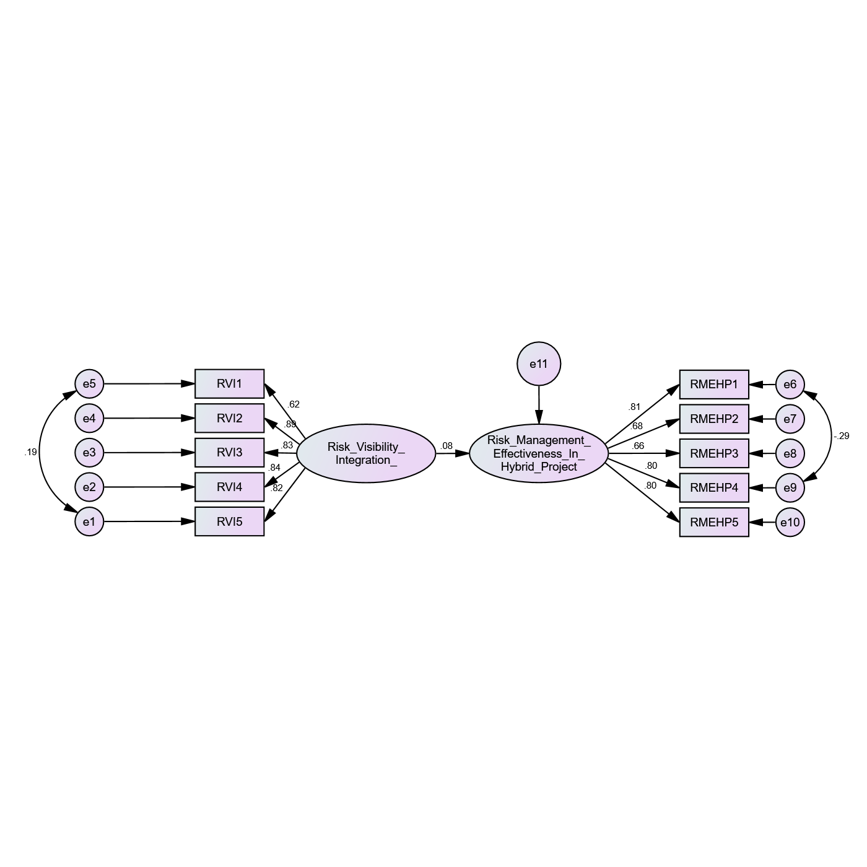

Path |  |  | Standardized Estimate | S.E. | C.R. | P
Risk_Management__Effectiveness_In__Hybrid_Project | <--- | Risk_Visibility__Integration_ | 0.076 | 0.063 | 1.346 | 0.178
RVI5 | <--- | Risk_Visibility__Integration_ | 0.822
RVI4 | <--- | Risk_Visibility__Integration_ | 0.84 | 0.057 | 19.094 | ***
RVI3 | <--- | Risk_Visibility__Integration_ | 0.827 | 0.053 | 18.709 | ***
RVI2 | <--- | Risk_Visibility__Integration_ | 0.886 | 0.054 | 20.487 | ***
RVI1 | <--- | Risk_Visibility__Integration_ | 0.615 | 0.06 | 13.819 | ***
RMEHP1 | <--- | Risk_Management__Effectiveness_In__Hybrid_Project | 0.814
RMEHP2 | <--- | Risk_Management__Effectiveness_In__Hybrid_Project | 0.676 | 0.06 | 13.066 | ***
RMEHP3 | <--- | Risk_Management__Effectiveness_In__Hybrid_Project | 0.662 | 0.058 | 12.775 | ***
RMEHP4 | <--- | Risk_Management__Effectiveness_In__Hybrid_Project | 0.798 | 0.063 | 14.567 | ***
RMEHP5 | <--- | Risk_Management__Effectiveness_In__Hybrid_Project | 0.795 | 0.061 | 15.307 | ***

Fit Index | Value
Chi-square (χ²) | 33.481
Degrees of Freedom (df) | 32
CMIN/DF | 1.046
P-value | 0.395
GFI | 0.958
RMR | 0.027
NFI | 0.984
RFI | 0.977
IFI | 0.999
CFI | 0.999
RMSEA | 0.011

H3

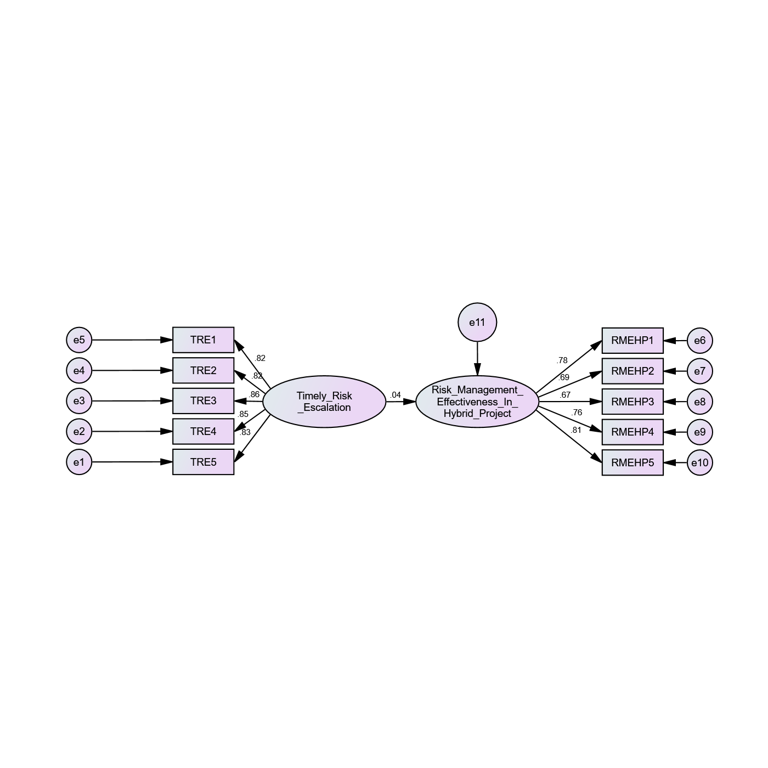

 |  |  | Estimate | S.E. | C.R. | P
Risk_Management__Effectiveness_In__Hybrid_Project | <--- | Timely_Risk__Escalation | 0.044 | 0.061 | 0.769 | ***
TRE5 | <--- | Timely_Risk__Escalation | 0.827
TRE4 | <--- | Timely_Risk__Escalation | 0.85 | 0.052 | 19.85 | ***
TRE3 | <--- | Timely_Risk__Escalation | 0.856 | 0.058 | 20.061 | ***
TRE2 | <--- | Timely_Risk__Escalation | 0.818 | 0.055 | 18.769 | ***
TRE1 | <--- | Timely_Risk__Escalation | 0.821 | 0.053 | 18.861 | ***
RMEHP1 | <--- | Risk_Management__Effectiveness_In__Hybrid_Project | 0.777
RMEHP2 | <--- | Risk_Management__Effectiveness_In__Hybrid_Project | 0.688 | 0.063 | 13.238 | ***
RMEHP3 | <--- | Risk_Management__Effectiveness_In__Hybrid_Project | 0.669 | 0.061 | 12.85 | ***
RMEHP4 | <--- | Risk_Management__Effectiveness_In__Hybrid_Project | 0.76 | 0.062 | 14.749 | ***
RMEHP5 | <--- | Risk_Management__Effectiveness_In__Hybrid_Project | 0.815 | 0.063 | 15.786 | ***

Fit Index | Value
Chi-square (χ²) | 47.194
Degrees of Freedom (df) | 34
CMIN/DF | 1.388
P-value | 0.066
GFI | —
RMR | —
NFI | 0.978
RFI | 0.971
IFI | 0.994
CFI | 0.994
RMSEA | 0.032

H4

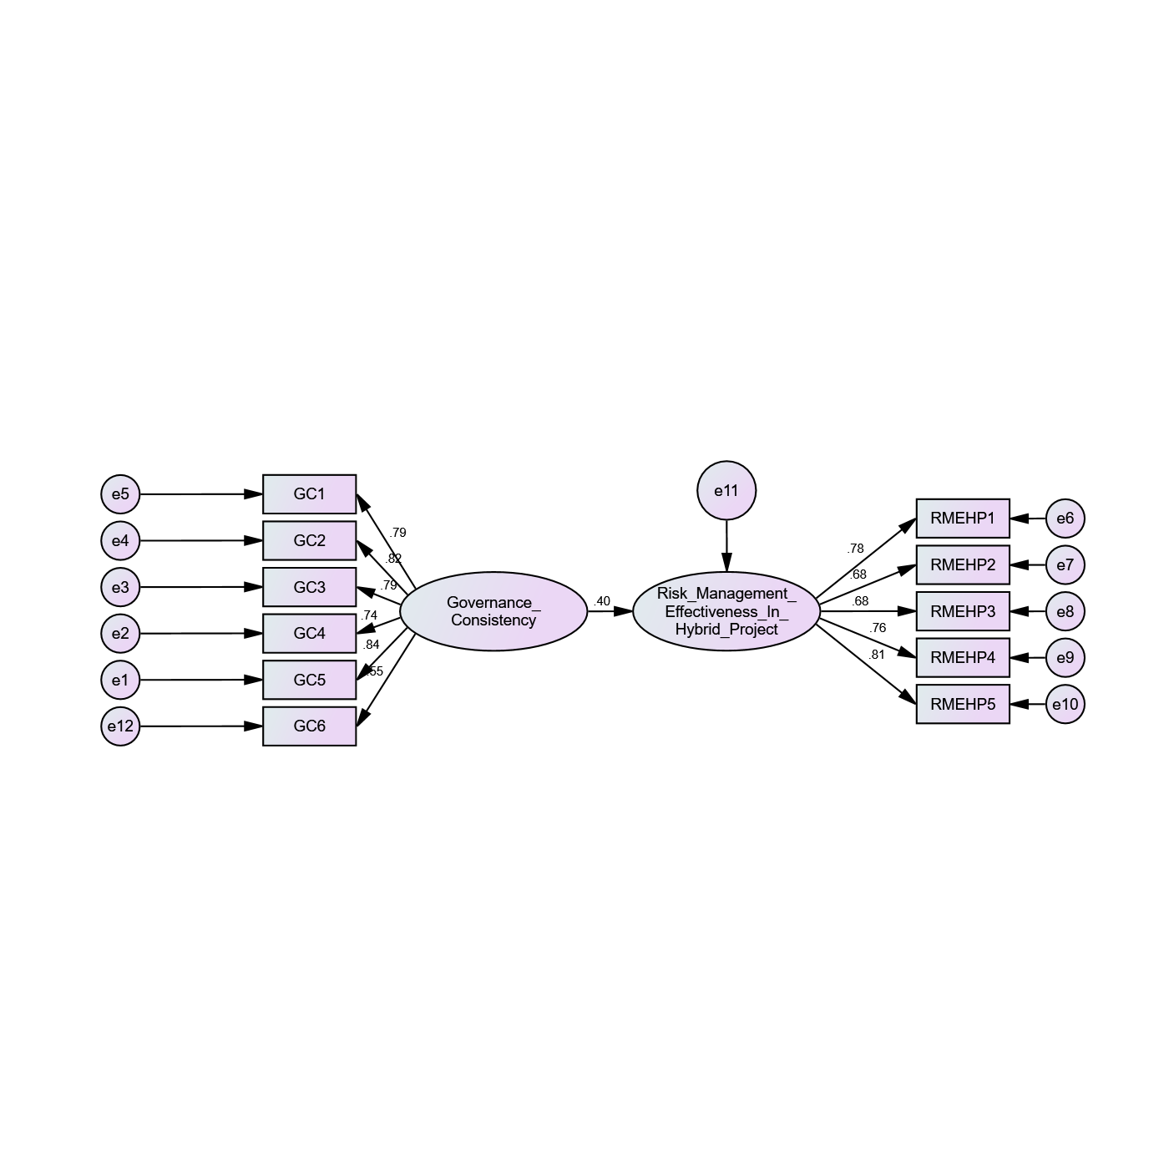
 |  |  | Estimate | S.E. | C.R. | P
Risk_Management__Effectiveness_In__Hybrid_Project | <--- | Governance__Consistency | 0.397 | 0.054 | 6.869 | ***
GC5 | <--- | Governance__Consistency | 0.841
GC4 | <--- | Governance__Consistency | 0.738 | 0.052 | 16.26 | ***
GC3 | <--- | Governance__Consistency | 0.795 | 0.054 | 18.04 | ***
GC2 | <--- | Governance__Consistency | 0.819 | 0.053 | 18.841 | ***
GC1 | <--- | Governance__Consistency | 0.791 | 0.055 | 17.908 | ***
RMEHP1 | <--- | Risk_Management__Effectiveness_In__Hybrid_Project | 0.778
RMEHP2 | <--- | Risk_Management__Effectiveness_In__Hybrid_Project | 0.683 | 0.063 | 13.182 | ***
RMEHP3 | <--- | Risk_Management__Effectiveness_In__Hybrid_Project | 0.678 | 0.06 | 13.092 | ***
RMEHP4 | <--- | Risk_Management__Effectiveness_In__Hybrid_Project | 0.757 | 0.062 | 14.756 | ***
RMEHP5 | <--- | Risk_Management__Effectiveness_In__Hybrid_Project | 0.814 | 0.063 | 15.881 | ***
GC6 | <--- | Governance__Consistency | 0.546 | 0.061 | 11.071 | ***

Fit Index | Value
Chi-square (χ²) | 73.809
Degrees of Freedom (df) | 43
CMIN/DF | 1.716
P-value | 0.002
GFI
RMR
NFI | 0.965
RFI | 0.955
IFI | 0.985
CFI | 0.985
RMSEA | 0.043

H5
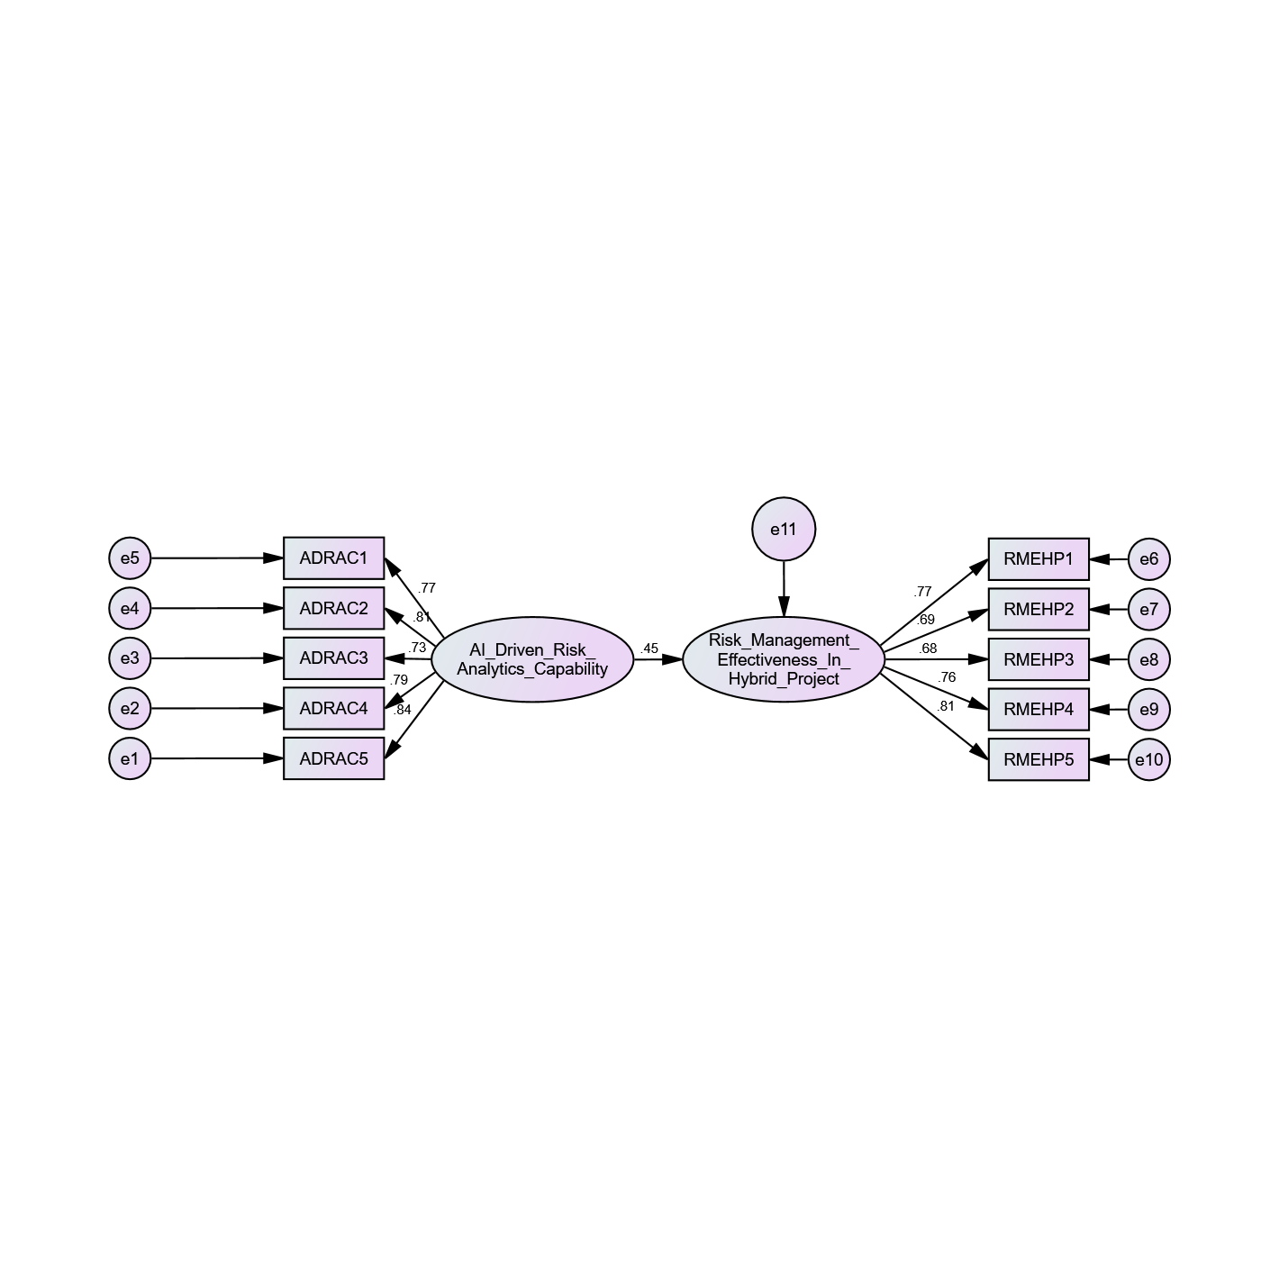

 |  |  | Estimate | S.E. | C.R. | P
Risk_Management__Effectiveness_In__Hybrid_Project | <--- | AI_Driven_Risk__Analytics_Capability | 0.449 | 0.051 | 7.697 | ***
ADRAC5 | <--- | AI_Driven_Risk__Analytics_Capability | 0.836
ADRAC4 | <--- | AI_Driven_Risk__Analytics_Capability | 0.791 | 0.053 | 17.526 | ***
ADRAC3 | <--- | AI_Driven_Risk__Analytics_Capability | 0.732 | 0.056 | 15.794 | ***
ADRAC2 | <--- | AI_Driven_Risk__Analytics_Capability | 0.809 | 0.054 | 18.068 | ***
ADRAC1 | <--- | AI_Driven_Risk__Analytics_Capability | 0.775 | 0.053 | 17.049 | ***
RMEHP1 | <--- | Risk_Management__Effectiveness_In__Hybrid_Project | 0.774
RMEHP2 | <--- | Risk_Management__Effectiveness_In__Hybrid_Project | 0.686 | 0.063 | 13.217 | ***
RMEHP3 | <--- | Risk_Management__Effectiveness_In__Hybrid_Project | 0.683 | 0.061 | 13.145 | ***
RMEHP4 | <--- | Risk_Management__Effectiveness_In__Hybrid_Project | 0.758 | 0.062 | 14.718 | ***
RMEHP5 | <--- | Risk_Management__Effectiveness_In__Hybrid_Project | 0.811 | 0.063 | 15.758 | ***

