
Academic Task-3 (Simulation based assignment)
CSE316 | Operating System | 6/04/2018
Student Name: CH . HEMANTH REDDY
Student ID: 11606756
Email Address: chityalahemanth@gmail.com
GitHub Link: https://github.com/HemanthChityala/k1616A20.11606756/upload/master

Ques. 16. Design a scheduler that can schedule the processes arriving system at periodical
intervals. Every process is assigned with a fixed time slice t milliseconds. If it is not able to
complete its execution within the assigned time quantum, then automated timer generates an
interrupt. The scheduler will select the next process in the queue and dispatcher dispatches the
process to processor for execution. Compute the total time for which processes were in the queue
waiting for the processor. Take the input for CPU burst, arrival time and time quantum from the
user.

#include<stdio.h>
int main()
{
int i,n,p[10]={1,2,3,4,5,6,7,8,9,10},min,k=1,btime=0;
int bt[10],temp,j,at[10],wt[10],tt[10],ta=0,sum=0;
float wavg=0,tavg=0,tsum=0,wsum=0;
printf("*********Non Preemptive Shortest Job First Scheduling***********\n");
printf("\nEnter the No of processes :");
scanf("%d",&n);

for(i=0;i<n;i++)
{
printf("\tEnter the burst time of %d process :",i+1);
scanf(" %d",&bt[i]);
printf("\tEnter the arrival time of %d process :",i+1);
scanf(" %d",&at[i]);
}

/*Sorting According to Arrival Time*/

for(i=0;i<n;i++)
{
for(j=0;j<n;j++)
{
if(at[i]<at[j])
{
temp=p[j];
p[j]=p[i];
p[i]=temp;
temp=at[j];
at[j]=at[i];
at[i]=temp;
temp=bt[j];
bt[j]=bt[i];
bt[i]=temp;
}
}
}

for(j=0;j<n;j++)
{
btime=btime+bt[j];
min=bt[k];
for(i=k;i<n;i++)
{
if (btime>=at[i] && bt[i]<min)
{
temp=p[k];
p[k]=p[i];
p[i]=temp;
temp=at[k];
at[k]=at[i];
at[i]=temp;
temp=bt[k];
bt[k]=bt[i];
bt[i]=temp;
}
}
k++;
}
wt[0]=0;
for(i=1;i<n;i++)
{
sum=sum+bt[i-1];
wt[i]=sum-at[i];
wsum=wsum+wt[i];
}

wavg=(wsum/n);
for(i=0;i<n;i++)
{
ta=ta+bt[i];
tt[i]=ta-at[i];
tsum=tsum+tt[i];
}

tavg=(tsum/n);

printf("************************");
printf("\n RESULT:-");
printf("\nProcess\t Burst\t Arrival\t Waiting\t Turn-around" );
for(i=0;i<n;i++)
{
printf("\n p%d\t %d\t %d\t\t %d\t\t\t%d",p[i],bt[i],at[i],wt[i],tt[i]);
}

printf("\n\nAVERAGE WAITING TIME : %f",wavg);
printf("\nAVERAGE TURN AROUND TIME : %f",tavg);
return 0;
}
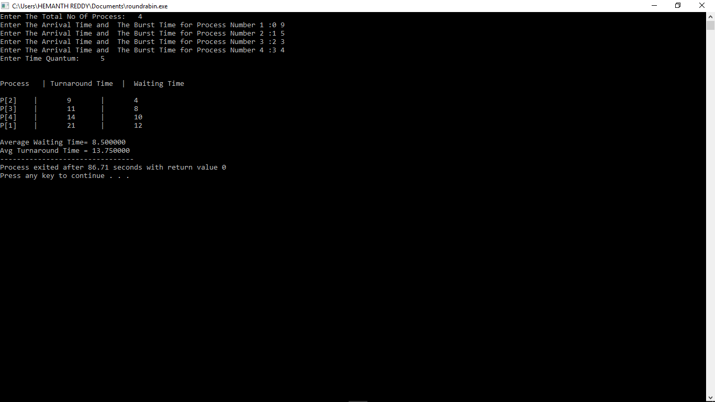

- Explain the problem in terms of operating system concept?

Process scheduling is an important component for process management. In a multi-user and a time-sharing system, response time is one of the most important objective to be accomplished.

2. Write the algorithm for proposed solution of the assigned problem.

Algorithm: Round Robin Scheduling Algorithm

1. The queue structure in ready queue is of First In First Out (FIFO) type.
2. A fixed time is allotted to every process that arrives in the queue. This fixed time is known as time slice or time quantum.
3. The first process that arrives is selected and sent to the processor for execution. If it is not able to complete its execution within the time quantum provided, then an interrupt is generated using an automated timer.
4. The process is then stopped and is sent back at the end of the queue. However, the state is saved and context is thereby stored in memory. This helps the process to resume from the point where it was interrupted.
5. The scheduler selects another process from the ready queue and dispatches it to the processor for its execution. It is executed until the time Quantum does not exceed.
6. The same steps are repeated until all the process are finished.
The round robin algorithm is simple and the overhead in decision making is very low. It is the best scheduling algorithm for achieving better and evenly distributed response time.
Example
one example to understand it.
Time Quantum = 2
Process | Arrival Time | Burst Time
P1 | 0 | 9
P2 | 1 | 5
P3 | 2 | 3
P4 | 3 | 4

Process | Arrival Time | Burst Time (x) | Turnaround Time(t) | Normalized Turnaround Time(t/x) | Waiting Time
P1 | 0 | 9 | 21 | 2.34 | 12
P2 | 1 | 5 | 17 | 3.4 | 12
P3 | 2 | 3 | 11 | 3.67 | 8
P4 | 3 | 4 | 12 | 3 | 8
Average Turnaround Time = 15.25
Average Normalized Turnaround Time = 3.10
Average Waiting Time = 10

Boundary points:
Enter Total Process: 6
Enter Arrival Time and Burst Time for Process Process Number 1 :0
4
Enter Arrival Time and Burst Time for Process Process Number 2 :1
5
Enter Arrival Time and Burst Time for Process Process Number 3 :2
2
Enter Arrival Time and Burst Time for Process Process Number 4 :3
1
Enter Arrival Time and Burst Time for Process Process Number 5 :4
6
Enter Arrival Time and Burst Time for Process Process Number 6 :6
3
Enter Time Quantum: 2
it is giving wrong answer for this entries.

