EXPLAINABLE PREDICTIVE MAINTENANCE
and Risk-Aware Failure Decision Support
AI4I 2020 | Project Documentation Report
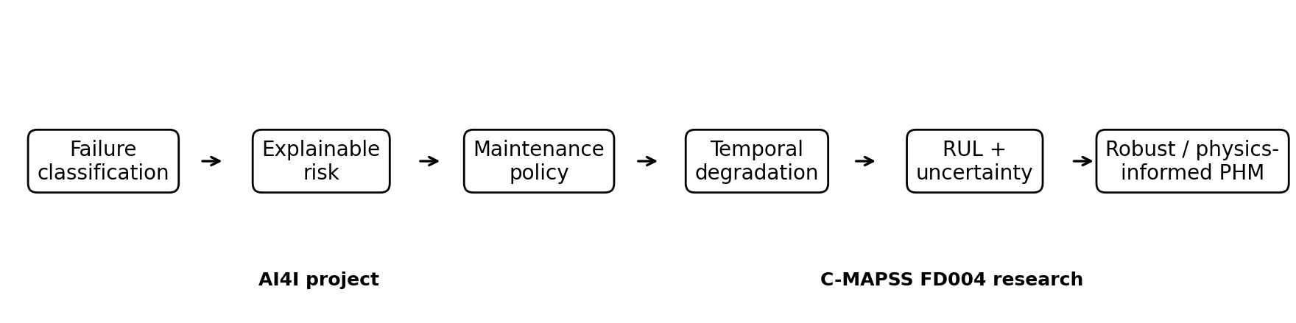
Project positioning: a compact failure-risk decision prototype that bridges toward probabilistic RUL prognostics.
Predict -> Explain -> Decide
Dataset: UCI AI4I 2020 Predictive Maintenance | 10,000 observations | 3.39% machine failures

Executive Summary
This project develops an explainable, imbalance-aware machine-failure classifier and translates its probability outputs into maintenance-oriented decisions. The emphasis is not simply on maximizing accuracy; it is on identifying failure-associated operating patterns, comparing interpretable and nonlinear models, selecting an operational threshold, and exposing the engineering variables that drive the resulting risk score.
- The dataset contains 339 machine failures among 10,000 observations (3.39%), making failure detection a rare-event classification problem.
- Logistic Regression provides an interpretable baseline, while tuned Random Forest and HistGradientBoosting capture nonlinear interactions substantially better.
- HistGradientBoosting records the highest test ranking metrics (ROC-AUC 0.9913, PR-AUC 0.9106); the tuned Random Forest is retained as the main decision-support model because its validation-based tuning, threshold policy, feature importance, SHAP interpretation, and risk scoring form one coherent workflow.
- Changing the Random Forest threshold from 0.50 to 0.557 increases failure precision from 0.7458 to 0.8776 and F1 from 0.8000 to 0.8600, with a small recall reduction from 0.8627 to 0.8431.
- The dominant risk drivers are rotational speed, torque-speed power interaction, torque, tool wear, wear-load, and temperature difference.
- The project intentionally stops at static failure-risk decision support; temporal degradation, RUL, calibrated uncertainty, distribution-shift robustness, and physics-informed prognostics are developed in the NASA C-MAPSS FD004 research project.
Scope statement: AI4I predicts failure risk for a current machine state. It does not estimate Remaining Useful Life (RUL).

1. Dataset and Failure Characterization
The AI4I 2020 dataset contains product type, air and process temperature, rotational speed, torque, tool wear, an overall machine-failure label, and five recorded failure-mode indicators. Identifier variables and failure-mode outcome columns are excluded from predictive inputs to avoid leakage.
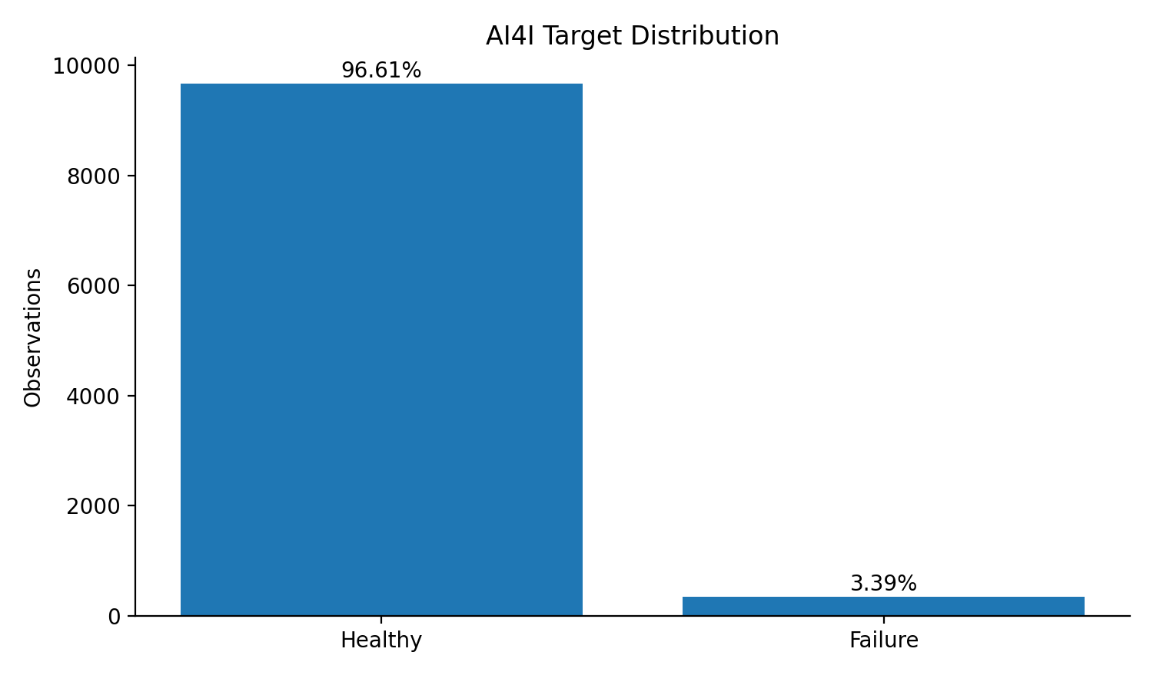
Figure 1. Strong target imbalance motivates PR-AUC, precision, recall, and F1 as primary evaluation measures.
The failure prevalence is low enough that a model could achieve high accuracy by predicting “healthy” most of the time. Therefore, the project treats failure-class recall and precision as operationally meaningful quantities and uses PR-AUC as a central ranking metric.
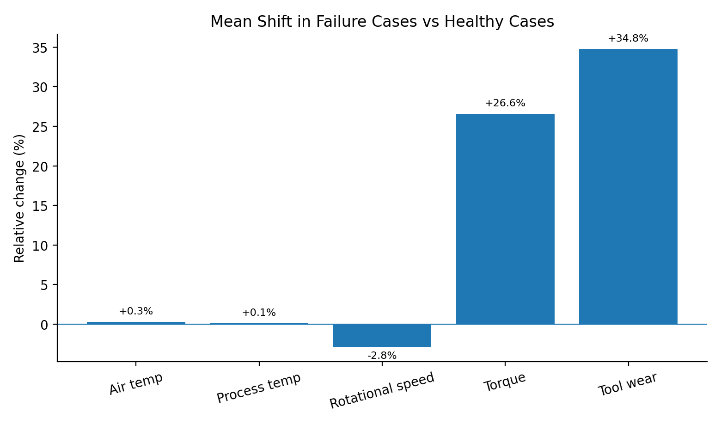
Figure 2. Relative changes in failure-case operating means compared with healthy observations.
The strongest descriptive shifts are mechanical rather than purely thermal. Failed observations show approximately 26.6% higher mean torque and 34.8% higher mean tool wear, while average rotational speed is about 2.8% lower. Temperature means shift much less, indicating that interactions among loading, speed, wear, and thermal state are more informative than any single temperature variable alone.

2. Failure Modes and Diagnostic Context
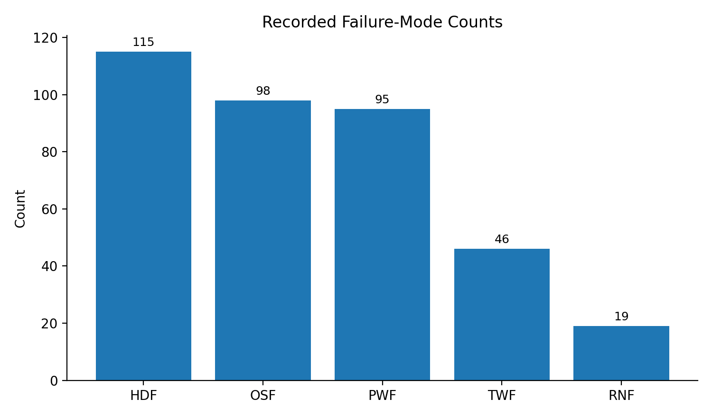
Figure 3. Failure-mode occurrences used for diagnosis, not as predictor inputs.
Heat-dissipation failure (HDF), overstrain failure (OSF), and power failure (PWF) are the most frequent recorded mechanisms. Tool-wear failure (TWF) is less common, and random failure (RNF) is rare. These labels provide post-hoc diagnostic context but are excluded from the classifier because they encode failure outcomes and would create target leakage if supplied to the model.
Leakage control: Failure-mode labels are analyzed to understand mechanisms; the classifier itself is trained only from variables that would plausibly be available before the failure outcome is known.

3. Modeling Strategy
The workflow uses a 70/15/15 stratified train/validation/test split. Numeric variables are median-imputed and standardized; machine type is imputed and one-hot encoded. Three engineered features introduce simple engineering relationships: temperature difference, a torque-speed power proxy, and a wear-load interaction.
Model | Role in the project | Key idea
Logistic Regression | Transparent baseline | Tests whether the failure boundary is approximately linear.
Random Forest | Primary decision-support model | Captures nonlinear interactions; tuned with cross-validated PR-AUC and linked to threshold, importance, SHAP, and risk scoring.
HistGradientBoosting | Alternative nonlinear ensemble | Tests a boosting mechanism without another expensive hyperparameter-search stage.
Random Forest tuning uses Average Precision rather than accuracy. The best cross-validation PR-AUC is 0.9007, and the tuned validation model reaches ROC-AUC 0.9913 and PR-AUC 0.9139 with failure recall 0.8824 at the default threshold.

4. Model Comparison and Interpretation
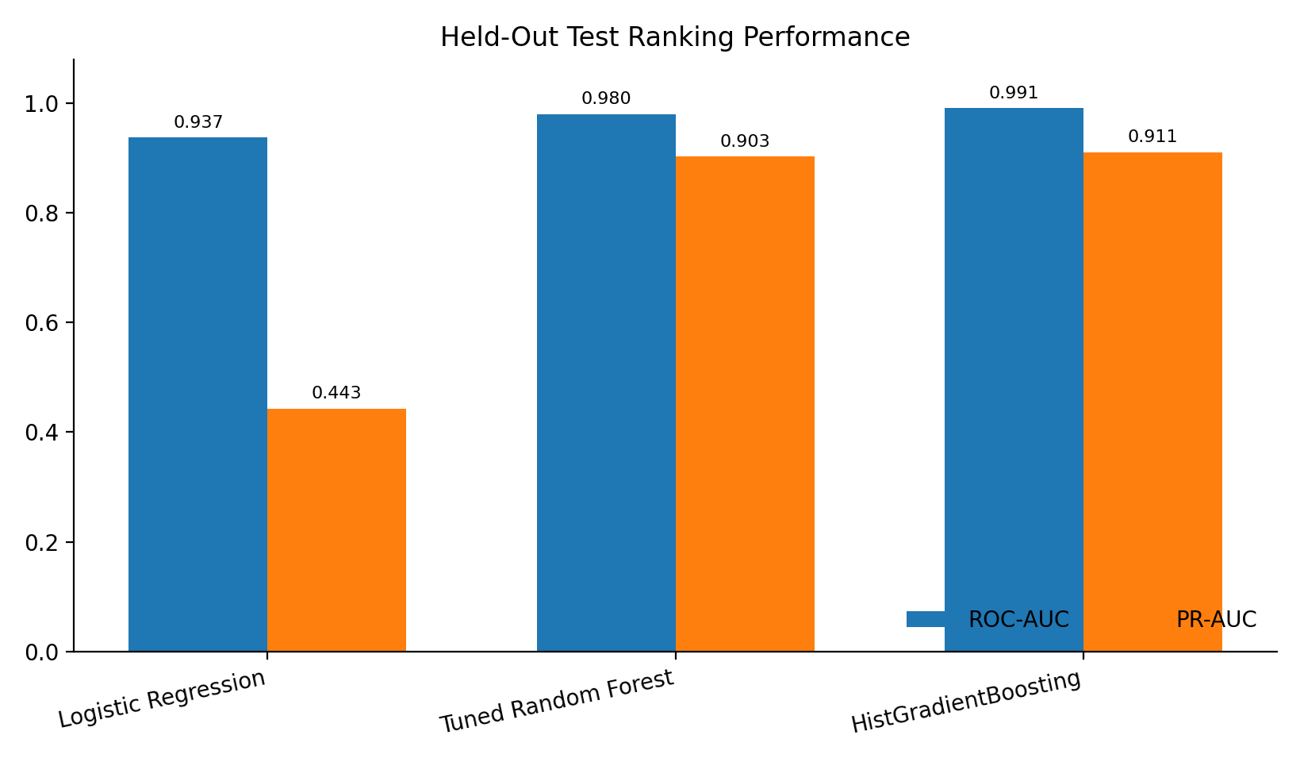
Figure 4. Test-set probability-ranking performance of the three model families.
Model | ROC-AUC | PR-AUC | Failure-class result | Interpretation
Logistic Regression | 0.9372 | 0.4432 | Val. recall 0.7843 | Strong ROC ranking but poor precision-recall separation for the rare class.
Tuned Random Forest | 0.9802 | 0.9029 | Test F1 0.800 @ 0.50 | High-quality nonlinear ranking plus a complete validation-based maintenance workflow.
HistGradientBoosting | 0.9913 | 0.9106 | Test F1 0.838 | Highest recorded ranking performance; useful comparison model.
The sharp PR-AUC jump from 0.4432 for Logistic Regression to roughly 0.90 for the tree ensembles is the clearest modeling result. The failure boundary is not well represented by a simple linear separator; nonlinear interactions among speed, load, wear, and thermal state carry much of the discriminative information.
Methodological interpretation: HistGradientBoosting has the best recorded test ranking metrics. The Random Forest is the cleaner “primary model” for this project because its hyperparameters and decision threshold are selected through a validation-centered workflow, and its explainability/risk-scoring pipeline is used consistently throughout.

5. From Probability to Maintenance Policy
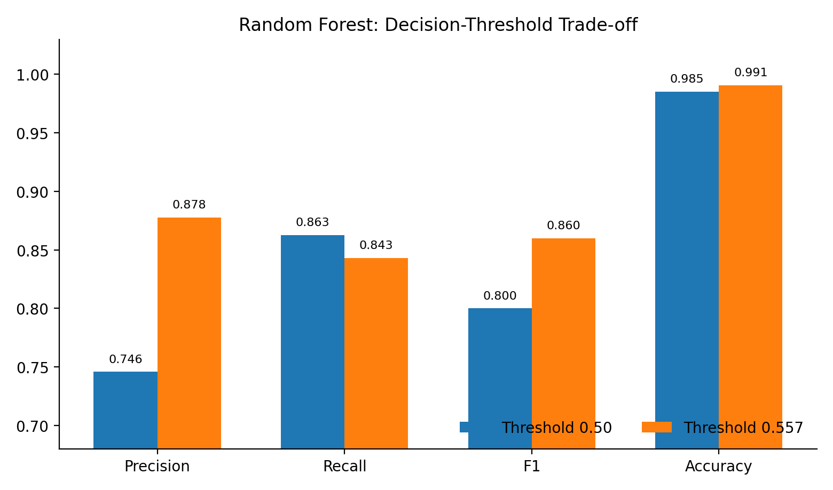
Figure 5. A higher operating threshold reduces false alarms and improves F1 while slightly reducing failure recall.
A probability threshold of 0.50 is a convention, not an engineering law. The notebook selects the highest-precision validation threshold that still satisfies a target-recall requirement, producing a threshold of approximately 0.557. On the held-out test set, this changes the behavior of the Random Forest as follows:
Threshold | Precision | Recall | F1 | Accuracy
0.50 | 0.7458 | 0.8627 | 0.8000 | 0.9853
0.557 | 0.8776 | 0.8431 | 0.8600 | 0.9907
The tuned policy is more selective: precision rises by about 13.2 percentage points and F1 improves by 6.0 percentage points, while recall decreases by only about 2.0 percentage points. ROC-AUC and PR-AUC do not change because the underlying probability ranking is unchanged.
The extended notebook also introduces a cost-aware threshold analysis. Rather than treating every error equally, it assigns a larger relative cost to missed failures than unnecessary inspections. This is a lightweight but important step from predictive modeling toward maintenance decision analysis.

6. Explainability and Engineering Interpretation
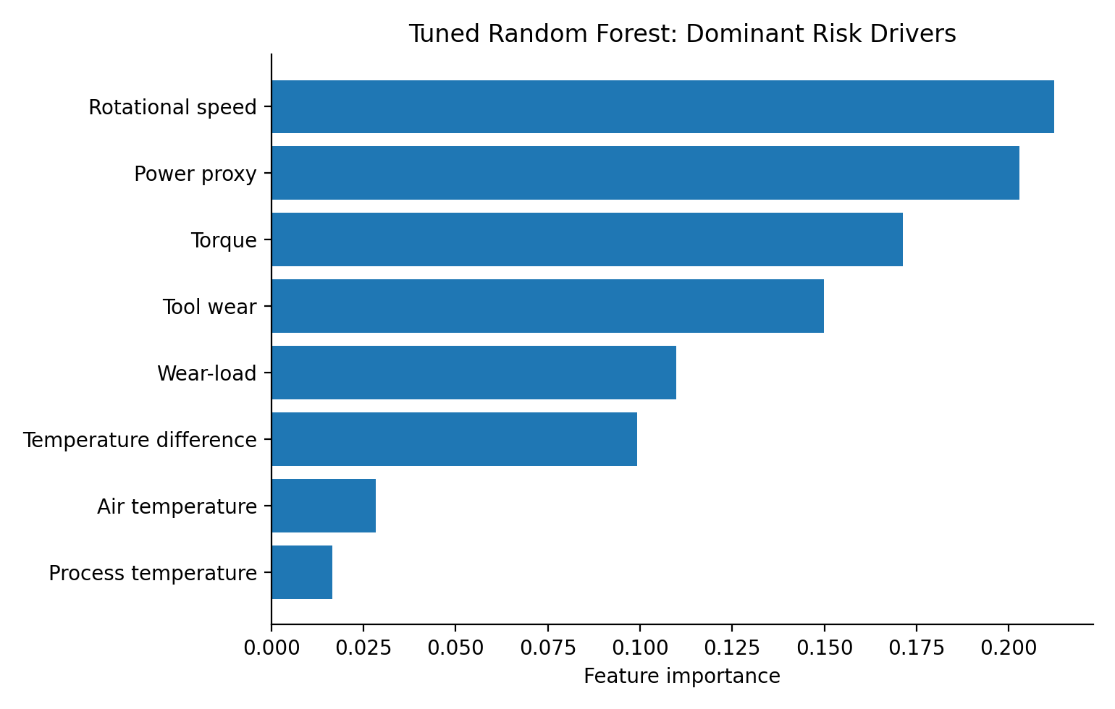
Figure 6. Random Forest feature-importance ranking.
The model is dominated by mechanically meaningful variables and interactions. Rotational speed and the torque-speed power proxy are the two largest contributors, followed by torque and tool wear. The engineered wear-load and temperature-difference variables also contribute materially, supporting the decision to encode interactions rather than rely only on raw sensor values.
- Rotational speed: failure observations exhibit lower mean speed and much higher variability, indicating abnormal operating regimes rather than a single monotonic threshold.
- Power proxy (torque × speed): captures the interaction between rotational demand and load.
- Torque: failed observations have substantially higher mean torque, consistent with increased mechanical load.
- Tool wear and wear-load: connect accumulated usage with mechanical stress.
- Temperature difference: contributes a compact thermal-loading signal even though raw temperature means shift only modestly.
SHAP is used as a complementary local/global explanation tool. The goal is not to claim causality from a predictive model, but to provide engineering and maintenance personnel with transparent evidence for why a particular observation receives a high or low risk score.

7. Lightweight Extensions that Complete the Project
The final notebook adds four intentionally lightweight sections rather than another model ladder. These additions improve the engineering story while keeping computational effort low:
Extension | Question answered | Value
Failure-mode operating profiles | Do recorded failure mechanisms exhibit different operating signatures? | Adds root-cause-oriented diagnostic context without target leakage.
Machine-type robustness | Does aggregate performance hide L/M/H subgroup weaknesses? | Introduces a basic robustness check before deployment.
Cost-aware thresholding | What happens when missed failures cost more than false alarms? | Separates model probability estimation from operational policy selection.
Reusable inference / joblib export | Can the fitted workflow be reused outside the notebook? | Creates a direct path toward a dashboard or API without building a full application.
These sections are sufficient for the AI4I scope. Adding additional classifiers such as SVM, KNN, XGBoost, or LightGBM would mostly turn the project into model shopping rather than strengthen its maintenance-engineering argument.

8. Limitations and Responsible Interpretation
- AI4I is a static/synthetic benchmark. It is suitable for controlled failure-classification experiments but not a substitute for real run-to-failure histories.
- The classifier estimates instantaneous failure risk; it cannot answer “how many cycles remain?”
- Feature importance and SHAP describe predictive association, not physical causality.
- Risk bands and cost weights are illustrative; a real plant would calibrate these values using downtime, inspection, safety, and replacement economics.
- Subgroup performance should be monitored over time because deployment data may shift relative to the benchmark.

9. Bridge to NASA C-MAPSS FD004
Figure 7. Methodological transition from static failure classification to research-grade probabilistic prognostics.
The AI4I and C-MAPSS projects are complementary. AI4I asks whether the current machine state is associated with failure and how that probability should trigger maintenance action. FD004 asks how much useful life remains, how uncertain that estimate is, and whether the prognostic method remains trustworthy across heterogeneous operating conditions and distribution shifts.
AI4I: completed project | NASA C-MAPSS FD004: research progression
Static machine-state observations | Engine-level temporal sequences
Binary machine-failure classification | Continuous RUL point prediction
Failure probability and risk band | Quantile intervals and conformal calibration
PR-AUC / precision / recall / F1 | RMSE / MAE / NASA score + calibration diagnostics
Feature importance and SHAP | Operating-regime, life-stage, residual, and uncertainty diagnostics
Validation-selected operating threshold | Distribution-shift stress testing
Illustrative maintenance cost policy | Future uncertainty-aware maintenance optimization

Current FD004 research position
The uploaded FD004 progress report describes a controlled progression from a baseline LSTM (B1) to a regime-aware LSTM (B2), architecture checks (B3/B4), quantile uncertainty modeling (B5), and conformal calibration variants (B6/B6.a/B6.b). In the point-model benchmark, B2 is the strongest simple candidate, with RMSE 21.67 ± 0.27, MAE 15.76 ± 0.31, and NASA score 192,720 ± 42,154.
The current Paper 2 experiments sharpen the research question. Oracle degradation-stage information dramatically improves mid-life RUL prediction, but leakage-safe approximations using the existing 30-cycle observable representation have not recovered that benefit robustly. The next controlled gate is P2-E8: a 60-cycle temporal-context experiment with matched endpoint comparison. If that is not promotable, the report recommends moving to a physics-informed or degradation-constrained branch rather than continuing open-ended handcrafted feature engineering.
Research continuity: AI4I establishes the “Predict -> Explain -> Decide” logic. FD004 adds time, degradation, RUL, uncertainty, distribution shift, and eventually physics-informed and risk-aware optimization.

10. Final Project Narrative
The AI4I project demonstrates an end-to-end predictive-maintenance workflow that is small enough to be reproducible yet rich enough to show engineering judgment. The strongest technical conclusion is that nonlinear ensemble models capture failure-associated operating interactions far better than the linear baseline, while threshold tuning and cost-aware analysis demonstrate that maintenance policy is a separate decision layer from probability estimation.
PREDICT | EXPLAIN | DECIDE
Estimate rare-event failure risk | Use feature importance, SHAP, and failure-mode diagnostics | Choose thresholds/risk bands based on maintenance objectives
Compare linear vs nonlinear models | Relate dominant features to loading, speed, wear, and thermal state | Extend to cost-aware actions and deployable inference
The project is therefore complete at the intended scope. The natural research continuation is not another failure classifier, but the C-MAPSS FD004 program: temporal degradation modeling, RUL prognostics, calibrated uncertainty, distribution-shift robustness, physics-informed learning, and risk-aware maintenance optimization.

