Advanced Software Engineering

INCREMENT 1 REPORT

Team -15

Team Members

Dantu,Hemanth Kumar Reddy - 11

Prudhvi Suggala - 51

Snehal Vantashala - 55

Dara venkata sai Sandeep - 61

**Project Objective:**

Objective of the project is to design an application which would facilitate to search for recipe online. If the listed ingredients to prepare a recipe is not present with the user application allows him to search for those ingredients in the stores near to him.

Main Objective of the application is to assist the user in his cooking, by allowing him to search for the recipes and providing the way to procure the missing ingredients from the nearby store.

**Project Inspiration:**

This application allows user to search for a recipe, and the missing items from the stores nearby.

Searching for a recipe we often lack in finding all the ingredients to cook, in such cases we don’t cook that recipe and switch to another one, but by using our app we can search for the ingredient in a store nearby or just scan the bar code of the missing item, we provide you the with the list of stores having the product available along with its price and direction to the store. User can store his list of ingredients in his cart. After having all the required ingredients, he can have a look at the recipe procedure and cook his delicious meal by using our small oven app.

**Application Features:**

1. Search for Recipes
2. Search for Groceries
3. Search Stores by Location
4. Get details of the product using barcode
5. Search Grocery by name
6. Search Grocery by UPC code
7. Visualize nutrition facts of recipe

**REST Services**

**Big Oven Recipe API**

**Description:**

The Big Oven Recipe API provides access to 350,000+ recipes and their related data, as well as a grocery shopping list in the cloud. It also allows users to Search over recipes by ingredient, title and more.

**API URL:**

[http://api.bigoven.com/recipe/{id}](http://api.bigoven.com/recipe/%7bid%7d)

**Google Mobile Vision API**

**Description:**

The Mobile Vison API allows users to detects barcodes in real-time, on device, in any orientation. It can also detect multiple barcodes at once.

**API URL:**

<https://codelabs.developers.google.com/codelabs/bar-codes>

**Super Market API**

**Description:**

The Supermarket API by allows users to access and integrate information of supermarkets into the android applications and services. Currently, the Supermarket API supports information from Whole Foods, Trader Joes, Safeway, Costco, and Wal-Mart in the US.

**API URL:**

<http://www.SupermarketAPI.com/API.asmx>

**Amazon AWS API**

**Description:**

Amazon web services API allows users to look for the 1000's of products by name, by amazon ID, by universal product code. It provides vast information about different products.

**API URL:**

<http://webservices.amazon.com/onca/>

**Class Diagram**

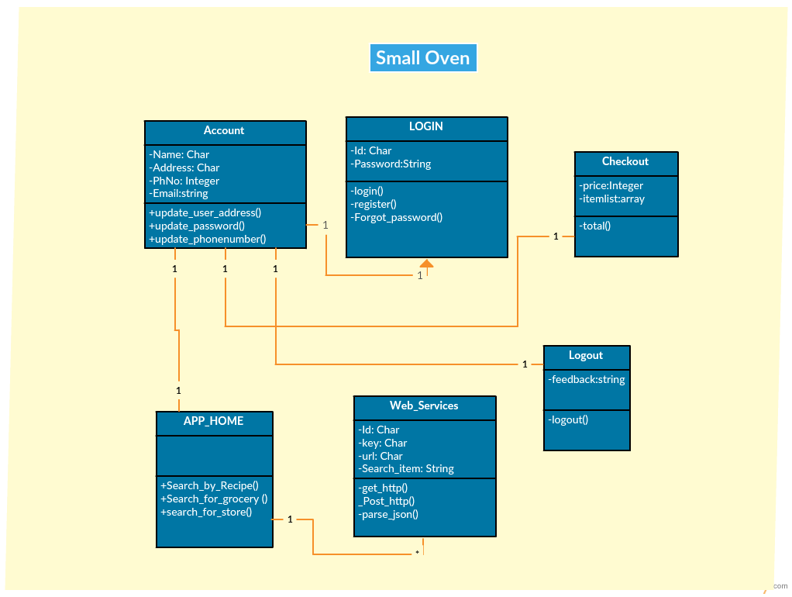

**Sequence Diagram**

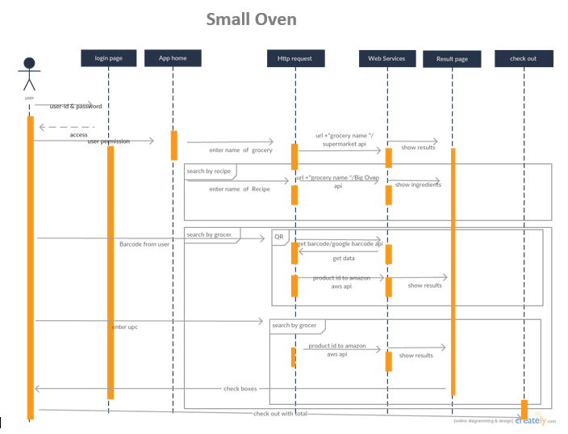

**Software Architecture**

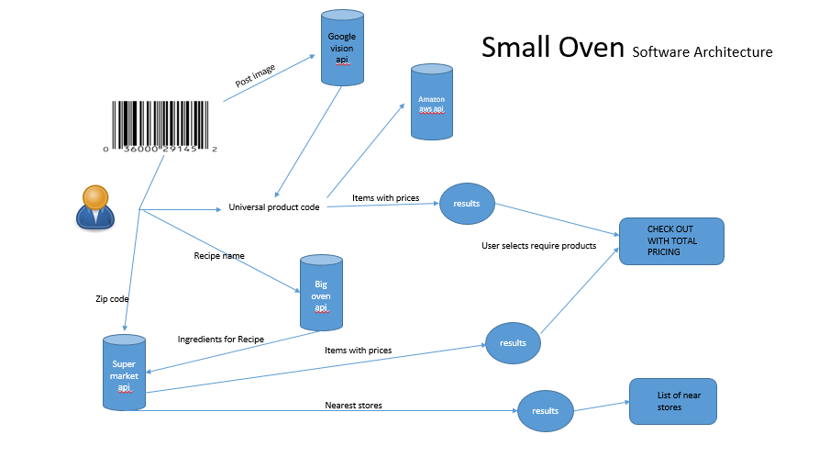

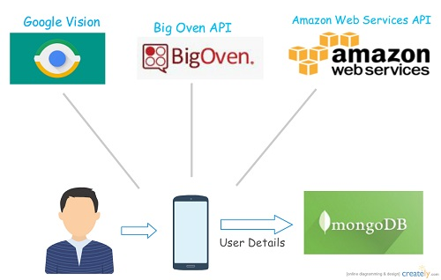

**Wire Frames**

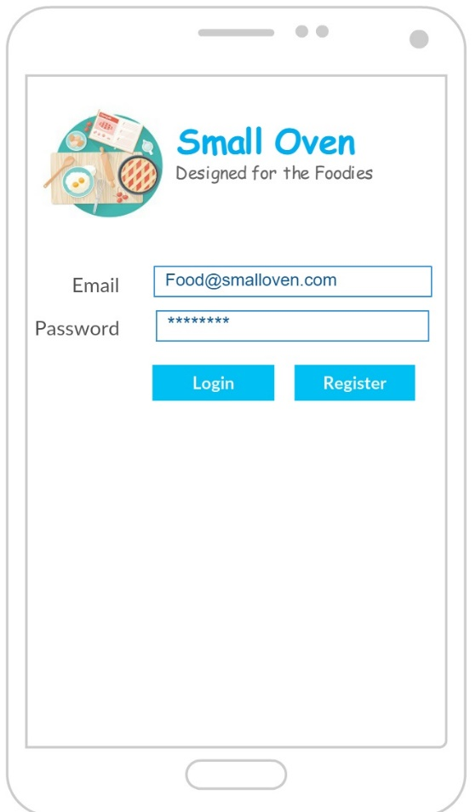

Wire Frame for Login Page

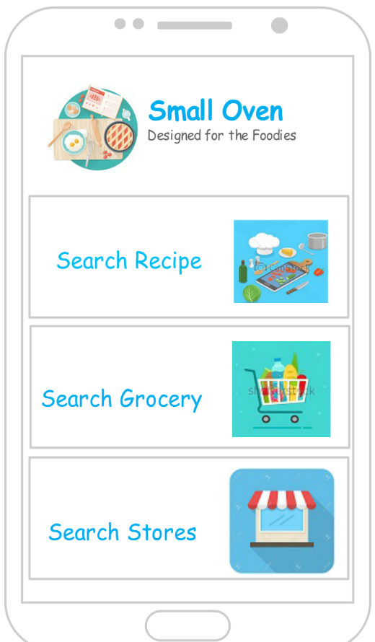

Wire Frame for Home Page

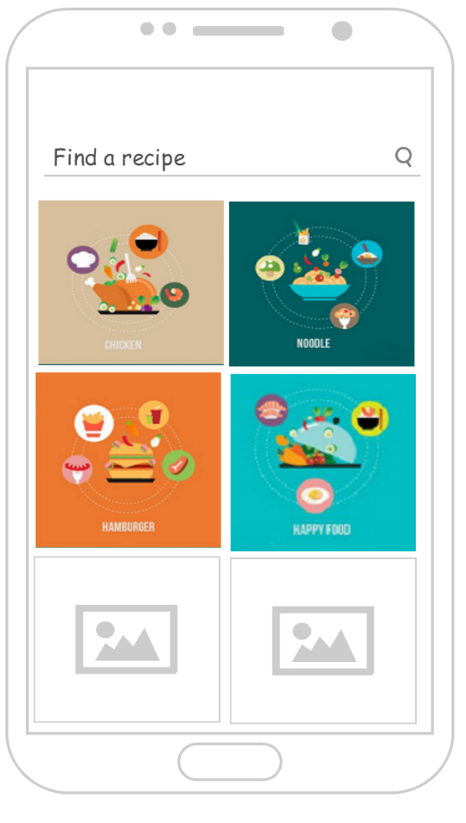

Wire Frame for Search Recipes

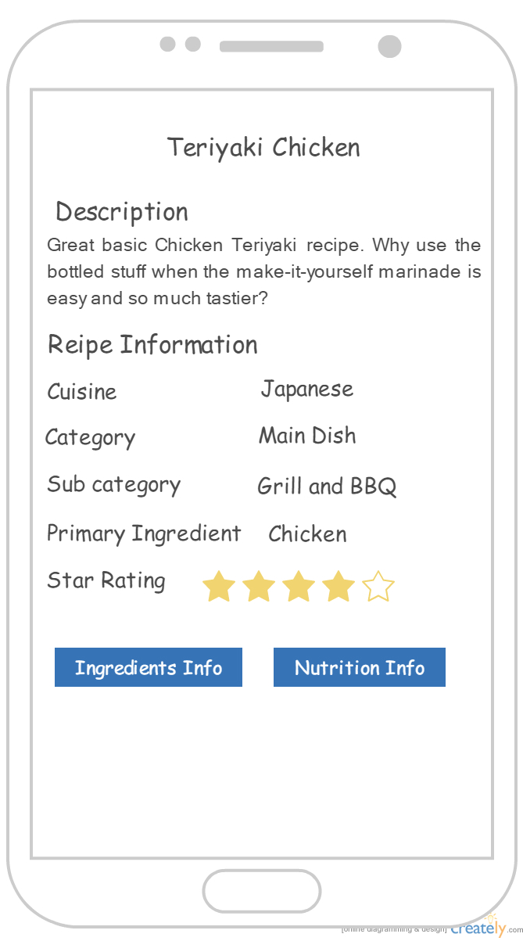

Wire Frame for Displaying Recipe Information

**Application Screenshots**

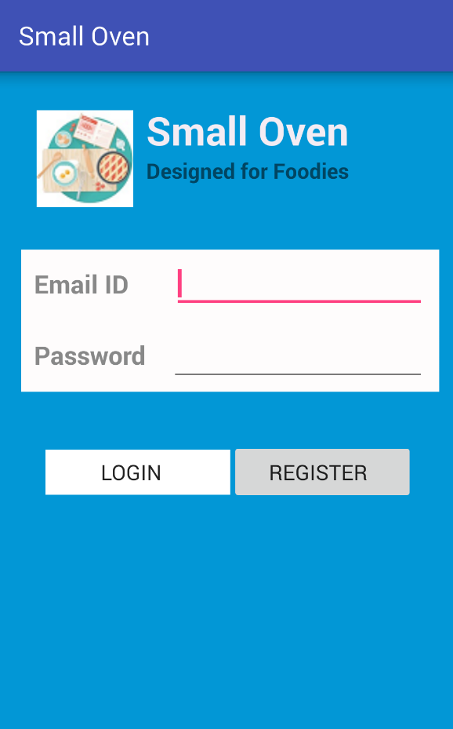 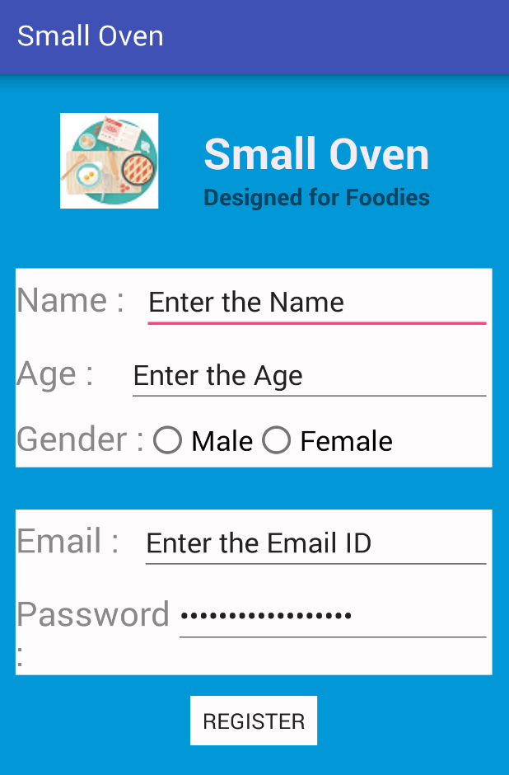

Login Page Registration Page

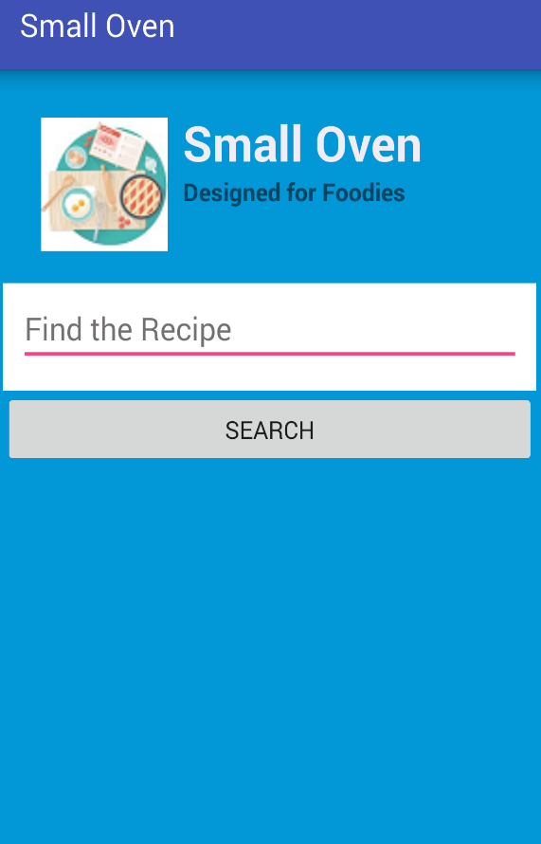 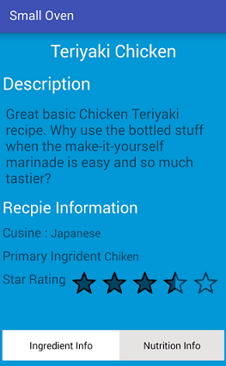

Search Recipe Recipe Information

**Bibliography**

* <https://developers.google.com/vision/>
* <http://www.bigoven.com/>
* <http://supermarketapi.com/Default.aspx>
* <https://market.mashape.com/dashboard>
* <http://docs.aws.amazon.com/AWSECommerceService/latest/DG/ItemLookup.html#ItemLookup-sr>