Optimizing Check out Efficiency: Analysing Self Service Versus Operator-Assisted Systems

Group 6
Hemanth Kumar Kottapalli
Abdel Ouedraogo
Goutham Puram
Santhosh Sai Kadudula

Table of Contents
1. OBJECTIVE: 2
2. PROBLEM DESCRIPTION: 3
3. Statistical and Data Analysis: 3
3.1 Data Collection: 4
3.2 Data Analysis: 4
3.3 Data Visualization: 4
Interarrival time bar chart: 4
Service Time Distribution of Cashier: 5
Distribution Fitting: 5
Fit of Distribution: 6
4. Assumptions: 8
Checkout Method Choice Based on line Length: 8
Preference for Self-Checkout: 8
Assumption of Similar Grocery Quantity: 8
5. Model Implementation (Jaamsim): 8
5.1 Prototype process flow: 8
5.2 Simulation Model: 9
5.3 Objects Used in Jaam sim: 9
5.4 Simulation Results For Current Model: 10
5.5 Developed Model: 11
5.6 Simulation results for Developed Model: 12
6. Conclusion And Recommendations: 13
7. References: 13

OBJECTIVE:

The objective of this project is to analyse and assess the service processes at Publix, focusing on checkout lines, and evaluate the utilization of existing resources. Specifically, the project aims to determine the effectiveness of both self-checkout and operator checkout lines in minimizing costs.

PROBLEM DESCRIPTION:

Main critical challenge in optimizing the efficiency and cost-effectiveness of its checkout processes. The key areas requiring attention include:
Assessing Operator and Self-Checkout Utilization Levels: needs to evaluate the utilization rates of both operator and self-checkout lines to identify any inefficiencies and areas for improvement. Understanding utilization levels will enable to allocate resources effectively and ensure that checkout lanes are adequately staffed to meet customer demand.
Cost Analysis of Operator and Self Checkouts: It's crucial to conduct a comprehensive cost analysis of both operator and self-checkout processes to understand their financial implications. This analysis should encompass labour costs, equipment expenses, maintenance costs, and operational overhead associated with operating both types of checkout lanes.
Identifying Methods of Cost Reduction: needs to explore potential strategies and initiatives to reduce costs associated with checkout processes.
This could involve optimizing resource allocation by adjusting staffing levels based on demand, streamlining operations to improve efficiency, and leveraging technology solutions to automate and simplify checkout procedures.

Statistical and Data Analysis:

The information has been imported and thoroughly cleaned to ensure accuracy and consistency. We meticulously checked for duplicates and missing values, guaranteeing the integrity of the dataset. Additionally, various calculations were conducted, including the determination of service times and the duration between arrival and exit times. Advanced software tools such as R-studios and Jupyter were employed for comprehensive data visualization and to fit distributions, enhancing our understanding of the data's patterns and characteristics. In summary, the key points of the process involved importing and cleaning data, conducting diverse calculations, and leveraging sophisticated software for data visualization and distribution fitting.

3.1 Data Collection:
Visited the store during peak hours at Publix: capturing the high customer traffic. We collected observational data from both self-checkout and operator checkout lines, recording arrival time, exit time, and queue time for each customer over a specific time (5.30 PM to 7.30 PM).

3.2 Data Analysis:
From the collected data, we computed interarrival time (time between consecutive customer arrivals) and service time (time taken to serve each customer) for both checkout methods.

3.3 Data Visualization:
We graphed the data to visualize the distribution of interarrival time and service time.
Interarrival time bar chart: We created a bar chart to visualize the interarrival time, providing insights into the waiting times. Specifically, we extracted data from both self-checkouts and cashiers to analyse this aspect. The aim was to understand how long customers waited between arrivals at these service points.

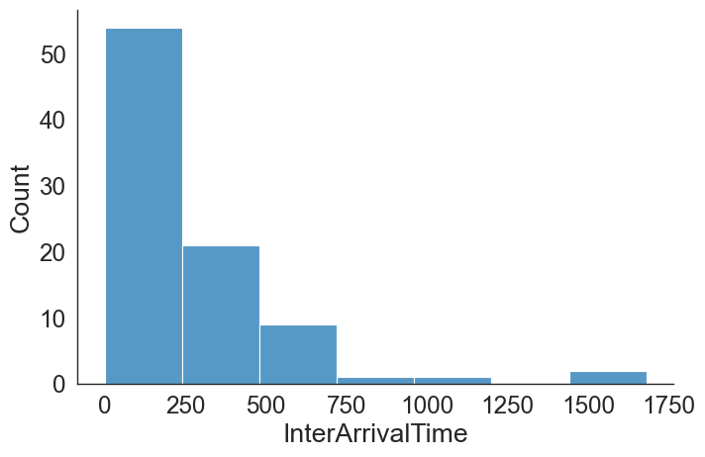
Interpretation: While both self-checkout and cashiers show similar trends in arrival frequency across different interarrival times, there are some subtle differences:
Self-checkout: The bars for self-checkout tend to be slightly higher than cashiers, especially at shorter interarrival times (0-1 minutes and 1-2 minutes). This suggests that customers might arrive a bit more frequently at self-checkouts compared to cashiers, potentially indicating shorter waiting times in self-checkout lines on average.
Cashiers: The bars for cashiers are slightly higher at longer interarrival times (above 3 minutes). This could suggest that cashier lines might experience slightly less frequent arrivals during periods with longer interarrival times.
The interarrival time distribution for customers at self-checkouts and cashiers, suggesting that self-checkouts might experience slightly more frequent arrivals, potentially leading to shorter waiting times compared to cashiers, especially during periods with shorter interarrival times.
Service Time Distribution of Cashier: It's important to note the significance of focusing on the distribution of cashier service times. This targeted analysis is prompted by the observation that cashier service times tend to be more unpredictable compared to those at the self-checkout.

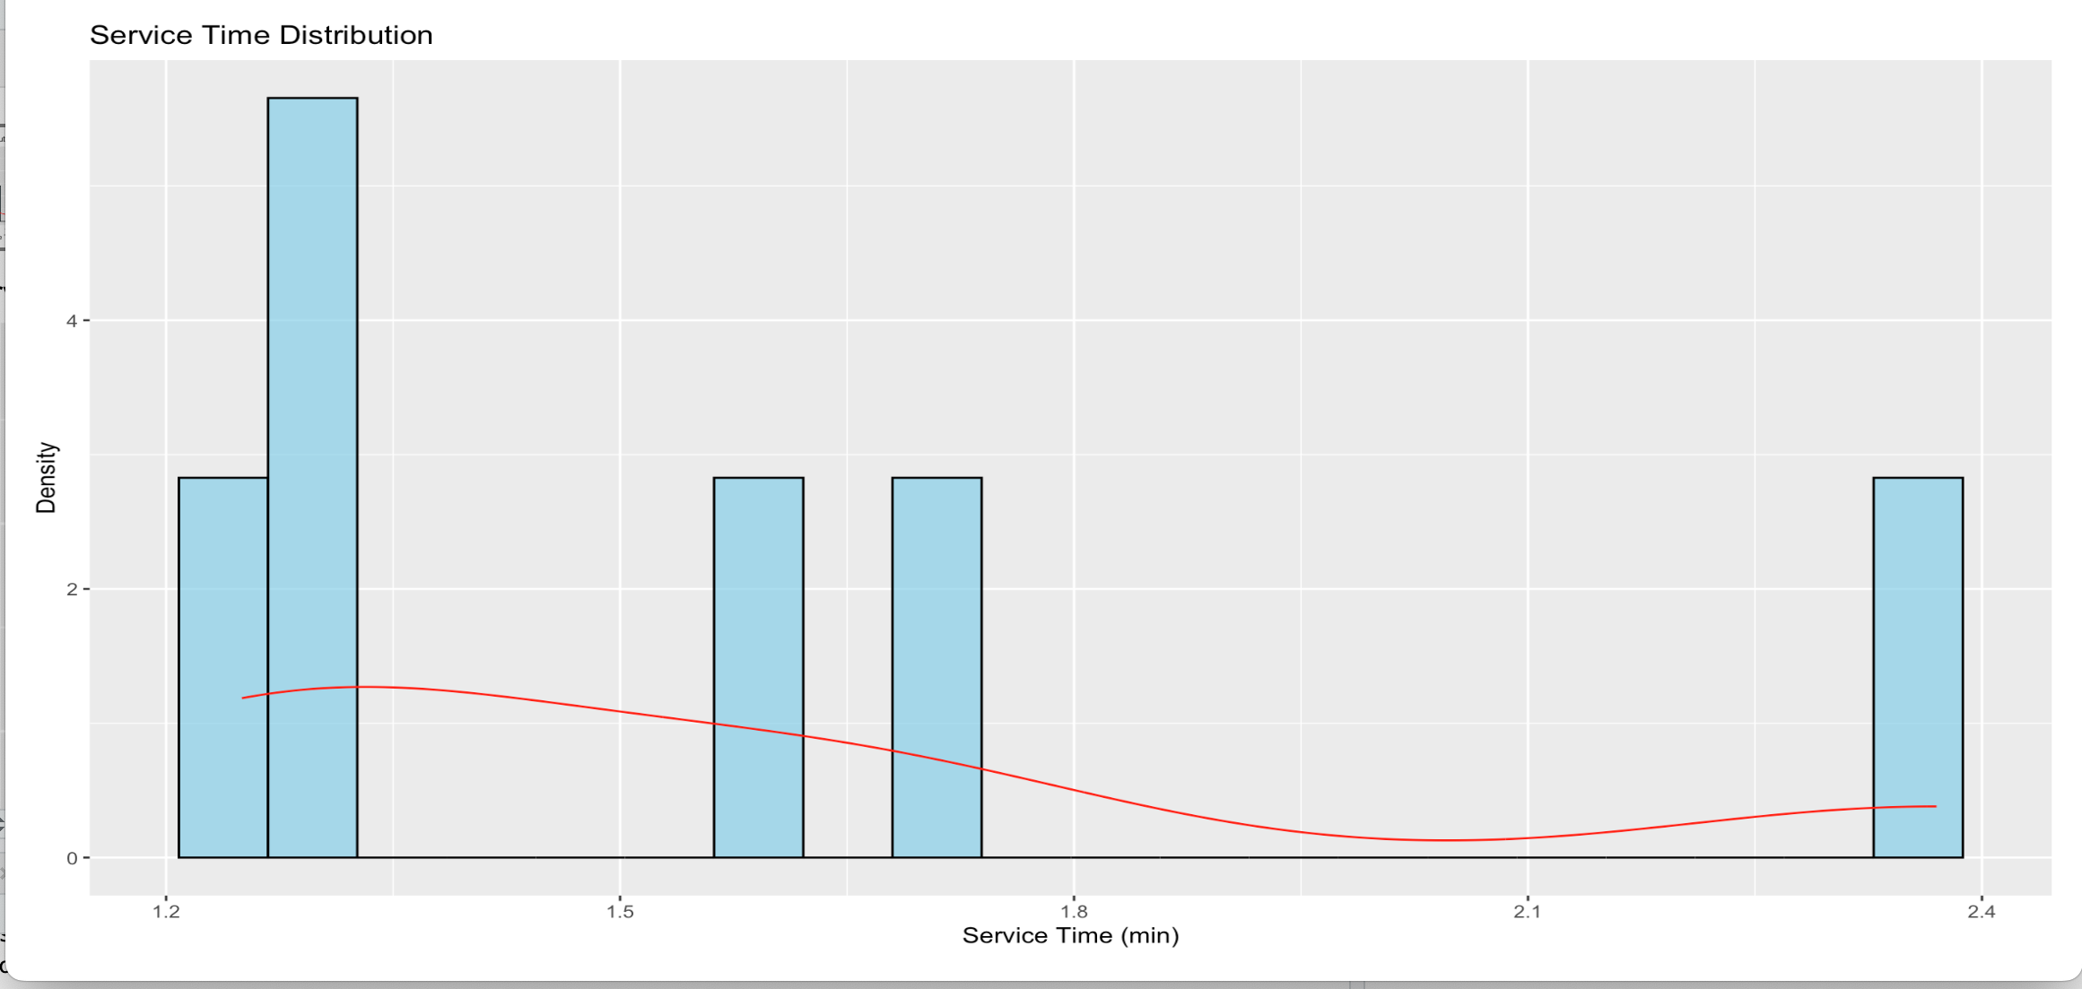

Interpretation: The chart reveals that cashier service times exhibit some level of predictability with a central tendency around 2-3 minutes. However, it also highlights the presence of variability in service times, with some customers experiencing significantly shorter or longer service times compared to the average. This information is valuable for understanding customer waiting times and potentially informing queue management strategies.

Distribution Fitting:
We used a fitting function in Python to fit probability distributions to the interarrival time and service time data. This involved scanning for all possible distributions and selecting the one with the lowest p-value, indicating that the observed data fit the chosen distribution well.
Distribution Selection:
Interarrival Time: We found that interarrival time followed an exponential distribution.
Service Time: For operator assisted checkout and self-checkouts, service time followed a beta distribution and a normal distribution.

Fit of Distribution:
Before delving into the summary statistics of the fitting distributions, it's important to assess the goodness of fit of each distribution to the data. In statistical analysis, the p-value serves as a crucial metric to evaluate this fit. A higher p-value indicates better compatibility between the observed data and the theoretical distribution. Now, let's examine the p-values obtained for the Beta, Normal, and Triangular distributions to determine the most suitable fit for our data.

 | sumsquare_error | aic | bic | kl_div | ks_statistic | ks_pvalue
triang | 0.004151 | 1295.850641 | 1303.282651 | inf | 0.098400 | 3.393141e-01
norm | 0.004171 | 1305.062823 | 1310.017496 | inf | 0.131607 | 8.651256e-02
beta | 0.004173 | 1286.582730 | 1296.492077 | inf | 0.143003 | 4.933052e-02
uniform | 0.004209 | 1262.313828 | 1267.268502 | inf | 0.176768 | 7.084516e-03
expon | 0.004300 | 1323.986755 | 1328.941428 | inf | 0.289488 | 5.029993e-07

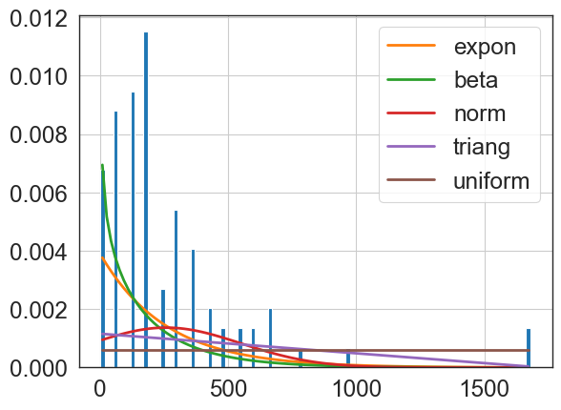

The Kolmogorov-Smirnov (K-S) test is the statistical method used to assess the goodness of fit between observed data and a theoretical probability distribution. It quantifies the maximum difference between the cumulative distribution functions (CDFs) of the observed data and the theoretical distribution.
it's notable that the p-value for the Beta and Normal distributions (0.04933052 and 0.08651256, respectively) is significantly higher than that of the Triangular distribution (0.3393141). This suggests stronger evidence that the distribution of the data follows either the Normal or Beta distribution compared to the Triangular distribution.

Assumptions:
Here's the summarized list of assumptions made for the project:
Checkout Method Choice Based on line Length: Customers select their checkout method based on the length of the queue. If the queue at the operator checkout exceeds five people, customers will choose self-checkout instead.
Preference for Self-Checkout: It is assumed that 70% of customers prefer self-checkout, considering it to be the easier option.
Assumption of Similar Grocery Quantity: Customers are assumed to have relatively consistent quantities of groceries per transaction.

Model Implementation (Jaamsim):

5.1 Prototype process flow:
Before arriving at a robust model, we underwent a series of trial-and-error iterations to refine our approach. The model presented below represents the prototype developed during our initial visit to the store.

Entry
Self-check out
Queue
Operated Assisted
Queue
Operator 1
Operator 2
Operator 1
Operator 2
Exit

5.2 Simulation Model:

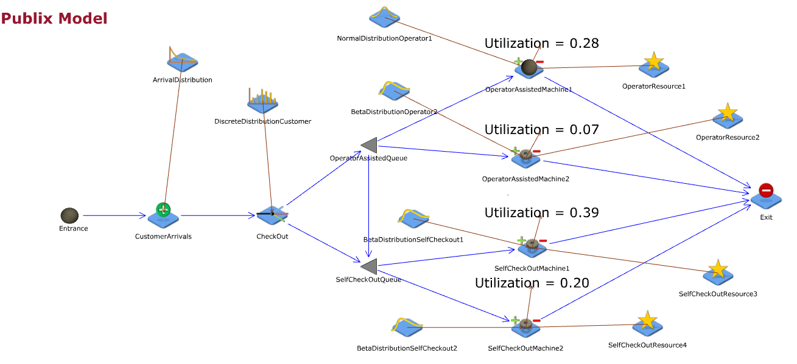
Process Flow: After finishing their shopping, customers are given the choice between self-checkout or operator checkout. The majority, 70%, opt for self-checkout, while the remaining 30% choose operator checkout. Once a choice is made, customers join a pooled queue where they wait in a single line, irrespective of their chosen checkout method. This queueing system ensures that customers proceed to the next available checkout station, minimizing wait times. At self-checkout, customers independently scan, bag, and pay for their items, unless assistance is required. Conversely, at operator checkout, customers wait as staff members scan and bag their groceries, proceeding to pay when prompted. Upon completing the checkout process and settling their payment, customers leave the system with their bags, making way for the next customer in the queue to be served.

5.3 Objects Used in Jaam sim:

Sim Entity: It is used to representing customers in this store or entering the system.
Entity Generator: It is a component used in simulation software to generate entities The use of discrete distribution implies that the arrival of customers is based on some predefined probability distribution.
Branch: This is likely a decision point in simulation model where customers decide which checkout method to use - self-checkout or being served by an operator. The choice could be influenced by factors like queue length, convenience, or customer preference.
Entity Processor: This component represents the service stations where customers are served. For both self-checkout and operator-assisted checkout, we are simulating the service time using a Beta distribution and normal distribution.
Entity Sink: This is where entities (customers) leave the system or store after completing their checkout process. It serves as the endpoint of the simulation model.
Exponential Distribution: This distribution is commonly used to model the inter-arrival times of customers. In this case, it represents the time between consecutive customer arrivals at the store entrance.
Beta and Normal Distributions: These distributions are used to model the service times at both self-checkout and operator-assisted checkout stations. The Beta distribution might be suitable for modelling service times constrained within a finite interval, while the Normal distribution could represent service times with a symmetric bell-shaped curve.
Renege Condition: We have implemented a condition based on our assumptions where customers will switch from operator-assisted checkout to self-checkout if the queue at the operator checkout exceeds a certain length (in this case, longer than 5 customers).
Discrete distribution: It is a statistical distribution has a countable or limited set of possible values. To simulate customer preferences, we use a discrete distribution assuming that 30% of customers prefer operator-assisted checkouts and the remaining 70% prefer self-checkouts.

5.4 Simulation Results For Current Model:

Simulation Duration: The simulation was run for 8 hours, representing a full workday.
Replications: 10 replications were conducted to ensure the robustness and reliability of the simulation results.
Time Units: All time inputs and outputs within the simulation are measured in units of seconds.

Replication | [Operator1].  Utilisation | [Operator2].  Utilisation | [Selfcheckout1].  Utilisation | [Selfcheckout2].  Utilisation
1 | 0.270669 | 0.064117 | 0.389101 | 0.198659
2 | 0.276926 | 0.065322 | 0.389936 | 0.201854
3 | 0.269841 | 0.064672 | 0.388728 | 0.198925
4 | 0.272698 | 0.064552 | 0.38887 | 0.197235
5 | 0.270447 | 0.065395 | 0.387335 | 0.196679
6 | 0.275912 | 0.065944 | 0.38643 | 0.197506
7 | 0.274111 | 0.066086 | 0.387068 | 0.198137
8 | 0.275054 | 0.06526 | 0.388023 | 0.198998
9 | 0.271303 | 0.064852 | 0.385673 | 0.195687
10 | 0.280095 | 0.069066 | 0.388659 | 0.19997
Average | 27.37% | 6.55% | 38.80% | 19.84%
Min Value | 26.98% | 6.41% | 38.57% | 19.57%
Max Value | 28.01% | 6.91% | 38.99% | 20.19%

The analysis reveals poor management of workload distribution and uneven allocation of staff and material resources. Particularly striking is the extremely low utilization of Operator 2 and Machine 2, indicating inefficient resource utilization, which ultimately leads to increased company expenses. Considering the minimal utilization of these operators, removing them from the model emerges as a cost-effective solution. This strategic action has the potential to significantly enhance the utilization rates of Operator Assisted Machine 1 by up to 38% and Self-Checkout Machine 1 by as much as 59%, thereby optimizing resource allocation and improving overall operational efficiency.
This reallocation strategy aims to streamline operations, reduce costs, and improve overall system efficiency. However, it's essential to conduct further analysis and potentially run additional simulations to validate these findings and assess the broader impact on system performance and customer experience.

5.5 Developed Model:

Removing one operator and one self-checkout machine presents an alternative strategy for optimizing resource utilization and cutting costs while preserving operational efficiency. By implementing this alternate solution, the company can achieve cost savings without significantly compromising service quality. However, it's essential to carefully analyse the potential impact and adjust operations accordingly to ensure a smooth transition and continued effectiveness of the checkout process.
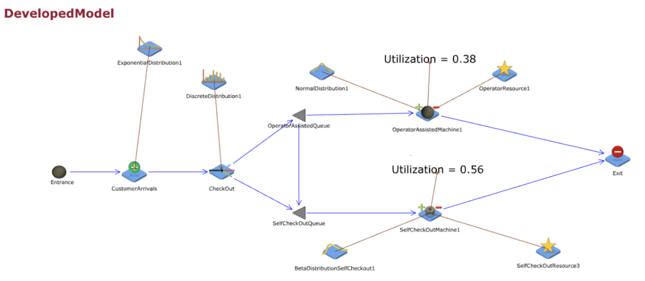

5.6 Simulation results for Developed Model:

Replication | [Operator1].Utilisation | [Selfcheckout1].Utilisation
1 | 0.36037 | 0.558956
2 | 0.367575 | 0.56234
3 | 0.360398 | 0.559093
4 | 0.363669 | 0.557435
5 | 0.362595 | 0.555618
6 | 0.369877 | 0.55527
7 | 0.367117 | 0.555953
8 | 0.367102 | 0.558142
9 | 0.36265 | 0.553031
10 | 0.377424 | 0.559309
Average | 36.59% | 55.75%
Min | 36.04% | 55.30%
Max | 37.74% | 56.23%

Conclusion And Recommendations:

Customers really like using self-checkout instead of having someone help them at the register. We noticed that some of our staff and machines aren't being used much, like Operator 2 and self-checkout 2. Since self-checkout is cheaper for us because they don't have to pay as much in wages, we can save money by using it more. But we need to think about the costs in the short term and long term. Even though cutting staff might save money now, we must consider other costs like maintenance and how much we'll need to spend later. It's important to find the right balance between saving money and making sure things keep running smoothly.
In conclusion, optimizing resource utilization and cost efficiency is essential for maintaining competitiveness and profitability in the retail industry. By removing underutilized resources such as Operatorcheckout2 and Selfcheckout2 and conducting a thorough cost-benefit analysis, companies can streamline operations, cut costs, and adapt to evolving customer preferences.
Continuous monitoring of customer behaviour and resource utilization is key to ensuring that operational strategies remain aligned with both customer needs and financial objectives. By implementing these recommendations, companies can enhance operational efficiency, improve cost-effectiveness, and ultimately enhance overall performance and competitiveness in the market.

References:

- https://ieeexplore.ieee.org/document/10150048/references#references
V. P. Chaudhari, R. V. Chaudhari, A. S. Burgul and S. A. Jain, "Smart Self-Checkout System for Supermarkets," 2023 IEEE 3rd International Conference on Technology, Engineering, Management for Societal impact using Marketing, Entrepreneurship and Talent (TEMSMET), Mysuru, India, 2023, pp. 1-6, doi: 10.1109/TEMSMET56707.2023.10150048.

- https://link.springer.com/article/10.1007/s12927-016-0001-z#citeas
Amorim, M., Lago, A., Moscoso, P. et al. Assisted vs. self-checkout in retail: An empirical analysis of the impact of operational process dimensions on customer satisfaction, recommendation and reuse. J Serv Sci Res 8, 1–39 (2016). https://doi.org/10.1007/s12927-016-0001-z

- https://www.sciencedirect.com/science/article/abs/pii/S0148296323006525?via%3Dihub
    - Department of Marketing, Knauss School of Business, University of San Diego, 5998 Alcalá Park, San Diego, CA 92110, USA
    - Department of Marketing, LeBow College of Business, Drexel University, 3220 Market St., Philadelphia, PA 19104, USA

