Date 08/22/2024 Current price: $77.23 (08/22/2024) NYSE: WMT Headquarters: Bentonville, 702 SW 8th St, United States

Executive Summary
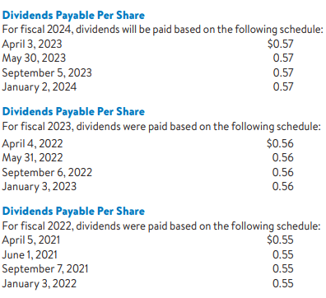
Walmart Inc., a global retail powerhouse, has consistently demonstrated robust financial results and strategic growth through the implementation of innovation and technology. Key features include leveraging AI and machine learning to enhance operations and enhance consumer interactions. Walmart has continued to see steady growth in revenue by staying dedicated to controlling costs, as demonstrated by its strong competition with industry leaders like Amazon and Costco. In order to enhance growth and maintain a competitive edge, strategies should involve expanding e-commerce functionalities, incorporating AI in various business segments, and enhancing sustainability initiatives.
Highlights
During CES 2024, Walmart's CEO, Doug McMillon, discussed the company's strategy of adaptive retail and the use of generative AI to improve customer experiences and business operations. He stressed the significance of prioritizing humans in technology investments. Generative AI Assistant: Walmart has launched 'My Assistant', an AI assistant, to 50,000 campus associates and is expanding its availability to countries like Canada, Mexico, and Chile. AI in Supply Chain: Walmart's Global CTO Suresh Kumar explained the use of AI in the company's supply chain, such as a cutting-edge forecasting system that anticipates customer actions and aids in precise product demand projections. Innovations in Customer Experience: Walmart is creating AI search tools, virtual try-on features, and personalized replenishment algorithms to enhance customer satisfaction. They also brought up a collaboration with Wing and Zipline to provide drone delivery to a large portion of the Dallas-Fort Worth community.
Recent News
Walmart+ has collaborated with Burger King to introduce a new dining perk, providing members with a 25% discount on digital orders and a complimentary Whopper every quarter, boosting the benefits of its membership program. Walmart is introducing a new logistics service called Walmart Cross Border to simplify the import process for sellers, enabling full-container load shipments from Asia to U.S. facilities as part of its logistics expansion.
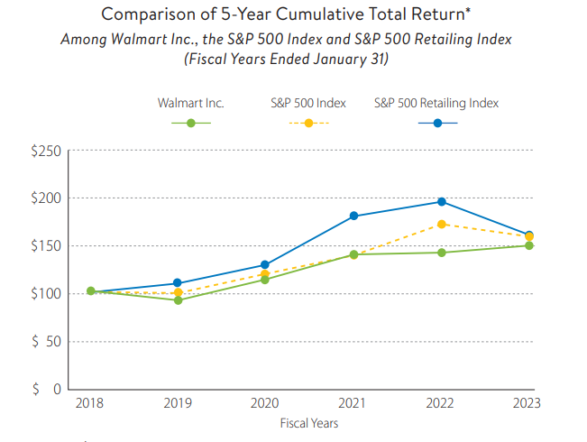
Walmart is increasingly focusing on environmental, social, and governance (ESG) efforts, with its Chief Sustainability Officer stating that ESG is integrated into operations and business strategies​.
Business Description
Walmart Inc. is a well-known retail company with a global presence, based in Bentonville, Arkansas, USA. Established by Sam Walton in 1962, the business has expanded to become the biggest retailer globally in terms of revenue, catering to over 255 million customers every week through more than 10,500 stores in 19 countries. Walmart has three main business divisions: U.S., International, and Sam's Club. The main goal of the business is to assist individuals in saving money and improving their lives by providing a diverse range of products such as groceries, clothing, electronics, and household items, all at affordable prices. Walmart has been leading in retail innovation by using technology to improve its eCommerce capabilities and simplify its supply chain operations. With Walmart's fiscal year 2024 revenues exceeding $648 billion, the company remains a strong presence in the worldwide retail industry.
Corporate Governance:
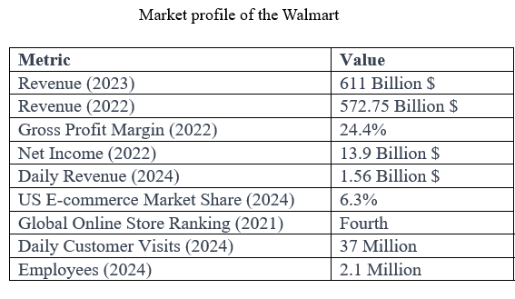
Walmart's corporate governance is characterized by a diverse and independent Board of Directors, with a clear separation of the Chair and CEO positions since 1988, and a Lead Independent Director position since 2004.
Structure of the board:
Walmart has had a strong and independent Board of Directors with separated Chair and CEO roles since 1988, which defines its corporate governance. This organization encourages autonomy in leadership and impartial decision-making, guaranteeing an equitable sharing of authority. The Lead Independent Director position, created in 2004, strengthens the board's supervision and responsibility.
Operations of the committee:
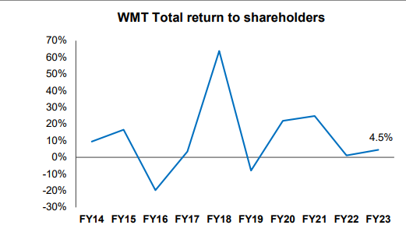
Walmart possesses six active committees that offer concentrated supervision on important areas: Strategic Planning and Finance, Technology and eCommerce, Audit, Compensation and Management Development, Nominating and Governance, and the Executive Committee. Every committee oversees certain governance aspects, like financial integrity, executive pay, and leadership growth, in line with Walmart's dedication to ethical business practices and social responsibility.
Engagement with stakeholders:
The Board of Directors actively interacts with shareholders to promote transparency and accountability in corporate decisions and strategies. This involvement guarantees that Walmart's governance procedures are in line with the desires of its stakeholders, strengthening the company's dedication to responsible and ethical practices.
Principles of morality in action:
Walmart is committed to maintaining elevated moral principles throughout every facet of its operations. The company places importance on following legal standards and encouraging ethical behavior in both its leaders and employees, making sure that all activities are carried out with integrity and accountability.

Research and Development
Walmart's focus on research and development is crucial for improving customer experiences, optimizing operations, and staying ahead in the retail industry. The company is promoting innovation in all areas of its business through investments in advanced technologies like artificial intelligence (AI), virtual and augmented reality (VR/AR), and robotics, which are utilized in tasks from inventory control to customer payment processing. Walmart's emphasis on sustainability has driven the company to embark on multiple green initiatives to reduce its ecological footprint. Through strategic partnerships and acquisitions, platforms into its operations, stimulating e-commerce expansion and broadening its sources of revenue. The company's research and development endeavors have resulted in a smoother omnichannel shopping experience, successfully integrating in-person and digital interactions. Furthermore, Walmart has seen a significant improvement in personalized customer service and marketing through increased investment in data analytics, allowing customized shopping experiences based on individual consumer preferences. By dedicating resources to research and development, Walmart remains at the forefront of the evolving retail industry, establishing itself as a pioneer in embracing innovative technologies to boost its expansion.
Financial Statements Analysis
An in-depth analysis of Walmart Inc.'s financial results between 2015 and 2024, examining important patterns and understandings. During this time, Walmart has shown resilience and flexibility, thanks to strategic investments in technology, sustainability, and global expansion. The financial review emphasizes steady revenue increase, operational effectiveness, and careful financial handling. Analyzing financial documents such as income statements, balance sheets, and important financial ratios helps us comprehend how Walmart has sustained its position as a market leader and preserved shareholder value for the long term.
Annual Income Statement:
During the past ten years, Walmart has steadily grown its revenue by expanding its e-commerce presence, making strategic acquisitions, and investing in technology. Revenue growth rates have fluctuated, particularly during years when Walmart increased its digital offerings and incorporated advanced technologies such as AI and automation operating expenses, Walmart has managed to keep a consistent gross profit margin, demonstrating effective cost control and taking advantage of economies of scale. Nevertheless, the profit margin has displayed fluctuations, influenced by investments in technology, infrastructure, and competitive pricing tactics to gain market share. Walmart's revenue growth is mainly driven by its efforts to improve the shopping experience across all channels, combine online and in-store activities, and use data analytics for personalized marketing and customer interaction.
Annual Balance Sheet:
Walmart's financial stability and strategic asset management are evidenced in its balance sheet between 2015 and 2024. A large part of Walmart's wealth is invested in property, plant, and equipment, reflecting its extensive physical retail locations and dedication to preserving its leadership in the market. Lately, Walmart has strategically shifted its attention towards technological resources, with significant investments in e-commerce platforms, digital infrastructure, and supply chain automation. This change highlights Walmart's proactive adjustment to the changing retail environment, where digital integration is essential for maintaining a competitive edge. Walmart has consistently optimized inventory levels to ensure products are available while minimizing holding costs, which has been a key feature of their operations. This method has increased available funds and maintained consistent growth in sales, even during times of economic instability.
Walmart has shown smart financial management on the liabilities side by using debt wisely to finance its growth strategies. This involves increasing its worldwide presence, improving its online shopping abilities, and funding innovative technologies. Even though Walmart has used debt to grow, it has kept a strong debt-to-equity ratio, managing its capital structure effectively to ensure lasting financial stability and easily handle its debt repayments.
The equity part of Walmart's balance sheet has experienced steady expansion, fuelled by strong retained earnings and capital appreciation. This increase shows Walmart's robust profitability and dedication to providing value to shareholders with dividends and share buybacks. Walmart continues to demonstrate strong capacity to meet short-term obligations as its liquidity ratios, like the current and quick ratios, remain in good standing. This financial freedom allows Walmart to handle economic changes and take advantage of growth opportunities when they appear. Moreover, Walmart's leverage ratios show a well-balanced utilization of debt, along with adequate earnings to cover interest payments, which strengthens the company's financial stability.
Financial Analysis of Walmart Inc. for Fiscal Years 2015–2024.
This financial assessment examines Walmart Inc.'s performance in the last decade, focusing on key indicators such as profitability, liquidity, leverage, efficiency, and asset management. During this time, Walmart has experienced fluctuations in its net profit margins, generally decreasing over time. Increased competition from brick-and-mortar stores and online platforms has likely led to this decrease, forcing Walmart to reduce prices and provide discounts to maintain its market share. Despite these difficulties, Walmart has managed to maintain a relatively consistent gross profit margin due to its successful implementation of cost-cutting strategies, including negotiating better deals with suppliers and improving efficiency in its supply chain.
Conversely, a drop in Walmart's operating profit margin indicates that expenses related to operations, such as labor, store upkeep, and logistics, are increasing more quickly than revenue. This may be due to Walmart's strategic initiatives to grow its online presence and enhance customer interactions, necessitating substantial investments in technology and e-commerce infrastructure, as well as increased labor expenses from higher wages. Walmart's rising debt-to-equity ratio suggests that the company is increasingly turning to debt financing to back its expansion into new markets and investments in technology to remain competitive against major e-commerce firms. Although this approach may support expansion, it also brings in more financial risk, so close monitoring is necessary to ensure the benefits from these investments are worth the risks involved. The existing current ratio, evaluating Walmart's ability to meet short-term financial obligations, has been decreasing, causing potential worries about the company's liquidity. This decrease could be connected to Walmart's assertive inventory management strategies, designed to ensure stores are well-supplied while reducing stockouts that may require additional working capital.
Even though Walmart still performs well in managing inventory, a small decrease in efficiency indicates there is potential for more improvements. The company must improve the alignment of its inventory levels with consumer demand patterns in order to avoid excess stock. Furthermore, the drop in fixed assets and total asset turnover suggests that assets are not being fully utilized, signaling a possible necessity to reassess the scope of store expansions and investments in technological infrastructure. Enhancing cash flow could also be achieved by improving the management of receivables through technological advances.
In brief, despite Walmart's dominance in retail, this financial review highlights the need to focus on margin pressures, improve operational efficiency, and be cautious with financial leverage. In order to succeed in a quickly changing retail landscape, Walmart may have to concentrate on additional investments in technology and e-commerce, streamline its inventory management procedures, and enhance asset utilization plans.
Industrial Analysis
Industrial analysis is a critical approach for examining economic and market trends in specific sectors, providing businesses, investors, and analysts with valuable insights into industry structure, competition, performance, regulations, and technological advancements to identify opportunities, evaluate rivals, and develop data-driven strategies. This strategic evaluation helps stakeholders make informed decisions by offering a comprehensive understanding of sector-specific dynamics, enabling them to navigate complex business landscapes and adapt to changing market conditions effectively.
Walmart's Financial Performance vs. Amazon ,Costco and Target
Throughout its history, Walmart has consistently kept its net profit margins stable, showing its strong profitability. This maintains Walmart's ability to manage effectively and adapt to market shifts, all while making a profit. On the flip side, Amazon's net profit margin has experienced significant fluctuations, shifting from loss to profit. This model showcases Amazon's bold approach to growth, involving substantial investments in expanding its capacities, especially in lucrative sectors such as cloud computing. Costco's profits fall between those of Walmart and Amazon, showing a steadier performance than Amazon but less fluctuation than Walmart, demonstrating a balanced strategy for growth and profitability.
Both Amazon and Walmart have current ratios above one, showing that they have enough assets to fulfil their short-term obligations in terms of liquidity. Costco's elevated current ratio sets it apart, showcasing a greater capacity to meet immediate financial obligations. The quick ratio does not take inventories into account when calculating current assets, suggesting that Amazon has a less conservative liquidity policy compared to Costco and Walmart.
Amazon's elevated debt-to-equity ratio indicates a bolder capital structure in comparison to Walmart and Costco. Walmart's decreased debt-to-equity ratio indicates a more conservative stance towards leverage, in contrast to Costco's approach of either decreasing debt or increasing equity gradually.
When it comes to managing inventory, Walmart excels over Amazon in inventory turnover because of its efficient supply chain specifically designed for its retail strategy. Costco's method of storing items in large quantities leads to a slower rate of inventory turnover when compared to Walmart. Walmart is also at the forefront when it comes to fixed asset turnover, showing effective utilization of assets to produce income. Amazon's reduced fixed asset turnover could be a result of considerable investments in technology and infrastructure that are anticipated to generate long-lasting profits. Costco's results in this sector are on par with Walmart's, demonstrating efficient use of fixed assets.
The financial strategy of every company is in accordance with its distinct business model and market strategy. Walmart's primary goals are maintaining steady profitability, responsible use of debt, and operational effectiveness. Amazon focuses on expanding and reinvesting, resulting in fluctuating profitability and increased debt levels. Costco manages to maintain a balance between making a profit and growing, thanks to its solid cash reserves and cautious borrowing strategy. These large retailers utilize unique financial tactics based on their operational requirements and market objectives, all showcasing strong performance in credit sales and accounts receivable handling.
In the retail industry competition, Target Corp. and Walmart Inc. show unique financial and strategic features. Target's financial stability is shown through a significant net profit margin, indicating the company's consistent emphasis on profitability despite varying fluctuations. This method differs from Walmart's approach, which usually leads to decreased profits by focusing on gaining market share with bold pricing strategies. Target maintains a streamlined liquidity management approach by holding only enough assets to cover short-term obligations. This is different from Walmart's strategy, as it uses higher liquidity ratios to show a more careful financial position focused on preserving short-term financial stability.
In managing its capital structure, Target effectively utilizes debt financing to support expansion while upholding its financial structure. On the contrary, Walmart possesses a reduced debt-to-equity ratio, suggesting a more cautious attitude towards borrowing.
The efficiency of Target's inventory turnover is influenced by catering to a variety of consumer preferences, whereas Walmart's focus on high volume and efficiency results in even faster inventory turnover. Moreover, Target has enhanced its management of receivables, leading to quicker turnover and showcasing its adeptness in effectively handling cash flows, a critical aspect in the rapidly evolving retail sector. The variations in operational efficiency and cash flow management might give Target a competitive advantage in the ever-changing retail industry.
Competitors positing
Competition within the industrial sector
Intense competition in the retail industry heavily impacts the strategic decisions made by Walmart. Walmart encounters tough competition from various sources, such as conventional retail stores, bargain outlets, and online shopping sites. To stay ahead in the market, Walmart keeps using its everyday low price (EDLP) approach and diverse range of products, competing against brick-and-mortar rivals such as Target and Costco, along with the e-commerce giant Amazon.

Positioning in the market and fundamental strengths
Walmart's competitive edge is derived from its unmatched market coverage and its position as a leader in cost control. The business guarantees that products will always be available at affordable prices by utilizing efficient operations on a large scale and a strong supply chain network. A strong financial base supports these qualities, allowing for strategic growth and technological progress.
Challenges in operations and weaknesses in strategy.
Walmart's strong dependence on the U.S. market, along with its intricate organizational framework, could constrain its ability to quickly adapt to changes in the market. Previous examination of its operational procedures has influenced the reputation of its brand and connections with customers.
Opportunities for growth and strategic initiatives
Walmart is adopting digital changes and is strategically positioned to take advantage of the growth of online shopping, with chances to expand in new markets. Its emphasis on sustainability is in line with worldwide patterns, which could boost its brand reputation and customer allegiance.
Outside pressures and competition challenges.
To stay ahead in the market, the retail powerhouse must adjust to intense competition, regulatory oversight, changes in consumer purchasing habits, and a quickly changing technology environment.
Porters Five Forces
Threat of New Entrants:
Walmart faces significant challenges for new competitors due to economies of scale and brand recognition in its market. However, the retail industry's digital transformation has lowered barriers to entry, enabling new e-commerce models to establish their own market niches. To ward off potential rivals, Walmart is responding by investing strategically in its online platforms, expanding its product range, and staying competitive with aggressive pricing tactics.
Bargaining Power of Suppliers:
Walmart's large global presence and purchasing power give it considerable influence over its suppliers. This impact allows Walmart to secure favourable terms, which helps its strategy of cost leadership. Nevertheless, suppliers who have unique products or strong brand reputations can wield power, requiring Walmart to implement a well-rounded supplier relationship management strategy.
Bargaining Power of Customers:
Consumers hold significant influence in the retail industry because of the wide range of choices available and their sensitivity to prices. Walmart aims to draw in and retain customers who are mindful of prices with its commitment to offering low prices. Yet customer loyalty is facing competition from rivals who offer convenience and personalized shopping experiences, especially in the e-commerce sector. Walmart's commitment to delivering customer value and service is crucial in this industry where prices are a major factor.
Threat of Substitutes:
Risks of substitution arise in alternative retail formats and channels. Consumers have the option to select between shopping in physical stores, making online purchases, or utilizing alternative service providers, all offering the same products. Walmart combats this risk by broadening its presence across various channels, providing a wide selection of products, and enhancing the shopping experience for customers both in physical stores and on the Internet.
Rivalry Among Existing Competitors:
Competition among existing rivals in the retail sector is intense. Walmart is challenged by a variety of competitors, including department and discount stores, traditional physical retailers, and an increasing amount of online retail giants. To maintain its market position, Walmart is investing in competitive pricing, technology advancements, store renovations, and exploring new industries and services like e-commerce and healthcare.
Embracing Innovation to Improve Customer Experience
Walmart has strategically established itself as a leading online merchant by reassessing its omnichannel approach and incorporating advanced technology to enhance customer convenience. The dedication of the company to offering a seamless shopping experience is shown through its significant investments in an automated supply chain and the incorporation of advanced technologies such as generative AI, augmented reality, and voice purchasing capabilities. These efforts focus on improving inventory precision, search results, and personalized shopping, showcasing Walmart's flexible strategy to meet evolving consumer demands and maintain its competitive advantage in the retail sector.
Projected Financial Statements
Walmart's projected financial outlook demonstrates a path of careful growth, emphasizing a balanced combination of scalability and financial caution. The forward-looking statements reveal a deep understanding of the complexities of the retail industry and Walmart's determination to maintain its dominance in this field. These forecasts demonstrate Walmart's commitment to financial responsibility and forward-thinking strategy, providing stakeholders with a clear view of the company's future financial well-being and potential for growth.
The increasing sales revenue over the projected timeframe shows Walmart's effective market strategies and quick adaptability in the competitive retail sector. The expected growth rates reflect careful planning, considering the various market factors such as consumer behavior and macroeconomic variables.
The predicted increase in gross profit and operating income shows a strong operational structure that effectively balances controlling costs with investing in growth projects. The slight increase in Selling, General, and administrative expenses shows Walmart's strategic investments in key areas such as technology, customer service, and logistics to maintain its market leadership. The differences in interest earnings and tax responsibilities showcase Walmart's flexible financial strategies, adapted to current interest rates and tax laws.
Additionally, the forecasts suggest a consistent path for profits, highlighting Walmart's financial stability and ability to sustain expansion. Maintaining this level of consistency is crucial for building investor confidence and showcases Walmart's ability to turn revenue into profits effectively despite the natural fluctuations in the retail industry.
The expected strengthening of the balance sheet, with a significant increase in cash reserves and equivalents, shows a strong liquidity position. This places Walmart in a favourable position to take advantage of investment opportunities and effectively handle operational demands. The careful management of resources compared to debts shows a disciplined approach to financial planning that will help Walmart navigate future market changes and take advantage of strategic opportunities.
In conclusion, Walmart's anticipated financial statements show a company well-positioned for calculated expansion, achieving a delicate equilibrium between expanding its market presence and maintaining profitability. The financial planning integrated into these forecasts shows a strong understanding of the retail environment and Walmart's goal to maintain its position as a market leader. For stakeholders, these forecasts demonstrate Walmart's commitment to financial honesty and long-term planning.
The expected growth in Walmart's gross profit and operating income demonstrates a strong operational framework that combines cost-saving actions with strategic expansion efforts. The increase in SG&A costs is probably a result of investments in technology advancements and improvements in customer satisfaction. Fluctuations in interest earnings and tax forecasts can indicate active financial planning. A steady pattern of net income growth boosts Walmart's financial well-being and potential for expansion, bolstering investor trust and showcasing its knack for turning sales into earnings.
DCF Model
Walmart's financial indicators highlight a robust Enterprise Value (EV) of approximately $207 million, reflecting its total market value, including equity and debt financing elements. The EV per share stands at 76.903, possibly suggesting a premium on Walmart’s shares driven by anticipated growth or the company’s strong competitive position.
Walmart's relatively low net debt of $4.08 million against its substantial enterprise value signals a prudent approach to leverage, portraying strong financial health and a potentially lower risk profile for investors. This is further supported by an equity value exceeding $203 million, representing shareholders’ residual claim on the company’s assets.
The projected stock price of $54 acts as a critical benchmark for valuation analysis. If this forecasted value is below the current trading price, it could indicate a premium driven by expected growth or perceived value. Conversely, if the forecasted price is higher, it may suggest that Walmart’s shares are undervalued, presenting a potential opportunity for investors.
For investment analysts, these metrics lay the groundwork for more comprehensive research, incorporating market trends, competitive positioning, and strategic business goals. The aim is to provide a holistic assessment of Walmart’s investment potential by considering its operational strength, growth strategies, and ability to maintain a dominant market presence amid shifting consumer and economic conditions.
Walmart’s market capitalization is currently valued at $472,691,000, a figure that should be validated against its operational performance. Market capitalization serves as a direct measure of a company's value as perceived by equity markets, and any significant deviations from expected values warrant further investigation.
Walmart’s capital structure ratios hover around 14%, indicating a balanced debt-to-equity ratio in its financial framework, which may reflect sound financial policies and effective risk management. The cost of equity, ranging from 5.0% to 6.2%, denotes the expected return demanded by shareholders, a key input for investment evaluations and valuation models such as the Discounted Cash Flow (DCF) analysis.
The Weighted Average Cost of Capital (WACC) fluctuates between 4.8% and 6.8%, representing the average return Walmart is expected to provide to security holders for financing its assets.
Investment Considerations
When comparing Walmart to the broader S&P 500 index, decisions are driven by a risk-adjusted return analysis. If Walmart’s performance aligns with its strategic strengths and market positioning, it could outperform the index. Lower stock volatility compared to the S&P 500 could signal a more stable investment. However, emerging risks or disruptive market dynamics might alter the risk profile.
Reasons to Invest in Walmart
Market Stability and Dividends: Walmart's substantial market capitalization and regular dividend payouts highlight its reliability and appeal for income-focused investors.
Growth Potential: Walmart’s strategic initiatives and market expansion plans could drive future value appreciation. Current valuation metrics might offer a compelling entry point if the stock is undervalued.
Strong Market Position: As a global retail leader, Walmart benefits from economies of scale, enabling competitive pricing. Its well-established brand and broad product range attract a consistent customer base.
Financial Performance: Walmart’s sizable market capitalization reflects investor confidence and its ability to sustain its market share.
Stability and Dividend Yield: Walmart’s history of stable returns and consistent dividend payments can be attractive for investors seeking regular income.
Cost of Equity and WACC: A stable cost of equity and relatively low WACC indicate efficient capital utilization for operations and growth.
E-Commerce Growth: Walmart’s investments in e-commerce and acquisitions position it to capitalize on the growing online shopping trends.

APPENDIX
Income Statement
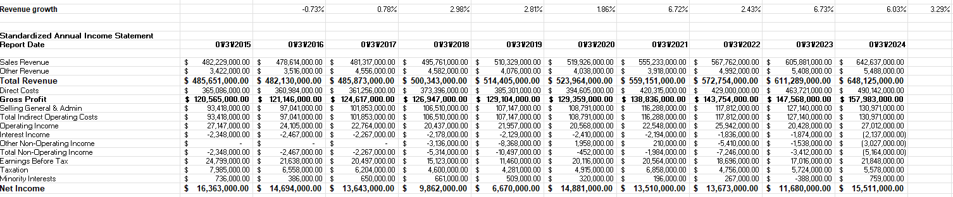
Balance sheet
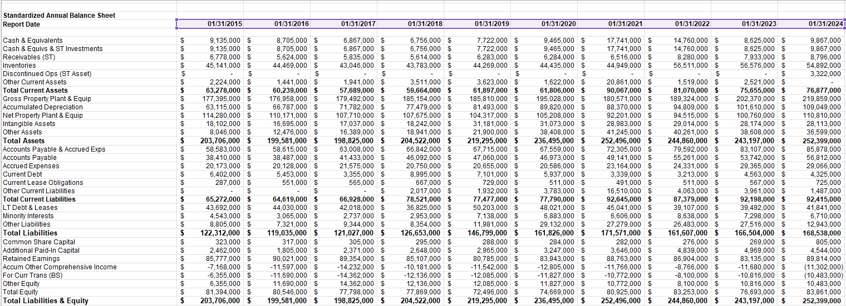

Walmart Financial Ratio
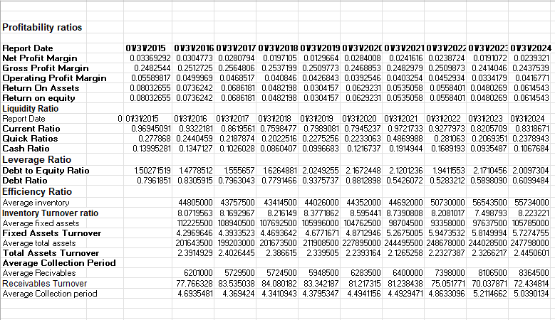
Costco Ratios
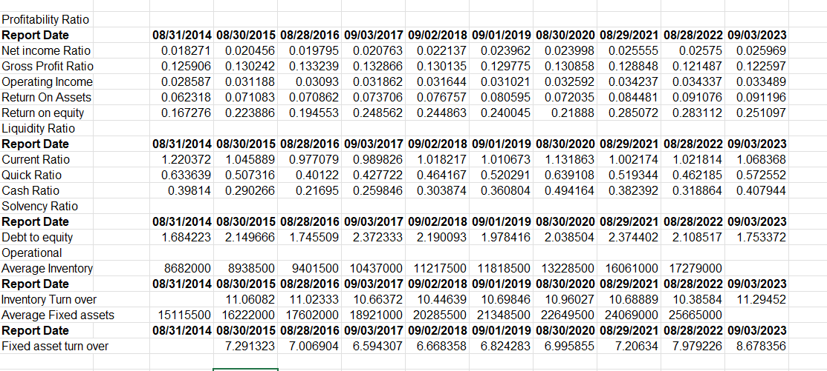
Amazon Ratios
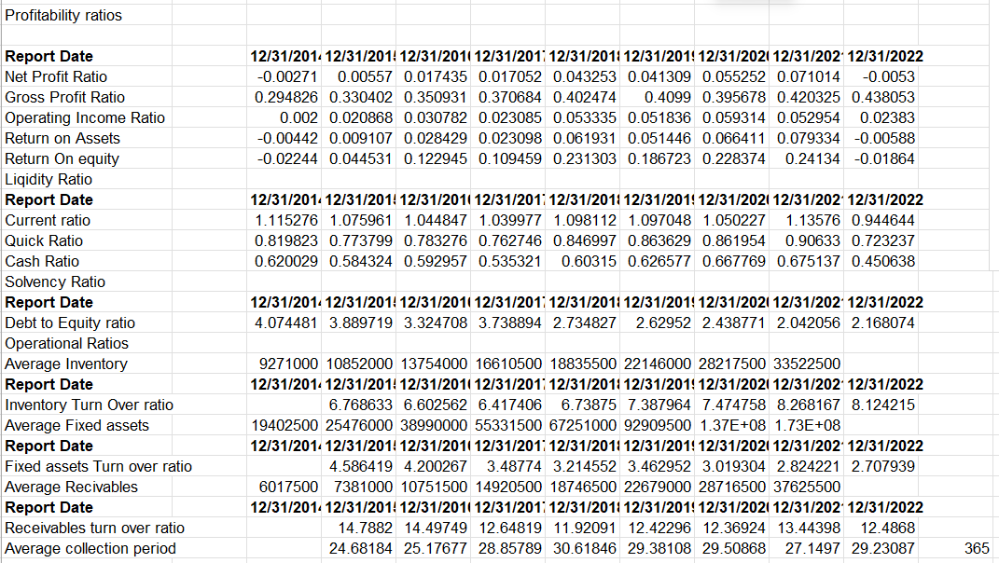
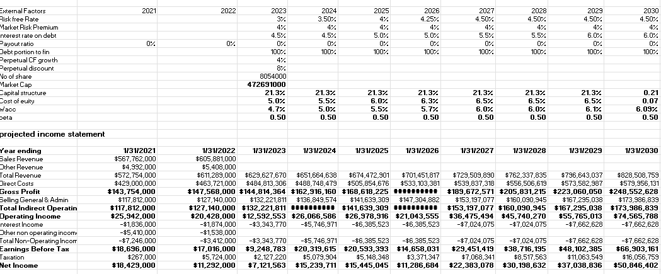
Projected Income statement

