**DOCTOR PATIENT MANAGEMENT SYSTEM**

**LOW LEVEL DESIGN**

**DPMS Overview:**

* The purpose of this project is to implement a system for doctor patient management which helps the client to manage the doctor patient appointments and treatment efficiently.
* This project plays a major role in managing doctor and patient services which in returns saves lot of time and effort.

**For User registration**:

* The patient and doctor registration has to be done and the registered data will be stored in patient and doctor database respectively.
* For login, the details from the doctor and admin should be authenticated and the details should match with the data file stored in database.

**New User:**

The user registration is to be created for doctors and patients and the data of the registered user is stored in doctor and patient database in a file. For login, the details from the doctor get compared with the data file stored in doctor database.

**For User Login:**

The doctor or admin can login into the DPMS by giving his/her login id and password.

**Login Failure:**

When login id and the password is not matched with the data present in the database, login failure occurs the system exits from DPMS.

**User Validation For client:**

The main function is to compare the entered id and password with registered id and password stored in the data file in the database.

**Book Appointment:**

Once the registration is completed the patient has to choose the specialization, select the doctor and slot as per his choice.

**View Appointment:**

After registered or logged in, the patient can see his/her appointment details, doctor can see his /her patient appointment details and also the history of the patient if he/she had already received treatment and admin can see all the appointment details.

**Modifying Information:**

The doctor can only change his/her basic information .The admin can add/edit/delete the details of both doctor and patient.

**View Details:**

The patient can view his/her details. The doctor can view his/her details and the details of patients he treated and the admin can view both the details of doctor and patient.

**Logout:**

The logout is used to exit from the application by the logged in users. After logged out, the users can also able to login again.

**Procedural Flow:**

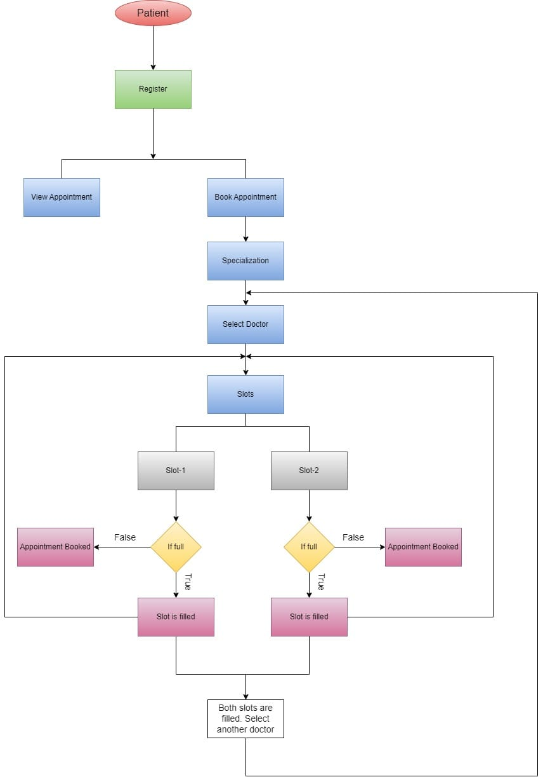

**Patient Flow Chart**

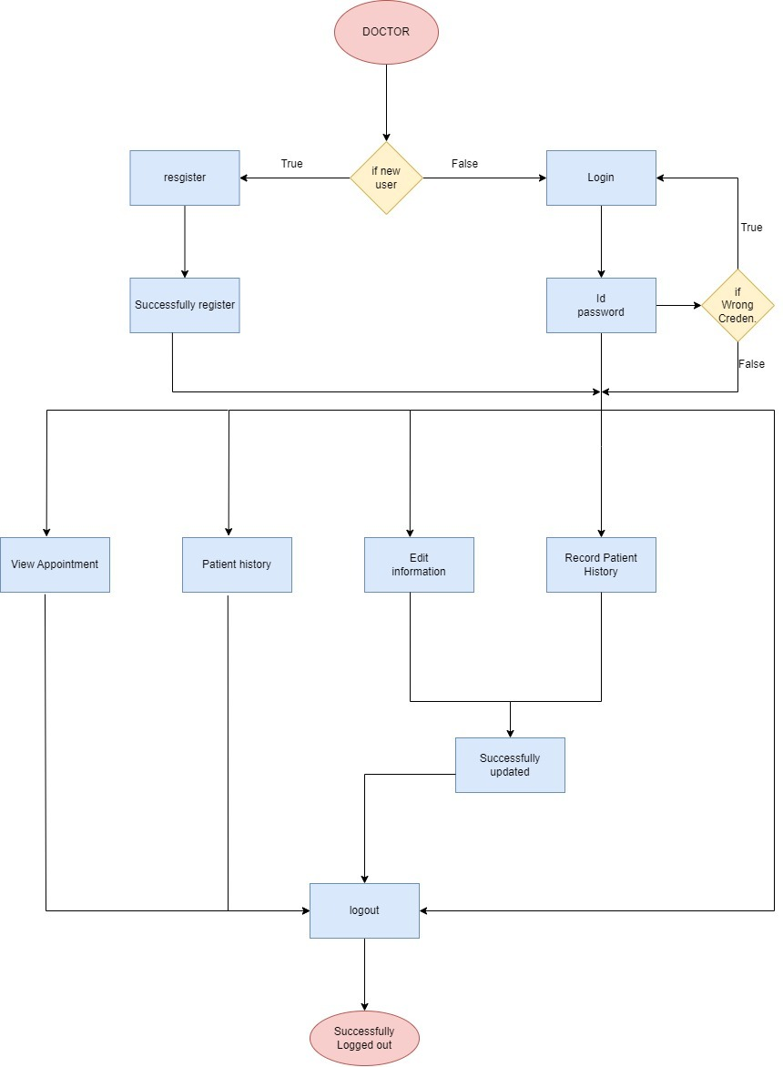

**Doctor Flow Chart**

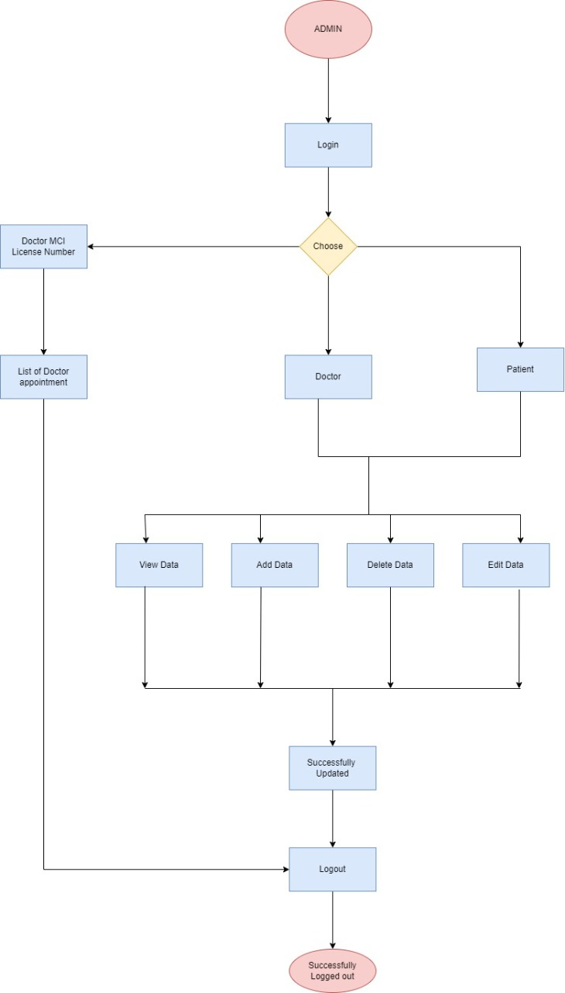

**Admin Flow Chart**