
MICRO-LEVEL PROJECT REPORT
25ML35T / FOUNDATIONS OF ARTIFICIAL INTELLIGENCE

PROJECT TITLE: A* 8-Puzzle Solver and Sudoku CSP Comparison

Submitted by: Hemanth Kumar A | VH15168 | II / III / A | Batch 11

Submitted to : Dr.Manoj Kumar D S
Associate Professor / Department of CSE(AI&ML)

Academic Year: 2026–2027 Submission Date: [enter actual date]

1. ABSTRACT AND PROJECT OBJECTIVES
1.1 Abstract
The project solves the 8-puzzle optimally with A* and compares misplaced-tile and Manhattan heuristics. It also models Sudoku as a constraint satisfaction problem (CSP), comparing plain backtracking, MRV, forward checking and AC-3 on 4×4 and 9×9 inputs. A parity rule rejects impossible 8-puzzle states before search, while the explanation output reports tile distances, candidate scores and an optimal-path hint. On the supplied 20-move puzzle, both A* runs found an optimal solution; Manhattan expanded 91 nodes versus 2,340 for misplaced tiles. The 9×9 Sudoku sample was solved by all four strategies, with sharply different search effort.
1.2 Keywords
A* search; admissible heuristic; Manhattan distance; inversion parity; Sudoku; constraint satisfaction problem.
1.3 Problem statement
Given a valid 3×3 sliding-tile board, find a minimum-move path to the goal configuration. Compare two admissible heuristics by their expanded nodes, reject unsolvable boards before search, and explain the selected moves. As an extension, solve 4×4 and 9×9 Sudoku boards using four CSP strategies and compare their assignments, backtracks and runtimes.
1.4 Objectives
1. Find an optimal 8-puzzle solution with A* using both heuristics.
2. Compare expanded and generated nodes on the same input.
3. Apply inversion parity before search and demonstrate both outcomes.
4. Solve Sudoku with plain backtracking, MRV, forward checking and AC-3.
5. Show one path explanation and discuss when search or CSP is suitable.
1.5 Scope
The project includes a local browser interface and command-line interface for user-provided 8-puzzle boards and Sudoku rows. Sudoku is limited to standard 4×4 and 9×9 boards. It measures search and CSP effort; puzzle generation, generalized board sizes and user accounts are outside scope.

2. INTRODUCTION AND PROPOSED SOLUTION
2.1 Background
The 8-puzzle is a small planning problem: an agent must choose legal actions that transform a start state into a goal state at minimum cost. Sudoku has a different structure: values must be assigned consistently across row, column and box constraints. Both are classic AI problems that demonstrate how a suitable representation can make search more effective and results easier to explain.
2.2 Existing system
A person may solve a sliding puzzle by trial and error, while a basic uninformed search explores states without estimating distance to the goal. Sudoku is commonly solved by repeatedly choosing a blank cell and trying values. These approaches can work on small examples, but effort grows when choices lead to dead ends.
2.3 Limitations
Uninformed exploration can spend time on states that are far from the goal. Manual puzzle solving does not provide reproducible node counts or a verifiable optimality guarantee. In Sudoku, row-major backtracking can make many guesses before it reaches a contradiction; without propagation, it may discover an empty domain only after deeper search.
2.4 Proposed AI-based solution
For the 8-puzzle, the program validates the board, counts inversions, then runs A* with misplaced tiles and Manhattan distance. It prints both optimal paths, cost, nodes expanded/generated, per-tile Manhattan values, legal successor scores and a reasoned next-move hint. For Sudoku, it runs four strategies on the same entered board and prints a solved grid plus assignments, backtracks and elapsed time.
2.5 Expected benefits
The intended users are students and instructors studying heuristic search and CSPs. The side-by-side metrics make the effect of a heuristic or propagation method observable. The move explanation exposes the basis for the recommendation, and the parity check avoids wasting search on a provably unreachable board.

3. AI CONCEPTS AND PROBLEM FORMULATION
3.1 AI concept used
The main method is informed state-space search using A*. The project also uses constraint satisfaction with backtracking and constraint propagation, a logical inversion-parity rule, and a rule-based hint derived from an optimal route.
3.2 Why this AI concept is suitable
A* is appropriate because the 8-puzzle asks for a least-cost sequence of actions. Both heuristics estimate remaining moves and are admissible, preserving optimality. Sudoku asks for a complete assignment satisfying interacting constraints; MRV and propagation can shrink domains and expose contradictions before all cells are assigned.
3.3 Problem formulation
8-puzzle state: nine row-major values 0–8, where 0 is blank. Initial state: user input. Actions: move the blank one square up, down, left or right when legal. Goal: (1,2,3,4,5,6,7,8,0). Step cost: 1. Constraints: each value 0–8 appears once; inversion parity must be even for a 3×3 board. A* prioritizes f(n)=g(n)+h(n). Sudoku: one variable per empty cell, domain of legal values 1…N, with all-different row, column and square-box constraints.

3.4 PEAS
Component | Project-specific description
Performance measures | Optimal move count; nodes expanded/generated; Sudoku assignments, backtracks and runtime.
Environment | Local browser interface and Python CLI on the student’s Windows computer.
Actuators | Displays paths, hints, per-tile explanations and comparison tables.
Sensors / inputs | Nine 8-puzzle tiles or 4/9 Sudoku rows entered by the user.
3.5 Input, output and assumptions
Input is a 9-value permutation for the 8-puzzle, or N rows for Sudoku. Output includes the solution path, move sequence, heuristic comparison, explanations, solved Sudoku grids and CSP metrics. The goal arrangement is fixed. Each 8-puzzle move costs one. Sudoku input is assumed to describe a standard puzzle; the solver checks contradictory clues and reports invalid or unsolved cases.

4. SYSTEM ARCHITECTURE AND DESIGN
4.1 System architecture
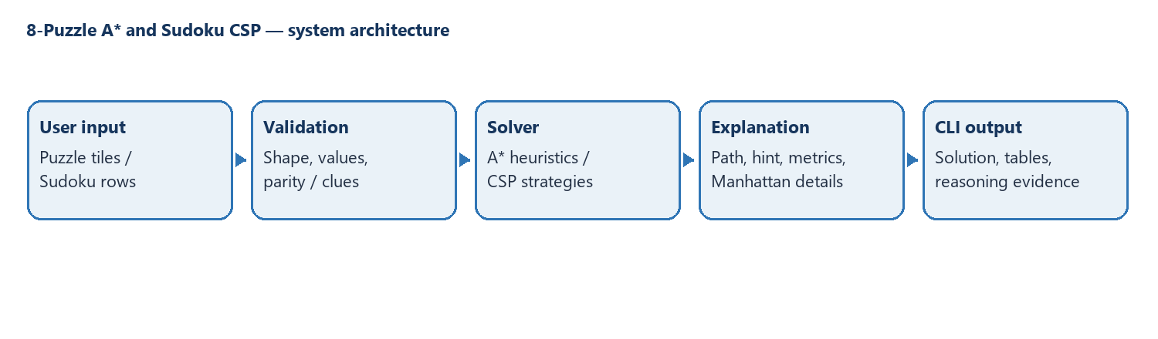
Figure 1. Data flow from user input through validation and search/CSP solvers to explanations and results.
4.2 Workflow
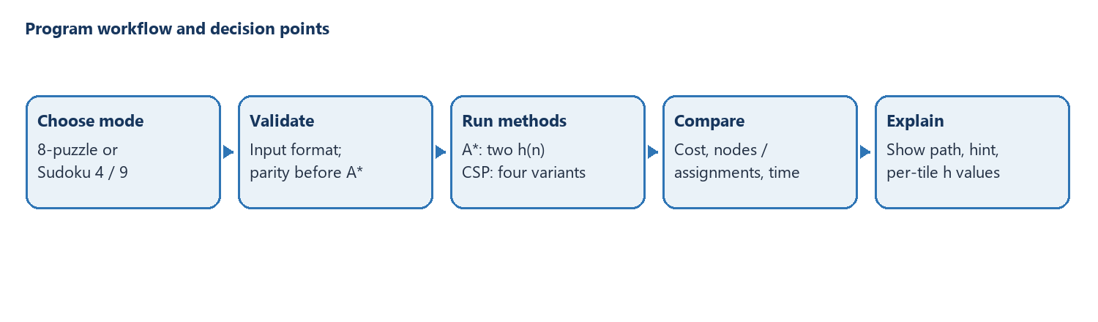
Figure 2. The execution sequence validates input, runs the selected methods, compares outcomes and prints reasoning.

4.3 Modules
Module | Responsibility / function
main.py | Command-line input, validation and output.
solver.py | A*, both heuristics, parity reasoning and move explanations.
sudoku.py | Plain backtracking, MRV, forward checking and AC-3 metrics.
web.py + web/ | Local JSON server and interactive browser interface.
4.4 Tools
Python 3.14.7 on Windows during the recorded runs; Visual Studio Code; browser interface in HTML, CSS and JavaScript; Python standard library only for the local HTTP server. No third-party packages or external services are required. Runtime depends on the machine and system load.

5. ALGORITHM AND METHODOLOGY
5.1 Methodology
The board is parsed and checked before the algorithm runs. Inversion parity is evaluated first. A* then performs two searches from the same state, changing only the heuristic. Its paths and metrics are compared. Manhattan contributions and legal successor f-scores are calculated along the selected optimal route. In Sudoku mode, the same entered puzzle is passed independently to each strategy; solved grids and counters are printed for comparison.
5.2 Algorithm / pseudocode
A* pseudocode: put the start state in a priority queue with priority g+h; repeatedly remove the lowest-priority state; if it is the goal, reconstruct the path; otherwise generate each legal neighbor; if this path improves its best known cost, record its parent and push it with updated g+h. For Sudoku, select an empty cell (first row-major or MRV), try each legal value, propagate constraints when enabled, recurse, and undo the choice on failure.
5.3 Explanation of the AI technique
Misplaced tiles counts numbered tiles outside their goal cells. Manhattan adds each numbered tile’s row and column distance from its goal. Each is admissible because it never exceeds the moves still required; Manhattan is at least as informed because every misplaced tile contributes at least one and distant tiles contribute more. A* combines cost-so-far g with estimate h. Sudoku’s MRV selects the cell with the smallest remaining domain. Forward checking removes a chosen value from its unassigned peers. AC-3 revises neighboring domains until arcs are consistent or a contradiction is found.
5.4 Data structures
A tuple represents each immutable 8-puzzle state. A priority queue orders frontier states, dictionaries record best costs and parent links, and a set tracks explored states. Sudoku uses a grid, peer sets and candidate domains; recursive calls represent assignments. The parity rule is a count of inverted numbered-tile pairs, excluding zero. The hint rule selects the first move on the complete Manhattan A* path and explains its tile and g, h and f scores.
5.5 Time and space complexity, if meaningful for the selected algorithm

6. IMPLEMENTATION AND GITHUB REPOSITORY
6.1 Development environment
Developed with Visual Studio Code on Windows using Python and a modern browser. The website uses HTML, CSS and JavaScript for interaction, with a local Python standard-library server calling the existing solvers. No pip installation or internet connection is required.
6.2 Implementation steps
`src/solver.py` contains A*, both heuristics, inversion parity and path explanations. `src/sudoku.py` implements the four CSP strategies and metrics. `src/main.py` provides the original command-line program. `src/web.py` exposes local JSON endpoints and serves `web/index.html`, `web/styles.css` and `web/app.js`. `tests/` contains sample boards; `README.md` gives run instructions.
6.3 GitHub repository URL
GitHub URL: [ADD YOUR REPOSITORY URL BEFORE SUBMISSION]. The code folder is available locally at `outputs/8-puzzle-solver`; no published URL was supplied for this report.
6.4 Repository name and access status
Repository name: 8-puzzle-solver. Hosting and access status: not verified; publish the project and replace this note with the actual public/private status before submitting.

6.5 Recommended repository structure
File / folder | Purpose | Included?
src/ | CLI, web server and both solver modules | Yes
web/ | Browser interface: HTML, CSS and JavaScript | Yes
README.md | Overview and run instructions | Yes
requirements.txt | No external packages required | Yes (informational)
tests/ | Sample 8-puzzle and Sudoku inputs | Yes
docs/ | Assignment extension and report source | Yes
.gitignore | Excludes local artifacts | Yes
6.6 Setup and execution instructions
In VS Code, open the `8-puzzle-solver` folder, choose Terminal → New Terminal and run `py src/web.py`. Keep the terminal open, then visit `http://127.0.0.1:8000`. Choose 8-Puzzle or Sudoku, enter a board or load a sample, then press Solve. The server binds to `127.0.0.1` and keeps puzzle data on the same computer. Stop it with Ctrl+C. To use the CLI instead, run `py src/main.py`; Sudoku modes are `py src/main.py --sudoku 4` and `py src/main.py --sudoku 9`.
6.7 Commit history / contribution summary
This report was prepared from the local project files and sample runs. The GitHub commit history and team contribution records were not provided; add the actual commit summary and identify any collaborators before submission. Do not present this note as a verified hosted history.

7. RESULTS AND OBSERVATIONS
7.1 Results summary
The command-line and browser interfaces expose the same solvers. On the comparison board, both A* heuristics returned an optimal 20-move path. Inversion parity accepted the even board and rejected the odd board before A*. All four Sudoku methods solved the 4×4 and 9×9 samples. The browser view presents heuristic metrics, the selected move explanation and Sudoku comparison results. Timings below are one-run measurements and can vary.
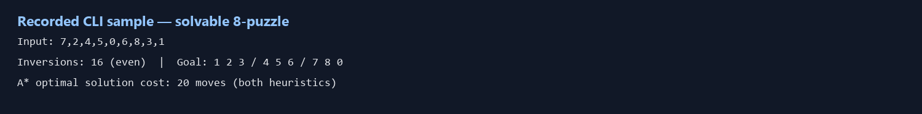
Figure 3. Recorded sample input and parity result for the 20-move 8-puzzle.
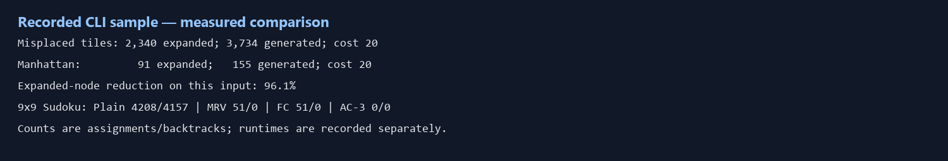
Figure 4. A* and Sudoku summary values transcribed from the program output; this is a generated evidence figure, not a screenshot of the student’s VS Code window.
7.2 Observations
Board / test | Outcome | Evidence
20-move even board | Accepted (16 inversions); optimal cost 20 | Misplaced 2,340 expanded; Manhattan 91
Easy even board | Accepted (2 inversions); optimal cost 2 | Both expanded 2 nodes
Odd-parity board | Rejected before search | 1 inversion (odd)
Sudoku 4×4 | All four solved sample | 8 / 8 / 8 / 1 assignments
Sudoku 9×9 | All four solved sample | 4,208 / 51 / 51 / 0 assignments
A* results for the same 20-move input:
Heuristic | Cost | Expanded | Generated
Misplaced tiles | 20 | 2340 | 3734
Manhattan distance | 20 | 91 | 155
Worked 8-puzzle solution with Manhattan distance
Start board: 7 2 4 / 5 0 6 / 8 3 1. The goal is 1 2 3 / 4 5 6 / 7 8 0. A* returns a 20-move optimal path: Down → Right → Up → Left → Left → Up → Right → Right → Down → Left → Down → Left → Up → Right → Up → Left → Down → Right → Right → Down. The next action is Down, which slides tile 3 into the blank.
At the start, Manhattan h=14. Each tile contributes its row-distance plus column-distance to its goal; the blank is excluded. The first-step candidates below show why the action is on an optimal route. Down and Left tie at f=14; the deterministic successor order selects Down first. A* completes the search and confirms the full route costs 20 moves.
Tile | Current cell | Goal cell | Contribution
1 | (3,3) | (1,1) | 4
2 | (1,2) | (1,2) | 0
3 | (3,2) | (1,3) | 3
4 | (1,3) | (2,1) | 3
5 | (2,1) | (2,2) | 1
6 | (2,3) | (2,3) | 0
7 | (1,1) | (3,1) | 2
8 | (3,1) | (3,2) | 1
Total |  |  | h=14
Blank move | Tile moved | g | h | f=g+h
Up | 2 | 1 | 15 | 16
Down — chosen | 3 | 1 | 13 | 14
Left | 5 | 1 | 13 | 14
Right | 6 | 1 | 15 | 16
On the 20-move 8-puzzle, Manhattan expanded 2,249 fewer nodes than misplaced tiles, a 96.1% reduction, while returning the same optimal cost. The easy two-move board expanded two nodes with each heuristic, so the benefit is input-dependent rather than universal. On the 9×9 Sudoku sample, MRV reduced assignments from 4,208 to 51; forward checking kept the assignment count at 51 and reduced runtime in this run. AC-3 solved this particular board through propagation before branching. The 4×4 sample was easy for every method, so it is not a demanding benchmark.
7.3 Performance measure
Sudoku variant | Assignments | Backtracks | Runtime (s)
Plain backtracking | 4208 | 4157 | 0.022619
Backtracking + MRV | 51 | 0 | 0.002668
MRV + forward checking | 51 | 0 | 0.000583
MRV + AC-3 | 0 | 0 | 0.004155
4×4 Sudoku sample (easy board):
Variant | Assignments | Backtracks | Runtime (s)
Plain backtracking | 8 | 0 | 0.000041
Backtracking + MRV | 8 | 0 | 0.000171
MRV + forward checking | 8 | 0 | 0.000065
MRV + AC-3 | 1 | 0 | 0.000227
Performance measures are solution cost and nodes expanded/generated for A*, plus tentative assignments, backtracks and wall-clock seconds for Sudoku. Both A* heuristics returned a 20-move solution on the same state. The odd-parity case was rejected before A*. Sudoku runtimes below are from one run under Python 3.14.7 on the development machine; their small values are sensitive to timer and system load. No general accuracy or universal speed claim is made.

8. DISCUSSION, LIMITATIONS AND FUTURE ENHANCEMENTS
8.1 Discussion
State-space search is the clearer model when the desired answer is a path through legal actions, as in the sliding puzzle. CSP is clearer when the answer is a consistent assignment subject to many local constraints, as in Sudoku. In A*, a more informed admissible estimate can direct search toward the goal while retaining optimality. In a CSP, MRV and propagation prune impossible value combinations. The explanation output makes selected steps and intermediate metrics inspectable.
8.2 Limitations
A* stores many states and can consume substantial memory on hard boards. Manhattan and misplaced-tile counts can tie on easy inputs, and a low f-score alone does not prove a move belongs to an optimal complete route. Sudoku metrics depend on the chosen puzzle; AC-3’s zero branch assignments here means propagation solved this sample, not that AC-3 always needs no assignments. The current interface is local and the parity theorem is implemented for the 3×3 puzzle.
8.3 Future enhancements
Animate the solution path in the browser and add multiple puzzle presets. Add a puzzle generator that creates reproducible boards by difficulty and report averages over a larger benchmark set. Extend evaluation to exportable results. Additional admissible heuristics, such as linear conflict, could be compared while verifying optimality.
8.4 Practical applications
The project is primarily a teaching aid for AI search and CSP concepts. Similar search methods support route planning and automated planning when actions and costs are explicit. CSP techniques are useful in scheduling, timetabling, configuration and resource allocation when decisions must satisfy multiple constraints.
8.5 Learning outcomes
The implementation demonstrates state and action modelling, admissibility, A* optimality, priority queues, inversion parity, variables and domains, backtracking, MRV and propagation. Comparing measured results also shows why one sample is not enough to claim a solver is always faster.

9. CONCLUSION AND REFERENCES
9.1 Conclusion
The project meets the core objective of optimally solving the 8-puzzle with two admissible heuristics and comparing expanded nodes. Its supplied comparison case demonstrates that Manhattan can substantially reduce expansions while preserving a 20-move optimal solution. The extension adds a parity rule, an explainable next-move hint and Sudoku CSP comparisons for both supported sizes. Results are reproducible from the included samples, subject to runtime variation. Before final submission, the student should add the actual hosted repository URL, verified access status, real commit history and personal VS Code screenshots.
9.2 References
1. Stuart Russell and Peter Norvig, Artificial Intelligence: A Modern Approach, 4th ed., Pearson, 2021.
2. Project implementation and sample inputs: src/main.py, src/solver.py, src/sudoku.py, tests/sample_states.txt and tests/sudoku_samples.txt (accessed 12 October 2026).
3. Python Software Foundation, Python 3 documentation, https://docs.python.org/3/ (accessed 12 October 2026).
4. AI assistance disclosure: OpenAI Codex assisted with code review, sample-run collection and report drafting. The student should verify the report and be prepared to explain the implementation.

Final submission checklist
☐ Check the final page count in Word against the 10–12 page requirement.
☒ Sample 8-puzzle and both Sudoku modes ran in the stated Python environment.
☐ Add and verify the GitHub URL and faculty access status.
☐ Project files are present locally; upload them to the required submission location.
☒ Five test inputs/outcomes and generated program-output evidence are included; add your own VS Code screenshots if required.
☐ Figures, tables and references are labelled; inspect print readability in Word.
☐ Review the final repository for credentials before publishing.
☐ Confirm team details and ensure each listed member can explain the AI concepts.
☐ Print the final report if a hardcopy is required.

