HYDROELECTRICITY

Harvesting nature’s power…….

CONTENTS:

* What is Hydroelectricity?..................
* Types of Hydropower…………………….
* How it works………………………………….
* Advantages and Disadvantages ……
* Examples of different dams……………

What is Hydroelectricity?

* Hydroelectricity is the form of electricity generation that uses the energy of flowing or falling water to produce electricity.
* It typically involves the construction of dams or other water controlled structures.
* Hydroelectric power is considered a clean and renewable energy source ,as it produces electricity without direct emissions of green house gases and relies on the earth’s water cycle.

TYPES OF HYDROPOWER

|  |  |  |
| --- | --- | --- |
| ASPECT | CONVENTIONAL  HYDROPOWER | SMALL SCALE HYDROPOWER |
| Size of the system | Large scale, typically>10mw | Small-scale,<10mw |
| Dam requirements | Often requires a dam or weir | May not require a dam |
| Environmental impact | Can have a significant impact on the environment , including wild life and river ecosystem | Typically has a lower environmental impact due to smaller scale |
| Permitting and regulation | Subject to extensive regulatory processes | May have simplified permitting |
| Energy generation | Produces a substantial amount of energy | Generates a small amount of electricity suitable for local uses |

HOW IT WORKS

It works by harnessing the energy of flowing water to generate electricity.

* Water source: A dam is built to create a reservoir, which stores a large amount of water at a higher elevation.
* Penstock: The water from the reservoir is released through a penstock, a large pipe or channel, and allowed to flow downhill due to gravity.
* Turbine : As the high-velocity water flows through the penstock, it strikes the blade of a turbine. The force of the flowing water causes the turbine to spin.
* Generator : The spinning turbine is connected to generator. Inside the generator , the mechanical energy from the turbine is converted into electric energy through electromagnetic induction.
* Electric generation : The generator produces electrical power, which can be transmitted through power lines to homes, businesses , and industries for various uses.

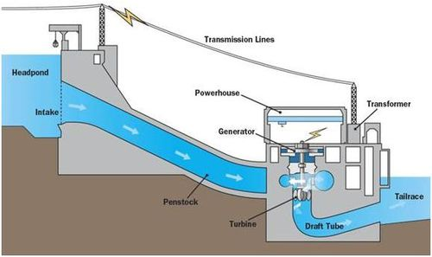

ADVANTAGES

* Renewable energy source
* Low greenhouse gas emissions
* Energy storage
* Long lifespan
* Reliable power generation

DISADVANTAGES

* Environmental impact
* High initial costs
* Limited location options
* Relocations of communities
* Weather-Dependent

Examples of different dams:

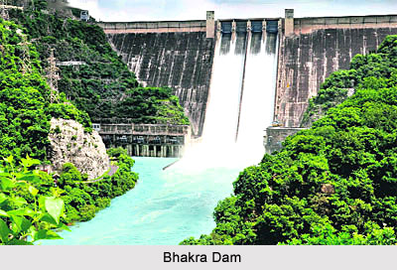

BHAKRA NANGAL dam helps in playing a pivotal role in the generation of electricity. It has 10 hydroelectric power generators on each side of different states and it can generates about 1325MW of electricity.

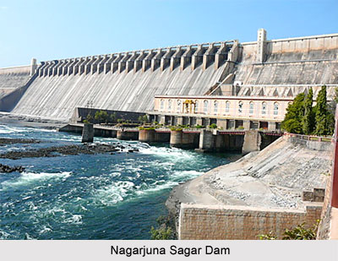

NAGARJUNA SAGAR dam is one of the largest dam in INDIA. The hydroelectric plant has a power generation capacity of 815.6MW with 8 Units. The water level of Nagarjuna Sager dam water level is 526.8 feet.

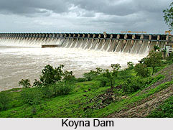

KOYNA DAM is a largest reservoir based project. The project generated 1960MW of electricity. The koyna has 4 electric generators installed at the site. It has 6 radial gates. In this dam the water is drawn from the penstocks of kolkewadi dam to an underground power station in the 3rd stage and then discharged to Arabian Sea.

FUTURE TRENDS:

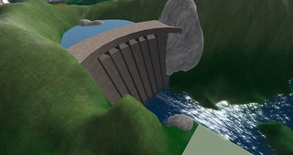

To produce electricity, a turbine generator set converts mechanical energy to electrical energy. Hydropower currently generates more electricity than all other renewable technologies combined and is expected to remain the world’s largest source of renewable electricity generation into 2030’s.thereafter, it will continue to play a critical role in decarbonising the power system and improving system flexibility.

Conclusion:Hydroelectricity is one of the cleanest sources of energy and reliable. eharnesses the power of flowing water to generate electricity. It has a long history of use and offers numerous advantages, including renewable energy geneion, minimal greenhouse gas emissions, and the ability to provide a reliable source of electricity. However, it also poses challenges related to environmental impact, habitat disruption, and the need for careful management of water resources. Despite these challenges, hydroelectric power remains an important contributor to the global energy mix and plays a key role in the transition to a more sustainable energy future.