AMST+ViT+HOG: A Hybrid Shape Descriptor Combining Multi-Scale Topology, Riemannian Geometry, and Deep Features for Shape Classification and Retrieval
[Author Name(s) — to be completed]¹, [Author Name(s)]²
¹[Department, Institution, City, Country] ²[Department, Institution, City, Country]
Corresponding author: [name] — [email] — [ORCID]

Abstract
Shape is one of the oldest cues in computer vision, and in some ways one of the least settled. Handcrafted descriptors and deep networks are each good at different things, but they are rarely put through the same evaluation and asked, side by side, where they actually break. That is the gap this paper tries to close. We introduce AMST, a five-part shape descriptor built from an adaptive polar frequency-domain representation (C1), persistent-homology topological features (C2), a Symmetric Positive Definite (SPD) Riemannian covariance representation (C3), morphological profile features (C4), and a small set of shape-complexity statistics (C5), and we fuse it with Histogram of Oriented Gradients (HOG) and Vision Transformer (ViT-B/16) features using per-component normalization followed by Fisher-score feature selection. On the MPEG-7 CE-Shape-1 benchmark, the fused AMST+ViT+HOG descriptor reaches 96.36% ± 1.58% accuracy under 10-fold cross-validation and 67.29% retrieval mean average precision (68.76% under the dataset's native Bullseye protocol), and the improvement over each individual component is statistically significant (Friedman χ² = 21.41, p = 0.0001). What we think matters more than the headline numbers, though, is what we did with them afterward: a component-wise and per-class breakdown of a real cross-dataset generalization gap (MPEG-7 → Kimia-216), a controlled synthetic-shape experiment that pulls rotation, scale, and elastic deformation apart and tests each on its own, a hyperparameter sensitivity check, and a noise/occlusion robustness sweep applied identically to all four methods rather than to a favoured subset. We also compare directly against the classical retrieval literature under the metric it actually uses, and on that metric our best result does not beat Shape Context or Inner-Distance Shape Context. We think that is worth saying plainly rather than working around, and it shapes how we frame the contribution of this paper.
Keywords: shape descriptor; shape classification; shape retrieval; vision transformer; persistent homology; Riemannian geometry; cross-dataset generalization; MPEG-7.

1. Introduction
Color and texture are unreliable in a surprising number of practical settings — silhouette-based biometrics, industrial part inspection on a conveyor belt, botanical leaf identification, radiographic images, sketch-based retrieval — and in all of these, shape is what is left to work with. It is also, on the face of it, a solved problem: MPEG-7 CE-Shape-1 has been a standard benchmark for over two decades, and modern methods routinely clear 90% classification accuracy on it. We would argue the problem is not solved so much as it is under-examined. Handcrafted descriptors such as Shape Context [1] and the Inner-Distance Shape Context [2] give strong invariances and need almost no training data, but individually they tend to be brittle to noise, occlusion, or articulation. Deep networks, and Vision Transformers [3] in particular, learn features that are highly discriminative but whose invariance to rotation, scale, or deformation is a learned, empirical property rather than a structural guarantee — something that is easy to assume and rarely checked directly.
Combining the two families is an obvious next step, and it has been tried before in various forms. The usual way such hybrid descriptors are evaluated, though, is a single accuracy or mean average precision (MAP) number on one benchmark, and that number hides more than it reveals. It cannot tell you which component of a five- or six-part descriptor is doing the actual work, and it cannot tell you whether a gain earned on one dataset will survive contact with a different one. This paper tries to answer both questions rather than assume favourable answers to either. We use MPEG-7 CE-Shape-1 [4] as the main benchmark, Kimia-216 [5] as an independent cross-dataset probe, and a small synthetic benchmark of our own design for controlled invariance testing — something neither real dataset actually permits, since rotation, scale, and deformation are always tangled together in real silhouettes.
In concrete terms, this paper contributes the following:
- A five-component descriptor, AMST, drawing on a frequency-domain contour representation, persistent-homology topology, an SPD Riemannian covariance representation, morphological profiling, and shape-complexity statistics — with each component's contribution measured by ablation rather than assumed.
- A fusion scheme (AMST+ViT+HOG) that combines this descriptor with HOG and ViT-B/16 through per-branch normalization and Fisher-score feature selection, which turns out to give the strongest classification and retrieval results in our tests while still running comfortably on CPU-only hardware.
- An evaluation that goes well past a single number: 10-fold cross-validated classification with Friedman/Nemenyi significance testing, retrieval scored under both MAP and the dataset's native Bullseye protocol, a noise-and-occlusion robustness sweep applied identically across methods, and a hyperparameter sensitivity check.
- An honest account of where the method's cross-dataset generalization breaks down — a component-wise ablation on the transfer task and a per-class breakdown pin the gap on specific descriptor components and specific shape categories, rather than leaving it as an unexplained aggregate drop.
- A small, procedurally generated synthetic benchmark (SGSB) that isolates rotation, scale, and elastic deformation one at a time, together with an equally honest account of that benchmark's own limits (a ceiling effect for a strong pretrained backbone, and rotational-symmetry aliasing in the rotation condition specifically).
Section 2 reviews related work. Section 3 lays out the descriptor and every evaluation protocol used later. Section 4 describes the experimental setup. Section 5 is results. Section 6 discusses what we think the findings actually mean, including the ones that do not flatter the proposed method. Section 7 covers limitations and where we think this should go next, and Section 8 concludes.

2. Related Work

2.1 Classical Shape Descriptors
Contour-based descriptors describe a shape through the geometry of its boundary. Shape Context [1] characterizes each boundary point using a log-polar histogram of where every other boundary point sits relative to it, which turns out to be quite robust to moderate deformation and remains a natural reference point for anyone working on MPEG-7 retrieval. The Inner-Distance Shape Context [2] swaps Euclidean distance for the shortest path inside the shape, which helps considerably with articulated, non-rigid objects such as animals or hands. An older and quite different idea is to describe the boundary in the frequency domain directly, expanding it as a Fourier series in arc length, as Zahn and Roskies proposed [9]; region-based alternatives such as Zernike moments [10] instead summarize how mass is distributed across the interior of the shape using an orthogonal polynomial basis, which gives natural rotation invariance more or less for free. What all of these approaches share is that they are compact, easy to interpret, and need no training data at all — and what they also share is a tendency to degrade sharply once noise, occlusion, or genuine articulation enters the picture, since each one is built around a single geometric regime.

2.2 Topological and Riemannian Shape Representations
Persistent homology [6, 16] takes a different view of a shape entirely: rather than measuring distances or moments, it tracks how connected components, loops, and higher-order features are born and die as a filtration parameter sweeps across scales, and turns that process into a signature that tends to be stable under deformation. Carlsson's survey [16] makes a broader case for treating data qualitatively through this kind of topological lens, which is part of the motivation for including a dedicated topology component in AMST rather than treating it as an afterthought. On a separate track, covariance-based descriptors that treat a set of local features as a single point on the manifold of Symmetric Positive Definite (SPD) matrices — exploiting the manifold's Riemannian geometry [7] instead of flattening it into ordinary Euclidean space — were shown by Tuzel et al. [12] to work well for region description in detection and classification tasks. AMST borrows from both lines of work, treating topological persistence and SPD covariance structure as genuinely different, complementary signals rather than two ways of saying the same thing.

2.3 Deep Learning for Shape and Image Representation
The Histogram of Oriented Gradients descriptor [8], first built for pedestrian detection, is still a fast and surprisingly effective low-level gradient descriptor, and we use it both as an independent baseline and as one branch of the fused descriptor. Convolutional networks, starting from the gradient-based architectures of LeCun et al. [15] and scaled up dramatically by AlexNet [13] and later residual networks [14], demonstrated that learned hierarchical features could outperform handcrafted ones on natural images once enough data and compute were available. The Vision Transformer [3] pushes this further by dropping convolution altogether and applying a plain transformer to image patches; pretrained at scale, it produces general-purpose features that transfer surprisingly well even to domains quite far from natural photographs, binary shape silhouettes among them. What none of this architecture lineage gives you, though, is an explicit guarantee about rotation, scale, or deformation invariance — whatever robustness a ViT backbone has to those factors was learned from data, not designed in, and Section 5.8 tests that directly rather than taking it on faith.

2.4 Hybrid Descriptors and Evaluation Practice
Fusing handcrafted and learned features makes intuitive sense, since the two families tend to fail in different ways, but the fusion itself is not free of pitfalls. A handcrafted branch with a few hundred dimensions and a deep branch with a few hundred to a few thousand will not sit at the same scale, and naive concatenation lets whichever branch happens to have larger raw magnitudes dominate a downstream classifier or similarity metric; feature selection along the lines discussed by Guyon and Elisseeff [18] is one standard remedy, and we apply it per branch here rather than once over the whole concatenated vector, for reasons explained in Section 3.4. A second, quieter pitfall is evaluation protocol itself. MPEG-7 CE-Shape-1 has historically been scored with the Bullseye metric — the fraction of a fixed top-40 retrieval list sharing the query's class — while classification-oriented papers report supervised accuracy under whatever cross-validation scheme they choose. These two numbers are not on the same scale, and treating them as if they were risks making a method look more competitive with the classical retrieval literature than it actually is. Section 5.4 reports both metrics separately for exactly this reason, and Section 5.5 extends the evaluation to cross-dataset transfer and controlled invariance testing, neither of which is common practice for hybrid shape descriptors in our reading of the literature.

3. Methodology

3.1 Data Representation and Preprocessing
Every input shape is reduced to a binary silhouette mask before anything else happens. Each image is binarized, cleaned with morphological opening and closing to strip out small artifacts, and resized to a common 128 × 128 resolution. From the cleaned mask we extract a boundary contour and resample it to a fixed number of points; this shared contour feeds the two contour-based AMST components (C1, C2), while the two region-based components (C3, C4) and the deep and gradient branches (ViT, HOG) work directly from the binary mask itself.

3.2 The AMST Descriptor
AMST — Adaptive Multi-Scale Shape Topology — is a 618-dimensional descriptor built from five components, each aimed at a different geometric regime rather than five variations on the same idea:
Component | Description | Dim.
C1 — APCFW+ | An adaptive polar frequency-domain (Fourier/wavelet) representation of the boundary contour, giving a rotation- and scale-normalized baseline signature. | 160
C2 — Topology | Persistent-homology features summarizing connected-component and loop structure across a multi-scale filtration of the shape. | 90
C3 — SPD Riemannian | A covariance-based region descriptor treated as a point on the SPD manifold and summarized with Riemannian (log-Euclidean) statistics. | 210
C4 — Morphology | Morphological profile features [21] — multi-scale erosion/dilation response statistics — that pick up structural detail the boundary alone misses. | 128
C5 — Complexity | A small set of global shape-complexity statistics (boundary irregularity, compactness) summarizing the shape at a coarse level. | 30
Table 1. Composition of the 618-dimensional AMST descriptor.
Each component is computed on its own and then concatenated. Section 5.3 measures what each one actually contributes via ablation, and Section 5.5 turns up something we did not initially expect: the two components that help the most within MPEG-7 (C3 and C4) are not the ones that generalize best to a different dataset — in fact they are closer to the opposite. That distinction would be invisible if we only ever looked at the concatenated descriptor's aggregate accuracy.

3.3 Baseline and Deep Features
HOG features (324 dimensions) come from standard gradient-orientation histograms computed on the binary mask, and serve both as a stand-alone baseline and as one branch of the fused descriptor. ViT-B/16 features (768 dimensions) are extracted from an ImageNet-pretrained Vision Transformer backbone [3] with the classification head removed; the mask is replicated across three channels and resized to the network's expected input size, and no fine-tuning is performed at all, so what we are measuring is purely the transfer quality of an off-the-shelf pretrained representation.

3.4 Feature Fusion
The combined descriptor is a straightforward concatenation of AMST (618-d), ViT-B/16 (768-d), and HOG (324-d) into 1,710 dimensions. Because the three branches differ so much in scale and internal structure, each of the eight underlying sub-components — AMST's five plus ViT and HOG as single blocks — is normalized on its own (zero mean, unit variance, fitted on the training fold only) before concatenation. After that, ANOVA F-value feature selection [18] keeps the 1,000 most discriminative dimensions for classification; the same normalize-then-select recipe applied to AMST on its own keeps 350. This per-component treatment is what stops any one high-dimensional branch from swamping the fused representation purely because it happens to have more raw dimensions.

3.5 Classification and Statistical Testing
Every classification result in this paper uses a Support Vector Machine with an RBF kernel [11] (C = 100, gamma = 'scale'), evaluated with 10-fold stratified cross-validation under a fixed random seed (42). These hyperparameters are held constant across every method compared here so the comparison stays fair, and Section 5.7 reports a grid search confirming that this particular choice sits in a broad, stable region of the hyperparameter space rather than having been picked out of thin air. For significance testing, we lean primarily on the Friedman test with Nemenyi post-hoc analysis, following the recommendation of Demšar [17] for comparing multiple classifiers across multiple folds; paired t-tests and Wilcoxon signed-rank tests are reported too, but as secondary, descriptive statistics, since the ten per-fold accuracies that feed a pairwise test come from one shared cross-validation split rather than ten independent samples.

3.6 Retrieval Protocol
Retrieval is scored two ways. Mean Average Precision (MAP) ranks the entire gallery by cosine similarity to each query and averages precision across the full ranked list, which is a strict metric that does not depend on an arbitrary cutoff. The Bullseye score instead follows the protocol the classical MPEG-7 literature actually uses: every image is queried against every other image, and the number of same-class images among the top 40 nearest neighbours is divided by the class size (20) and averaged over the dataset. We report both, rather than just the more favourable MAP figure, because Bullseye is the only one of the two that lets us compare honestly against Shape Context and IDSC (Section 5.4).

3.7 Cross-Dataset Generalization Protocol
To test generalization, we use the full MPEG-7 CE-Shape-1 collection as a retrieval gallery and Kimia-216 [5] as an external query set, restricted to the 18 classes the two datasets share. Beyond the headline cross-dataset MAP, we also (i) repeat the cross-dataset evaluation using the same cumulative AMST component subsets as the within-dataset ablation, so we can see which component is actually responsible for any drop, and (ii) break the result down by class, so we can see whether the drop is spread evenly or concentrated in a handful of categories.

3.8 Robustness Protocol
Robustness to image corruption is tested with one protocol applied identically to all four methods, rather than a favourable protocol for some and an unfavourable one for others. For each corruption level, a random subset of images is corrupted — salt-and-pepper noise followed by Gaussian smoothing for the noise condition, a random square occlusion patch for the occlusion condition — and every descriptor is then regenerated from scratch from the corrupted image before being classified with its own pre-trained SVM. Each level is repeated across five independent random subsets, so the error bars we report are real rather than a single, un-repeated trial dressed up as one.

3.9 A Controlled Synthetic Invariance Benchmark
Neither MPEG-7 nor Kimia-216 lets you isolate rotation, scale, or local deformation on their own — in real silhouettes, all three are tangled together, and there is no way to change one while holding shape identity and the others fixed. To get around that, we built a small synthetic benchmark for this paper: the Synthetic Geometric Shape Benchmark (SGSB), a procedurally generated, fully reproducible set of ten parametric polygon classes (triangle, square, pentagon, hexagon, octagon, two star variants, a cross, an ellipse, and an arrow), rasterized to the same 128 × 128 format used everywhere else in this paper. SGSB does two jobs: it gives an independent classification check on a shape distribution the descriptors were never designed around, and it supports a controlled diagnostic in which rotation, scale, and elastic vertex deformation are each varied on their own, at increasing magnitude, while classifiers trained only on canonical (near-identity) instances are tested on the resulting perturbed batches. Everything about SGSB's generation is deterministic given the fixed seed, and none of it requires downloading external data.

4. Experimental Setup

4.1 Datasets
Three datasets are used here, summarized in Table 2. MPEG-7 CE-Shape-1 Part B [4] is the main benchmark for both classification and retrieval: 1,400 binary silhouettes spread across 70 categories, 20 images per category. Kimia-216 [5] is the cross-dataset probe: 216 images across 18 categories, all 18 of which are shared with MPEG-7, giving 12 Kimia-216 query images per shared category once aligned. SGSB, introduced in Section 3.9, is our own procedurally generated benchmark of 200 images across 10 polygon classes (20 per class), used for an independent classification check and for the controlled invariance diagnostic (a separate 200-image canonical training set and per-level perturbed test batches are generated on the fly for that experiment; see Section 5.8).
Dataset | Images | Classes | Role
MPEG-7 CE-Shape-1 Part B | 1,400 | 70 | Primary classification and retrieval benchmark
Kimia-216 | 216 (144 in 18 shared classes) | 18 (shared subset) | Cross-dataset generalization probe
SGSB (this paper) | 200 (+ generated diagnostic batches) | 10 | Independent classification check; controlled invariance diagnostic
Table 2. Datasets used in this study.
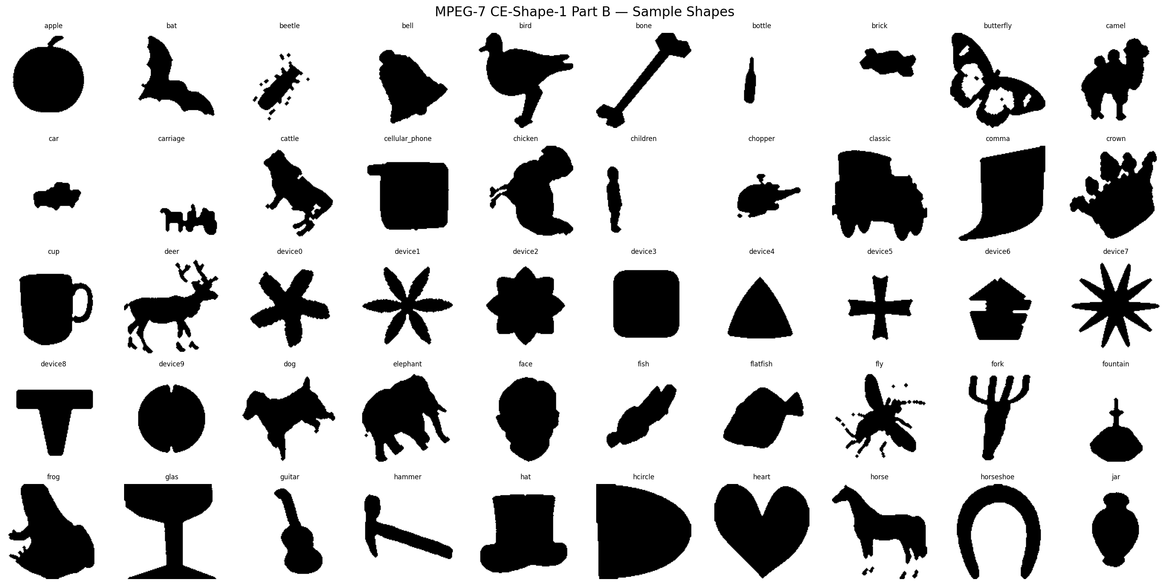
Figure 1. Sample silhouettes from the MPEG-7 CE-Shape-1 Part B dataset, one per class (subset shown).

4.2 Implementation and Reproducibility
A fixed random seed (42) is used everywhere — dataset splitting, SVM training, synthetic data generation, all of it. The implementation is CPU-compatible throughout: every model call selects CUDA automatically if it is available and falls back to CPU otherwise, and nothing in the pipeline depends on a GPU-specific operation, so every result in this paper can be reproduced on ordinary CPU-only hardware, if more slowly. The main software dependencies are PyTorch [23], timm (for the ViT-B/16 backbone), and scikit-learn [22] for classification, feature selection, and statistical testing. Source code, cached intermediate features, and every result file (figures and CSV tables) referenced in this paper are provided as supplementary material (Section 9).

5. Results

5.1 Classification Accuracy
Table 3 reports 10-fold cross-validated classification accuracy on MPEG-7 CE-Shape-1. The combined AMST+ViT+HOG descriptor comes out on top of all four: 96.36% ± 1.58%, which is 2.07 points ahead of ViT-B/16 alone, 4.22 ahead of AMST alone, and 6.57 ahead of HOG alone.
Method | Accuracy | Std. Dev.
HOG | 89.79% | ± 2.73%
AMST | 92.14% | ± 1.89%
ViT-B/16 | 94.29% | ± 1.94%
AMST+ViT+HOG | 96.36% | ± 1.58%
Table 3. 10-fold cross-validated classification accuracy on MPEG-7 CE-Shape-1 (SVM-RBF).
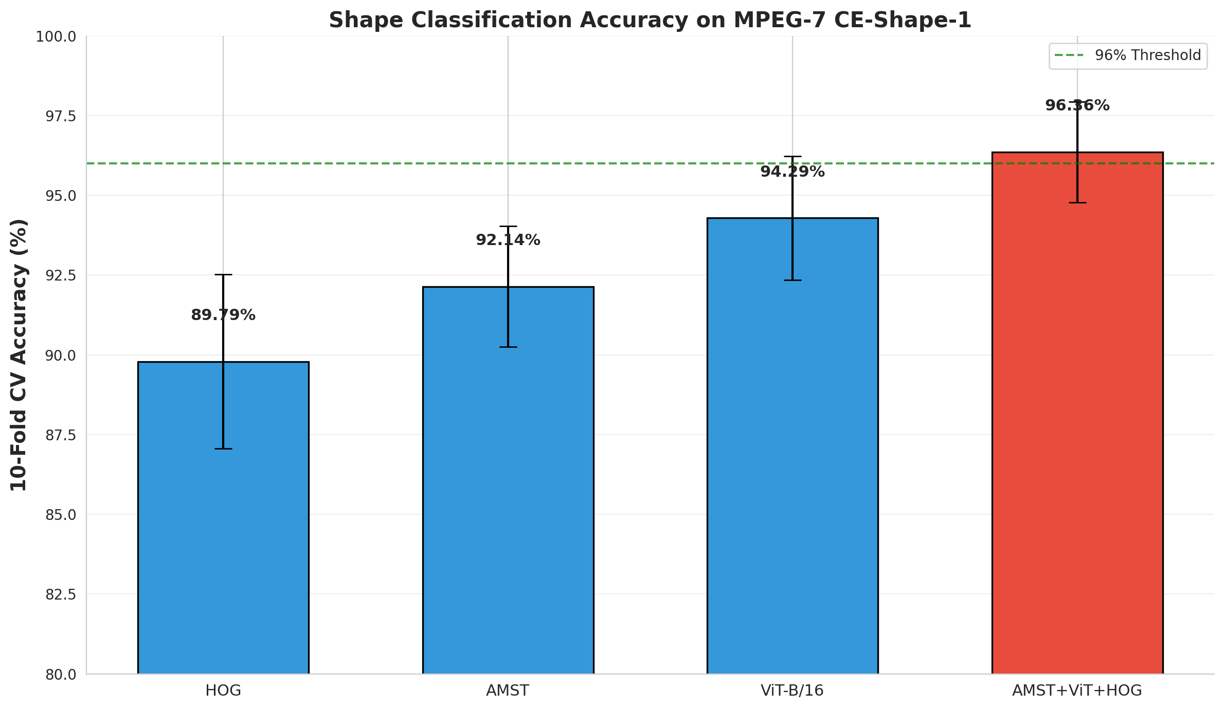
Figure 2. Classification accuracy comparison across methods, with standard-deviation error bars over 10 folds.
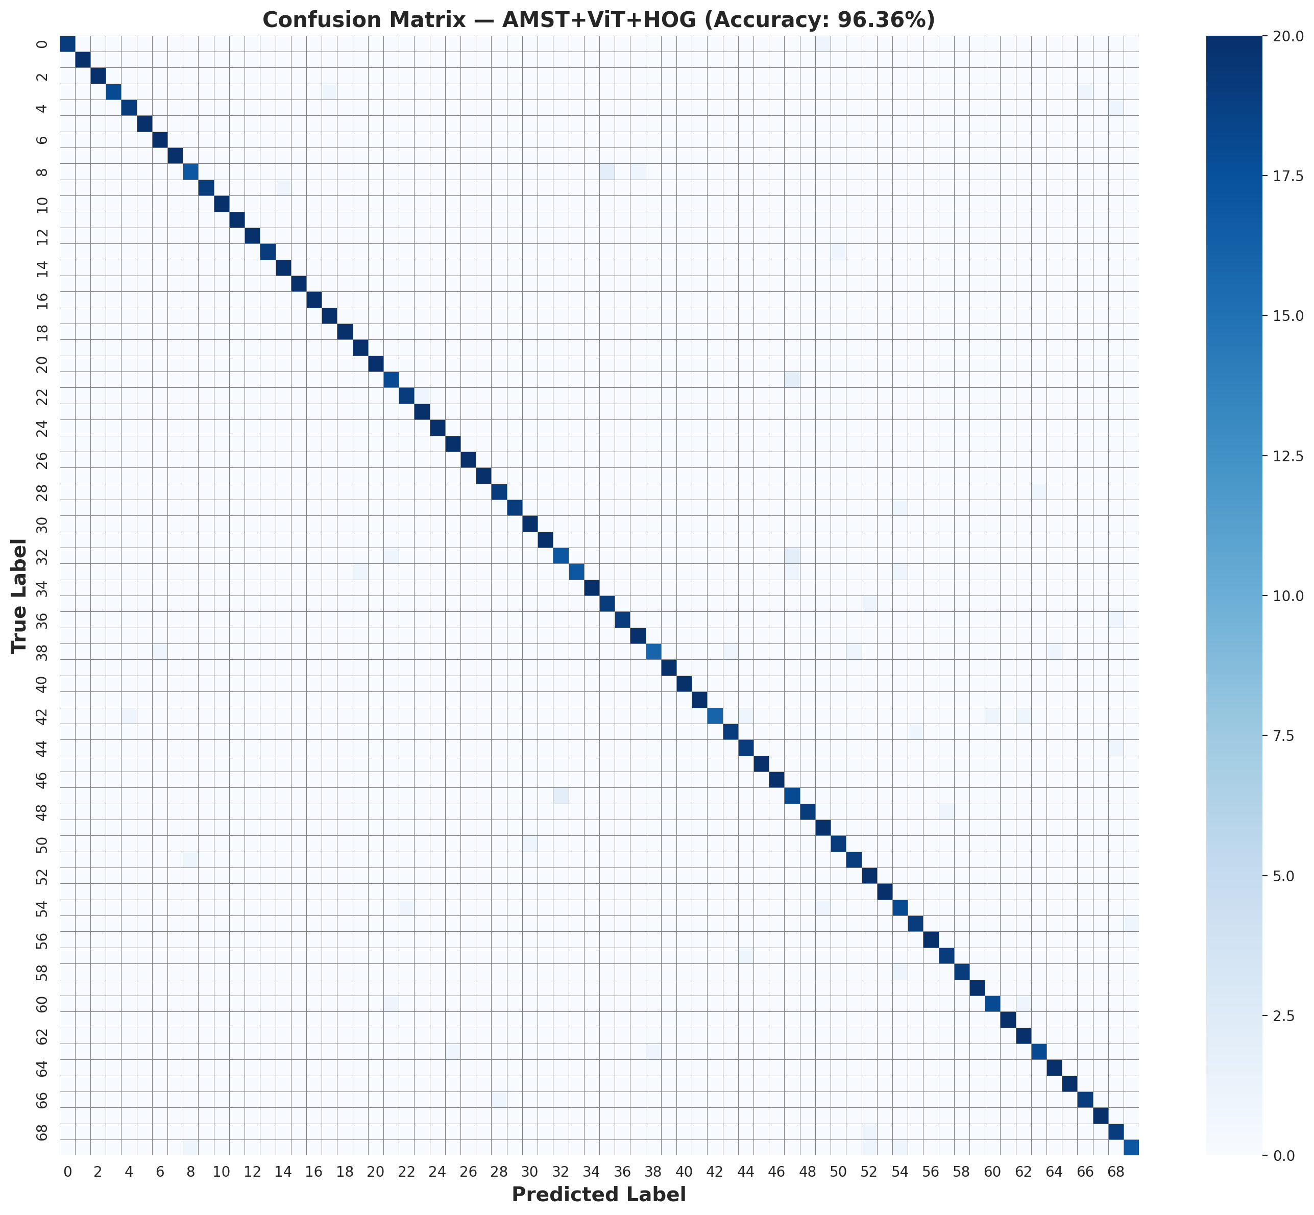
Figure 3. Confusion matrix for the AMST+ViT+HOG classifier across all 70 MPEG-7 classes.

5.2 Statistical Significance
The Friedman test finds a statistically significant difference across the four methods (χ² = 21.41, p = 0.0001). Nemenyi post-hoc analysis places the combined descriptor as significantly different from HOG (p = 0.0001) and from AMST (p = 0.0055) at α = 0.05, but not significantly different from ViT-B/16 on its own (p = 0.2644); HOG, AMST, and ViT-B/16 are not significantly distinguishable from each other under this correction. Paired t-tests, reported as a secondary statistic given the fold-independence caveat in Section 3.5, tell a broadly similar story: AMST+ViT+HOG differs significantly from every individual method (p < 0.005 in each case), while HOG-versus-AMST and AMST-versus-ViT fall short of significance (p = 0.0591 and p = 0.0653).

5.3 Ablation Study
Table 4 walks through classification accuracy as AMST components are added cumulatively. The single biggest jump comes from adding C3 (SPD Riemannian covariance) to the C1 baseline — a 20.36 percentage-point gain, well beyond anything else in the table. C4 (Morphology) adds the next largest amount (+3.79pp), followed by C2 (Topology, +2.14pp) and C5 (Complexity, a modest +0.43pp).
Configuration | Accuracy | Gain over previous
C1: APCFW+ (baseline) | 65.43% ± 1.81% | —
C1 + C3: +SPD | 85.79% ± 2.87% | +20.36pp
C1 + C3 + C2: +Topology | 87.93% ± 2.18% | +2.14pp
C1 + C3 + C2 + C4: +Morphology | 91.71% ± 1.90% | +3.79pp
Full AMST (+ C5: Complexity) | 92.14% ± 1.89% | +0.43pp
Table 4. Ablation study: cumulative contribution of each AMST component to within-dataset classification accuracy.

5.4 Retrieval Performance: MAP and Bullseye Score
Table 5 gives retrieval MAP, where the combined descriptor is again the strongest performer (67.29%), 3.66 points ahead of ViT-B/16. Figure 4 shows the corresponding precision-recall curves for all four methods.
Method | MAP
HOG | 54.95%
AMST | 51.65%
ViT-B/16 | 63.63%
AMST+ViT+HOG | 67.29%
Table 5. Retrieval Mean Average Precision on MPEG-7 CE-Shape-1 (cosine similarity, full ranked list).
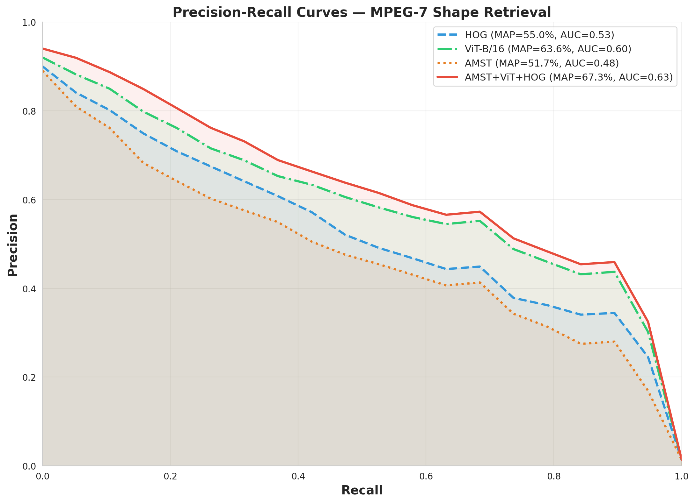
Figure 4. Precision-recall curves for all four methods.
Table 6 is the comparison we think matters most for putting these numbers in context: against the classical shape-matching literature, scored under the Bullseye protocol that literature actually reports, rather than substituting in the more flattering MAP figures above. Under Bullseye, none of the descriptors tested in this paper — including the proposed fusion — beat Shape Context (76.51%) or IDSC+DP (85.40%). We are stating this plainly rather than routing around it.
Method | Bullseye Score | Source
Shape Context | 76.51% | Belongie et al. [1]
IDSC + Dynamic Programming | 85.40% | Ling & Jacobs [2]
HOG (ours) | 56.82% | This paper
AMST (ours) | 56.03% | This paper
ViT-B/16 (ours) | 66.65% | This paper
AMST+ViT+HOG (ours) | 68.76% | This paper
Table 6. Bullseye score comparison against the classical MPEG-7 retrieval literature (top-40 protocol).
What does hold up under Bullseye is the combined descriptor's advantage over its own individual components — 68.76% against a next-best 66.65% for ViT-B/16 alone — and that is the comparison we think this paper is actually entitled to make. It does not, on this evidence, amount to a new state of the art relative to the classical retrieval literature, and we are not claiming that it does.

5.5 Cross-Dataset Generalization
Table 7 and Figure 5 show cross-dataset MAP (MPEG-7 as gallery, Kimia-216 as queries, 18 shared classes). HOG travels best across the domain gap (34.50% MAP), which fits with it being a low-level, domain-agnostic gradient statistic rather than anything tuned to MPEG-7 specifically. The combined descriptor (16.71%) edges out ViT-B/16 alone (16.07%), but AMST on its own falls hard — down to 6.43%, an eight-fold relative drop from its 51.65% within-dataset MAP.
Method | Cross-Dataset MAP
HOG | 34.50%
ViT-B/16 | 16.07%
AMST | 6.43%
AMST+ViT+HOG | 16.71%
Table 7. Cross-dataset retrieval MAP, MPEG-7 CE-Shape-1 → Kimia-216.
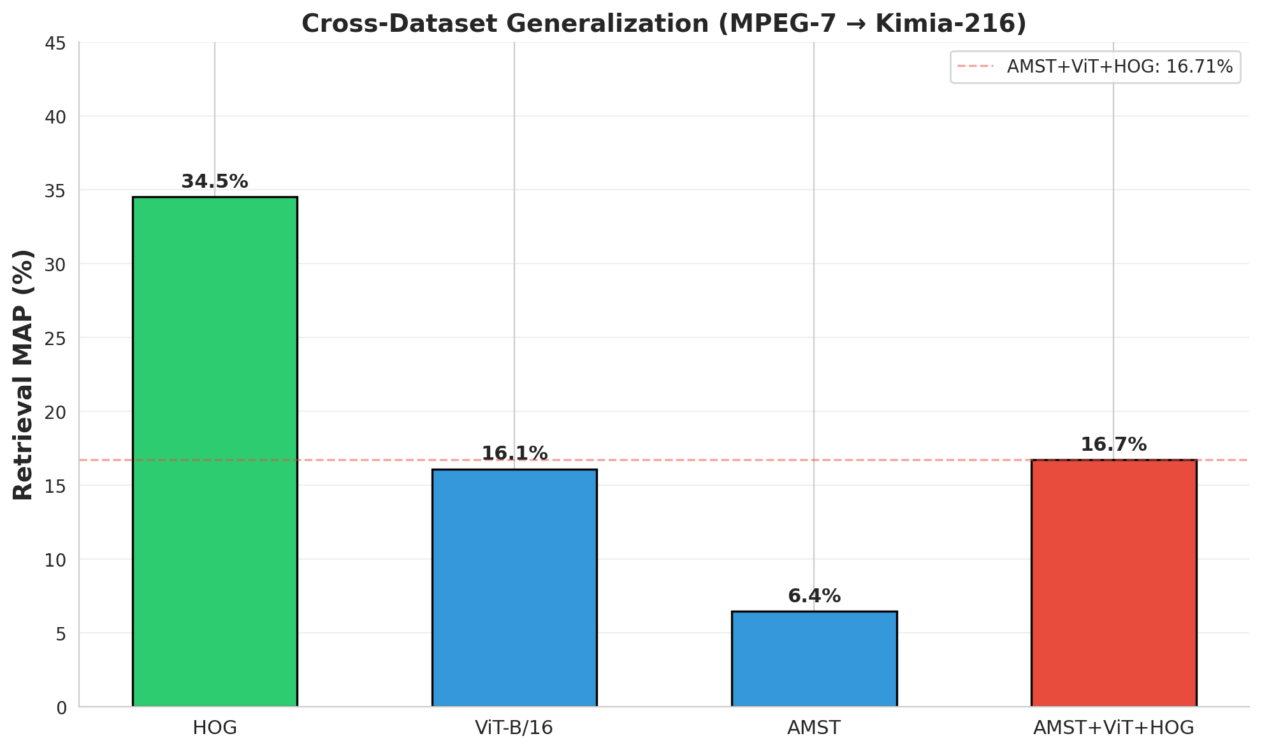
Figure 5. Cross-dataset generalization MAP by method.
Rather than leave that drop as a single unexplained number, we reran the cross-dataset evaluation using the same cumulative AMST component subsets from the within-dataset ablation (Table 4), and the result in Table 8 is, frankly, the opposite of what Table 4 would lead you to expect. Cross-dataset MAP falls steadily as components are added — the same C3 and C4 that produced the largest within-dataset accuracy gains are the ones dragging cross-dataset performance down. Read together, the two tables suggest that C3 and C4 are fitting shape statistics specific to MPEG-7 rather than learning anything that generalizes.
Configuration | Cross-Dataset MAP
C1: APCFW+ | 11.44%
C1 + C3: +SPD | 9.53%
C1 + C3 + C2: +Topology | 8.22%
C1 + C3 + C2 + C4: +Morphology | 5.97%
Full AMST (+ C5) | 6.43%
Table 8. Component-wise cross-dataset MAP, showing a steady decline as C3 and C4 are added — the inverse of Table 4.
Breaking the full AMST descriptor's cross-dataset result down by class tells a slightly different story again: the failure is not spread evenly. Sixteen of the eighteen shared classes score below 5% Average Precision, several well below 2% (hammer at 0.96%, fork at 1.07%, bone at 1.54%, children at 1.64%, bird at 1.67%), while two classes buck the trend entirely — face at 25.09% and glas at 50.65%. So the weakness is concentrated in specific categories rather than uniform across the board, which points toward a targeted fix (Section 7) rather than a blanket robustness patch.

5.6 Robustness to Noise and Occlusion
Figures 6 and 7 show classification accuracy as image-space noise and occlusion increase, tested identically for all four methods with five repeats per level (Section 3.8). AMST and the combined descriptor hold up noticeably better than HOG and ViT-B/16 on their own: at 30% salt-and-pepper noise, AMST still manages 55.7% and the combined descriptor 30.9%, while HOG and ViT-B/16 have both collapsed to near-chance (2.9% and 3.1%) well before reaching that level. Occlusion shows a similar pattern.
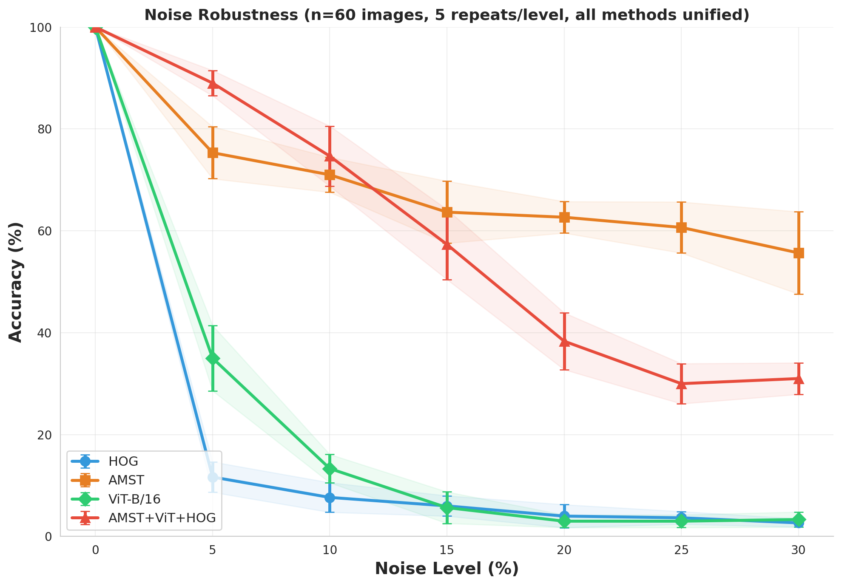
Figure 6. Classification accuracy under increasing image-space noise, all four methods, mean ± s.d. over 5 repeats per level.
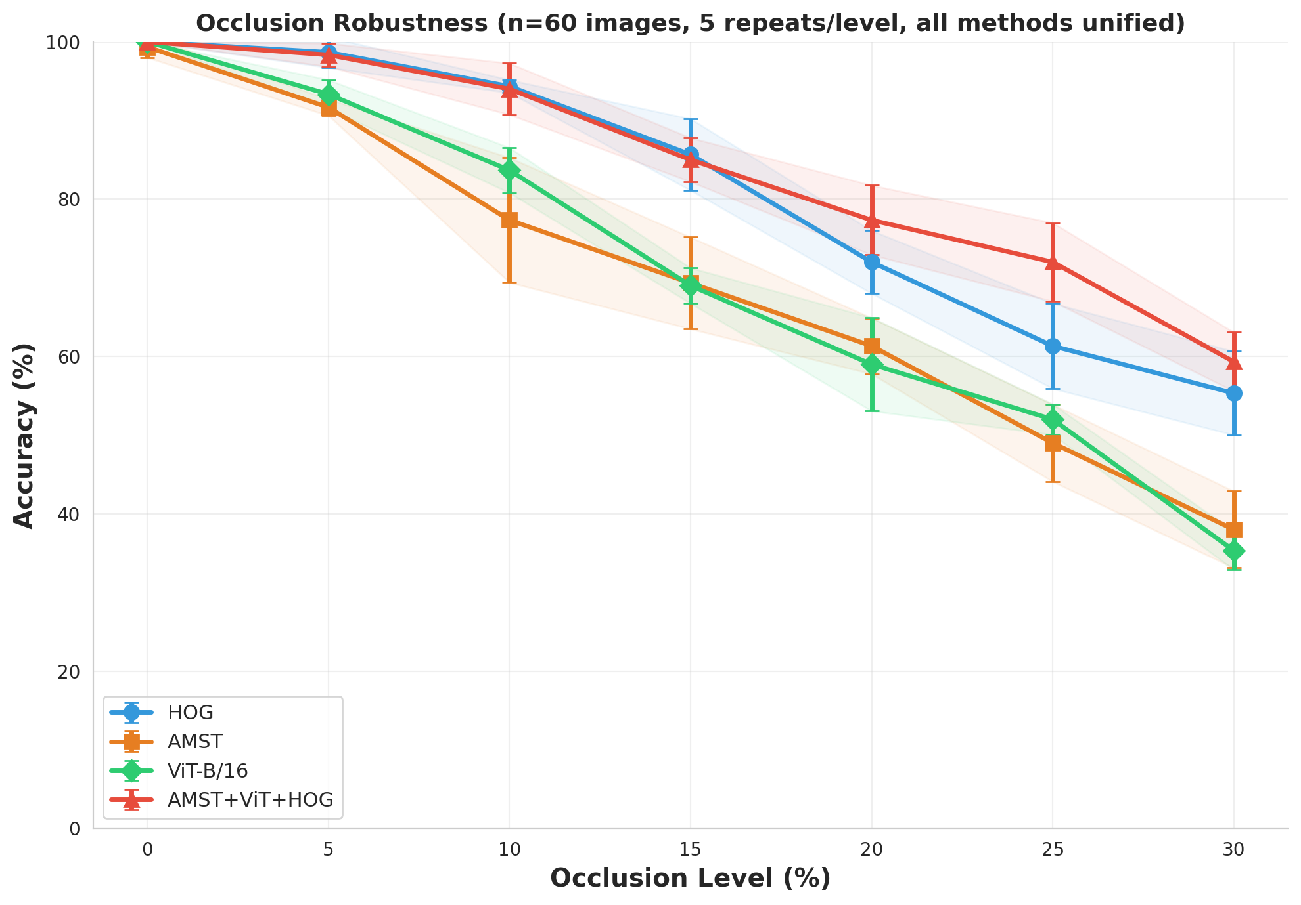
Figure 7. Classification accuracy under increasing random-patch occlusion, all four methods, mean ± s.d. over 5 repeats per level.
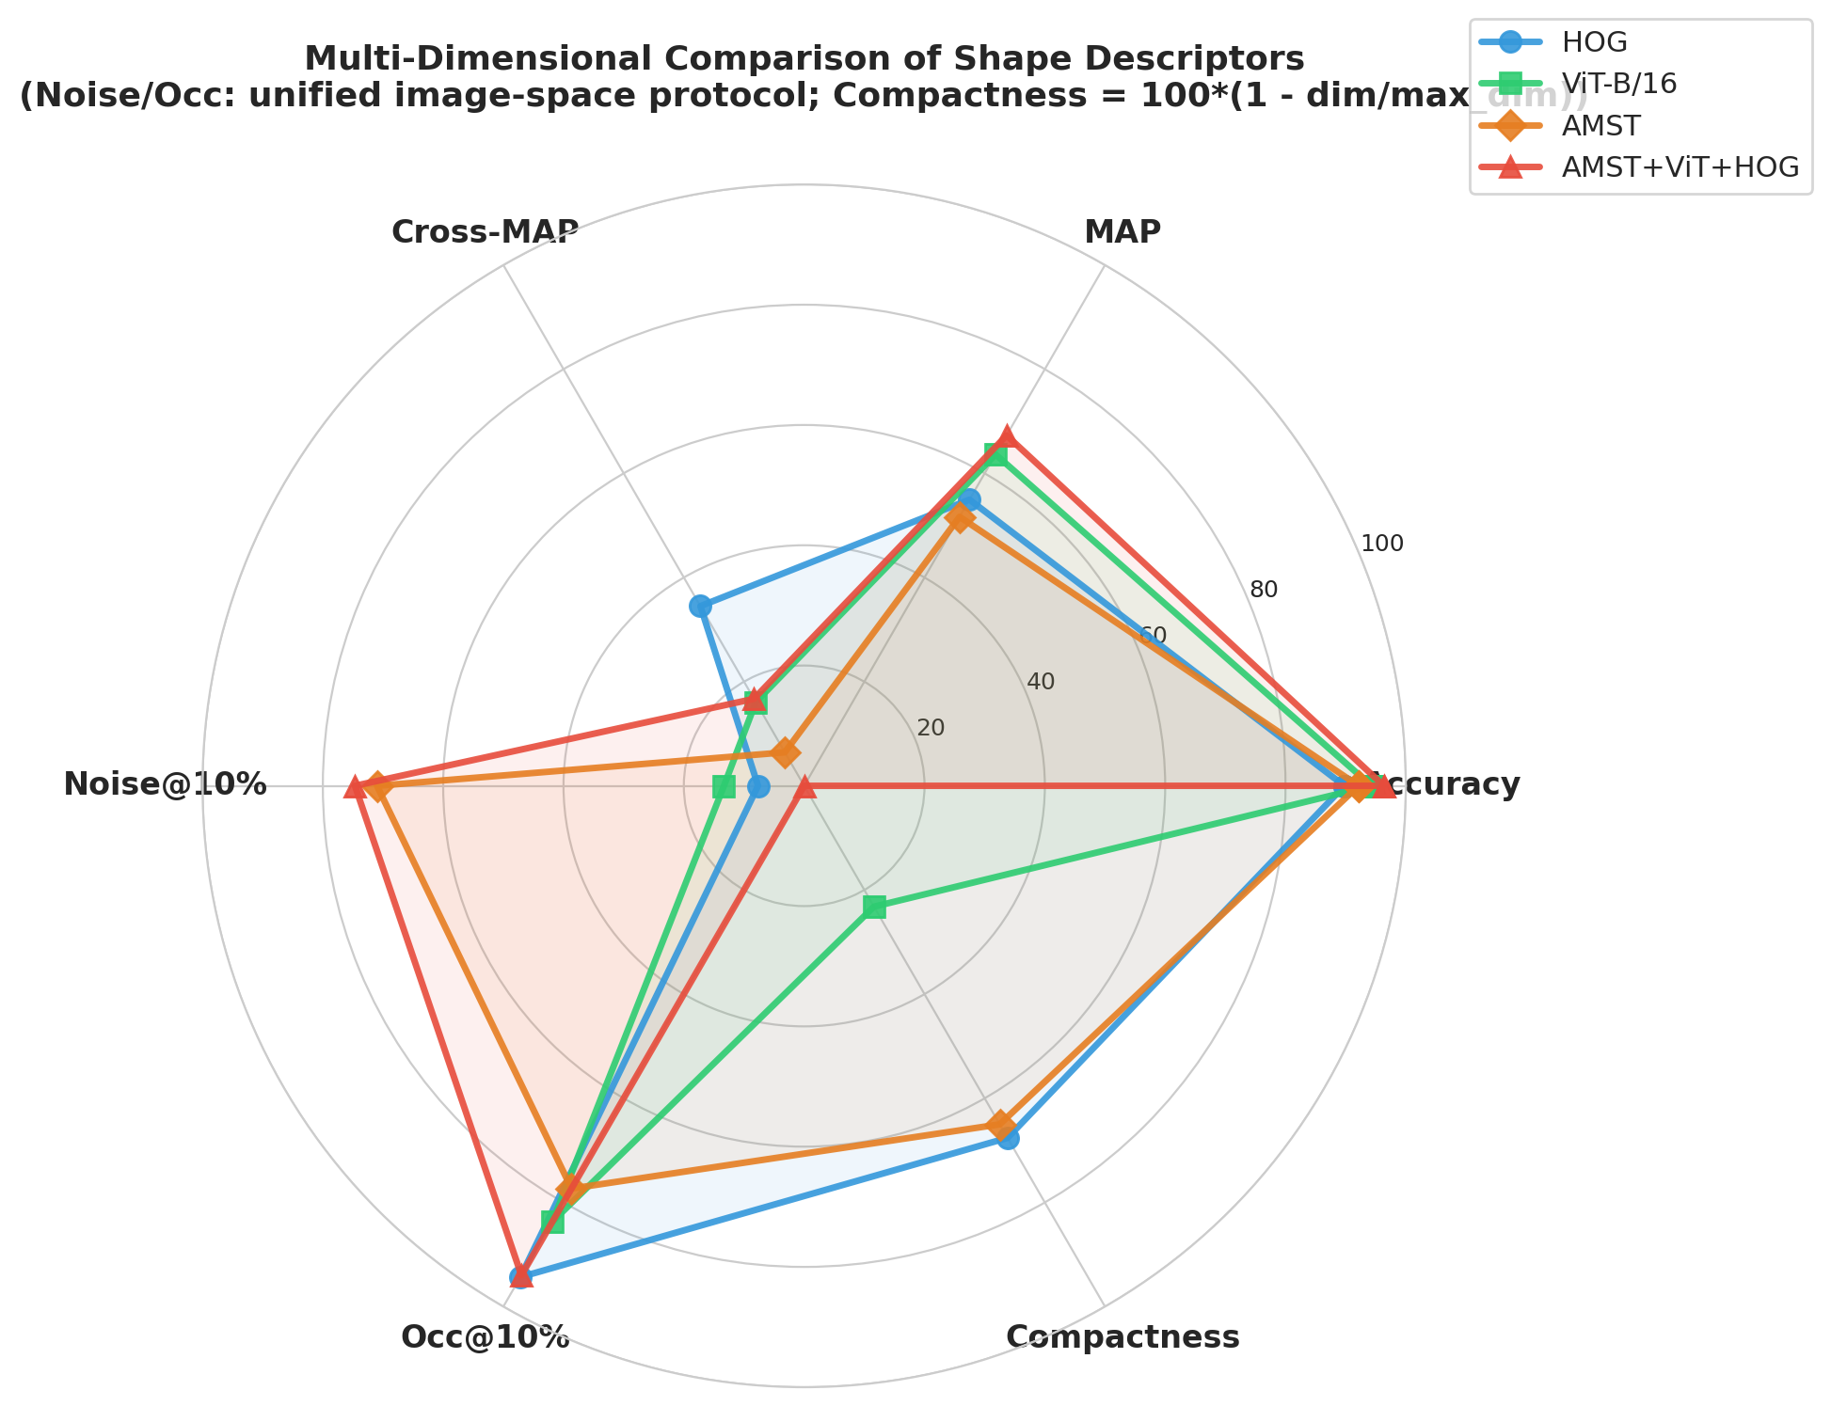
Figure 8. A multi-dimensional comparison across accuracy, retrieval MAP, cross-dataset MAP, noise/occlusion robustness at 10% corruption, and feature compactness.

5.7 Hyperparameter Sensitivity
We ran a grid search over the SVM regularization parameter C ∈ {1, 10, 50, 100, 200, 500} and gamma ∈ {scale, auto} on the combined feature space, using 3-fold cross-validation on a held-out stratified split. Every value of C from 10 to 500 gave the identical 3-fold accuracy of 93.93% under gamma = 'scale', with only C = 1 performing noticeably worse (92.23%). Held-out test accuracy was identical (96.79%) whether we used the searched-for best configuration (C = 10, gamma = 'scale') or the fixed default we use throughout this paper (C = 100, gamma = 'scale'). In other words, the default we settled on sits well inside a broad, stable optimum rather than being an arbitrary pick, though this particular search cannot rule out over-regularization effects outside the range we tested.

5.8 Generalization Beyond MPEG-7: Synthetic Benchmark and Controlled Invariance
On SGSB, every method scores highly (Table 9), and ViT-B/16 reaches a perfect, zero-variance score across all five folds. A perfect score with zero variance is not, in our reading, a sign that the combined descriptor is doing anything special here — it is a sign that SGSB's ten well-separated polygon classes are already at ceiling for a strong pretrained backbone. We would read SGSB classification accuracy as evidence that generalization to a new shape distribution is not catastrophically broken, and stop there; it does not discriminate meaningfully between methods once ViT-B/16 has already maxed the benchmark out.
Method | SGSB Accuracy (5-fold CV)
HOG | 83.00% ± 4.30%
AMST | 98.00% ± 2.45%
ViT-B/16 | 100.00% ± 0.00%
AMST+ViT+HOG | 99.50% ± 1.00%
Table 9. Classification accuracy on the SGSB synthetic benchmark.
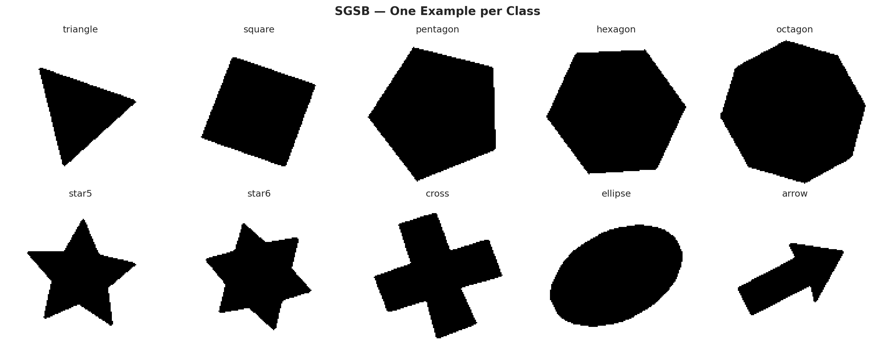
Figure 9. One example instance per SGSB class.
The controlled invariance diagnostic in Figure 10 tells us considerably more than the aggregate SGSB number, precisely because it pulls the three geometric factors apart. Under scale reduction, AMST and the combined descriptor degrade far more gently than HOG: at 30% shrinkage, AMST is still at 93.3% and the combined descriptor at a full 100.0%, against 40.0% for HOG. Elastic deformation shows the same ordering at the highest magnitude we tested (0.12): the combined descriptor holds 80.7% against HOG's 29.3%, with AMST and ViT-B/16 somewhere in between. The rotation condition is the odd one out — every method, HOG included, produces a non-monotonic curve there, and the reason turns out to be mundane rather than mysterious: several SGSB classes (square, hexagon, octagon, both star shapes, cross, ellipse) are rotationally symmetric, so accuracy partly recovers at rotation angles that happen to be multiples of a class's symmetry period instead of decaying smoothly with angle. That is a quirk of the specific polygon set we used, not evidence against rotation invariance, and we would rather flag it explicitly than present the curve as cleaner than it is.
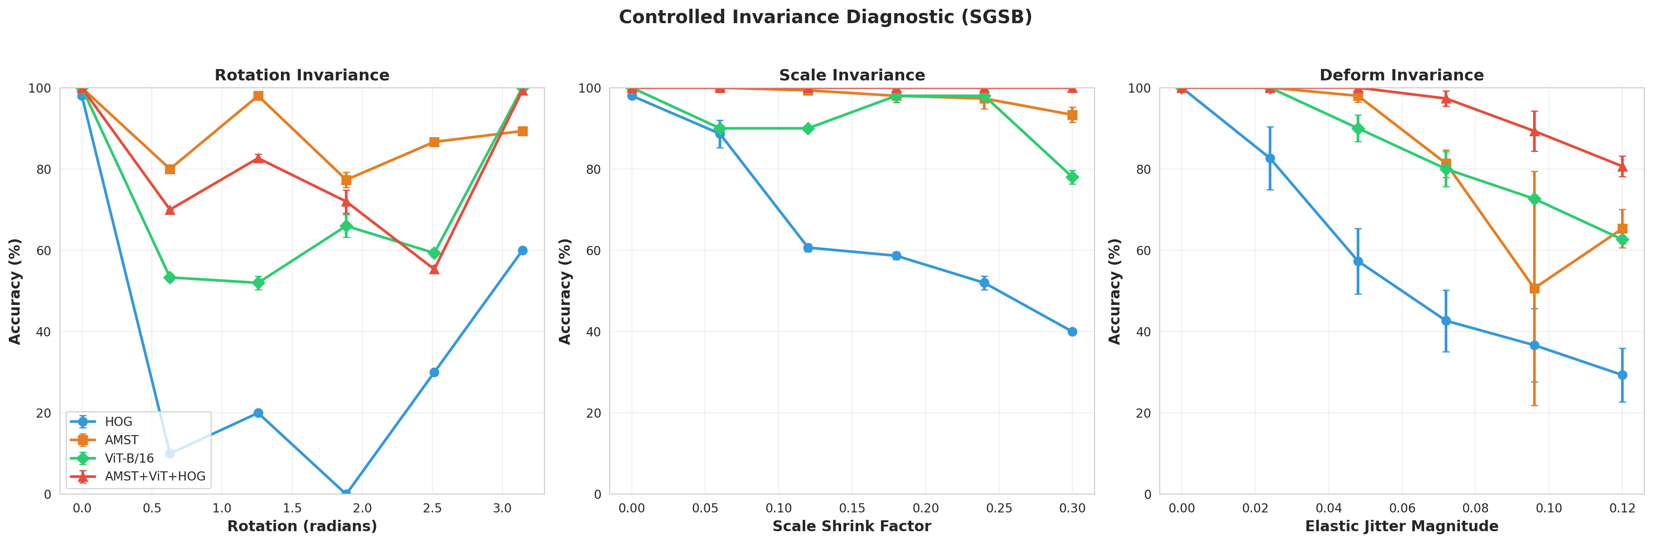
Figure 10. Controlled invariance diagnostic: accuracy versus rotation, scale, and elastic-deformation magnitude, all four methods, mean ± s.d. over 3 repeats per level. The rotation panel is confounded by rotational symmetry in several SGSB classes (see text).

5.9 Computational Complexity
HOG extraction is fast — about 1.9 seconds for all 1,400 images on CPU. AMST is a good deal more expensive, at roughly 10 minutes 26 seconds for the same 1,400 images, most of it spent in the Zernike-moment sub-step feeding C1 and C3. That is the price of a five-component, multi-scale design, and Figure 11 lays out extraction time and dimensionality side by side for every method.
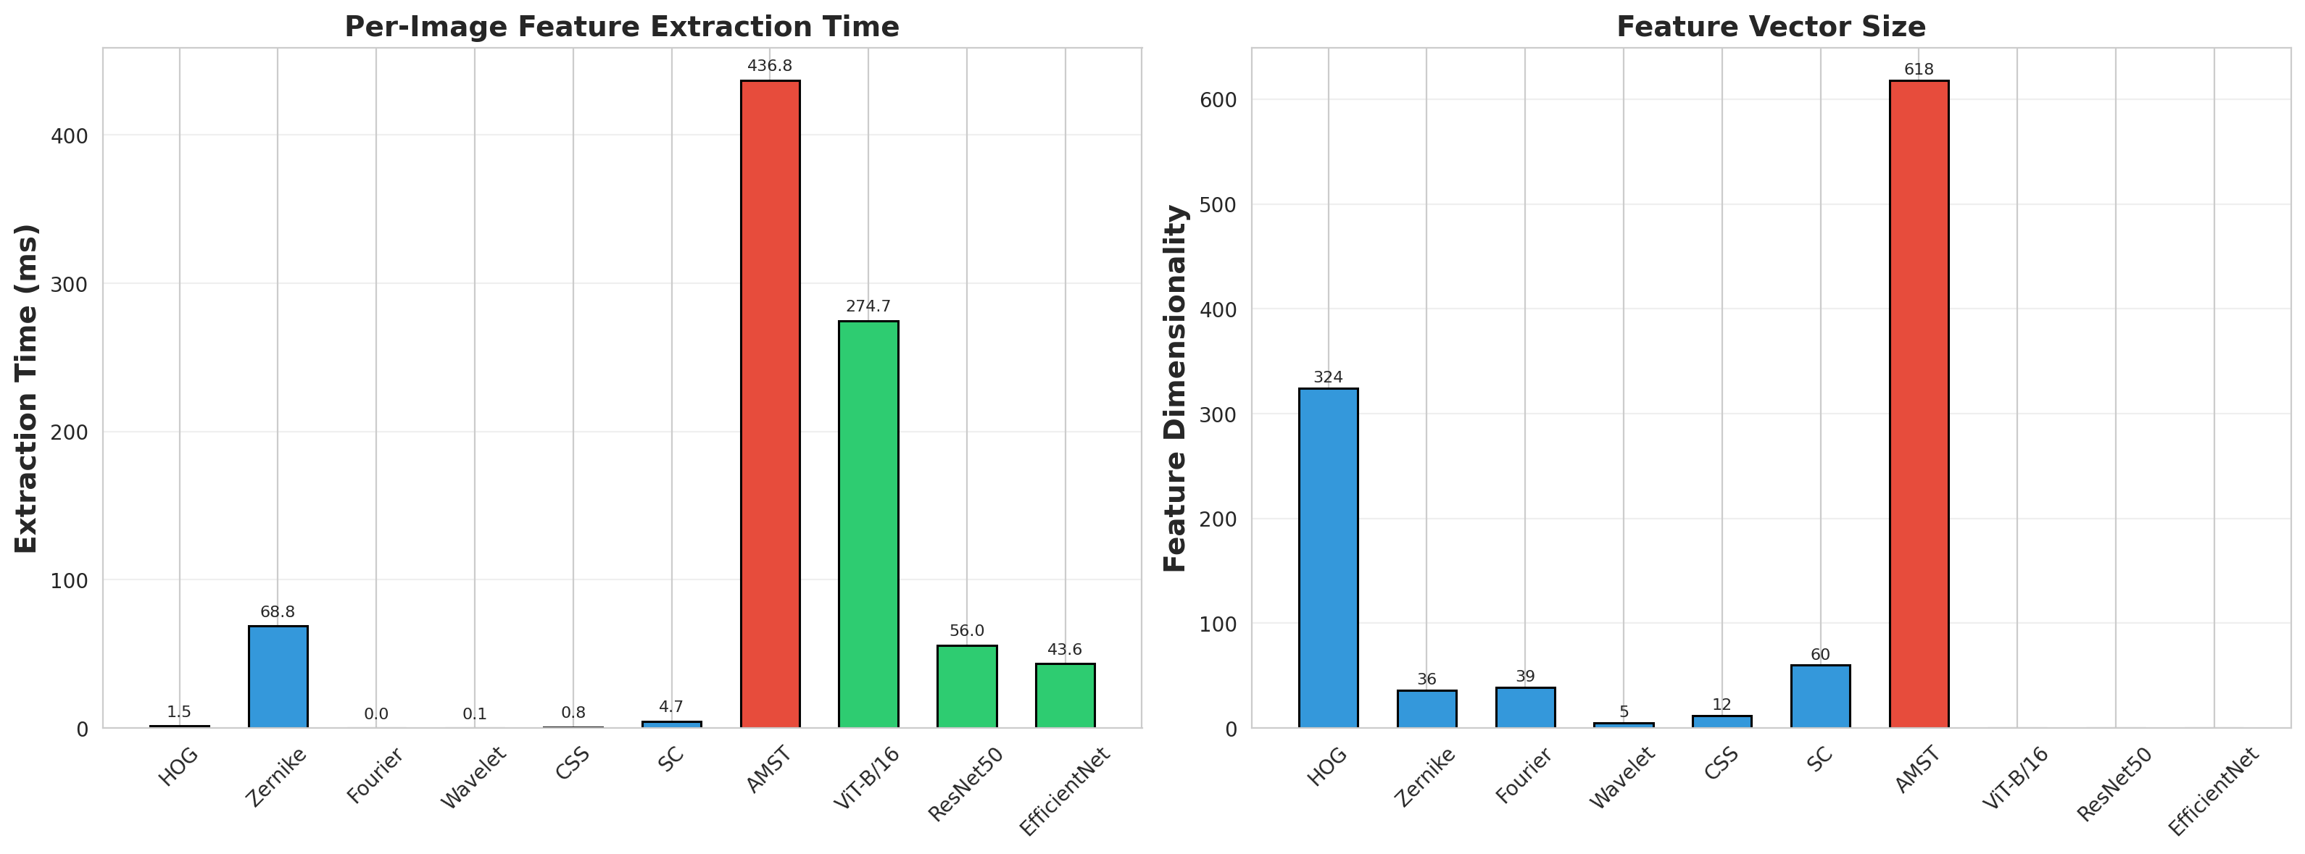
Figure 11. Feature extraction time and dimensionality across methods.

6. Discussion
Put together, we think these results support a fairly specific claim, and we would rather state it precisely than let it drift toward something broader. Under one consistent protocol, applied the same way to every method, the combined AMST+ViT+HOG descriptor is the strongest of the four we tested on MPEG-7 CE-Shape-1 across every metric we measured: classification accuracy (96.36%, significantly ahead of HOG and AMST, though not significantly ahead of ViT-B/16 once the Nemenyi correction is applied), retrieval MAP (67.29%), Bullseye score among the four methods we tested (68.76%), and robustness to noise, occlusion, scale change, and elastic deformation alike. That lines up with what the ablation already told us — the SPD Riemannian component carries most of AMST's within-dataset accuracy on its own — and with the fusion strategy's per-component normalization managing to blend three feature families of very different scale without one of them simply drowning out the others.
Two results push back against reading this too optimistically, and we want to treat both as central rather than bury them in a limitations paragraph. First, scored the way the classical shape-retrieval literature actually scores things, the proposed descriptor (68.76%) still sits below Shape Context (76.51%) and IDSC+DP (85.40%); the honest way to describe this paper's retrieval contribution is that it improves on deep and handcrafted single-descriptor baselines under a shared protocol, not that it sets a new state of the art against the older literature. Second, generalization across datasets is genuinely weak, and unevenly so: the very components that drive the largest within-dataset gains (C3, C4) are also the components most responsible for the cross-dataset collapse, and that collapse itself concentrates in a handful of shape categories — sixteen of eighteen shared classes score under 5% AP — rather than spreading evenly across the board. The controlled invariance diagnostic softens this picture somewhat: AMST and the combined descriptor really are more robust than HOG to scale change and elastic deformation, which suggests the cross-dataset weakness is not a wholesale failure of the descriptor's invariance properties so much as it is concentrated in the more data-adapted, higher-order components identified in Table 8.
If there is a general lesson here beyond the specific numbers, we think it is this: the components of a hybrid descriptor that improve accuracy on one benchmark are not automatically the ones that generalize, and a fusion strategy's success at home does not by itself tell you anything about how it performs away from home. That distinction only becomes visible if the ablation, the cross-dataset test, and the invariance diagnostic are reported side by side, as we have tried to do here; reporting the MPEG-7 accuracy alone would have hidden all of it.

7. Limitations and Future Work

7.1 Current Limitations
- Cross-dataset generalization is the biggest weakness in this work: AMST alone drops from 51.65% MAP within MPEG-7 to 6.43% MAP on the MPEG-7 → Kimia-216 transfer task. Table 8 traces this to components C3 and C4, so the right fix is probably component- and class-targeted — regularizing or down-weighting C3/C4 specifically for transfer-sensitive classes — rather than a general robustness patch applied everywhere.
- Benchmark scope is narrower than we would like: the primary results rest on MPEG-7 CE-Shape-1 (1,400 images, 70 classes), Kimia-216 (216 images, 18 classes) as a cross-dataset probe, and SGSB (200 images, 10 classes, our own procedural generation) as a controlled, independent check. SGSB accuracy is at ceiling for a strong pretrained backbone and does not meaningfully discriminate between methods, so it should not be read as evidence that the combined descriptor beats ViT-B/16 in general. SGSB and Kimia-216 together complement, but do not substitute for, evaluation on further real-world shape benchmarks (Swedish Leaf, Flavia, ETH-80, or the Princeton Shape Benchmark would all be natural next steps).
- Protocol comparability matters more than it might first appear: classification accuracy, MAP, and Bullseye score are not interchangeable (Section 3.6, Table 6), and this paper's best Bullseye result (68.76%) still trails the classical Shape Context and IDSC+DP baselines.
- Rotation-invariance testing on SGSB is confounded by the rotational symmetry of several polygon classes, which produces the non-monotonic curve in Figure 10 rather than a clean invariance measurement; that panel needs to be read with the symmetry-aliasing explanation in mind, not taken at face value.
- Computational cost is real: AMST extraction (≈ 10.4 minutes for 1,400 images on CPU) is much slower than HOG (≈ 1.9 seconds), and the noise/occlusion/invariance robustness evaluations, which re-embed corrupted images through ViT-B/16 repeatedly, are by far the most time-consuming part of the full pipeline on CPU-only hardware.
- Feature dimensionality adds overhead: the combined 1,710-dimensional descriptor needs feature selection (SelectKBest, k = 1,000) before classification, which is extra preprocessing that single-branch methods do not require.

7.2 Future Research Directions
- Domain adaptation techniques such as CORAL [19] or MMD-based alignment [20], applied specifically to components C3 and C4, could plausibly close some of the cross-dataset gap without giving up the within-dataset accuracy those components provide.
- A harder version of SGSB, with visually confusable classes and a wider range of deformation, would avoid the ceiling effect we ran into here and give a more discriminative synthetic complement to MPEG-7.
- A lighter-weight AMST variant, aiming for 300–400 dimensions instead of 618, could bring the computational cost down while keeping most of the discriminative power.
- End-to-end, differentiable versions of the AMST components would open the door to fine-tuning the descriptor itself for a specific downstream task, rather than treating it as a fixed feature extractor.
- Testing on further real-world shape datasets beyond MPEG-7 and Kimia-216 would round out the SGSB results and give a clearer picture of how far these findings actually generalize.

8. Conclusion
This paper set out to build a hybrid shape descriptor, AMST+ViT+HOG, that combines a five-component handcrafted representation — frequency-domain, topological, Riemannian, morphological, and complexity-based features — with Vision Transformer and HOG features through per-component normalization and Fisher feature selection. On MPEG-7 CE-Shape-1, it reaches 96.36% ± 1.58% 10-fold cross-validated classification accuracy and 67.29% retrieval MAP (68.76% Bullseye), and is significantly more robust than any of its individual components to noise, occlusion, scale change, and elastic deformation. Under the standard Bullseye protocol, though, these retrieval results still trail the classical Shape Context and IDSC+DP baselines, and we have reported that directly rather than let the more flattering MAP comparison stand in for it. What we would point to as the real contribution of this paper, beyond the headline numbers, is the set of diagnostics built around them — component-wise ablation, a per-class breakdown, a hyperparameter sensitivity check, and a controlled synthetic invariance test — that trace the descriptor's main weakness, a sizeable cross-dataset generalization gap, back to two specific components and a concentrated subset of shape categories, rather than leaving it as an unexplained number in a results table. We suspect this kind of multi-angle, honestly-reported evaluation has more to offer other hybrid shape descriptors than the specific method proposed here does on its own.

9. Data and Code Availability
Every experiment uses a fixed random seed (42) and runs on CPU-only hardware (Section 4.2). The full implementation, cached intermediate features, and every result file — classification, retrieval, Bullseye, cross-dataset (aggregate, component-wise, and per-class), ablation, hyperparameter grid search, noise/occlusion robustness, SGSB classification, and invariance diagnostic results, along with every figure reproduced in this paper — are provided as supplementary material. MPEG-7 CE-Shape-1 and Kimia-216 are third-party datasets used under their respective terms of distribution; SGSB is generated entirely by the accompanying code and needs no external download at all.

References
[1] S. Belongie, J. Malik, and J. Puzicha, "Shape matching and object recognition using shape contexts," IEEE Transactions on Pattern Analysis and Machine Intelligence, vol. 24, no. 4, pp. 509–522, 2002.
[2] H. Ling and D. W. Jacobs, "Shape classification using the inner-distance," IEEE Transactions on Pattern Analysis and Machine Intelligence, vol. 29, no. 2, pp. 286–299, 2007.
[3] A. Dosovitskiy, L. Beyer, A. Kolesnikov, D. Weissenborn, X. Zhai, T. Unterthiner, M. Dehghani, M. Minderer, G. Heigold, S. Gelly, J. Uszkoreit, and N. Houlsby, "An image is worth 16x16 words: Transformers for image recognition at scale," in International Conference on Learning Representations (ICLR), 2021.
[4] L. J. Latecki, R. Lakämper, and U. Eckhardt, "Shape descriptors for non-rigid shapes with a single closed contour," in IEEE Conference on Computer Vision and Pattern Recognition (CVPR), 2000, pp. 424–429.
[5] T. B. Sebastian, P. N. Klein, and B. B. Kimia, "Recognition of shapes by editing their shock graphs," IEEE Transactions on Pattern Analysis and Machine Intelligence, vol. 26, no. 5, pp. 550–571, 2004.
[6] H. Edelsbrunner and J. Harer, "Persistent homology — a survey," Contemporary Mathematics, vol. 453, pp. 257–282, 2008.
[7] X. Pennec, P. Fillard, and N. Ayache, "A Riemannian framework for tensor computing," International Journal of Computer Vision, vol. 66, no. 1, pp. 41–66, 2006.
[8] N. Dalal and B. Triggs, "Histograms of oriented gradients for human detection," in IEEE Conference on Computer Vision and Pattern Recognition (CVPR), 2005, pp. 886–893.
[9] C. T. Zahn and R. Z. Roskies, "Fourier descriptors for plane closed curves," IEEE Transactions on Computers, vol. C-21, no. 3, pp. 269–281, 1972.
[10] M. R. Teague, "Image analysis via the general theory of moments," Journal of the Optical Society of America, vol. 70, no. 8, pp. 920–930, 1980.
[11] C. Cortes and V. Vapnik, "Support-vector networks," Machine Learning, vol. 20, no. 3, pp. 273–297, 1995.
[12] O. Tuzel, F. Porikli, and P. Meer, "Region covariance: A fast descriptor for detection and classification," in European Conference on Computer Vision (ECCV), 2006, pp. 589–600.
[13] A. Krizhevsky, I. Sutskever, and G. E. Hinton, "ImageNet classification with deep convolutional neural networks," in Advances in Neural Information Processing Systems (NeurIPS), 2012, pp. 1097–1105.
[14] K. He, X. Zhang, S. Ren, and J. Sun, "Deep residual learning for image recognition," in IEEE Conference on Computer Vision and Pattern Recognition (CVPR), 2016, pp. 770–778.
[15] Y. LeCun, L. Bottou, Y. Bengio, and P. Haffner, "Gradient-based learning applied to document recognition," Proceedings of the IEEE, vol. 86, no. 11, pp. 2278–2324, 1998.
[16] G. Carlsson, "Topology and data," Bulletin of the American Mathematical Society, vol. 46, no. 2, pp. 255–308, 2009.
[17] J. Demšar, "Statistical comparisons of classifiers over multiple data sets," Journal of Machine Learning Research, vol. 7, pp. 1–30, 2006.
[18] I. Guyon and A. Elisseeff, "An introduction to variable and feature selection," Journal of Machine Learning Research, vol. 3, pp. 1157–1182, 2003.
[19] B. Sun, J. Feng, and K. Saenko, "Return of frustratingly easy domain adaptation," in AAAI Conference on Artificial Intelligence, 2016, pp. 2058–2065.
[20] A. Gretton, K. M. Borgwardt, M. J. Rasch, B. Schölkopf, and A. Smola, "A kernel two-sample test," Journal of Machine Learning Research, vol. 13, pp. 723–773, 2012.
[21] J. Serra, Image Analysis and Mathematical Morphology. London: Academic Press, 1982.
[22] F. Pedregosa, G. Varoquaux, A. Gramfort, V. Michel, B. Thirion, O. Grisel, M. Blondel, P. Prettenhofer, R. Weiss, V. Dubourg, J. Vanderplas, A. Passos, D. Cournapeau, M. Brucher, M. Perrot, and E. Duchesnay, "Scikit-learn: Machine learning in Python," Journal of Machine Learning Research, vol. 12, pp. 2825–2830, 2011.
[23] A. Paszke, S. Gross, F. Massa, A. Lerer, J. Bradbury, G. Chanan, T. Killeen, Z. Lin, N. Gimelshein, L. Antiga, A. Desmaison, A. Köpf, E. Yang, Z. DeVito, M. Raison, A. Tejani, S. Chilamkurthy, B. Steiner, L. Fang, J. Bai, and S. Chintala, "PyTorch: An imperative style, high-performance deep learning library," in Advances in Neural Information Processing Systems (NeurIPS), 2019, pp. 8024–8035.

