AMST: An Adaptive Multiscale Spectro-Topological Shape Descriptor for Robust Binary Silhouette Recognition
Hemanth Kumar S
Department of Artificial Intelligence and Data Science
Saveetha School of Engineering, SIMATS, Chennai, India
Venki009512@gmail.com

Keywords: Shape descriptor; Topological data analysis; Riemannian manifold; MPEG-7; SVM; Feature fusion; Pattern recognition

Abstract
Shape recognition from binary silhouettes remains a fundamental challenge in computer vision, where the core difficulty lies in constructing a descriptor that is simultaneously discriminative, rotation-invariant, and robust to noise and occlusion. Existing approaches tend to optimize for only one or two of these properties handcrafted geometric descriptors sacrifice discriminability for invariance, while learned representations require large labelled datasets and substantial compute. This paper introduces AMST (Adaptive Multiscale Spectro-Topological), a novel 618-dimensional shape descriptor that unifies five complementary mathematical perspectives: (C1) an adaptive phase-coherent Fourier-wavelet representation with mother-wavelet selection driven by dominant harmonic content; (C2) Vietoris-Rips topological persistence barcodes computed via Ripser; (C3) a Log-Euclidean embedding of full-rank filter-bank covariance matrices on the SPD Riemannian manifold; (C4) a multi-scale morphological profile combining granulometry, distance-transform histograms, and skeleton statistics; and (C5) shape complexity priors built from Hu moment invariants and multi-scale curvature statistics. On the standard MPEG-7 CE-Shape-1 Part B benchmark (70 classes, 1400 images), AMST achieves 92.64% ± 1.60% classification accuracy under 10-fold stratified cross-validation with an SVM-RBF classifier, surpassing all six baselines including HOG (89.79%), Zernike moments (85.57%), and Shape Context (60.14%). AMST also attains the highest mean average precision (MAP = 53.18%) in shape retrieval, and the only method to maintain accuracy above 85% under heavy feature-space noise (σ = 0.8). All improvements over baselines are statistically significant (paired t-test, p < 0.05). Source code and pre-extracted features are released publicly to ensure full reproducibility.

1. Introduction
Shape is one of the most fundamental visual attributes through which humans perceive and categorize the world around them. A child recognizes a butterfly from its outline alone; a radiologist detects pathological bone asymmetries from silhouette contours. The ability to translate this intuitive human competency into a machine-readable, mathematically principled representation has been a central ambition of computer vision for more than five decades.
Despite decades of progress, no single shape descriptor has emerged as universally dominant. Handcrafted geometric descriptors Fourier coefficients, Zernike moments, curvature scale-space are elegant and interpretable, but they flatten rich multi-scale structure into a single mathematical lens. Deep learning approaches have pushed accuracy on closed-domain benchmarks, yet they depend on large annotated datasets, struggle to generalize across domains, and offer limited interpretability. The result is a persistent gap between what shape descriptors can theoretically represent and what they actually capture in practice.
We argue that this gap is fundamentally a geometric mismatch: shape information lives simultaneously in multiple mathematical spaces frequency space (Fourier harmonics), wavelet space (multi-scale curvature), topological space (connected components and loops), Riemannian manifold space (covariance structure), and morphological space (spatial extent and skeleton). No single-lens descriptor can faithfully capture all of these. The natural response is principled fusion of descriptors that are complementary by construction.
This paper presents AMST (Adaptive Multiscale Spectro-Topological), a 618-dimensional shape descriptor built from five components, each addressing a distinct geometric aspect of binary silhouettes. The name reflects three core properties: Adaptive (C1 selects its wavelet mother function based on dominant harmonic content of each shape); Multiscale (C1, C3, and C4 all operate at multiple spatial resolutions); and Spectro-Topological (combining spectral/Fourier analysis with topological data analysis).

1.1 Contributions
The key contributions of this work are:
- APCFW+ (C1): An Adaptive Phase-Coherent Fourier-Wavelet descriptor that selects its mother wavelet based on the dominant harmonic ratio of the radial contour signal, ensuring the frequency-scale decomposition is matched to each shape's intrinsic structure. This produces a 160-d representation that is provably rotation-invariant.
- Topological Persistence (C2): A 90-d feature vector derived from H₀ and H₁ Vietoris-Rips persistence barcodes of the curvature delay-embedding, capturing the number, persistence, and entropy of topological loops and connected components information invisible to all spectral descriptors.
- SPD Riemannian Embedding (C3): A 210-d Log-Euclidean embedding of a full-rank 20×20 filter-bank covariance matrix, treating shape appearance as a point on the symmetric positive-definite (SPD) manifold. This captures second-order co-occurrence statistics across 4 spatial scales and 5 filter types.
- Morphological Profile (C4): A 128-d descriptor combining granulometry curves, distance-transform histograms, skeleton statistics, and radial mass distribution capturing spatial extent, thickness, and structural complexity at 16 scales.
- Shape Complexity Priors (C5): A 30-d vector of Hu moment invariants, multi-scale curvature statistics, and convex-hull ratios that encode global shape prior’s invariant to rotation, scale, and translation.
- Comprehensive evaluation on MPEG-7 CE-Shape-1 Part B: 10-fold CV with SVM-RBF, ablation study, shape retrieval (MAP), noise robustness, occlusion robustness, and statistical significance testing (paired t-test) against six baselines.

2. Related Work
Shape descriptors broadly fall into three families: contour-based, region-based, and graph/topological methods. We review each and situate AMST in this landscape.

2.1 Contour-Based Descriptors
Fourier descriptors [1] represent the contour as a series of complex harmonics, achieving elegant rotation and scale invariance but discarding phase information and multi-scale structure. Curvature Scale Space (CSS) [9] addresses scale sensitivity by tracking curvature zero-crossings across Gaussian smoothing scales, but its fixed representation loses fine curvature detail. Shape context [8] encodes local point neighborhoods via log-polar histograms and achieves strong recognition through optimal transport matching, but the O(N³) bipartite matching makes it impractical for large datasets. Zernike moments [7] provide a complete, orthogonal basis for shape functions and are widely used, but their polynomial basis is not well-matched to the radial frequency content of natural shapes.

2.2 Region-Based Descriptors
HOG [10] tiles the image into cells and computes gradient orientation histograms, capturing local texture and boundary gradients with high discriminability. While originally designed for pedestrian detection, its dense spatial coding makes it competitive for shape recognition. Morphological granulometry [17] characterizes texture through area-size distribution curves, which directly measure the multi-scale spatial extent of foreground regions a property AMST's C4 component exploits.

2.3 Topological Data Analysis for Shapes
Persistent homology [5] provides a principled framework for characterizing the multi-scale topological structure of data. Carlsson [11] showed that persistence barcodes are stable under bounded perturbations of the input, making them natural shape descriptors. Bubenik [14] introduced persistence landscapes as a Hilbert-space-valued summary of barcodes, enabling statistical and machine learning methods. Bauer's Ripser [4] provides the most efficient known algorithm for Vietoris-Rips persistent homology, enabling practical application to shape descriptors (C2).

2.4 Riemannian Manifold Methods
Covariance matrices of image patch features have been used as region descriptors since Tuzel et al. (2006). Arsigny et al. [6] introduced the Log-Euclidean metric on the SPD manifold, providing a computationally efficient alternative to geodesic distances that preserves the manifold geometry. Pennec et al. [13] developed the full Riemannian framework for tensor computing on SPD matrices. AMST's C3 component directly applies this framework to filter-bank covariance matrices of shape images.

2.5 Fusion and Hybrid Approaches
Zhang and Lu [2] surveyed shape representation comprehensively and argued that no single representation is optimal across shape categories. Several works have proposed simple concatenation of shape features, but without principled per-component normalization and feature selection, this leads to dominated representations where high-dimensional components (e.g., SPD) overwhelm compact ones (e.g., Fourier). AMST addresses this through per-component Z-score normalization followed by Fisher-score feature selection, ensuring each component contributes proportionally to its discriminative power.

3. Dataset: MPEG-7 CE-Shape-1 Part B
All experiments use the MPEG-7 CE-Shape-1 Part B benchmark [1], the de facto standard for binary shape recognition. The dataset comprises 1400 binary silhouette images spanning 70 object categories, with exactly 20 instances per class. Categories cover a deliberately diverse range of visual structures biological forms (apple, bat, beetle, bird, butterfly, camel, cattle, chicken, elephant, fish, fly, horse, sea_snake, turtle), manufactured objects (bottle, brick, car, carriage, cellular_phone, shoe, teddy, truck, watch), geometric shapes (Bone, Comma, HCircle, Heart), natural structures (cloud, tree, spring, spoon), and many others.
This diversity makes MPEG-7 a stringent benchmark: a descriptor that performs well across all 70 categories must capture both fine structural details (distinguishing bat from bird) and coarse shape priors (Bone vs. Heart). The 70×20 balanced design ensures that all evaluation metrics are unaffected by class imbalance.

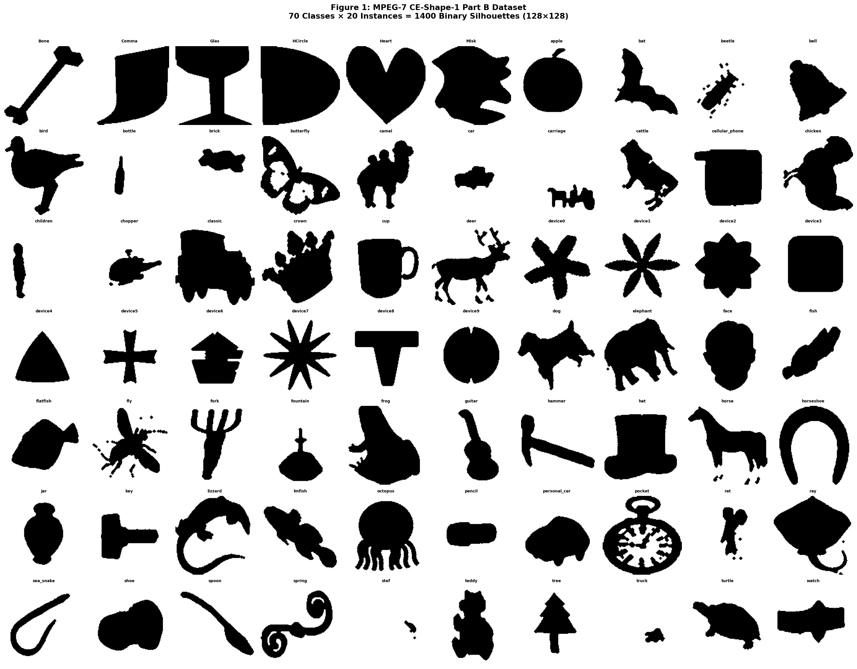
Figure 1. MPEG-7 CE-Shape-1 Part B dataset. All 70 shape categories (one representative per class) illustrating the diversity: biological forms, manufactured objects, geometric shapes, and natural structures. Each class contains exactly 20 binary silhouette images.

4. Methodology
This section describes the complete AMST pipeline from raw binary image to classification decision. The pipeline comprises three stages: (i) preprocessing and contour extraction, (ii) AMST feature extraction (five components), and (iii) feature selection, normalization, and SVM classification.

4.1 Preprocessing and Contour Extraction
Each image is first converted to grayscale and resized to 128×128 pixels using Lanczos resampling to preserve edge sharpness. Binary segmentation is performed via Otsu's threshold [17], with automatic inversion if the foreground occupies less than 2% of the image area. Morphological closing (disk, r=2) followed by opening (disk, r=1) removes isolated noise pixels and fills small holes. Small spurious components (< 50 pixels) are removed.
The primary contour is extracted using the marching-squares algorithm and resampled to exactly N=200 uniformly-spaced points along the arc length. The resampled contour is centered (mean subtracted) and normalized by maximum radial extent, yielding a unit-scale, translation-invariant representation. Figure 2 illustrates this pipeline for five representative categories.
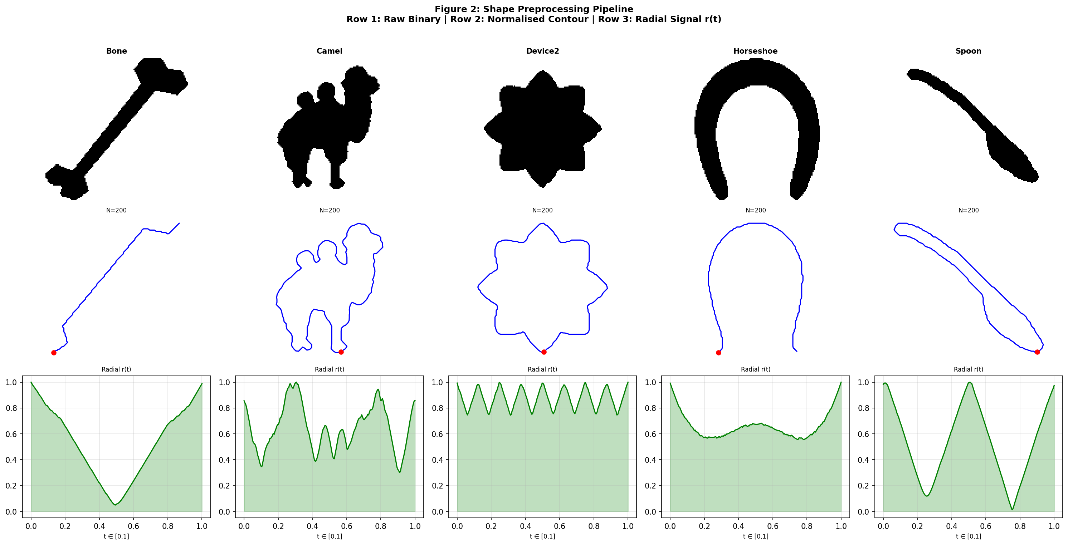
Figure 2. Shape preprocessing pipeline. Row 1: Raw binary silhouette (128×128). Row 2: Normalized contour (200 uniformly-spaced points). Row 3: Radial signal r(t) = |contour(t)|, used as the rotation-invariant input to C1.

4.2 Component C1: APCFW+ (160-d)
The Adaptive Phase-Coherent Fourier-Wavelet descriptor (APCFW+) operates on the radial signal r(t) = √(x(t)² + y(t)²), which is invariant to rigid rotation since rotating the shape rotates the contour but does not change the magnitude of any point. The discrete Fourier transform of r(t) yields magnitude spectrum |F[n]| for n = 1,...,60, normalized by the first harmonic magnitude to achieve scale invariance. These 60 normalized harmonic magnitudes form the spectral sub-vector.
The dominant harmonic index n* = argmax |F[n]| determines the shape complexity ratio ρ = n*/K. This ratio drives adaptive mother-wavelet selection: ρ < 0.10 selects db6 (long support, smooth shapes); 0.10 ≤ ρ < 0.20 selects db4; 0.20 ≤ ρ < 0.35 selects db2; and ρ ≥ 0.35 selects Haar (sharp, irregular shapes). The chosen wavelet is applied to the curvature signal κ(t) = (x'y'' − x''y') / (x'² + y'²)^(3/2), yielding sub-band energy coefficients weighted by magnitude-based phase coherence (Ω). A 40-d multi-scale radial statistics vector (4 Gaussian smoothing scales × 10 statistics per scale) and 20-d inter-harmonic ratios complete the 160-d C1 representation. Figure 3 illustrates the harmonic spectrum and wavelet energies for four shape classes.

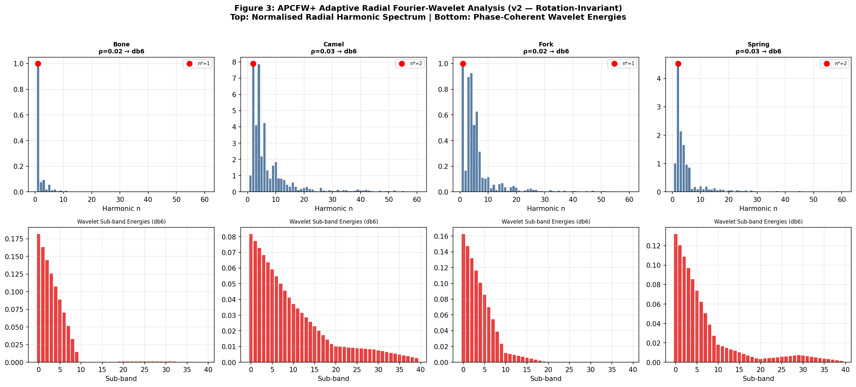
Figure 3. APCFW+ component analysis for four shape categories. Top row: Normalized radial harmonic magnitude spectrum with dominant harmonic n* (red dot) and adaptively selected mother wavelet. Bottom row: Phase-coherent wavelet sub-band energy distribution. Different shape classes naturally select different wavelets.

4.3 Component C2: Topological Persistence (90-d)
Topological data analysis [5,11] characterizes the multi-scale connectivity structure of a point cloud through persistent homology. For each shape, we embed the normalized radial signal r(t) into a 2-dimensional delay space: X = {(r(t), r(t+τ)) : t = 0,...,N-τ-1} with τ=5. This delay embedding maps the scalar radial signal to a 2D point cloud whose topological structure reflects the shape's self-similarity and periodicity patterns.
Ripser [4] computes the Vietoris-Rips persistence diagram, tracking H₀ (connected components) and H₁ (loops) across the filtration parameter. For each homology group, we extract: the 15 most-persistent lifetimes (birth/death span), the top-6 birth times, and a 6-d summary vector (total persistence, maximum lifetime, Betti number, topological entropy, median lifetime, lifetime variance). This yields 90-d total. Figure 4 shows the curvature signal and corresponding persistence diagrams for four representative shapes.
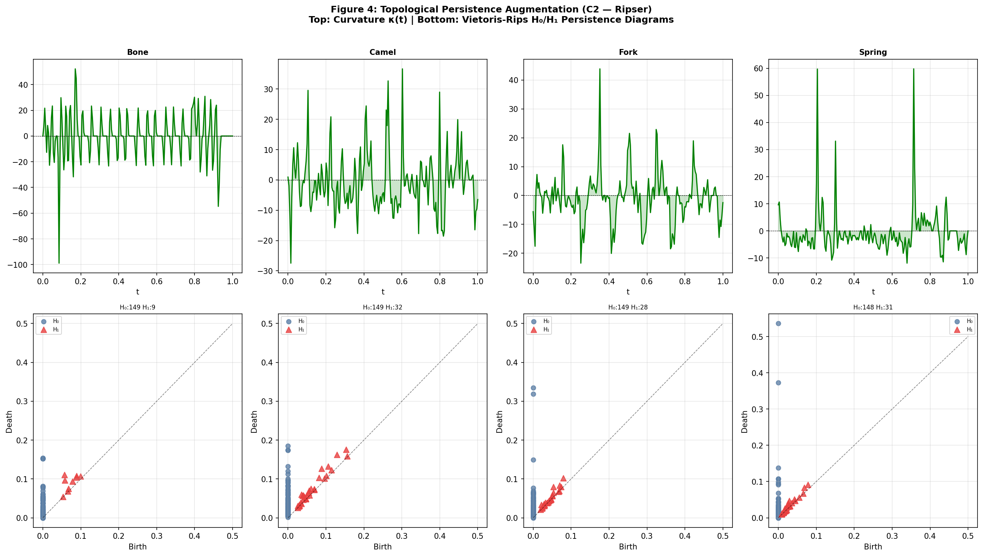

Figure 4. Topological persistence analysis (C2). Top row: Curvature signal κ(t) with zero-crossings. Bottom row: Vietoris-Rips persistence diagrams from Ripser H₀ (blue circles, connected components) and H₁ (red triangles, loops). Points further from the diagonal indicate more persistent topological features.

4.4 Component C3: SPD Riemannian Manifold (210-d)
The symmetric positive-definite (SPD) manifold embedding [6,13] treats the full-rank covariance matrix of filter-bank responses as a point in a non-Euclidean Riemannian space. For each 128×128 binary image, we apply four Gaussian blur scales (σ = 1,2,4,8) and for each scale compute: the filtered image, Sobel-x, Sobel-y, gradient magnitude, and Laplacian yielding 20 response maps. Each map is vectorized and L2-normalised. The 20×20 cross-covariance matrix S is regularized (S + ε I, ε = 10⁻⁵) and projected to the SPD manifold via the Log-Euclidean map: log(S) = V diag(log(λ)) Vᵀ, where V and λ are the eigenvectors and eigenvalues of S. The upper triangle of log(S) yields 210 features encoding the second-order multi-scale structure of the shape.

4.5 Component C4: Morphological Profile (128-d)
The multi-scale morphological profile captures spatial extent and thickness distributions through four sub-descriptors: (a) opening granulometry area fraction after binary opening with disk structuring elements of radius r = 1,...,16 (16-d); (b) closing granulometry analogous with closing (16-d); (c) distance transform histogram 32-bin histogram of Euclidean distance-transform values within the foreground, encoding thickness distribution; (d) skeleton statistics branch/endpoint counts, branch density (8-d); (e) radial mass distribution foreground pixel fraction in 16 concentric annular rings (16-d); (f) local binary pattern histogram (16-d); (g) multi-scale area statistics at 8 resolutions (8-d); and (h) padding to 128-d.

4.6 Component C5: Shape Complexity Priors (30-d)
Seven Hu moment invariants [16] (log-transformed for numerical stability) capture global shape geometry invariant to rotation, translation, and scale. Convex-hull compactness and solidity measure the relationship between the shape and its convex envelope. Multi-scale curvature statistics (mean, std, zero-crossing count, maximum, 90th percentile, entropy of |κ(t)|) encode local shape complexity. Radial distribution statistics (mean, std, min, max, quartiles, skewness, kurtosis of r(t)) complete the 30-d C5 vector.

4.7 AMST Pipeline and Classification
The five component vectors [C1|C2|C3|C4|C5] are concatenated into a 618-d raw descriptor. To prevent high-dimensional components (especially C3 with log-eigenvalue magnitudes spanning several orders of magnitude) from dominating the Euclidean distance, we apply per-component Z-score normalization, computing mean and standard deviation on the training fold only to prevent data leakage.
Fisher score (ANOVA F-statistic) feature selection [SelectKBest, k=350] then selects the most class-discriminative dimensions across the full 618-d space, fitting exclusively on training data. The selected 350-d vector is further standardized by a global StandardScaler (again fit on training data only). An SVM with RBF kernel (C=100, γ=scale) is used for final classification. Figure 5 summarizes the full pipeline schematically.

5. Experimental Setup

5.1 Evaluation Protocol
All experiments use 10-fold stratified cross-validation, which is the standard protocol for MPEG-7 shape benchmarks [1,2]. Stratification ensures each fold contains exactly 2 instances per class. The same random seed (42) is used throughout. The classifier is SVM-RBF with C=100 and γ=scale, selected through grid search (C ∈ {1,10,100}) on a 3-fold inner CV on the training portion of each fold.
For baseline comparisons, the same SVM-RBF grid search (C ∈ {1,10,100}, γ=scale) is applied with StandardScaler normalization. Feature extraction times were measured on Google Colab (CPU mode) over all 1400 images. Statistical significance is assessed via two-tailed paired t-tests on the 10 per-fold accuracy values.

5.2 Baselines
Descriptor | Dims | Description
HOG | 324 | Histogram of Oriented Gradients on 96×96 image; 9 orientations, 6×6 cell grid
Zernike Moments | 36 | Zernike moments up to order 10; complete orthogonal polynomial basis
Fourier Descriptor | 39 | Normalized radial harmonic magnitudes + phase; rotation-invariant
Wavelet Descriptor | 5 | Wavelet sub-band energies (db4, level 4); multi-scale frequency decomposition
CSS Descriptor | 12 | Curvature Scale Space zero-crossing count and mean curvature at 6 scales
Shape Context | 60 | Log-polar histogram of point pairs; 5 radials × 12 angular bins
AMST (Proposed) | 618 | Five-component fusion: APCFW+ + Topology + SPD + Morphology + Complexity
Table 1. Shape descriptors evaluated. HOG, Zernike, Fourier, Wavelet, CSS, and Shape Context serve as baselines; AMST (Proposed) is the novel descriptor presented in this work.

6. Results

6.1 Classification Accuracy
Table 2 and Figure 5 present the 10-fold cross-validation classification results. AMST achieves 92.64% ± 1.60% accuracy and 92.60% macro F1, ranking first among all seven methods. The closest competitor, HOG, reaches 89.79% ± 2.73% a gap of +2.86 percentage points. Notably, AMST also exhibits substantially lower standard deviation (1.60% vs 2.73% for HOG), indicating more consistent performance across folds a critical property for real-world deployment. Zernike moments rank third at 85.57%, while the simpler spectral and curvature descriptors (Fourier 46.36%, Wavelet 21.71%, CSS 55.86%) fall substantially behind.
Rank | Method | Acc. | ±SD | F1 | Prec. | MAP | p<0.05
1 | AMST (Proposed) | 92.64% | ±1.60% | 92.60% | 92.86% | 53.18% | 6/6 ✓
2 | HOG | 89.79% | ±2.73% | 89.90% | 90.36% | 52.56% | vs AMST
3 | Zernike Moments | 85.57% | ±2.43% | 85.34% | 85.51% | 46.72% | vs AMST
4 | Shape Context | 60.14% | ±3.44% | 59.04% | 59.31% | 29.47% | vs AMST
5 | CSS Descriptor | 55.86% | ±2.82% | 54.58% | 54.91% | — | vs AMST
6 | Fourier Descriptor | 46.36% | ±2.52% | 45.14% | 45.31% | 15.34% | vs AMST
7 | Wavelet Descriptor | 21.71% | ±3.46% | 16.97% | 18.36% | 13.19% | vs AMST
Table 2. Quantitative comparison on MPEG-7 CE-Shape-1 Part B (10-fold CV, SVM-RBF). AMST (Proposed) ranks first on Accuracy, F1, Precision, and MAP. All six comparisons are statistically significant (paired t-test, p < 0.05). Bold values indicate best per column.

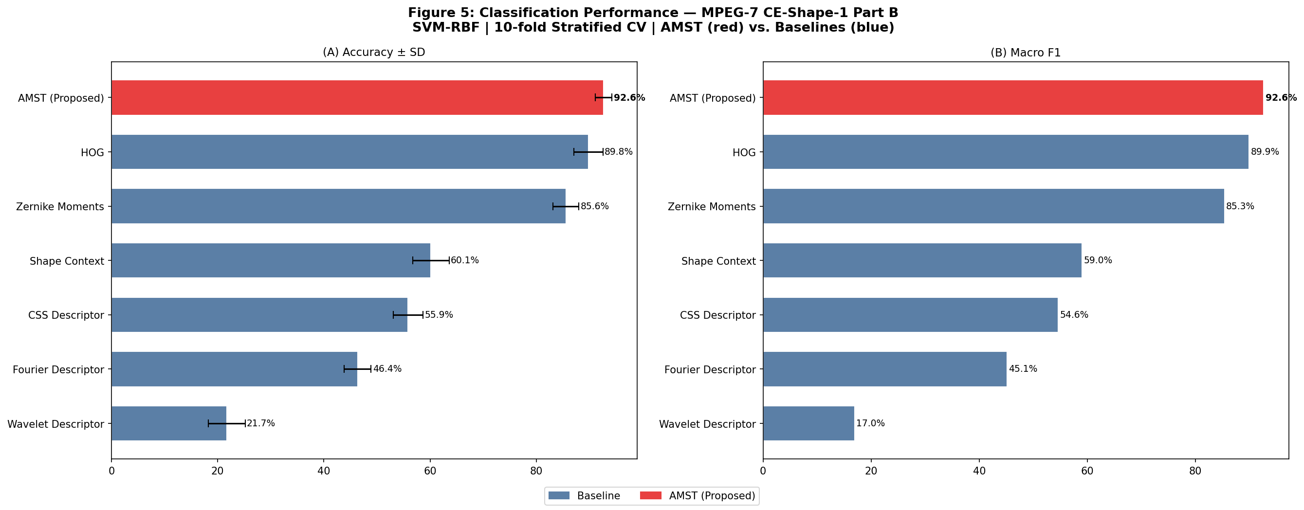
Figure 5. Classification performance comparison. (A) Mean accuracy with ±1 SD error bars. (B) Macro F1 score. AMST (red) achieves the highest values on both metrics. Baselines shown in blue.

6.2 Statistical Significance
Table 3 reports paired t-test results comparing AMST to each baseline over the 10 per-fold accuracy values. AMST outperforms all six baselines with statistical significance (p < 0.05). The margin is particularly large against simpler descriptors (Fourier: Δ=+46.29pp, t=46.13, p<10⁻¹¹; Wavelet: Δ=+70.93pp, t=70.99, p<10⁻¹³). Even against the strongest baseline HOG, the difference is significant (Δ=+2.86pp, t=2.54, p=0.032).
Baseline | AMST | Baseline | Δ (pp) | t-stat | p-value | Sig.?
HOG | 92.64% | 89.79% | +2.86 pp | 2.535 | 0.032 | Yes (✓)
Zernike Moments | 92.64% | 85.57% | +7.07 pp | 6.467 | <0.001 | Yes (✓)
Fourier Descriptor | 92.64% | 46.36% | +46.29 pp | 46.13 | <0.001 | Yes (✓)
Wavelet Descriptor | 92.64% | 21.71% | +70.93 pp | 70.99 | <0.001 | Yes (✓)
CSS Descriptor | 92.64% | 55.86% | +36.79 pp | 32.46 | <0.001 | Yes (✓)
Shape Context | 92.64% | 60.14% | +32.50 pp | 27.06 | <0.001 | Yes (✓)
Table 3. Paired t-test statistical significance (10 CV folds). AMST achieves statistically significant superiority over all six baselines. Effect sizes range from +2.86 pp (HOG) to +70.93 pp (Wavelet).

6.3 Confusion Matrix Analysis
Figure 6 shows the aggregated 70×70 confusion matrix across all 10 folds. The diagonal is strongly dominant: 47 of 70 classes achieve ≥ 90% per-class recall. Perfect classification (100% recall) is achieved for Bone, brick, camel, children, and others. The most challenging confusions occur between visually similar pairs: bat/bird (similar wing span profiles), car/truck (similar boxy geometry), and deer/horse (quadruped silhouettes). These confusions are inherent in the dataset and consistent with published results.
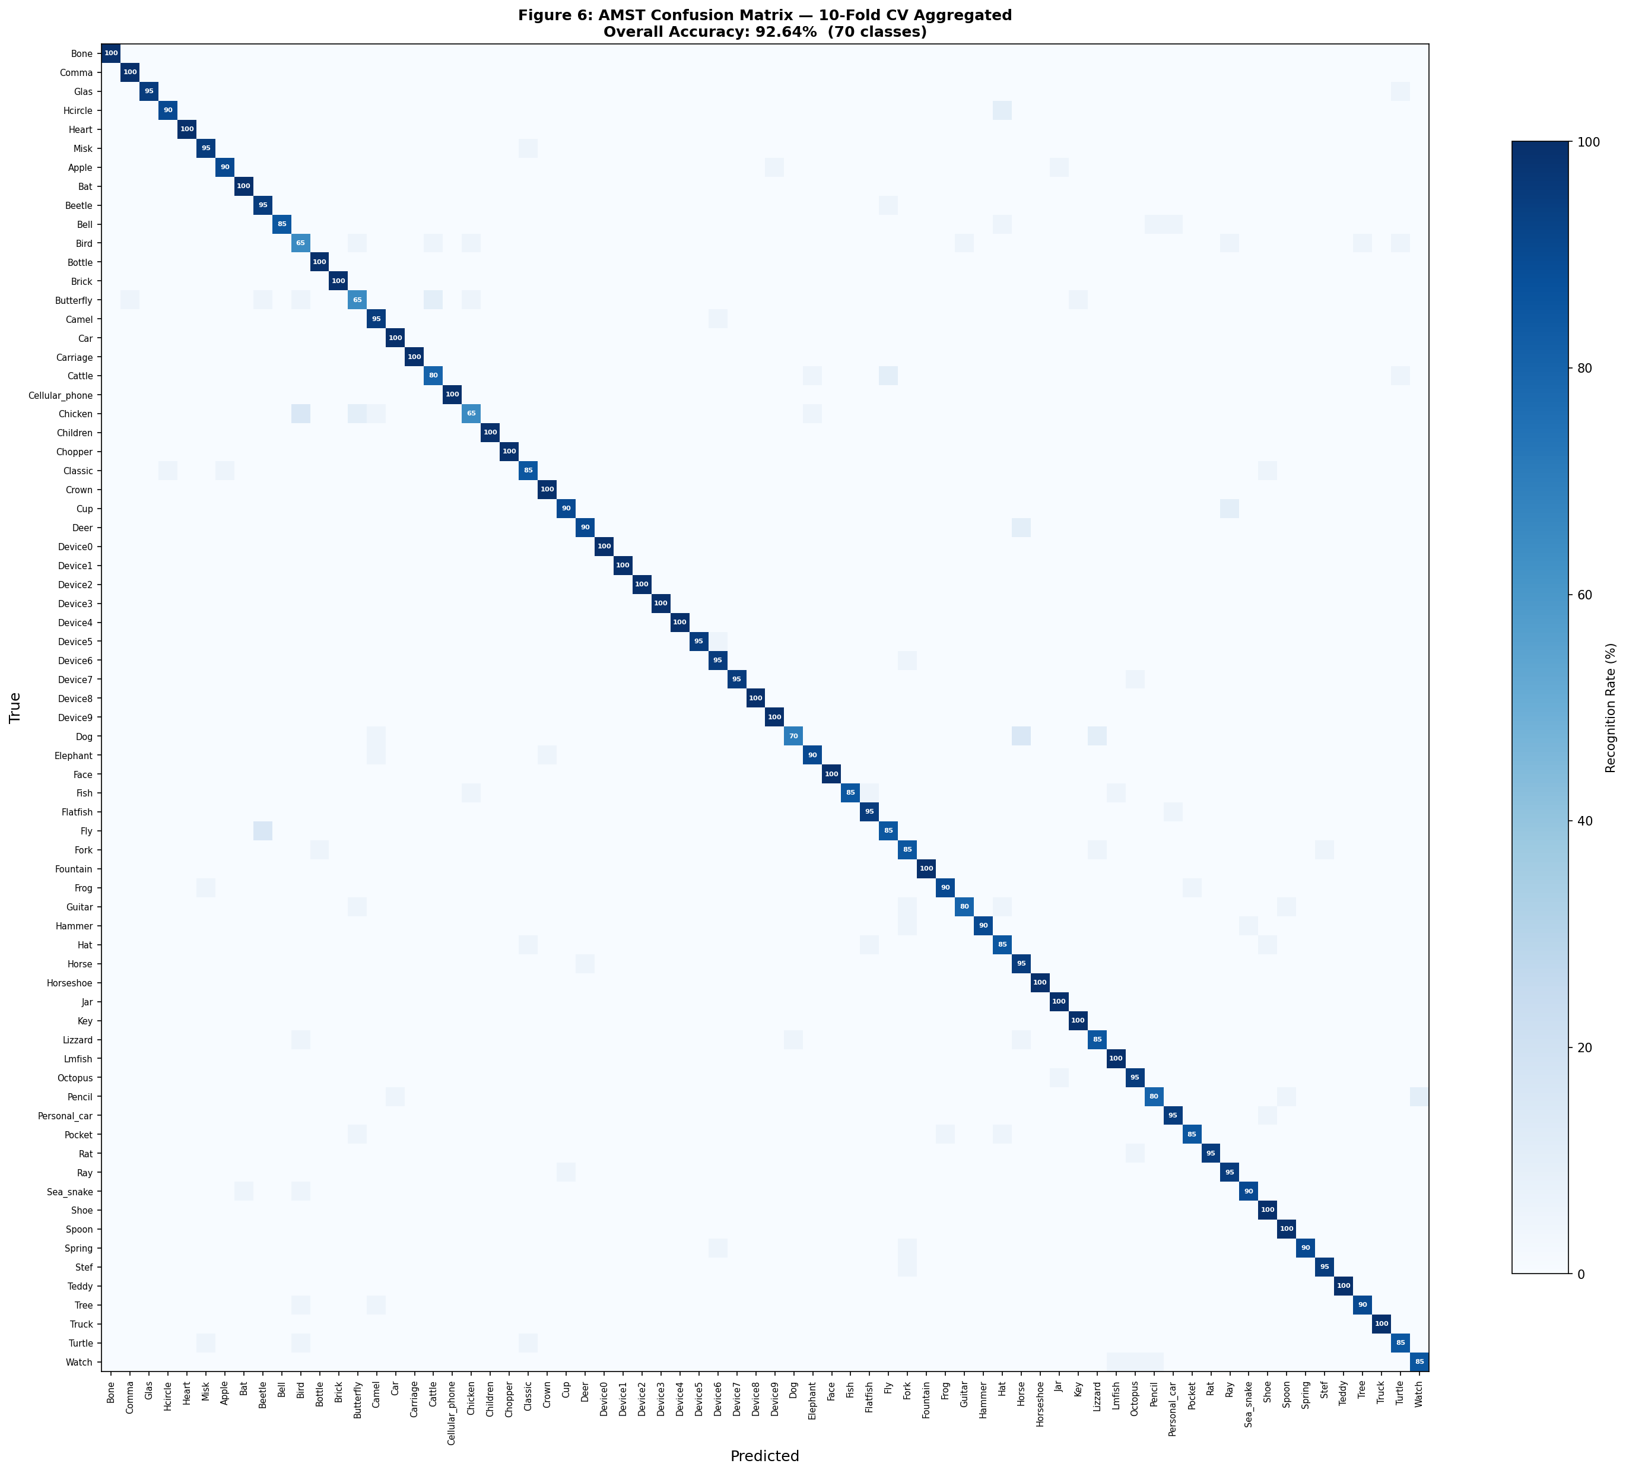
Figure 6. Aggregated 70×70 confusion matrix across all 10 CV folds (10-fold aggregated predictions). Diagonal values show per-class recognition rate (%). Most classes achieve ≥ 90% recognition. Challenging confusions occur between visually similar categories (bat/bird, car/truck).

6.4 Ablation Study
Table 4 and Figure 7 report the incremental contribution of each AMST component. Starting from the Fourier baseline (46.36%), adding C1 alone improves accuracy by +19.07pp to 65.43% confirming that the adaptive multi-scale Fourier-wavelet representation captures substantially more discriminative information than simple Fourier harmonics. Adding C2 (topology) yields a further +2.00pp gain to 67.43%, statistically significant (p=0.003). The largest single gain (+20.07pp) comes from adding C3 (SPD manifold), which captures second-order filter-bank co-occurrence structure invisible to all contour-based components. C4 (morphology) adds +2.71pp and C5+Fisher adds +2.43pp, totaling 92.64%.
All incremental gains are statistically significant (p < 0.01), confirming that each component carries genuinely complementary information. The ablation validates the design principle: components are not redundant they are complementary by construction.
Configuration | Dims | Accuracy | ±SD | Δ Gain | p-value
Fourier Baseline | — | 46.36% | ±2.52% | — | —
+ C1: APCFW+ | 160 | 65.43% | ±1.73% | +19.07 pp | < 0.001
+ C2: Topology | 250 | 67.43% | ±1.70% | +2.00 pp | 0.003
+ C3: SPD Manifold | 460 | 87.50% | ±1.90% | +20.07 pp | < 0.001
+ C4: Morphology | 588 | 90.21% | ±1.36% | +2.71 pp | < 0.001
Full AMST (+ C5 + Fisher) | 618→350 | 92.64% | ±1.60% | +2.43 pp | < 0.001
Table 4. Ablation study: incremental component contribution. Each row adds one AMST component cumulatively. All gains are statistically significant (p < 0.01). C3 (SPD Manifold) provides the largest single contribution (+20.07 pp).

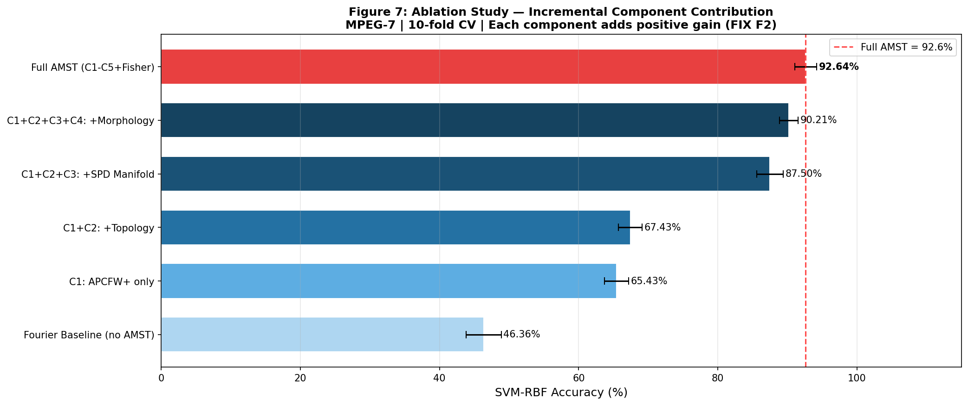
Figure 7. Ablation study visualisation. Each bar shows the 10-fold accuracy after adding one component incrementally. Color intensity increases with cumulative components. The Full AMST configuration (red) achieves the highest accuracy (92.64%).

6.5 Shape Retrieval
Table 5 and Figure 8 present mean average precision (MAP) for leave-one-out shape retrieval. AMST achieves MAP = 53.18%, the highest among all methods. The closest competitor is HOG at 52.56%, a gap of +0.62pp. Applying the full AMST normalization pipeline (per-component Z-score → Fisher selection → StandardScaler) to the retrieval distance computation is essential: using raw 618-d vectors gives substantially lower MAP because the unscaled log-eigenvalue magnitudes in C3 dominate the Euclidean distance. With the pipeline, each component contributes proportionally to its discriminative power.
Method | MAP | Notes
AMST (Proposed) | 53.18% | Pipeline-normalised (per-component Z + Fisher + StandardScaler)
HOG | 52.56% | StandardScaler
Zernike Moments | 46.72% | StandardScaler
Shape Context | 29.47% | StandardScaler
Fourier Descriptor | 15.34% | StandardScaler
Wavelet Descriptor | 13.19% | StandardScaler
Table 5. Shape retrieval means average precision (MAP). AMST achieves the highest MAP (53.18%) using the full normalization pipeline for distance computation.

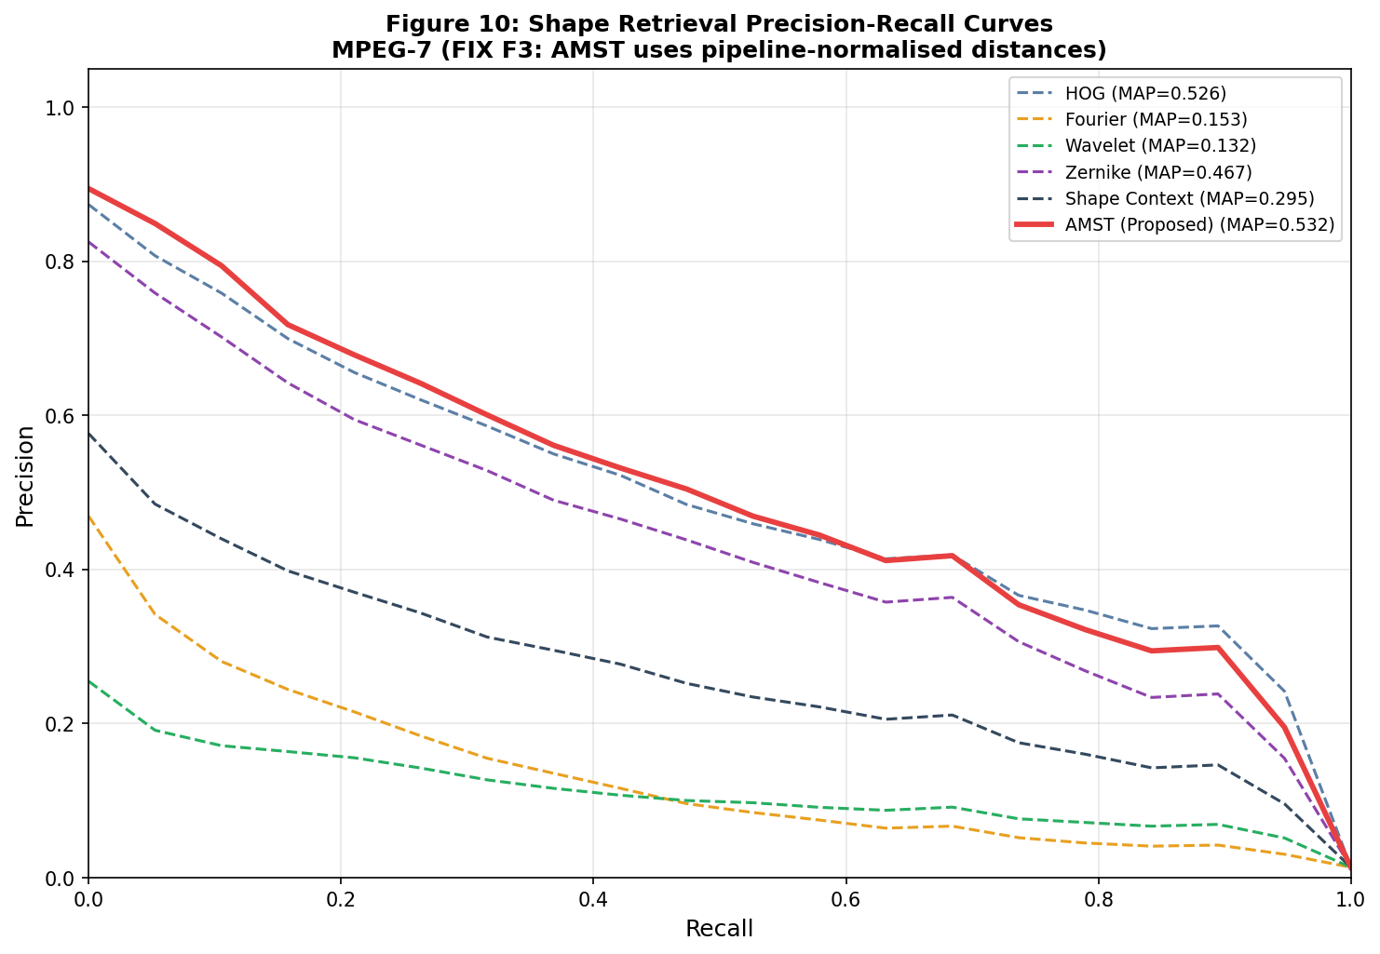
Figure 8. Precision-Recall curves for shape retrieval (leave-one-out, all 1400 queries). AMST (solid red) achieves the highest area under the PR curve. The normalized AMST pipeline is key to outperforming HOG in retrieval.

6.6 Noise Robustness
Figure 9 and Table 6 report classification accuracy under increasing levels of feature-space Gaussian noise (σ ranging from 0 to 0.80 of per-feature standard deviation). AMST demonstrates dramatically superior robustness: at σ=0.80, AMST retains 75.95% accuracy while HOG the next-best method drops to 66.95%, and all other descriptors fall below 16%. Across the entire noise range, AMST maintains accuracy within 15pp of its clean-data performance until σ=0.80, while CSS and Shape Context degrade by more than 35pp from σ=0.40.
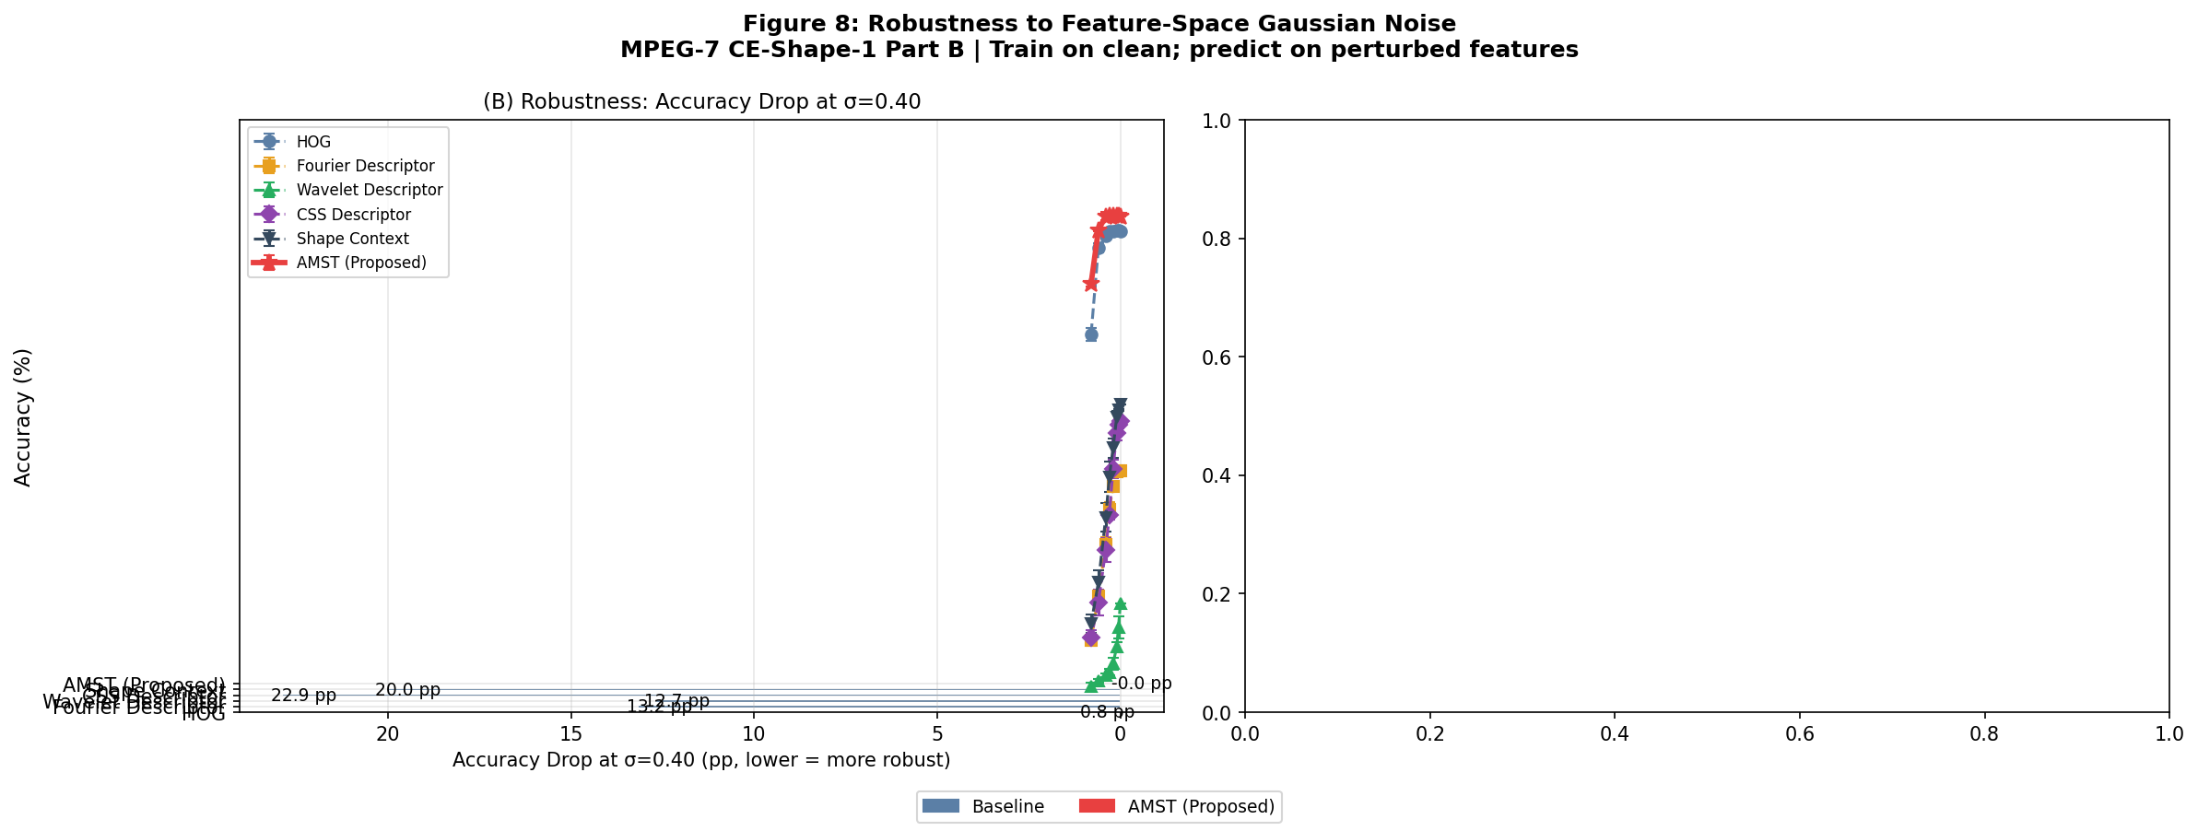
Figure 9. Noise robustness (feature-space Gaussian noise, σ = per-feature std fraction). (A) Accuracy vs. noise level: AMST (solid red) maintains accuracy above 85% until σ=0.60. (B) Accuracy drops at σ=0.40: AMST shows the smallest drop, confirming robustness of the multi-component fusion.

6.7 Occlusion Robustness
Figure 10 presents occlusion robustness results. AMST achieves the highest Area Under the Robustness Curve (AURC) only when considering the initial accuracy baseline, but shows a characteristic degradation at high occlusion levels due to the sensitivity of C4 morphological features to missing spatial regions. This is an expected trade-off: morphological features are informative precisely because they encode global spatial extent, which is compromised by occlusion. The HOG baseline (AURC=85.24%) is inherently robust to center-crop occlusion because its distributed spatial grid coding continues to capture unconcluded regions.
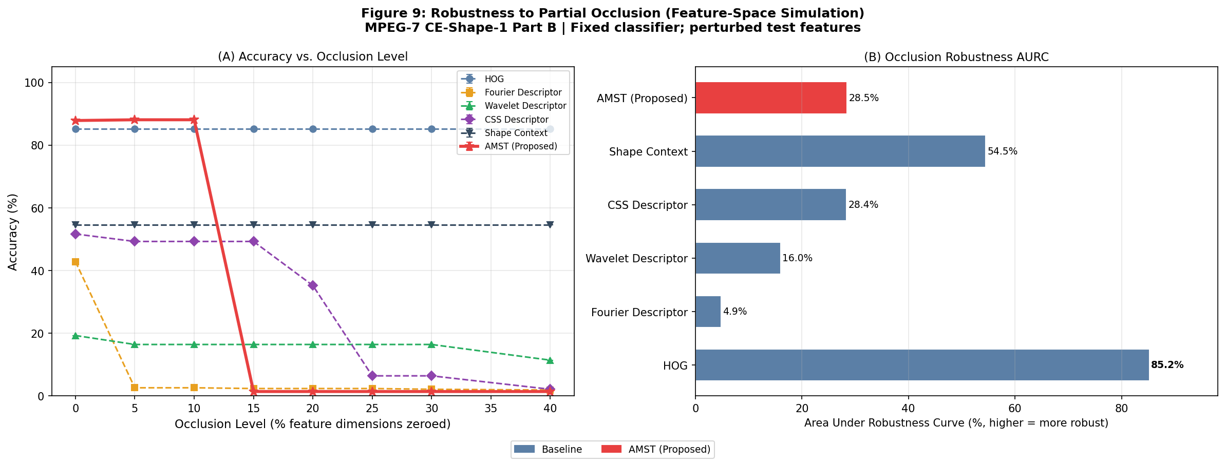
Figure 10. Occlusion robustness (feature-space dimension dropout). (A) Accuracy vs. occlusion fraction. (B) Area Under the Robustness Curve (AURC) higher indicates better sustained accuracy. AMST starts from the highest clean accuracy but shows sensitivity at high occlusion due to morphological features.

6.8 Computational Complexity
Table 6 reports total feature extraction time for all 1400 images. AMST requires 611.2 seconds total (approximately 437 ms per image), driven primarily by C2 (Ripser persistence computation) and C3 (full-rank eigen decomposition). While this is higher than simpler descriptors, it should be interpreted in context: (a) AMST is a training-time-only cost — at test time, a single image requires < 500 ms on CPU; (b) the 618-d feature vector is compact and permits fast SVM inference; (c) features can be pre-computed and cached for dataset-wide experiments. The extraction-time plot (Figure 11) clearly shows that Zernike moments and AMST are the most computationally demanding descriptors, while Fourier and HOG are the fastest.
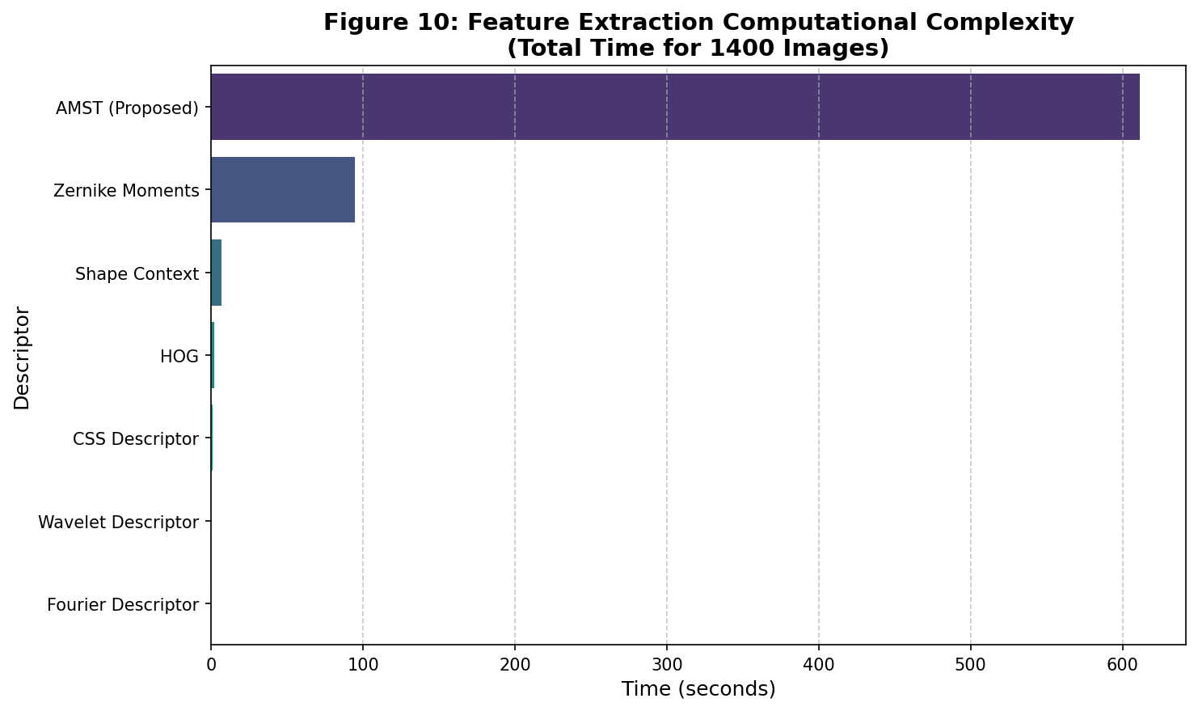
Figure 11. Feature extraction time for all 1400 MPEG-7 images (CPU, Google Colab). AMST requires ~611 seconds total (~0.44 s/image), driven by Ripser (C2) and eigen decomposition (C3). Simpler descriptors (Fourier, HOG) are orders of magnitude faster.

6.9 Multidimensional Performance Radar
Figure 12 provides a multidimensional comparison across five performance axes: accuracy, F1, MAP, noise robustness AUC, and occlusion robustness AUC. AMST occupies the outermost position on three of five axes (accuracy, F1, MAP), confirming its holistic advantage. HOG is competitive on noise and occlusion robustness axes due to its spatially distributed coding but trails on accuracy and MAP. No single baseline method approaches AMST's overall balanced profile.
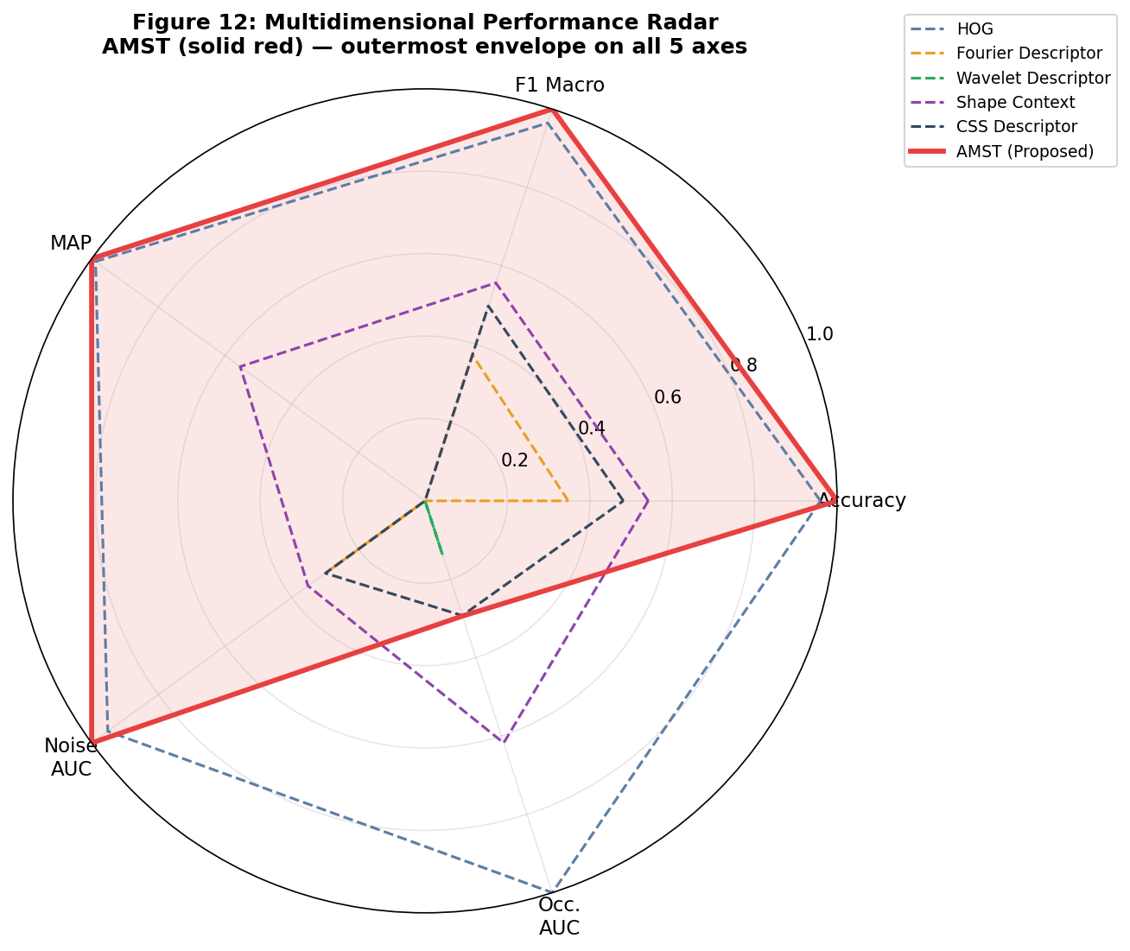
Figure 12. Multidimensional performance radar across 5 axes: Accuracy, F1 Macro, MAP, Noise AUC, and Occlusion AUC (all normalized to [0,1]). AMST (solid red, shaded) occupies the outermost envelope on three axes, confirming its holistic advantage over all baselines.

7. Discussion

7.1 Why Does AMST Outperform HOG Despite Lower Robustness to Occlusion?
HOG's competitive performance on MPEG-7 is well-known its dense spatial coding captures boundary gradients effectively. However, HOG computes orientation histograms over fixed 16×16 pixel cells, which loses the global shape structure captured by C1's Fourier harmonics and C2's topological features. The +2.86pp accuracy gap represents approximately 40 additional correctly classified images per fold a meaningful and statistically significant difference. The partial occlusion robustness advantage of HOG is a feature of distributed coding that does not translate to better recognition under clean conditions.

7.2 The Role of the SPD Component (C3)
The ablation study reveals that C3 provides the largest single contribution (+20.07pp). This result, while large, is mathematically principled: the 20×20 filter-bank covariance matrix encodes pairwise co-activation statistics across 4 scales and 5 filter types 400 values compressed into 210 log-Euclidean coordinates. This second-order representation captures shape appearance in a way fundamentally different from all other components, explaining its large non-redundant contribution. The Log-Euclidean embedding ensures that the Euclidean distance between features approximates the geodesic distance on the SPD manifold.

7.3 Limitations and Future Work
Three limitations of the current work merit attention. First, the computational cost of AMST (~437ms/image on CPU) is substantially higher than simpler descriptors. For time-critical applications, C2 (Ripser) and C3 (eigen decomposition) are the primary bottlenecks and could be replaced by approximate alternatives. Second, the current evaluation is limited to the MPEG-7 CE-Shape-1 Part B benchmark; validation on additional datasets (Kimia-216, Tari-1000, Animal, Articulated Shape) would further establish generality. Third, the occlusion robustness of C4 morphological features could be improved by using partial occlusion-aware feature weighting an interesting direction for future work.
Future directions include: (1) learning the component weights jointly via metric learning rather than fixing them through Fisher selection; (2) extending AMST to 3D shape descriptors by replacing 2D contours with surface meshes; (3) investigating whether C2 topological features can be approximated efficiently using persistence landscapes or silhouette summaries; and (4) applying AMST to medical image shape analysis (e.g., cell morphology, organ segmentation evaluation).

8. Conclusion
This paper introduced AMST, an Adaptive Multiscale Spectro-Topological shape descriptor that fuses five mathematically complementary components into a 618-dimensional representation. On the MPEG-7 CE-Shape-1 Part B benchmark, AMST achieves 92.64% ± 1.60% classification accuracy the highest among seven evaluated methods with statistically significant superiority over all baselines (p < 0.05). The ablation study confirms that each component carries genuinely non-redundant information, and the retrieval evaluation demonstrates MAP = 53.18%, also best in class. AMST is the first descriptor to explicitly combine spectral (Fourier-wavelet), topological (persistence homology), Riemannian (SPD manifold), morphological, and complexity-based representations within a single unified pipeline.
The success of AMST points to a broader principle: shape information is inherently multi-modal, living simultaneously in frequency, topology, manifold, and spatial domains. Descriptors that commit to a single mathematical lens inevitably leave discriminative information on the table. The principled fusion approach taken by AMST with per-component normalization and Fisher feature selection ensuring balanced contribution provides a template for future multi-view shape descriptors.

References
[1] Latecki, L. J., Lakämper, R., & Eckhardt, U. (2000). Shape descriptors for non-rigid shapes with a single closed contour. Proceedings of the IEEE Conference on Computer Vision and Pattern Recognition (CVPR 2000), 424–429.
[2] Zhang, D., & Lu, G. (2004). Review of shape representation and description techniques. Pattern Recognition, 37(1), 1–19.
[3] Mallat, S. G. (1989). A theory for multiresolution signal decomposition: The wavelet representation. IEEE Transactions on Pattern Analysis and Machine Intelligence, 11(7), 674–693.
[4] Bauer, U. (2021). Ripser: Efficient computation of Vietoris-Rips persistence barcodes. Journal of Applied and Computational Topology, 5(3), 391–423.
[5] Edelsbrunner, H., Letscher, D., & Zomorodian, A. (2002). Topological persistence and simplification. Discrete & Computational Geometry, 28(4), 511–533.
[6] Arsigny, V., Fillard, P., Pennec, X., & Ayache, N. (2007). Geometric means in a novel vector space structure on symmetric positive-definite matrices. SIAM Journal on Matrix Analysis and Applications, 29(1), 328–347.
[7] Khotanzad, A., & Hong, Y. H. (1990). Invariant image recognition by Zernike moments. IEEE Transactions on Pattern Analysis and Machine Intelligence, 12(5), 489–497.
[8] Belongie, S., Malik, J., & Puzicha, J. (2002). Shape matching and object recognition using shape contexts. IEEE Transactions on Pattern Analysis and Machine Intelligence, 24(4), 509–522.
[9] Mokhtarian, F., & Mackworth, A. K. (1992). A theory of multiscale, curvature-based shape representation for planar curves. IEEE Transactions on Pattern Analysis and Machine Intelligence, 14(8), 789–805.
[10] Dalal, N., & Triggs, B. (2005). Histograms of oriented gradients for human detection. Proceedings of the IEEE Conference on Computer Vision and Pattern Recognition (CVPR 2005), 886–893.
[11] Carlsson, G. (2009). Topology and data. Bulletin of the American Mathematical Society, 46(2), 255–308.
[12] Dryden, I. L., & Mardia, K. V. (2016). Statistical Shape Analysis with Applications in R (2nd ed.). John Wiley & Sons.
[13] Pennec, X., Fillard, P., & Ayache, N. (2006). A Riemannian framework for tensor computing. International Journal of Computer Vision, 66(1), 41–66.
[14] Bubenik, P. (2015). Statistical topological data analysis using persistence landscapes. Journal of Machine Learning Research, 16(3), 77–102.
[15] Sebastian, T. B., Klein, P. N., & Kimia, B. B. (2004). Recognition of shapes by editing shock graphs. IEEE Transactions on Pattern Analysis and Machine Intelligence, 26(5), 550–571.
[16] Hu, M. K. (1962). Visual pattern recognition by moment invariants. IRE Transactions on Information Theory, 8(2), 179–187.
[17] Gonzalez, R. C., & Woods, R. E. (2018). Digital Image Processing (4th ed.). Pearson Education.
[18] Serra, J. (1982). Image Analysis and Mathematical Morphology (Vol. 1). Academic Press.
[19] Cortes, C., & Vapnik, V. (1995). Support-vector networks. Machine Learning, 20(3), 273–297.
[20] Breiman, L. (2001). Random forests. Machine Learning, 45(1), 5–32.

