Python Environment, Package Installation and Jupyter Notebook Setup Guide

Install Python: Open Python .org
Download and install Python 3.11 (64-bit). During installation, enable 'Add Python to PATH'.

select version download python.exe file,
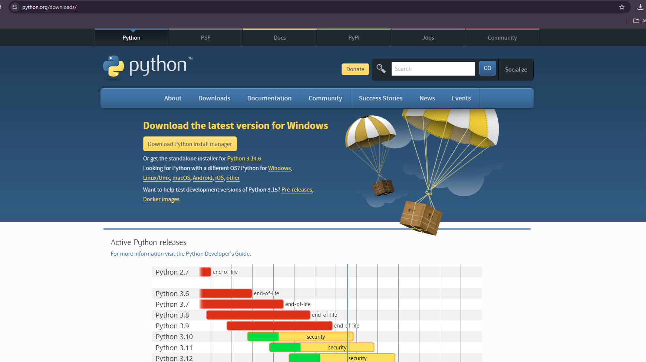

Verify Installation
Open cmd
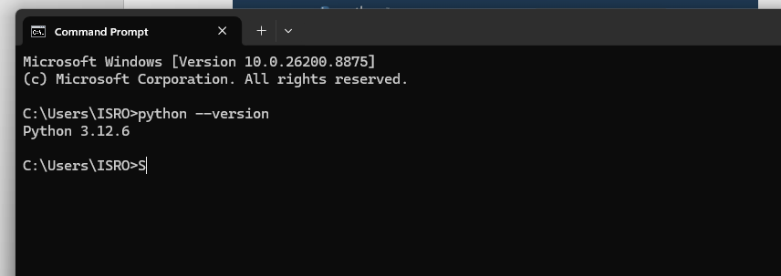
python --versio
pip --version

3. Create a Virtual Environment
- mkdir D:\Projects (create directory)
- cd /d D:\Projects (change to current directory)
- python -m venv vision_env (create virtual environment)

4. Activate the Environment
vision_env\Scripts\activate
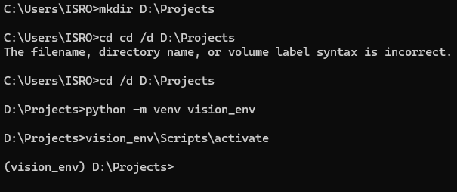

5. Upgrade pip
python -m pip install --upgrade pip

6. Create requirements.txt
Create a file named requirements.txt with the following contents:
torch
torchvision
numpy
pandas
opencv-python
matplotlib
seaborn
scikit-learn
psutil
jupyter
notebook
ipykernel

7. Install Packages from requirements.txt
pip install -r requirements.txt

8. Register the Environment in Jupyter

python -m ipykernel install --user --name vision_env --display-name "Python (vision_env)"

9. Launch Jupyter Notebook

cmd type jupyter notebook

10. Verify Installed Packages
pip list

Code Details
Code1 :
Active learning Pipeline_Entropy.ipynb
github link: https://github.com/HemanthKumarGadi/Sematic-Segmentation-using-Active-Learning-/blob/main/Active%20learning%20Pipeline_Entropy.ipynb
gdrive link: https://drive.google.com/file/d/1d09emWcC-DrIKSfLmKEEwYQx_cQ2Fjrd/view?usp=sharing
Dataset description: open open earth dataset link below & download data files
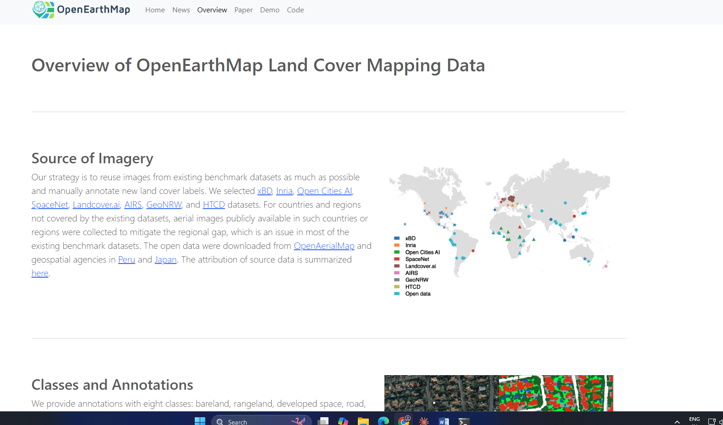
https://open-earth-map.org/overview_oem.html
Data Folders Creation: Take sou folder of images plus ONE source folder of labels (~4300 pairs) and splits them into the four folders the active learning pipeline
Example:
train_data / train_labels 500 pairs ->>>>>> Initial LABELLED pool
val_img / val_lab 100 pairs ->>>>>> Drives early stopping
test_img / test_lab 100 pairs ->>>>>final held-out evaluation
Unlabeled_data / Validation_labels ~3600 ->>>> the QUERY pool

Set Dataset Paths
Modify the following variables before running the program:
BASE_DIR = r"Path" (where output folders need to create)

DATA_ROOT = r"Path" (data folder path)

INITIAL_TRAIN_DATA = os.path.join(DATA_ROOT, "train_data")

INITIAL_TRAIN_LABELS = os.path.join(DATA_ROOT, "train_labels")

UNLABELED_DATA = os.path.join(DATA_ROOT, "Unlabeled_data")

VALIDATION_LABELS = os.path.join(DATA_ROOT, "Validation_labe

Configure Training Parameters:
- Total_iterations = 10
- Samples_per_iteration = 50 (Number of new images selected after every iteration.)

- Num_epochs = 200 ( Training epochs)
- Batch_size = 8 (Training batch size)

- Uncertainty_threshold = 0.5 (Threshold used for reporting high and low uncertainty images).

- Run code using either cmd python active_learning.py or Jupyter notebook (option run all cells)
- For each Active Learning iteration, the pipeline generates the training dataset (train_data, train_labels), predicted segmentation masks, uncertainty heatmaps, high- and low-uncertainty sample folders, validation reports, confusion matrices, training loss curves, class distribution plots, epoch-wise loss logs, and training details.
- After the final iteration, it produces summary visualizations including mIoU progression, training loss progression, class-wise IoU progression, uncertainty progression, training time progression, and the consolidated active_learning_metrics.xlsx report.

Code 2:
Grid search used to find the best hyper parameters based on grid search.
grid_search_lr+miou.ipyndb
github link: https://github.com/HemanthKumarGadi/Sematic-Segmentation-using-Active-Learning-/blob/main/grid_search_lr%2Bmiou.ipynb
gdrive link: https://drive.google.com/file/d/1hwGS6SLAVKar0jo26rM2vp4qgUrAUB3P/view?usp=sharing
- Before running the code, organize the dataset into the required folders: train_data, train_labels, val_img, val_lab, test_img, and test_lab.
- configurable hyperparameter search ranges for patience ([5, 8, 12, 15, 20]), delta ([0.001, 0.01, 0.05]), and learning rate ([0.0001, 0.001, 0.005, 0.01]).

Code3:
Fully supervised code all code with all data, to check overall performance of the model.
Fully Supervised_code. Ipyndb
github link: https://github.com/HemanthKumarGadi/Sematic-Segmentation-using-Active-Learning-/blob/main/Fully%20Supervised_code.ipynb
drive link : https://drive.google.com/file/d/1rxKv5f5zoC8sOaFsE-U6pWLBhrQzoDIo/view?usp=sharing
- Before running the code, organize the dataset into the required folders: train_data, train_labels, Unlabeled_data, Validation_labels, val_img, val_lab, test_img, and test_lab, then update the corresponding dataset paths in the main() function according to your local directory structure.
- The training parameters, including the learning rate (0.0001), were selected based on the optimal hyperparameter configuration obtained through the grid search procedure, while the remaining Active Learning parameters (batch size = 8, training epochs = 100, and 50 samples per iteration) were used in the final implementation.

Code 4:
DCAU_Class_Balance.ipynb
github link : https://github.com/HemanthKumarGadi/Dynamic-Class-Aware-Active-Learning-for-Unbiased-Satellite-Image-Segmentation/blob/main/DCAU_Gamma_Sample_Selection.ipynb
gdrive link: https://drive.google.com/file/d/1eHw9a5xuD9qTUA77f0eeCS08Jxdw6FH_/view?usp=sharing
Before running the code, organize the dataset into the required folders: train_data, train_labels, Unlabeled_data, Validation_labels, val_img, val_lab, test_img, and test_lab, then update the corresponding dataset paths in the main() function according to your local directory structure.
Training parameters, including the learning rate (0.0001), were selected based on the optimal hyperparameter configuration obtained through the grid search procedure, while the remaining DCAU Active Learning parameters (15 iterations, batch size = 8, training epochs = 100, and 50 samples selected per iteration) were used in the final implementation.
DCAU parameters (gamma = 0.5)
Refer below image for path declaration & hyperparameters
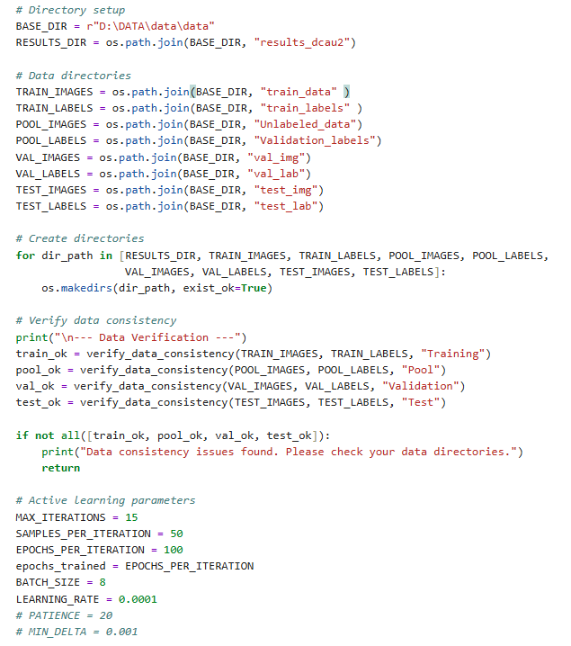

Per Iteration:
- Train UNet model on current training set with class-weighted loss
- Validate on validation set (accuracy, mIoU, class-wise metrics)
- Evaluate on test set for performance tracking
- Select Samples using DCAU:
  - Compute class performance gaps (IoU-based)
  - Generate dynamic class weights
  - Calculate hybrid uncertainty scores (entropy + class-awareness)
  - Select top 50 most uncertain samples from pool
- Move selected samples to training set
- Save model, metrics, plots, and selection logs

Code 5
DCAU_Gamma_Sample_Selection.ipynb
GitHub link: https://github.com/HemanthKumarGadi/Dynamic-Class-Aware-Active-Learning-for-Unbiased-Satellite-Image-Segmentation/blob/main/DCAU_Gamma_Sample_Selection.ipynb
gdrive link: https://drive.google.com/file/d/1R7Yjgb2Oji7_vGQuoijvqnnGUc6M5KyK/view?usp=sharing

Before running the code, organize the dataset into the required folders: train_data, train_labels, Unlabeled_data, Validation_labels, val_img, val_lab, test_img, and test_lab, then update the corresponding dataset paths in the main() function according to your local directory structure.
Training parameters, including the learning rate (0.0001), were selected based on the optimal hyperparameter configuration obtained through the grid search procedure, while the remaining DCAU Active Learning parameters (15 iterations, batch size = 8, training epochs = 100, and 50 samples selected per iteration) were used in the final implementation.
gamma learnable parameter based on model performance

Code 6
AMEAL_Final_Code.ipynb
Github link : https://github.com/HemanthKumarGadi/AMEFAL/blob/main/AMEAL_Final_Code.ipynb
Gdrive link:
https://drive.google.com/file/d/1_hx9af6zNJli6mEpcFp0TkAhgb1-8ArK/view?usp=sharing

It is interactive at startup — it will ask you, via stdin:
1. GPU mode (single / multi)
2. Sampling methods (which of the 3 signals to use, e.g. "1,2,3")
3. DINOv2 config (supervised (1) vs self-supervised (2); multilabel (1) vs LoRA (2))
4. Visualizations (which plot types to produce every iteration 1,2,3,4)
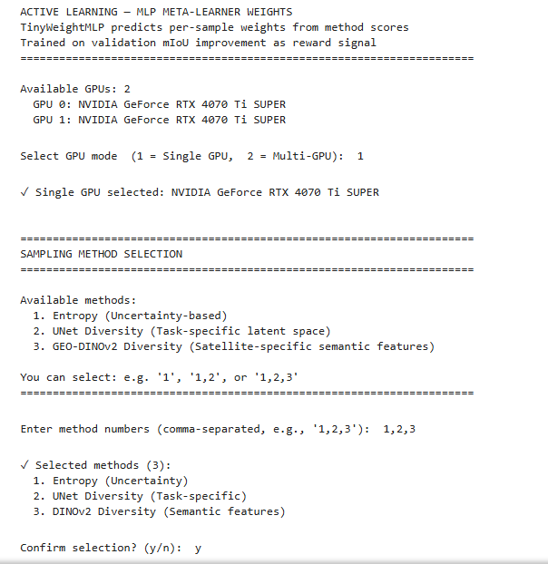
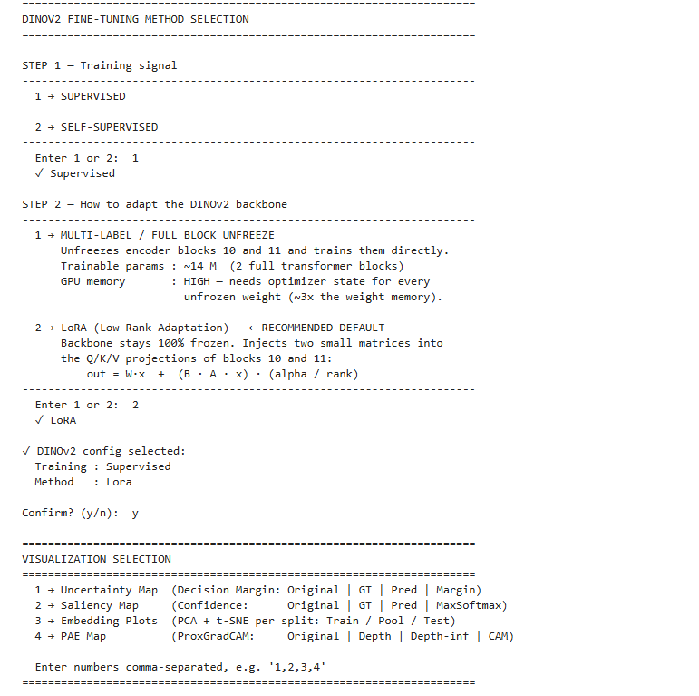

Before running the code, organize the dataset into the required folders: train_data, train_labels, Unlabeled_data, Validation_labels, val_img, val_lab, test_img, and test_lab, then update the corresponding dataset paths in the main() function according to your local directory structure.
Training parameters, including the learning rate (0.0001), were selected based on the optimal hyperparameter configuration obtained through the grid search procedure, while the remaining DCAU Active Learning parameters (15 iterations, batch size = 8, training epochs = 100, and 50 samples selected per iteration) were used in the final implementation.

Code 7:
AMEFAL_LOVEDA_Updated_8_Class.ipynb
Github link: https://github.com/HemanthKumarGadi/AMEFAL/blob/main/AMEFAL_LOVEDA_Updated_8_Class.ipynb
Drive link: https://drive.google.com/file/d/1wbFohI6NHbZtPsPOTptpxUMv8h4oKgDC/view?usp=sharing
Code is similar to AMEFAL change is dataset, apart form that all are same

