**Project Design Phase-II**

**Data Flow Diagram & User Stories**

|  |  |
| --- | --- |
| Date | 31 January 2025 |
| Team ID | LTVIP2025TMID53097 |
| Project Name | OrderOnTheGo- Your On-Demand Food Ordering Solution |
| Maximum Marks | 4 Marks |

**Data Flow Diagrams:**

A Data Flow Diagram (DFD) is a traditional visual representation of the information flows within a system. A neat and clear DFD can depict the right amount of the system requirement graphically. It shows how data enters and leaves the system, what changes the information, and where data is stored.

**Example:** [**(Simplified)**](https://developer.ibm.com/patterns/visualize-unstructured-text/)

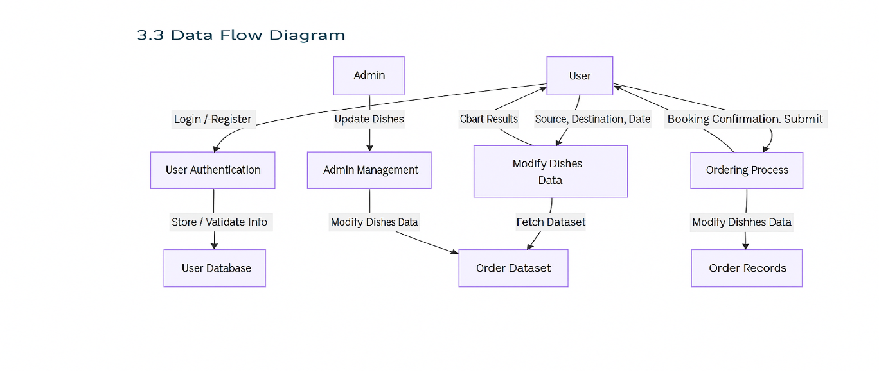

**User Stories**

Use the below template to list all the user stories for the product.

| **User Type** | **Functional Requirement (Epic)** | **User Story Number** | **User Story / Task** | **Acceptance criteria** | **Priority** | **Release** |
| --- | --- | --- | --- | --- | --- | --- |
| Customer (Mobile user) | Registration | USN-1 | As a user, I can register for the application by entering my email, password, and confirming my password. | I can access my account / dashboard | High | Sprint-1 |
|  |  | USN-2 | As a user, I will receive confirmation email once I have registered for the application | I can receive confirmation email & click confirm | High | Sprint-1 |
|  |  | USN-3 | As a user, I can register for the application through Facebook | I can register & access the dashboard with Facebook Login | Low | Sprint-2 |
|  |  | USN-4 | As a user, I can register for the application through Gmail |  | Medium | Sprint-1 |
|  | Login | USN-5 | As a user, I can log into the application by entering email & password |  | High | Sprint-1 |
|  | Dashboard |  |  |  |  |  |
| Customer (Web user) |  |  |  |  |  |  |
| Customer Care Executive |  |  |  |  |  |  |
| Administrator |  |  |  |  |  |  |
|  |  |  |  |  |  |  |
|  |  |  |  |  |  |  |
|  |  |  |  |  |  |  |

|  |  |  |  |  |  |  |
| --- | --- | --- | --- | --- | --- | --- |
| User Type | Functional Requirement (Epic) | User Story Number | User Story / Task | Acceptance criteria | Priority | Release |
| Customer | Registration | USN-1 | As a user, I can register with email and password | Account created, redirected to dashboard | High | Sprint-1 |
| Customer | Registration | USN-2 | As a user, I receive a confirmation email | Confirmation email received and verified | High | Sprint-1 |
| Customer | Registration | USN-3 | As a user, I can register using Facebook | Facebook login success, user logged in | Low | Sprint-2 |
| Customer | Registration | USN-4 | As a user, I can register using Gmail | Gmail login success, user logged in | Medium | Sprint-1 |
| Customer | Login | USN-5 | As a user, I can log in with email & password | Access to dashboard after login | High | Sprint-1 |
| Customer | Browse Menu | USN-6 | As a user, I can browse dishes by cuisine, restaurant, or reviews | Filtered list of dishes displayed | High | Sprint-2 |
| Customer | Add to Cart | USN-7 | As a user, I can add items to my cart | Selected items stored in cart | High | Sprint-2 |
| Customer | Place Order | USN-8 | As a user, I can place an order with delivery address and payment method | Order confirmation screen shown with delivery ETA | High | Sprint-2 |
| Customer | Order Tracking | USN-9 | As a user, I can track my order status | Real-time updates of order status | Medium | Sprint-3 |
| Customer | Review System | USN-10 | As a user, I can leave reviews after receiving the order | Rating and comments stored and shown | Medium | Sprint-3 |
| Admin | Admin Login | USN-11 | As an admin, I can log in to the admin dashboard | Access to admin panel | High | Sprint-1 |
| Admin | Manage Users | USN-12 | As an admin, I can view, block, or delete user accounts | Admin can take action on user list | High | Sprint-2 |
| Admin | Manage Restaurants | USN-13 | As an admin, I can approve or reject restaurant partners | Admin sees list and changes status | High | Sprint-2 |
| Admin | Manage Orders | USN-14 | As an admin, I can view all user orders and statuses | Order logs viewable with user/order filters | Medium | Sprint-3 |
| Customer Support Agent | Order Assistance | USN-15 | As a support agent, I can search for user orders and assist | Search by order ID/email and respond | Medium | Sprint-3 |
| Customer Support Agent | Issue Logging | USN-16 | As a support agent, I can log issues reported by users | Issues stored in a ticket system for follow-up | Medium | Sprint-3 |