**Assignment-7 :Hemanth Reddy**

TensorFlow is an open-source software library for machine learning and artificial intelligence that focuses on training and inference of deep neural networks. You can install the latest version of TensorFlow on your local machine by selecting any installed python3 or conda3 module and installing it in your home directory Turn in the path of the command/python script and the screenshot to display the version and location of the TensorFlow you have installed.

A:

To install tensorflow: pip3 install tensorflow

Below is the screenshot :

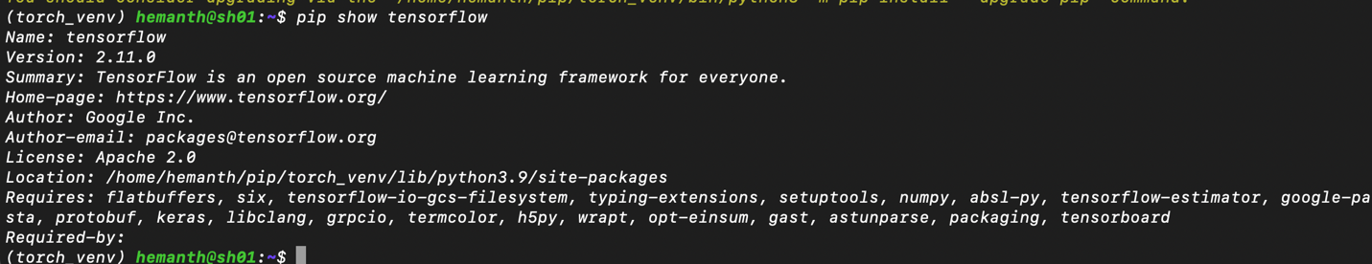

**Re-deploy individual WS:**

**hemanth@sh01**:**~**$ aws ec2 create-image --region us-east-1 --instance-id i-0f8ebb12c5c8d9c70 --name "csye-hemanth-c04"--no-reboot

{

"ImageId": "ami-0e14a3e4433783c68"

}



**Remove the slurmctld.service and slurmdbd.service services using the following commands:**

sudo systemctl stop slurmctld.service

sudo systemctl disable slurmctld.service

sudo systemctl stop slurmdbd.service

sudo systemctl disable slurmdbd.service

**Set cron job to only start EC2 at your work period**

Crontab -e

0 9-17 * * 1-5 aws ec2 start-instances --instance-ids i-0c6276a8edcfff6c5

0 18 * * 1-5 aws ec2 stop-instances --instance-ids i-0c6276a8edcfff6c5

0 9 * * 1-5 ssh -i "~/CSYE7374Spring23.pem" [ubuntu@](mailto:ubuntu@ec2-100-24-59-134.compute-1.amazonaws.com) [ec2-3-88-10-75.compute-1.amazonaws.com](http://ec2-18-212-162-236.compute-1.amazonaws.com)

0 18 * * 1-5 echo "exit" | ssh -i "~/CSYE7374Spring23.pem" [ubuntu@](mailto:ubuntu@ec2-100-24-59-134.compute-1.amazonaws.com) [ec2-3-88-10-75.compute-1.amazonaws.com](http://ec2-18-212-162-236.compute-1.amazonaws.com)

**The patching script is a custom script that contains the necessary commands to patch the OS.**

**Step-1: nano patching_script.sh**

#!/bin/bash

# Update the package lists

sudo apt-get update

# Upgrade the packages

sudo apt-get upgrade -y

# Clean up the package cache

sudo apt-get clean

sudo apt-get autoclean

sudo apt-get autoremove -y

**Final step:** 0 0 * * 0 ~/ **patching_script.sh (Added this after crontab -e)**

**Re-configure team server (Team) o Remove OS services: slurmctld.service, slurmdbd.service o Remove MYSQL package (apt installed) o Set up cron job to patch the OS every week:**

Remove the **MYSQL** package using the following command:

This command will remove the **mysql-server** package that was previously installed using **apt**.



Set up a cron job to patch the os everyweek

