**AWS Project using SHELL SCRIPTING for DevOps:**

**AWS resource tracker using Shell scripting:**

**Tech stack used: Shell scripting, AWS EC2, S3, LAMBDA, IAM, AWS CLI**

**Project expectation: We are going to write a script which tracks the all aws services that are present in your AWS account and redirect the output to the file which can be used as a reporting dashboard**

**Script:**

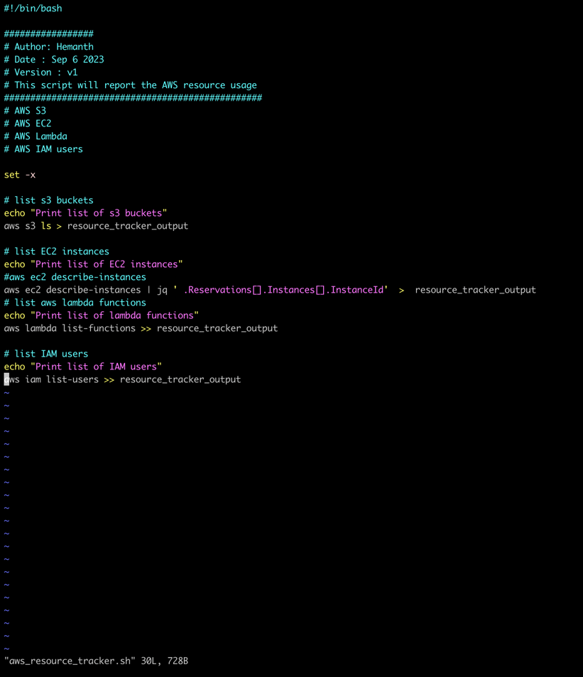

* **We will know the output by running the script :**

**./aws_resource_tracker.sh | more**

* **We can see the output using cat command:**

**Cat resource_tracker_output**

