**Defer**:

A statement that schedules a function call to be run after the function completes.

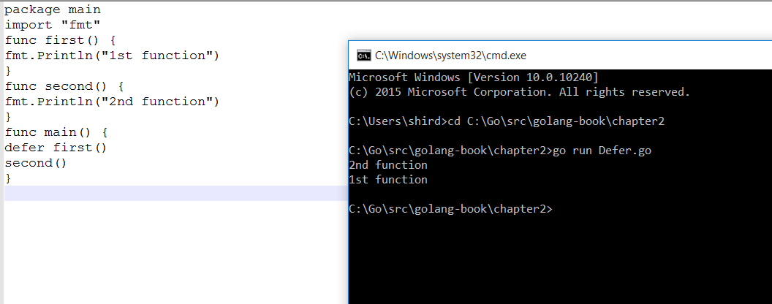

**Panic**:

Causes a runtime error and immediately stops the execution of the function.

**Recover**:

It stops the panic and returns the value that’s passed to call the Panic.

*Pairing the built in recover function with defer will help us recover from a runtime panic. Recover should be called under Defer function.*

