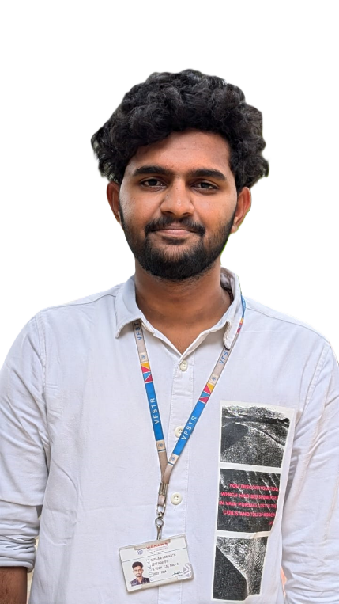

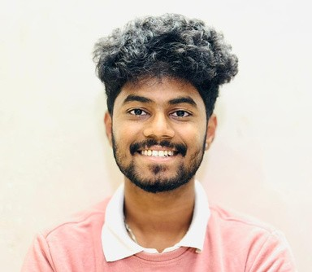

[HEMANTH SEELAM](https://www.canva.com/design/DAF4DSRFNCs/tL1gelwnHZ5x2F2gdhpcEA/edit?utm_content=DAF4DSRFNCs&utm_campaign=designshare&utm_medium=link2&utm_source=sharebutton)

SUMMARY

A positive and simple approach to problem solving.. I believe teamwork does the dream work. Forward-thinking computer science student with solid technical and requirements gathering skills. Good verbal and written communication, project planning and organizational skills.

# EDUCATION

## Vignan Foundation for Science, Technology & Research- Guntur

B. Tech - Computer Science and Engineering

7.7 **CGPA currently**

2022 – 2026

## Sri Chaitanya Chilakaluripet .

Intermediate - MPC 80 **CGPA**

2020 – 2022

## St. Charles Chilakaluripet

10th-SSC

9.5 **CGPA**

2019-2020

# SKILLS

JAVA SQL

Python

C

# CERTIFICATIONS

Accenture certified of Data Analytics and Visualization job stimulation on Forage

Certificate of Completion Database Management System Excellence from Udemy.

* Certified in “Preliminary English test (level A2)” at Vignan University conducted by Cambridge University in 2019.

# HOBBIES

Travelling Photography Playing sports Dancing

# REAL TIME EXPERIENCE

## Have built Cold drink vending machine to help small scale merchants in the society

## Have good communication skills and have delivered many presentations at school

## Captained to my state in National level cricket league for under 16 & also vice-captained in district level softball tournament for 3 times.

## Completed 2 months course in Web Technology in TechnoHacks 1) Created a calculator using HTML. 2) Created a Currency Convertor in HTML. 3) Created a Landpage using css &HTML.

## I have been the volunteer and coordinator for the college level Cultural events .

## 

## 

# CONTACT

+91-8919029249 

hem4691.vu@gmail.com  Guntur, India