Cyber Bullying Detection Using Machine Learning Techniques

Abstract: As the cyberbullying has become more prevalent a lot of attention is brought to cyberbullying detection as cyberbullying has deadly effect on both the users of social media platforms society .Social media has become the medium for lot of people to share views ,information etc.it would have been one of the best thing if it would not have become a tool for lot of people to take revenges, manipulate others or harass and humiliate others. So we t need a monitoring system to control these types of misbehavior and bullying that spread around social networks which has led to development of this model to automate the detection of cyberbullying. Our major objective is to make a model that classifies the comments as positive and negative. For this we have to develop a machinelearning model that uses Naïve bayes ,Random Forest and J48 for dimensionality reduction and detection of cyberbullying in Twitter data
Keywords: Cyber Bullying, Sentiment Analysis , Personality Analysis.

Introduction
Cyber Bullying is simply bullying or harassing other people through various Social Media platforms .As being the Technological Era the usage of Social Media has increased very rapidly to the point where more than half of the worlds population are using these. As its usage has increased a piece of news or some other information is getting known by others with in seconds .This has become one of the most important usage of it .But some people had taken this as an advantage and started seeking excitement from it .From this point the cyberbullying has started and increased rapidly.
Cyberbullying is known as an unnoticed crime and there are many victims who have been bullied online through toxic comments. Some statistics show that as many as 50% of children have experienced cyberbullying. Victims of cyberbullying can experience wide-ranging effects, including mental health issues, poor academic performance, a desire to drop out of school, and even suicidal ideation. Even though many victims face this, many of them are not being registered because of social status and other reasons and are being unnoticed. Cyberbullying also tarnishes the image of a person. It hampers their reputation with the false rumors spread about them. Nearly 8 out of 10 children are being subjected to these various cyberbullying. Cyberbullying detection using machine learning involves using algorithms and statistical models to identify and classify instances of online harassment, abuse, and bullying. This process typically involves training a model on a large dataset of examples of cyberbullying, along with examples of non-cyberbullying text. The model can then be used to make predictions about whether new instances of online text are likely to be cyberbullying. The features that the model considers when making these predictions can include Personality Analysis ,Sentiment Analysis and User Traits. The goal of this approach is to provide a fast, scalable, and automated way to detect and address cyberbullying, so that online communities can be safer and more supportive for everyone.

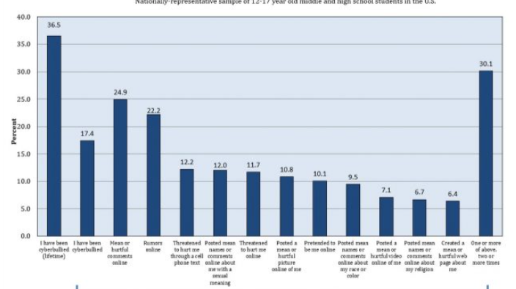

Fig.1.CyberBullying Victimization and Reasons

There has been a lot of cyberbullying cases which range from a mother taking revenge for her kid which lead to the sucide of thirteen year old young girl to users bullying others for seeking excitement.Intially this has been taken lightly and there were no laws for it.But it has increased rapidly and many people are victims of it .Even though there are a lot of laws that are used to punish the those who bully others.Even so the number of has never decreased. So we are going for a prevention strategy where we would be using a machine learning model to identify the words are sentences that are used to harm or harass others and then we are going to replace them with positive comments.we are going to use the concept of ensemble algorithms here which increases the accuracy of the model.

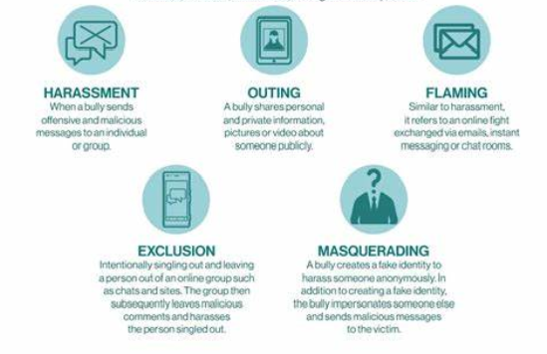

Fig.2.Types of CyberBullying

RESEARCH OBJECTIVES

- We would be using various machine Learning Techniques to build a model that accurately identifies instances of cyberbullying.
- To develop a model that Classifies the type of cyberbullying being used .Various types of cyberbullying being harassment, threats, spreading rumors ,Flaming etc.
- To train and test the model using the twitter dataset that is available online.
- The dataset consists of both positive and negative contexts of cyberbullying.
- The primary objective is to reduce the rate of cyberbullying.
- Optimize the performance of model using ensemble algorithms.

SCOPE OF THE WORK
The supervised learning model will be used in the system. The dataset will have two sets of data collected both positive and negative context of cyberbullying .The proposed approach will detect the cyberbullying and change those comments into positive ones. We'll use various algorithms like naïve bayes, random forest and decision tree learning.

PROBLEM STATEMENT
Cyber bullying is the use of various social media platforms to manipulate, torment, or harass someone ,it is a growing problem in present technological era. With the increased usage of social media and other online platforms, cyber bullying has increased a lot and it lead a lot of severe problems in victims like depression inferiority complex and even suicides . The challenge is to develop a model that can detect the instances of cyber bullying and other sentiments and traits like humor, sarcasm, and disagreement, while also considering the sentimental, linguistic, and contextual differences of the content. The model should also be able to handle the large amount of data that increases rapidly and operate in real-time without violating the privacy and security standards.

LITERATURE SURVEY

Machine Learning has various sets of algorithms which are used to develop different kinds of predictive models .This has made lot of problems simpler one such problem is cyberbullying detection .As the usage of social media platforms increased cyberbullying has become more prevalent .As detection of cyberbullying includes large amount of data that increases rapidly ,we need a model that detects the cyberbullying context in real time. It can be made possible by using the Machine learning algorithms like naive Bayes ,Decision tree and Random forest and to optimize the model we would be using ensemble algorithms

RELATED WORK:

- Al-garadi, M. A. Varathan, K. D., & Ravana, S. D. (2016). Cybercrime detection in online communications: The experimental case of cyberbullying detection in the Twitter network.
- Andreas Weiler et al , studied the run-time and task-based performance of several state-of the art event detection techniques for Twitter. The authors presented a two-pronged approach.
- A study proposed an approach for offensive language detection that was equipped with a lexical syntactic feature and demonstrated a higher precision than the traditional learning-based approach (Chen, Zhou, Zhu, & Xu, 2012). A YouTube data-based study (Dadvar, Trieschnigg, Ordelman, & de Jong, 2013) applied SVM to detect cyberbullying, and determined that incorporating user-based content improved the
detection accuracy of SVM. Using data sets from MySpace, Dadvar et al.
- Hannah L. Schacter at al examined how cyber victims' disclosures on Facebook influence bystanders' attributions of blame, empathy, and intention to intervene on behalf of a victim following a cyberbullying incident. Participants of 118 numbers have been randomly assigned to view the Facebook profile of a cyber-victim who posted an update ranging in personal disclosure and valence. Their results indicated that viewing the high disclosure profile regardless of valence, caused participants to blame the victim more and feel less empathy for the victim, which in turn predicted lower likelihood of bystander intervention with the bullying incident.
- Hosein Jafarkarimi et al identified the influential factors that have impact on individuals' ethical decision-making and also proposed a model of the factors that are significant in the ethical decision-making process in the SNS context. Their study employed the Theory of Planned Behavior (TPB). A scenario based questionnaire has been used to predict the behavioral intention, which included personal normative beliefs, moral intensity and perceived threat of legal punishment to the main constructs of TPB namely attitude, subjective norms, and perceived behavioral control. The probable effect on the proposed model has been investigated by moderating effects of several factors, including age, gender, level of income, ego strength, locus of control and religion.
- Matthew Pittman and Brandon Reich used a mixed-design survey to test the potential possibility of image-based platforms such as Instagram and Snapchat and text-based platforms such as Twitter and Yik Yak, in ameliorating loneliness due to the enhanced intimacy they offer. Their study has been made on young adults as this population is at once most likely to use social media and to suffer from loneliness. Their quantitative results suggested that loneliness may decrease, while happiness and satisfaction with life may increase, as a function of image-based social media use. In contrast, text-based media use appears ineffectual. Qualitative results suggested that the observed effects were being due to the enhanced intimacy offered by image based social media use
- .Kassandra Gahagan investigated the experience of the college students with various social media cyberbullying on Social Networking Sites (SNS). College students of 196 numbers from a north western university have participated in the study. Their study revealed that19% of the college students had been bullied on SNS and 46% indicated that they had witnessed cyberbullying on SNS. 61% of the college students who witnessed cyberbullying on SNS did nothing to intervene. In their study, the college students were also questioned about their perceived responsibility
when they witnessed cyberbullying on SNS. Two
diverging themes have been emerged that indicated
some college students believed their responsibility
to intervene was circumstantial, while others
supposed that there is a constant clear level of
responsibility for college student cyberbullying
bystanders on SNS.

METHODOLOGY

We use various machine learning algorithms together to detect the context of cyberbullying .Here we will be using a supervised machine learning model as the dataset is of labeled data .The dataset has both the positive comments and negative comments .we will be using various algorithms like naïve bayes ,Random Forest and decision tree .Next we are going to combine all these using ensemble algorithms which are going to give us the optimized output .The performance also increases .Along the bunch of words here we would be concentrating on personality analysis .
The dataset is first collected, then divided into two halves. Training accounts for 75% of the time while testing accounts for 25%. Then, various machine learning techniques are used to build the model .Then this model is used to predict the context of cyberbullying.

MODEL DESCRIPTION:

Building a machine learning model to identify cyber bullying requires several steps:
Data Collection:
Collect a large and diverse dataset of text (such as social media posts or online comments) that contain instances of cyber bullying and noncyber bullying examples.
Data Preprocessing:
Clean the data by removing any irrelevant information, such as URLs, and perform any necessary text normalization, such as converting all text to lowercase.
Feature Engineering:
Decide on the features that the model will use to make its predictions. In the case of text classification, this usually involves creating numerical representations of the text, such as using term frequency-inverse document frequency (TF-IDF) or word embedding’s.
Model Selection:
Choose an appropriate machine learning algorithm for the task of text classification, such as a support vector machine (SVM), a neural network, or a random forest.
Model Training:
Train the model on the preprocessed and feature-engineered data. This involves providing the model with the features and corresponding labels (e.g., cyber bullying or non-cyber bullying) for each instance in the training data.
Model Evaluation:
Evaluate the performance of the model by testing it on a heldout test set and computing metrics such as accuracy, precision, recall, and F1 score.

Model Fine-tuning:
If necessary, fine-tune the model by adjusting its parameters or trying a different algorithm, and then repeat the evaluation step.

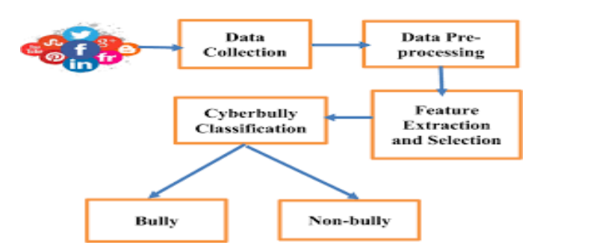

B Cyber bullying detection Model :
- Import all the modules required such as numpy , pandas , matplotlib , sklearn , Tensorflow.
- Load the cyberbullying dataset and extract the attributes.
- Perform the necessary preprocessing techniques and analyze the data.
- Split the dataset into training and testing data.
- Perform training the machine learning model using Ensemble learning, Naïve Bayes, SVM, K Nearest Neighbors, Logistic Regression.
- Compare the accuracies of the algorithms and use the best algorithm for prediction.
- Predict the new data using the algorithm which obtained better accuracy.

3.4 DATASET DESCRIPTION:

EXPERIMENTS AND RESULTS

IMPORTING LIBRARIES AND LOADING DATASET:

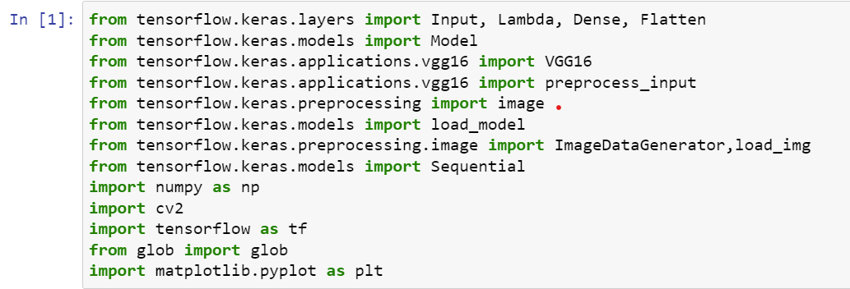

Here, we are resizing the image size and taking the path of the train and test set.

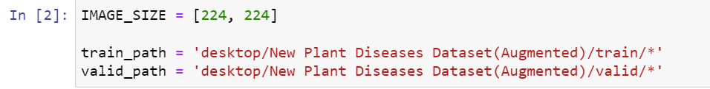

VGG16(Transfer Learning):

Here we are using VGG16, we will be using image net as weights and here 3 indicates a channel that is RGB, to make it an RGB channel we use 3 indexes.

Summary of model:

Here, we have our own input in the first layer we are giving our own images and in the last layer, we have to add an output layer based on the output category we have.

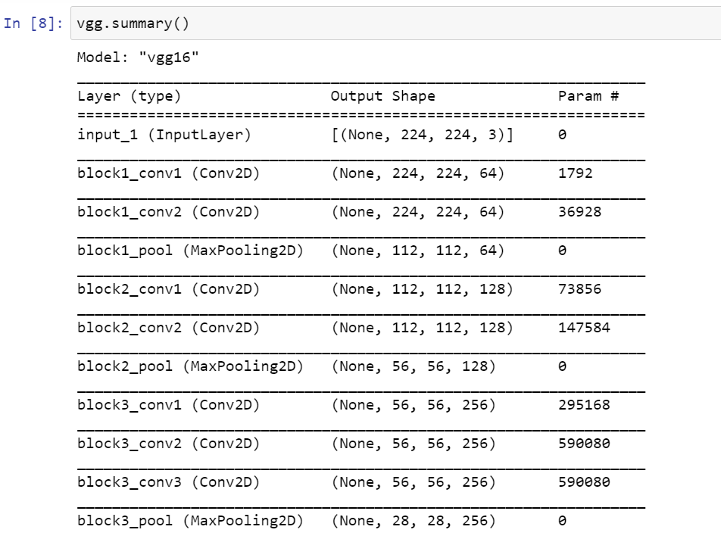
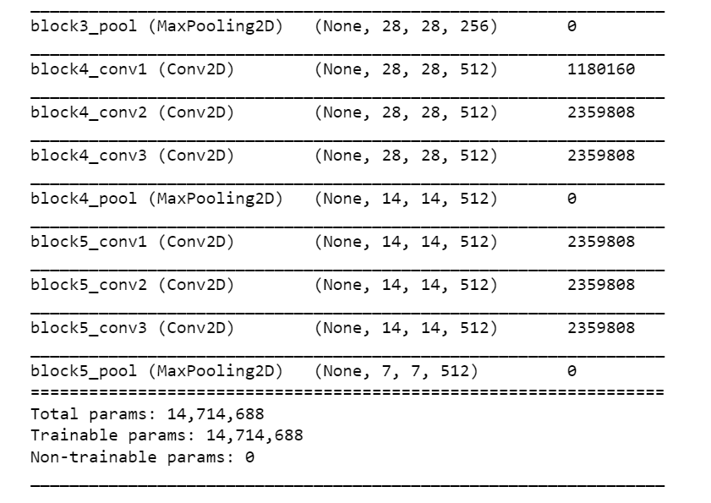

Glob function:

It indicates how many number of folders we have (number of categories we have in our NN).
As we see below, it shows the number of folders are 10, so our output layer had 10 categories.
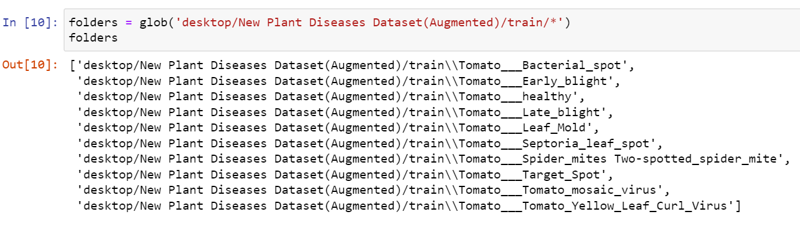
Flattening the output:

A single lengthy feature vector is created using the flattening() method and joined to a fully-connected layer (converts 2D into 1D).

Adding dense layer as output:

We are using len(folder) which indicates the length of folders is 10. Activation function we have used softmax because the type of problem is classification.

Model creation:

Summary of model:

Dense layer is used which is our output layer with 3 categories.

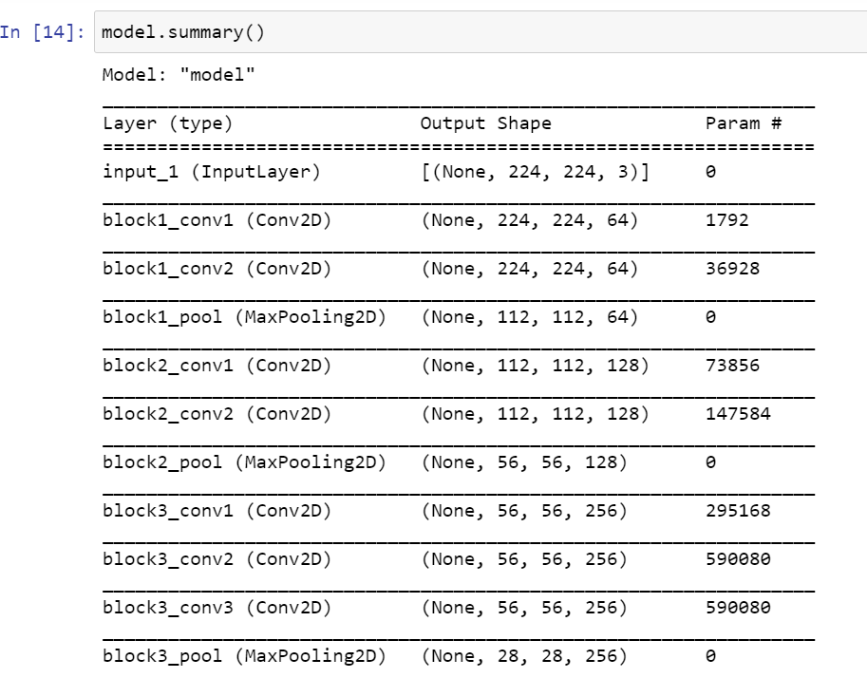

Compiling the model:

Here our output layer has categories, type of classification problem.

Data Augmentation:

Here we are using Image Generator to read the images from the folder and apply data augmentation like scaling, zooming, horizontal flipping, and vertical flipping. Below we are rescaling the pixel of an image as we know each pixel ranges between 0 to 255, to convert the pixel between 0 to 1 we are rescaling the pixel.

RESULT:

CONCLUSION AND FUTURE WORK
Along with the laws that are used to punish those people who cause cyber violence having an system that automatically detects the context of cyberbullying and changes it into a positive comment will be of great help as the saying goes prevention is the best .Using this will prevent lot of people from depression ,low self-esteem and also suicides.it also never let the users to use the social media as a tool to humiliate or bully others .The cyberbullying detecting system will lead to healthy environment on social media .It can be embedded into all social media and messaging apps.

REFERENCES

BASE PAPER:

- Improving Cyberbullying Detection using Twitter Users’ Psychological Features and Machine Learning
- Date Added to ELSEVIER: 31 December 2019
- Publisher: ELSEVIER
- Authors: Vimala Balakrishnan Ph.D , Shahzaib Khan , Hamid R. Arabnia Ph.D
Cyberbullying is the act of using technology, such as the internet and smartphones, to harass, humiliate, threaten, or intimidate someone. It can take many forms, including mean and hurtful messages, spreading rumors or lies, sharing personal information or photos without consent, and creating fake social media profiles. The impact of cyberbullying can be severe, leading to emotional distress and even mental health problems.

LIST OF REFERENCE PAPERS

- ALBayari, Reem, Sharif Abdullah, and Said A. Salloum. "Cyberbullying classification methods for Arabic: A systematic review." Proceedings of the International Conference on Artificial Intelligence and Computer Vision (AICV2021). Cham: Springer International Publishing, 2021.
- Gencoglu, Oguzhan. "Cyberbullying detection with fairness constraints." IEEE Internet Computing 25.1 (2020): 20-29.
- Ali, Wan Noor Hamiza Wan, Masnizah Mohd, and Fariza Fauzi. "Cyberbullying detection: an overview." 2018 Cyber Resilience Conference (CRC). IEEE, 2018.
- Zhao, Rui, Anna Zhou, and Kezhi Mao. "Automatic detection of cyberbullying on social networks based on bullying features." Proceedings of the 17th international conference on distributed computing and networking. 2016
- Dadvar, Maral, et al. "Improving cyberbullying detection with user context." Advances in Information Retrieval: 35th European Conference on IR Research, ECIR 2013, Moscow, Russia, March 24-27, 2013. Proceedings 35. Springer Berlin Heidelberg, 2013

