SVM:

-------------------------------------------------

Training Results for SVM Linear SVC Kernel Model:

Training Accuracy = 0.989

Training Sensitivity = 0.988

Training Precision = 0.988

Training F1 Score = 0.988

Training Recall = 0.988

--------------------------------------------------

Testing Results for SVM Linear SVC Kernel Model:

Testing Accuracy = 0.988

Testing Sensitivity = 0.988

Testing Precision = 0.987

Testing F1 Score = 0.988

Testing Recall = 0.988

--------------------------------------------------

KNN:

--------------------------------------------------

Training Results for KNN Model:

Training Accuracy = 0.999

Training Sensitivity = 0.998

Training Precision = 1.0

Training F1 Score = 0.999

Training Recall = 0.998

--------------------------------------------------

Testing Results for KNN Model:

Testing Accuracy = 0.998

Testing Sensitivity = 0.998

Testing Precision = 0.999

Testing F1 Score = 0.998

Testing Recall = 0.998

--------------------------------------------------

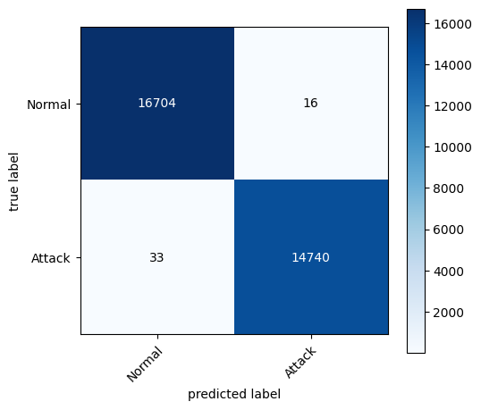

Random Forest:

--------------------------------------------------

Training Results for Random Forest Classifier Model:

Training Accuracy = 0.999

Training Sensitivity = 0.998

Training Precision = 0.999

Training F1 Score = 0.999

Training Recall = 0.998

--------------------------------------------------

Testing Results for Random Forest Classifier Model:

Testing Accuracy = 0.998

Testing Sensitivity = 0.998

Testing Precision = 0.999

Testing F1 Score = 0.998

Testing Recall = 0.998

--------------------------------------------------

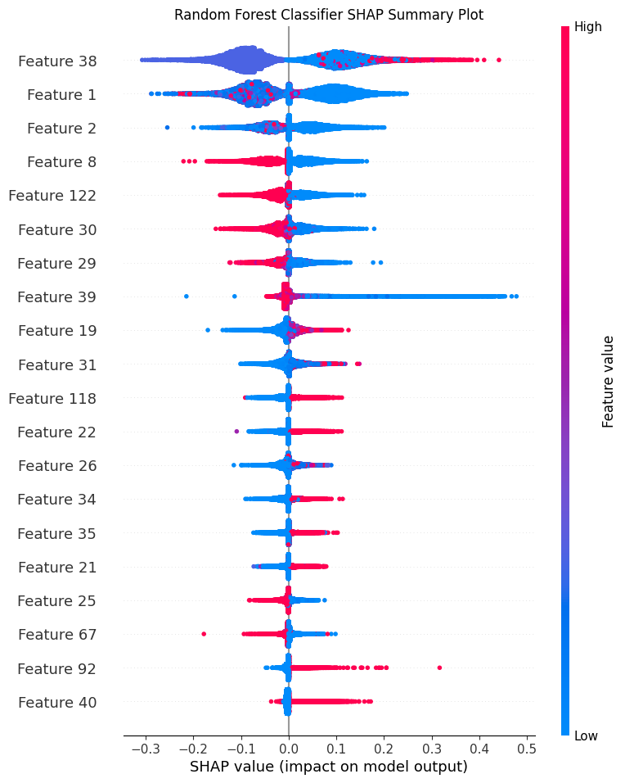

Logistic Regression:

--------------------------------------------------

Training Results for Logistic Regression Model:

Training Accuracy = 0.99

Training Sensitivity = 0.992

Training Precision = 0.987

Training F1 Score = 0.99

Training Recall = 0.992

--------------------------------------------------

Testing Results for Logistic Regression Model:

Testing Accuracy = 0.99

Testing Sensitivity = 0.992

Testing Precision = 0.986

Testing F1 Score = 0.989

Testing Recall = 0.992

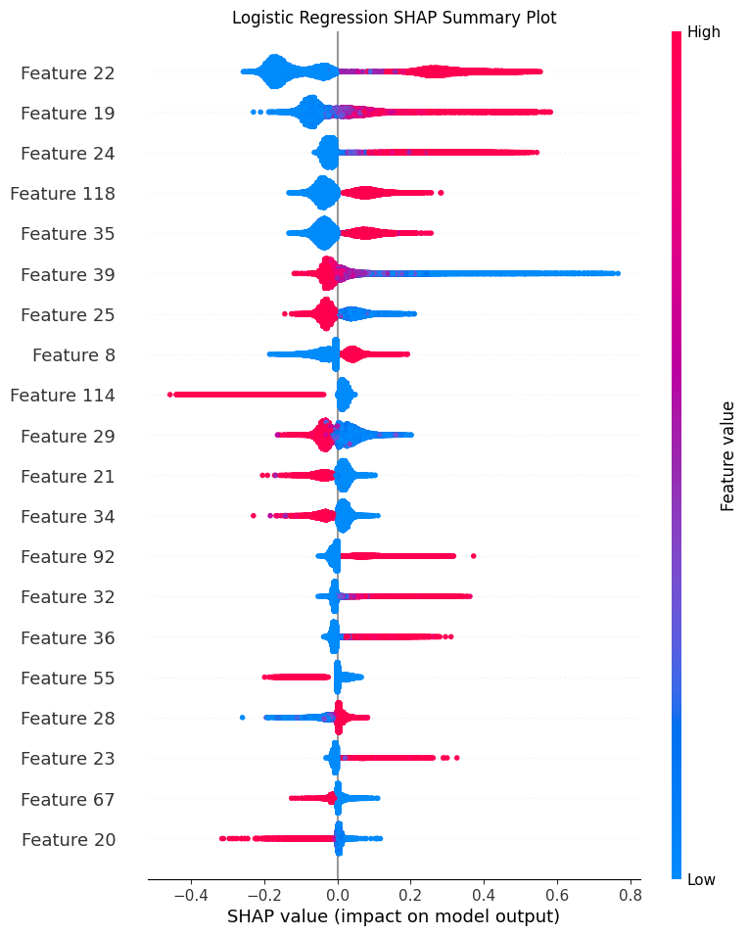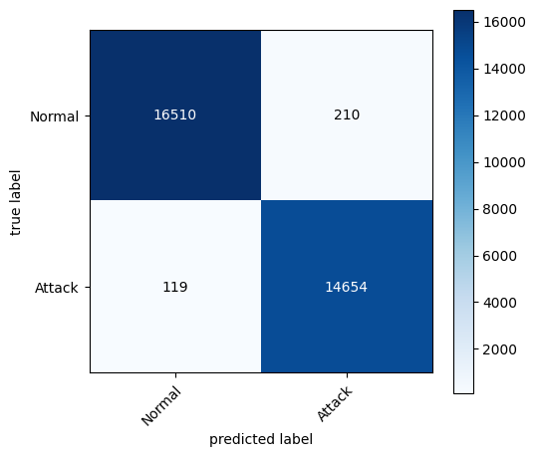

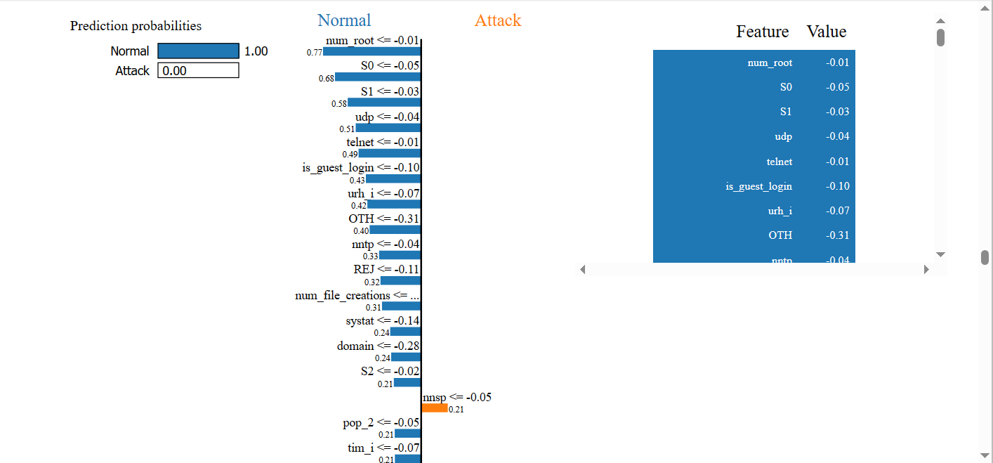

Decision Tree:

--------------------------------------------------

Training Results for Decision Tree Classifier Model:

Training Accuracy = 0.923

Training Sensitivity = 0.914

Training Precision = 0.92

Training F1 Score = 0.917

Training Recall = 0.914

--------------------------------------------------

Testing Results for Decision Tree Classifier Model:

Testing Accuracy = 0.921

Testing Sensitivity = 0.912

Testing Precision = 0.92

Testing F1 Score = 0.916

Testing Recall = 0.912

--------------------------------------------------



