E-COMMERCE CUSTOMER & SALES INTELLIGENCE
Identifying High-Value Customers, Potentially At-Risk Customers and Revenue Opportunities

PROJECT REPORT
AICTE | IBM SkillsBuild Data Analytics with AI Internship 2026
Submitted by
BACHAMGARI HEMANTH GOUD
INTERNSHIP ID: IBMUEDA1255
B.Tech – Electrical & Electronics Engineering
Gokaraju Rangaraju Institute of Engineering and Technology (GRIET)
Hyderabad, Telangana
September 2026

1. Executive Summary
This project presents an E-Commerce Customer & Sales Intelligence solution using the UCI Online Retail dataset. The analysis combines sales performance analysis with RFM (Recency, Frequency and Monetary) customer analysis to identify revenue patterns, customer segments, potentially at-risk customers and areas for business action.
The completed analysis covers data cleaning, exploratory data analysis, customer-level aggregation, RFM scoring and segmentation, business insights, recommendations and an interactive Streamlit dashboard.
The cleaned analysis contains 19,960 distinct orders, 4,338 customers, 4,026 product descriptions and approximately £10.64 million in historical sales revenue. A separate rule-based flag identifies 697 potentially at-risk customers associated with approximately £1.07 million in historical monetary value.

2. Project Objective
The objective is to transform raw e-commerce transaction data into useful business information and customer insights.
- Understand overall revenue and order performance.
- Identify important products and geographic markets by revenue.
- Analyze monthly revenue patterns and seasonal trends.
- Segment customers using Recency, Frequency and Monetary (RFM) measures.
- Identify potentially at-risk customers using the project's completed RFM rule.
- Translate analytical findings into practical business recommendations.
- Present the results through an interactive Streamlit dashboard.

3. Dataset Description
Dataset: UCI Online Retail. The project uses the Online Retail.xlsx source dataset and cleaned CSV outputs generated during the analysis.
Field | Description
InvoiceNo | Invoice / transaction identifier
StockCode | Product or item code
Description | Product description
Quantity | Quantity purchased
InvoiceDate | Date and time of transaction
UnitPrice | Unit price
CustomerID | Customer identifier
Country | Customer country
Revenue | Calculated as Quantity × UnitPrice
The source data covers transactions from December 2010 through December 2011. Invoice numbers beginning with C indicate cancellations; cancellation transactions were excluded from the sales analysis.

4. Data Cleaning and Preparation
- Removed duplicate records.
- Excluded cancellation invoices from the sales dataset.
- Kept positive Quantity and UnitPrice values for sales analysis.
- Created a customer-level dataset by retaining records with CustomerID.
- Converted InvoiceDate to datetime format.
- Calculated Revenue as Quantity × UnitPrice.
- Created date-related fields for monthly analysis.
- Exported cleaned sales and customer-sales datasets as CSV files.
The principal cleaned files used by the dashboard are clean_sales_data.csv, clean_customer_sales_data.csv and customer_rfm_segments.csv.

5. Exploratory Data Analysis

5.1 Key Performance Indicators
KPI | Result
Total Revenue | £10,642,111
Total Orders | 19,960
Total Customers | 4,338
Unique Product Descriptions | 4,026
Average Order Value | £533.17

5.2 Monthly Revenue Analysis
Monthly revenue was aggregated from the cleaned transaction data. The highest monthly revenue is November 2011 at approximately £1.50 million and the lowest is February 2011 at approximately £0.52 million. Revenue reaches strong levels in the final part of the observed year, consistent with seasonal shopping activity.

5.3 Geographic Analysis
The United Kingdom is the dominant revenue market, contributing approximately £9.00 million, or 84.6% of total revenue. The Netherlands, EIRE, Germany and France are the next significant markets.

5.4 Product Analysis
DOTCOM POSTAGE is the highest-revenue product description, generating approximately £206,249 in historical revenue. Because this description is related to postage/logistics rather than conventional merchandise, it should be interpreted as a high-revenue description rather than automatically as the best-selling physical product.

6. RFM Customer Analysis
RFM analysis evaluates customers across three dimensions:
- Recency (R): days since the customer's latest purchase; lower values indicate more recent activity.
- Frequency (F): number of distinct orders placed by the customer.
- Monetary (M): total historical revenue associated with the customer.
Each dimension was converted into a 1–5 score. The project then applied its defined segmentation rules to assign customers to Champions, Loyal Customers, Potential Loyalists, At Risk, or Inactive / Others.

7. Customer Segmentation Results
Segment | Customers | Historical Monetary Value
Champions | 957 | £5,791,640.74
Loyal Customers | 693 | £1,298,467.95
Potential Loyalists | 526 | £519,252.99
Inactive / Others | 1,705 | £628,216.30
At Risk | 457 | £649,630.91
Champions generated the highest historical monetary value among the defined customer segments, at approximately £5.79 million. Inactive / Others is the largest segment by customer count, with 1,705 customers.

8. Potentially At-Risk Customer Analysis
The project separately identifies potentially at-risk customers using R_Score ≤ 2 and M_Score ≥ 3. This flag focuses on customers with relatively low recency scores and relatively high historical monetary scores.
Measure | Result
Potentially At-Risk Customers | 697
Historical Revenue Associated with This Group | £1,070,170.21
Average Historical Spend per Customer | Approximately £1,535
The 697-customer flag is not a churn prediction and should not be interpreted as a guaranteed amount of revenue that will be lost. It represents a historical-value group suitable for targeted re-engagement and retention analysis.
The 697-customer potentially-at-risk flag is calculated separately from the ordered segment assignment. Therefore, it does not have to equal the 457 customers assigned to the At Risk segment.

9. Key Business Findings
- Total historical sales revenue is approximately £10.64 million.
- The United Kingdom accounts for approximately 84.6% of total revenue.
- Champions customers generated approximately £5.79 million in historical monetary value, the highest among the defined segments.
- Inactive / Others is the largest customer segment by count, with 1,705 customers.
- 697 customers satisfy the separate potentially-at-risk rule and are associated with approximately £1.07 million in historical monetary value.
- DOTCOM POSTAGE is the highest-revenue product description, requiring careful service/logistics interpretation.
- Monthly revenue reaches its highest level in November 2011.

10. Business Recommendations
Customer Retention: Prioritize retention analysis for Champions and Loyal Customers and examine ways to maintain purchase activity.
Potentially At-Risk Re-engagement: Use the 697-customer potentially-at-risk group for win-back and retention analysis, with attention to higher historical-value customers.
Inactive Customer Analysis: Analyze the large Inactive / Others segment to understand barriers to reactivation.
Geographic Strategy: Monitor the UK market closely while evaluating significant international markets for diversification.
Product/Service Interpretation: Separate postage or logistics-related descriptions from conventional merchandise when making product decisions.

11. Streamlit Dashboard
The completed analytics project was converted into an interactive Streamlit dashboard using the existing cleaned datasets and RFM output.
Live Dashboard: Open Live Dashboard
- Page 1 — Executive Overview: KPIs, monthly revenue trend, top countries and business summary.
- Page 2 — Sales & Product Analysis: product revenue, monthly performance and country-level revenue.
- Page 3 — Customer & Risk Analysis: RFM segmentation, segment revenue, potentially at-risk analysis and top customers.

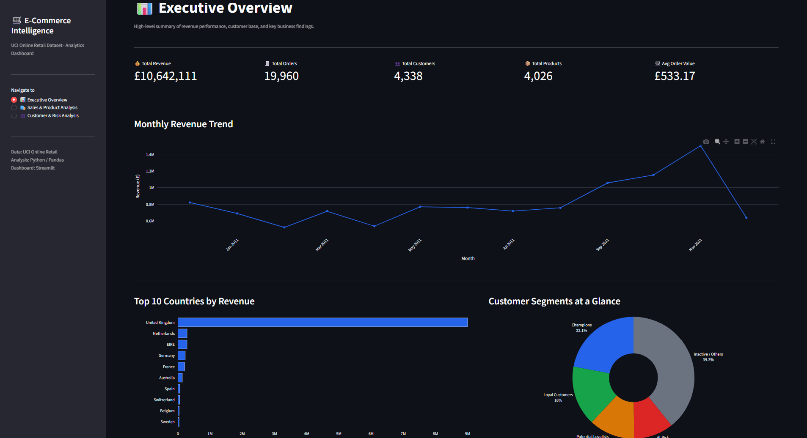
Figure 1. Executive Overview 1
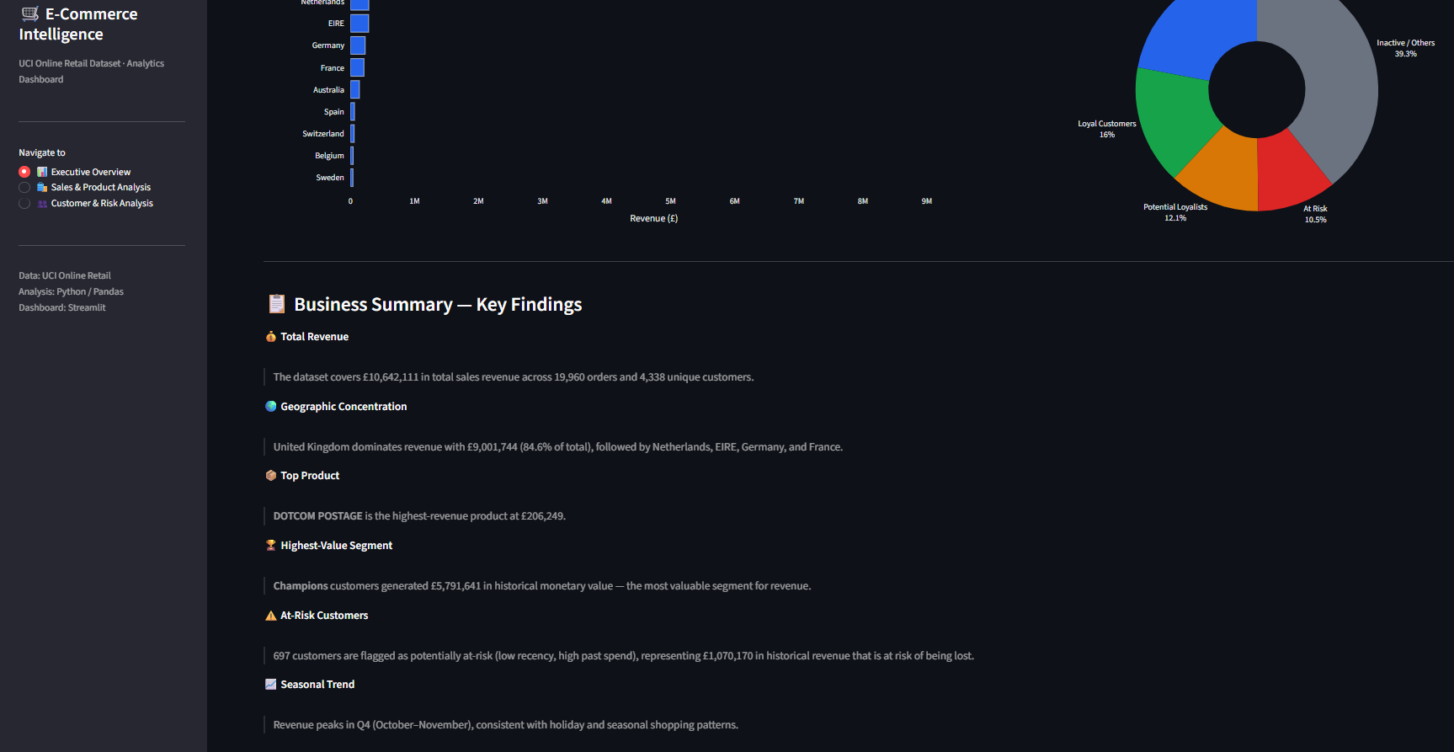Figure 2. Executive Overview 2
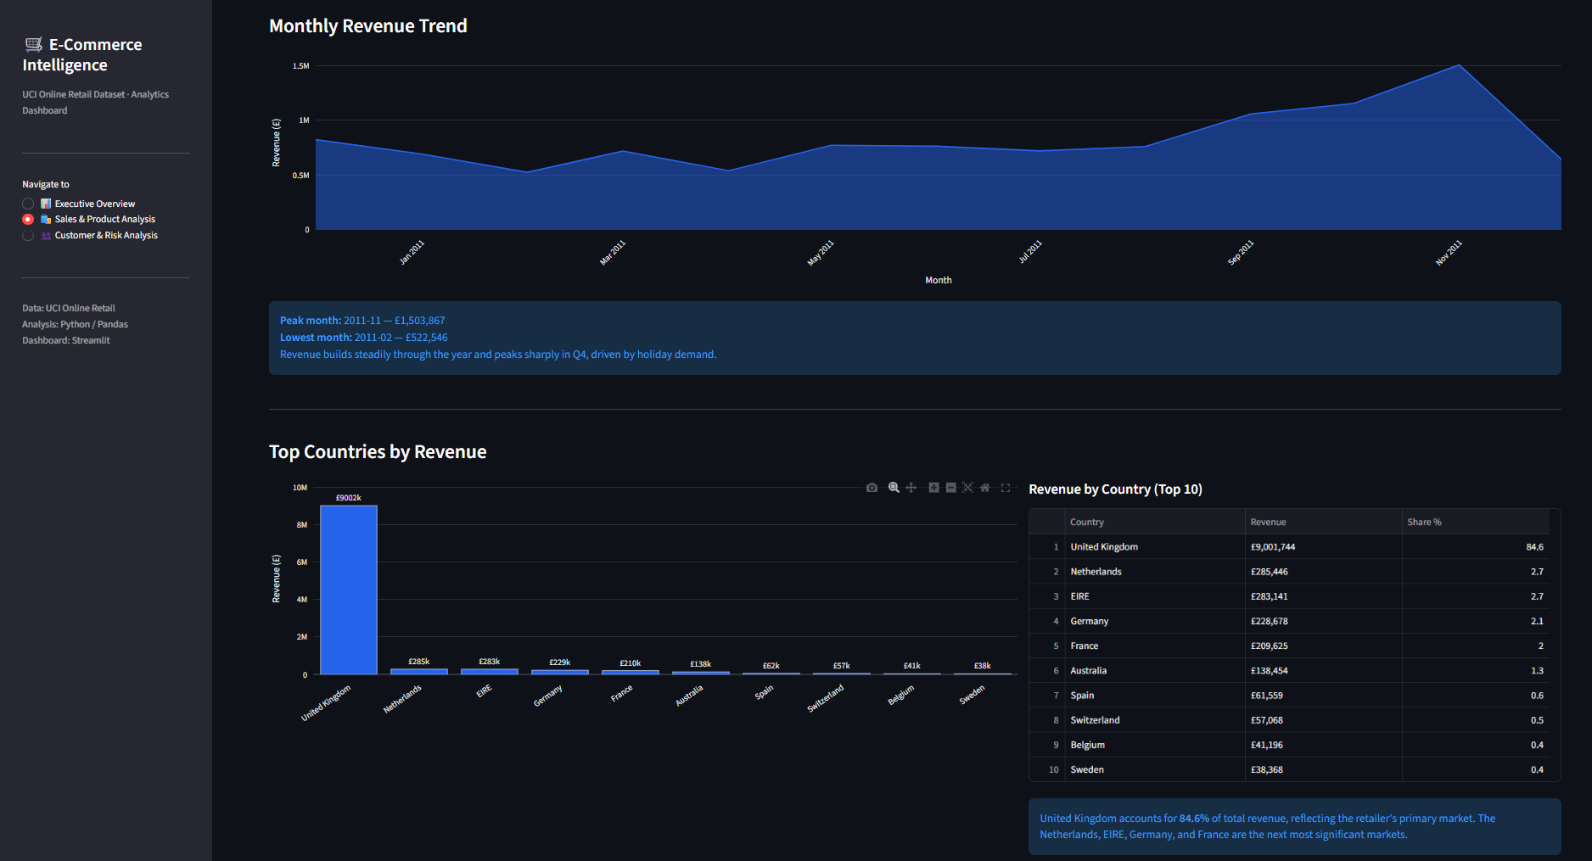
Figure 3. Sales & Product Analysis 1
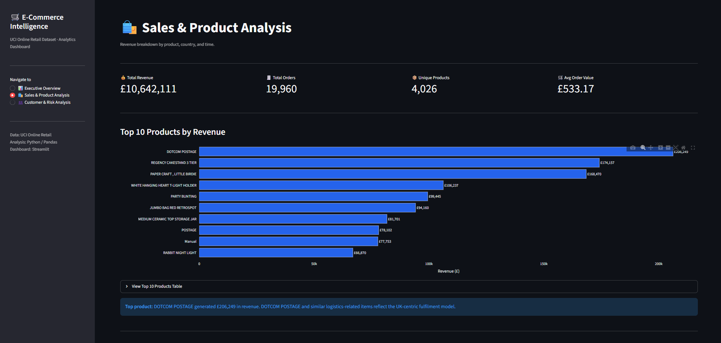
Figure 4. Sales & Product Analysis 2
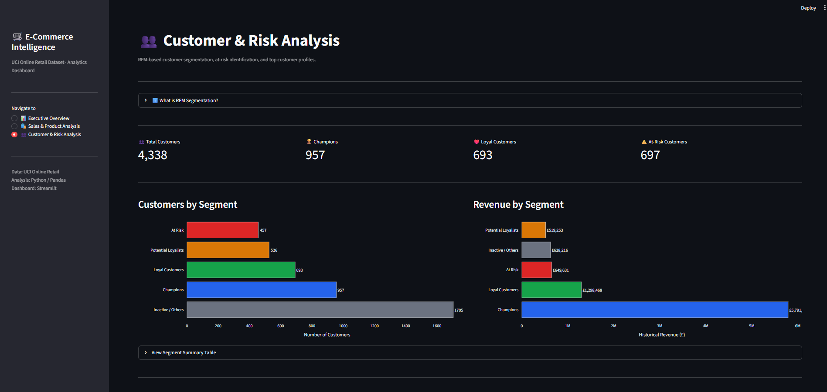
Figure 5. Customer & Risk Analysis 1
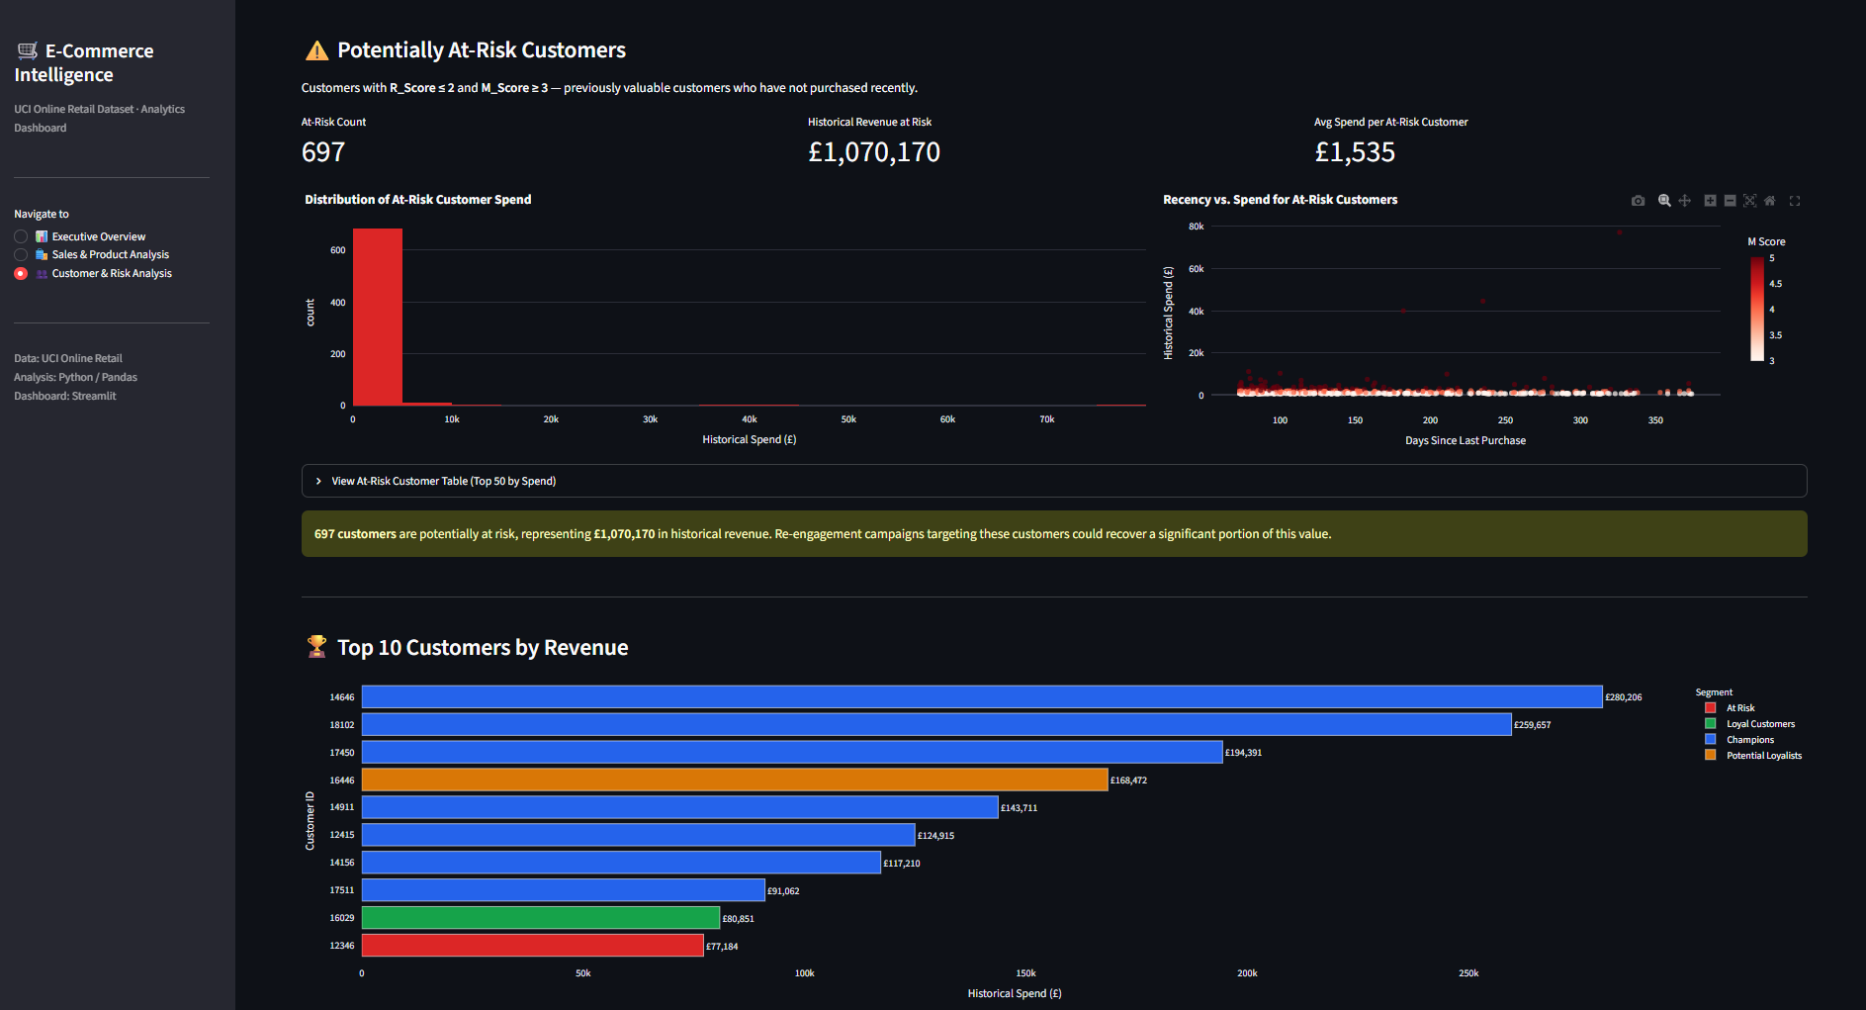
Figure 6. Customer & Risk Analysis 2
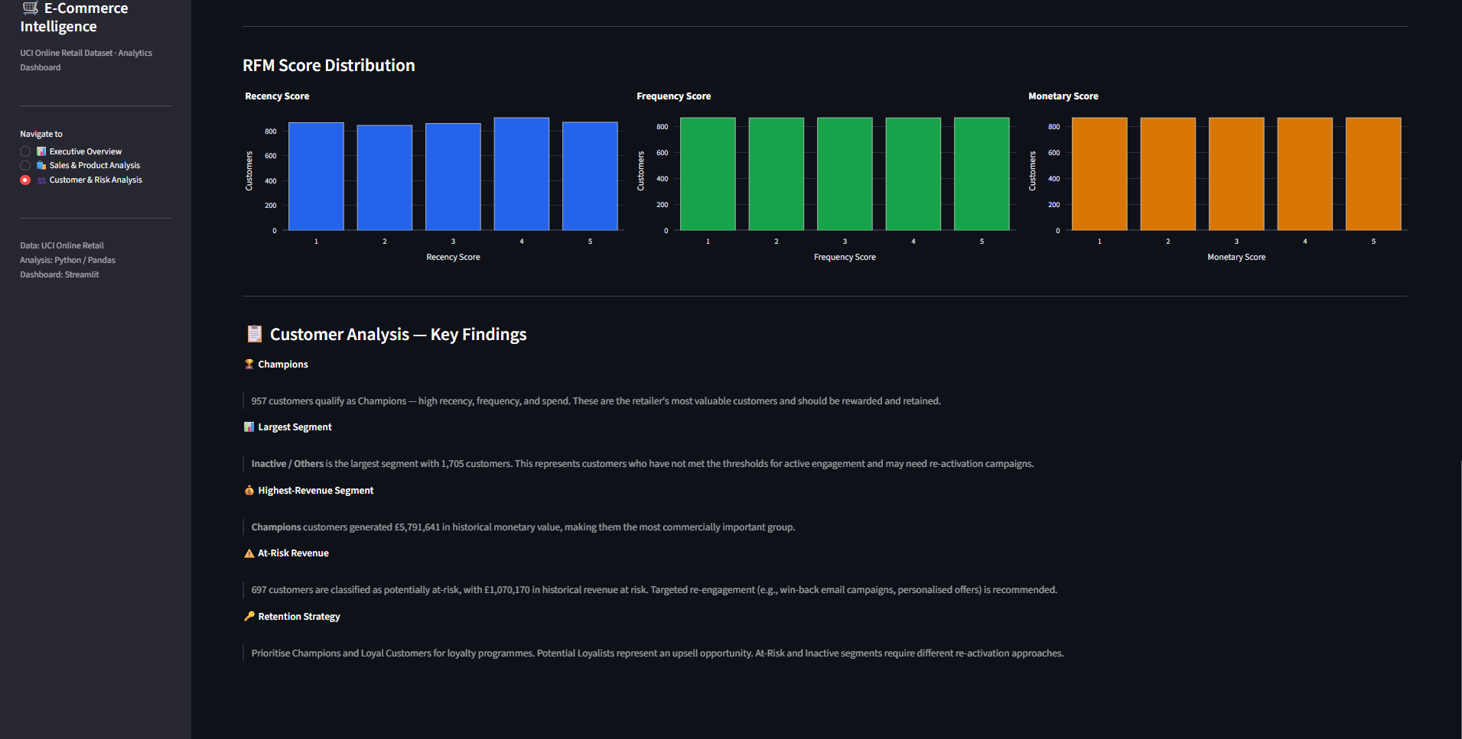
Figure 6. Customer & Risk Analysis 3

12. Tools and Technologies
- Python
- Pandas
- Plotly
- Streamlit
- Jupyter / Google Colab
- IBM Bob
- UCI Online Retail dataset

13. Project Structure
The project is organized into raw data, analysis, cleaned datasets, visualizations, dashboard and final submission files. The GitHub repository should contain the Streamlit application, requirements, README, notebook and supporting files needed to review or reproduce the project.

14. Limitations
- The analysis is historical and does not predict future revenue or customer churn.
- The potentially-at-risk rule is a project-defined RFM flag, not a machine-learning churn probability.
- The customer segment assignment and separate potentially-at-risk flag are different constructs, so their counts are not expected to be identical.
- Revenue concentration in the UK means findings may not represent international markets equally.
- DOTCOM POSTAGE is a service/logistics-related description and should be separated from conventional product interpretation.

15. Conclusion
The E-Commerce Customer & Sales Intelligence project demonstrates how transactional data can be transformed into business information and customer insights. Through cleaning, exploratory analysis and RFM-based customer analysis, the project identifies major revenue patterns, customer groups and a potentially at-risk customer population. The Streamlit dashboard packages these findings into an interactive format for exploring sales and customer performance.
The project follows the analytics flow from data preparation to information, insights and business actions while keeping the dashboard aligned with the completed Python analysis.

16. Dataset Source
UCI Machine Learning Repository — Online Retail dataset: https://archive.ics.uci.edu/dataset/352/online+retail

