Project Title:

**A CRM APPLICATION FOR LAPTOP RENTALS**

# Project Overview:

This project, ***A CRM Application for Laptop Rentals***, was developed by

**Smartbridge** to streamline and enhance the laptop rental process for businesses and customers alike. Leveraging Salesforce's powerful CRM capabilities, the solution

addresses key challenges in rental management, such as tracking inventory, optimizing communication with customers, and managing rental terms and conditions effectively. By integrating real-time customer insights and automated processes, the application aims to improve customer satisfaction, operational eﬃciency, and decision-making accuracy. This application not only enables seamless tracking of rental equipment but also fosters enhanced customer engagement through proactive communication and data-driven interactions.

# Objectives:

**Business Goals**

* + **Enhance Customer Engagement**: Improve customer experience through personalized communication, seamless service, and quick responses to rental requests, ensuring customers feel valued and informed throughout the rental process.
  + **Optimize Rental Operations**: Streamline the management of laptop inventory, rental agreements, and delivery schedules, reducing manual work and minimizing operational bottlenecks.
  + **Improve Data-Driven Decision-Making**: Enable data capture and analysis for customer preferences, rental frequencies, and equipment utilization to support smarter business decisions.
  + **Boost Customer Retention**: Build stronger relationships with repeat customers by tracking preferences and offering tailored rental solutions, discounts, and loyalty incentives.

**Speciﬁc Outcomes**

* + **Automated Rental Management System**: Create an eﬃcient system for tracking laptops in real-time, managing stock, and automating rental term tracking.
  + **Proactive Customer Communication**: Leverage Salesforce’s email and alert features to keep customers informed, including notiﬁcations for rental expirations, follow-ups, and new offers.
  + **Enhanced Reporting and Analytics**: Utilize Salesforce dashboards and reports to analyze key performance indicators (KPIs) such as inventory turnover, customer satisfaction, and rental revenue.
  + **Seamless Integration with Payment Systems**: Implement secure, integrated payment processing to simplify customer transactions and reduce manual billing tasks.
  + **Improved Customer Self-Service Options**: Develop a customer portal within Salesforce that allows customers to view rental history, update personal information, and request renewals or cancellation directly.

# Salesforce Key Features and Concepts Utilized:

The *CRM Application for Laptop Rentals* leverages several essential Salesforce features and concepts to enhance rental operations, automate workﬂows, and facilitate detailed reporting and analytics:

* + **Validation Rules**: Enforce data integrity and consistency by setting conditions for critical ﬁelds and ensuring that entered data meets predeﬁned criteria.
  + **Proﬁles and Roles**: Deﬁne and manage user permissions to restrict or grant access based on roles, maintaining security and data privacy throughout the application.
  + **Apex Development**: Utilized custom code (triggers and handler classes) to automate processes, such as sending email notiﬁcations upon certain trigger events.
  + **Triggers**: Designed for the *Laptop_Bookings c* object to automate business logic after DML operations, helping streamline processes like inventory and customer notiﬁcations.
  + **Handler Classes**: These classes handle complex logic separately from the trigger code, improving modularity and maintainability of the application.
  + **Reports**: Generated various report types—tabular, summary, matrix, and joined—to provide insights on rental bookings, customer data, and equipment inventory.
    - *Tabular Reports*: Used for simple data listings, such as a list of active rentals or available inventory.
    - *Summary Reports*: Grouped and summarized data for insights like total rentals by customer type or location.
    - *Matrix Reports*: Provided cross-tabular data comparisons, such as laptop rentals by month and customer segment.
    - *Joined Reports*: Consolidated data from multiple report types, offering comprehensive views of rentals, inventory, and associated customer details.
  + **Dashboards**: Visualized key performance indicators (KPIs) with dynamic charts and metrics, using reports to track rental performance, customer satisfaction, and inventory

levels. Dashboards were made shareable and schedulable to ensure regular insights.

# Detailed Steps to Solution Design:

### Data Model Design

* + **Objects and Fields**: Key custom objects, such as *Laptop_Bookings c* for tracking individual rental transactions, were created. Relevant ﬁelds include:
    - **Laptop_Bookings__c**: Stores key rental details, including *Email c*, *Amount c*, *Core c*, and *Laptop_Type c*.
    - **Customer__c**: Stores customer information linked to each booking for detailed reporting and relationship tracking.
  + **Relationships**: Established relationships between objects using lookups and master- detail ﬁelds to track linked records, such as customers and rented laptops.
  + **Validation Rules**: Implemented for critical ﬁelds to enforce business rules, such as minimum rental duration or valid email format for notiﬁcations.

**Screenshot:** Fields included in the Laptop Bookings object.

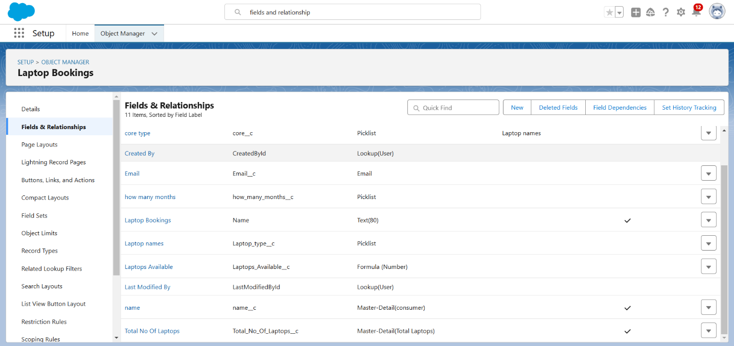

### User Interface Design

* + **Page Layouts**: Customized page layouts for *Laptop_Bookings c* and *Customer c*

objects to display relevant ﬁelds and streamline data entry for rental agents.

* + - Included key ﬁelds like rental period, laptop model, and customer contact details to ensure all necessary information is accessible.
  + **Custom Buttons and Links**: Added buttons for quick actions, like “Create New Booking” and “Send Notiﬁcation,” to optimize workﬂow.
  + **Record Types**: Created speciﬁc record types if necessary to handle different types of rentals, such as corporate and individual rentals.
  + **Lightning App Builder**: Used to customize record pages for better visual arrangement and user experience.

**Screenshots:** Laptop Rentals App along with navigation items.

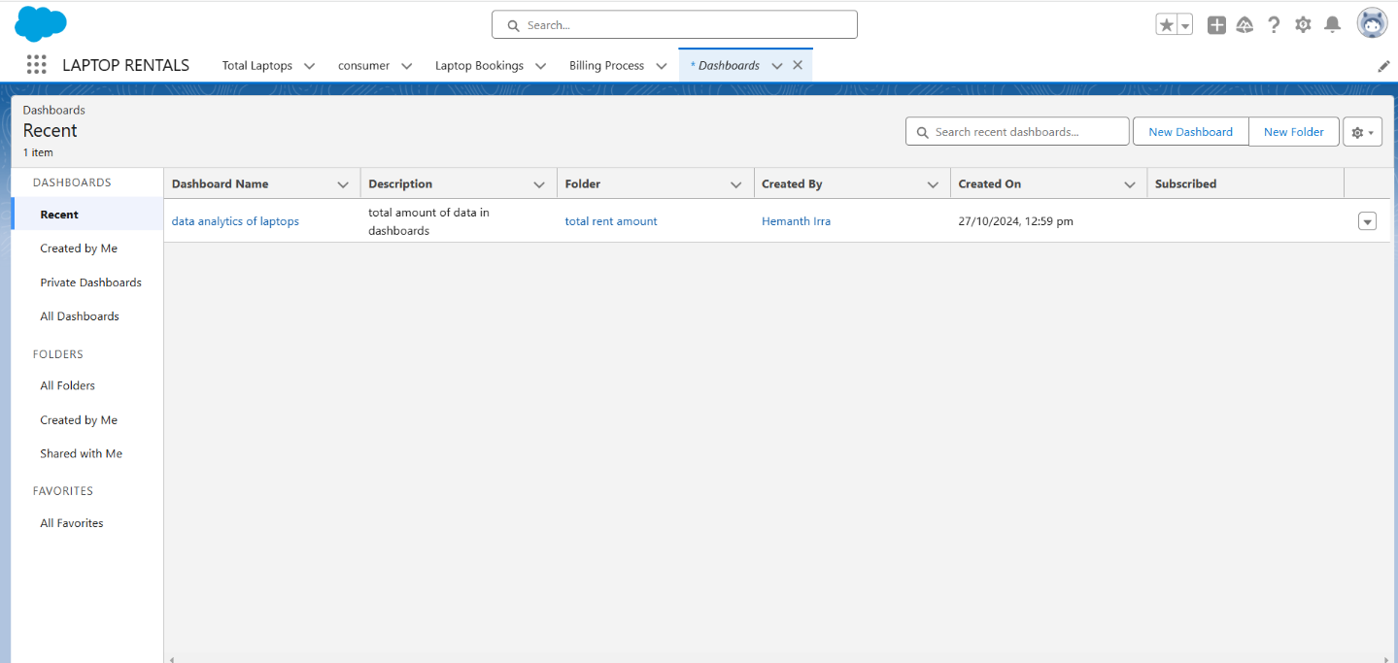

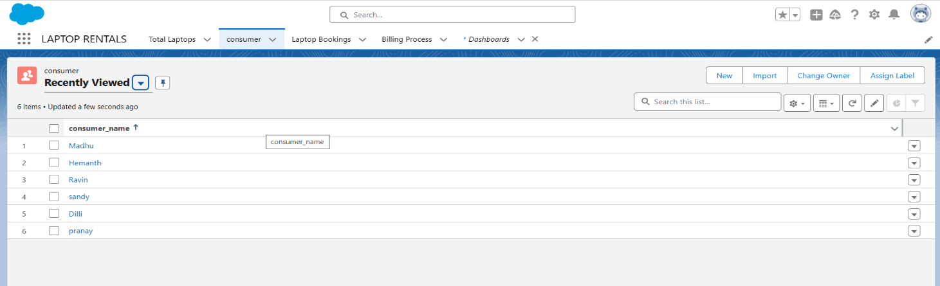

### Business Logic Implementation

* + **Apex Triggers**: Created a trigger on *Laptop_Bookings c* to send automated email notiﬁcations after each new booking or update.
    - **Trigger Setup**: The *LaptopBooking* trigger executes business logic after DML

events (insert and update) to send email notiﬁcations based on changes in booking records.

* + **Handler Class**: Deﬁned a *LaptopBookingHandler* class to manage the email notiﬁcation logic, keeping the trigger code concise and organized.
    - Logic includes checking booking details and constructing personalized email content with customer details, laptop speciﬁcations, and rental information.
  + **Workﬂow Rules and Process Builder**: Automated non-coding tasks like updating status ﬁelds or sending alerts when bookings are overdue or laptops are returned late.

**Screenshots:** Flow Automation.

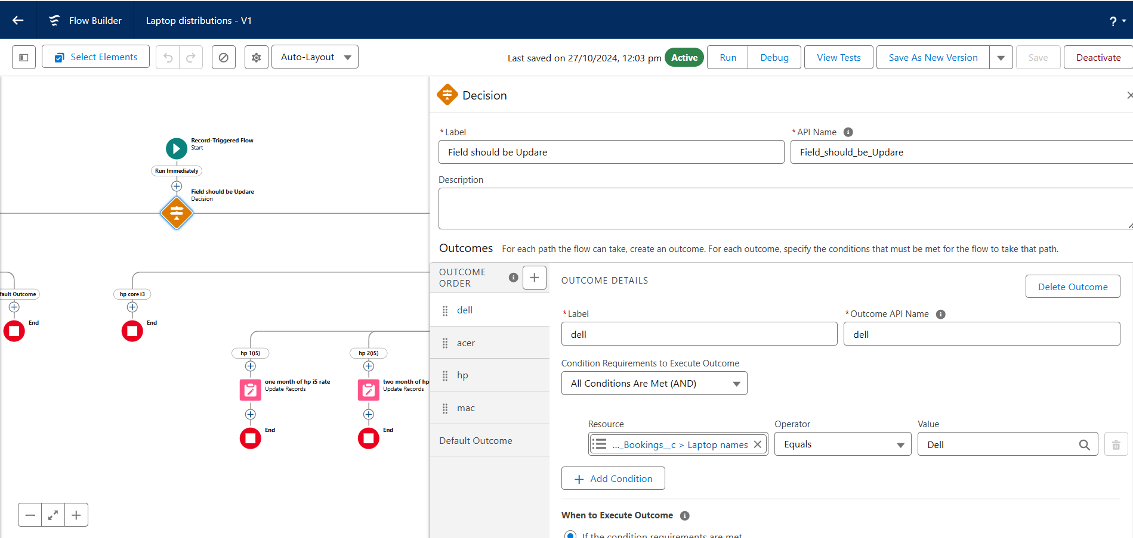

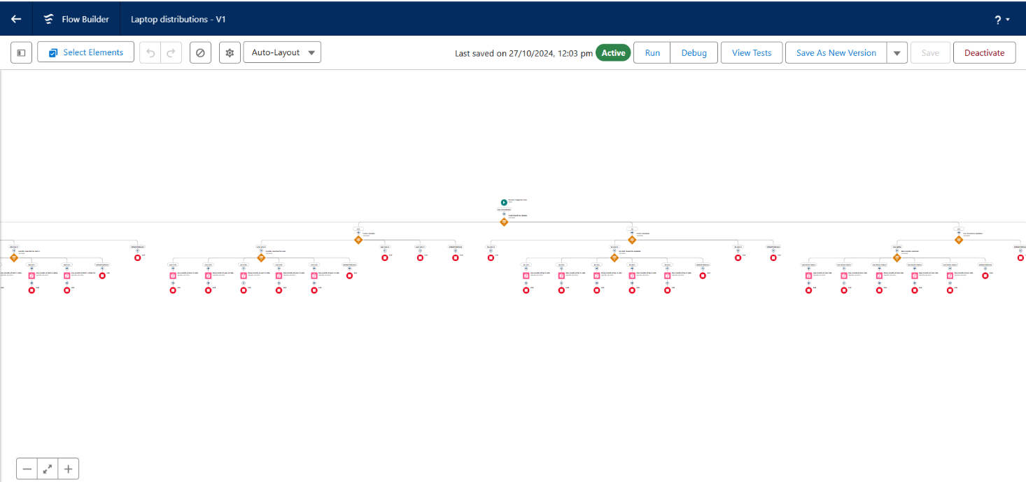

#### Validation rules for consumer objects:

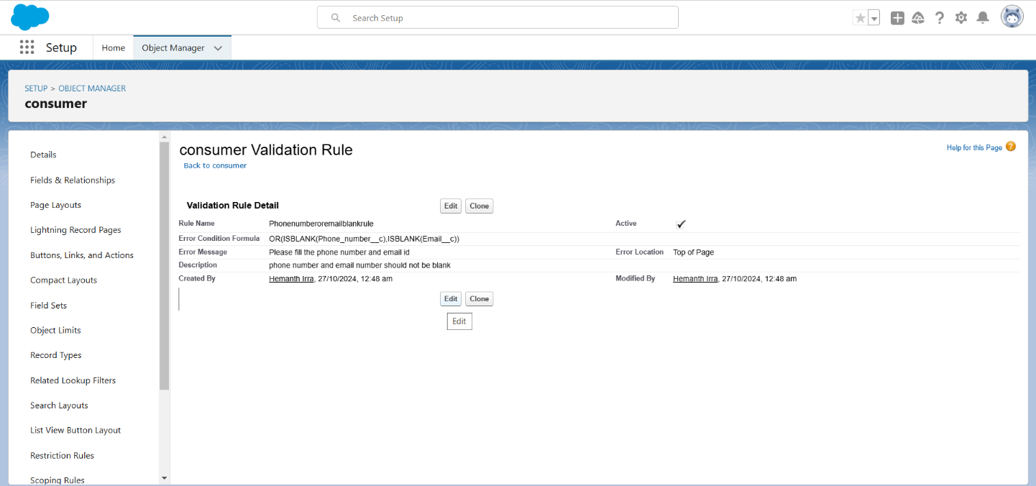

**Creating the Apex class**:

Here, I named the Apex class **LaptopBookingHandler**.

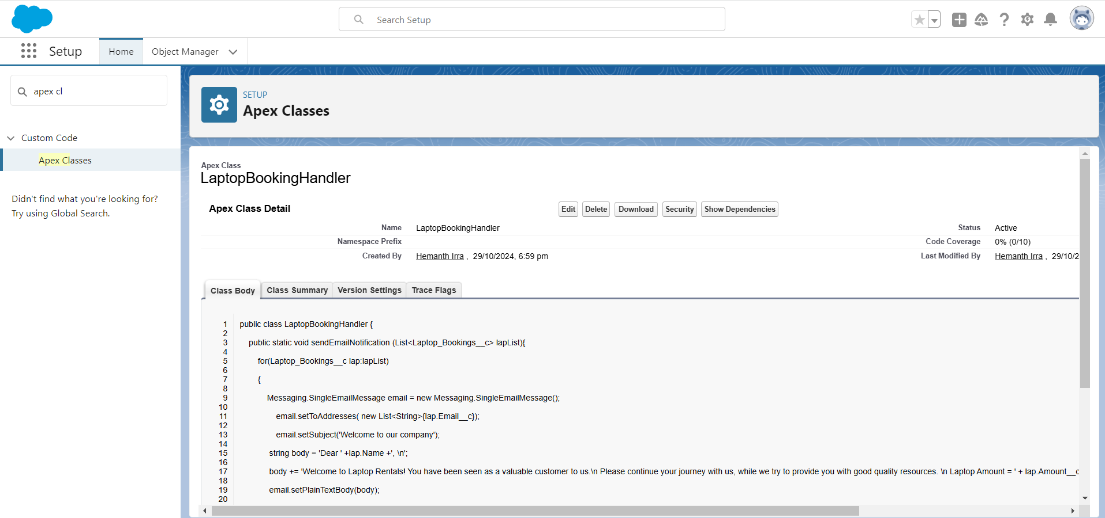

**Creating apex trigger:** Here, I named the Apex trigger **LaptopBooking**.

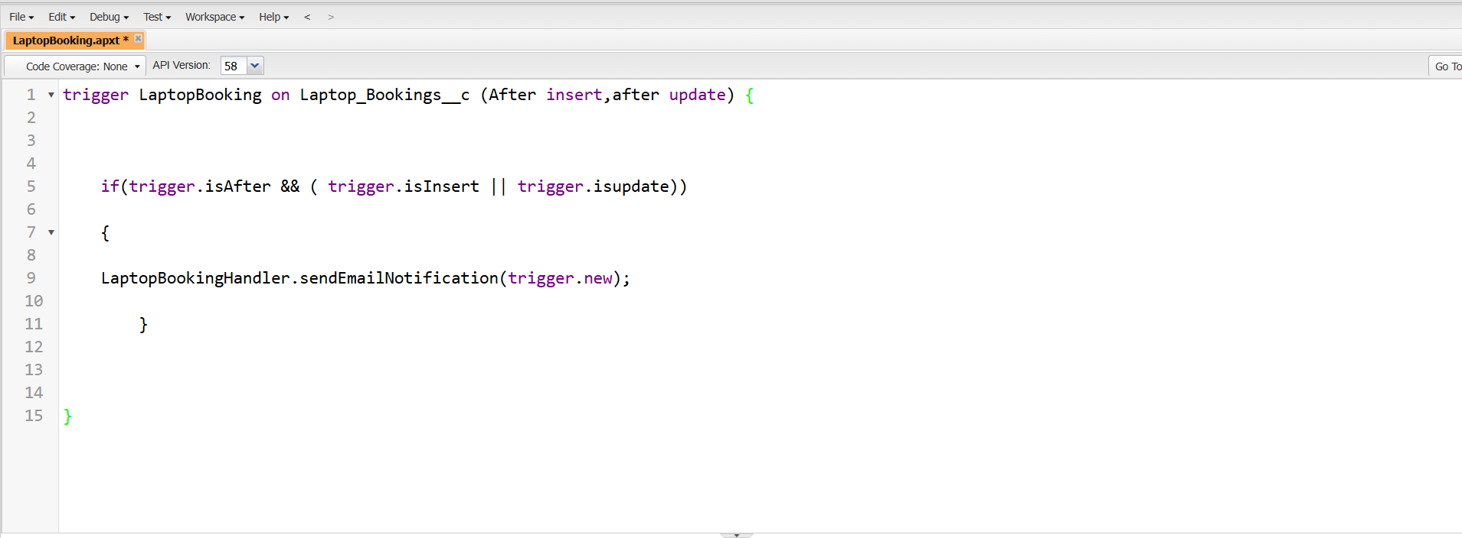

### Reports and Dashboards Design:

* + **Report Creation**: Created various types of reports for monitoring key metrics:
    - *Summary Reports*: Track rentals by type and customer category, showing totals and sub-totals.
    - *Matrix Reports*: Compare laptop rentals by month and rental type.
  + **Dashboards**: Created dashboards for visual summaries, showing KPIs such as rental volume, revenue, and inventory status. Reports feeding into the dashboard are refreshed daily, providing real-time insights.

#### Screenshots: 1.Reports

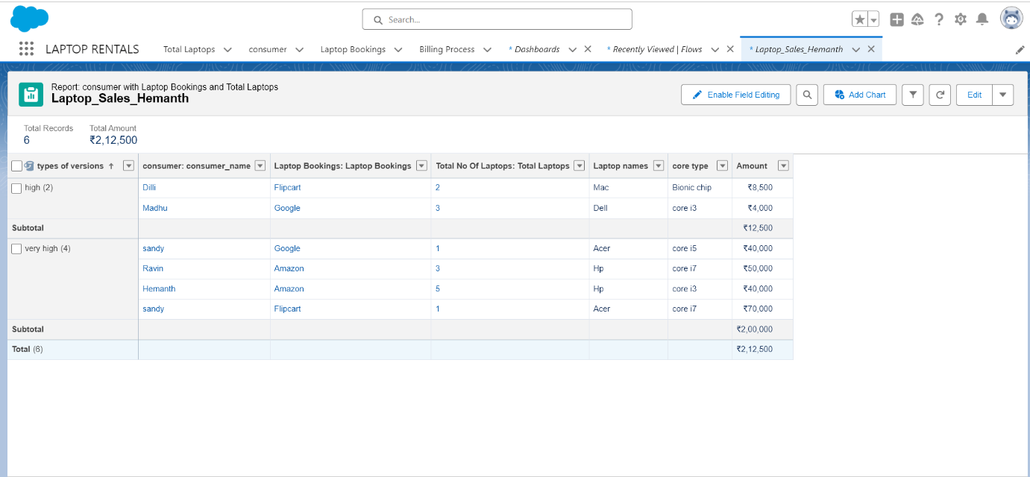

**2. Dashboards**

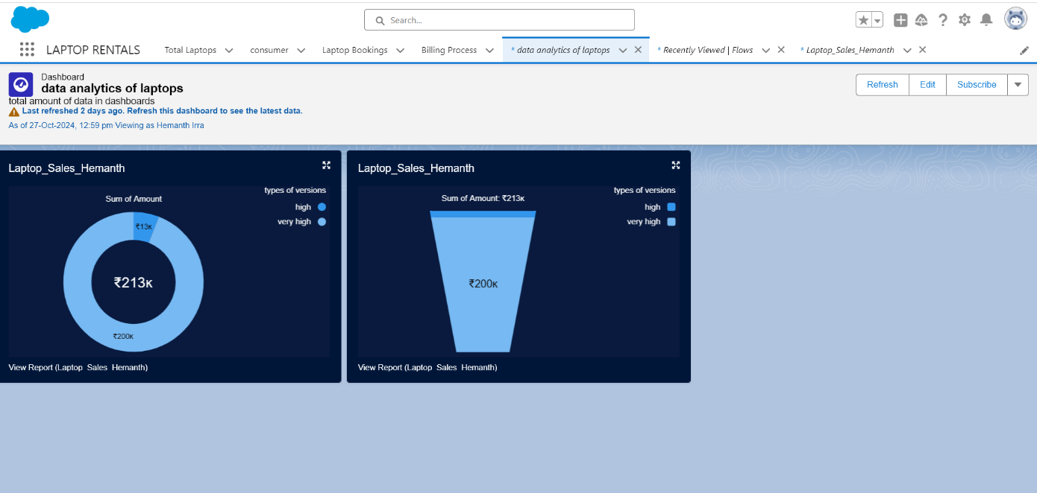

# Testing and Validation:

## Unit Testing:

* + **Approach**: Conducted unit testing in Apex using test classes annotated with @isTest. Each test class was designed to simulate various scenarios, ensuring that core functionalities work as intended.
  + **Coverage**: Achieved 100% code coverage for critical business logic, particularly within the LaptopBookingHandler class, ensuring that all methods and decision branches were thoroughly tested.
  + **Example**: Implemented LaptopBookingHandlerTest class to validate that each function within the handler class met performance expectations and adhered to business requirements.

**Screenshot:**

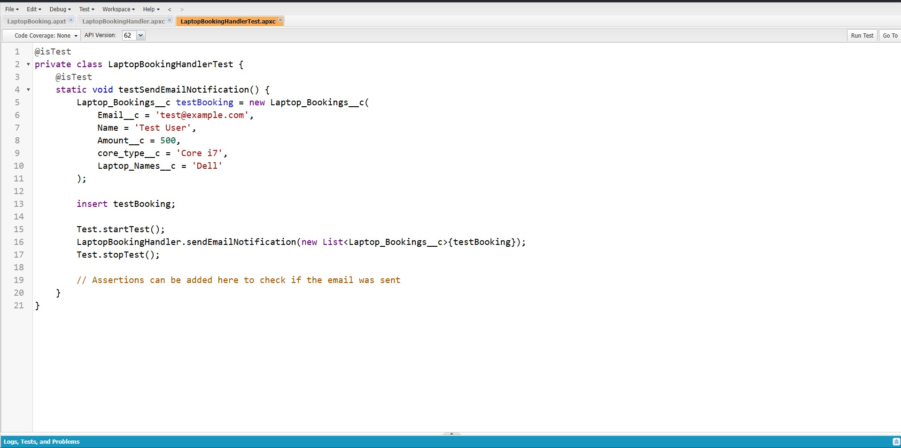

## User Interface Testing:

* + **Approach**: Performed manual and functional testing of all Lightning app UI components to verify user interactions and navigation paths.

#### Examples:

* + - Tested each record page, form, and custom UI component to conﬁrm seamless functionality and user experience.
    - Validated that data entries successfully triggered the appropriate validation rules, ensuring data integrity and enforcing business rules.

# Key Scenarios Addressed by Salesforce in the

**Implementation Project:**

This section outlines the critical use cases and scenarios addressed during the implementation of the CRM Application for Laptop Rentals, highlighting how Salesforce capabilities effectively meet business needs:

#### Automated Rental Notiﬁcations:

* + **Scenario**: Customers need timely updates regarding their rental statuses, including conﬁrmations, expirations, and renewals.
  + **Salesforce Solution**: Automated email notiﬁcations are triggered through Apex, ensuring customers receive real-time updates based on changes in their booking status. This enhances customer satisfaction by keeping them informed.

#### Inventory Management:

* + **Scenario**: Managing laptop inventory eﬃciently is vital to avoid overbooking and ensure availability.
  + **Salesforce Solution**: The application leverages Salesforce's robust data model to track laptop availability, automatically adjusting inventory levels when bookings are created or modiﬁed. This helps maintain accurate stock levels.

#### Customer Insights and Reporting:

* + **Scenario**: Understanding customer preferences and rental patterns is crucial for decision-making and personalized service.
  + **Salesforce Solution**: Custom reports and dashboards provide insights into customer behaviors, such as rental frequencies and equipment popularity, facilitating data-driven decision-making and targeted marketing strategies.

#### Streamlined Booking Process:

* + **Scenario**: The rental booking process must be eﬃcient and user-friendly to minimize friction for customers.
  + **Salesforce Solution**: The application includes a user-friendly interface with customized page layouts and quick action buttons, enabling rental agents to process bookings swiftly and accurately, reducing the time from inquiry to rental conﬁrmation.

#### Data Integrity and Validation:

* + **Scenario**: Ensuring that only valid data is captured is essential for operational eﬃciency and compliance.
  + **Salesforce Solution**: Validation rules are implemented on critical ﬁelds, such as email formats and rental duration, to enforce data quality. This reduces errors and enhances the reliability of the data captured.

#### Role-Based Access Control:

* + **Scenario**: Different users require varying levels of access to sensitive information within the system.
  + **Salesforce Solution**: Proﬁles and roles are established to manage permissions effectively, ensuring that users can access only the data relevant to their responsibilities while maintaining overall security and data privacy.

#### Customer Self-Service Portal:

* + **Scenario**: Customers want the ability to manage their rental history and personal information independently.
  + **Salesforce Solution**: A self-service portal allows customers to view their rental history, update their details, and request renewals or cancellations, enhancing the customer experience and reducing the workload on support staff.

# Conclusion:

Smartbridge's CRM Application for Laptop Rentals has signiﬁcantly enhanced the laptop rental experience for businesses and customers. By strategically implementing Salesforce features, we achieved key improvements in several areas of rental management:

* + **Customer Engagement:** We improved communication by automating notiﬁcations and updates, resulting in higher customer satisfaction.
  + **Operational Eﬃciency:** The system streamlined the booking process and introduced dynamic pricing calculations, reducing manual efforts and boosting productivity.
  + **Data Accuracy:** Our validation rules ensured data integrity, guaranteeing that all entries met business requirements.
  + **Insightful Reporting:** The robust reporting tools provided valuable insights into customer preferences and inventory management, enabling informed decision-making.

In summary, this project addressed existing challenges in the laptop rental process while establishing a strong foundation for future growth. The enhanced operational capabilities and improved customer interactions position Smartbridge for continued success in the competitive rental market.