SYSTEM DESIGN DOCUMENT
AI-Powered Resume Screening & Recruitment Automation System

Author: Hemanth Kaleru
Email: kaleruhemanth19@gmail.com
July 2026

1. Project Overview
This project automates the end-to-end recruitment process using n8n workflows, Groq-hosted Llama models, Airtable, Gmail, Google Drive, and Google Calendar. The system receives resumes via email, extracts and parses candidate information, evaluates candidates against job descriptions, and automates interview workflows end to end.

2. High-Level Solution Architecture
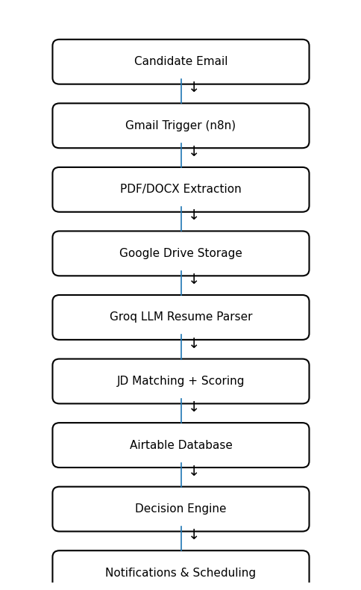
Figure 1: High-Level System Architecture

3. Core Components
Component | Description
Email Monitoring Service | Gmail trigger detects and captures incoming candidate resume submissions in real time.
Resume Processing Service | Extracts raw text content from PDF and DOCX attachments for downstream processing.
AI Resume Parsing Service | Uses Groq-hosted Llama 3.1 models to convert unstructured resume text into structured JSON.
Candidate Evaluation Engine | Applies deterministic scoring logic to match candidate profiles against job requirements.
Airtable Candidate Repository | Serves as the central data store for candidate records, scores, and status tracking.
Interview Automation Service | Generates interview emails and schedules calendar events automatically.
Error Handling & Retry Layer | Provides centralized exception handling, retries, and validation across the workflow.

4. Data Flow
- Candidate submits a resume via email.
- n8n downloads the attachment and stores it in Google Drive.
- Resume text is extracted from the PDF or DOCX file.
- The Groq LLM converts resume text into structured JSON.
- The candidate profile is matched against predefined job descriptions.
- Deterministic scoring calculates the final candidate fit score.
- The candidate record is stored in Airtable.
- The workflow routes candidates to Shortlisted, Manual Review, or Rejected paths.
- Interview emails and calendar events are generated automatically.

5. Security and Reliability
API keys are managed using n8n credentials and environment variables, keeping secrets out of workflow definitions. OAuth authentication is used for all Google services to avoid storing static passwords. Retry mechanisms, JSON validation, unsupported file filtering, and centralized error handling collectively improve system reliability and prevent incomplete or corrupted processing.

6. Scalability Considerations
The architecture is modular by design and can be extended to support ATS integrations, PostgreSQL for relational persistence, vector databases for semantic search, analytics dashboards for recruitment insights, and multi-tenant recruitment workflows for supporting multiple client organizations.

7. Assumptions
- Candidates submit resumes through email attachments.
- Only PDF and DOCX file formats are supported.
- Email addresses act as unique candidate identifiers.
- Predefined job descriptions are available for matching.
- External services (Gmail, Airtable, Google Drive, Calendar) are configured and accessible.

8. Conclusion
The solution demonstrates a production-oriented recruitment automation platform that combines workflow orchestration, AI-assisted decision making, deterministic business rules, and cloud integrations to significantly reduce manual recruitment effort while improving consistency and speed of candidate evaluation.
GitHub link: https://github.com/Hemanthkaleru/AI-Resume-Screening-System

This document was prepared with the assistance of Claude (Anthropic).

