INVENTION DISCLOSURE FORM
Confidential & Attorney-Client Privileged

Applicant Name SR University
Applicant Address: Ananthsagar, Hasanparthy (M), Warangal Urban, Telangana - 506371,

- Particulars of Inventors

Mr./Ms/Dr. | Name (Full) | Department | Designation | Mobile No. | Email | Postal Address
Mr. | Naresh Kumar Sripada | CS&AI | Asst. Professor | 9866000203 | Naresh22.in@gmail.com | Hanamkonda
Mr. | P.Hemanth | CS & AI | Student | 8881249999 | parumandlahemanthkumar@gmail.com | Hanamkonda
Mr. | A.Arun | CS&AI | Student | 7207813747 | akulaarun528@gmail.com | Hanamkonda
Mr. | K. Navneeth | CS & AI | Student | 9849301449 | navaneethkomuravelli06@gmail.com | Hanamkonda
Mr. | T. Aravind | CS & AI | Student | 8688815998 | aravind108028@gmail.com | Hanamkonda

- Provide a brief descriptive title of the invention:
An Adaptive Multi-Phase Deep Learning Framework for Real-Time Detection of IoT Botnet Attacks using Multi-Modal Feature Extraction and Ensemble Learning

- In 100 words or less, please provide an abstract or summary of the invention:
This invention proposes a multi-phase deep learning framework for detecting botnet attacks in IoT environments. It integrates statistical, entropy-based, and graph-theoretic feature extraction with an adaptive ensemble of CNN, LSTM, and BiGRU models. A dynamic threshold optimization module enables real-time adaptation to evolving network behavior. The system achieves high detection accuracy, low false positives, and efficient processing suitable for edge devices. It is capable of detecting zero-day botnet attacks and supports continuous learning through incremental updates, making it highly effective for securing modern IoT infrastructures.
- Detail description of the invention:( Answer to all below are required in detail)

  - Problem the invention is solving
The rapid growth of IoT devices has introduced significant security challenges, particularly in the form of botnet attacks that exploit vulnerabilities in interconnected devices. Existing intrusion detection systems and machine learning approaches are inadequate due to their inability to detect zero-day attacks, high false-positive rates, and lack of adaptability to continuously evolving attack patterns. Furthermore, IoT environments generate high-dimensional and noisy network traffic data with complex temporal and spatial dependencies that traditional models fail to capture effectively. The heterogeneity of IoT devices and the scarcity of labeled datasets further complicate accurate detection, making current solutions inefficient and unreliable.
  - General Utility/application of the invention
The proposed invention has broad applicability across various domains where IoT systems are deployed. It can be effectively used in smart home environments to detect botnet attacks targeting devices such as cameras and routers. In industrial IoT settings, it helps secure critical infrastructure like SCADA systems and sensors. In healthcare, it ensures the protection of connected medical devices such as monitoring systems and implants. The invention is also applicable in telecommunications for monitoring large-scale network traffic, as well as in cloud and edge computing environments where real-time detection is essential. Additionally, it can be utilized in government and defense sectors to safeguard critical networks from cyber threats.
  - Advantages of the invention disclosing about the increased efficiency/efficacy
The invention offers several significant advantages over existing systems. It achieves a high detection accuracy of approximately 98.7%, ensuring reliable identification of malicious activities. The adaptive threshold mechanism reduces false-positive rates substantially, improving operational efficiency. The system is capable of real-time processing, enabling it to handle large volumes of IoT traffic effectively. Its ability to detect zero-day attacks makes it robust against unknown threats. The incremental learning component allows the model to adapt to changing patterns without requiring complete retraining, thereby reducing computational costs. Additionally, the lightweight design ensures compatibility with resource-constrained IoT devices, and the inclusion of explainability features enhances transparency in decision-making.
  - Best way of using the invention as well as possible variants
The optimal implementation of the invention is achieved by deploying it at the IoT network gateway, where it can monitor and analyze incoming and outgoing traffic in real time. The system passively captures network data, processes it through the feature extraction modules, and classifies it using the adaptive ensemble model to generate alerts. Several variants of the invention are possible, including an edge-only deployment model for environments without cloud connectivity, a federated learning approach that enables collaborative training while preserving data privacy, and a hybrid cloud-edge model where lightweight processing is performed at the edge and intensive computations are handled in the cloud. Protocol-specific adaptations can also be implemented to enhance detection for communication protocols such as MQTT, CoAP, and Zigbee.
  - Working of invention along with Drawing, schematics and flow diagrams if required with complete explanations
The working of the invention is structured into three main phases. In the first phase, the system performs multi-modal feature extraction by analyzing network traffic to derive statistical features such as packet size and flow rates, entropy-based features that capture randomness in data, and graph-theoretic features that represent communication patterns among devices. These features are combined into a unified feature vector. In the second phase, the extracted features are processed by an adaptive ensemble classification model consisting of a Convolutional Neural Network for spatial pattern recognition, a Long Short-Term Memory network for capturing temporal dependencies, and a Bidirectional Gated Recurrent Unit for analyzing sequential patterns in both directions. The outputs from these models are fused to produce a final classification result. In the third phase, a self-calibrating threshold mechanism dynamically adjusts decision boundaries based on real-time data, and an incremental learning component updates the model continuously. The system then generates alerts with confidence scores and explanatory insights, enabling effective response to detected threats.

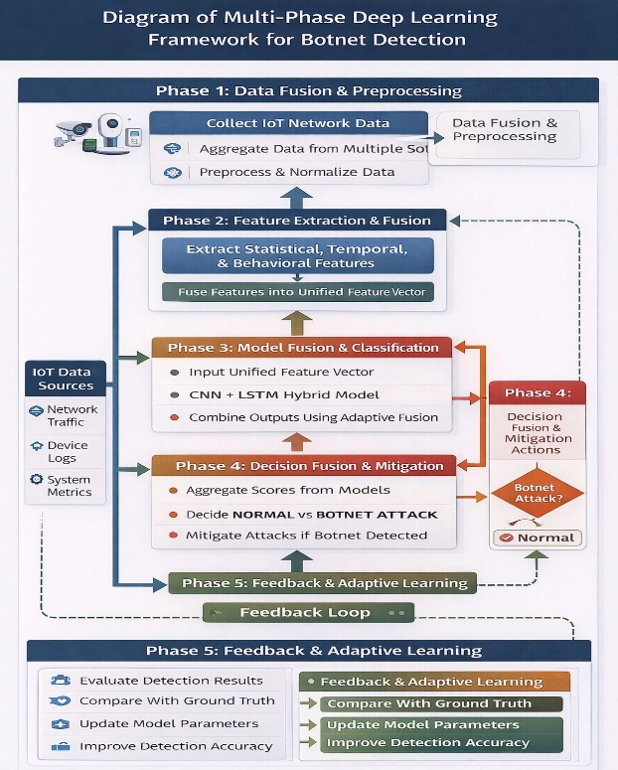

Figure 1: Layered Deep Learning for Botnet Detection in IoT
This figure illustrates the complete layered architecture of the proposed multi-phase deep learning model, showing data flow from IoT input sources through data fusion, feature extraction, model fusion (CNN + LSTM), decision fusion, and the Phase 5 feedback & adaptive learning loop. It serves as the master system diagram for the entire invention.
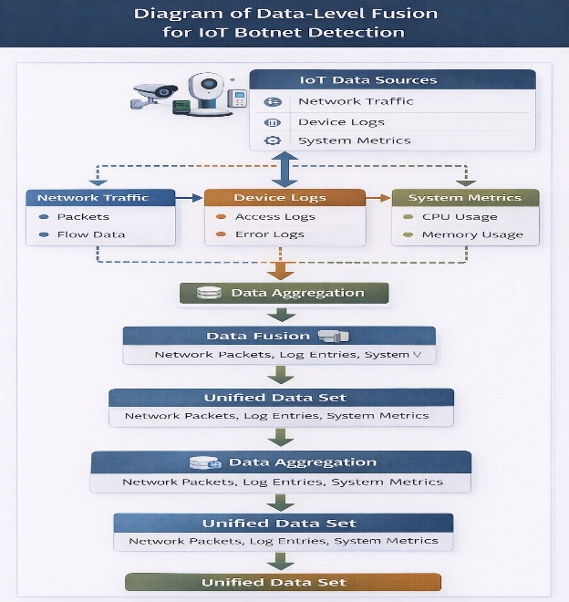

Figure 2: Diagram of Data-Level Fusion for IoT Botnet Detection
This figure depicts the data-level fusion pipeline where raw inputs from three IoT data source types—Network Traffic (packets, flow data), Device Logs (access logs, error logs), and System Metrics (CPU/memory usage)—are aggregated and fused into a Unified Data Set. The unified representation forms the input foundation for the feature extraction phases

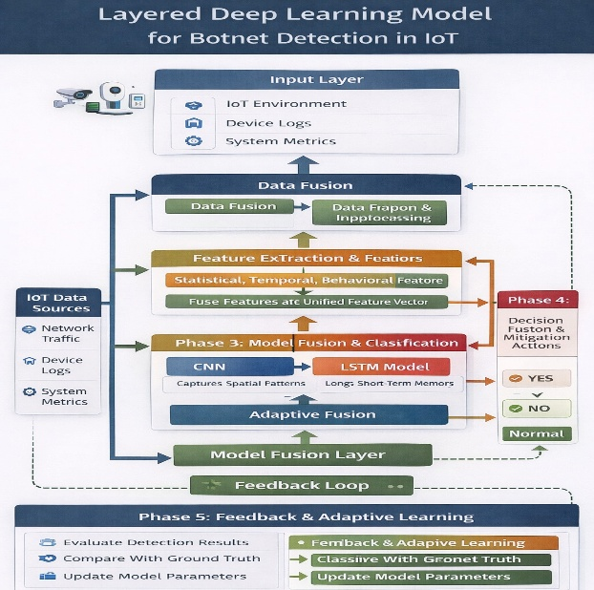

Figure 3: Diagram of Multi-Phase Deep learning Framework for Botnet Detection
This figure presents a high-level overview of all five operational phases of the invention: Phase 1 (Data Fusion & Preprocessing), Phase 2 (Feature Extraction & Fusion), Phase 3 (Model Fusion & Classification using CNN + LSTM), Phase 4 (Decision Fusion & Mitigation), and Phase 5 (Feedback & Adaptive Learning). It illustrates how IoT data flows sequentially through each phase to reach a final Botnet Attack or Normal classification.

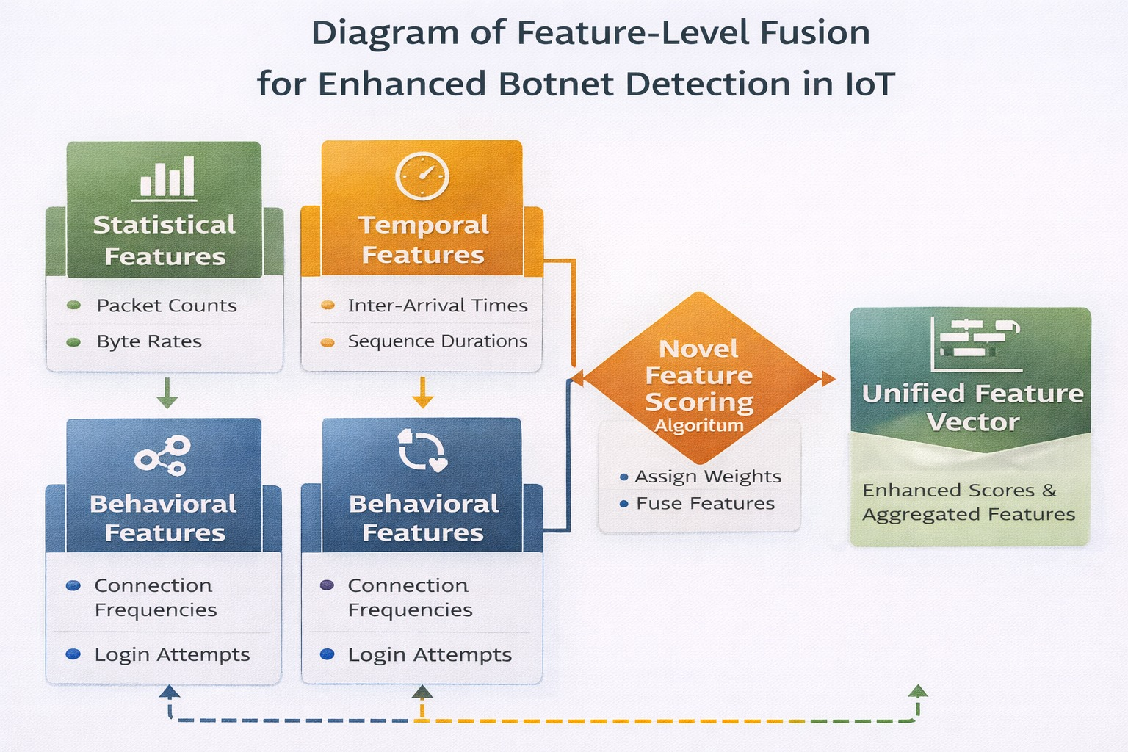
Figure 4: Diagram of Feature-Level Fusion for Enhanced Botnet Detection in IoT
This figure shows the feature-level fusion architecture where Statistical Features (packet counts, byte rates), Temporal Features (inter-arrival times, sequence durations), and Behavioral Features (connection frequencies, login attempts) are independently extracted and then combined through the Novel Feature Scoring Algorithm that assigns weights and fuses them into a Unified Feature Vector of enhanced scores and aggregated features.

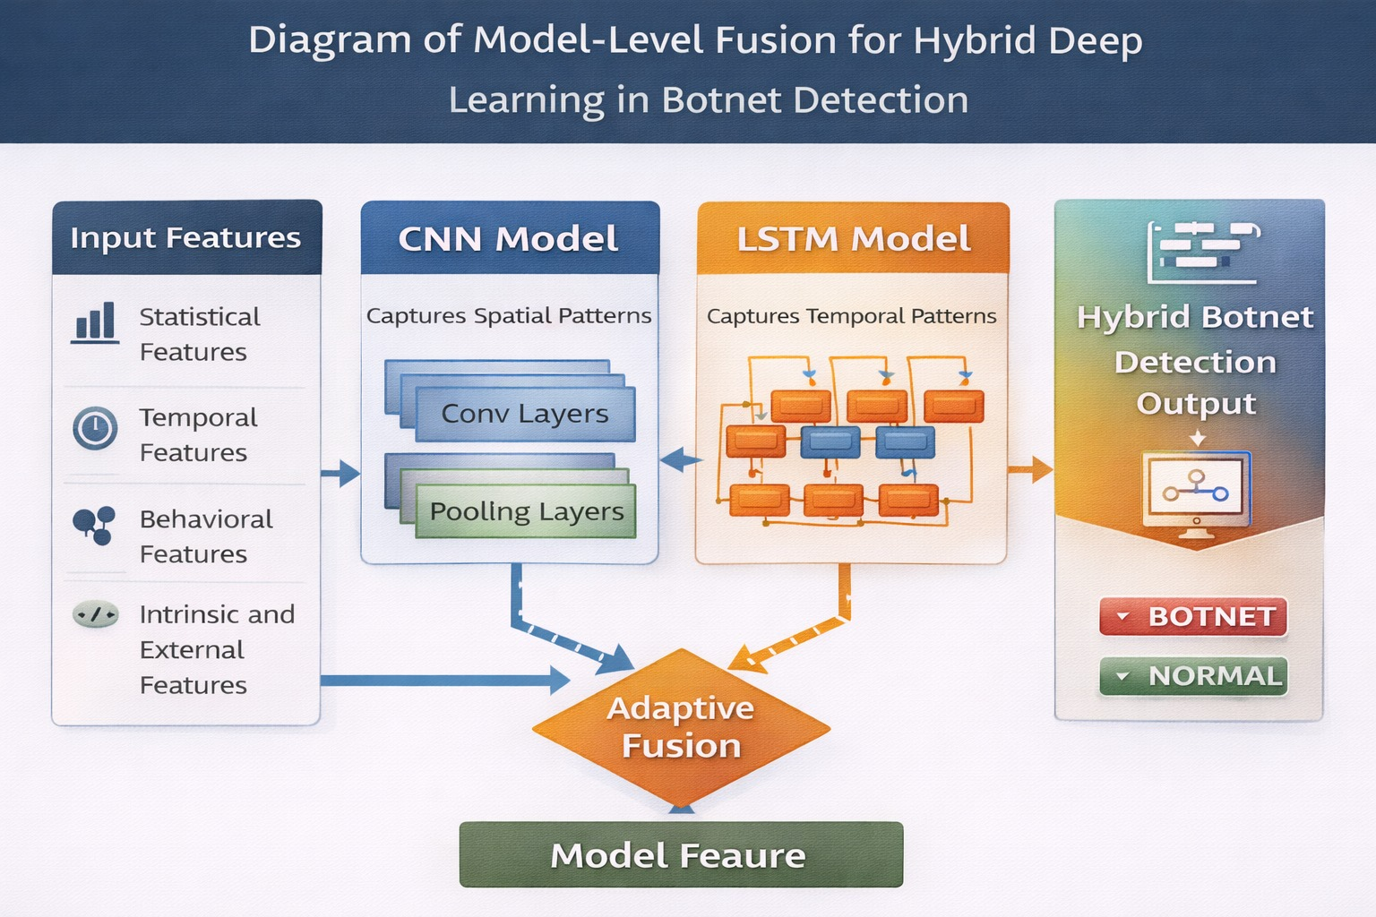
Figure 5: Diagram of Model-Level Fusion for Hybrid Deep Learning in Botnet Detection
This figure illustrates the model-level fusion architecture in which four types of input features—Statistical, Temporal, Behavioral, and Intrinsic/External—feed in parallel into both a CNN Model (capturing spatial patterns via Conv and Pooling layers) and an LSTM Model (capturing temporal patterns). The individual model outputs are combined by an Adaptive Fusion mechanism to produce the final Model Feature vector that drives the Hybrid Botnet Detection Output (BOTNET / NORMAL).
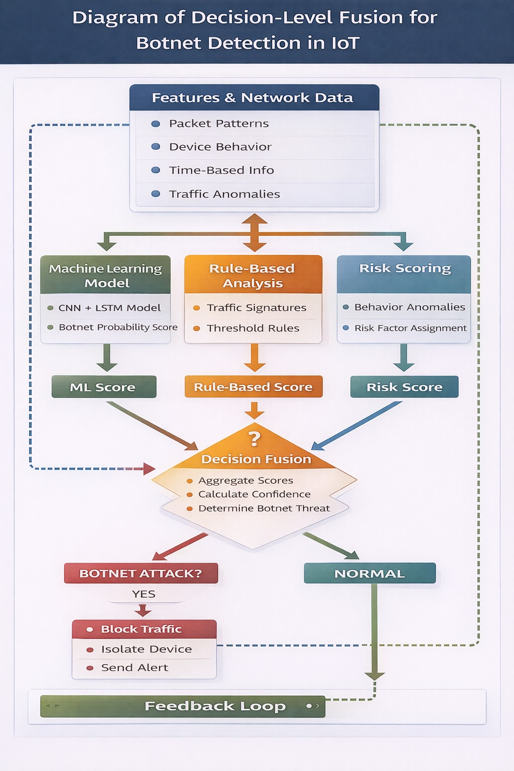
Figure 6: Diagram of Decision-Level Fusion for Botnet Detection in IoT
This figure depicts the decision-level fusion process where network data (packet patterns, device behavior, time-based info, traffic anomalies) is simultaneously analyzed by three independent subsystems: a Machine Learning Model (CNN + LSTM producing an ML Score), a Rule-Based Analysis module (traffic signatures and threshold rules producing a Rule-Based Score), and a Risk Scoring module (behavior anomalies and risk factor assignment producing a Risk Score). These three scores converge at a Decision Fusion node that aggregates them, calculates confidence, and determines the final botnet threat classification with subsequent mitigation actions and a feedback loop.
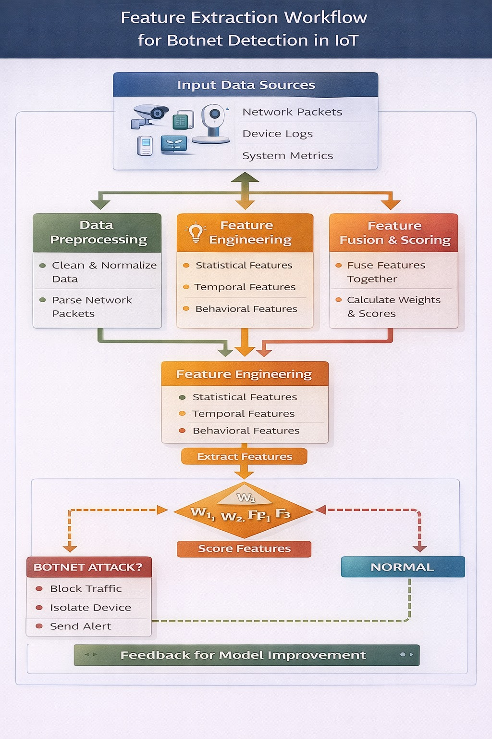
Figure 7: Feature Extraction Workflow for Botnet Detection in IoT
This figure shows the end-to-end feature extraction workflow starting from Input Data Sources (network packets, device logs, system metrics), passing through Data Preprocessing (clean, normalize, parse), Feature Engineering (statistical, temporal, and behavioral features), and Feature Fusion & Scoring (fuse features, calculate weights W₁, W₂, FP₁, F₃). The scored features classify traffic as either a Botnet Attack (triggering block, isolate, and alert actions) or Normal, with a feedback loop enabling continuous model improvement.

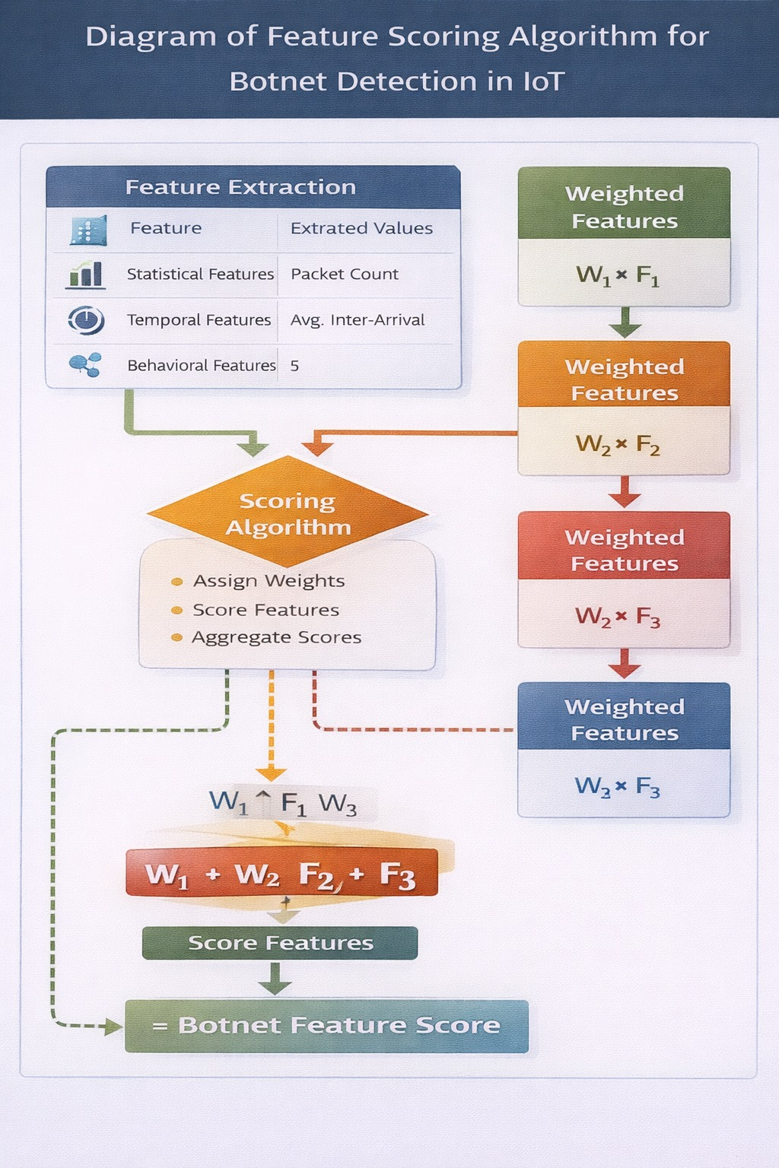
Figure 8: Diagram of Feature Scoring Algorithm for Botnet Detection in IoT
This figure details the novel feature scoring algorithm that takes extracted values (packet count for Statistical Features, average inter-arrival for Temporal Features, and behavioral score 5) and applies a Scoring Algorithm that assigns weights, scores individual features, and aggregates them. The right side shows the four weighted feature outputs (W₁×F₁, W₂×F₂, W₂×F₃, W₃×F₃) that are summed using the formula W₁ + W₂·F₂ + F₃ to yield the final Botnet Feature Score.

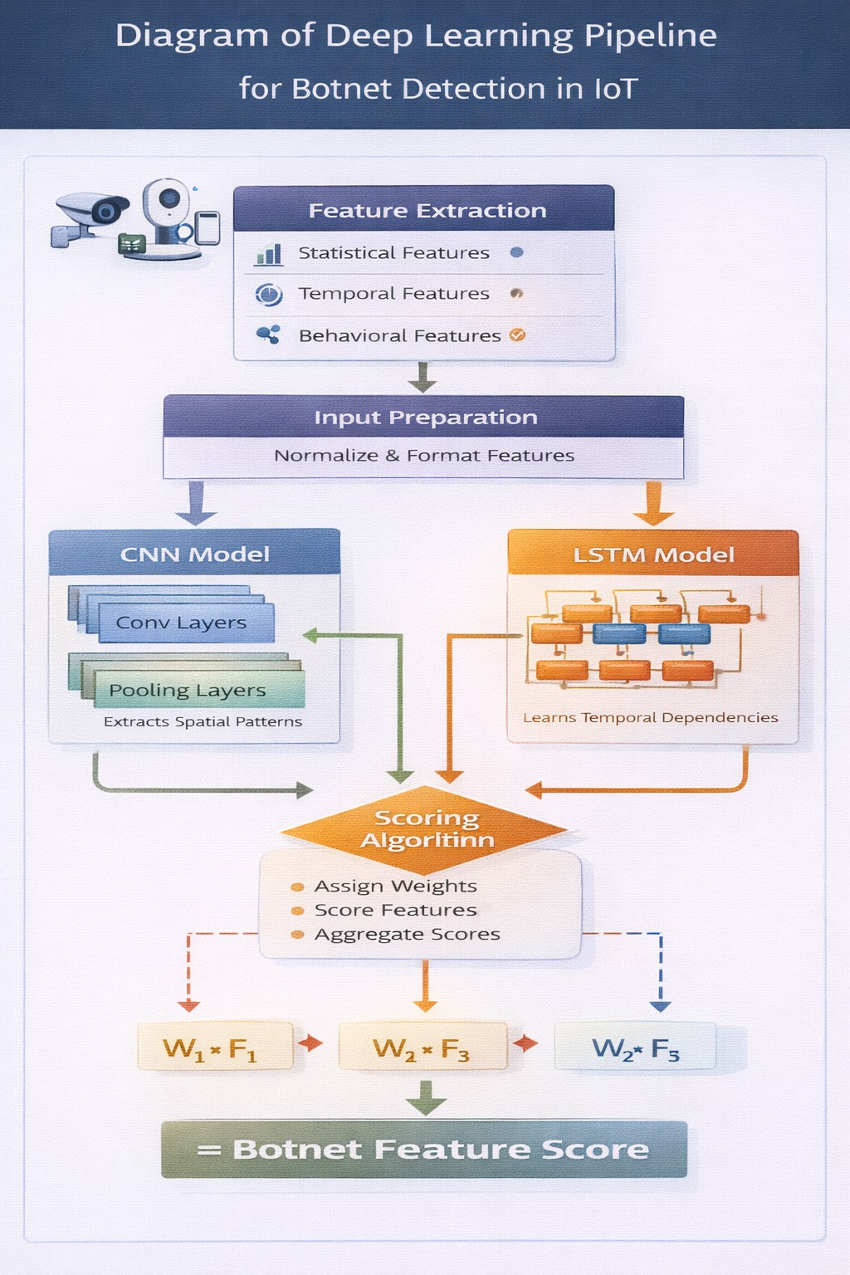
Figure 9: Diagram of Deep Learning Pipeline for Botnet Detection in IoT
This figure illustrates the deep learning inference pipeline where IoT device traffic passes through Feature Extraction (statistical, temporal, behavioral) and Input Preparation (normalize & format) before being processed in parallel by a CNN Model (Conv and Pooling layers extracting spatial patterns) and an LSTM Model (learning temporal dependencies). Both model outputs feed a Scoring Algorithm that assigns weights and aggregates scores to compute weighted feature outputs (W₁×F₁, W₂×F₃, W₂×F₅), resulting in the final Botnet Feature Score.

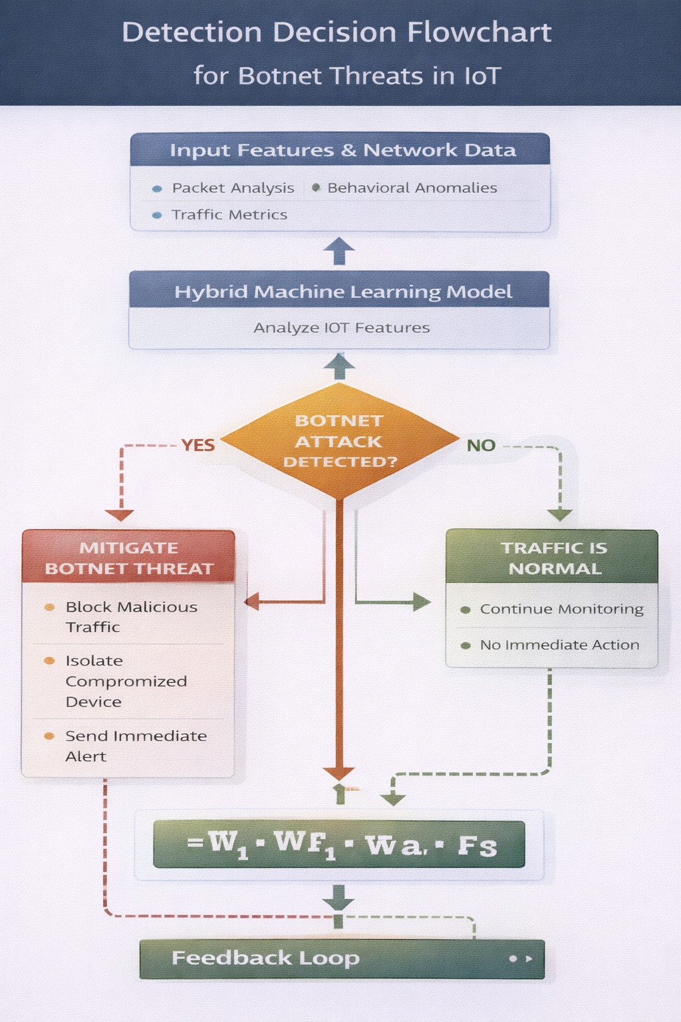
Figure 10: Detection Decision Flowchart for Botnet Threats in IoT
This figure presents the real-time detection decision flowchart in which Input Features & Network Data (packet analysis, traffic metrics, behavioral anomalies) are analyzed by a Hybrid Machine Learning Model. When a Botnet Attack is Detected, the system triggers Mitigation actions including blocking malicious traffic, isolating the compromised device, and sending an immediate alert; when no attack is found, the system continues monitoring normal traffic. Both paths feed back through the adaptive weight formula (W₁·WF₁·Wa·Fs) into a Feedback Loop for continuous model refinement.

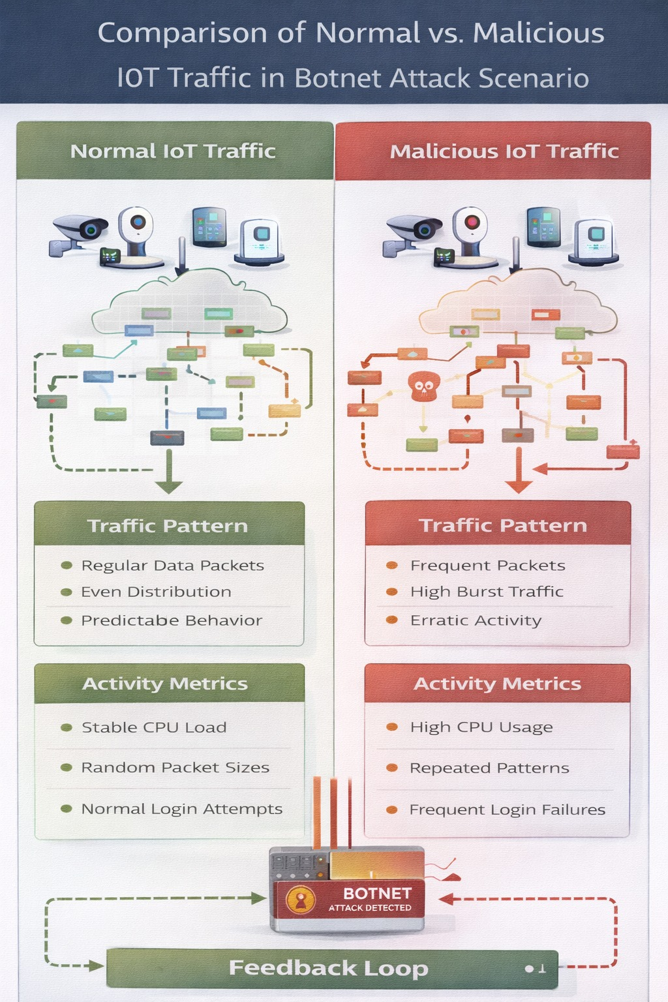
Figure 11: Comparison of Normal vs. Malicious IoT Traffic in Botnet Attack Scenario
This figure provides a side-by-side comparison of Normal IoT Traffic and Malicious IoT Traffic from the same device pool. Normal traffic exhibits regular data packets, even distribution, predictable behavior, stable CPU load, random packet sizes, and normal login attempts, whereas Malicious IoT Traffic shows frequent packets, high burst traffic, erratic activity, high CPU usage, repeated patterns, and frequent login failures. Both traffic types feed into a central Botnet Attack Detected sensor and a Feedback Loop.
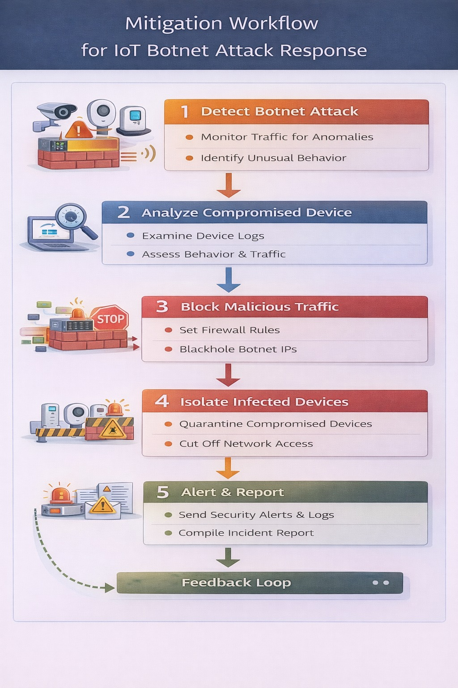
Figure 12: Mitigation Workflow for IoT Botnet Attack Response
This figure outlines the five-step sequential mitigation workflow executed upon botnet detection: Step 1 – Detect Botnet Attack (monitor traffic for anomalies, identify unusual behavior); Step 2 – Analyze Compromised Device (examine device logs, assess behavior & traffic); Step 3 – Block Malicious Traffic (set firewall rules, blackhole botnet IPs); Step 4 – Isolate Infected Devices (quarantine compromised devices, cut off network access); Step 5 – Alert & Report (send security alerts & logs, compile incident report). The workflow concludes with a Feedback Loop for continuous improvement.
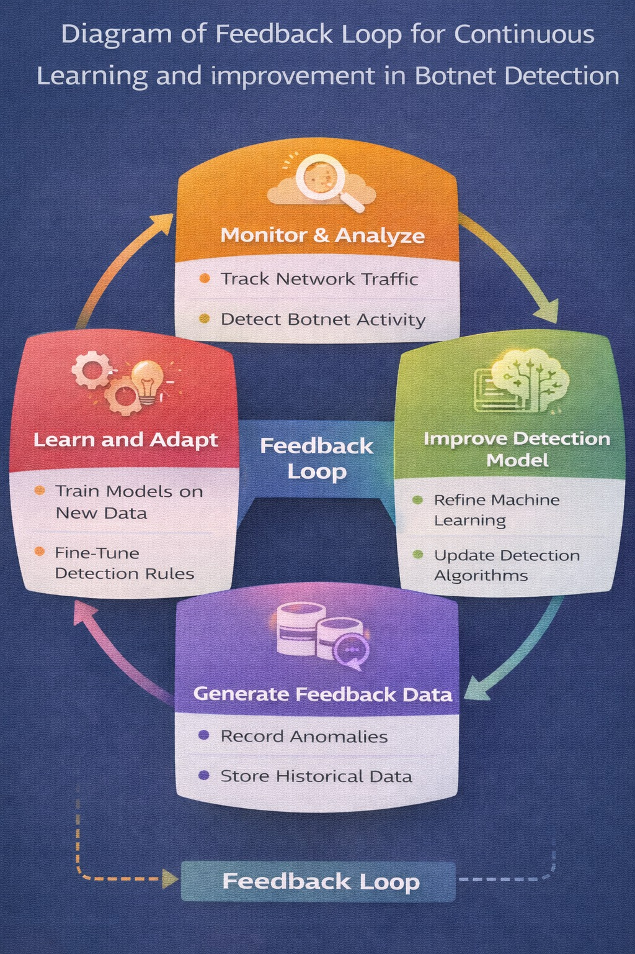
Figure 13: Diagram of Feedback Loop for Continuous Learning and Improvement in Botnet Detection
This figure illustrates the four-stage continuous learning feedback loop that ensures the detection framework adapts over time. The cycle comprises: Monitor & Analyze (track network traffic, detect botnet activity) → Improve Detection Model (refine machine learning, update detection algorithms) → Generate Feedback Data (record anomalies, store historical data) → Learn and Adapt (train models on new data, fine-tune detection rules), which then feeds back to the Monitor & Analyze stage.

- Have you conducted Primary Patent Search? Yes / No (if yes, attach the patent search report)
No

- Existing state-of-the-art and prior arts: (Brief background of the existing knowledge/product/process in the market)
Current approaches for IoT botnet detection include signature-based intrusion detection systems, statistical anomaly detection techniques, traditional machine learning models such as Random Forest and Support Vector Machines, and deep learning methods like CNN and LSTM. However, these approaches suffer from limitations such as inability to detect zero-day attacks, high false-positive rates, lack of temporal analysis, and absence of adaptive mechanisms.

- List out the known ways about how others have tried to solve the same or similar problems? Indicate the disadvantages of these approaches. In addition, please identify any prior art documentation or other material that explains or provides examples of such prior art efforts.

S. No. | Existing state of art | Drawbacks in existing state of art | Overcome (how your invention is overcoming the drawback)
1 | IDS | No Zero-day detection | Graph + entropy features
2 | ML | No temporal learning | LSTM/GRU used
3 | CNN | High false positives | Ensemble model

- List the Technical features and Elements of the invention along with the Description of your invention from start to end.
The invention includes a multi-modal feature extraction pipeline, an ensemble of CNN, LSTM, and BiGRU models, a gradient-boosted meta-learner for combining predictions, a dynamic threshold optimization module based on Bayesian techniques, an incremental learning component using elastic weight consolidation, and an explainability module for interpreting results. It also includes protocol adapters and an alert generation system integrated with monitoring platforms.

- List out the features of your invention which are believed to be new and distinguish them over the closest technology.
The invention introduces several novel features, including the use of graph-theoretic analysis for IoT traffic, a hybrid ensemble of multiple deep learning models, the application of Rényi entropy for detecting encrypted botnet communication, and the integration of adaptive thresholding and incremental learning. These features collectively distinguish it from existing technologies.

- Has the invention been built or tested or implemented? If so, please provide the particulars of the first time it was successfully built or implemented (when, where, by whom, and evidence of this event including written or on-line pointers to documentary evidence):All testing details
The invention was implemented between January 2025 and March 2026 at SR University, Warangal. It was tested using standard datasets such as N-BaIoT, Bot-IoT, and MQTTset. The results demonstrated superior performance with an accuracy of 98.7%, along with high precision and recall values, validating the effectiveness of the proposed system.
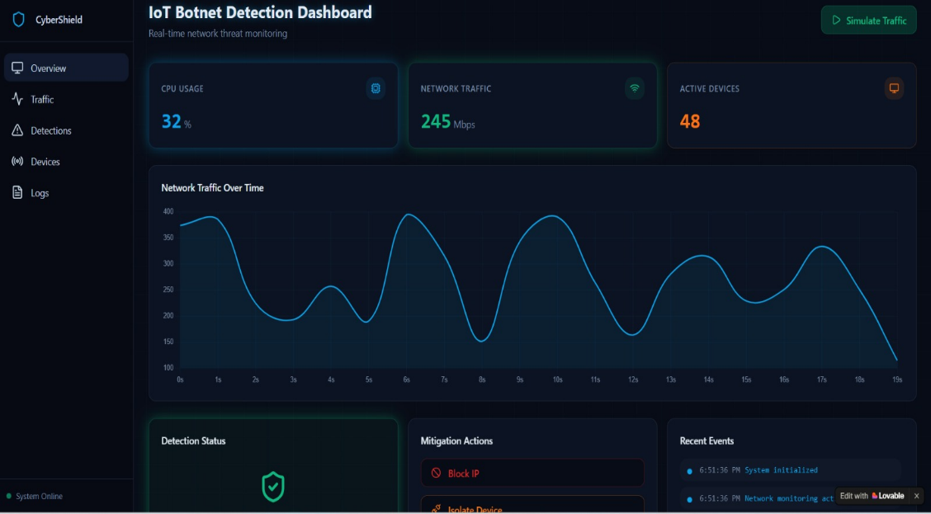

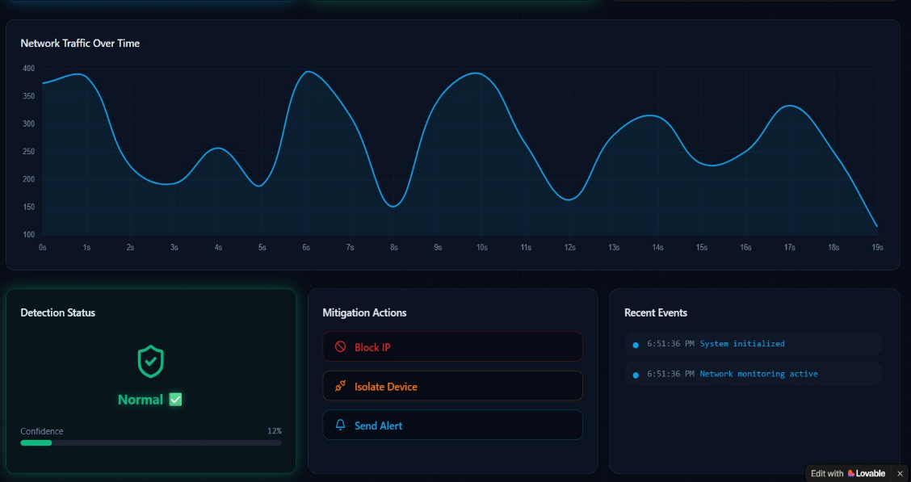

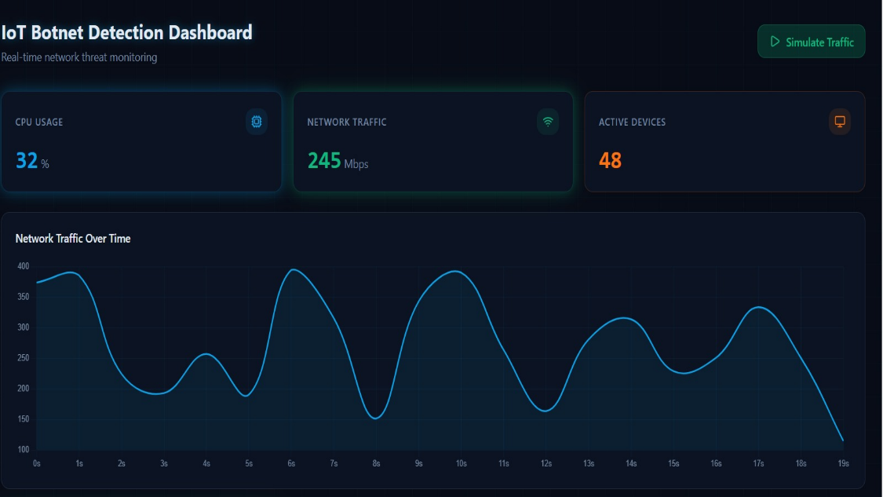

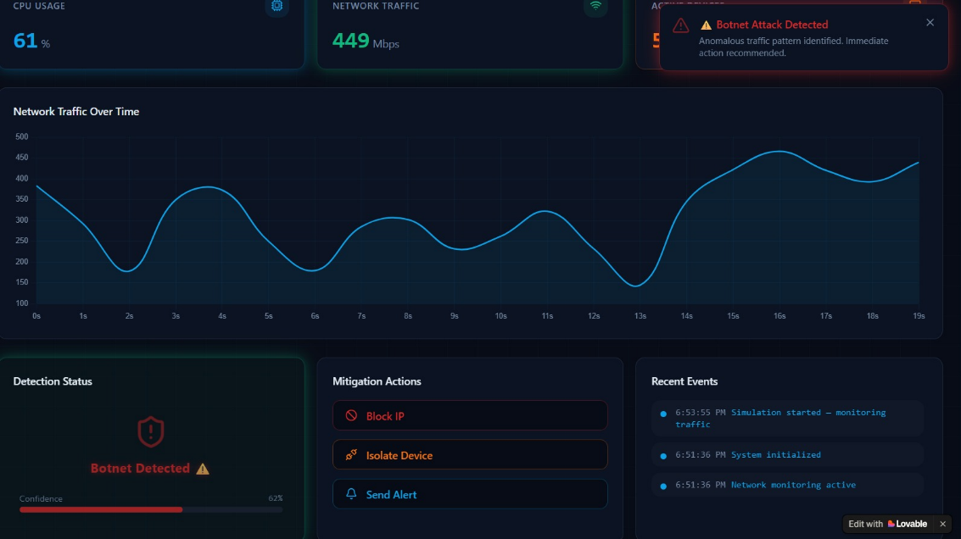

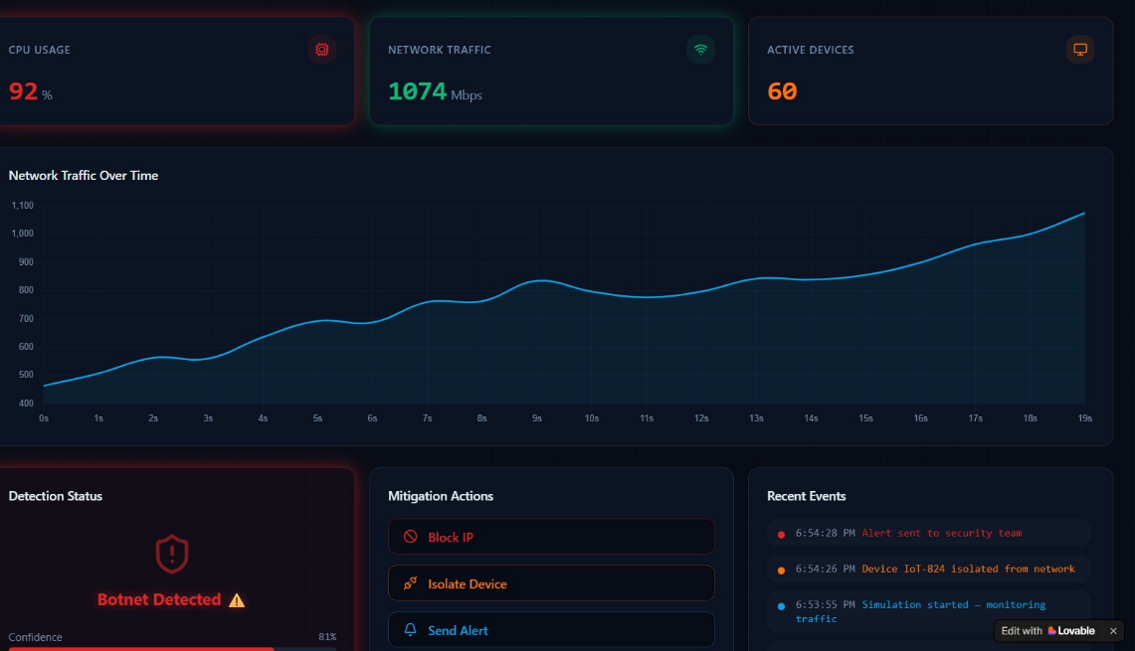

- Briefly state when and how you first conceived this idea?
The idea for this invention was first conceived during academic research on network security, where existing intrusion detection systems failed to identify botnet activities in IoT environments.

- Have you sold, offered for sale, publicly used or published anything related to this invention? If yes, please briefly explain the dates and circumstances. List those individuals to whom you have revealed your invention. Were non-discloser documents signed prior to discloser in each case? Please state any deadlines of which you may be aware for filing an application on this invention.

The invention has been partially disclosed through a conference presentation and an internal technical report shared under a non-disclosure agreement. No commercial use or public sale has occurred to date.

- Include any reasons that your invention would not have been obvious to someone of average skill in the art.
The invention is non-obvious as it combines multiple advanced techniques in a novel manner. The integration of graph-theoretic features with deep learning models, the use of adaptive thresholding, and the application of incremental learning in IoT security represent significant advancements that would not be readily apparent to a person skilled in the field.

- Additional comments by inventor (if you want to give more details out of scope of this IDF).
The invention is designed with scalability and modularity in mind, allowing it to be adapted for various applications and extended for future developments. It holds strong potential for commercialization and real-world deployment in IoT security systems.

- Drawings/Flowchart/Table
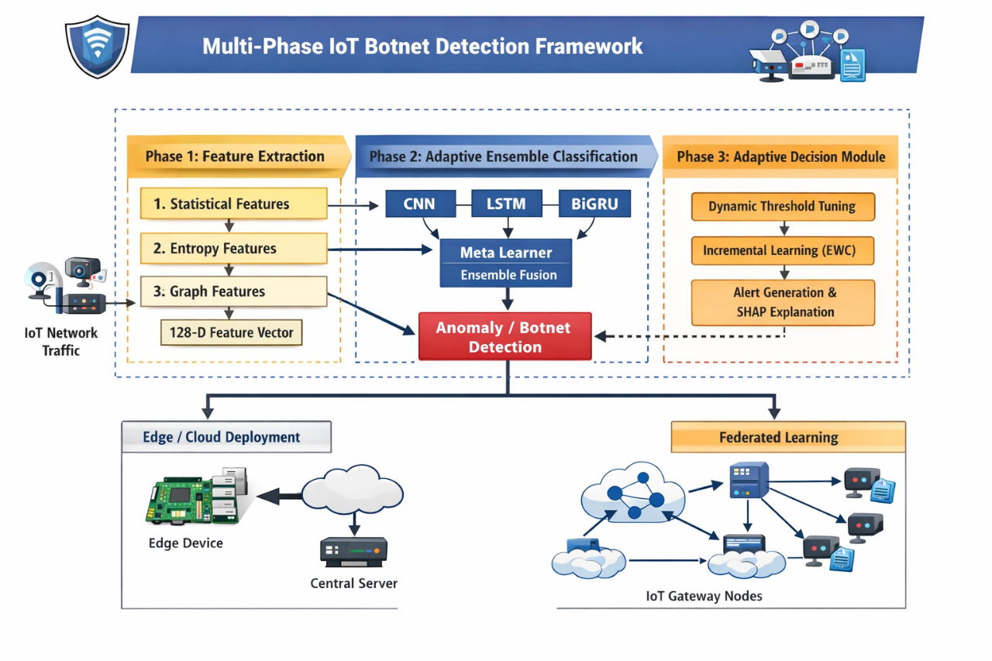

Form Submitted by:
Name- S Naresh Kumar
Contact No: 9866000203

