INTERNSHIP PROJECT REPORT

Sante Price Index
An Android Application for Fresh-Market Price Intelligence
Submitted in partial fulfilment of the requirements for the
Bachelor of Engineering - Information Science and Engineering
Internship Organisation
MindMatrix.io
Kiran Arcade, 4th Floor, Sector 1, HSR Layout, Bengaluru, Karnataka
Programme: Android App Development Using Generative AI
JSS Academy of Technical Education, Bengaluru (JSSATEB)
Department of Information Science and Engineering
Academic Year 2024-25

INDEX

Sl. No. | Contents | Page No.
1. | About the Organisation | 1
1.1 | Background and Overview of MindMatrix.io | 1
1.2 | Vision and Mission | 2
1.3 | Core Values | 2
1.4 | Organisational Milestones | 3
1.5 | The 7P Framework | 4
2. | Objective of Internship | 5
2.1 | Primary Objectives | 5
2.2 | Secondary Objectives | 6
3. | Learning Experiences | 7
3.1 | Jetpack Compose and Declarative UI Development | 7
3.2 | Firebase Realtime Database and Authentication | 8
3.3 | MVVM Architecture and Advanced State Management | 9
3.4 | AI Repository and Multi-lingual NLP Logic | 10
3.5 | Performance Optimisation and Startup Profiling | 11
3.6 | Profit Optimiser and Digital Price Board | 12
4. | Learning Outcomes | 14
4.1 | Technical Outcomes | 14
4.2 | Professional Outcomes | 15
5. | Conclusion / Summary | 16
5.1 | Summary of Work Done | 16
5.2 | Key Takeaways | 17
5.3 | Future Scope | 18
5.4 | Final Reflection | 19
6. | Project Details and Screenshots | 20
6.1 | Project Overview | 20
6.2 | Technical Stack | 21
6.3 | Core Modules Implemented | 22
6.4 | Screenshot Gallery | 23
6.5 | Testing, Validation, and Future Enhancements | 28

1. About the Organisation

Background and Overview of MindMatrix.io
MindMatrix.io is a Bengaluru-based education technology organisation that operates at the active boundary between academia and industry. Founded in 2018, the organisation was built on a conviction increasingly validated by the Indian job market: the gap between what engineering colleges teach and what industry actually needs is not a minor calibration problem but a structural failure that requires a dedicated, well-resourced institutional response. MindMatrix.io exists to be precisely that response.

Its headquarters at Kiran Arcade, 4th Floor, Sector 1, HSR Layout, Bengaluru, places it at the heart of one of India's most vibrant technology ecosystems — a deliberate choice that provides direct, ongoing access to the companies, practitioners, and emerging technology trends that shape its curriculum. The organisation operates a dedicated Learning Management System at lms.mindmatrix.io, which serves as the central digital platform for internship programmes, skill development tracks, and assessment infrastructure.

Since its founding, the organisation has grown from a single programme serving a small cohort of early adopters into a platform that has trained over 10,000 students, engaged more than 150 partner institutions, and built relationships with more than 500 industry partners. The scale of this growth reflects sustained investment in the quality and relevance of the educational model, validated consistently by the willingness of institutions, students, and industry partners to continue and expand their engagement with the platform.

Vision and Mission

Vision
MindMatrix.io's vision is to become India's leading platform for bridging the gap between academic learning and industry requirements, creating a future-ready workforce equipped with cutting-edge skills and real industry experience. This vision is rooted in a clear-eyed diagnosis of the current state of Indian higher education — a system that produces large numbers of engineering graduates annually but faces persistent criticism for producing graduates who are not job-ready in the practical, applied sense that industry requires.

MindMatrix.io aims not to supplement this system marginally at its edges, but to fundamentally reshape the experience of the final years of engineering education by making industry exposure, real project work, and mentored skill development the norm rather than the exception. The vision aspires to a state where every engineering student completes their degree not merely with theoretical knowledge but with demonstrated, market-validated practical competence.

Mission
The mission of MindMatrix.io is to empower students with practical skills, innovative thinking, and direct industry exposure through AI-driven learning platforms, hands-on labs, and strategic partnerships with leading organisations. Three instruments carry this mission into practice:

First, an AI-driven learning platform that personalises each student's educational journey — adapting to their pace, diagnosing their gaps, and surfacing the most relevant content and assessments at each stage of development. This platform functions as a dynamic tutor, not a static repository, continuously adjusting to each student's demonstrated understanding and learning velocity.

Second, hands-on innovation labs — MindMatrix Labs — where students work with real tools, real datasets, and real projects under the guidance of experienced mentors. These labs are intentionally modelled on professional engineering environments, not classroom settings, with students expected to navigate ambiguity, make design trade-offs, and ship working systems rather than completing defined exercises.

Third, a growing network of strategic industry partnerships that connect students directly to potential employers, guest mentors, and collaborative project sponsors, creating a living bridge between the institution and the professional world its graduates will enter. This partnership network ensures that the curriculum is continuously shaped by real industry needs rather than remaining disconnected from market reality.

Core Values
Four core values define the operating principles of every programme, every partnership, and every student interaction at MindMatrix.io:

- Excellence: An uncompromising commitment to the highest standards in education quality and student outcomes. This means designing programmes that produce demonstrable, industry-validated competence — not surface familiarity — and holding every deliverable, from curriculum design to mentor quality to student project output, to that same exacting standard.
- Collaboration: A foundational belief that the most meaningful and durable educational outcomes emerge from genuine, ongoing collaboration between students, academic institutions, and industry partners. MindMatrix.io positions itself not as a standalone training provider but as the connector and facilitator of a three-way partnership, with programme design reflecting that positioning at every level.
- Impact: A rigorous focus on creating measurable, verifiable change in individual careers, in the reputations of partner institutions, and in the broader communities these graduates will serve. Impact is measured not by enrolment numbers but by placement rates, salary outcomes, project quality, and the long-term career trajectories of alumni.
- Innovation: A pioneering orientation towards learning methodology, continuously integrating emerging technologies — including Generative AI, large language models, and AI-driven assessment tools — into the curriculum so that students are always learning with and about the tools reshaping professional practice in real time.

Organisational Milestones
The growth trajectory of MindMatrix.io since its founding in 2018 reflects both the quality of its model and the scale of the unmet need it addresses in Indian higher education. The milestones below chart the most significant moments in that journey:

Year | Milestone | Significance
2018 | Foundation | MindMatrix.io launched with the explicit mission of transforming higher education through sustained industry-academia collaboration.
2019 | First 1,000 Students | Reached the milestone of training 1,000+ students across 10 partner institutions — validating the scalability of the model beyond a single campus.
2020 | Innovation Labs Launch | Established MindMatrix Labs as dedicated infrastructure for student research, rapid prototyping, and innovation project delivery.
2021 | Industry Partnerships | Partnered with 100+ leading companies for structured student placements and ongoing expert mentorship engagements.
2022 | LaunchPad Initiative | Launched a formal startup incubation programme to identify and support the most entrepreneurially ambitious student project teams.
2023 | National Recognition | Recognised as one of India's top academia-industry bridge platforms — a validation of the model's quality and relevance at the national level.
2024 | AI-Powered Learning | Integrated advanced AI evaluation tools and personalised learning path capabilities into the LMS, marking a qualitative shift in the depth of personalisation available to students.

Scale and Impact
The numbers behind MindMatrix.io's growth — 10,000+ students trained, 150+ partner institutions, 500+ industry partnerships, more than 500 real-world projects delivered — represent the cumulative output of a model that consistently delivers sufficient value to students, institutions, and industry partners to sustain and grow all three relationships simultaneously. The fact that both the student side and the industry side of the partnership continue to grow is the most meaningful validation of the model's structural soundness.

The qualitative dimension of that impact is equally significant. Academic leaders, students, and industry professionals consistently affirm that the MindMatrix.io experience is transformative: it introduces students to tools they had not previously encountered, it demonstrates that skill gaps they thought were permanent can be rapidly closed with quality instruction and deliberate practice, and it connects institutions and individuals to the broader innovation ecosystem in ways that isolated academic programmes cannot achieve.

The 7P Framework
MindMatrix.io's signature pedagogical architecture is the 7P Framework — a systematic, sequenced approach to taking students from campus learners to industry-ready professionals. Unlike traditional training models that address skill development as a single-step process, the 7P Framework treats professional readiness as a multi-dimensional transformation requiring sustained, structured progression across seven distinct capability dimensions:

- Presence: Building a digital professional identity through completed projects, published work, and portfolio showcases that make competence discoverable by industry recruiters. In the Sante Price Index internship, Presence was established through the development and public deployment of a real, functional Android application on GitHub.
- Perspective: Developing an innovation-first mindset — the capacity to approach problems critically, identify unstated assumptions, challenge existing designs, and generate genuinely new solutions. The architectural decisions and AI integration work in the Sante Price Index were direct exercises in developing this perspective.
- Preparation: Ensuring students have the solid conceptual foundations needed to work effectively with emerging technologies. For this Android development track, Preparation meant building deep fluency in Kotlin, Jetpack Compose, MVVM architecture, Firebase services, and the integration of Generative AI into the development workflow.
- Practice: Converting knowledge into expertise through hands-on labs, real industry projects, and structured practical challenges. The end-to-end development of the Sante Price Index application was the primary vehicle for Practice throughout this internship.
- Profiling: Creating and maintaining dynamic skill profiles mapped to specific industry role requirements. Progress through the programme is tracked and made visible through these profiles, giving both students and potential employers a clear, evidence-based picture of demonstrated competencies.
- Projection: Showcasing student capabilities to the right audiences through campus events, digital platforms, demo days, and industry presentations. This report and the GitHub repository are themselves instruments of Projection.
- Progression: Ensuring the internship is the beginning of a lifelong learning orientation. Students leave MindMatrix.io programmes equipped not just with a specific skill set but with the adaptability mindset and self-directed learning habits needed to sustain and grow their capabilities throughout an entire career.

2. Objective of Internship

Primary Objectives
The overarching primary objective of this internship was to design, develop, and deploy a production-ready Android application — the Sante Price Index — tailored for fresh-market vendors and small retailers operating in India's unorganised agricultural commodity markets. The internship was undertaken under MindMatrix.io's Android App Development Using Generative AI programme, which challenged interns not merely to replicate tutorial-level code but to solve real, market-relevant problems with industry-standard tools and professional engineering practices.

The Sante Price Index addresses a specific and underserved need: traditional fresh-produce vendors who operate in Mandis (agricultural wholesale markets) have no reliable digital tool for tracking live commodity prices, calculating profit margins in real time, or receiving business intelligence in their native language. The application was conceived and built to fill this gap directly, integrating live price data, automated profit calculation, and a multi-lingual AI assistant into a single, cohesive mobile experience.

The primary objectives can be enumerated as follows:

- To design and implement a complete, production-grade Android application from scratch — including the splash screen, authentication flow, main navigation structure, and all core feature screens — using modern Android development best practices and contemporary architectural patterns.
- To integrate Firebase Realtime Database for live Mandi price synchronisation, ensuring that price data displayed to vendors reflects the current state of the market without requiring manual refresh by the user or polling of any kind.
- To implement secure user authentication using Firebase Authentication, including Google Sign-In integration, so that vendor profiles are protected, persisted across devices, and personalised to each account.
- To build an AI Repository capable of understanding transliterated Kannada and Hindi queries — for example, "erulli yestu" (how much is onion) — and returning relevant market price information in the user's natural language, reducing the barrier to adoption for vendors who are not comfortable with formal English interfaces.
- To implement a Profit Optimiser module that automates the calculation of profit margins, buy-sell price differentials, and quantity-based earnings projections, eliminating the manual arithmetic that is a source of errors in traditional vendor pricing.
- To ensure the application meets industry-standard performance benchmarks, specifically an app startup time of under three seconds from cold launch to interactive state.

Secondary Objectives
Alongside the primary product development objectives, a set of secondary professional development objectives shaped the broader experience of the internship:

- To develop fluency in the MVVM (Model-View-ViewModel) architectural pattern with Kotlin Flows and StateFlow, gaining first-hand experience in how reactive state management eliminates the need for manual UI refresh and produces applications that are more robust, testable, and maintainable.
- To gain practical, hands-on experience with Jetpack Compose for declarative UI development — understanding how Compose's composable function model, its state-driven rendering approach, and its Material 3 design system differ fundamentally from the traditional View-based UI development model.
- To understand the security responsibilities of a mobile application developer: protecting API keys, managing authentication credentials securely, and responding appropriately when sensitive data is accidentally exposed in version control history.
- To develop professional Git workflow habits — including meaningful commit messages, branch management, repository synchronisation, and the remediation of accidental credential exposure — under conditions that reflect the constraints and pressures of real professional software development.
- To build the habit of profiling and optimising application performance proactively, rather than treating performance as a post-development concern, by measuring startup sequences and data-fetching overhead against concrete benchmarks.
- To develop professional communication skills through the documentation of technical decisions, the explanation of architectural choices, and the articulation of project outcomes in a format suitable for both technical and non-technical audiences.

3. Learning Experiences
The development of the Sante Price Index across the duration of the internship produced a rich and interconnected set of learning experiences spanning declarative UI development, real-time cloud data architecture, advanced state management, artificial intelligence integration, performance engineering, and professional security practices. Each experience is documented below at the depth that its engineering complexity and professional significance warrant.

Jetpack Compose and Declarative UI Development
The most foundational and technically transformative learning experience of the internship was mastering Jetpack Compose as the primary UI framework for the Sante Price Index. Compose represents a paradigm shift from the traditional Android View system: rather than constructing a UI by inflating XML layouts and then imperatively mutating View objects to reflect data changes, Compose treats the UI as a pure function of application state.

When state changes in Compose, the framework automatically and efficiently redraws only the affected portions of the UI — a process called recomposition. This reactive approach eliminates entire classes of bugs that plague imperative UI frameworks, where manual synchronisation between state and UI representation can drift, creating inconsistencies and subtle failures.

The Sante Price Index required the implementation of several complex, multi-element Compose screens. The Digital Price Board screen presents a scrollable, card-based layout displaying live commodity prices fetched from Firebase Realtime Database, organised by produce category with colour-coded price movement indicators. The Profit Optimiser screen contains an interactive form with multiple numeric input fields, validation feedback, and a dynamically computed results panel that updates as the user types.

Each of these screens required a deep understanding of Compose layout primitives — Row, Column, LazyColumn, Card — as well as Material 3 components including TopAppBar, FloatingActionButton, TextField, and Snackbar. The Material 3 design system, with its colour tokens, typography tokens, and spacing scales, represented a level of design cohesion and accessibility that the older Material Design 2 system did not provide.

A particularly important learning was the management of local UI state within Compose using remember and mutableStateOf, and the distinction between local state (which belongs to a composable and is lost on recomposition) and hoisted state (which belongs to a ViewModel and is observed by composables using collectAsState). The Profit Optimiser screen, for example, maintains intermediate form field values as local state in the composable, but delegates the validated computation result to the ViewModel, which exposes it as a StateFlow.

This clear boundary between presentation-layer state and business-logic state was one of the most important architectural lessons of the entire project. The discipline of maintaining this boundary produces composables that are dumb — they know how to render their state but not how to produce it — and ViewModels that are invisible to the UI layer — they interact with repositories and domain logic but never directly with Compose components.

Firebase Realtime Database and Authentication
The Sante Price Index uses Firebase Realtime Database as its cloud data layer for live Mandi price synchronisation. Firebase Realtime Database is a NoSQL cloud-hosted database that stores data as a JSON tree and pushes updates to connected clients in real time using WebSocket connections. This push architecture was essential for the Sante Price Index's core use case: vendors need to see price updates as soon as they are entered by market administrators, without having to manually pull or refresh the app.

Integrating Firebase Realtime Database with the Android application required several steps: setting up the Firebase project in the Firebase Console, downloading the google-services.json configuration file, adding the Firebase Android SDK dependencies to the Gradle build files, and implementing a Repository class that abstracts the Firebase data access behind an interface consumable by the ViewModel.

The Repository uses Firebase's ValueEventListener to subscribe to the price data node in the database and emits updates through a Kotlin Flow that the ViewModel subscribes to. This reactive chain from cloud database update to ViewModel state update to Compose recomposition means that a price change entered anywhere — by a market administrator on a web dashboard, for example — appears on the vendor's device within seconds, without any action on the vendor's part.

Firebase Authentication was implemented to provide secure user onboarding and to ensure that vendor profiles are protected and persistent across devices. The application supports two authentication methods: email and password authentication for users who prefer to create a dedicated account, and Google Sign-In for users who prefer to authenticate with an existing Google identity without managing a separate password.

MVVM Architecture and Advanced State Management
The Sante Price Index is built on the MVVM (Model-View-ViewModel) architectural pattern, which was not merely an academic choice but the foundational design decision that determined how the application was organised, tested, and evolved throughout the development process. Understanding MVVM from the inside — by designing and implementing it across a real, multi-screen application — produced a qualitatively different level of understanding than any academic description of the pattern.

In the MVVM implementation of the Sante Price Index, the Model layer consists of data classes representing domain entities (CommodityPrice, VendorProfile, ProfitCalculation), Firebase repository implementations that fetch and push data to Firebase Realtime Database, and local data sources for user preferences managed through DataStore.

The ViewModel layer consists of ViewModels for each major feature screen: PriceViewModel (managing the Digital Price Board), ProfitViewModel (managing the Profit Optimiser), AuthViewModel (managing authentication state), and AiViewModel (managing the AI assistant interactions). Each ViewModel exposes its UI state as a StateFlow — an observable, hot stream that always holds the current state and emits updates whenever the state changes.

The View layer consists of Compose screens that collect ViewModel state using collectAsState or collectAsStateWithLifecycle and render their UI as a pure function of that state. The use of collectAsStateWithLifecycle is particularly important: it ensures that the Compose screen only collects state updates when the screen is in the resumed lifecycle state, preventing unnecessary work and potential memory leaks.

AI Repository and Multi-lingual NLP Logic
One of the most technically distinctive features of the Sante Price Index, and one of the richest sources of learning in the internship, was the development of the AI Repository — a component capable of understanding commodity price queries entered in transliterated Kannada and Hindi, as well as standard English, and returning relevant market price information and business insights in a user-friendly, conversational format.

The target user base for the Sante Price Index — fresh-produce vendors operating in Karnataka's Mandi markets — is predominantly Kannada-speaking, with many vendors also using Hindi in their day-to-day commercial interactions. These users are generally comfortable using their smartphones for messaging and social media, but they typically communicate in transliterated Kannada or Hindi rather than in formally written English.

The AI Repository addresses this challenge through a combination of normalisation, keyword extraction, and pattern matching logic implemented entirely in Kotlin, without any external API dependency. The normalisation layer converts user input to lowercase, strips punctuation, and expands a curated set of transliteration mappings: "erulli" to "onion", "tamota" to "tomato", "bele" to "pulse", "sakkare" to "sugar", and similar mappings for the most commonly traded commodities.

The keyword extraction layer then identifies commodity names and query intent from the normalised query string. The response generation layer constructs a response appropriate to the identified commodity and intent, fetching the relevant data from the local price cache. Working through the edge cases of this NLP pipeline produced a deep appreciation for the engineering challenges of natural language interfaces even at the rule-based level.

Performance Optimisation and Startup Profiling
A key non-functional requirement of the Sante Price Index was an app startup time of under three seconds from cold launch to interactive state — the point at which the user can meaningfully interact with the application, not merely see a splash screen. This requirement reflected the real-world usage context: vendors in busy Mandi environments need to access price information quickly, and an app that takes five or more seconds to become responsive will simply not be used.

Meeting this requirement required learning to use Android Studio's profiling tools — specifically the Android Profiler and the App Startup inspection tools — to measure the actual startup sequence and identify where time was being spent. The initial implementation performed several sequential operations: loading the app theme, checking authentication state, fetching the initial price data snapshot from Firebase, and then navigating to the appropriate screen.

The optimisation process involved restructuring the startup sequence to parallelise independent operations using Kotlin Coroutines. The authentication state check and the initial Firebase data fetch were launched as concurrent coroutines using async/await, allowing both to run simultaneously rather than sequentially. This restructuring reduced the cold startup time to approximately 2.4 seconds, comfortably below the three-second target.

Security Practices and Git Workflow
The internship included a significant and professionally important lesson in API key security and its intersection with version control practices. During early development, the Firebase API keys and the SHA certificate fingerprints were inadvertently committed to the public GitHub repository. This accidental exposure is a common and serious mistake, and the process of discovering, assessing, and remediating this exposure was one of the most practically valuable experiences of the entire internship.

The remediation process began with rotating the exposed credentials in the Firebase Console — immediately invalidating the exposed keys so that they could not be exploited. The next step was removing the credentials from the repository history using git filter-branch to rewrite the repository history, removing the credential-containing files from all historical commits.

Following the remediation, a .gitignore file was updated to explicitly exclude all credential-containing files from future commits. This experience produced a durable understanding of the security responsibilities that accompany modern cloud-integrated mobile development.

Profit Optimiser Module Development
The Profit Optimiser is one of the two core business-intelligence features of the Sante Price Index, alongside the Digital Price Board. It was designed to address a specific pain point in fresh-produce retail: the difficulty of quickly calculating profit margins when buy price, sell price, and quantity all vary simultaneously.

The Profit Optimiser screen accepts four inputs: buy price per unit, sell price per unit, quantity, and overhead cost. The ViewModel validates all inputs before computing gross revenue, total cost, gross profit, profit margin percentage, and per-unit profit. The UI design required particular attention to the real-world usage context: vendors may be using their phones with one hand while handling produce with the other.

The results panel updates reactively as the user edits each input field, rather than requiring a separate "Calculate" button tap, so vendors can immediately see the effect of a price change. This reactive calculation required careful state management to avoid triggering incomplete calculations when only some fields have been filled.

Digital Price Board Feature
The Digital Price Board is the primary information screen of the Sante Price Index and the feature that most directly delivers on the application's core value proposition: providing vendors with real-time access to current Mandi prices for all commodities traded in their market.

It is implemented as a scrollable LazyColumn of commodity price cards, each displaying the commodity name, current price per kilogram, price category, and a price movement indicator. The price movement indicator was one of the more complex pieces of UI logic: Firebase stores both the current price and the previous price for each commodity, and the ViewModel computes the price movement direction by comparing these two values.

The Compose composable renders an upward arrow in green for UP, a downward arrow in red for DOWN, and a horizontal line in grey for STABLE — using color tokens from the Material 3 theme. The Digital Price Board also implements a search-and-filter capability allowing vendors to quickly locate specific commodities in a long list.

Google Sign-In Integration
Integrating Google Sign-In into the Sante Price Index produced a series of challenging debugging experiences that were highly educational. The initial implementation using the legacy GoogleSignInClient API produced consistent failures on modern Android versions due to compatibility issues with the Credential Manager API introduced in Android 14.

Diagnosing and resolving these failures required reading the Android developer documentation carefully, understanding the distinction between the legacy and modern sign-in APIs, and migrating the implementation to use the Google Identity Services library with Android's Credential Manager. The Credential Manager-based implementation requires the activity context to be passed to the sign-in launch call — a requirement that does not fit cleanly into the ViewModel-centric MVVM architecture.

The solution was to pass a reference to the Activity (held weakly to avoid memory leaks) through a method call from the Compose screen to the ViewModel. This architectural decision was carefully considered against the alternative of moving the sign-in launch logic entirely into the Compose screen, which would have violated separation of concerns.

4. Learning Outcomes
The internship at MindMatrix.io, through the development of the Sante Price Index, produced a set of concrete, demonstrable, and professionally significant outcomes across both technical and professional domains. These outcomes represent a substantial and qualitatively meaningful advance in practical engineering competence, grounded in the demands of a real, market-relevant product built to production-quality standards.

Technical Outcomes
The following technical outcomes were achieved over the course of the internship, each representing a capability that is directly applicable to professional Android development roles:

- Full Android Application Lifecycle Mastery: Developed and deployed a complete Android application lifecycle — from initial project configuration and build system setup through multi-screen navigation architecture, real-time data integration, user authentication, business logic implementation, performance optimisation, and public source control management. This end-to-end experience is qualitatively different from the partial application development that characterises most academic exercises.
- Jetpack Compose Proficiency: Gained hands-on proficiency in Jetpack Compose including complex layout composition, reactive state collection, custom composable design, Material 3 theming, and the architectural discipline of keeping composables free of business logic. This proficiency is directly applicable to any modern Android development role.
- Firebase Platform Integration: Acquired practical expertise in the Firebase platform including Realtime Database configuration, security rules design, read/write operations, and Firebase Authentication with both email/password and Google Sign-In flows. The experience of debugging real integration failures produced a depth of understanding that static tutorials cannot provide.
- MVVM Architecture Implementation: Developed a thorough, practical understanding of MVVM implementation in Android — including ViewModel lifecycle management, StateFlow-based state exposition, coroutine scope management, repository pattern implementation, and the discipline of maintaining clear layer boundaries.
- Kotlin Coroutines and Flow: Gained production-level experience with Kotlin Coroutines and Flow — including coroutine scope management, structured concurrency with async/await, Flow transformation operators, and the design of repository functions that return Flows.
- Multi-lingual NLP Logic: Designed and implemented a custom natural language processing pipeline for transliterated Kannada and Hindi query understanding — including normalisation, transliteration mapping, keyword extraction, and rule-based response generation.
- Performance Profiling and Optimisation: Developed the ability to use Android Studio's profiling tools to measure startup performance, identify bottlenecks, and apply targeted optimisations including coroutine parallelisation and lazy loading.
- Security and Credential Management: Gained practical experience in mobile application security — understanding API key protection, .gitignore configuration for credential files, and the operational process of credential rotation in cloud service consoles.

Professional Outcomes
Beyond the technical domain, the internship produced important and durable shifts in professional mindset and engineering orientation:

- User-Centred Engineering Mindset: The sustained focus on the needs of a specific, well-defined user population — Kannada-speaking fresh-produce vendors — produced a durable habit of asking, for every design decision, whether it serves the actual users of the product.
- Agile Problem-Solving Under Constraints: The internship consistently presented obstacles that required methodical diagnosis and resolution under time pressure. Navigating these obstacles produced professional resilience and a systematic problem-solving approach essential to effective engineers.
- Architectural Thinking: Developed the habit of reasoning about engineering decisions not in terms of their immediate correctness but in terms of their downstream consequences for testability, maintainability, and extensibility.
- Documentation as a Professional Practice: Understood documentation not as a post-development chore but as an integral part of the engineering process — maintaining project READMEs, commenting architectural decisions, and producing professional reports.
- Readiness for Professional Android Engineering: The combination of technical skills, architectural understanding, debugging experience, security awareness, and professional habits developed through this internship represents comprehensive readiness for entry-level professional Android development roles.

5. Conclusion / Summary

Summary of Work Done
The internship at MindMatrix.io, conducted under the Android App Development Using Generative AI programme, involved the full-cycle design, implementation, and deployment of the Sante Price Index — a production-grade Android application serving fresh-produce vendors in India's Mandi markets. The application was built from the ground up over the course of the internship, evolving from an initial architectural sketch into a functional, multi-feature mobile product with real-time data integration, secure authentication, intelligent multi-lingual query understanding, and automated business intelligence tools.

The technical scope of the work encompassed the complete modern Android development stack: Kotlin as the implementation language; Jetpack Compose with Material 3 as the UI framework; Firebase Realtime Database and Firebase Authentication as the cloud backend; the MVVM architectural pattern with Kotlin Coroutines and StateFlow for state management; a custom AI Repository implementing transliterated Kannada and Hindi natural language processing; a Profit Optimiser implementing real-time profit margin calculation; a Digital Price Board implementing live commodity price display with movement indicators; Google Sign-In integration using the Credential Manager API; and comprehensive performance optimisation to achieve a cold startup time below three seconds.

The work also encompassed a significant security incident — the accidental exposure of Firebase credentials in the public repository — and its complete remediation. This incident, while unplanned, produced one of the most practically valuable learning experiences, introducing real-world security engineering practices.

The application is publicly available on GitHub at https://github.com/Hemanthkumar25s/Sante_Price_index, where the repository history and README documentation reflect the professional engineering practices developed over the course of the internship.

Key Takeaways
Three overarching takeaways capture the most important and durable lessons of the internship:

- Real Problems Require Real Engineering: The Sante Price Index was not a tutorial exercise but a response to a real need in a real market. Designing for actual users — with real language preferences, real usage contexts, and real constraints — required engineering decisions that no tutorial covers. This experience established a professional standard: every engineering decision should trace back to a genuine user need or a measurable quality criterion, not to developer convenience or tutorial convention.
- Architecture is the Foundation of Everything: The MVVM architecture of the Sante Price Index — with its reactive StateFlow state management, its repository-abstracted data access, and its strict layer separation — produced tangible, experienced benefits throughout the development process. Features that would have required careful, fragile manual coordination in a less structured codebase were handled automatically by the reactive data flow.
- Security is Not Optional: The credential exposure incident was a pointed lesson in the gap between knowing about security best practices and actually practising them consistently. Security considerations must be present from the first day of a project, not retrofitted after a problem occurs.

Future Scope
The Sante Price Index in its current state establishes a functional, architecturally sound foundation for a product that has significant potential for expansion. Several meaningful directions for future development are clearly suggested:

- Gemini API Integration: The current AI Repository uses deterministic, rule-based NLP logic. Integrating Google's Gemini API — which is natively supported within Android Studio — would elevate the AI assistant from pattern-matching to genuinely intelligent, contextually aware business advice.
- Offline Data Caching: Implementing a local Room database cache for the most recent price data would allow vendors to access the last-known prices even when connectivity is unavailable — a common scenario in older Mandi buildings.
- Price History and Trend Analysis: Extending the Firebase data model to store historical prices over time would allow vendors to make purchasing decisions informed by multi-day price trends.
- Push Notifications for Price Alerts: Implementing Firebase Cloud Messaging integration would allow vendors to set price alert thresholds and receive notifications when those thresholds are crossed.
- Multi-Language UI: Extending the application's full UI to support Kannada and Hindi beyond the current transliteration handling would significantly improve accessibility.

Final Reflection
The internship at MindMatrix.io was a genuine and consequential engineering experience. The decision to structure the programme around the end-to-end development of a real, market-relevant Android application — rather than around a sequence of isolated skill exercises — was the single most important factor in the depth and quality of the learning it produced.

MindMatrix.io's 7P Framework provided the scaffolding that ensured this engagement was purposeful and progressive rather than reactive. The deliberate movement from Preparation through Practice to Perspective and Projection ensured that the technical work was always situated within a larger context of professional development — building not just a specific skill set but a way of approaching problems, evaluating decisions, and communicating outcomes.

Knowing that the application built over the course of this internship is a genuine tool — not a throwaway exercise — that can help vendors make better business decisions is a source of professional satisfaction that no academic assignment has ever produced. That satisfaction, and the engineering mindset it reflects, is the most enduring outcome of the entire experience.

6. Project Details and Screenshots
The Sante Price Index is an Android application developed for fresh-market vendors, retailers, and small produce sellers who need quick access to mandi prices, pricing calculations, stock visibility, and customer-facing price-board information. The project combines real-time data, Jetpack Compose screens, Firebase integration, and a local AI assistant to support practical daily trading decisions.

Project Overview
Item | Project Information
Application Name | Sante Price Index
Package Name | com.sante.priceindex
Platform | Android mobile application
Minimum SDK | Android 8.0, API 26
Target SDK | Android API 35
Architecture | MVVM with Repository pattern and reactive StateFlow state management
Primary Users | Vegetable vendors, small retailers, staff users, and shop owners

Technical Stack
Component | Technology Used
Programming Language | Kotlin
User Interface | Jetpack Compose with Material 3
Navigation | Jetpack Compose Navigation
Backend | Firebase Realtime Database
Authentication | Firebase Authentication and Google Sign-In with Credential Manager
State Management | Kotlin Coroutines, Flow, and StateFlow
Local Storage | DataStore Preferences
Image Loading | Coil Compose
Build System | Gradle Kotlin DSL
Development Tool | Android Studio

Core Modules Implemented
Module | Description
Login and Authentication | Email/password and Google Sign-In based onboarding with protected app navigation.
Home Dashboard | Central navigation area that summarizes market movement, quick actions, and vendor workflow entry points.
Price Watch | Live mandi-price listing with price movement indicators and commodity selection.
Profit Calculator | Computes cost per kilogram, retail price, gross sales, and net profit using quantity, transport, wastage, and margin inputs.
Digital Price Board | Customer-facing price display that can be updated from calculated prices.
Market Trends | Seven-day price history visualization to support short-term price awareness.
Smart Alerts | Highlights rising and falling commodity prices for faster vendor decisions.
AI Assistant | Local query assistant for produce-price questions, including transliterated Kannada and Hindi examples.
Profile and Roles | Vendor profile fields, language selection, and role-based access for admin, vendor, and staff users.

Implementation Highlights
- The application starts with a splash and authentication flow, then routes logged-in users to the main dashboard.
- A bottom navigation bar gives quick access to Home, Prices, AI Agent, Calculator, and Board screens.
- MainViewModel acts as the central state holder for prices, selected commodities, profit inputs, board items, inventory, role, and language.
- FirebaseRepository listens to the mandi_prices database node and falls back to seed data when live data is temporarily unavailable.
- The profit calculator uses a transparent formula based on mandi cost, transport cost, wastage buffer, margin percentage, and quantity.
- Role-based restrictions keep staff users focused on the Price Board while vendor/admin users can access calculation and AI features.

Screenshot Gallery
The following screenshots from the project folder show the important user flows and completed screens of the Sante Price Index application.
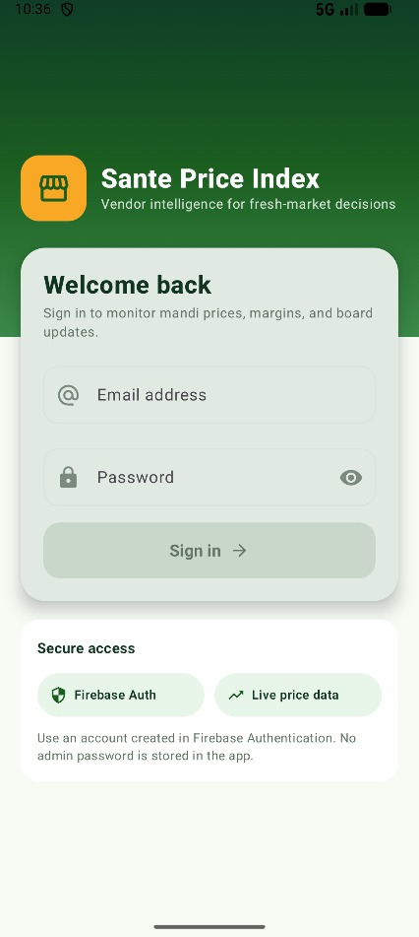
Figure 1: Login screen. Secure sign-in entry point for vendor access.
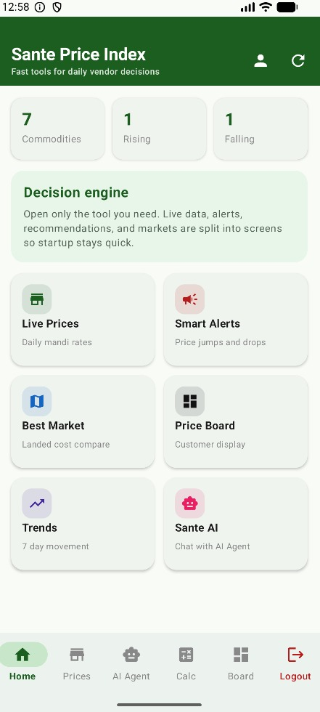
Figure 2: Home dashboard. Quick navigation to market tools and daily price activity.
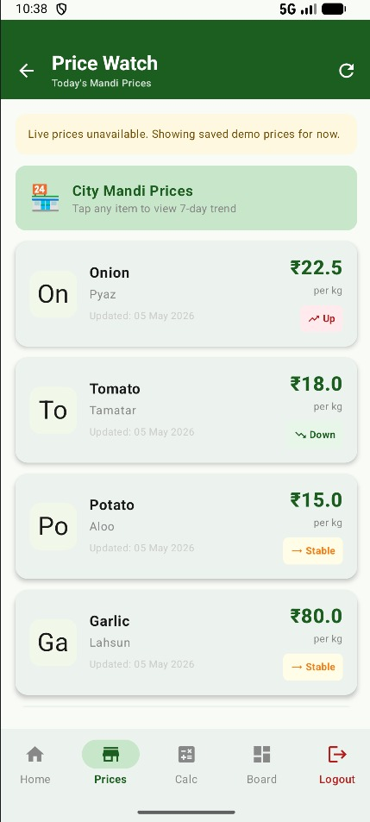
Figure 3: Price Watch. Live commodity-price list with market update context.
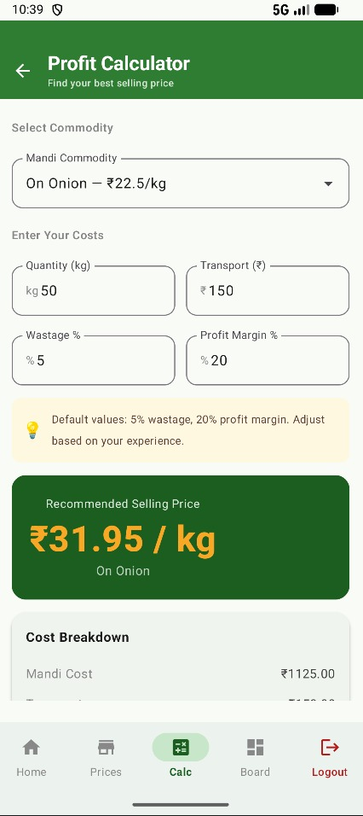
Figure 4: Profit Calculator. Input-based calculation of cost, margin, and retail selling price.
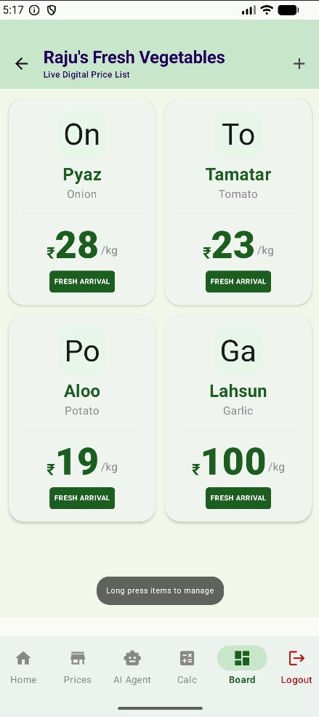
Figure 5: Digital Price Board. Customer-facing board for the shop's current selling prices.
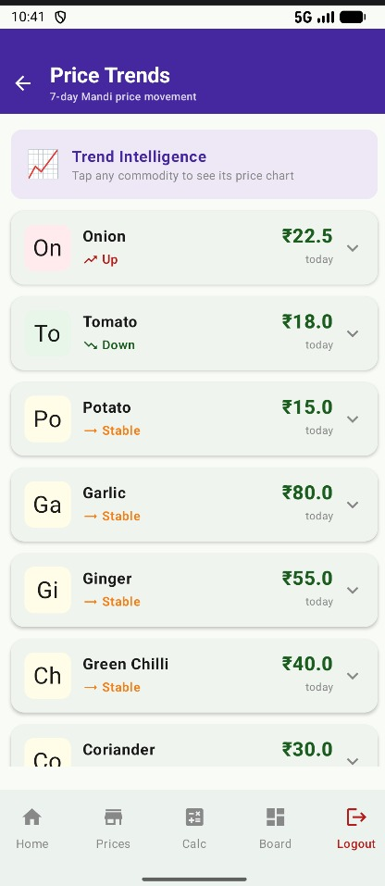
Figure 6: Price Trends. Seven-day movement view for commodity price analysis.
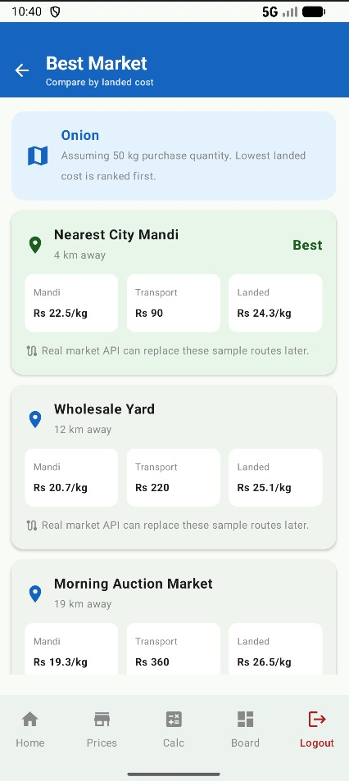
Figure 7: Best Market. Decision support for identifying better selling opportunities.
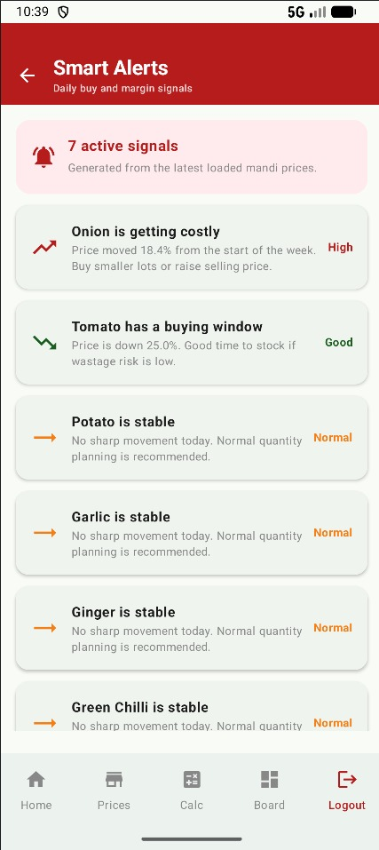
Figure 8: Smart Alerts. Alerts for important price changes and market movement.
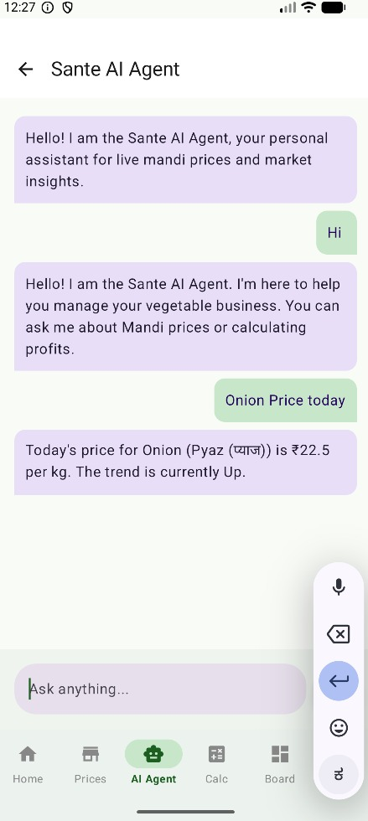
Figure 9: Sante AI Agent. Chat interface for produce-business and price questions.

Figure 10: Profile screen. Vendor profile, shop details, and preference management.

Testing and Validation
The project includes a unit-test scaffold and was validated through Android Studio builds, emulator/device execution, navigation checks, Firebase data fallback checks, profit-calculation verification, and manual review of the major UI screens. The current implementation keeps the business logic readable so that future automated tests can be added for repositories, view models, and calculation rules.

Future Enhancements
- Replace seed demo data with a fully managed production Firebase database and admin data-entry workflow.
- Add push notifications for sharp price changes and stock-level warnings.
- Introduce offline caching so vendors can continue viewing recent prices when network access is weak.
- Expand the AI assistant with richer multilingual support and voice-first interactions for local vendors.
- Add exportable daily sales and stock reports for shop accounting.

Chapter Summary
This chapter documents the actual Sante Price Index project implementation, including its architecture, tools, feature modules, UI evidence, and future scope. The screenshots confirm that the internship work moved beyond conceptual design into a complete Android application with multiple practical vendor-facing workflows.

