**WSGI (Web Server Gateway Interface):**

It is a standard that lets web servers talk to web applications written in Python. It acts like a bridge between the server and your web app.

How It Works:

1. Client: A user sends a request from their browser.
2. Web Server: The server receives the request.
3. WSGI: The server uses WSGI to pass the request to your Flask app.
4. Flask App: Your app processes the request and sends a response back.
5. Client: The server sends the response back to the user's browser

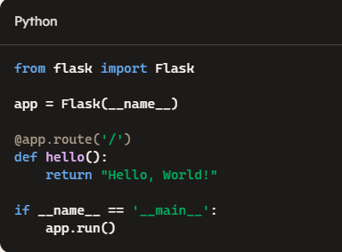

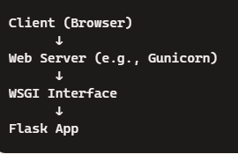

**Jinja :**

Jinja2 acts as a bridge between your data and your web page.

Data Source (Python list: items, or any other data source)

↓

Flask App → Jinja2 Template (items.html)

↓

Rendered HTML Page