WSGI (Web Server Gateway Interface):
It is a standard that lets web servers talk to web applications written in Python. It acts like a bridge between the server and your web app.

How It Works:
- Client: A user sends a request from their browser.
- Web Server: The server receives the request.
- WSGI: The server uses WSGI to pass the request to your Flask app.
- Flask App: Your app processes the request and sends a response back.
- Client: The server sends the response back to the user's browser
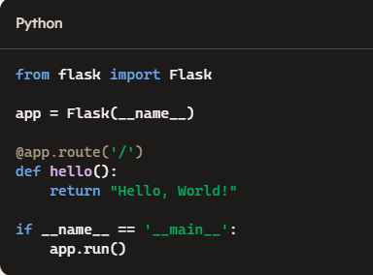
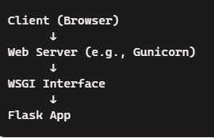

Jinja :
Jinja2 acts as a bridge between your data and your web page.

Data Source (Python list: items, or any other data source)
↓
Flask App → Jinja2 Template (items.html)
↓
Rendered HTML Page

