Full Stack Development with MERN
Project Documentation — MediLink (Book a Doctor Appointment System)

1. Introduction
Project Title: MediLink — Online Doctor Appointment Booking System
Team Members:
Name | Role
Muvvala Hemanth Venkata Naga Pavan Kumar | Team Lead & Full Stack Developer (Frontend + Backend integration, deployment)
Kunaparaju Kiran Varma | Backend Developer (Node.js/Express APIs, MongoDB models)
Praveen Siva Sai Uppuluri | Frontend Developer (React pages & routing)
Akhila Palagani | Frontend Developer / UI-UX (styling, component design)
Vishnu Vardhan | Testing & Documentation (QA, project documentation)

Note: Hemanth (Team Lead) is a full-stack developer and assigned the roles above across the team based on project needs; adjust names/roles as needed.

2. Project Overview

Purpose
MediLink digitizes the process of finding and booking a doctor’s appointment. Instead of phone calls and walk-ins, patients can browse doctors, compare specialty/experience/fee, and book a slot online. Doctors manage incoming requests from a dashboard, and admins oversee the entire platform — doctors, patients, and appointments — from one place.

Features
- Patient registration and login (email + password).
- Doctor and Admin login with role-specific credentials.
- Browse all doctors with specialty, experience, and consultation fee.
- Book an appointment with a chosen doctor, date, time, and optional symptom notes.
- Patients can view and cancel their own appointments ("My Appointments").
- Doctors can view appointments booked with them and confirm or cancel each one.
- Admin dashboard to add/remove doctors and view all doctors, patients, and appointments with live counts.

3. Architecture

Frontend
The frontend is a React.js single-page application built with Vite. Routing is handled by react-router-dom with a ProtectedRoute wrapper that checks the logged-in user (stored in localStorage) and their role (patient / doctor / admin) before rendering a page, redirecting to /login otherwise.
- Pages: LoginPage, RegisterPage, HomePage (doctor listing), BookingPage, MyAppointments, DoctorDashboard, AdminDashboard.
- Shared component: Navbar (shown only when a user is logged in).
- api.js centralizes the backend base URL, reading VITE_API_URL in production (Vercel) and falling back to the Vite dev proxy locally.

Backend
The backend is a Node.js + Express.js REST API. It exposes four route groups, each in its own file, and connects to MongoDB via Mongoose on startup before the HTTP server begins listening.
Route Prefix | File | Responsibility
/api/auth | routes/authRoutes.js | Patient registration, patient login, doctor login
/api/doctors | routes/doctorRoutes.js | List all doctors, get single doctor
/api/appointments | routes/appointmentRoutes.js | Create, list (by patient/doctor), update status, delete appointment
/api/admin | routes/adminRoutes.js | Get all platform data, add doctor, remove doctor

Database
MongoDB (via Mongoose) stores three collections:
Collection | Key Fields | Notes
Users | name, email (unique), password, phone, role (patient/admin), timestamps | role defaults to "patient"; the seeded admin also lives here with role "admin"
Doctors | name, specialty, experience, consultationFee, email (unique), password, phone, available, timestamps | available flags whether the doctor currently accepts bookings
Appointments | patientId (ref Users), doctorId (ref Doctors), date, time, status (Pending/Confirmed/Cancelled), notes, timestamps | status defaults to "Pending" until the doctor confirms

4. Setup Instructions

Prerequisites
- Node.js (v18 or later recommended)
- npm (bundled with Node.js)
- A MongoDB connection string (MongoDB Atlas or a local MongoDB instance)

Installation
1. Clone the repository:
git clone https://github.com/Hemanthmuvvala/MediLinl.git
cd MediLinl
2. Backend setup:
cd backend
npm install
# create a .env file with:
# PORT=5000
# MONGO_URI=your_mongodb_connection_string
node seedAdmin.js # run once to create the admin account
npm run dev # or: node server.js
3. Frontend setup:
cd frontend
npm install
npm run dev
4. Open the app at http://localhost:5173. Default admin credentials (created by seedAdmin.js): admin@bookadoctor.com / admin123.

5. Folder Structure

Client (frontend/)
frontend/
src/
components/
Navbar.jsx
pages/
LoginPage.jsx
RegisterPage.jsx
HomePage.jsx
BookingPage.jsx
MyAppointments.jsx
DoctorDashboard.jsx
AdminDashboard.jsx
api.js
App.jsx
main.jsx
index.css
index.html
vite.config.js
package.json

Server (backend/)
backend/
models/
User.js
Doctor.js
Appointment.js
routes/
authRoutes.js
doctorRoutes.js
appointmentRoutes.js
adminRoutes.js
server.js
seedAdmin.js
.env.example
package.json

6. Running the Application
Start the backend and frontend servers in two separate terminals:
- Frontend: npm run dev in the frontend directory (Vite dev server at http://localhost:5173).
- Backend: npm run dev (nodemon) or npm start in the backend directory (Express server, default port 5000).
In production, the frontend is deployed on Vercel and the backend must be hosted on a Node-compatible host (e.g., Render/Railway) with MONGO_URI and PORT set as environment variables, and VITE_API_URL set on the frontend to point at the deployed backend URL.

7. API Documentation

Auth — /api/auth
Method & Endpoint | Body | Response
POST /register | { name, email, password, phone } | 201 { message, user }
POST /login | { email, password } | 200 { message, user } (role: patient/admin)
POST /doctor-login | { email, password } | 200 { message, user } (role: doctor)

Doctors — /api/doctors
Method & Endpoint | Params | Response
GET / | — | 200 [ { doctor } ... ] (password excluded)
GET /:id | id (path) | 200 { doctor } or 404 if not found

Appointments — /api/appointments
Method & Endpoint | Body / Params | Response
POST / | { patientId, doctorId, date, time, notes } | 201 { appointment } (populated with patient & doctor)
GET /patient/:patientId | patientId (path) | 200 [ { appointment } ... ]
GET /doctor/:doctorId | doctorId (path) | 200 [ { appointment } ... ]
PATCH /:id/status | { status: Pending|Confirmed|Cancelled } | 200 { appointment } or 404
DELETE /:id | id (path) | 200 { message } or 404

Admin — /api/admin
Method & Endpoint | Body / Params | Response
GET /all | — | 200 { doctors, patients, appointments }
POST /doctors | { name, specialty, experience, consultationFee, email, password, phone } | 201 { message, doctor }
DELETE /doctors/:id | id (path) | 200 { message }

8. Authentication
MediLink uses a simple, credential-based authentication model suited to its MVP scope:
- Patients register via POST /api/auth/register; passwords are stored on the User document.
- Login (POST /api/auth/login for patients/admin, POST /api/auth/doctor-login for doctors) checks the submitted email and password directly against the stored record.
- On successful login, the returned user object (with role) is stored in the browser’s localStorage under the key bad_user.
- The frontend’s ProtectedRoute component reads this stored user on every navigation and redirects to /login if absent, or to / if the user’s role does not match the route’s allowedRoles.
Note: passwords are currently compared as plain text and there is no JWT/session token — this is acceptable for an academic MVP but should be replaced with hashed passwords (bcrypt) and signed tokens (JWT) before any real-world deployment (see Future Enhancements).

9. User Interface
Representative screens from the running application, covering all three roles:
Login — Role Selection (Patient / Doctor / Admin)
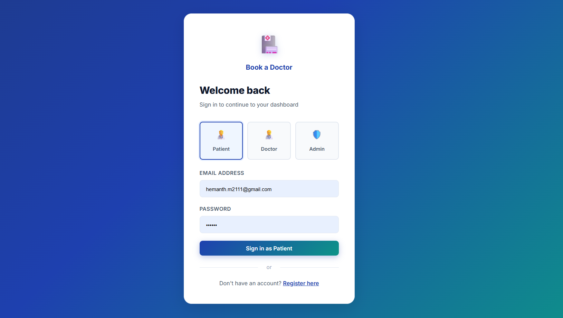
Login page
Patient Home — Doctor Listing
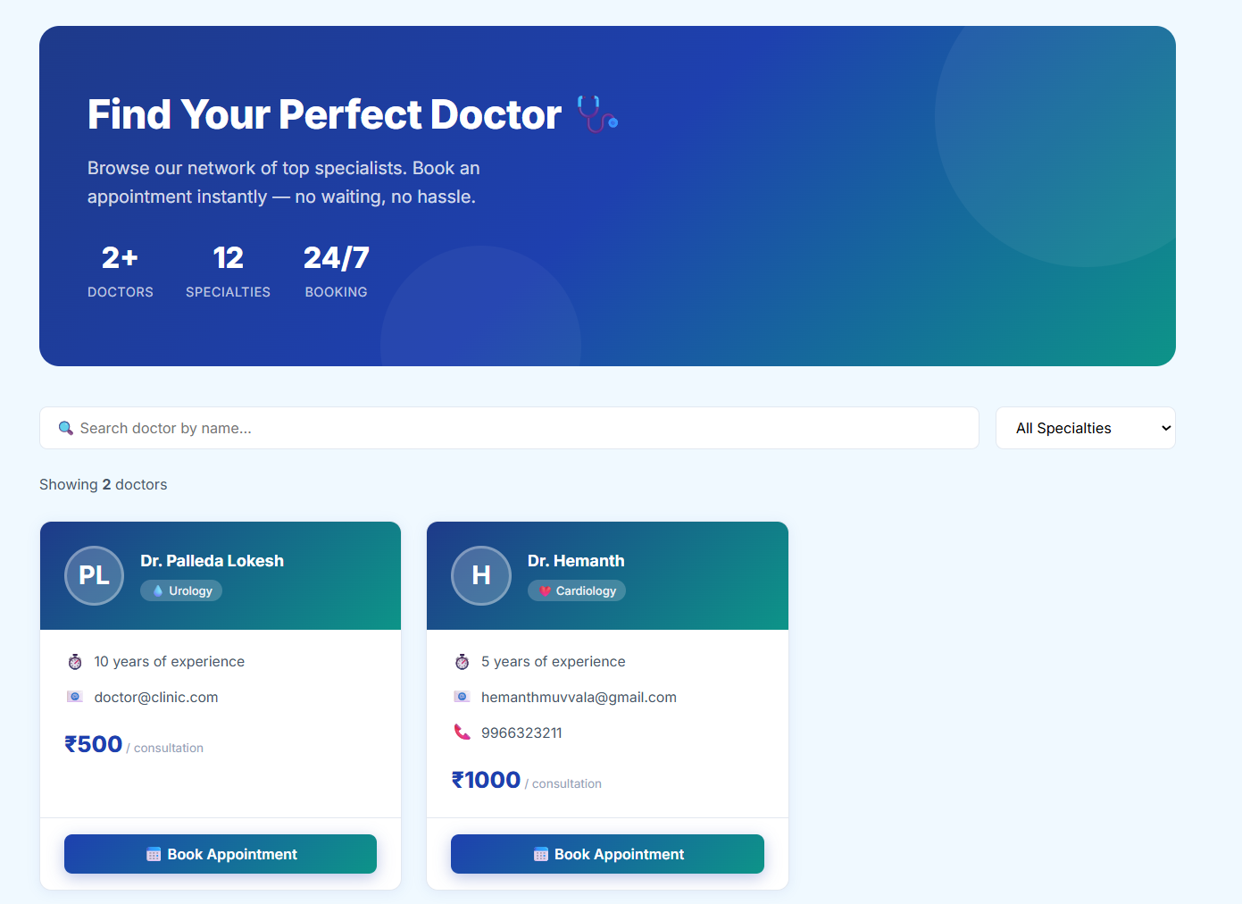
Doctor listing with search and specialty filter
Book Appointment
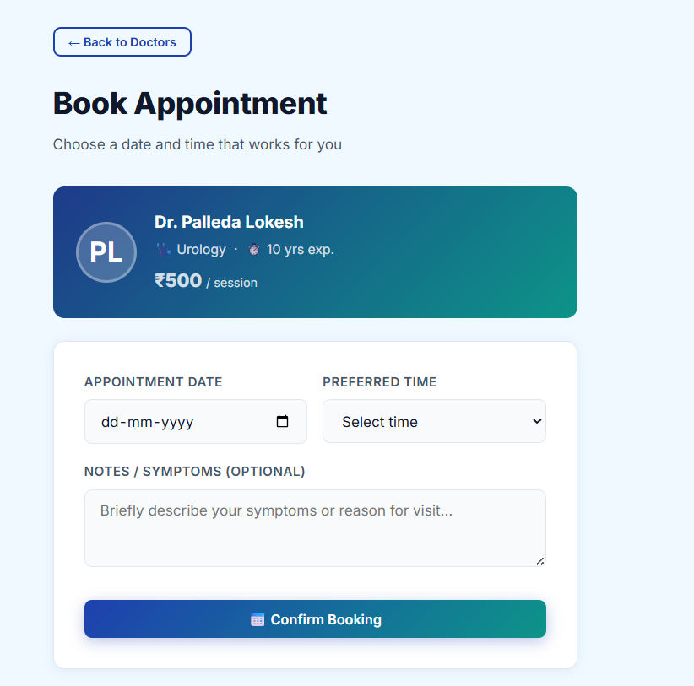
Appointment booking form
Doctor Dashboard
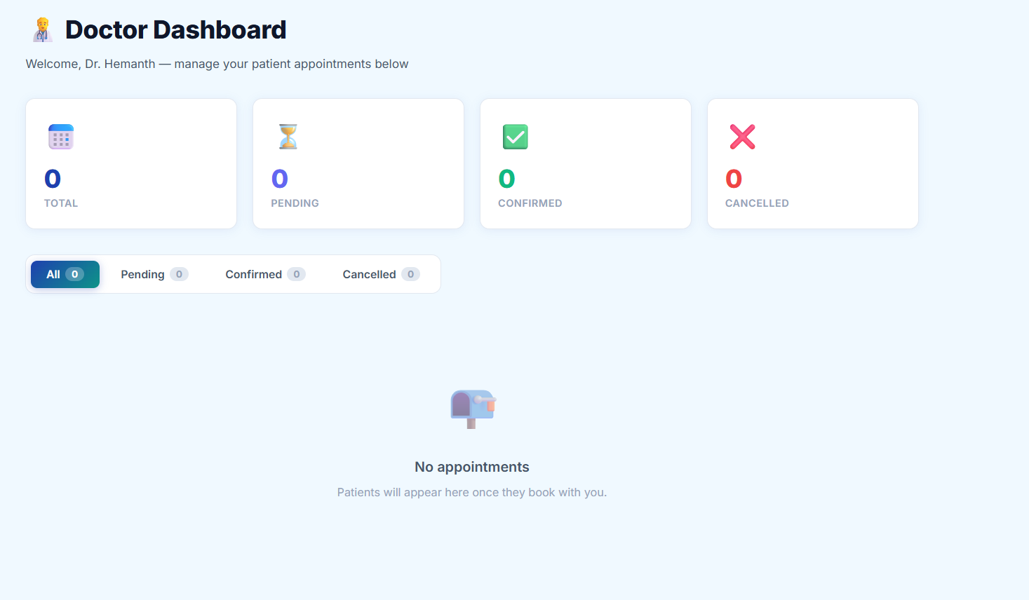
Doctor dashboard with appointment summary counters
Admin Dashboard
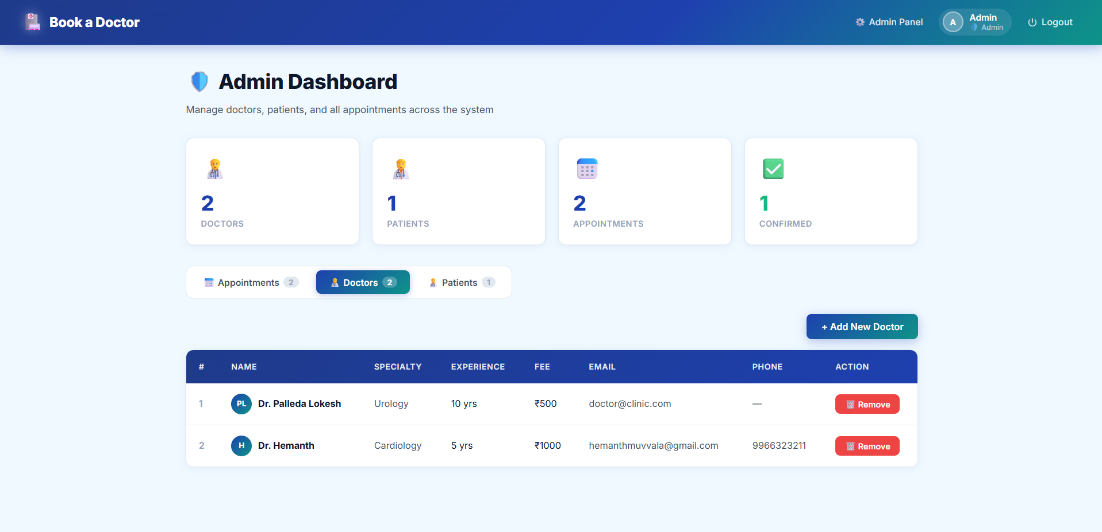
Admin dashboard — Doctors tab, with Add/Remove doctor actions

10. Testing
Testing was performed manually across all user roles by exercising each core flow end-to-end on the deployed application (frontend on Vercel, backend REST API, MongoDB Atlas):
- Functional testing of registration, login (all three roles), doctor listing, appointment booking, cancellation, doctor confirm/cancel, and admin add/remove doctor.
- API testing of each endpoint’s success and error paths (e.g., duplicate email on registration, invalid status value on PATCH).
- Manual UI/UX testing across the booking flow to confirm state updates (e.g., dashboard counters) reflect correctly after each action.
See the companion Final Report document (Section 6: Functional and Performance Testing) for the detailed test case table and results.

11. Screenshots or Demo
Live demo: https://medi-linl.vercel.app/
GitHub repository: https://github.com/Hemanthmuvvala/MediLinl
Additional screenshots (Admin — Appointments tab, Admin — Patients tab) are included in the Final Report document, Section 7 (Results).

12. Known Issues
- Passwords are stored and compared in plain text; no hashing (bcrypt) is applied yet.
- No JWT/session-based authentication — the logged-in user is trusted from localStorage on the client side only.
- No slot-locking mechanism, so two patients could book the same doctor at the same date/time.
- No email/SMS notifications for booking confirmation or status changes.
- Admin cannot currently edit an existing doctor’s details (only add or remove).

13. Future Enhancements
- Add password hashing (bcrypt) and JWT-based authentication with proper session/token expiry.
- Add doctor slot management (available time blocks) to prevent double-booking.
- Email/SMS notifications for booking, confirmation, and cancellation events.
- Payment gateway integration for consultation fee collection.
- Allow Admin to edit doctor details, not just add/remove.
- Add automated tests (Jest/Supertest for backend, React Testing Library for frontend).
- Video consultation and patient medical history features.

