MediLink
Online Doctor Appointment Booking System
(MERN Stack Web Application)
Project Report
Submitted by
Muvvala Hemanth Venkata Naga Pavan Kumar (Team Lead)
Kunaparaju Kiran Varma
Praveen Siva Sai Uppuluri
Akhila Palagani
Vishnu Vardhan

GitHub Repository: https://github.com/Hemanthmuvvala/MediLinl
Live Demo: https://medi-linl.vercel.app/

1. Introduction

1.1 Project Overview
MediLink is a full-stack MERN (MongoDB, Express.js, React.js, Node.js) web application that lets patients discover doctors and book appointments online, without phone calls or in-person visits just to check availability. The platform supports three roles — Patient, Doctor, and Admin — each with a dedicated, role-based dashboard.
Patients can register, browse doctors by specialty, view experience and consultation fees, and book an appointment for a preferred date and time. Doctors can log in to view and manage the appointments booked with them, confirming or cancelling requests. Admins have full oversight of the platform: adding or removing doctors, and monitoring all patients and appointments from a single dashboard.

1.2 Purpose
The purpose of MediLink is to digitize and simplify the doctor appointment booking process for small clinics and independent practitioners who do not have access to expensive hospital-management software. It aims to:
- Reduce the friction patients face in finding an available doctor and booking a slot.
- Give doctors a simple dashboard to manage incoming appointment requests.
- Give clinic administrators a single place to manage doctors, patients, and appointments.
- Demonstrate a complete, production-style MERN application with authentication, role-based access, and a REST API backend.

2. Ideation Phase

2.1 Problem Statement
Problem Statement Template | Description
I am (Persona) | A patient who needs to consult a doctor
I am trying to | find and book an appointment with a suitable, available doctor quickly
But | clinics rely on phone calls and walk-ins, so I often do not know a doctor’s availability, specialty, or fee in advance
Because | there is no simple online system that shows doctor details and lets me book a specific time slot
Which makes me feel | frustrated and like I am wasting time and effort on something that should be simple

2.2 Empathy Map Canvas
An empathy map was created for the primary persona (a patient seeking a doctor appointment) to understand their thoughts, feelings, statements, and actions when trying to book a consultation.
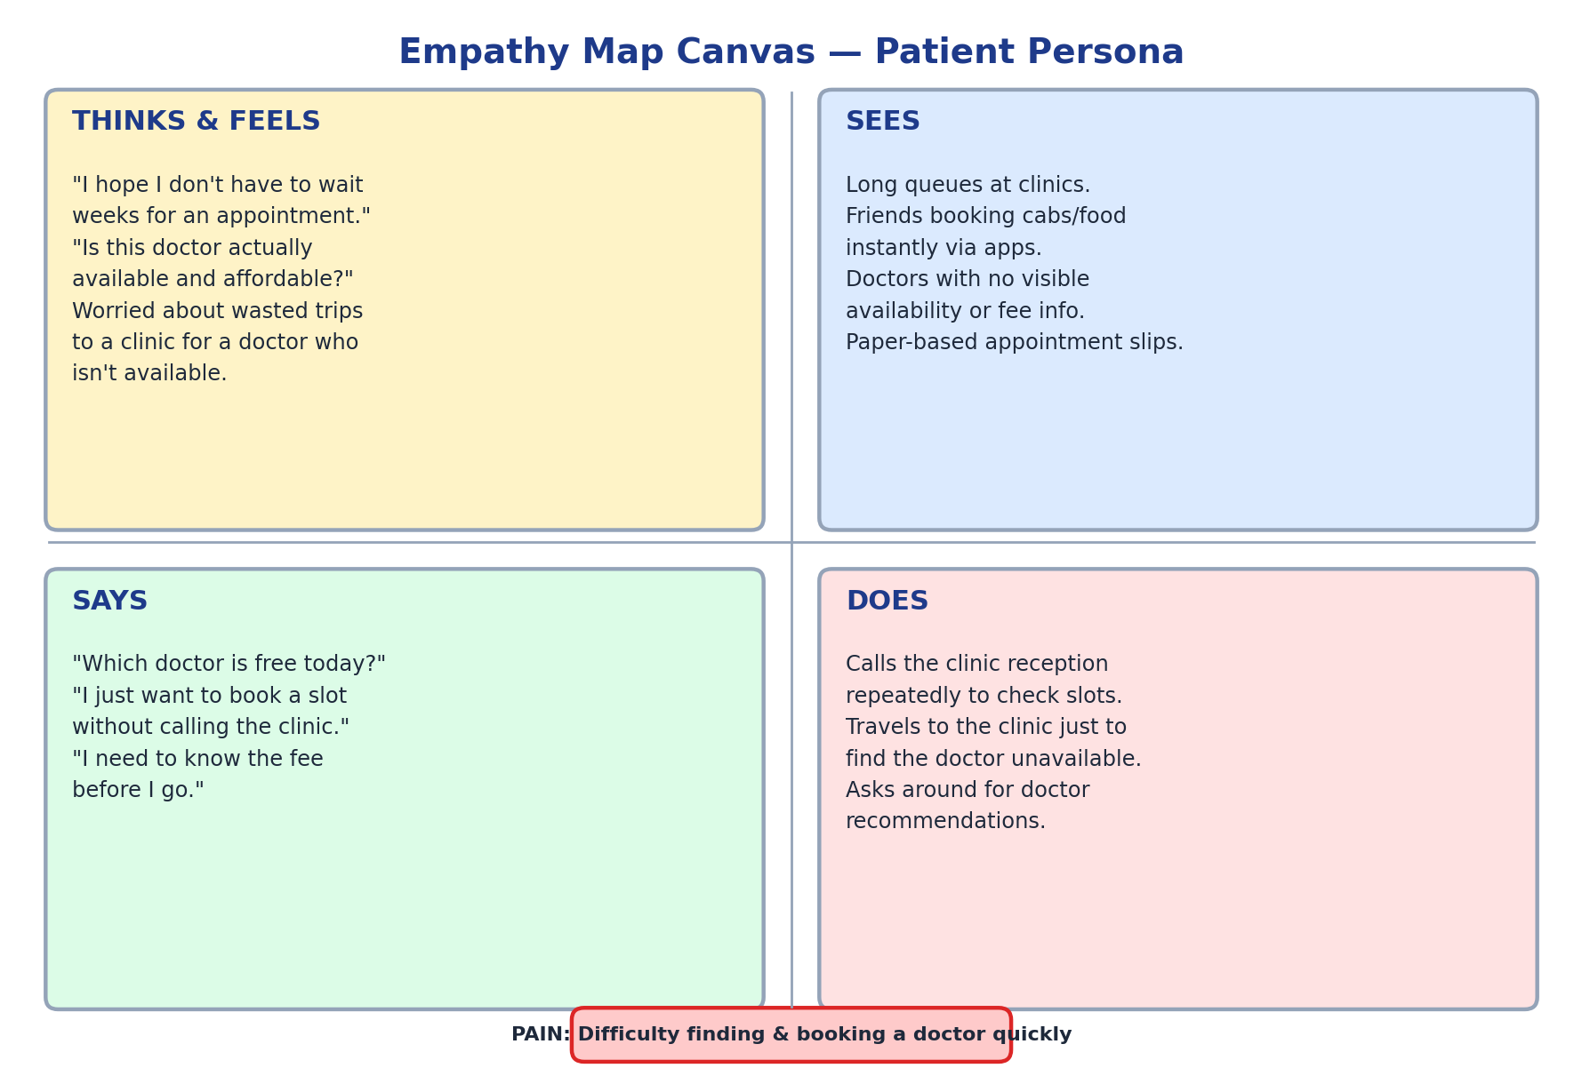
Figure 2.1 — Empathy Map Canvas for the Patient persona

2.3 Brainstorming
The team brainstormed possible features and solutions to address the problem statement. Ideas were grouped and prioritized based on feasibility and impact:
- Online doctor directory with specialty, experience, and fee filters.
- Simple email/password based registration and login for patients.
- Role-based dashboards for Patient, Doctor, and Admin.
- Date/time-based appointment booking with an optional symptom note.
- Doctor-side confirmation/cancellation workflow instead of automatic confirmation, so doctors retain control of their schedule.
- Admin panel to onboard new doctors and monitor platform-wide activity.
- (Considered, deferred to future scope) SMS/email notifications, payment gateway integration, video consultations.
Final selected ideas (highest feasibility + highest impact) formed the basis of the Product Backlog: Registration & Login, Doctor Listing, Doctor Management, Appointment Booking, My Appointments, Doctor Dashboard, and Admin Dashboard.

3. Requirement Analysis

3.1 Customer Journey Map
The diagram below traces a patient’s journey from first hearing about MediLink to completing a consultation and reviewing their appointment history.
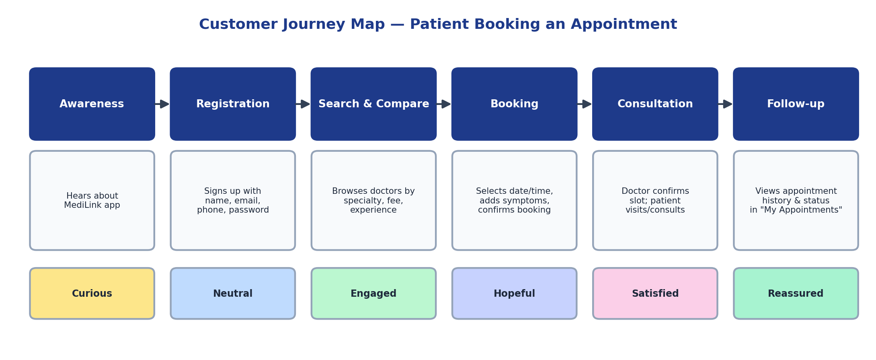
Figure 3.1 — Customer Journey Map

3.2 Solution Requirement
Functional Requirements
FR No. | Requirement | Description
FR-1 | User Registration | Patients can create an account with name, email, password, and phone number.
FR-2 | User Login | Patients, Doctors, and Admin can log in with role-specific credentials.
FR-3 | Doctor Listing | Patients can view all doctors with specialty, experience, and consultation fee.
FR-4 | Appointment Booking | Patients can book an appointment by choosing a doctor, date, time, and optional notes.
FR-5 | Appointment Management | Patients can view and cancel their own appointments.
FR-6 | Doctor Dashboard | Doctors can view appointments booked with them and confirm or cancel them.
FR-7 | Admin Management | Admin can add/remove doctors and view all doctors, patients, and appointments.

Non-Functional Requirements
NFR No. | Requirement | Description
NFR-1 | Usability | Simple, uncluttered UI usable without training.
NFR-2 | Performance | API responses return within acceptable time for typical clinic-scale data volumes.
NFR-3 | Availability | Frontend deployed on Vercel for high uptime and global CDN delivery.
NFR-4 | Scalability | Stateless REST API and MongoDB allow horizontal scaling as usage grows.
NFR-5 | Security | Role-based route protection on the frontend; passwords stored per user/doctor record.
NFR-6 | Maintainability | Modular Express routes and Mongoose models for easy extension.

3.3 Data Flow Diagram
The Level 0 (context) diagram shows MediLink as a single process interacting with Patient, Doctor, and Admin actors. The Level 1 diagram decomposes the system into its four core processes and the data stores they read from/write to.
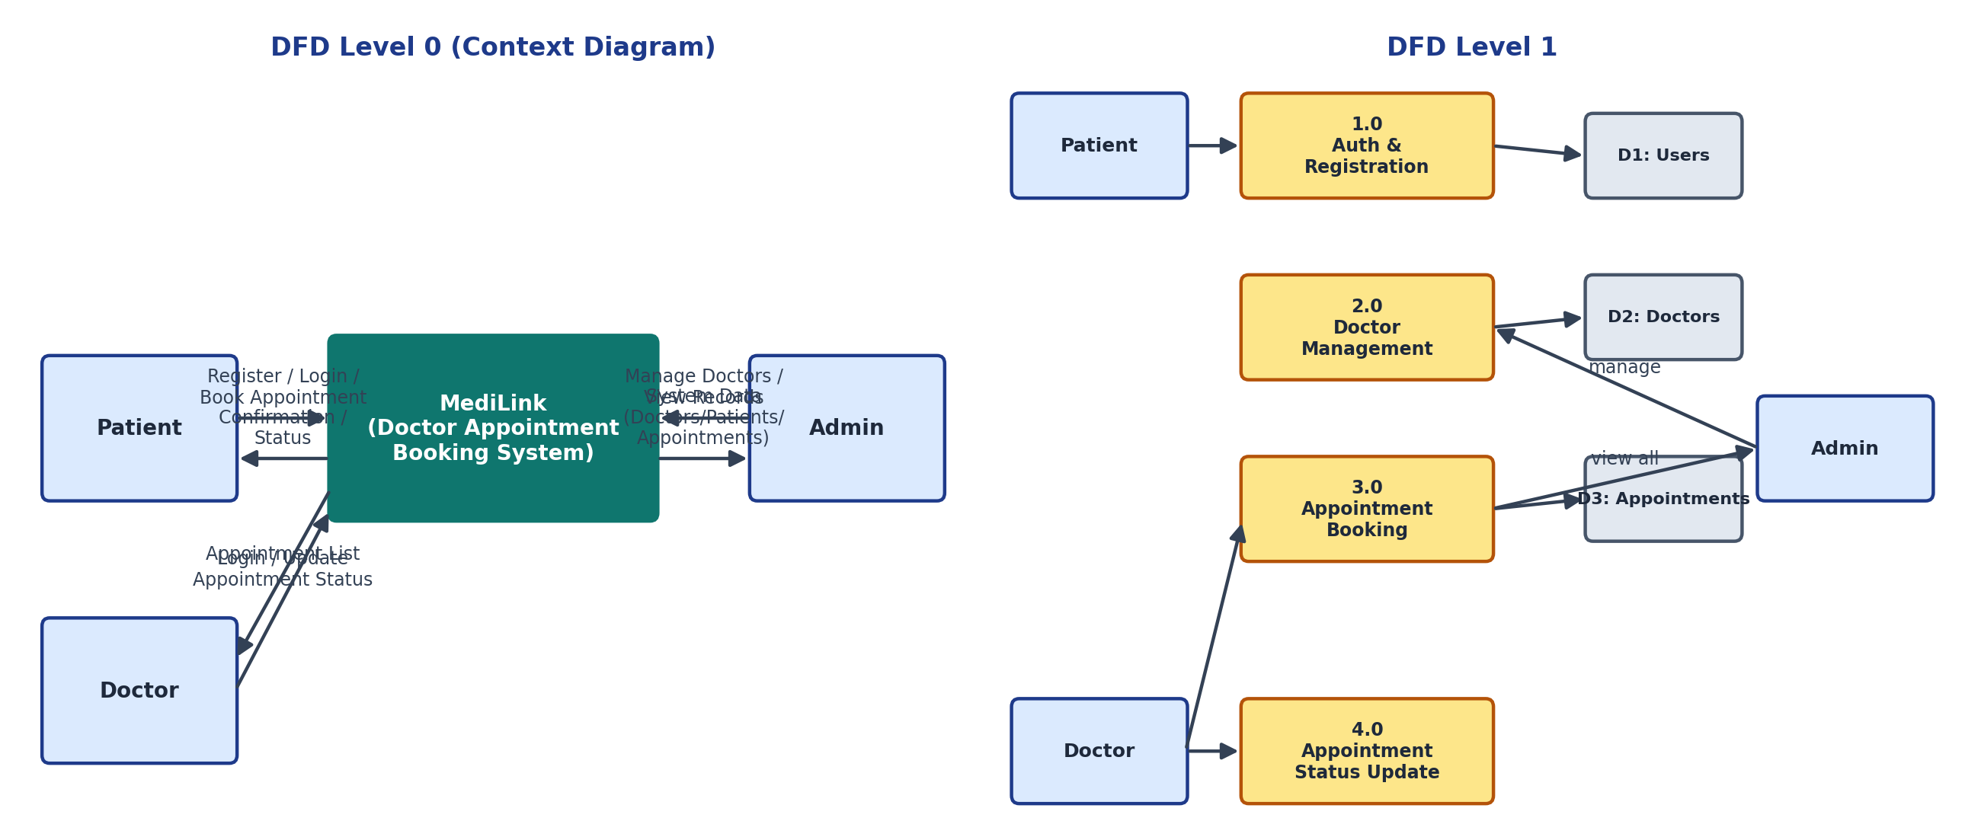
Figure 3.2 — Data Flow Diagram (Level 0 and Level 1)

3.4 Technology Stack
Layer | Technology | Purpose
Frontend | React.js (Vite) | Component-based single-page application
Frontend Routing | react-router-dom | Client-side routing and role-based protected routes
Styling | Vanilla CSS | Application styling
Backend | Node.js + Express.js | REST API server
Database | MongoDB + Mongoose | Document database and schema modelling
Cross-Origin Support | cors (npm) | Allow frontend (Vercel) to call backend API
Environment Config | dotenv | Manage environment variables (PORT, MONGO_URI)
Dev Tooling | nodemon | Auto-restart backend server during development
Deployment (Frontend) | Vercel | Hosting for the React build

4. Project Design

4.1 Problem — Solution Fit
The core problem is that booking a doctor’s appointment through phone calls and walk-ins is slow, opaque, and inconvenient for patients, and hard to manage for doctors and clinic staff. MediLink fits this problem by replacing the phone-call/walk-in workflow with a transparent, self-service web application: patients see doctor availability, specialty, and fees upfront, and book a slot directly; doctors confirm or decline from a dashboard instead of a receptionist relaying messages; admins get a single source of truth for the whole clinic’s doctors, patients, and bookings.

4.2 Proposed Solution
Parameter | Description
Problem Statement | Patients struggle to discover doctor availability and book appointments without calling or visiting the clinic.
Idea / Solution | A MERN web app (MediLink) offering doctor discovery, appointment booking, and role-based dashboards for Patient, Doctor, and Admin.
Novelty / Uniqueness | Single application serving three distinct roles with tailored dashboards and a lightweight, dependency-minimal MERN stack.
Social Impact | Improves healthcare access, especially for smaller clinics that cannot afford enterprise hospital-management systems.
Business Model | Could be offered as a SaaS subscription to independent clinics/doctors, or a per-booking convenience-fee model.
Scalability | Stateless Express API + MongoDB Atlas allow scaling to more doctors, clinics, and concurrent bookings with minimal re-architecture.

4.3 Solution Architecture
MediLink follows a classic three-tier MERN architecture: a React single-page application (frontend) communicates over a REST API with an Express.js server (backend), which in turn persists data in MongoDB via Mongoose models (Users, Doctors, Appointments).
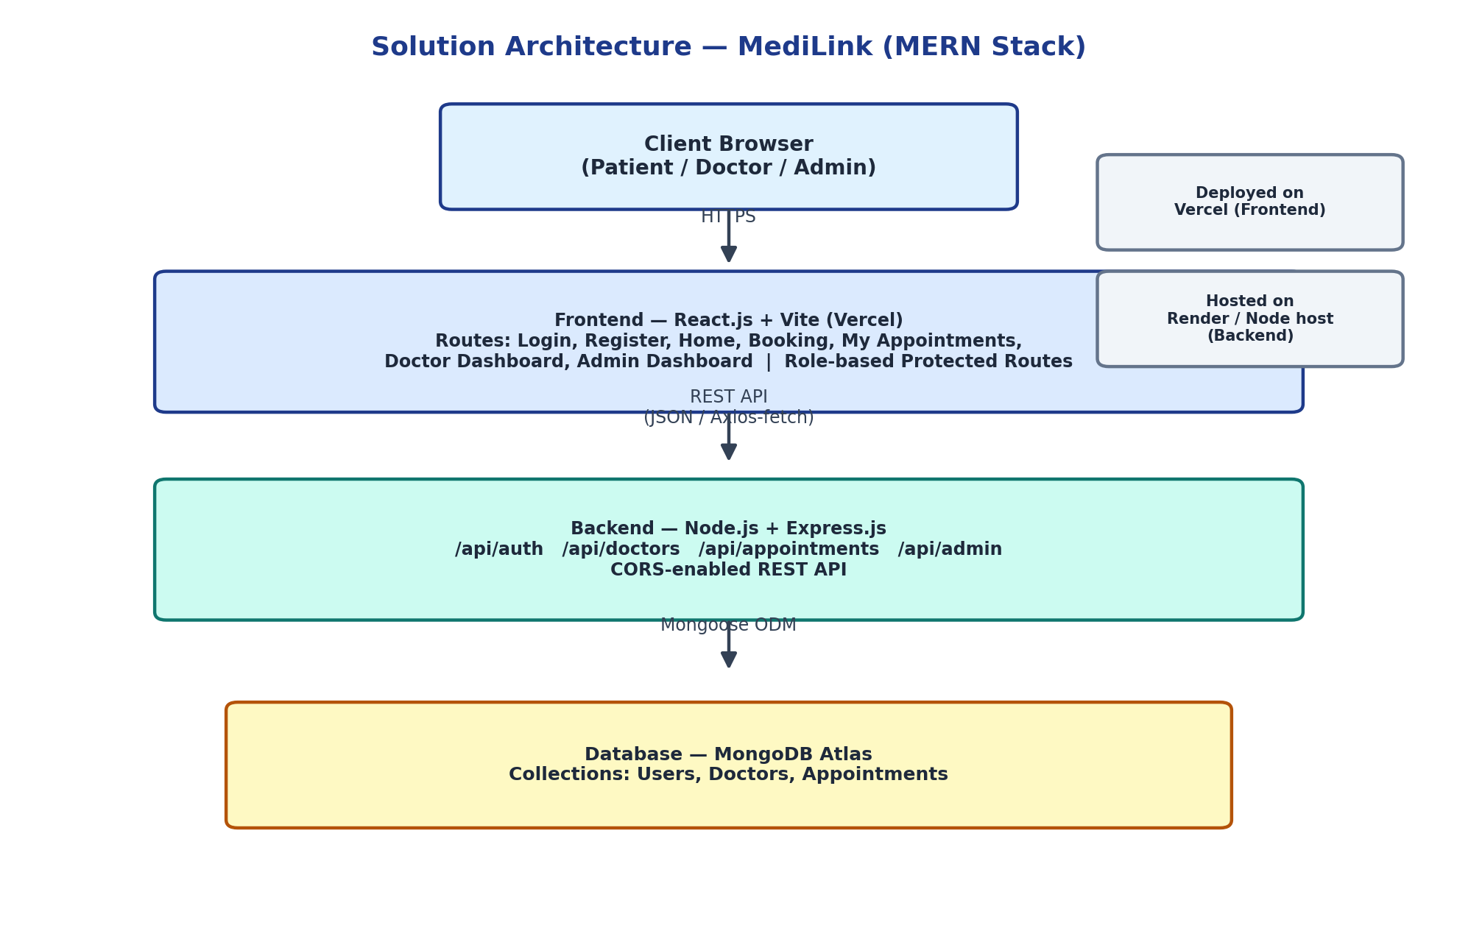
Figure 4.1 — Solution Architecture Diagram

5. Project Planning & Scheduling

5.1 Project Planning
The product backlog was broken into 4 sprints covering Authentication, Doctor Listing & Management, Appointment Booking, and Doctor/Admin Dashboards (see the separate Project Planning Template document for the full backlog, story points, and sprint tracker). A summary is provided below.
Sprint | Focus Area | Story Points | Duration
Sprint-1 | Registration & Login (Patient, Doctor, Admin) | 10 | 6 Days
Sprint-2 | Doctor Listing & Doctor Management | 12 | 6 Days
Sprint-3 | Appointment Booking & My Appointments | 12 | 6 Days
Sprint-4 | Doctor Dashboard & Admin Dashboard | 15 | 6 Days

Total Story Points: 49 | Number of Sprints: 4 | Team Velocity ≈ 12.25 story points per sprint.

6. Functional and Performance Testing

6.1 Performance Testing
The following test cases validate the core functional flows of MediLink across all three roles.
Test ID | Test Case | Expected Result | Status
TC-01 | Patient registers with a new email | Account created; redirected to login | Pass
TC-02 | Patient registers with an already-used email | Error: "Email already registered." | Pass
TC-03 | Patient logs in with correct credentials | Redirected to Home / doctor listing page | Pass
TC-04 | Doctor logs in with credentials set by Admin | Redirected to Doctor Dashboard | Pass
TC-05 | Admin logs in with seeded admin credentials | Redirected to Admin Dashboard | Pass
TC-06 | Patient books an appointment with valid date/time | Appointment created with status "Pending" | Pass
TC-07 | Patient cancels an existing appointment | Appointment removed from "My Appointments" | Pass
TC-08 | Doctor confirms a pending appointment | Status updates to "Confirmed" on all dashboards | Pass
TC-09 | Admin adds a new doctor | Doctor appears in doctor listing and Admin dashboard | Pass
TC-10 | Admin removes a doctor | Doctor no longer appears in listings | Pass

Performance was verified by observing API response times for typical dashboard loads (doctor listing, admin "get all" endpoint, and appointment queries), which returned promptly for the current data volumes used during testing (2 doctors, 1 patient, 2 appointments, as reflected in the screenshots in Section 7).

7. Results

7.1 Output Screenshots
Screenshots of the working MediLink application across all three roles are presented below.
Login Page (Role Selection: Patient / Doctor / Admin)
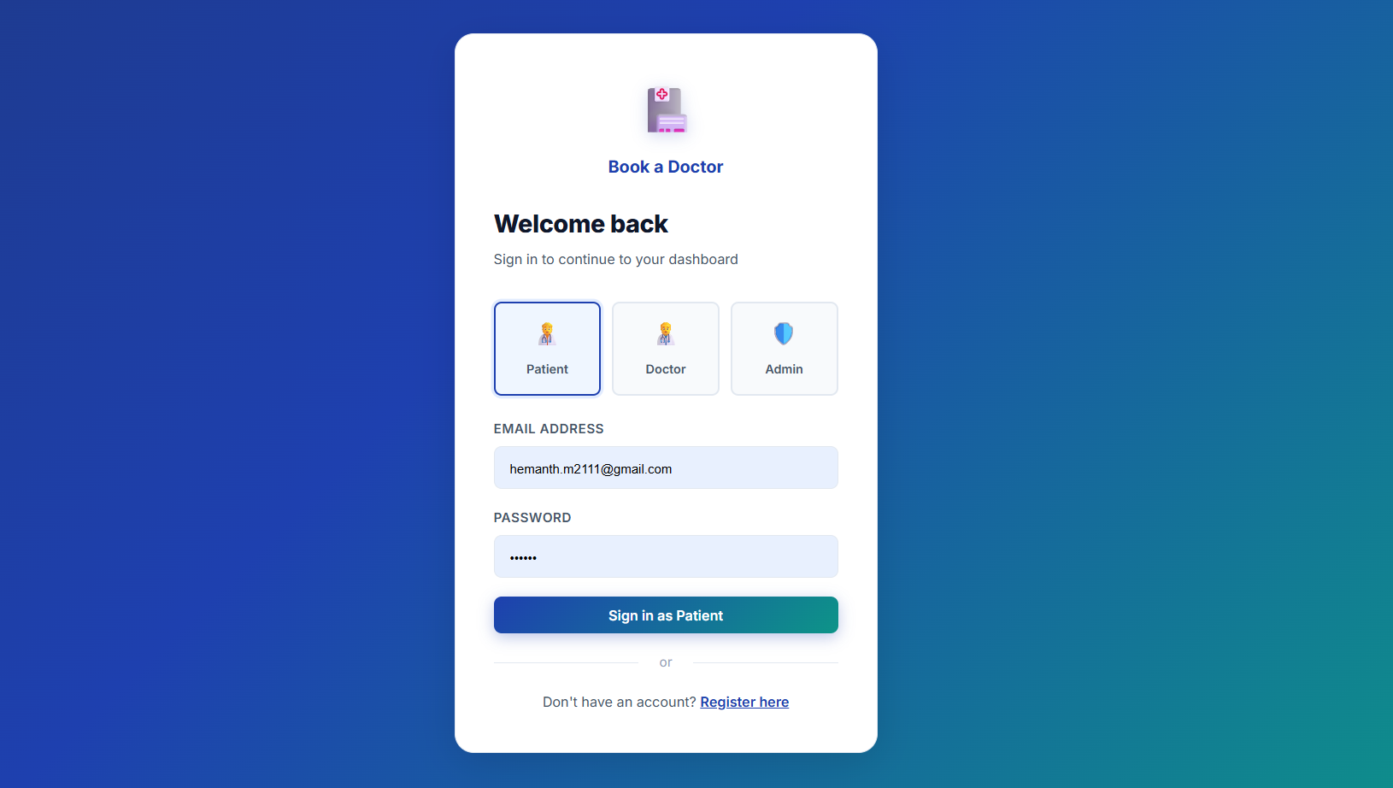
Figure 7.1 — Login page with role selection
Patient Home Page — Doctor Listing
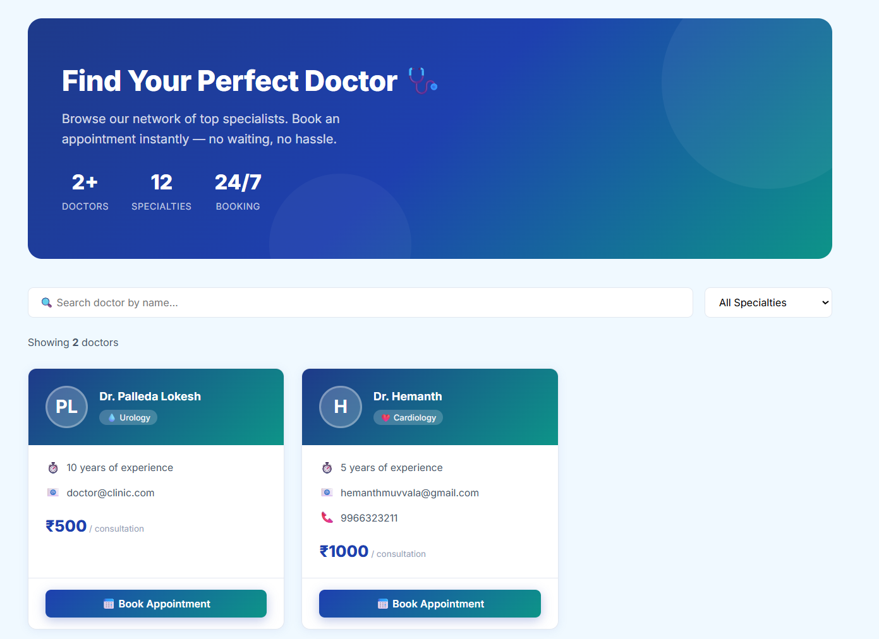
Figure 7.2 — Patient home page showing available doctors
Book Appointment Page
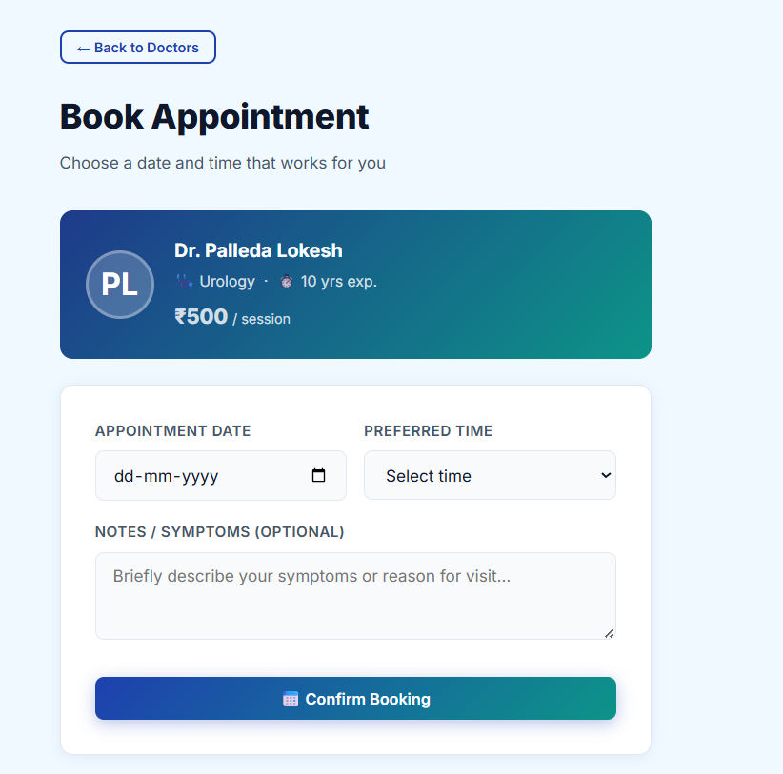
Figure 7.3 — Appointment booking form
Doctor Dashboard
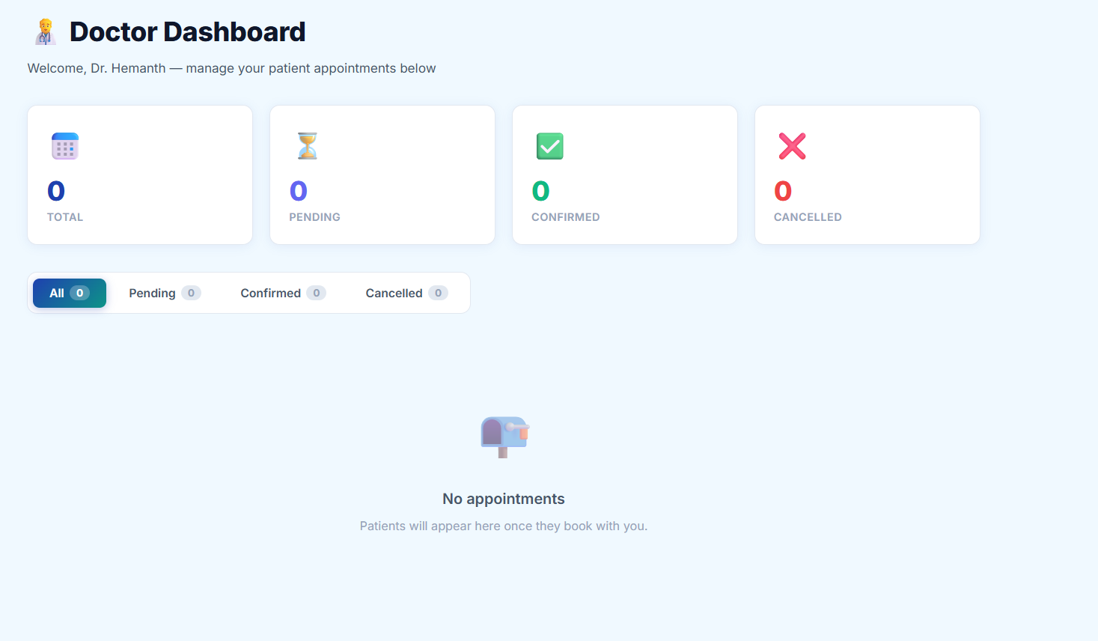
Figure 7.4 — Doctor dashboard showing appointment summary
Admin Dashboard — Appointments
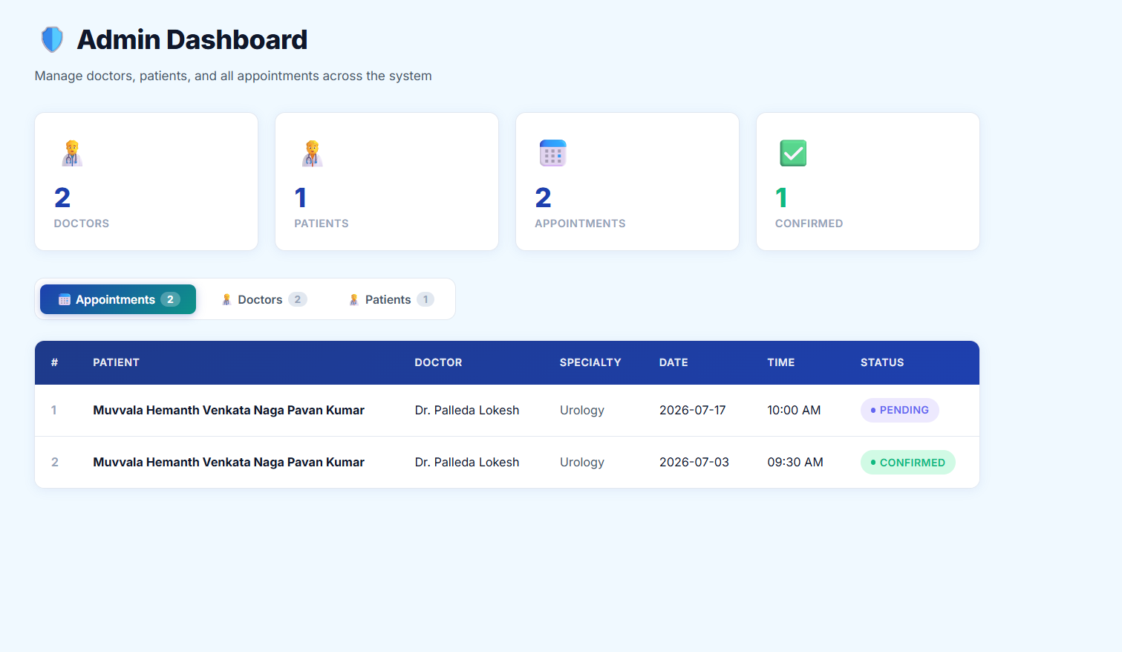
Figure 7.5 — Admin dashboard, Appointments tab
Admin Dashboard — Doctors
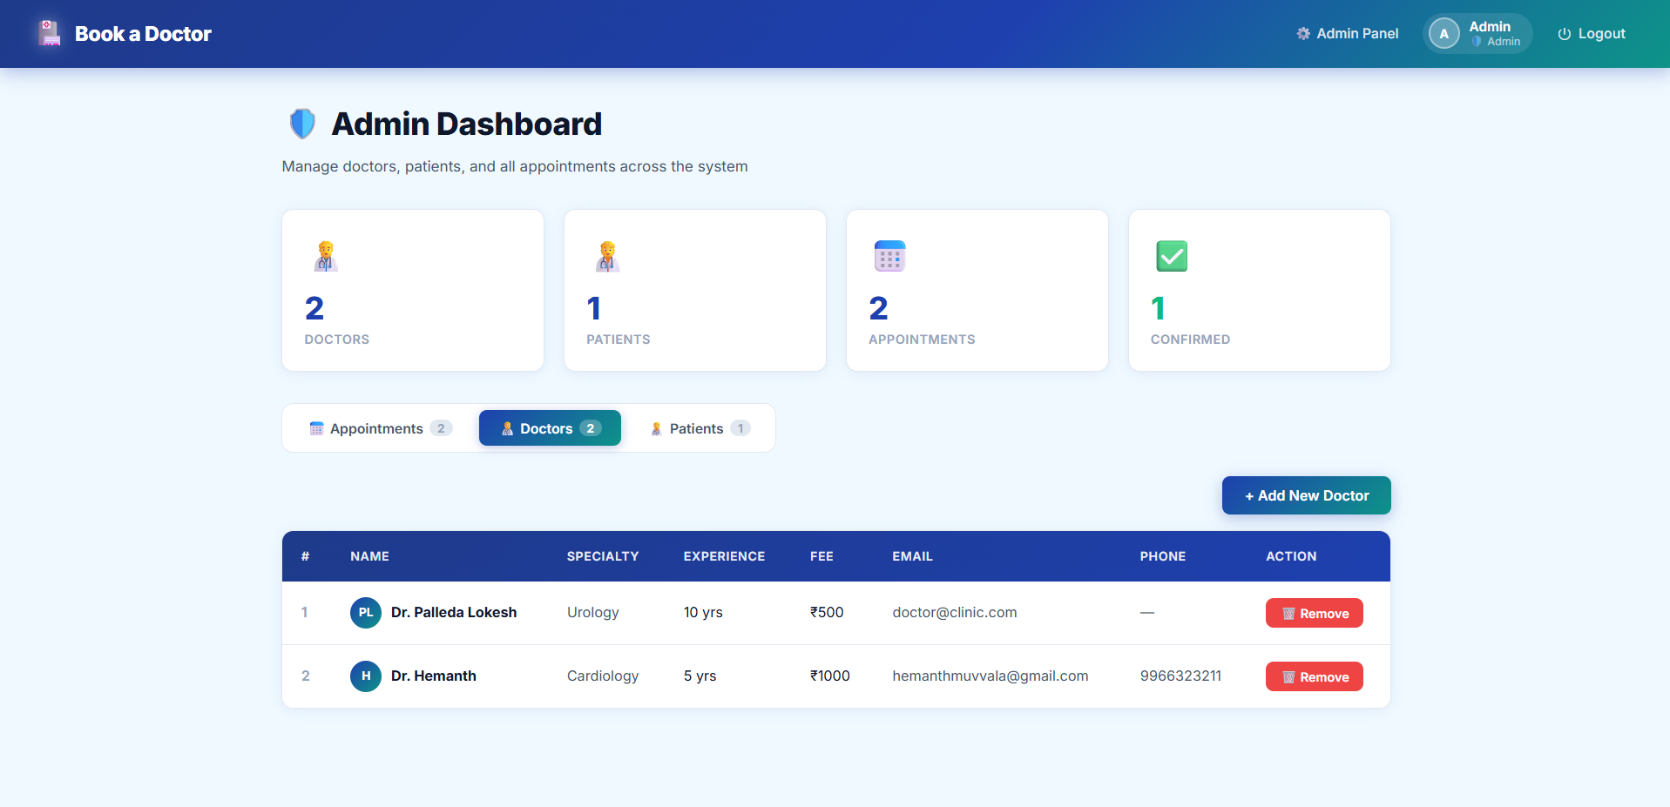
Figure 7.6 — Admin dashboard, Doctors tab
Admin Dashboard — Patients
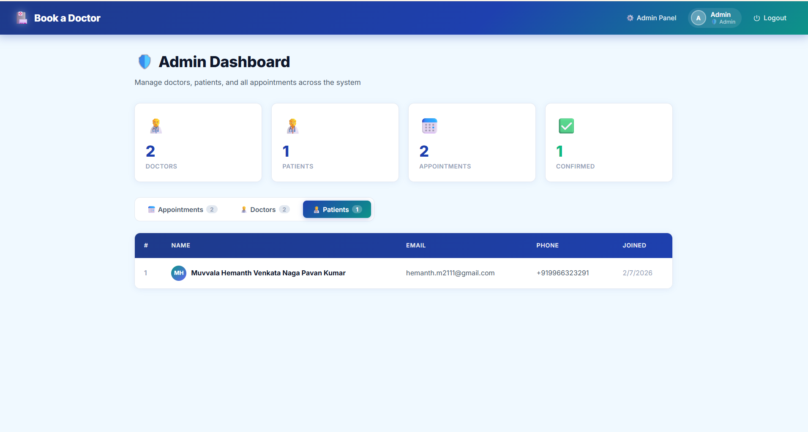
Figure 7.7 — Admin dashboard, Patients tab

8. Advantages & Disadvantages
Advantages
- Removes the need for phone calls or in-person visits just to check doctor availability.
- Transparent view of doctor specialty, experience, and consultation fee before booking.
- Role-based dashboards keep each user (patient, doctor, admin) focused on exactly what they need.
- Doctors retain control of their schedule via a confirm/cancel workflow rather than automatic booking.
- Lightweight MERN stack keeps hosting/running costs low, suiting small clinics and independent practitioners.
- Centralized admin dashboard simplifies onboarding and oversight of doctors and appointments.
Disadvantages
- No email/SMS notification system yet, so users must check the app manually for status updates.
- Passwords are currently stored and compared without hashing, which is not production-safe (see Future Scope).
- No payment gateway integration; consultation fees are informational only.
- No calendar-based slot-locking, so two patients could theoretically pick the same time slot with a doctor.
- Limited to appointment booking; does not yet cover e-prescriptions, video consultations, or medical records.

9. Conclusion
MediLink successfully demonstrates a complete MERN-stack solution to a real, everyday problem: booking a doctor’s appointment without the friction of phone calls and uncertain availability. The application implements three role-based experiences (Patient, Doctor, Admin), a REST API backend with clear separation of concerns, and a MongoDB data layer modelling Users, Doctors, and Appointments. The working screenshots in Section 7 confirm that the core user journeys — registration, login, doctor discovery, appointment booking, doctor confirmation, and admin oversight — function end-to-end. The project meets its stated purpose of digitizing and simplifying the appointment booking workflow for small clinics and independent practitioners.

10. Future Scope
- Password hashing (e.g., bcrypt) and token-based authentication (JWT) for production-grade security.
- Email/SMS notifications for booking confirmation, reminders, and cancellations.
- Payment gateway integration for online consultation fee payment.
- Slot-based calendar to prevent double-booking of the same doctor time slot.
- Doctor availability calendar (working days/hours) instead of a simple available/unavailable flag.
- Video consultation support for remote appointments.
- Patient medical history and prescription management.
- Ratings and reviews for doctors.
- Native mobile app (React Native) for patients and doctors.

11. Appendix
Source Code
The complete source code (frontend and backend) is available in the project repository: https://github.com/Hemanthmuvvala/MediLinl
Dataset Link
Not applicable — MediLink does not use a static/training dataset. Application data (Users, Doctors, Appointments) is created at runtime and stored in MongoDB.
GitHub & Project Demo Link
GitHub Repository: https://github.com/Hemanthmuvvala/MediLinl
Live Demo: https://medi-linl.vercel.app/

