Project Design Phase-II
Data Flow Diagram & User Stories

Date | 19 July 2026
Team ID
Project Name | MediLink
Maximum Marks | 4 Marks

Data Flow Diagrams:
A Data Flow Diagram (DFD) is a traditional visual representation of the information flows within a system. A neat and clear DFD can depict the right amount of the system requirement graphically. It shows how data enters and leaves the system, what changes the information, and where data is stored.
Example: DFD Level 0 (Industry Standard)
Example: (Simplified)
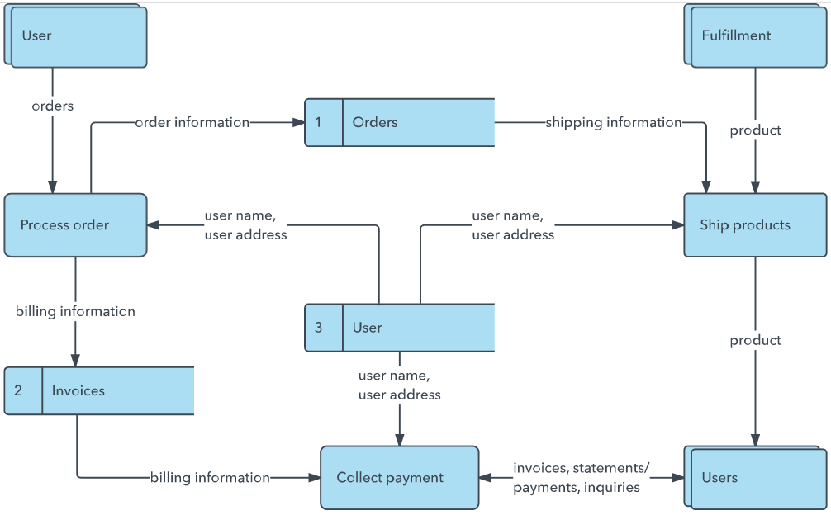


MediLink — Data Flow Diagram (Level 0 & Level 1)
Level 0 (Context Diagram): Patient, Doctor and Admin (external entities) send requests to the MediLink System, which reads from and writes to a single MongoDB database (Users, Doctors, Appointments collections).
Level 1 (Process Breakdown):
Process No. | Process Name | Input (From) | Output (To) | Data Store Used
1.0 | Register / Login | Patient, Doctor, Admin (credentials) | Session/user data returned to client | Users, Doctors
2.0 | Manage Doctors | Admin (add/remove doctor details) | Updated doctor list to Patient &amp; Admin | Doctors
3.0 | Browse Doctors | Patient (search/filter request) | Doctor list with specialty, fee, experience | Doctors
4.0 | Book Appointment | Patient (doctor, date, time, notes) | New appointment record (status: Pending) | Appointments
5.0 | Update Appointment Status | Doctor / Patient / Admin | Updated status (Confirmed / Cancelled) | Appointments
6.0 | View Appointments | Patient, Doctor, Admin (query) | Filtered appointment list | Appointments

User Stories
Use the below template to list all the user stories for the product.
User Type | Functional Requirement (Epic) | User Story Number | User Story / Task | Acceptance criteria | Priority | Release
Patient (Web user) | Registration | USN-1 | As a user, I can register for the application by entering my email, password, and confirming my password. | I can access my dashboard after registering | High | Sprint-1
 |  | USN-2 | As a user, I will receive confirmation email once I have registered for the application | I can receive confirmation email & click confirm | High | Sprint-1
 |  | USN-3 | As a patient, I can browse all available doctors with specialty, experience & fee | I can view a full list of doctors with their details | Low | Sprint-2
 |  | USN-4 | As a patient, I can book an appointment by choosing a doctor, date & time |  | Medium | Sprint-1
 | Login | USN-5 | As a patient or admin, I can log in using my registered email & password |  | High | Sprint-1
 | Dashboard | USN-6, USN-7, USN-8 | As a patient, I can browse doctors, book an appointment (choosing doctor, date &amp; time), and view/cancel my own appointments from a single dashboard. | Doctor list, booking form, and My Appointments page all reflect the correct status (Pending / Confirmed / Cancelled) in real time | High | Sprint-2
Doctor | Login &amp; Dashboard | USN-9 | As a doctor, I can log in with my email &amp; password and view all appointments booked with me, then confirm or cancel each one. | Appointment status updates to Confirmed or Cancelled and is instantly visible to the patient | High | Sprint-2
Admin | Doctor &amp; Appointment Management | USN-10 | As an admin, I can log in, add or remove doctors, and view all patients, doctors &amp; appointments in one dashboard. | Newly added doctors appear immediately in the patient-facing doctor list; removed doctors no longer appear | High | Sprint-1
Administrator | N/A | — | MediLink uses a single unified Admin role for all administrative tasks; no separate Administrator / Customer Care Executive role exists in the current MVP. | Not applicable | Low | Backlog

