**Problem Number: 13 Group Number: 96**

**Flour Packing Machine**

By

**GAJULA SAI SARATH KRISHNA 2017A7PS0154P**

**DESHMUKH ADVAIT MAHESH 2017A7PS0155P**

**ADITYA MITHAL 2017A7PS0157P**

**PAIDIPELLY HEMANTH RAO 2017A7PS0159P**

**CS F241 – Microprocessors Programming And Interfacing**



**BIRLA INSTITUTE OF TECHNOLOGY AND SCIENCE  
PILANI RAJASTHAN -333031**

**April 25,2019**

**PROBLEM STATEMENT:**

Design a Microprocessor based flour packing system. The flour to be packed is contained in a tower. The user keys-in the required amount of flour per packet which could be 5, 10 or 20kgs. The system should take the input and pack the specified amount of flour upon press of a START key. It is also required to monitor the temperature of the floor where packing is going on. This temperature range can be user settable which should also be displayed on a seven segment display. An alarm for any malfunctioning of the system like out of range temperature should be provided.

**DESIGN SPECIFICATIONS:**

**Temperature Sensor**

Calibrated in degree Celsius

Linear+10mV/degree Celsius scale factor

Operating voltage: 4-20 Volt

Output range: 2−150degreeCelsius

Accuracy: +-0.2degreeCelsius

**Weight Sensor**

Calibrated in pounds

Linear 10mV/ pound scale factor

Output Range: 0-500 pounds

**ASSUMPTIONS**

• User inputs the temperature in °C.

• Four temperature sensors (LM 35) are sufficient to monitor the packaging area.

• Minimum temperature entered is 2°C.

• Maximum temperature entered is 99°C.

• Minimum temperature range is less than maximum temperature range.

• Weigh per packet is entered in Kgs and is less than 99Kgs.

• All user inputs should be whole numbers.

• ‘+’ button on keypad is taken to be ‘Start’.

• ‘-’ button on keypad is taken to be ‘Weight’.

• ‘*’ button on keypad is taken to be ‘Temp.Higher’.

• ‘/’ button keypad is taken to be ‘Temp.Lower’.

**COMPONENTS USED**

**Sr. No.  Components Used  Quantity          Purpose**

|  |  |  |  |  |
| --- | --- | --- | --- | --- |
| 1 | 8086 | 1 |  | Central processor |
| 2 | 8255 | 3 |  | PPI for I/) |
| 3 | 8253 | 1 |  | Programmable interval timer |
| 4 | 6116 RAM | 1 |  | RAM for the Memory |
| 5 | 2732 ROM | 1 |  | EPROM |
| 6 | 74LS138 | 1 |  | Address Decoder |
| 7 | 73LS373 | 11 |  | Latching the bus |
| 8 | 74LS245 | 2 |  | Bi-Directional Buffer |
| 9 | L293D | 1 |  | Motor Driver |
| 10 | ADC0808 | 1 |  | ADC 8 Channel 8 bit |
| 11 | 7447 | 7 |  | BCD to Seven Segment Display |
| 12 | Load Cell | 1 |  | Weight Sensor |
| 13 | LM35 | 4 |  | Temperature Sensor |
| 14 | OR Gate | 6 |  |  |
| 15 | Keypad | 1 |  | 16 Key Matrix |
| 16 | 7- Segment common anode Display | 6 |  | O/p Display |
| 17 | 7-Segment common anode Multiplexed | 1 |  | O/p Display |
| 18 | LED | 3 |  | Output Status |
| 19 | 74LS447 | 1 |  | Decoder |
| 20 | 2716 ROM | 1 |  | EPROM |
| 21 | Motor | 1 |  | For rotation of the Belt |

**Complete Address Mapping of Memory and I/O Devices**

RAM (min 2k chip): 4k

ROM (min 4k chip): 8k

ROM1: 00000h -01FFFh

RAM1 :02000h-02FFFh

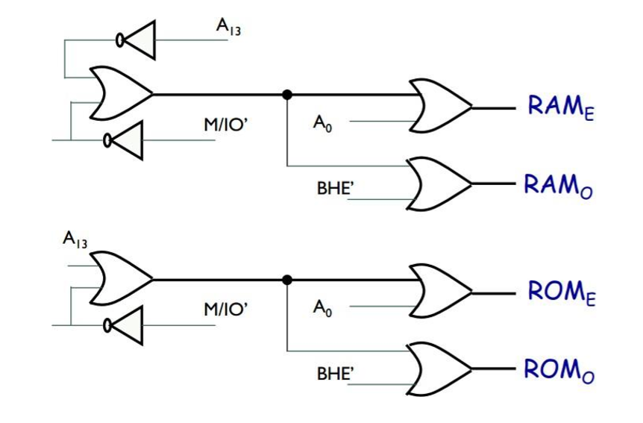

**8255(1) Port A:** 00h

**Port B: 02h**

**Port C: 04h**

**CWR: 06h**

**8255(2) Port A: 10h**

**Port B: 12h**

**Port C: 14h**

**CWR: 16h**

**8255(3) Port A: 18h**

**Port B: 1Ah**

**Port C: 1Ch**

**CWR: 1Eh**

**8253 Counter 0: 8h**

**Counter 1: 0Ah**

**Counter 2: 0Ch**

**CWR: 0Eh**

**Flow Charts**

Wait for Key Press

Top

System Start

Start Temp Temp Weight

Set Set Set

(Lower) (Upper)

Alarm

Stop flour motor and conveyor motor

Temp set lower

Jump to Top

Weight Set

Jump to Top

Take Weight input

Temp set upper

Take temperature input

Jump to Top

Take temperature input

Start Alarm

Wait for Acknowledge

Jump to Top

Top

Take weight input

Take average temperature from ADC

Temperature within range

No

Alarm

Yes

If required Weight Filled

Motor Forward

Yes No

Display min and max temperature

**END**

**No**

**No**

**No**

**yes**

**yes**

KEYBOARD

Zero to all rows

Read Columns

All Keys Open?

Read Columns

Key Pressed?

Wait

Read Columns

Key Pressed?

Output zero to one row

Read Columns

Key Found?

Convert to Hex

Return

**Complete Design**

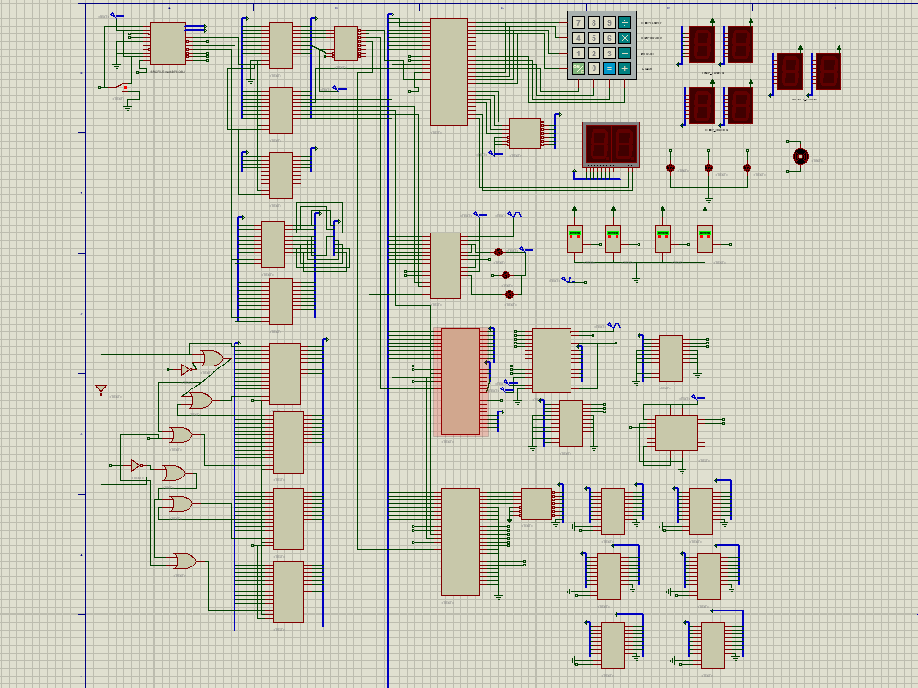

**Memory Interfacing**

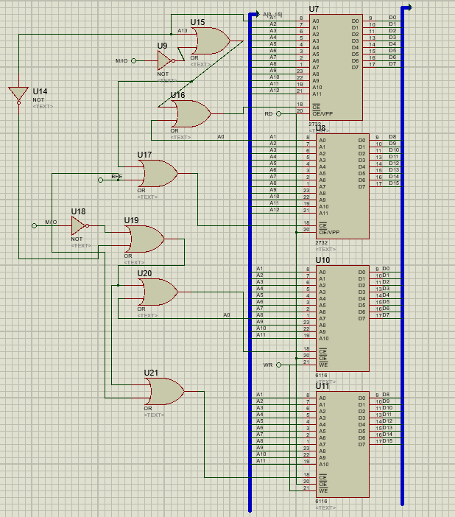

**Keypad, Display, Motor and LEDs**

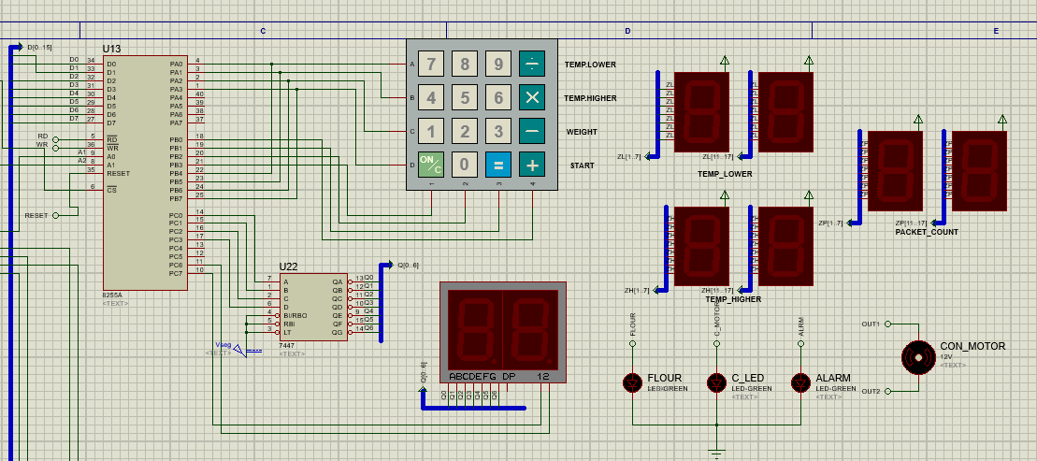

**Sensors**

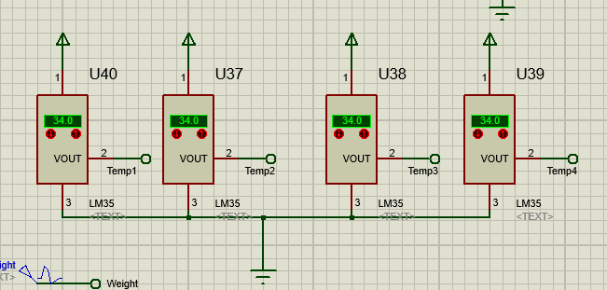

**ADC0808**

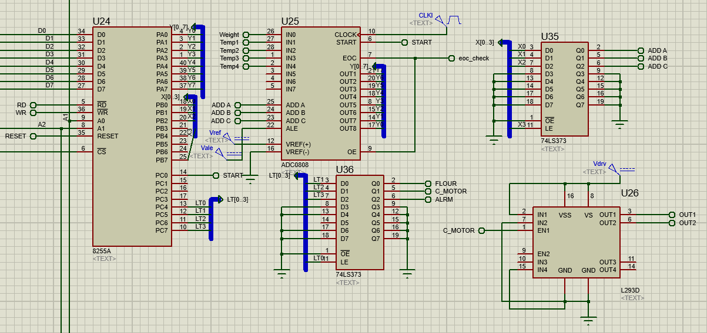

**CODE**

#make_bin#

#LOAD_SEGMENT=FFFFh#

#LOAD_OFFSET=0000h#

#CS=0000h#

#IP=0000h#

#DS=0000h#

#ES=0000h#

#SS=0000h#

#SP=FFFEh#

#AX=0000h#

#BX=0000h#

#CX=0000h#

#DX=0000h#

#SI=0000h#

#DI=0000h#

#BP=0000h#

;Code---------------------------------------------------------------------------------

jmp st1

db 509 dup(0)

TABLE db 77h,7Bh,7Dh,7Eh,0B7h,0BBh,0BDh,0BEh,0D7h,0DBh,0DDh,0DEh,0E7h,0EBh,0EDh,0EEh

TABLE_D db 00h,01h,02h,03h,04h,05h,06h,07h,08h,09h,0AH,0bH,0CH,0DH,0eH,0FH

weight1 db ?

weight2 db ?

weight_mod db ?

temp1 db ?

temp2 db ?

temp1U db ?

temp2U db ?

temp_mod db ?

tempU_mod db ?

weight_read db ?

temp_read db ?

key_in db ?

counter1 db ?

counter2 db ?

hr db ?

db 465 dup(0)

;main program------------------------------------------------------------------------

st1: cli

;intialize ds, es, ss to start of RAM------------------------------------------------

mov ax, 0200h

mov ds, ax

mov es, ax

mov ss, ax

mov sp, 0FFFEH

;initializing variables--------------------------------------------------------------

mov tempU_mod, 99

mov temp1, 0

mov temp2, 2

mov temp1U, 9

mov temp2U, 9

mov weight1, 0

mov weight2, 0

mov al, 02h

mov temp_mod, al

mov al, 00h

mov weight_mod, al

mov counter1, 0

mov counter2, 0

mov hr, 0

;8255(keypad) initializing-----------------------------------------------------------

;starting address 00h

;port a, port c o/p port b i/p

mov al, 10000010b

out 06h, al

;8253(timer) initializing------------------------------------------------------------

;initial clock 10kHz

;starting address 08h

;counter 0

mov al, 00110110b

out 0Eh, al

mov al, 64h ;count 100 100hz clock

out 08h, al

mov al, 00h

out 08h, al

;counter 1

mov al, 01110110b

out 0Eh, al

mov al, 14h ;count 20 5Hz clock ;in simulation this clock is used If 1 hour clock is need put output of counter 2 in hr label

out 0Ah, al

mov al, 00h

out 0Ah, al

;counter 2

mov al, 10110110b

out 0Eh, al

mov al, 0a0h ;count 36000 1Hr Timer

out 0Ch, al

mov al, 8ch

out 0Ch, al

;8255(ADC) initializing--------------------------------------------------------------

;starting address 10h

;port a , port c o/p port b I/p

mov al, 10010000b

out 16h, al

;8255(7 Segment) initihalizing--------------------------------------------------------

;starting address 18h

;port a, port b o/p port c i/p

mov al, 10001001b

out 1eh, al

;initializing over-------------------------------------------------------------------

top:

;every motor and led is off

mov al, 10h

out 14h, al

;latch enable off

mov al, 00h

out 14h, al

call keybrd

cmp al, 0EEh

jz t1

cmp al, 0DEh

jz t2

cmp al, 0BEh

jz w

cmp al, 7Eh

jz s

jmp top

;setting minimum temperature-------------------------------------------------------------

t1:

waitstate:

in al, 02h

and al, 0fh

cmp al, 0fh

jnz waitstate

mov al, 41h

out 04h, al

call TempSetL

jmp top

;setting maximum temperature---------------------------------------------------------

t2:

waitstate1:

in al, 02h

and al, 0fh

cmp al, 0fh

jnz waitstate1

mov al, 42h

out 04h, al

call TempSetU

jmp top

;setting weight per packet-----------------------------------------------------------

w:

waitstate2:

in al, 02h

and al, 0fh

cmp al,0fh

jnz waitstate2

mov al, 43h

out 04h, al

call WeightSet

jmp top

;On pressing Start-------------------------------------------------------------------

s:

waitstate3:

in al, 02h

and al, 0fh

cmp al, 0fh

jnz waitstate3

mov al, 44h

out 04h, al

jmp Start

;Start-------------------------------------------------------------------------------

Start:

CALL display

;taking temperature inputs from sensors and comparing from required conditions---------------------

;sensor 1

;start flour stop conv stop alarm

mov al, 30h

out 14h, al

mov al, 00h ;latch enable off

out 14h, al

mov al, 81h ;select adc channel 1

out 12h, al

mov al, 00h ; latch enable off

out 12h, al

;high to low transition

mov al, 00000001b ;high

out 16h, al

mov al, 00000000b ;low

out 16h, al

call delay1

;check eoc for high

x123:

in al, 1ch

and al, 01h

cmp al, 00h

jz x123

;initialize 8255 again for taking input

mov al, 10010000b

out 16h, al

;after initializing making sure flour motor on

mov al, 30h

out 14h, al

mov al, 00h

out 14h, al

;reading input from ADC

in al, 10h

;store input

mov temp_read, al

;sensor 2

mov al, 82h ;select adc channel 2

out 12h, al

mov al, 00h ; latch enable off

out 12h, al

;high to low transition

mov al, 00000001b ;high

out 16h, al

mov al, 00000000b ;low

out 16h, al

call delay1

;check eoc for high

x126:

in al, 1ch

and al, 01h

cmp al, 00h

jz x126

;initialize 8255 again for taking input

mov al, 10010000b

out 16h, al

;after initializing making sure flour motor on

mov al, 30h

out 14h, al

mov al, 00h

out 14h, al

;reading input from ADC

in al, 10h

;store input

add temp_read, al

;sensor 3----------

mov al, 83h ;select adc channel 3

out 12h, al

mov al, 00h ; latch enable off

out 12h, al

;high to low transition

mov al, 00000001b ;high

out 16h, al

mov al, 00000000b ;low

out 16h, al

call delay1

;check eoc for high

x124:

in al, 1ch

and al, 01h

cmp al, 00h

jz x124

;initialize 8255 again for taking input

mov al, 10010000b

out 16h, al

;after initializing making sure flour motor on

mov al, 30h

out 14h, al

mov al, 00h

out 14h, al

;reading input from ADC

in al, 10h

;store input

add temp_read, al

;sensor 4

mov al, 84h ;select adc channel 4

out 12h, al

mov al, 00h ; latch enable off

out 12h, al

;high to low transition

mov al, 00000001b ;high

out 16h, al

mov al, 00000000b ;low

out 16h, al

call delay1

;check eoc for high

x125:

in al, 1ch

and al, 01h

cmp al, 00h

jz x125

;initialize 8255 again for taking input

mov al, 10010000b

out 16h, al

;after initializing making sure flour motor on

mov al, 30h

out 14h, al

mov al, 00h

out 14h, al

;reading input from ADC

in al, 10h

;store input

add temp_read, al

;calculating temperature avg---------------------------------------------------------

mov al, temp_read

shr al, 01

shr al, 01

mov temp_read, al

;compare and call alarm procs

mov ah, temp_read

mov al, temp_mod

cmp ah, al

jb Alarm ;jump to alarm if below lower limit

mov al, tempU_mod

cmp ah, al

ja Alarm ;jump to alarm if above upper limit

jmp Mf

;taking weight input from sensor and comparing---------------------------------------

mov al, 80h ; select adc channel 0

out 12h, al

mov al, 00h ; latch enable off

out 12h, al

;high to low transition

mov al, 00000001b ;high

out 16h, al

mov al, 00000000b ;low

out 16h, al

call delay1

;check for high eoc

x1:

in al, 1ch

and al, 01h

cmp al, 00h

jz x1

;initialize again for reading input

mov al, 10010000b

out 16h,al

;start flour stop conv stop alarm

mov al, 30h

out 14h, al

mov al, 00h ; latch enable off

out 14h, al

;read input

in al, 10h

;store input

mov weight_read, al

;compare weight

mov al, weight_mod

mov ah, weight_read

cmp ah, al

jae Mf

;Alarm on code-----------------------------------------------------------------------

Alarm:

mov al, 90h ;start alarm

out 14h, al

mov al, 00h ;latch enable off

out 14h, al

jmp Ack

;Acknowledging alarm-----------------------------------------------------------------

Ack:

mov al, 00h

call keybrd

waitstate7:

in al, 02h

and al, 0fh

cmp al, 0fh

jnz waitstate7

mov al, 10h ;stop alarm

out 14h, al

mov al, 00h ;latch enable off

out 14h, al

jmp top

;Rotating Motor----------------------------------------------------------------------

Mf:

;stop flour and start conveyer

mov al, 50h

out 14h, al

mov al, 00h ;latch enable off

out 14h, al

;call delay

call delay

;stop conveyer and start flour

mov al, 30h

out 14h, al

mov al, 00h ;latch enable off

out 14h, al

jmp top

;------------------------------------------------------------------------------------

;procedures--------------------------------------------------------------------------

;procedure for short delay------------------------------------------------------------

delay1 proc near

mov cx, 300

nxt11:

LOOP nxt11

ret

delay1 endp

;procedure for long delay------------------------------------------------------------

delay proc near

mov cx, 1000

x2:

nop

nop

loop x2

ret

delay endp

;procedure for weightset------------------------------------------------------------

WeightSet proc near

PUSHF

PUSH BX

PUSH CX

PUSH DX

call keybrd

call key_press

mov weight1, al

mov weight_mod, al

;display tens place value

mov weight1, al

or al, 80h

out 04h, al

;mul tens place val by 10

mov cx, 09h

mov al, weight_mod

mov bl, weight_mod

wt_loop:

add al, bl

loop wt_loop

mov weight_mod, al

;wait for key release

waitstate4:

in al, 02h

and al, 0fh

cmp al, 0fh

jnz waitstate4

;wait for key press

call keybrd

call key_press

mov weight2, al

add weight_mod, al

;display units place value

mov al, weight2

or al, 40h

out 04h, al

mov al, weight_mod

mov ah, 00h

POP DX

POP CX

POP BX

POPF

ret

WeightSet endp

;procedure for tempset minimum---------------------------------------------------------

TempSetL proc near

PUSHF

PUSH BX

PUSH CX

PUSH DX

mov al, 00h

out 04h, al

call keybrd

call key_press

mov temp1,al

mov temp_mod, al

mov al, temp1

;display tens place

or al, 80h

out 04h, al

;mul tens place val by 10

mov cx, 09h

mov bl, temp_mod

mov al, temp_mod

add_loop:

add al, bl

loop add_loop

mov temp_mod, al

;wait for key release

waitstate5:

in al, 02h

and al, 0fh

cmp al, 0fh

jnz waitstate5

call keybrd

call key_press

mov temp2, al

add temp_mod, al

mov al, temp_mod

mov ah, temp2

mov al, temp2

;display units place

or al, 40h

out 04h, al

mov al, temp_mod

mov ah, 00h

POP DX

POP CX

POP BX

POPF

ret

TempSetL endp

;procedure working for tempset maximum-----------------------------------------------

TempSetU proc near

PUSHF

PUSH BX

PUSH CX

PUSH DX

;wait for key press

call keybrd

call key_press

;store values

mov temp1U, al

mov tempU_mod, al

;display tens place

or al, 80h

out 04h, al

;mul tens place val by 10

mov cx, 09

mov al, tempU_mod

mov bl, tempU_mod

add_loopU:

add al, bl

loop add_loopU

mov tempU_mod, al

;wait for key release

waitstate6:

in al, 02h

and al, 0fh

cmp al, 0fh

jnz waitstate6

;wait for key press

call keybrd

call key_press

mov temp2U, al

add tempU_mod, al

mov temp2U, al

;display units place

or al, 40h

out 04h, al

mov al, tempU_mod

mov ah, 00

POP DX

POP CX

POP BX

POPF

ret

TempSetU endp

;procedure for keyboard--------------------------------------------------------------

keybrd proc near

PUSHF

PUSH BX

PUSH CX

PUSH DX

;send 0's to all rows

mov al, 00

mov dx, 00h

out dx, al

;read columns

mov dx, 02h ;load input port address

wait_open:

in al, dx

and al, 0fh

cmp al, 0fh

jne wait_open

;read colunms to see if key is pressed

wait_press:

in al, dx

and al, 0fh

cmp al, 0fh

je wait_press

;debounce

mov cx, 0127h ;2.5 ms

delay123:

loop delay123

;read columns to see if key still pressed

in al, dx

and al, 0fh

cmp al, 0fh

je wait_press

;find key

mov al, 0feh

mov cl, al

next_row:

mov dx, 00h

out dx, al

mov dx, 02h

in al, dx

and al, 0fh

cmp al, 0fh

jne encode

rol cl, 01

mov al, cl

jmp next_row

encode:

mov bx, 000fh

in al, dx

try_next :

cmp al, table[bx]

je done

dec bx

jns try_next

mov ah, 01h

jmp exit

done:

mov al, bl

mov key_in, al

mov ah, 00h

exit:

POP DX

POP CX

POP BX

POPF

ret

keybrd endp

;procedure for decoding the pressed key----------------------------------------------

key_press proc near

PUSHF

PUSH BX

PUSH CX

PUSH DX

x21:

cmp al, 7Bh

jnz x5

mov al, 00h

jmp x0

x5:

cmp al, 0B7h

jnz x6

mov al, 01h

jmp x0

x6:

cmp al, 0BBh

jnz x7

mov al, 02h

jmp x0

x7:

cmp al, 0BDh

jnz x9

mov al, 03h

jmp x0

x9:

cmp al, 0D7h

jnz xA

mov al, 04h

jmp x0

xA:

cmp al, 0DBh

jnz xB

mov al, 05h

jmp x0

xB:

cmp al, 0DDh

jnz xD

mov al, 06h

jmp x0

xD:

cmp al, 0E7h

jnz xE

mov al, 07h

jmp x0

xE:

cmp al, 0EBh

jnz xF

mov al, 08h

jmp x0

xF:

cmp al, 0EDh

jnz x0

mov al, 09h

jmp x0

x0:

nop

POP DX

POP CX

POP BX

POPF

ret

key_press endp

;procedure for displaying the values on 7 Segment------------------------------------

display proc near

pushf

push bx

push cx

push dx

mov al, 00h

out 1ah, al

mov al, 01h

out 1ah, al

mov al, temp1

out 18h, al

mov al, 02h

out 1ah, al

mov al, temp2

out 18h, al

mov al, 04h

out 1ah, al

mov al, temp1U

out 18h, al

mov al, 08h

out 1ah, al

mov al, temp2U

out 18h, al

;checking for hr timer then only display

in al, 1ch

and al, 02h

cmp al, hr

je skipc

mov bl, hr

cmp bl, 0

jne one

mov hr, 02h

jmp ahead

one:

mov hr, 0

ahead:

mov al, 10h

out 1ah, al

mov al, counter2

out 18h, al

mov al, 20h

out 1ah, al

mov al, counter1

out 18h, al

skipc:

mov al, 00h

out 1ah, al

pop dx

pop cx

pop bx

popf

ret

display endp

;

-----------------------------------------------------------------------------

**REFERENCES**

ADC0808

http://html.alldatasheet.com/html- pdf/8097/NSC/ADC0808/38/1/ADC0808.html

Load Cell

http://www.velamed.com/englisch/products/electromyography/noraxon - sensors/noraxon-sensors.html

LS138

http://www.alldatasheet.com/datasheet-pdf/pdf/46206/SLS/LS138.html

74373

http://www.alldatasheet.com/datasheet-pdf/pdf/192081/TI/LS373.html

74245

http://www.alldatasheet.com/datasheet- pdf/pdf/44472/SIEMENS/BF245.html

L293D

http://www.ti.com/lit/ds/symlink/l293d.pdf

LM 35

http://www.ti.com/lit/ds/symlink/lm35.pdf