**VISVESVARAYA TECHNOLOGICAL UNIVERSITY**

**JNANASANGAMA, BELGAVI – 590018.**



**REPORT ON MINI PROJECT TITLED**

**“ROBOTIC ARM”**

*Submitted in the partial fulfilment for the award of the degree of*

**BACHELOR OF ENGINEERING**

**IN**

**ELECTRICAL AND ELECTRONICS ENGINEERING**

*Submitted by*

**HEMANTH S 1SG20EE012**

**NITEESH SS 1SG20EE021**

**SUMANTH Y 1SG20EE032**

**SUJAY R 1SG20EE031**

*Under the supervision of*

**Prof.SWETHA**

Designation, Dept. of EEE



**For the Academic year of 2022 – 2023**

**DEPARTMENT OF ELECTRICAL AND ELECTRONICS ENGINEERING**

**SAPTHAGIRI COLLEGE OF ENGINEERING**

***(Affiliated to VTU, Belagavi and Recognized by AICTE, New Delhi)***

***(An ISO 9001:2015 and 14001: 2015 certified Institution)***

***(ACCREDITED BY NAAC WITH “A” GRADE, ACCREDITED BY NBA)***

**14/5, Chikkasandra, Hesaraghatta Main Road, Bengaluru – 560057.**

**SAPTHAGIRI COLLEGE OF ENGINEERING**

***(Affiliated to VTU, Belagavi and Recognized by AICTE, New Delhi)***

***(An ISO 9001:2015 and 14001:2015 certified Institution)***

**Accredited by NAAC with “A” Grade, Accredited by NBA**

#14/5, Chikkasandra, Hesaraghatta Main Road, Bangalore – 560057.



**DEPARTMENT OF ELECTRICAL AND ELECTRONICS ENGINEERING**

# CERTIFICATE

Certified that the mini project entitled **“ROBOTIC ARM”** is carried out by

**HEMANTH S(1SG20EE012), NITEESH SS(1SG20EE021), SUMANTH Y(1SG20EE032), SUJAY R (1SG20EE031)** bonafide student of **Sapthagiri College of Engineering** in partial fulfilment for the award of **Bachelor of Engineering** in department of **Electrical and Electronics Engineering** of Visvesvaraya Technological University, Belagavi during the academic year **2022-2023**. It is certified that all corrections/suggestions indicated in the Internal Assessment have been incorporated in the report deposited. The mini project report has been approved as it satisfies the academic requirements in respect of mini project prescribed for the Bachelor of Engineering Degree.

**Signature of the Internal Guide Signature of the HOD Signature of the Principal**

**Prof.SWETHA Dr. REKHA S N Dr. H. RAMAKRISHNA**

Professor & H.O.D Principal

# ACKNOWLEDGEMENT

The satisfaction and euphoria that accompany the successful completion of any task would be incomplete without mention of the people who made it possible and whose support has been a constant source of encouragement which crowned my efforts with success.

I am deeply indebted and I would like to express my sincere thanks to our beloved

Principal **Dr. H RAMAKRISHNA**, for providing me an opportunity to do this seminar.

My special gratitude to **Dr. REKHA** , HOD, Department of Electrical

and Electronics Engineering, SCE for his guidance, constant encouragement and

wholehearted support.

My sincere thanks to my guide **Prof.SWETHA,** Department of Electrical and Electronics Engineering, Sapthagiri College of Engineering, for his guidance, constant encouragement and wholehearted support.

Finally, I would like to express my sincere thanks to all the staff members of

Department of Electrical and Electronics Engineering, Sapthagiri College of Engineering for their valuable guidance and support.

**NAME OF THE STUDENTS**

**USN**

**HEMANTH S 1SG20EE012**

**NITEESH SS 1SG20EE021**

**SUMANTH Y 1SG20EE032**

**SUJAY R 1SG20EE031**

## CONTENTS

|  |  |  |
| --- | --- | --- |
| **Chapter No.** | **Description** | **Page No.** |
| 1 | Introduction | 1 |
| 2 | Literature Survey | 2 |
| 3 | Objectives | 3 |
| 4 | Methodology and Block Diagram. | 4 |
| 5 | Components Description | 7 |
| 6 | Project design | 17 |
| 7 | Conclusion | 18 |
| 8 | References | 19 |
| 9 | Appendix | 20 |

## Introduction

Robotic arm is a mechanical product, its manufacture and sold

rate is very high over the world. Figure 1 shows A robotic arm

with labels. Thousands type of arm are available in the market

and developed by different companies. Industrial use of the

robotic arm is more than the domestic because at this time

robot are not used for normal purpose; it’s always used for

specific purpose and in the industry some condition where

humans are not able to work i.e. high temperature, polluted air

zone, heavy weight lifting etc. Robotic arm also uses for high

accuracy places where error not allowed. Robotic arm is set a

task and perform it accurately in the various environment. A

robotic arm is meant a set of rigid jointed bodies able to take

different configuration, and to move between these

configurations with prescribed limits on velocity and

acceleration. Industrial robotic arm differs by the size of the

fixed bodies, the type of joint, the sequence in which the joints

are connected and the range of motion acceptable at each joint.

The individual fixed bodies are called links. Robotic arms are

manufactured by using different parameters like number of

axis, degree of freedom, working envelope and working space

that arm cover, kinematics, payload, speed and acceleration,

accuracy and repeatability, motion control and drive of an arm

etc. This survey papers to summarize the development in a

robotic arm

Robotic arm is a mechanical product, its manufacture and sold

rate is very high over the world. Figure 1 shows A robotic arm

with labels. Thousands type of arm are available in the market

and developed by different companies. Industrial use of the

robotic arm is more than the domestic because at this time

robot are not used for normal purpose; it’s always used for

specific purpose and in the industry some condition where

humans are not able to work i.e. high temperature, polluted air

zone, heavy weight lifting etc. Robotic arm also uses for high

accuracy places where error not allowed. Robotic arm is set a

task and perform it accurately in the various environment. A

robotic arm is meant a set of rigid jointed bodies able to take

different configuration, and to move between these

configurations with prescribed limits on velocity and

acceleration. Industrial robotic arm differs by the size of the

fixed bodies, the type of joint, the sequence in which the joints

are connected and the range of motion acceptable at each joint.

The individual fixed bodies are called links. Robotic arms are

manufactured by using different parameters like number of

axis, degree of freedom, working envelope and working space

that arm cover, kinematics, payload, speed and acceleration,

accuracy and repeatability, motion control and drive of an arm

etc. This survey papers to summarize the development in a

robotic arm

Robotic arm is a mechanical product, its manufacture and sold

rate is very high over the world. Figure 1 shows A robotic arm

with labels. Thousands type of arm are available in the market

and developed by different companies. Industrial use of the

robotic arm is more than the domestic because at this time

robot are not used for normal purpose; it’s always used for

specific purpose and in the industry some condition where

humans are not able to work i.e. high temperature, polluted air

zone, heavy weight lifting etc. Robotic arm also uses for high

accuracy places where error not allowed. Robotic arm is set a

task and perform it accurately in the various environment. A

robotic arm is meant a set of rigid jointed bodies able to take

different configuration, and to move between these

configurations with prescribed limits on velocity and

acceleration. Industrial robotic arm differs by the size of the

fixed bodies, the type of joint, the sequence in which the joints

are connected and the range of motion acceptable at each joint.

The individual fixed bodies are called links. Robotic arms are

manufactured by using different parameters like number of

axis, degree of freedom, working envelope and working space

that arm cover, kinematics, payload, speed and acceleration,

accuracy and repeatability, motion control and drive of an arm

etc. This survey papers to summarize the development in a

robotic arm

Robotic arm is a mechanical product, its manufacture and sold

rate is very high over the world. Figure 1 shows A robotic arm

with labels. Thousands type of arm are available in the market

and developed by different companies. Industrial use of the

robotic arm is more than the domestic because at this time

robot are not used for normal purpose; it’s always used for

specific purpose and in the industry some condition where

humans are not able to work i.e. high temperature, polluted air

zone, heavy weight lifting etc. Robotic arm also uses for high

accuracy places where error not allowed. Robotic arm is set a

task and perform it accurately in the various environment. A

robotic arm is meant a set of rigid jointed bodies able to take

different configuration, and to move between these

configurations with prescribed limits on velocity and

acceleration. Industrial robotic arm differs by the size of the

fixed bodies, the type of joint, the sequence in which the joints

are connected and the range of motion acceptable at each joint.

The individual fixed bodies are called links. Robotic arms are

manufactured by using different parameters like number of

axis, degree of freedom, working envelope and working space

that arm cover, kinematics, payload, speed and acceleration,

accuracy and repeatability, motion control and drive of an arm

etc. This survey papers to summarize the development in a

robotic arm

Robotic arm is a mechanical product, its manufacture and sold

rate is very high over the world. Figure 1 shows A robotic arm

with labels. Thousands type of arm are available in the market

and developed by different companies. Industrial use of the

robotic arm is more than the domestic because at this time

robot are not used for normal purpose; it’s always used for

specific purpose and in the industry some condition where

humans are not able to work i.e. high temperature, polluted air

zone, heavy weight lifting etc. Robotic arm also uses for high

accuracy places where error not allowed. Robotic arm is set a

task and perform it accurately in the various environment. A

robotic arm is meant a set of rigid jointed bodies able to take

different configuration, and to move between these

configurations with prescribed limits on velocity and

acceleration. Industrial robotic arm differs by the size of the

fixed bodies, the type of joint, the sequence in which the joints

are connected and the range of motion acceptable at each joint.

The individual fixed bodies are called links. Robotic arms are

manufactured by using different parameters like number of

axis, degree of freedom, working envelope and working space

that arm cover, kinematics, payload, speed and acceleration,

accuracy and repeatability, motion control and drive of an arm

etc. This survey papers to summarize the development in a

robotic arm.

## Now a Days, Robotic arms had been mostly used for industry automation and operation in the hazardous environment. Many robotic controls are very expensive, due to high-precision actuators and custom machining of components. We recommend that robotic control research can advance more rapidly if robotic arms of valuable performance were highly reduced in price. Increased affordability can lead to wider acceptance, which in turn can lead to faster progress. However, drastic cost reduction will require design trade-offs and compromises.

## There are number of dimensions on which robotic arms can be evaluated, such as backlash, payload, speed, repeatability, compliance, human safety, and cost. In robotics research, some of these dimensions are more important than others: for grasping and object manipulation, high repeatability and low backlash are important. Human-safety is difficult if the manipulator is to be used in close to the people. Arduino UNO A000066 is used as the brain of the robotic arm, force sensors are placed at the gripper for finding the force applied on the object, and potentiometers are used at the joints for detecting the position of the motor shaft. We used the exact model of the developed robotic arm built using Aluminium due to its characteristics such as light weight, do not wear out easily, cheaper and machining is easier.

## Robotic Arm Images - Free Download on Freepik

## Literature Survey

In this paper a 5 Degree of Freedom (DOF) robotic arm have been developed. It is controlled by an Arduino Uno microcontroller which accepts input signals from a user by means of a set of potentiometers. The arm is made from four rotary joints addend effector also, where rotary motion is provided by a servomotor. Each link has been first designed using Solid Works Sheet Metal Working Toolbox and then fabricated using a 2mm thick Aluminium sheet. The servomotors and links thus produced assembled with fasteners produced the final shape of the arm. The Arduino has been programmed to provide rotation to each servo motor corresponding to the amount of rotation of the potentiometer shaft. A robot can be defined according to the nature of the relative movements between the links that constitute.

• Review on development of industrial robotic arm, this selective operation robotic control method is need to be overcome the problem such as placing or picking object that at distant from the worker. The robotic arm has been developed successfully as the movement of the robot can be controls precisely. It is expensive to change the cable and therefore the designing to reduce the friction on table, is crucial to increase time between maintenance.

• Survey on Design and Development of competitive low cost Robot Arm with Four Degrees of Freedom, this paper the representation of the design, development and implementation of robot arm is done, which has the ability to perform simple tasks, such as light material handling. The robotic arm is designed and made from acrylic material where servo motors are used to perform links between arms. The servo motors consist of encoder so that no need to use controller. However, the rotation range of the motor is less than 180º span, which greatly decreases the region reached by the arm and the possible positions. The design of the robot arm was for four degrees of freedom. The end effector is not considered while designing because a readily available gripper is used as it is much easier and economical to use a commercial.



**SAPTHAGIRI COLLGE OF ENGINEERING**

***(Approved by AICTE, Affiliated to VTU, Belagavi)***

***(An ISO 9001:2015 and 14001:2015 certified institution)***

***(Accredited by NAAC with “A” Grade, Accredited by NBA)***

**14/5, CHIKKASANDRA, HESARAGHATTA MAIN ROAD, BENGALURU – 560 057.**

**DEPARTMENT OF ELECTRICAL AND ELECTRONICS ENGINEERING**

**OBJECTIVES OF MINI PROJECT**

This mini project is carried out to meet the following objectives.

1. Demonstrate the design and solution of the selected mini-project.
2. Build the critical thinking and use problem solving skills in societal and environmental contexts.
3. Develop on their own, reflect on their learning and take appropriate actions to improve it.
4. Develop team work for conducting the mini-project and Communicate effectively through reports & presentations.

## Methodology

We studied the servo motors so to control them, we need to use the pulse width modulation [PWM](https://en.wikipedia.org/wiki/Pulse-width_modulation). we will use in variable resistance Potentiometers (10K) using variable resistance will change the angle of the servo motor, in the code we will define the motors and resistors and determine the range from 0 to 1024 according to the motor and Arduino datasheet. But what is potentiometer?

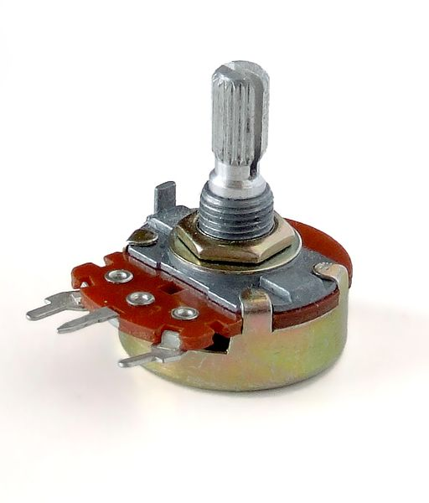Potentiometer it is variable resistance but its value can be changed manually using knob since the increase of resistance will reduce the current, this piece is used for example in the control of the volume in radio, in our project we use to control the degree of servo motor. There are many types of them, some of which moves in a linear and some moves in a rotating, the following picture shows some types:

The Arduino takes the input from the potentiometers, the change in resistance of pot gives input to the servo motors. And the motors rotates accordingly.

## Block Diagram

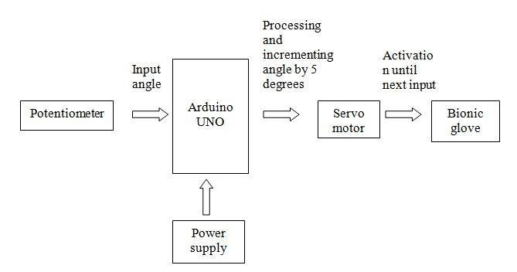

block diagram of the proposed Bionic glove prototype consists of the potentiometer input unit, Arduino interfacing unit and the servo motor controlled glove as shown in Figure 1. The power supply is given by a 9V battery to the Arduino UNO board. As per the robotic arm developed by Katal et al., 2013 a servo motor with a stall torque of 10kg/cm is employed to perform pick and place operations with precision [12]. The bionic glove employs a metal gear servo motor with a torque of 11kg/cm, operating on 4.8V to achieve better motion and flexibility. According to Krishna.R etal., 2012, the pick and place robot is operated using a servo motor with better accuracy in medical and industrial applications. In our proposed design, the servo motor, potentiometer and the Arduino board is permanently fixed on a plastic plate which is attached to the wearable glove and can be placed on the forearm of the patient during therapy. The glove is made of a light weight synthetic material which is easy to wear and includes an adjustable Velcro band. Nylon strings are used to pull the fin- gears of the glove upwards with the help of a servo motor. One end of the four nylon strings is sewn to the glove material and the other end is tied together with the rim of the servo motor.

## Connection Diagram

## https://static.wixstatic.com/media/b31662_92fbb79aee334fdab6c1ae2f3f12078b~mv2.png

## We provide variable voltage at the ADC channels of Arduino UNO using Pot. So the digital values of Arduino are under control of user. These digital values are mapped to adjust the servo motor position, hence the servo position is in control of user and by rotating these Pots user can move the joints of Robotic arm.

## Components Description

[Arduino Mega 2560](https://robu.in/product/arduino-mega-2560-board-with-compatible-usb-cable/) is an open source development board based on [Atmega2560](https://robu.in/product/atmel-mcu-atmega16u2-mega-2560-r3-improved-version-ch340g-cable-arduino-mega-2560-transparent-acrylic-case-arduino-mega-2560/) AVR microcontroller. This microcontroller is an 8- bit Microcontroller. It uses ATmega16U2 Microchip Technology. This board can be programmed using programmed using wiring/ processing language. It includes: -

1. 54 digital input/ output pins out of which 14 pins can be used as PWM outputs
2. 16 analog pins
3. 4 UARTs (hardware serial ports)
4. A 16 MHz crystal oscillator
5. A USB connection
6. A power Jack
7. An ICSP Header
8. A reset button

The revision 3 of the Arduino Mega 2560 has come up with some more additional features, they are as:

1. SDA and SCL pins besides AREF pin
2. IOREF and one more extra pin besides RESET

Don’t know how to use the above features? Don’t worry I’ll give you a brief idea of the purpose of the major pins and ports.

**Digital Input/ Output Pins:**It is used to transmit and receive the digital signals respectively.

**PWM Outputs:**PWM (Pulse Width Modulation) pin is used to control the signals. For example, controlling the speed of the motors, brightness of LED.

**Analog Pins:** It performs the function of reading analog signals. For example, reading the sensors data. Also it serves as general purpose Input/ output pins.

**UART (Universal Asynchronous Receiver/Transmitter):**It is used for serial communication purpose.

**USB:** It serves two purpose i.e. it can connect Mega 2560 board to your PC in order to program your board as well as it can be used to dram power to the board.

**Power Jack:** It is used to supply power to the board externally.

**ICSP Header:** In Circuit Serial Programming (ICSP) is one of the way to program the Arduino Board. Generally, it is used to restore the missing or damaged bootloader of Arduino. You can have an idea of it by looking at the diagram below.

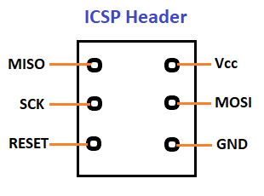**SDA (Serial Data):** Used for exchanging data between Master and Slave device.

**SCl (Serial clock):** Used as synchronous clock between master and slave devices.

**IOREF:** It provides us with a voltage reference with which the board can operate.

## ****Technical Features of Arduino Mega 2560****

|  |  |
| --- | --- |
| Microcontroller | ATmega2560 |
| Operating Voltage | 5V |
| Input Voltage (Recommended) | 7 - 12V |
| Input Voltage (Limit) | 6 - 20V |
| Analog Input Pins | 16 |
| Digital I/O Pins | 54 |
| DC Current for 3.3V Pin | 50mA |
| DC Current per I/O Pin | 20mA |
| Flash Memory | 256 kB |
| SRAM | 8kB |
| EEPROM | 4kB |
| Clock Speed | 16MHz |
| LED_BUILTIN | 13 |

## ****Pin Configuration****

## https://robu.in/wp-content/uploads/2020/11/Mega-Pin-Configuration.png

**Pin 3.3V & 5V:**This pins are used to provide regulated power supply to the Mega 2560 board.

**GND Pin:**Total 5 ground pins are provided on the Mega 2560 board.

**Reset (RST) Pin:**It is used to rearrange the functionality of the board.

**Vin Pin:**This pin serves the purpose of providing input voltage to the board. Remember! The range of input voltage through this pin should be in the range of 7V- 12V. In case you take output from this pin, the board will automatically set up the voltage to 5V.

**Serial Communication:**TXD and RXD are the serial pins of this board which is used to transmit & receive the serial data respectively.

We can make the group of this serial pins in four possible combinations:

|  |  |  |
| --- | --- | --- |
|  | **Pin No. for Tx** | **Pin No. for Rx** |
| Serial 0 | 1 | 0 |
| Serial 1 | 18 | 19 |
| Serial 2 | 16 | 17 |
| Serial 3 | 14 | 15 |

**External Interrupts**: These are six pins that provide number of ways to trigger an interrupt for example, Providing LOW value, rising or falling edge or changing the value to the interrupt pins. The pin numbers used for this interrupt is as follows:

|  |  |
| --- | --- |
| **Interrupts** | **Pin No.** |
| Interrupt 0 | 2 |
| Interrupt 1 | 3 |
| Interrupt 2 | 21 |
| Interrupt 3 | 20 |
| Interrupt 4 | 19 |
| Interrupt 5 | 18 |

**AREF (Analog Reference Voltage):**This pin is used as reference voltage for analog inputs.

**Analog Pins:**There are total of 16 Analog pins from A0 - A15. The high values of this pins can be altered using AREF pin.

**Digital Pins:**There are 54 digital Input/output pins on the Arduino Mega board from pin numbered from 0 to 53. Out of 54 pins, 15 pins numbered from D2 - D13 and D44 - D46 are PWM (Pulse Width Modulation) pins.

**I2C:**It is one way of communication to the board using pin number 20 & 21.

**SPI (Serial Peripheral Interface) Communication:**It is popularly used by the microcontrollers to communicate with one or more peripheral devices.

## ****Advantages and Disadvantages****

Out of many advantages, Arduino Mega 2560 has few disadvantages too. Let’s see what they are.

### Advantages of Arduino Mega 2560

1. It comes with more memory space, bigger size and more I/O pins.
2. Speedy communication can be achieved since there is a reset button and 4 hardware serial port (USART).
3. There are three ways to power the board i.e. either through USB cable, or by using Vin pin of the board, or through Power jack.
4. This board comes with resettable polyfuse that prevents the USB port of your computer from overheating in the presence of high current flowing through the board.
5. This board comes with two voltage regulator i.e. 5V and 3.3V which provides the flexibility to regulate the voltage as per requirements.

### Disadvantages of Arduino Mega 2560

1. It is available only for 8-bits not for 32 bits.
2. Clock speed is limited to 20 MHz

|  |  |
| --- | --- |
| **Component** | **Number** |
| Arduino Mega | 1 |
| Potentiometers 22K | 4 |
| Servo motors (any type support +5DC) | 4 |
| Bread board | 1 |
| wires | 20 |

## POTENTIOMETER

A potentiometer is a three-terminal resistor with a sliding or rotating contact that forms an adjustable voltage divider. If only two terminals are used, one end and the wiper moves, it acts as a variable resistor or rheostat.

There are various types of potentiometers:

* digital potentiometer
* rotary potentiometer
* logarithmic potentiometer
* manually adjustable potentiometer
* linear potentiometer

The measuring instrument called a potentiometer. This is essentially an output voltage divider used for measuring the potential energy (voltage); the component measures the resistance of the potentiometer, hence its name.

Potentiometers are commonly used to control electrical devices such as volume controls on audio equipment. Potentiometers operated by a mechanism can be used as position transducers, for example, in a [g](https://en.wikipedia.org/wiki/Joystick)ame joystick. Potentiometers are rarely used to directly control significant power (more than a single watt), since the power dissipated in the potentiometer would be comparable to the power in the controlled load.

Figure 6-8 illustrates the construction geometry of a potentiometer, which acts as a variable resistor. A resistive tracks, similar to that found on film type fixed resistors, forms approximately 3/4 of a circle (an arc of 2700), with terminals connected to either end. This strip exhibits a fixed value of maximum resistance element. To obtain the variable resistance, a sliding contact, attached to a rotatable shaft and bearing, goes to a third (middle) terminal. The resistance between the middle terminal and either terminal can vary from zero up to the resistance of the whole strip. Most potentiometers can handle only low levels of current, at low to moderate voltages.

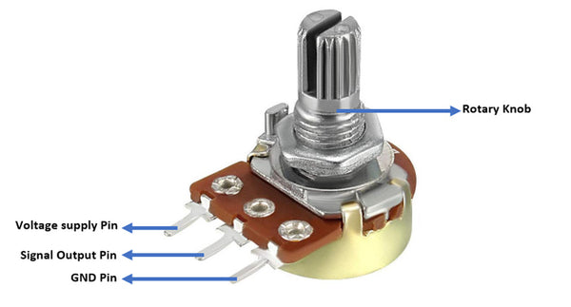

## SERVO MOTOR

A **servo motor** is a type of motor that can rotate with great precision. Normally this type of motor consists of a control circuit that provides feedback on the current position of the motor shaft, this feedback allows the servo motors to rotate with great precision. If you want to rotate an object at some specific angles or distance, then you use a servo motor. It is just made up of a simple motor which runs through a **servo mechanism.**

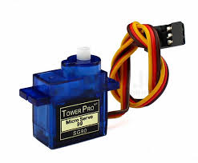

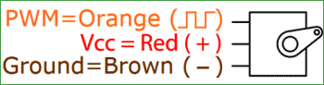

### ****Servo Motor Working Mechanism:****

It consists of three parts:

1. Controlled device
2. Output sensor
3. Feedback system

It is a closed-loop system where it uses a positive feedback system to control motion and the final position of the shaft. Here the device is controlled by a feedback signal generated by comparing output signal and reference input signal.

Here reference input signal is compared to the reference output signal and the third signal is produced by the feedback system. And this third signal acts as an input signal to the control the device. This signal is present as long as the feedback signal is generated or there is a difference between the reference input signal and reference output signal. So the main task of servomechanism is to maintain the output of a system at the desired value at presence of noises.

### Servo Motor Working Principle:

A servo consists of a Motor (DC or AC), a potentiometer, gear assembly, and a controlling circuit. First of all, we use gear assembly to reduce RPM and to increase torque of the motor. Say at initial position of servo motor shaft, the position of the potentiometer knob is such that there is no electrical signal generated at the output port of the potentiometer. Now an electrical signal is given to another input terminal of the error detector amplifier.

### Interfacing Servo Motors with Microcontrollers:

Interfacing hobby Servo motors like s90 servo motor with MCU is very easy. **Servos have three wires coming out of them**. Out of which two will be used for Supply (positive and negative) and one will be used for the signal that is to be sent from the MCU.

### ****Controlling Servo Motor:****

Servo motor works on **PWM (Pulse width modulation)** principle, means its angle of rotation is controlled by the duration of applied pulse to its Control PIN. Basically servo motor is made up of **DC motor which is controlled by a variable resistor (potentiometer) and some gears**. High speed force of DC motor is converted into torque by Gears. We know that WORK= FORCE X DISTANCE, in DC motor Force is less and distance (speed) is high and in Servo, force is High and distance is less. The potentiometer is connected to the output shaft of the Servo, to calculate the angle and stop the DC motor on the required angle.

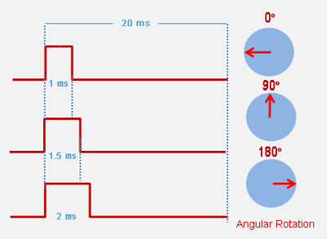

## Software Used

The Arduino Software (IDE) makes it easy to write code and upload it to the board offline. We recommend it for users with poor or no internet connection. This software can be used with any Arduino board.

There are currently two versions of the Arduino IDE, one is the IDE 1.x.x and the other is IDE 2.x. The IDE 2.x is new major release that is faster and even more powerful to the IDE 1.x.x. In addition to a more modern editor and a more responsive interface it includes advanced features to help users with their coding and debugging.

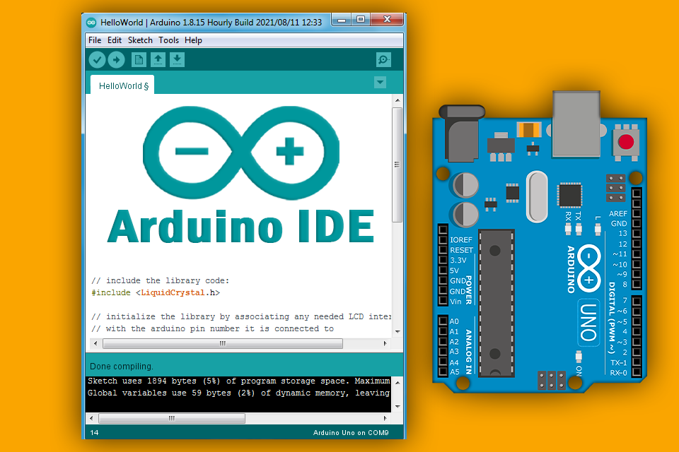

## 

Arduino software (IDE) is compatible with different operating systems (Windows, Linux, Mac OS X), and supports the programming languages (C/C++)

The Arduino software is easy to use for beginners, or advanced users. It uses to get started with electronics programming and robotics, and build interactive prototypes.

So Arduino software is a tool to develop new things. and create new electronic projects, by Anyone (children, hobbyists, engineers, programmers, … etc.)

## Program Code Used

#include <Servo.h>

Servo servo1;

Servo servo2;

Servo servo3;

Servo servo4;

int pot1 = A0;

int pot2 = A1;

int pot3 = A2;

int pot4 = A3;

int valPot1;

int valPot2;

int valPot3;

int valPot4;

void setup()

{

servo1.attach(3);

servo1.write(0); //define servo1 start position

servo2.attach(5);

servo2.write(90); //define servo2 start position

servo3.attach(6);

servo3.write(90); //define servo3 start position

servo4.attach(9);

servo4.write(70); //define servo4 start position

}

void loop()

{

valPot1 = analogRead(pot1);

valPot1 = map (valPot1, 0, 1023, 90, 180); //(servo value between 0 and 180)

servo1.write(valPot1);

valPot2 = analogRead(pot2);

valPot2 = map (valPot2, 0, 1023, 0, 180);

servo2.write(valPot2);

valPot3 = analogRead(pot3);

valPot3 = map (valPot3, 0, 1023, 0, 180);

servo3.write(valPot3);

valPot4 = analogRead(pot4);

valPot4 = map (valPot4, 0, 1023, 0, 180);

servo4.write(valPot4);

}

## Project design

## C:\Users\hemanth\AppData\Local\Microsoft\Windows\INetCache\Content.Word\IMG-20230205-WA0005.jpg

This Arduino Robotic Me Arm can be controlled by four Potentiometer attached to it, each potentiometer is used to control each servo. You can move these servos by rotating the pots to pick some object, with some practice you can easily pick and move the object from one place to another. We have used low torque servos with metal gear here but you can use more powerful servos to pick heavy objects.

Connecting the Servo Motor to the Arduino uno

Black wire of servo motor to the GND pin of Arduino uno

Red wire of servo motor to the 5V pin of Arduino uno

Orange wire of servo motor to the D5, D6,D7,D8 of Arduino uno

## Conclusion

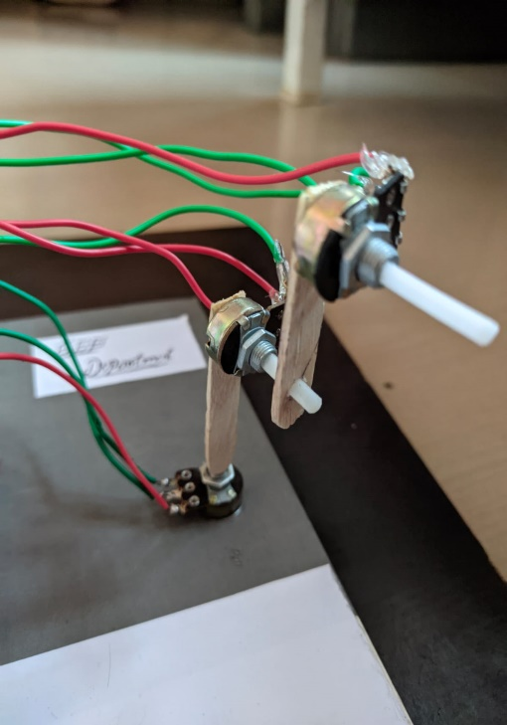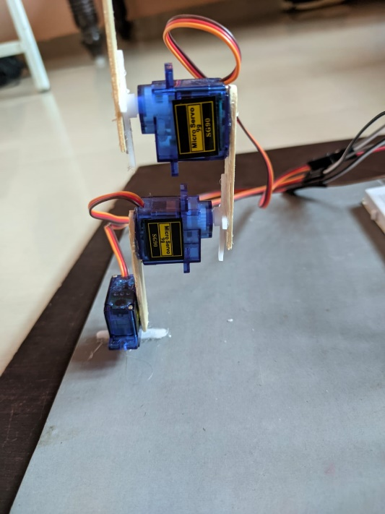

It is true that human arms can do many works at a time but it always involves risk of injury during work involving lifting of heavy items and picking of radioactive substances. Moreover, medical industry need an arm for people who lost it in accidents.

Also, it is seen that efficiency of a person decreases as his age advances due to which one involved in rough work becomes unproductive and inefficient. In manufacturing industry and nuclear industry, a large fraction of the work is repetitive and judicious application of automation will most certainly result in optimum utilization of machine and manpower. A pneumatic `Pick and Place ‘Robot has been developed to achieve automation in applications where great

sophistication is not needed and simple tasks like picking up of small parts at one location and placing them at another location can be done with great ease. This robot is a mechanical arm, a manipulator designed to perform many different tasks and capable of repeated, variable programming. To perform its assigned tasks, the robot moves parts, objects, tools, and special devices by means of programmed motions and points. The robotic arm performs motions in space. Its function is to transfer objects or tools from point to point, as instructed by the controller. Robotic arm is an asset for those people who are involved in nuclear industry as by robotic arms, picking of the radio substances can be done by the instructions given by them and they don’t physical go at the site and pick these harmful

substances. Also in manufacturing industry risk of injury is prevented as now these robotic arms are involved in doing repetitive work and people of all age can control it without any loss in efficiency

## References

1. [**https://www.academia.edu/39160736/PROJECT_REPORT_ON_ROBOTIC_ARM**](https://www.academia.edu/39160736/PROJECT_REPORT_ON_ROBOTIC_ARM)
2. [**https://www.dofbot.com/post/arduino-based-4dof-robotic-arm-control**](https://www.dofbot.com/post/arduino-based-4dof-robotic-arm-control)
3. [**https://tocircuit.com/en/basic-robotic-arm/**](https://tocircuit.com/en/basic-robotic-arm/)
4. [**https://youtu.be/ADJGxOrEZAM**](https://youtu.be/ADJGxOrEZAM)
5. [**https://youtu.be/JFFHzGBWSE4**](https://youtu.be/JFFHzGBWSE4)
6. [**https://www.evsint.com/robotic-arms-used-in-manufacturing/**](https://www.evsint.com/robotic-arms-used-in-manufacturing/)

## Appendix

While robotic systems keep improving in terms of motor capabilities thanks to progress in mechatronics, developing control strategies and interfaces allowing a human to harness the full potential of an advanced robotic arm proves to be a key challenge in the field of humanoid robotics and in particular, rehabilitation engineering. Indeed, user surveys and reviews ([Biddiss and Chau, 2007](https://www.frontiersin.org/articles/10.3389/fnbot.2019.00065/full" \l "B6); [Cordella et al., 2016](https://www.frontiersin.org/articles/10.3389/fnbot.2019.00065/full" \l "B14)) have already revealed that the lack of functionality and the necessity of a long and difficult training were some main reasons behind upper-limb prosthesis abandonment. As examples drawn from some of the most advanced devices currently on the prosthesis market, Michelangelo (Ottobock) and i-limb quantum (Touch Bionics) hands include too many actuators for an amputee to operate them independently, and their control relies a lot on pre-programmed grip patterns. Even in the case of an able-bodied human, the gap between robotic devices' complexity and available command signals highlights the need for efficient and usable control interfaces and strategies.

To bridge this gap, researchers have investigated techniques to retrieve additional input data from the human. One of these solutions is the sensor fusion approach, which intends to combine measurements from multiple sensors running at once. This approach can be used with various devices and sensing modalities ([Novak and Riener, 2015](https://www.frontiersin.org/articles/10.3389/fnbot.2019.00065/full#B44)), whether vision-based, kinematic, or physiological. In particular, as object recognition from egocentric videos can help grasping actions for neuroprostheses ([de San Roman et al., 2017](https://www.frontiersin.org/articles/10.3389/fnbot.2019.00065/full#B16)), recent works explored how a robotic system could be controlled by fusing eye-tracking with EMG ([Corbett et al., 2013](https://www.frontiersin.org/articles/10.3389/fnbot.2019.00065/full#B12), [2014](https://www.frontiersin.org/articles/10.3389/fnbot.2019.00065/full#B13); [Markovic et al., 2015](https://www.frontiersin.org/articles/10.3389/fnbot.2019.00065/full" \l "B39); [Gigli et al., 2017](https://www.frontiersin.org/articles/10.3389/fnbot.2019.00065/full" \l "B21)) or Electroencephalography (EEG) signals ([McMullen et al., 2014](https://www.frontiersin.org/articles/10.3389/fnbot.2019.00065/full#B41); [Wang et al., 2015](https://www.frontiersin.org/articles/10.3389/fnbot.2019.00065/full#B52)). Other works also investigated how Augmented Reality (AR) can be employed to provide relevant visual feedback about a robotic arm's state ([Markovic et al., 2014](https://www.frontiersin.org/articles/10.3389/fnbot.2019.00065/full" \l "B38), [2017](https://www.frontiersin.org/articles/10.3389/fnbot.2019.00065/full#B40)), with the aim of improving the control loop.

Another approach to overcome this limit is to reduce the need for command signals, by making the robotic system take charge of part of its own complexity. In this way, techniques are developed to allow a human to drive a robot through higher-level, task-relevant commands instead of operating the robot directly in actuator space. A common implementation of this approach is to perform endpoint control through Inverse Kinematics (IK), which convert command signals from the 3D operational space into the actuator space. IK solving is a key research topic in the whole field of robotics, including autonomous humanoid robotics ([Bae et al., 2015](https://www.frontiersin.org/articles/10.3389/fnbot.2019.00065/full#B4); [Rakita et al., 2018](https://www.frontiersin.org/articles/10.3389/fnbot.2019.00065/full" \l "B47)), but can also be employed to manage the kinematic redundancy of human-driven robots ([Zucker et al., 2015](https://www.frontiersin.org/articles/10.3389/fnbot.2019.00065/full" \l "B53); [Rakita et al., 2017](https://www.frontiersin.org/articles/10.3389/fnbot.2019.00065/full" \l "B46); [Meeker et al., 2018](https://www.frontiersin.org/articles/10.3389/fnbot.2019.00065/full#B42)).