**VISVESVARAYA TECHNOLOGICAL UNIVERSITY**

**JNANASANGAMA, BELGAVI – 590018.**



**REPORT ON MINI PROJECT TITLED**

**“SMART PARKING SYSTEM”**

*Submitted in the partial fulfilment for the award of the degree of*

**BACHELOR OF ENGINEERING**

**IN**

**ELECTRICAL AND ELECTRONICS ENGINEERING**

*Submitted by*

**Hemanth S – 1SG20EE012**

**Kavya S Jevargi – 1SG20EE014**

**M V Harshitha – 1SG20EE015**

**Sumanth Y – 1SG20EE032**

*Under the guidance of*

**Mr.A. DHAMODARAN,**

Assistant Professor,Dept. of EEE



**For the Academic year of 2022 – 2023**

**DEPARTMENT OF ELECTRICAL AND ELECTRONICS ENGINEERING**

**SAPTHAGIRI COLLEGE OF ENGINEERING**

***(Affiliated to VTU, Belagavi and Recognized by AICTE, New Delhi)***

***(An ISO 9001:2015 and 14001: 2015 certified Institution)***

***(ACCREDITED BY NAAC WITH “A” GRADE, ACCREDITED BY NBA)***

**14/5, Chikkasandra, Hesaraghatta Main Road, Bengaluru – 560057.**



**SAPTHAGIRI COLLEGE OF ENGINEERING**

***(Affiliated to VTU, Belagavi and Recognized by AICTE, New Delhi)***

***(An ISO 9001:2015 and 14001: 2015 certified Institution)***

***(ACCREDITED BY NAAC WITH “A” GRADE, ACCREDITED BY NBA)***

**14/5, Chikkasandra, Hesaraghatta Main Road, Bengaluru – 560057.**

**DEPARTMENT OFELECTRICAL AND ELECTRONICS ENGINEERING**

# CERTIFICATE

Certified that the mini project entitled **“SMART PARKING SYSTEM”** is carried out byHemanth S (1SG20EE012), Kavya S Jevargi (1SG20EE014), M V Harshitha (1SG20EE015) and Sumanth Y (1SG20EE032)**,** bonafide students of Sapthagiri College of Engineering in partial fulfilment for the award of **Bachelor of Engineering** in department of **Electrical and Electronics Engineering** of Visvesvaraya Technological University, Belagavi during the academic year **2022-2023**. It is also certified that all corrections/suggestions indicated in the internal assessment have been incorporated in the report deposited. The mini project report has been approved as it satisfies the academic requirements in respect of mini project prescribed for the Bachelor of Engineering Degree.

**Signature of the Internal Guide Signature of the HOD Signature of the Principal**

**Prof. A. DHAMODARAN Dr. REKHA S N Dr. H. RAMAKRISHNA**

Assistant Professor Professor & H.O.D Principal

External viva

Name of the examiners: Signature with date

1.

2.

**ABSTRACT**

Whenever we go to malls or any shopping complex, we find it difficult to search for parking slots. We have designed a layout in which, when a slot is filled the people will see visual that the slot is filled so that they can look for empty slot in the app and can go and park there. Outside there is also a display which displays the number of empty and filled slots. Online booking of the parking slots is also available in the app. The users can book the slots and can pay the price accordingly.

The proposed solution aims to address the common challenge of finding parking slots in malls and shopping complexes by introducing a smart parking system. This system utilizes a combination of visual indicators, a dedicated mobile application, and an external display to enhance the parking experience for users.

The smart parking system aims to streamline the parking process, reduce congestion, and enhance the overall user experience in shopping complexes. By providing real-time parking information and the option to book slots in advance, it helps users save time and avoid unnecessary hassle when searching for parking.

# ACKNOWLEDGEMENT

The satisfaction and euphoria that successful completion of any task would be incomplete without mention of the people who made it possible and whose support has been a constant source of encouragement which crowned our efforts with success.

Firstly, I would like to be grateful to **Mr. G. Dayanand, Chairman, and Mr. Manoj G.D, Managing Director, Sapthagiri College of Engineering, Bangalore** for providing all the necessary facilities and for grooming me to become a good engineer.

We deeply indebted and would like to express our sincere thanks to our beloved principal **Dr. H. RAMAKRISHNA**, for providing me this opportunity to do this seminar.

Our special gratitude to **Dr. REKHA** **S N**, **HOD**, Dept. of Electrical and Electronics Engineering, SCE for her guidance, constant encouragement and wholehearted support.

Our sincere thanks to our guide **Prof. A. DHAMODARAN,** Assistant Professor, Department of Electrical and Electronics Engineering, SCE, for his guidance, constant encouragement and wholehearted support.

We would like to express our sincere thanks to all the staff members of Department of Electrical and Electronics Engineering, SCE for their valuable guidance and support.

Last, but not the least, we would hereby acknowledge and thank our parents who have been a source of inspiration and also instrumental in the successful completion of the mini-project work.

**Hemanth S-1SG20EE012**

**Kavya S Jevargi-1SG20EE014**

**M V Harshitha -1SG20EE015**

**Sumanth Y-1SG20EE032**



**SAPTHAGIRI COLLGE OF ENGINEERING**

***(Approved by AICTE, Affiliated to VTU, Belagavi)***

***(An ISO 9001:2015 and 14001:2015 certified institution)***

***(Accredited by NAAC with “A” Grade, Accredited by NBA)***

**14/5, CHIKKASANDRA, HESARAGHATTA MAIN ROAD, BENGALURU – 560 057.**

**DEPARTMENT OF ELECTRICAL AND ELECTRONICS ENGINEERING**

**OBJECTIVES OF MINI PROJECT**

This mini project is carried out to meet the following objectives.

1. Demonstrate the design and solution of the selected mini-project.
2. Build the critical thinking and use problem solving skills in societal and environmental contexts.
3. Develop on their own, reflect on their learning and take appropriate actions to improve it.
4. Develop team work for conducting the mini-project and Communicate effectively through reports & presentations.

## CONTENTS

|  |  |  |
| --- | --- | --- |
| **Chapter No.** | **Description** | **Page No.** |
| 1 | Introduction | 1 |
| 2 | Literature Survey |  |
| 3 | Component Description and Project Design |  |
| 4 | Hardware Implementation |  |
| 5 | Result and discussion | 14-16 |
| 6 | Conclusion and Future Scope | 17 |

**LIST OF FIGURES**

|  |  |  |
| --- | --- | --- |
| **Figure No.** | **Description** | **Page No.** |
|  | Arduino Mega 2560 | 14 |
|  | NodeMCU | 14 |
|  | IR Sensors | 15 |
|  | Servomotor | 15 |
|  | Display | 16 |

**CHAPTER – 01**

**INTRODUCTION**

In these modern days finding car parking is a big issue in congested cities. There are too many vehicles on the road but not enough parking spaces. One of the biggest problems is when we enter a parking area then we realize that there are no empty parking slots to park our cars. Another biggest problem is after entering in a big parking area we are confused to find the empty slots to park our car. Sometimes maybe we all have been facing these two problems that wasted our important time. That’s why we need efficient parking management system in all parking areas that will provide confusion free and easy parking.

Smart parking is a parking strategy that combines technology and human innovation in an effort to use as few resources as possible-such as fuel, time and space–to achieve faster, easier and denser parking of vehicles for the majority of time they remain idle.

Smart Parking and its Smart Parking Sensors can be seen as a part of smart cities. These smart cities are cities that are driven by an IT infrastructure and by using this infrastructure cities can enhance the quality of life and improve economic development for its inhabitants. Becoming a smart city can be a good way to collect historical data in a relatively easy way. By collecting this data, cities can analyze how processes, like parking can be optimized. As a result of using Smart Parking, people who are looking to find a parking spot will find it in the most efficient way possible and companies or municipalities can optimize their parking territories. It also makes cities more livable, safer and less congested.

**1.1 OBJECTIVES**

* To develop a smart parking system by optimizing the parking space utilization.
* To enhance user convenience in vehicle parking in commercial places.

**CHAPTER – 02**

**LITERATURE SURVEY**

**[1] Renuka R, and S. Dhanalakshmi, "ANDROID BASED SMART PARKING SYSTEM** **USING SLOT ALLOCATION AND RESERVATION”, 2006.**

Among the challenges that we face in our day-to-day life one of most unavoidable challenge is parking the car wherever we go. As our need increases our travelling increases but due to drastic increase in usage of vehicles and increase in population, we face the tough task of parking our car particularly during busiest hours of the day. During peak hours most of the reserved parking area gets full and this leaves the user to search for their parking among other parking area which creates more traffic and leaves them with no indication on availability of parking space.

This paper proposes an android application, which is used to implement a prototype of Smart Parking System based on Reservation (SPSR) that allows drivers to effectively find and reserve the vacant parking spaces with the help of IoT (Internet of Things) with slot allocation method and performs automatic billing process.

**[2] Prathibha G, Mamatha K, Meenakshi HS, Roja K. “ANDROID BASED PARKING BOOKING SYSTEM”**

The proposed work is a parking booking system that provides customers an easy way of reserving a parking space online. It overcomes the problem of finding a parking space in commercial areas that consumes time. Hence the work offers a slot reservation system where users can view various parking areas and select the space to view whether space is available or not. If the booking space is available then he can book it for specific time slot. The booked space will be marked red and will not be available for anyone else for the specified time. Users can even make payment online via credit card. After booking the slot users will get a SMS on his/her phone with unique parking number. Dijkstra’s algorithm and Hungarian method were used for finding a shortest path to source vertex to destination vertex and for solving the queries of parking slots.

The difficulty of searching available parking slots will be eliminated by reserving slots in the proposed system. Users can get to know about parking areas for particular locations. It saves user time in finding the parking space available in a parking area. The benefits of smart parking go well beyond avoiding time wasting. Enables cities to develop fully integrated multimodal intelligent transportation systems with great security and efficiency.

[3] **Mehala Chandran, Nur Fadila Mahrom , Thennarasan Sabapathy, Muzammil Jusoh , Mohd Nasrun Osman, Mohd Najib Yasin , N.A.M Hambali , R.Jamaluddin , N.Ali , Yasmin Abdul Wahab, “AN IOT BASED SMART PARKING SYSTEM”**

In the past, there have been many works done on smart parking system approaching an even smarter system in where researches have been done and still being done to create a system which is not technologically savvy but also at ease. This paper proposes a design of smart parking system where it helps the users to reserve parking slots using Android application. This project is aimed to create a system that helps people with personal vehicles to find for parking easily at selected areas. Both software and hardware platform have been developed in this system.

This system is to ease the drivers to find parking slots during peak hours by using Android Application. This is an efficient system as it helps to solve heavy traffic congestion and reduces the driver’s frustrations. The system can be more enhanced by providing the route to the selected parking location with the help of Global Position Search (GPS) System)

**CHAPTER - 03**

**COMPONENT DESCRICPTION AND PROJECT DESIGN**

**3.1. Arduino Mega 2560:**

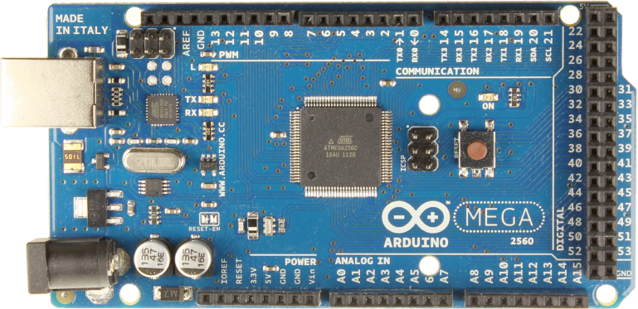

The Arduino Mega 2560 is a microcontroller board based on the ATmega2560. It has 54 digital input/output pins (of which 15 can be used as PWM outputs), 16 analog inputs, 4 UARTs (hardware serial ports), a 16 MHz crystal oscillator, a USB connection, a power jack, an ICSP header, and a reset button.

**3.2 NodeMCU:**

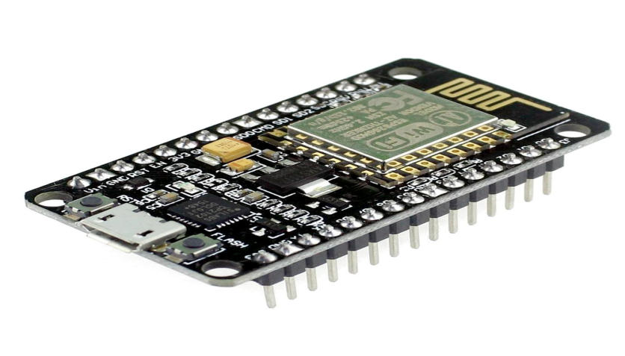

Type- 32bit microcontroller

Input- 17 GIPO pins

Power- 3.3V DC

**3.3**. **Infrared sensor:**

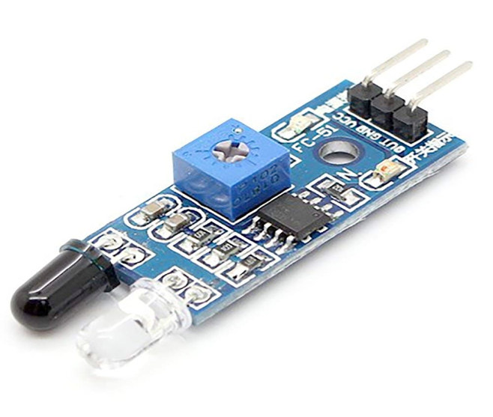

Operating voltage- 3.6 to 5V

Average current consumption- 0.06mA

Distance measuring range- 2 to 30cm

**3.4 Servo motor:**

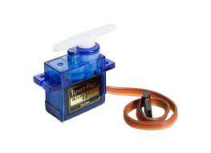

Stall torque- 1.8 kgf.cm

Operating speed- 0.1s/60 degree

Operating voltage- 4.8V(5V)

**3.5 LCD Display:**

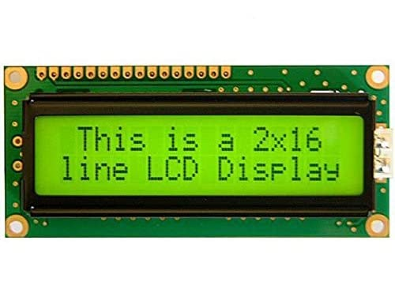

A 16x2 LCD means it can display 16 characters per line and there are 2 such lines. This 16x2 lcd display has the outline size of 80.0 x 36.0 mm and VA size of 66.0 x 16.0 mm and the maximum thickness is 13.2 mm. WH1602W 16x2 LCD Displays are built-in controller ST7066 or equivalent. It is optional for + 5.0 V or + 3.0 V power supply.

**CHAPTER - 04**

**HARDWARE IMPLEMENTATION**

**4.1 Methodology:**

Every parking slot in the given mall is identified with a unique Parking id. The User registers using either the app/website which prompts him to enter the Username and Password. Once he is registered, he is given a unique Customer id. This id is used every time he wants to book a parking slot. To book a parking slot he initially needs to select a destination of his choice. The available number of parking slots in that place will be displayed. One constraint we consider is that the user is allowed to book only when he is within 30 minutes from his arrival time.

Case 1: For parking in public areas

Case 2: For parking inside malls:

1. User didn’t arrive at the specified time
2. Cancelled before the time slot opens
3. Cancelled after the time slot opens

A smart parking system is an advanced solution that utilizes technology to efficiently manage parking spaces in a designated area. The system incorporates various components, including an Arduino board, NodeMCU for app updating, IR sensors, servo motors for gate movement, LEDs in each parking slot for indication, and a display to show the availability of empty and filled slots.

* The Arduino board acts as the central control unit of the system. It receives inputs from various sensors and controls the output devices accordingly.
* The NodeMCU is a small development board based on the ESP8266 Wi-Fi module. It allows for wireless communication and enables the updating of the associated mobile application.
* Infrared (IR) sensors are placed in each parking slot to detect the presence of a vehicle. These sensors emit and receive infrared light, and when a vehicle enters or leaves a parking spot, the interruption in the light beam triggers a signal. Servo motors are used to control the movement of the gates or barriers at the entry and exit points of the parking area. The Arduino board sends appropriate commands to the servo motors based on the vehicle's entry or exit.
* LED lights are installed in each parking slot to indicate its status. A green LED indicates an available slot, while a red LED indicates that the slot is occupied. The Arduino board controls the LEDs based on the inputs received from the IR sensors.
* A display, such as an LCD or LED screen, is used to provide real-time information on the availability of parking slots. It shows the number of empty and filled slots, allowing drivers to quickly identify available parking spaces.

**4.2 Block Diagram:**

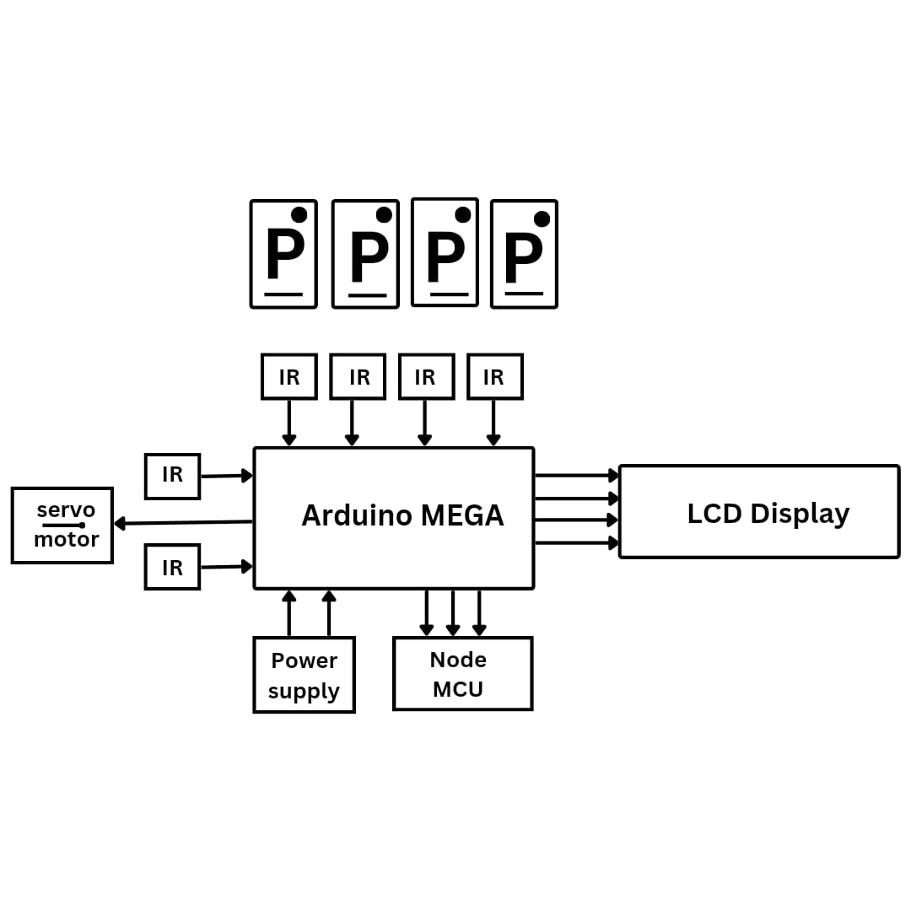

* **IR sensor**-For detecting empty slots and for gate motion
* **Servo motor** -Entry and exit gate operation
* **LCD display**-For display of empty slots
* **Nodemcu** -For wifi and app connectivity

**4.3 Circuit diagram:**

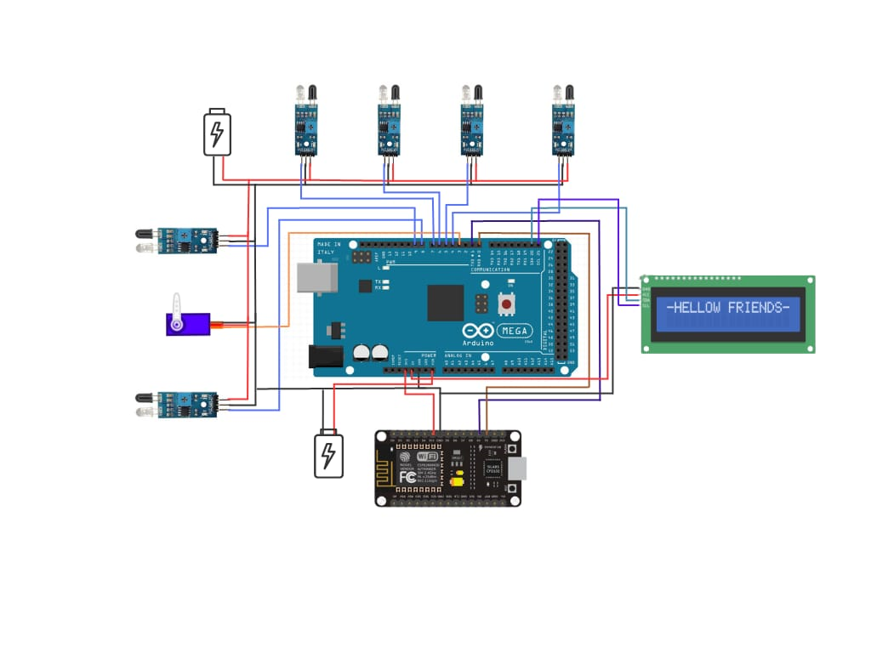

**IR Sensors for Servo Gate Movement**:

Place two IR sensors at appropriate positions to detect incoming and outgoing vehicles.When a vehicle approaches the entrance, the first IR sensor detects it and triggers the servo gate to open.After the vehicle passes, the second IR sensor detects it and triggers the servo gate to close.

**LCD Display to Show Empty and Filled Slots**:

Connect an LCD display to the circuit to show the status of parking slots (empty or filled).Use appropriate programming to update the LCD display based on the inputs received from the IR sensors in each slot.

* **IR Sensors in Every Slot**:

Install IR sensors in each parking slot to determine the availability of parking spaces.When a vehicle enters a parking slot, the IR sensor detects its presence and sends a signal to the microcontroller.

* **NodeMCU for App Connectivity:**

Use a NodeMCU (a development board based on the ESP8266 microcontroller) for wireless connectivity and communication with a mobile app.The NodeMCU connects to the internet via Wi-Fi and communicates with the mobile app using protocols such as HTTP or MQTT.

* **LEDs in Every Slot to Indicate Booking**:

Install LEDs in each parking slot to indicate whether the slot is booked or available.When a vehicle is booked for a specific slot through the mobile app, the LED in that slot turns on to indicate its reservation status.

* **Working of the Circuit:**

When a vehicle approaches the entrance, the first IR sensor detects it, triggering the servo gate to open.The vehicle proceeds to an available parking slot, and the corresponding IR sensor in that slot detects its presence, indicating the slot is occupied.The LCD display updates to show that the slot is filled, and the LED in that slot turns on to indicate its booking status.If all slots are occupied, the app connected to the NodeMCU will display that the parking is full.When the vehicle leaves the parking slot, the IR sensor detects its absence, marking the slot as available.The LCD display updates to show that the slot is empty, and the LED in that slot turns off to indicate its availability.The app connected to the NodeMCU reflects the availability of the slot.

**4.4 Program:**

#include <SoftwareSerial.h>

#include <Servo.h>

#include <Wire.h>

#include <LiquidCrystal_I2C.h>

LiquidCrystal_I2C lcd(0x27, 16, 2);

SoftwareSerial nodemcu(0,1);

Servo myservo;

#define led_slot1 10

#define led_slot2 11

#define led_slot3 12

#define led_slot4 13

#define ir_enter 8

#define ir_back 9

#define ir_car1 4

#define ir_car2 5

#define ir_car3 6

#define ir_car4 7

int S1=0, S2=0, S3=0, S4=0;

int flag1=0, flag2=0;

int slot = 4;

String sensor1;

String sensor2;

String sensor3;

String sensor4;

String cdata ="";

void setup(){

nodemcu.begin(9600);

Serial.begin(9600);

pinMode(ir_car1, INPUT);

pinMode(ir_car2, INPUT);

pinMode(ir_car3, INPUT);

pinMode(ir_car4, INPUT);

pinMode(ir_enter, INPUT);

pinMode(ir_back, INPUT);

pinMode(led_slot1, OUTPUT);

pinMode(led_slot2, OUTPUT);

pinMode(led_slot3, OUTPUT);

pinMode(led_slot4, OUTPUT);

myservo.attach(3);

myservo.write(180);

lcd.init();

lcd.backlight();

lcd.setCursor (0,0);

lcd.print(" Smart ");

lcd.setCursor (0,1);

lcd.print(" Parking ");

delay (2000);

lcd.clear();

Read_Sensor();

int total = S1+S2+S3+S4;

slot = slot-total;

}

void loop()

{

slot1();

slot2();

slot3();

slot4();

Read_Sensor();

cdata = cdata + sensor1 +"," + sensor2 + ","+ sensor3 +","+ sensor4 + ","; // comma will be used a delimeter

Serial.println(cdata);

nodemcu.println(cdata);

delay(10); // 100 milli seconds

cdata = "";

digitalWrite(ir_car1, HIGH);

digitalWrite(ir_car2, HIGH);

digitalWrite(ir_car3, HIGH);

digitalWrite(ir_car4, HIGH);

lcd.setCursor (0,0);

if(S1==1||led_slot1==HIGH){lcd.print("S1:Full");}

else{lcd.print("S1:Free");}

lcd.setCursor (9,0);

if(S2==1||led_slot2==HIGH){lcd.print("S2:Full");}

else{lcd.print("S2:Free");}

lcd.setCursor (0,1);

if(S3==1||led_slot3==HIGH){lcd.print("S3:Full");}

else{lcd.print("S3:Free");}

lcd.setCursor (9,1);

if(S4==1||led_slot4==HIGH){lcd.print("S4:Full");}

else{lcd.print("S4:Free");}

if(digitalRead (ir_enter) == 0 && flag1==0){

if(slot>0){flag1=1;

if(flag2==0){myservo.write(90); slot = slot-1;}

}else{

lcd.clear();

lcd.setCursor (0,0);

lcd.print(" Parking Full ");

delay(2000);

lcd.clear();

}

}

if(digitalRead (ir_back) == 0 && flag2==0){flag2=1;

if(flag1==0){myservo.write(90); slot = slot+1;}

}

if(flag1==1 && flag2==1){

delay (200);

myservo.write(180);

flag1=0, flag2=0;

}

delay(1);

}

void slot1() // parkng slot1

{

if( digitalRead(ir_car1) == LOW)

{

sensor1 = "255";

digitalWrite(led_slot1, HIGH);

delay(200);

}

if( digitalRead(ir_car1) == HIGH)

{

sensor1 = "0";

digitalWrite(led_slot1, LOW);

delay(200);

}

}

void slot2() // parking slot2

{

if( digitalRead(ir_car2) == LOW)

{

sensor2 = "255";

digitalWrite(led_slot2, HIGH);

delay(200);

}

if( digitalRead(ir_car2) == HIGH)

{

sensor2 = "0";

digitalWrite(led_slot2, LOW);

delay(200);

}

}

void slot3() // parking slot3

{

if( digitalRead(ir_car3) == LOW)

{

sensor3 = "255";

digitalWrite(led_slot3, HIGH);

delay(200);

}

if( digitalRead(ir_car3) == HIGH)

{

sensor3 = "0";

digitalWrite(led_slot3, LOW);

delay(200);

}

}

void slot4() // parking slot4

{

if( digitalRead(ir_car4) == LOW)

{

sensor4 = "255";

digitalWrite(led_slot4, HIGH);

delay(200);

}

if( digitalRead(ir_car4) == HIGH)

{

sensor4 = "0";

digitalWrite(led_slot4, LOW);

delay(200);

}

}

void Read_Sensor(){

S1=0, S2=0, S3=0, S4=0;

if(digitalRead(ir_car1) == 0){S1=1;}

if(digitalRead(ir_car2) == 0){S2=1;}

if(digitalRead(ir_car3) == 0){S3=1;}

if(digitalRead(ir_car4) == 0){S4=1;}

}

**4.4 Benefits :**

* Manages traffic well inside the malls without any havoc.
* Limited parking spaces can be utilized efficiently.
* Guides the drivers to the available vacant parking slots.
* It helps in managing parking space effectively which results in significant revenue generation.
* It plays an important role in making our environment pollution free by reducing the emission of CO, NO2 and CO2.

**CHAPTER – 05**

**RESULT AND DISCUSSION**

The results and discussion of a smart parking system can vary depending on the specific implementation and evaluation conducted. However, here are some general points that could be covered:

System Performance: The results section would typically include an assessment of the overall performance of the smart parking system. This could involve metrics such as parking occupancy rates, average parking duration, and vehicle turnover. It may also highlight any improvements or efficiencies achieved compared to traditional parking systems.

User Experience: The discussion might delve into the user experience of the smart parking system. This could include feedback from users regarding the convenience, ease of use, and reliability of the system. Any potential challenges or areas for improvement identified by users could be discussed as well.

Technology Evaluation: The results and discussion could address the effectiveness of the underlying technologies used in the smart parking system. This might involve evaluating the accuracy of vehicle detection and tracking mechanisms, the reliability of communication protocols, or the performance of sensor networks. The section could also highlight any technological limitations encountered and suggestions for future enhancements.

Traffic Optimization: If the smart parking system aimed to optimize traffic flow and reduce congestion, the results might include data on the impact of the system on overall traffic patterns.

This could involve analyzing traffic volume, travel times, and congestion levels in the vicinity of the parking facility. The discussion could explore the system's effectiveness in mitigating traffic-related issues.

Environmental Impact: If the smart parking system aimed to promote sustainability or reduce environmental impact, the results and discussion might examine the effects achieved. This could include evaluating reductions in carbon emissions, fuel consumption, or vehicle idling time due to improved parking efficiency.

Scalability and Cost Considerations: The discussion could touch upon the scalability of the smart parking system and its cost implications. It might explore how the system can be expanded to accommodate larger parking areas or increased user demand. Additionally, considerations regarding the initial setup costs, maintenance expenses, and potential cost savings in the long run could be addressed.

**Project Design**:

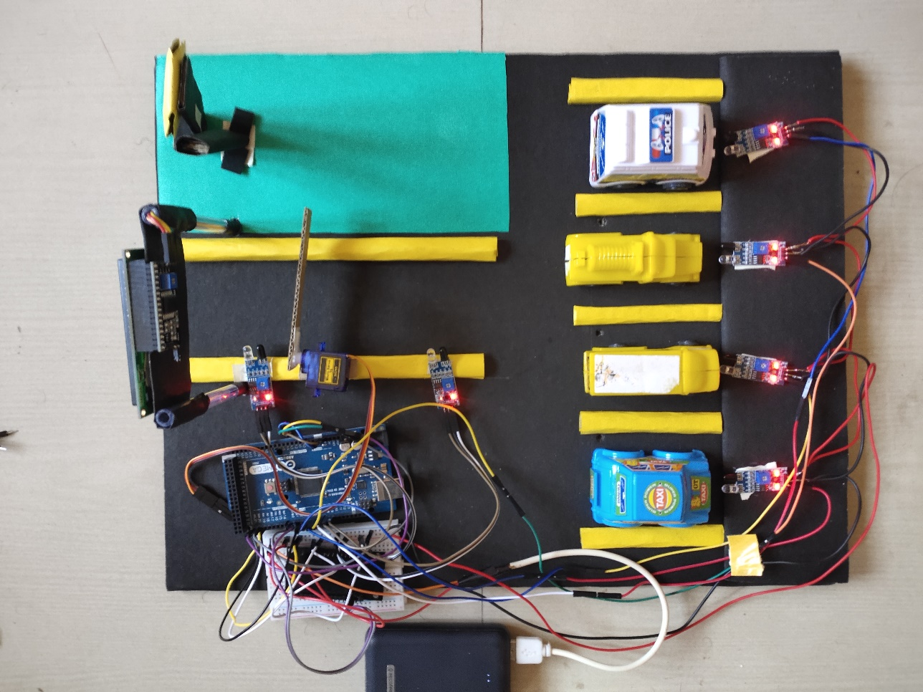

**CHAPTER – 06**

**CONCLUSION AND FUTURE SCOPE**

**6.1 Conclusion:**

* The smart parking system is an innovative solution that leverages technology to improve the efficiency and convenience of parking. By integrating sensors, data analysis, and communication technologies, it aims to address the challenges associated with parking, such as limited space, traffic congestion, and wasted time.

* Overall, the smart parking system offers several benefits. It helps drivers locate available parking spaces in real-time, reducing the time and effort spent searching for parking. This results in reduced traffic congestion, fuel consumption, and carbon emissions. Additionally, the system can optimize parking space utilization, maximizing the efficiency of parking facilities.

**6.2 Future Scope**

* Increased Efficiency: Smart parking systems will further enhance efficiency by utilizing real-time data and sensors to provide accurate information about available parking spaces. This will help drivers quickly locate and reserve parking spots, reducing traffic congestion and the time spent searching for parking.
* Predictive Analytics: By leveraging historical data and machine learning algorithms, smart parking systems can predict parking demand patterns and adjust availability accordingly. This predictive capability will help optimize parking space utilization and ensure efficient allocation of resources.
* Integration with Smart Cities: Smart parking systems will be integrated into broader smart city initiatives. By connecting with other urban infrastructure and systems, such as traffic management systems and public transportation, smart parking systems can contribute to creating more sustainable and efficient cities.
* Sustainability and Environmental Benefits: Smart parking systems can help reduce traffic congestion and vehicle emissions by efficiently guiding drivers to available parking spaces, minimizing the time spent circling around in search of parking. Additionally, integration with EV charging infrastructure will encourage the transition to cleaner transportation options.
* Enhanced User Experience: Future smart parking systems will focus on improving the user experience through mobile applications, intuitive interfaces, and personalized services. Features like mobile payments, parking reservations, and loyalty programs will provide convenience and enhance customer satisfaction.

**REFERENCES**

[1] Renuka R. and S. Dhanalakshmi “*Android Based Smart Parking System Using Slot Allocation and Reservation*”, ARPN Journal of Engineering and Applied Sciences - VOL. 10, NO. 7, APRIL 2015.

[2] Prathibha G, Mamatha K, Meenakshi HS, Roja K. “*Android Based Parking Booking System*”, International Journal of Innovative Research in Science, Engineering and Technology, Vol. 9, Issue 6, June 2020.

[3] Mehala Chandran, Nur Fadila Mahrom , Thennarasan Sabapathy, Muzammil Jusoh , Mohd Nasrun Osman, Mohd Najib Yasin , N.A.M Hambali , R.Jamaluddin , N.Ali , Yasmin Abdul Wahab, “*An Iot Based Smart Parking System*”, International Conference on Computer Science and Engineering, Journal of Physics: Conference Series, doi:10.1088/1742-6596/1339/1/ 012044, 2019.