The Game of Cricket
Source: http://news.bbc.co.uk/sportacademy/hi/sa/cricket/rules/the_basics Adapted by Cricket Ireland

The Aim
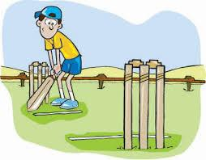

The aim of cricket is simple – score more runs than the other side.

Two teams, both with 11 players (there are sometimes less players in junior cricket), take it in turns to bat and bowl. When one team is batting, they try and score as many runs as they can by hitting the ball around a field.

The other team must get them out by bowling the ball overarm* at the stumps, which are at either end of a 22-yard area called a wicket.

The bowling team can get the batsmen out by hitting the stumps when bowling the ball, catching the ball when it’s hit in the air, running the batsman out, stumping, or LBW (leg before wicket; we won’t try and explain that here!).

Once the batting team is all out, the teams swap over and they then become the bowling side.

Each time a team bats it is known as their ‘innings’. Teams can have one or two innings depending on how long there is to play.

Test matches are over five days so teams have two innings each to score as many runs as they can.

Whoever scores the most runs wins. But a cricket match can be drawn too. That happens when the team bowling last fails to get all the batsmen out. But this is only when there are two innings per team.

If there is one innings, the only way a match can be drawn is if the two teams score the same amount of runs.

*The laws do allow you to bowl underarm (don’t ask an Australian about this!).
Law 24. 1(b) Underarm bowling shall not be permitted except by special agreement before the match. This law came into effect after the notorious ‘underarm controversy’ in 1981 between Australia and NZ.

The Players
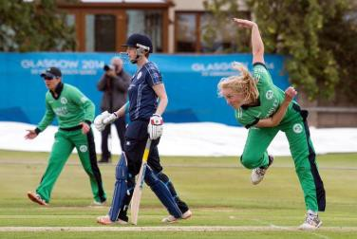

The fielding team have all 11 players on the field at the same time but there are only ever two batsmen.

Nine members of the fielding team can be positioned around the field depending on where the captain wants them.

The other two members of the team are the wicketkeeper and the bowler.

The bowler delivers the ball, overarm, at one of the batsmen who will try and hit the ball to score runs. One run is scored each time the batsmen ‘cross’ and reach the set of stumps at the other end of the pitch.

Four runs can be scored if the ball reaches the perimeter of the field and hits the ground before this, or six runs if the ball crosses the perimeter without bouncing (‘on the full’).

Although all 11 players have the chance to bat, the team are "all out" when 10 wickets have fallen as the "not out" batsman is left without a teammate at the other end of the wicket.

A team doesn't have to be all out for an innings to close. If a captain feels their team has scored enough runs, they can bring the innings to a close by making a "declaration".

Teams also have a "12th man" who acts as a substitute fielder if one of the first 11 is injured.

However, the 12th man (or woman) is not allowed to bat or bowl.

The Ball

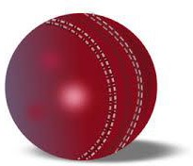

The inside of the cricket ball is made of cork while the outside is made of red or white (or even pink!) leather.

The leather is then stitched together around the centre and this area being called the seam.

This seam is slightly raised and it's this area that fast bowlers try to hit the pitch with when it bounces.

With a little help from the pitch, the angle of the delivery will (hopefully) change direction and cause lots of problems for the batsman.

Ever since coloured clothing was introduced in one-day matches, a white ball is used instead of a red one. And recently a pink ball has been introduced for Test matches where part of the game is played at night under floodlights (‘pink ball Tests’).

The Umpires
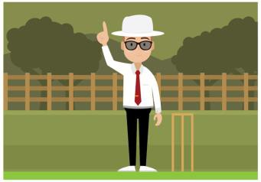

Two umpires officiate the game on the field of play, but at international level there’s also a third umpire on the sideline plus a match referee.

One umpire stands behind the stumps at the bowler's end of the pitch, while the other umpire stands at square leg.

The umpire at the bowler's end makes decisions on lbw decisions, no-balls, wides and leg byes. The square leg umpire will judge stumpings and run-outs.

When making a decision, the umpire should give the batsmen any benefit of doubt. This means that if an umpire is unsure about a decision, then the batsman should be given ‘not out’.

The umpires change position at the end of each over.

An umpire can only give a batsman out after an appeal from the fielding side.
If a batsman stands their ground and no appeal is made by the fielding side, then they shouldn't be given out by an umpire.

The umpires indicate no-balls, byes, leg-byes, wides, boundaries and sixes to the scorers, who keep a running total of the runs scored.

The third umpire uses replays to rule on run-outs, stumpings, whether a ball has hit the ground before being caught or when it's unclear if the ball has crossed the boundary or not.

However, the third umpire can only rule if the decision is referred to them by the umpires out on the pitch.

The match referee rules on disciplinary matters.

The Toss
Before the match starts, the two captains take part in a coin toss. The winning captain gets to decide whether his team will bat or field first.

The captain who wins the toss will take a number of factors into consideration, like the ‘state’ of the pitch, weather conditions, and the form of his side.

Play changes end after each over. An over is six deliveries bowled by one bowler.

When an over is completed, play switches to the other end and continues like this throughout the game.

The Duration
For a limited overs game (e.g. a one-day, 50-over game; or a T20, with 20 overs each innings), each side bats once.

For matches played over a number of days teams get to bat twice (depending on how the match goes).

Test matches are played over five days, while County Championship matches in England and State matches in Australia are played over four days.

Limited-over cricket involves both sides bowling the same amount of overs to score their runs from, with the winner being the team that scores the most.

In most first class competitions each side will receive up to 50 overs, but in schools and junior club cricket it can be a lot less.

However, if, for example, a team is bowled out after 40 overs in a 50-over match, the other team still has the full 50 overs in which to beat their score.

Play in Test matches is usually split into three two-hour sessions, although a minimum number of overs to be bowled in a day is also usually agreed between the sides before a series begins.

A 40-minute lunch break is taken between the first two sessions of a day's play, with 20 minutes being allowed for tea after the end of the second session.

Pitch & Weather Conditions
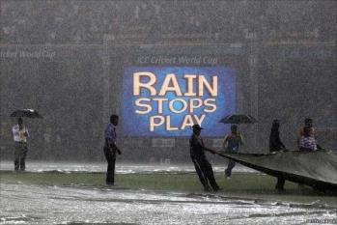

On a cloudy, humid day, the ball is more likely to move sideways (‘swing’) more through the air when bowled.

Those sort of conditions are most commonly found in cooler countries like England, New Zealand, and Ireland.

"Greener" wickets with more grass on and/or a damper surface are found in these countries and they help the quicker bowlers as they help movement off the seam.

The bowler will try and keep the seam of the ball in an upright a position so that it makes good contact with the wicket when it pitches.

When the ball hits the pitch, the seam will react with the ground and create "movement off the seam".

Drier pitches in places like India and Bangladesh are far more helpful to spin bowlers. The pace of these pitches is a lot slower, giving a spinning ball more time to grip and "turn off the pitch".

But on these surfaces the bounce of the ball is far more inconsistent. Play will be stopped if it rains or if there's bad light, which may make batting conditions dangerous.

Pitch size
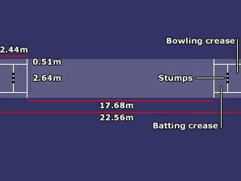

While playing fields and grounds will vary in size, the pitch is always a rectangular area of 22 yards in length and 10-foot in width.

The ‘popping’ (batting) crease is marked 1.22m in front of the stumps at either end, with the stumps set along the bowling crease.

The return creases are marked at right angles to the popping and bowling creases and are measured 1.32m either side of the middle stumps.

The two sets of wickets at opposite ends of the pitch stand 71.1cm high and three stumps measure 22.86 cm wide in total.

The stumps often made from willow and have two bails on top. The wicket is only broken if at least one bail is removed.

If a bowler hits the wicket with the ball without knocking a bail off, then the batsman is not out.

THE END OF THIS INNINGS

