ECOMMERCE Project Analysis Using HIVEQL In CLOUDXLAB
Steps for analyzing problems using HiveQL
- Access Cloudx Lab
- Open cloudxlab.com
- Click on MyLab
- Open Jupyter
- Upload Dataset
- Click on Upload button
- Upload data.csv from your local ECOMMERCE folder
- Load Data into HDFS
- Open webserver and enter your credentials (username and password)
- Create a directory in HDFS
>> hdfs dfs -mkdir -p /user/cloudxlabusername/project
- Load the file into HDFS
>> hdfs dfs -put data.csv /user/cloudxlabusername/project/
- Verify the file
>> hdfs dfs -ls /user/cloudxlabusername/project
- Work with HIVE
- Go to HIVE
>> hive
- Create Database
>> CREATE DATABASE project_db;
- Set the database
>> USE project_db;
- Create table
>> CREATE TABLE ecom_data (
InvoiceNo STRING,
StockCode STRING,
Description STRING,
Quantity INT,
InvoiceDate STRING,
UnitPrice DECIMAL(10, 2),
CustomerID INT,
Country STRING
)
ROW FORMAT DELIMITED
FIELDS TERMINATED BY ‘,’
STORED AS TEXTFILE
LOCATION ‘/user/cloudxlabusername/project’
TBLPROPERTIES (“skip.header.line.count”=”1”);

- Describe Table
>> DESC ecom_data;

- Store cleaned data into new table
>> CREATE TABLE ecom_clean as
SELECT
invoiceno STRING,
stockcode STRING,
description STRING,
quantity INT,
invoicedate STRING,
unitprice DECIMAL(10,2),
customerid INT,
country STRING
FROM ecom_raw
WHERE quantity > 0 and description IS NOT NULL
AND customerid IS NOT NULL
AND invoiceno IS NOT NULL;

- Apply optimizations for cleaned table
- Here we store it as ORC and apply partitions on columns(country, invoicedate, invoiceno) which has high cardinality
>> CREATE TABLE ecom_data (
stockcode STRING,
description STRING,
quantity INT,
unitprice DECIMAL(10,2),
customerid INT,
)
PARTITIONED BY (invoiceno STRING,
country STRING,
invoicedate STRING
)
STORED AS ORC;

- Enable hive properties
>> SET hive.exec.dynamic.partition = true;
>> SET hive.exec.dynamic.partition.mode = nonstrict;
>> SET hive.vectorized.execution.enabled = true;
>> SET hive.vectorized.execution.reduce.enabled = true;

Dynamic partitioning (hive.exec.dynamic.partition, hive.exec.dynamic.partition.mode) controls how Hive writes data into partitions when inserting.
Vectorized execution (hive.vectorized.execution.enabled, hive.vectorized.execution.reduce.enabled) controls how Hive reads/processes data in batches for faster query execution.

- Load data from cleaned table into optimized table
>> INSERT OVERWRITE TABLE ecom_data
PARTITION (invoiceno, country, invoicedate)
SELECT
invoiceno,
stockcode,
description,
quantity,
invoicedate,
unitprice,
customerid,
country
FROM ecom_clean;

UserStory1: Find the no.of customers in each invoice number.
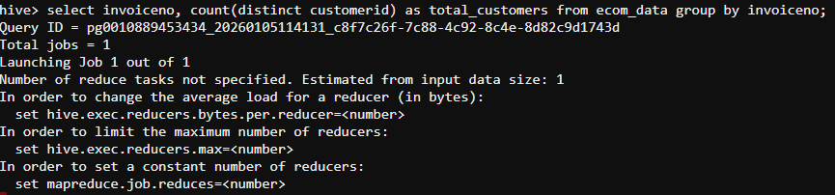
>> Partition by ‘Invoiceno’ for faster grouping

Output
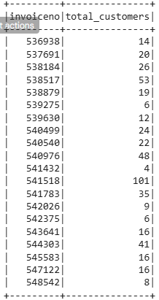

- UserStory2: Display the customerid, invoiceno, quantity in the country france.
>> works with orc
>> Partition pruning on ‘Country’
Output
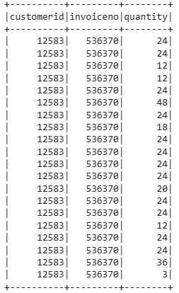
- UserStory3: Display the average quantity of each country.
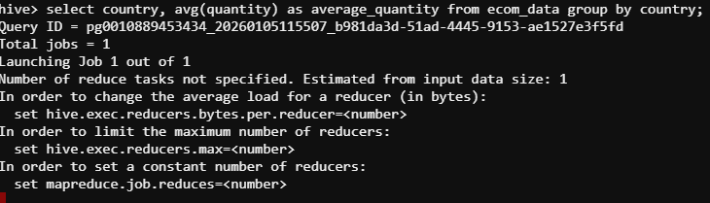
>> Used Partition by ‘Country’ with ORC format for efficiency
Output:
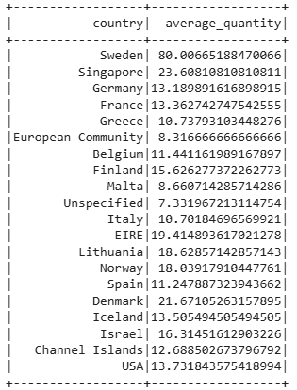
- Userstory4: Display the countries with unitprice greater than 50.
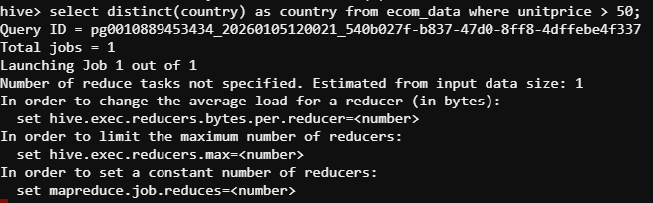
>> works with ORC
>>Here unitprice column has decimal datatype.
>> Decimal allows Hive’s vectorized operators to work efficiently.
Output:
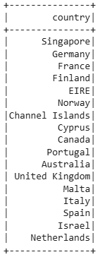

- Userstory5: Find the customerId who are from country United Kingdom and has Invoice date at July month
>> Partition by `InvoiceDate` (month) for faster filtering.
Output:
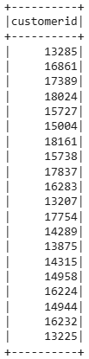
- Save results to HDFS
>> INSERT OVERWRITE DIRECTORY ‘/user/cloudxlabusername/otpt/prb1’
ROW FORMAT DELIMITED
FIELDS TERMINATED BY ‘,’
SELECT invoiceno, count(distinct customerid) as total_customers FROM ecom_data group by invoiceno;
- Move results to CloudxLab file system
>> hadoop fs -get /user/cloudxlabusername/otpt/prb1/0000_0 /home/cloudxlabusername/final_report.csv
- Download to Local System
- Open Jupyter in cloudxlab
- Navigate to home folder
- Find final_report.csv
- Click Download
- Reports
