**ABSTRACT**

Automatic retinal blood vessel segmentation algorithms provides useful information for the diagnosis and monitoring of eye diseases such as diabetic retinopathy, hypertension, glaucoma etc. Many of the methods in a variety of edge detection algorithms do not always lead to acceptable results in extracting various features in an image. Automatic retinal blood vessel segmentation algorithms provides useful information for the diagnosis and monitoring of eye diseases such as diabetic retinopathy, hypertension, glaucoma etc.

Many of the methods in a variety of edge detection algorithms do not always lead to acceptable results in extracting various features in an image. The concepts of matched filtering is used to detect piecewise linear segments of blood vessels in these images. Generally we construct different templates that are used to search for vessel segments along all possible directions. All these templates are combined to get a accurate segmented vessel structure. The concepts of matched filtering is used to detect piecewise linear segments of blood vessels in these images. Generally we construct different templates that are used to search for vessel segments along all possible directions. All these templates are combined to get a accurate segmented vessel structure

INTRODUCTION:

Vision is the most fundamental of human senses. The eye is a very complex and truly amazing organ. It is approximately one inch wide and deep, and 0.9 inches tall. Human eyes allow humans to appreciate all the beauty of the world they live in, to read and gain knowledge, and to communicate their thoughts and desires to each other through visual expression and visual arts. The human eye is wrapped in three layers of tissue: the external layer, formed by the sclera and cornea; the intermediate layer, divided into two parts: anterior (iris and culinary body) and posterior (choroid); and the internal layer, or the sensory part of the eye, the retina.

Cornea: the clear front window of the eye. The cornea transmits and focuses light into the eye Iris: the colored part of the eye. The iris helps regulate the amount of light that enters the eye. Lens: the transparent structure inside the eye that focuses light rays onto the retina.

Macula: a small area in the retina that contains special light-sensitive cells. The macula allows us to see fine details clearly. Optic Nerve: The nerve that connects the eye to the brain. The optic nerve carries the impulses formed by the retina to the brain, which interprets them as images. Pupil:the dark center in the middle of the iris. The pupil determines how much light is let into the eye. It changes sizes to accommodate for the amount of light that is available. Retina:the nerve layer that lines the back of the eye. The retina senses light and creates impulses that are sent through the optic nerve to the brain.

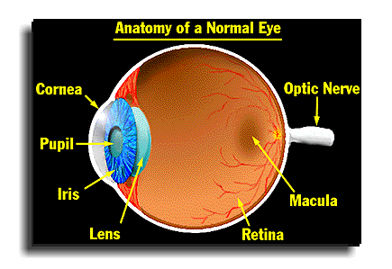

Fig * human eye

Fundus photography involves capturing a photograph of the back of the eye i.e. [fundus](https://en.wikipedia.org/wiki/Fundus_(eye)). Specialized fundus cameras that consist of an intricate microscope attached to a flash enabled camera are used in fundus photography. The main structures that can be visualized on a fundus photo are the central and peripheral [retina](https://en.wikipedia.org/wiki/Retina), [optic disc](https://en.wikipedia.org/wiki/Optic_disc) and [macula](https://en.wikipedia.org/wiki/Macula_of_retina).

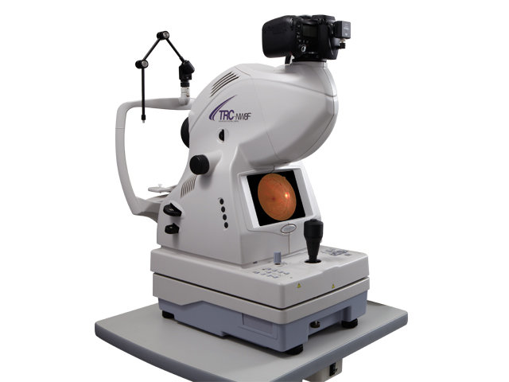

Fig fundus camera

Retina is the tissue lining the interior surface of the eye which contains the light-sensitive cells (photoreceptors). Photoreceptors convert light into neural signals that are carried to the brain through the optic nerves. In order to record the condition of the retina, an image of the retina (fundus image) can be obtained. A fundus camera system (retinal microscope) is usually used for capturing retinal images. Retinal image contains essential diagnostic information which assists in determining whether the retina is healthy or unhealthy. Retinal images have been widely used for diagnosing vascular and non-vascular pathology in medical society. Retinal images provide information on the changes in retinal vascular structure, which are common in diseases such as diabetes, occlusion, glaucoma, hypertension, cardiovascular disease and stroke.

These diseases usually change reflectivity, tortuosity, and patterns of blood vessels .For example, hypertension changes the branching angle or tortuosity of vessels and diabetic retinopathy can lead to neovascularization i.e., development of new blood vessels. If left untreated, these medical conditions can cause sight degradation or even blindness. The early exposure of these changes is important for taking preventive measure and hence, the major vision loss can be prevented

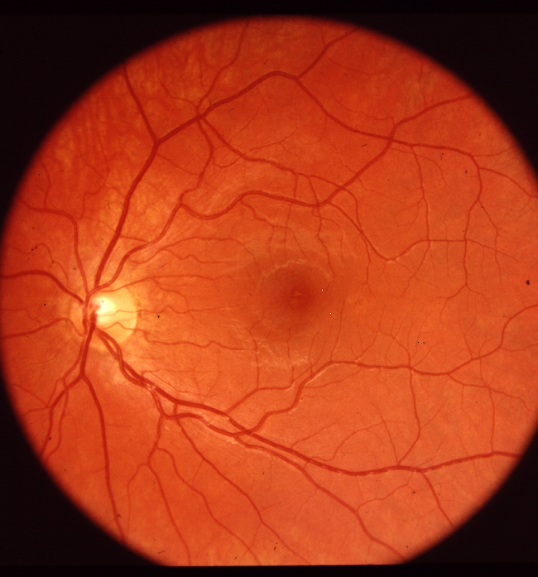

Fig * fundus image

Automatic segmentation of retinal blood vessels from retinal images would be a powerful tool for medical diagnostics. For this purpose, the segmentation method used should be as accurate and reliable as possible. The main aim of segmentation is to differentiate an object of interest and the background from an image.

SCOPE OF THE PROJECT:

The aim of this project is Automatic Segmentation of retinal blood vessels from retinal images using Matched Filter would be a powerful tool for medical diagnostics. Thus, automated segmentation is valuable as it decreases the time and effort required.

The algorithms for retinal blood vessel segmentation concentrate on automatic detection related to diabetic retinopathy, which is found to be major cause of blindness in recent years.

Organization of this report:

Chapter 1:Here structure of the human eye, introduction about the fundus images are covered. And the scope of this project also discussed.

Chapter 2: a brief discussion about the literature survey.

Chapter 3: it involves the methodologies proposed and the flowchart of the steps used to detect the blood vessels

Chapter 4: it contains the introduction about the matched filter and implementation of the algorithm and the applications of the matched filter.

Chapter 5:

Chapter 6:

Literature survey:

Subhasis chaudhury,shankar chatterjee,Norman katz and Mark nelson "Detection of blood vessels in retinal images using two dimensional matched filters" year 1989.-

In this paper, the concept of matched filter detection of signals is used to detect piece wise linear segments of blood vessels in these images. 12 different templates are constructed that are used to search vessel segments along all possible directions. Template matching algorithm offers the advantage of ease of implementation on specialized high speed hardware as well as the possibility for parallel computations. Unlike edge detection algorithms, this method extracts blood vessels as a whole. Matched filter detection method is applicable only to stationary processes. Usually a prepossessing step is performed in which the local mean is subtracted from the image and then pixel intensities are divided by the square root of local variances to approximate image as a stationary process.

2.Jan odstrcilik, Radim kolar, Attila budai, joachim hornegger, Jiri Jan "Retinal vessel segmentation by improved matched filtering",year 2012-2013: evaluation on a new high resolution fundus image database. In this paper, the proposed method utilizes MF and minimum error thresholding technique to extract binary blood vessel tree. The 2D MF used locally exploits the correlation between local image areas and 2D masks developed according to the appearance of typical blood vessel segments of different widths(diameter) and orientations. DRIVE and STARE databases were included in the analysis in order to compare the proposed methods with state-of-the-art methods. Besides that new retinal database of high resolution fundus images of healthy subjects and subjects affected by DR and glaucoma are presented, corresponding gold standard images were created for each fundus image in the database by manual labelling of the blood vessel tree.

3]Anil Maharjan, School of Computing Computer Science, university of eastern finland, Joensuu “blood vessel segmentation from retinal images” June 2016

In this thesis, the literatures regarding different methods for retinal blood vessel segmentation were studied and the three state-of-the-art methods from three different categories (i.e. supervised, unsupervised, and match filtering methods) were selected based on their good performance results as published in the literature. Among the three state-of-the-art methods, the literature related to the supervised method and matched filtering based method are well documented, which made the implementation process easier. Whereas the unsupervised method is relatively poorly documented, so other similar kind of literature was taken into consideration for studying and implementing the algorithm.

Matched filter:

In signal processing, a matched filter is obtained by correlating a known signal, or template, with an unknown signal to detect the presence of the template in the unknown signal. This is equivalent to convolving the unknown signal with a conjugated time-reversed version of the template. The matched filter is the optimal linear filter for maximizing the signal-to-noise ratio (SNR) in the presence of additive stochastic noise. Matched filters are commonly used in radar, in which a known signal is sent out, and the reflected signal is examined for common elements of the out-going signal. Pulse compression is an example of matched filtering. It is so called because impulse response is matched to input pulse signals. Two-dimensional matched filters are commonly used in image processing, e.g., to improve SNR for X-ray. Matched filtering is a demodulation technique with LTI (linear time invariant) filters to maximize SNR. it was originally also known as a North filter.   Retinal blood vessels possess three different characteristics:

1. The blood vessels have small curvatures and may be approximated by piecewise linear segmentation.
2. The width of blood vessel decreases when moving away from the optic disk.
3. Due to lower reflectance of vessels in comparison to other retinal structures, they seem to be darker compared to the background.

Using matched filtering, image’s features can be detected, which are most similar to a predefined template (which we term as KERNEL). Matched filter (MF) has ability to respond to both the vessels’ and non-vessels’ edges. A retinal image is convolved individually by each of the 12 kernels with different orientations and, from the set of these 12 output images, the maximum value for each pixel (x,y) is selected to form the matched filter response image

The two dimensional matched filter kernel in a discrete grid is designed as follows. Let p=[x, y] be a discrete point in the kernel and Ꝋi be the orientation of the ith kernel matched to a vessel at an angle Ꝋi . In order to compute the weighting coefficients for the kernel, it is assumed to be centered about the origin.

The rotation matrix is given by

and the corresponding point in the rotated coordinate system is given by pi= [u v] = pri .Assuming an angular resolution of 150 ,we need 12 different kernels to span all possible orientations set of 12 such kernels is applied to a fundus image and at each pixel only the maximum of their responses is retained. A Gaussian curve has infinitely long double sided trails. We truncate the trail at u=±3σ .A neighborhood N is defined such that N= {(u ,v)| |u| ≤ 3σ , |v| ≤ L/2} .

The corresponding weights in the kernel are given by

Ki(x, y) = -exp(-u2 / 2σ2) ꓯp1 N.

If A denotes the number of points in N, the mean value of the kernel is determined as

/ A

Thus, the convolutional mask used in this algorithm is given by

Ki`(x, y)= Ki(x, y) – mi ꓯ pi  N

Because of the hardware design of the image processing system, the weighting coefficients in the kernel need to be integers in the range (-128, 127). The coefficients are each multiplied by a scale factor of 10 and truncated to their nearest integer. A higher scale factor would increase the accuracy, but might lead to buffer overflow. Due to the truncation errors, the mean value of the kernel may not be exactly equal to zero. Kernels, for which the mean value is positive, are forced to have slightly negative mean values in order to reduce the effect of background noise where no blood vessel is present. Two such kernels for two different angles are given in figure.

**CURRENT METHODOLOGIES:**

There are several techniques for blood vessel segmentation and diagnosis of diseases related to retina. Different authors have categorized those methods in different way.

In, the authors divided the retinal vessel segmentation into seven main categories;

1. pattern recognition techniques
2. matched filtering,
3. mathematical morphology,
4. multi-scale approaches,
5. vessel tracking,
6. model based approaches,
7. Parallel/hardware based approaches.

Pattern recognition deals with classification of retinal blood vessels and non-vessels together with background, based on key features. This approach has two methods;

1. supervised and
2. Unsupervised.

If a priori information is used to determine a pixel as a vessel or not, then that method is super-vised, otherwise it is unsupervised method. Matched filtering uses convolution of two dimensional kernels, which is designed to model a feature at some position and orientation, with the retinal image and detect vessels by maximizing the responses of kernels used [2, 4]. Mathematical morphology deals with the mathematical theory of representing shapes like features, boundaries, etc. using sets.

Mainly two morphological operators; erosion and dilution, are used for applying structuring element to the images. The idea behind multi-scale approach is to use the vessel’s width to determine blood vessels having varying width at different scales.

Many of the multi-scale algorithms are based on the vessel enhancement filters. Vessel tracking method segments a vessel between two points by identifying vessel center line rather than entire vessels at once. In this method, the tracing of the vessel, which seems like a line, is done by using local information and by following vessel edges. Parallel hardware based approach is mainly for fast and real time performance, and implementation is done in hardware chips. The implementation of this approach for real time image processing is done in VLSI chip by representing cellular neural network

Based on the classification method, pattern recognition can be either supervised or unsupervised. Supervised classification is the procedure in which user interaction is required: user defines the decision rules for each class/pixels or provides training data for each class/pixels to guide the classification. It uses supervised learning algorithm for creating a classifier, based on training data from different object classes. The input data are provided to the classifier, which assigns the appropriate label for each input. Whereas unsupervised method attempts to identify the patterns or clusters from the input dataset without predefined classification rules. It learns and organizes information on its own to find the proper solution

PROPOSED METHODOLOGY:

Extract all three

color channels

Final output

Apply xnor between above output and channel filtering image

Apply xor between R & B channel filtering image

Apply matched filtering on all three channel images

IMAGE INPUT:

Here the input fundus image is actually obtained from the fundus camera for the detection of retinal blood vessels.The blood vessels have small curvatures and may be approximated by piecewise linear segmentation. The width of blood vessel decreases when moving away from the optic disk. Due to lower reflectance of vessels in comparison to other retinal structures, they seem to be darker compared to the background. certain same images were collected from the database available.

THR ORIGINAL FUNDUS RETINAL IMAGES:



Fig :input retinal fundus image

Extraction of all three channel:

A coloured(RGB) image is a combination of red, green and blue light which are added together in various ways reproducing a broad array of colors. One can extract any channel from the RGB image. Prominently green channel image is profound in providing a contrast between the vessels and the background of the vessels. Extraction of all the three channel images will help in analyzing the contrast between the vessels and the vessel background at different levels. All these three channel images are considered for the further processing.

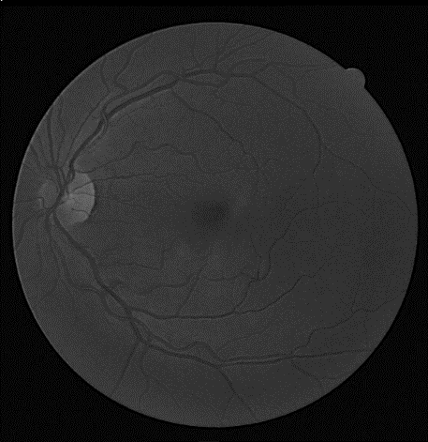

Exctracted blue channel

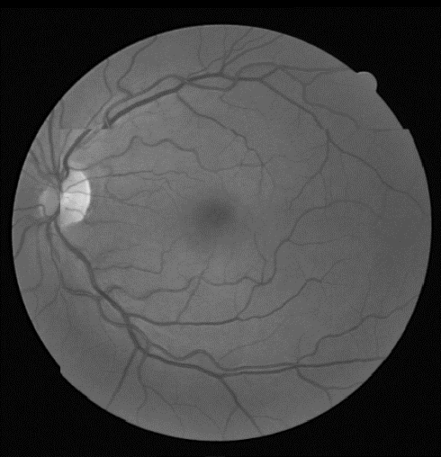

Exctracted green channel:

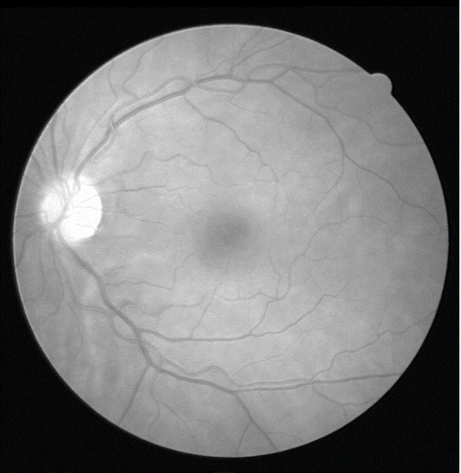

Exctracted red channel

APPLY MATCHED FILTER TO ALL CHANNEL :

Matched filter (MF) is the most widely used template matching algorithm for retina vessel segmentation. It was first proposed by Chaudhuri et al. [[16]](http://www.sciencedirect.com/science/article/pii/S111086651500033X#b0080). Here, we used the prior assumption that the cross section of the vessels can be approximated by a Gaussian function.

The Gaussian MF is defined as

equation(1)

View the MathML source

[Turn MathJaxon](javascript:void(0);)

http://www.sciencedirect.com/sd/blank.gif

*σ* is the scale of the filter.

*L* is the length of the vessel segment directed in one direction which is assumed as piecewise linear.

Kernel, *k*(*x*, *y*) is rotated in different orientations to detect the vessels in different orientations and (*x*, *y*) is the coordinate of each element in kernel. The matched filter above is valid only for a segment of the vessels of certain Gaussian width. This filter must have different values of  *σ* to act as a matched filter for different widths of the vessels lying along the y-axis. For vessels other than along the y-axis, the filter above needs to be rotated to act as a matched filter for vessels with different orientations. In our simulation, we used only one value of *σ* but rotated the filter from 0° to 180° . The application of matched filtering with these orientations shows vessel enhancement for a particular orientation of the filter. Then the maximum value of the pixels is retained. The resultant image gives a vessels enhanced version of the retinal image.

Kernel image

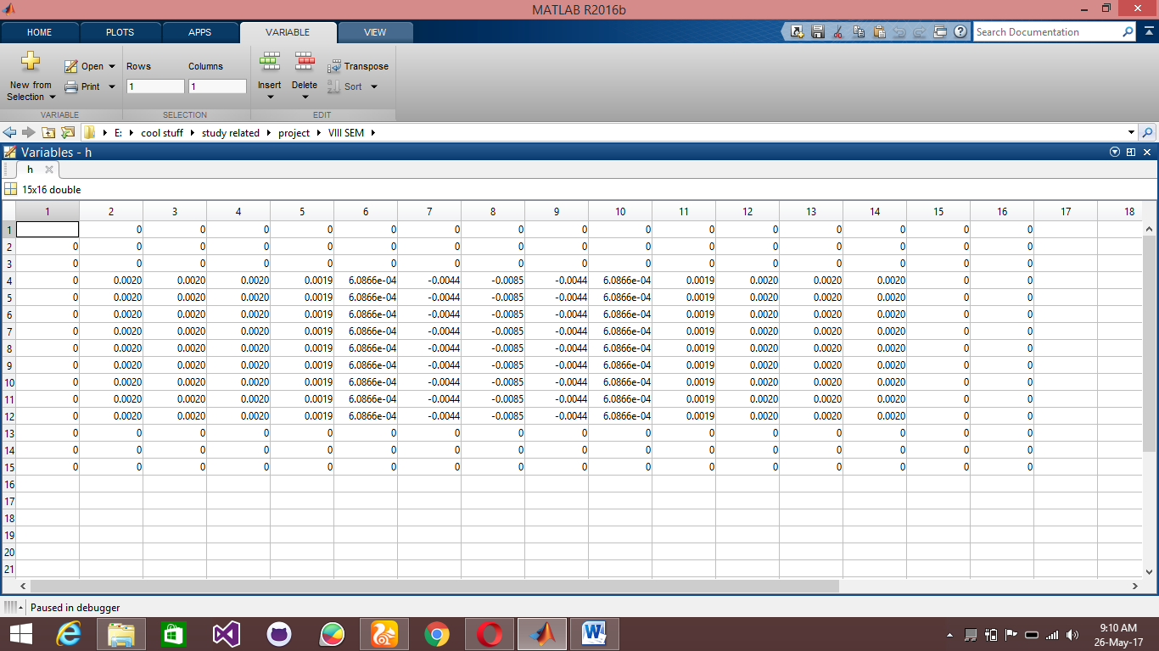

table kernel matrix

**Threshloding**

In order to get the coordinates of the blood vessels we need to threshold the image obtained after the matched filtering. The selection of an adequate threshold of the grey-level for extracting objects of interest from background is very important. Most of the methods used to threshold the image automatically were based on the image histogram. In the ideal case the histogram for the image should be bimodal. The two peaks represent the background and the foreground. Ideally there is a deep and sharp valley between these two peaks, but practically, for most grey-level images, it is difficult to detect the exact valley bottom precisely, especially when two peaks are unequal in height producing no trace of a valley. If the image histogram is unimodal, such methods do not work. The algorithm used here for automatic thresholding is called OTSU [[18](https://www.hindawi.com/journals/jme/2013/408120/#B18)]. This method is based on discriminant analysis. In this method threshold operation is regarded as the partitioning of the pixels of an image into two classes.

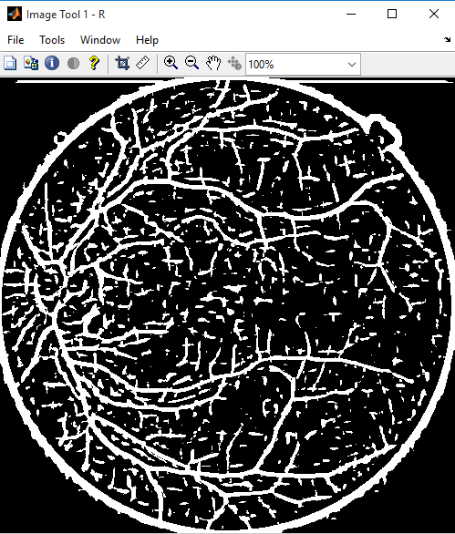 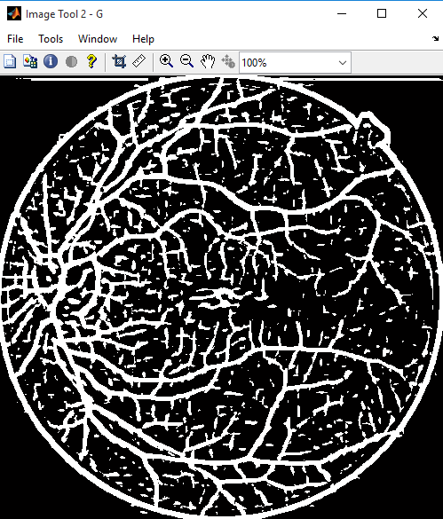 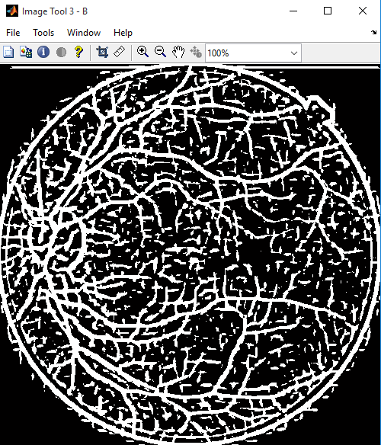

a)red channel b)green channel c)blue channel

APPLY XOR BETWEEN R & B CHANNEL FILTERING IMAGES:

XOR operation is carried out between all the three channels to retain the common elements in all of them.

This is the output obtained from R(Red) channel

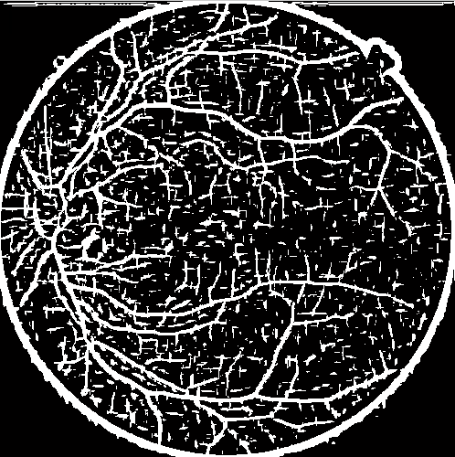

This is the output obtained from B(blue) channel:

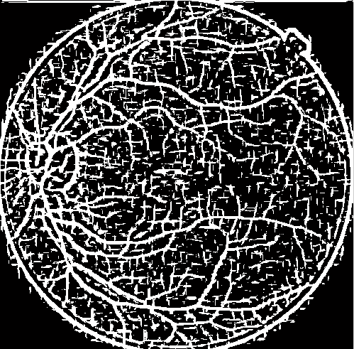

This is the output obtained from Green channel. This channel is characterized by better contrast between the background and blood vessels on comparison with other two channels. Hence this output is further carried for an XNOR operation with the result of XOR between Red & Blue channels.

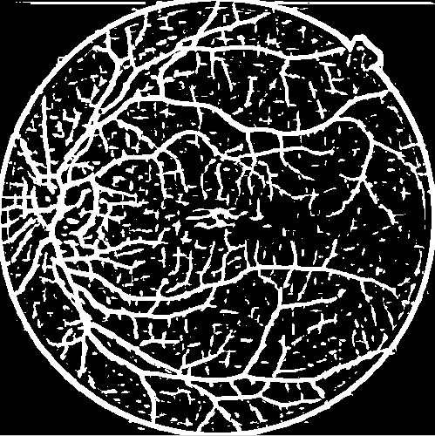

|  |  |  |
| --- | --- | --- |
| A | B | OUTPUT |
| 0 | 0 | 0 |
| 0 | 1 | 1 |
| 1 | 0 | 1 |
| 1 | 1 | 0 |

Table truth table of xor

APPLY XNOR BETWEEN OUTPUT OBTAINED FROM R(RED) AND B(BLUE) CHANNEL WITH G(GREEN) CHANNEL

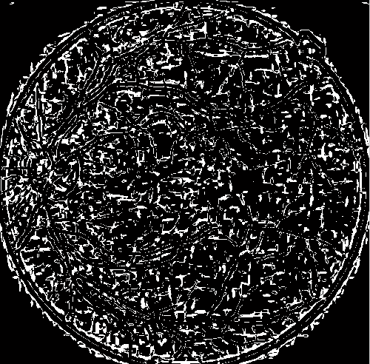

Initially obtain the R channel output and B channel output of Original image then apply XOR between those channel in order to obtained desired segmentation of blood vessel.



Green channel output

After obtaining the G green channel output of original image. Then, finally apply the XNOR between output of R and B with obtained green channel output is as shown in below fig

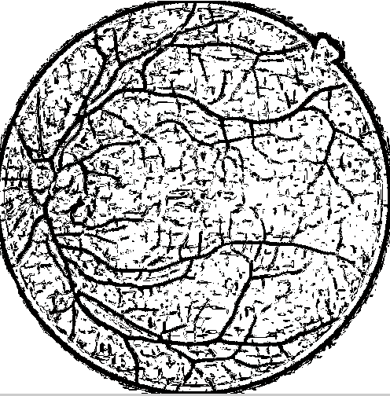

|  |  |  |
| --- | --- | --- |
| A | B | OUTPUT |
| 0 | 0 | 1 |
| 0 | 1 | 0 |
| 1 | 0 | 0 |
| 1 | 1 | 1 |

Table truth table of xnor

result and conclusion:

Using matched filtering, image’s features are detected, which are most similar to a predefined template (which we term as KERNEL).

Matched filter (MF) has ability to respond to both the vessels’ and non-vessels’ edges. Here we can see the segmented vessels out of the given RGB fundus image.

OUTPUT :



CONCLUSION:

The algorithms have the capability of differentiating vessels from background from fundus images but only to a certain extent. As the manual segmentation of blood vessels is hard and time consuming, fast and automated system which could detect higher amount of blood vessels was employed. Besides saving time, it could decrease the number of experts required and increase the ability to segment large numbers of fundus images in a short period of time. Since the currently implemented algorithms have relatively low correctly classified vessel rates, they are not feasible for implementation into automatized system. Although the accuracy rate of algorithms is reasonable, improvement in the true vessel and background detection should be done. Hence, the automated vessel detection system is not fully trustworthy with the results being achieved.

There are few areas for improving algorithms’ performance. For the evaluation of algorithms, many other available image databases could be included. The noise in fundus image usually lowers the overall results, if it is not handled properly. Hence, other preprocessing and post-processing strategies could be included along with the existing ones in order to improve the overall performance results. The study of these subjects is considered to be important for the future research. The propose scheme retains the computational simplicity of the enhancement / thresholding type of edge operator and at the same time incorporates the advantages of using the model based edge detector based on the large size of the convolution kernel. It may take long time to run this algorithm on an ordinary commuter. However, this operators can be efficiently implemented in may machine vision systems having special hardware support for real time convolution operation.

FUTURE WORK:

1. Presently the matched filter detection method is applicable only to stationary process. Usually the pre-processing step is performed in which the local mean is subtracted from the image and then the pixel intensities are divided by the square root of the local variances to approximate the image as a stationary process. This pre-processing step may be omitted as the qualitative improvement. Future work proposes to introduce vessel morphology to improve the vessel segmentation results for achieving improved performances.
2. Investigate the use of more robust segmentation techniques for the detection of both large and thin vessels in retinal images.
3. The future insight includes applying enhanced post-processing techniques to achieve the better results for the segmented image.
4. In the future work detection of combined together, to develop a software package, that accepts retinal color fundus image as input and provide a set of numerical indices as output that describes the current status of the vessel morphology vessel tortuosity, branching angle, branching coefficient, vessel width, and fractal dimensions
5. Histogram equalization is performed to improve the image quality and to improve the contrast. Instead of using normal histogram equalization, adaptive histogram equalization is used since it operates on small regions in the original image

MATLAB CODE:

%browse and select the input image from the filesystem

[fn pn]=uigetfile('*.jpeg;*.jpg;*.tiff','select image');

im = sprintf('%s%s',pn,fn);

I = imread(im);%reading the original image

%extraction of all the three channels of the RGB image

ired = I(:,:,1)

igreen = I(:,:,2)

iblue = I(:,:,3)

mtool(ired)

imtool(iblue)

imtool(igreen)

imtool(I)

%image is being resized

P=imresize(I, [384 365])

ima = im2double(P)

imtool(ima)

%conversion to grey scale

ima2gray=rgb2gray(ima)

imhist(ima2gray)

imtool(ima2gray)

s = 1.5;

y = [-6: 6];

%applying matched filter function to all three channel images

G = getVasculatureMatchedFilterResponse(igreen, y, s)

R = getVasculatureMatchedFilterResponse(ired, y, s)

B = getVasculatureMatchedFilterResponse(iblue, y, s)

imtool(R)

imtool(G)

imtool(B)

tim=xor(R,B)

final=~xor(tim,G)

imtool(tim)

imtool(final)

function used:

function vasculature = getVasculatureMatchedFilterResponse(img, x, sa)

%GETVASCULATUREMATCHEDFILTERESPONSE: The vessel profile is assumed to be an

%inverted gaussian described by x and sa. The maximum response for the

%image for all possible rotations is noted. The matched filter image is

%then binarized using OTSU's method.

%

% Input: Colour Fundus Image img, vessel profile width x, standard deviation sa?

% Output: Vessel segmented binary image

% Parameters: x, sa

grayImg =img;

%sa = 0.5;

%x = [-6: 6];

%x = -x:x;

size_x = size(x,2);

tmp1 = exp(-(x.*x)/(2*sa*sa)); %probability equation of matched filter

tmp1 = max(tmp1)-tmp1;

ht1 = repmat(tmp1,9,1); %replication of the matrix

sht1 = sum(ht1(:));

mean1 = sht1/(size_x*9);

ht1 = ht1 - mean1;

ht1 = ht1./sht1;

h = zeros(15,size_x+3);

for i = 1:9

for j = 1:size_x

h(i+3,j+1) = ht1(i,j);

end

end

ROTATION_ANGLE = 90;

NUM_ROTATIONS = 4;

for k=1:NUM_ROTATIONS

if(k==1)

curr = conv2(double(grayImg),h, 'same');

rt = curr;

continue;

end

h = imrotate(h,ROTATION_ANGLE,'bicubic','crop');

curr = conv2(double(grayImg), h, 'same');

curr = max (rt,curr);

end

%Otsu’s thresholding over the output

mn=mean(mean(curr));

vasculature = im2bw(curr,mn);

end

References:

(1)Jan Odstrcilik, Radim Kolar1,2, Attila Budai3, Joachim Hornegger3, Jiri Jan1, Jiri Gazarek1, Tomas Kubena4, Pavel Cernosek4, Ondrej Svoboda1, Elli Angelopoulou3, "Retinal vessel segmentation by improved matched filtering: evaluation on a new high-resolution fundus image database"

(2) Anil Maharjan, "Blood Vessel Segmentation from Retinal Images"

(3) Carmen Alina Lupas¸cu, Domenico Tegolo, and Emanuele Trucco , "FABC: Retinal Vessel Segmentation Using AdaBoost"

(4) M.M. Fraza,*, S.A. Barmana, P. Remagninoa, A. Hoppea, A. Basitb,

B. Uyyanonvarac, A.R. Rudnickad, C.G. Owend , "An approach to localize the retinal blood vessels using bit planes and centerline detection"

(5) Carmen Alina Lupas¸cu1, Domenico Tegolo1, and Emanuele Trucco2, "A Comparative Study on Feature Selection for Retinal Vessel Segmentation Using FABC"

(6) Kanika Verma, Prakash Deep and A. G. Ramakrishnan, Senior Member, IEEE, "Detection and Classification of Diabetic Retinopathy using Retinal Images"

(7) Anil Maharjan, "Thesis for vessel segmentation" (8) Rafael C. Gonzalez,Richard E. Woods, Steven L.Eddins,Second edition, "Digital Image Processing Using MATLAB” (9) K.Jeyasri, P.Subathra, K.Annaram, "Detection of Retinal Blood Vessels for Disease Diagnosis"

(10) Gutana Sukkaew, "Automatic Blood Vessels Detection of the Retinal Image of Premature Infant"

(11) M. Niemeijer, J. Staala, B. van Ginnekena, M. Looga and M.D. Abr`amoff, "Comparative study of retinal vessel segmentation methods on a new publicly available database". (12)A. Hoover, V. Kouznetsova, and M. Goldbaum, “Locating blood vessels in retinal images by piecewise threshold probing of a matched filter response,” IEEE Transactions on Medical Imaging 19(3), pp. 203–210 (13) S. Chaudhuri, S. Chatterjee, N. Katz, M. Nelson, and M. Goldbaum, “Detection of blood vessels in retinal images using two-dimensional matched filters,” IEEE Transactions on Medical Imaging 8(3), pp. 263–269, 1989. (14) F. Zana and J. Klein, “Segmentation of vessel-like patterns using mathematical morphology and curvature evaluation,” IEEE Transactions on Image Processing 10(7), pp. 1010–1019, 2001. (15) Ciulla, T.A., Regillo, C.D., Harris, A.H.: ‘Retina and optic nerve imaging’ (Lippincott Williams and Wilkins, 2003), pp. 369.

(16) Bock, R., Meier, J., Nyúl, L.G., Hornegger, J., Michelson, G.: ‘Glaucoma risk index: automated glaucoma detection from color fundus images’, Med. Image Anal., 2010, 14, (3), pp. 471–481 (17)Calvo, D., Ortega, M., Penedo, G.M., Rouco, J.: ‘Automatic detection and characterization of retinal vessel tree bifurcations and crossovers in eye fundus images’, Comput. Methods Programs Biomed.,, 103, (1), pp. 23–38 ,2011 (18)Odstrcilik, J., Jan, J., Kolar, R., Gazarek, J.: ‘Improvement of vessel segmentation by matched filtering in colour retinal images’. Proc. World Congress on Med. Physics and Biomed. Eng., Munich, Germany, September 2009, pp. 327–330

(19) C. Sinthanayothin, J.F. Boyce, H.L. Cook, T.H. Williamson, Automated localisation of the optic disc, fovea, and retinal blood vessels from digital colour fundus images, British Journal of Ophthalmology 83 (1999) 902–910.

(20)Soares, V.J., Leandro, J.J., Cesar, R.M.J., Jelinek, F.H., Cree, M.J.: Retinal vessel segmentation using the 2-d gabor wavelet and supervised classification. IEEE Transactions on Medical Imaging 25(9), 1214–1222 (2006)

[21] J.V.B. Soares, J.J.G. Leandro, R.M. Cesar-Jr., H.F. Jelinek, and M.J. Cree, “Retinal vesselsegmentation using the 2-d gabor wavelet and supervised classification,” IEEE Trans. On Medical Imaging, vol. 25, pp. 1214–1222, 2006

[22] M. Niemeijer, J.J. Staal, B. van Ginneken, M. Loog, and M.D. Abramoff, “Comparative studyof retinal vessel segmentation methods on a new publicly available database”, SPIE Medical Imaging, vol. 5370, pp. 648-656, 2004.

[23] M. Martínez-Pérez, A. Hughes, A. Stanton, S. Thom, A. Bharath, and K. Parker, “Scale-spaceanalysis for the characterisation of retinal blood vessels,” Medical Image Computing andComputer-Assisted Intervention, pp. 90–97, 1999