For Data Entry

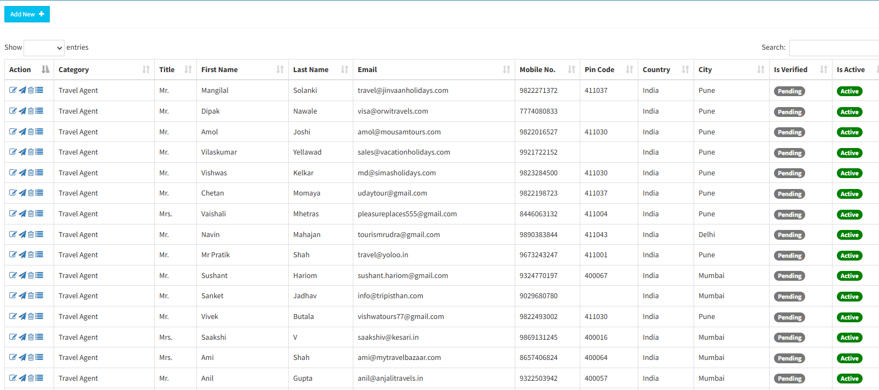
Entry Form
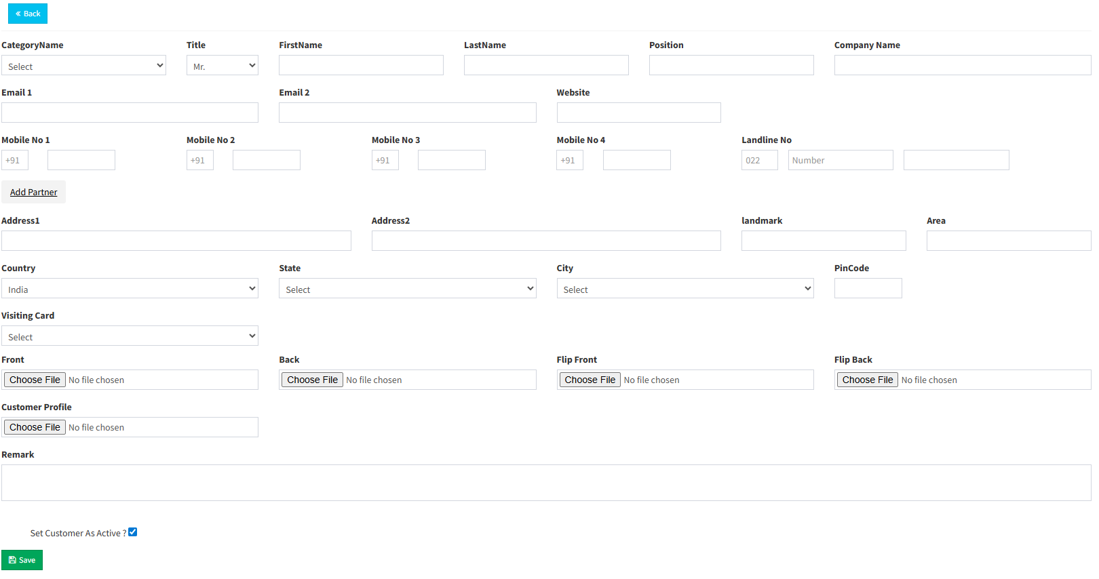
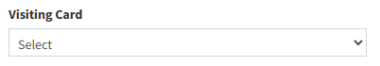
Under Visiting Card Drop Fall ( Horizontal / Vertical )

I should be able to create a Category and then select from here
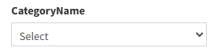
In Add Partner, I should be able to enter the second person name on visiting Card along with minimum 2 Options for Cell no and 2 Options for email id
Category Master
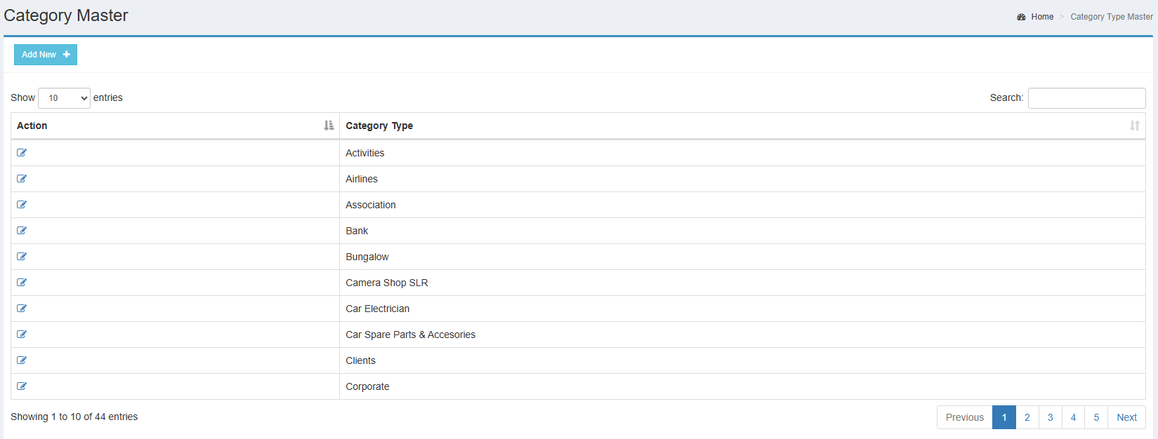
Add Category
