International Packages

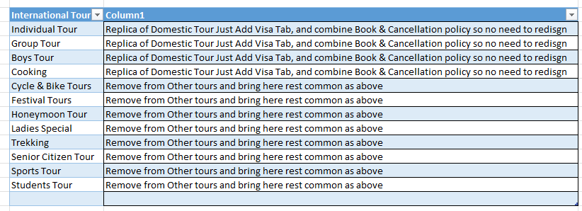

==========================================================================
Flight Ticket Blocks

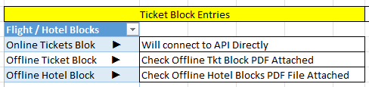

I have shown you exactly how much space I need in the box so accordingly keep the spacing
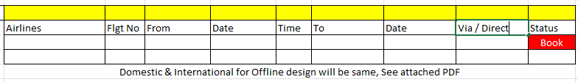
==========================================================================
Exhibitions Scroll down code for Exhibition will start from DOME00001 & for International code will start from INTE00001

In Exhibition, there will be 3 Drop down,

About Exhibition
Domestic Exhibition
International Exhibition

In About Exhibition there will be one Photo and below that there will be questionnaire, Photo shown below

Domestic Exhibition after clicking on domestic all product headings will reflect sample shown below
Then when we click on specific product such as Pharmaceutical then there will be a brief description on produce, in which city will be exhibition, the dates,
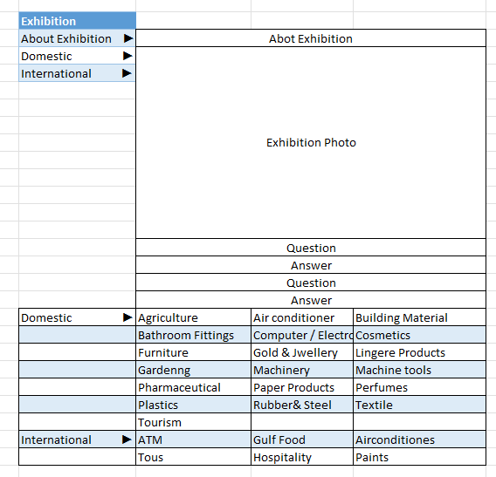

Every question there will be a drop-down arrow with a free flow entry where I will write down my answer, I should have the facility to add questions and answers both will be free flow. Besides after all close the answer windows only questions must display. Left ladder will display as below

Product
Rubber
Plastic
Steel
Machinery

India Exhibition
Mumbai
New Delhi
Pune
Chennai
Bangalore

International Exhibition
Dubai
Spain
Germany
China
Singapore

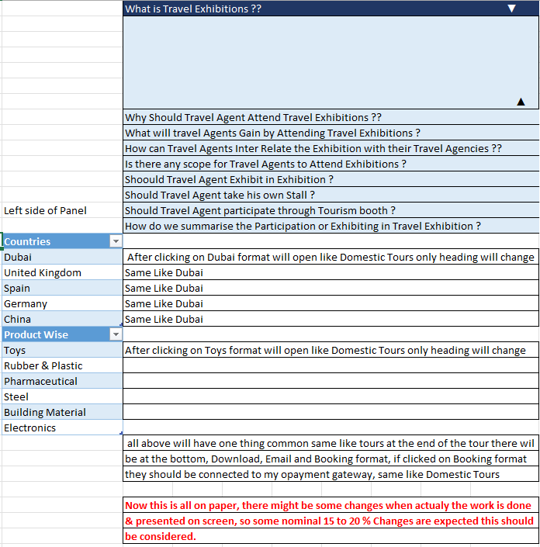

==========================================================================

MICE

About MICE somewhat the format will be like Exhibitions only, But in MICE there will be no search as Product wise, In this template I have shown you on eft hand side 2 Panels, its actually one panel only below one is to show you the reference, but the above is correct

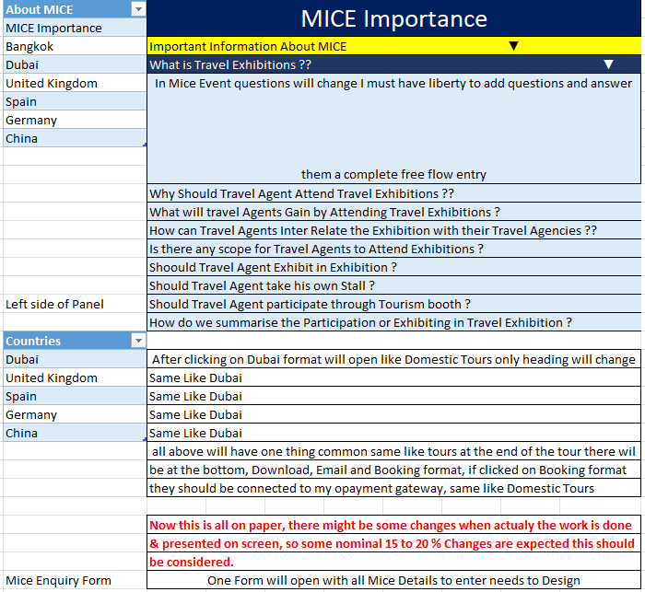

==========================================================================Visa

Visa Format is also some what same, below is what you will see after clicking on Visa Tab

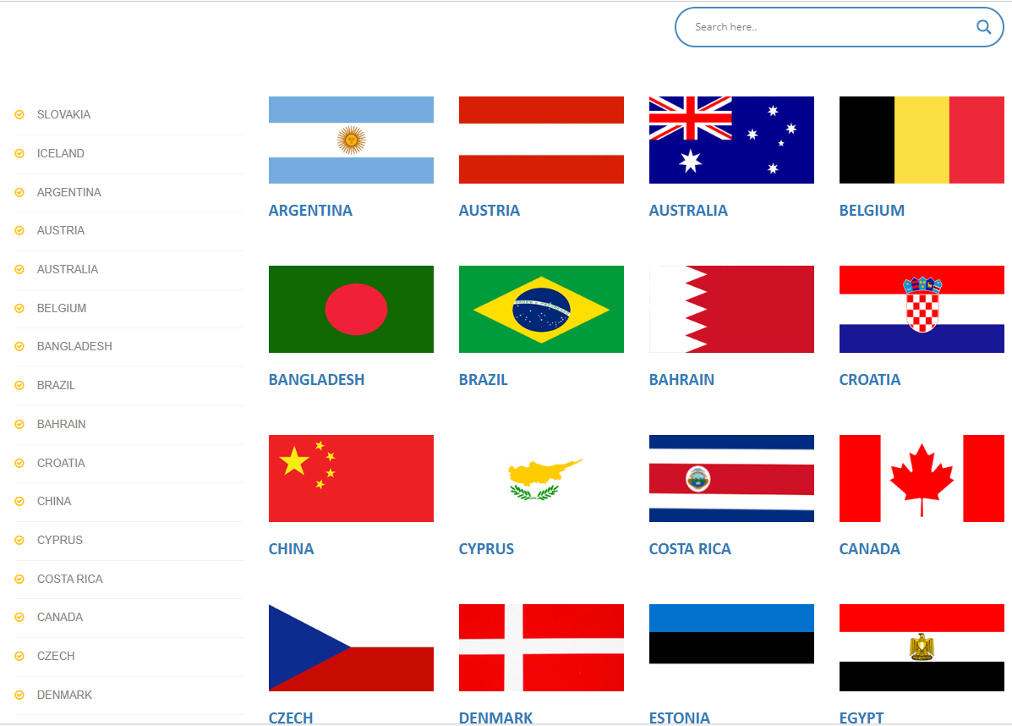

On click on any Flag you will enter that country, Left side tab will remain common so if the client wants to shift from one Country to other, they can do it easily, How will the right tab look I have shown below.

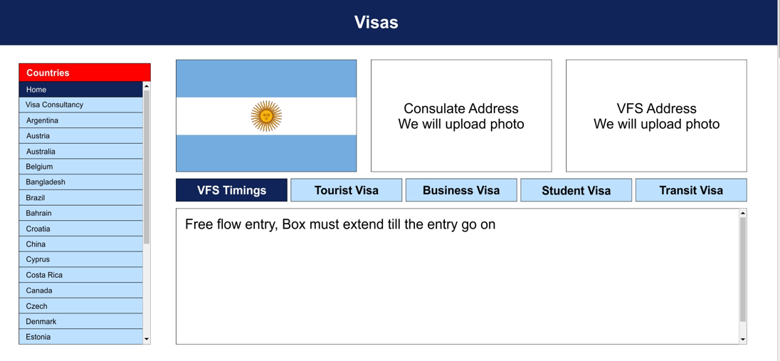
Visa Remarks

VFS, Tourist Visa, tabs may be re arranged or changed this is just a sample, There will be one Remarks column below the visa Column a free flow entry like how we added in Domestic Tours. First Tab will be Tourist Visa, Transit Visa, Business Visa, Visa Fees, VFS Submission, PP Collection

