**A PROJECT REPORT ON-**

“SUPER MARKET

BILLING SYSTEM”

**MASTER OF COMPUTER APPLICATION (MCA)**



**SUBMITTED TO: SUBMITTED BY:**

**Mrs. Rachana Ma’am Mr.Hemantwati**

**22032602022**

**CANDIDATE’S DECLARATION**

I, Hemantwati , declare that the work presented in this project entitled “SUPER MARKET BILLING SOFTWARE” in partial fulfillment for the award of degree of Master of Computer Applications submitted in Advance institute of technology and management, is an authentic record of my own research work under the supervision of Mrs. Rachana ma’am

I also declare that the work embodied in the present Project report is my original work/ extension of the existing work and has not been copied from any Journal/ project report/book, and has not been submitted by me for any other degree/diploma.

Name: Hemantwati

Roll no.: 222032602022

Date:

CERTIFICATE OF THE SUPERVISOR(S)

This is to certify that the Project entitled “SUPER MARKET BILLING SYSTEM” submitted by Hemantwati bearing roll no. 22032602022 in partial fulfillment for award of Degree of Master of Computer Applications at Advance institute of technology and management, is a record of authentic work carried out by her under my supervision.

The matter embodied in this Project Report is the original work of the candidate and has not been submitted for the award of any other degree or diploma. It is further certified that she has worked with me for the required period in the Department of

Advance institute of technology and management.

Mrs. Rachana Ma’am

Date:

ACKNOWLEDGEMENTS

I would like to express my sincere gratitude to my project guide “Mrs. Hemantwati” for giving me the opportunity to work on this topic. It would never be possible for me to take this project to this level without his innovative ideas and his relentless support and encouragement.

Hemantwati

222032602022

CONTENTS

* Introduction
* Purpose
* Scope
* Overview
* Technologies used
* About c++
* Elements of c++
* Objects
* Encapsulation
* Inheritance
* Polymorphism
* Objective of the proposed system
* Header files
* Classes and objects
* Function used in the program
* Working
* Problems with existing system
* Requirement analysis
* Feasibility study
* Technical feasibility
* Economical feasibility
* Operational feasibility
* Schedule feasibility
* Advantage of the proposed system
* Source code
* Output
* Bibliography

INTRODUCTION

Supermarket is the place where customers come to purchase their daily using products and pay for that. So there is a need to calculate how many products are sold and to generate the bill for the customer.

“Super market billing software” aims at developing into software that can be used at places like Shopping malls, super markets to easily maneuver the daily tasks of taking the order, calculating the bill etc.

* Purpose:
* The software is for the supermarket billing system.
* **It maintains two levels-**

1.Administration level

2.User level

* **Software include-**

1.Creating products

2.Modifying products

3.Deletion of products

4.Ordering products

* Administration will decide the taxes and commissions on the products and can see the report of any product. He is the one who will decide the products available for the customer.

The customer or billing manager who can purchase the items available or can make the bill for the customers.

* SCOPE:

It can be used in any supermarket, mall, factory for maintaining product details.

* OVERVIEW:

Main facilities available in this project are-

**a.** Maintaining records of all the products.

**b.** Maintaining details of products.

**c.** Calculating bills of products purchased by the customers.

**d.** Providing menu to the customer.

* TECHNOLOGIES USED:

Platform: C++ Front end: C++

Windows XP M.S. word

ABOUT C++

C++ is a general purpose programming language. It has imperative, object-oriented and generic programming features, while also providing the facilities for low level memory manipulation.

It is designed with a bias for systems programming with performance, efficiency and flexibility of use as its design requirements. C++ has also been found useful in many other contexts, including desktop applications, servers, performance critical applications and entertainment software (video games, etc).

It is a compiled language, with implementations of it available on many platforms. Various organizations provide them, including Microsoft, intel , etc.

C++ is standardized by the International organization for standardization (ISO), which the latest having being ratified and published by ISO in September 2011 as ISO/IEC 14882:2011. The C++ programming language was initially standardized in 1998 s ISO/IEC 14882:1998, which was then amended by the C++ 03, ISO/IEC 14882:2003, standard. The current standard supersedes these, with new features and enlarged standard library.

Before standardization, C++ was developed by Bjarne Stroustrup at Bell Labs, starting in 1979, who wanted an efficient flexible language that also provided high level features for program organization.

Many other programming languages have been influenced by C++, including C#, Java, and newer version of C.

Elements of C++

* Objects-

C++ introduces object object-oriented programming (OOP) features to C. It offers classes which provide the four features commonly present in OOP languages: abstraction, encapsulation, inheritance and polymorphism. One distinguishing feature of C++ classes compared to classes in other programming languages is support for deterministic destructors, which in turn provide support for the Resource acquisition is initialization concept.

* Encapsulation-
* Encapsulation is the hiding of information to ensure that data structures and operators are used as intended and to make the usage model more obvious to the developer. C++ provides the ability to define classes and functions as its primary encapsulation mechanisms. Within a class, members can be declared as either public, protected, or private to explicitly enforce encapsulation. A public member of the class is accessible to any function. A private member is accessible only to functions that are member of that class and to functions and classes explicitly granted access permission by the class. A protected member is accessible to members of classes that inherit from the class in addition to the class itself and any friends.
* INHERITANCE-

Inheritance allows one data type to acquire properties of the other data types. Inheritance from a base class may be declared as public, protected, or private. This access specifier determines whether unrelated and derived classes can access the inherited public and protected members of the base class.

Only public inheritance corresponds to what is usually meant by inheritance.

* Polymorphism-

Polymorphism enables one common interface for many implementations, and for objects to act differently under different circumstances.

Objectives of the proposed system

**1. Automation:** The software automatically calculates the price. Thus the response time of the system is very less and it works very fast.

**2. Accuracy:** The software provides the user a quick response with very accurate information regarding the bill calculation and product details.

**3. User friendly:**  The software has a very user friendly interface, more interactive and speedy.

**4. Availability:** All the products details stored permanently in the database. One can see the data whenever required.

**5. Maintenance cost:** Less maintenance cost.

Header files:-

1.#include<conio.h>

Functions used: getch( ) , getche( ) , gotoxy(X,Y).

2. #include<stdio.h>

Functions used: puts( ), gets( ), rename( ), remove( ).

3. #include<process.h>

Function used: exit( ).

4. #include<fstream.h>

Functions used: open( ), close( ), seekp( ).

5.#include<iostream.h>

Functions used: cout<<, cin>>.

Classes and objects-

**1.Product** : The object declared for this class is **pr.**

This class stores the product number, name, price, quantity, tax and discount available on it; which are declared as private members so customers can not modify them.

Functions of this class and their purpose:

**create_product():** This function is to be used by the administrator to create new products to their list with name,price,discount,etc.

**show_product():** This function is used by the administrator to display the details of all the products with description and price.

**retpno():**It returns the product number.

**retprice():** It returns the price of the product.

**retname():**It returns the name of the product.

**retdis():**It returns the discount available on the product.

**2. fstream**: The object declared for this class is **fp**. It is the predefined class used for both File-to-Memory/ Memory-to-File linking.

Functions-

**1.write_product()** : This function writes the information about the product in the file Shop.dat.

**2. display_all()** : This function displays all the records of products saved in the file Shop.dat.

**3. display_sp**() : This function displays some specific records based on the product number entered by the user.

**4.modify_product()** :This function modifies the product details by entering the product number.

**5.delete_product():** This function deletes the product by entering the product number.

**6.menu()** : This function display list of the product number, its name and its price.

**7.place_order()** :This function places order and generates bill for the products bought.

**8. intro()** : This function displays the project name and the developers.

**9.admin_menu() :** This function displays a list of function to be operated by administrator to modify/update products details .The function uses above user-defined functions.

**10. main()** : This is the main function from where the control is transferred to other functions.

Working-

The project mainly consists of three menus:

1. Customers

2. Administrators

3. Exit

Customer menu shows product list with product no., name and price. This menu is used to place order.

The steps involved are-

1.Enter the product no. Of the product from the list.

2.enter the quantity

3.then place your order

Administrator menu consists of -

1. Create product

2. Display all products

3. Query

4. Modify products

5. Delete product.

6. View product menu

7. Back to menu

Enter choice

1. When we chose the 1st option i.e. create product, we need to mention product no., name, price and discount of the product to create it.

2. In 2nd , all the details of the products is displayed one by one with product no. ,name , price and discount.

3. In 3rd option, we have to enter the product no. To see the details of the respective product.

4. 4th option is used to modify the product list, we have to mention the new product no., name , price , discount.

5. In 5th option, we have to mention the product no. Of those product which is to be deleted.

6. In 6th , product menu is displayed.

Exit menu is used to come out of the program.

Problem with the existing system

* Manual system faces lot of inefficiencies.
* Hinders smooth flow of work.
* Lack of security of data.
* Time consuming.
* Consumes large volume of paper work.
* Needs manual calculations which are prone to errors.
* More men power but less efficiency.

Requirement Analysis:

* Information about the Super market.
* Details of products to sell.
* Staffs and employees.
* Stock of products.
* Special training to staffs that are not from IT background.

Feasibility study:

“Feasibility study” is a test of the system according to its workability, impact of the organization, ability to meet and effective use of the resources.

We can test our system by different types of the feasibilities. There are 5 types of feasibilities :

1.Technical feasibility-

A study of resources availability that may affect the ability to achieve an acceptable system.

This evaluation determines whether the technology needed for the proposed system is available or not. This system can be made in any language that supports good user interface and easy database handling.

Technical needs may include-

**Front end selection-**

Front end means a language used for user interface designing and coding. Front end should have following qualities-

a. It must have graphical user interface that assist employees that are not from IT background .

b. Scalability and extensibility

c. Robustness

d. According to the organization requirements and culture.

e. Must provide excellent reporting features with good printing support.

f. Platform independent

g. Easy to deploy and maintain

h. Event driven programming.

2.Economic feasibility:

In this we consider-

* The cost to conduct a full system investigation.
* The cost of hardware and software for class of application being considered.
* The benefit in the form of the reduced cost.
* Our system has a lot of features at a minimum cost so it is feasible to implement and it will be very much beneficial to the sellers in the reduced cost.
* Its software and hardware cost is also low then the existing system.

3.Operational feasibility:

The points to be considered are:

• What changes will be brought with the system?

• What organization structures are disturbed?

• What new skills will be required? Do the existing staff members have these skills? If not, can they be trained in due course of time?

The system is operationally feasible as it very easy for the End users to operate it. It only needs basic information about Windows platform.

4.schedule feasibility:

Time evaluation is the most important consideration in the development of project. The time schedule required for the developed of this project is very important since more development time effect machine time, cost and cause delay in the development of other systems.

A reliable Super Market billing System can be developed in the considerable amount of time.

Advantages

1. It converts all the manual work which is time consuming and error prone to fully automated system helps in eliminating all the paper work, saves time, improves customer services.
2. It also speeds up various processes such as addition of new items to the menu, deletion of items from the menu, modification of details of items
3. Easy calculation of bills thus providing convenience to the workers as well as customers.
4. Makes the system more feasible and flexible and thus retrieval of information becomes convenient.

OUTPUT SCREEN

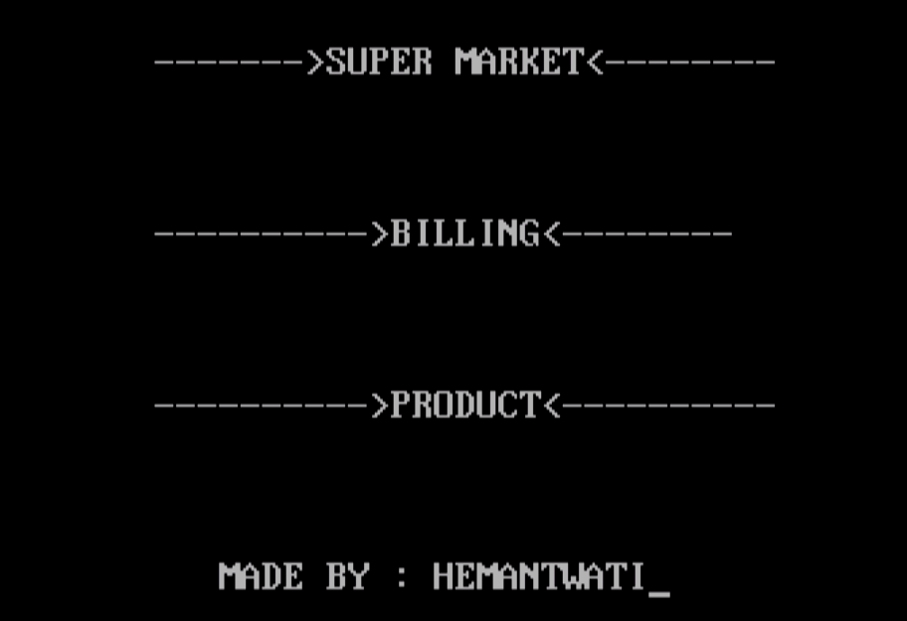

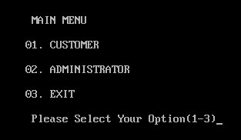

CUSTOMER:

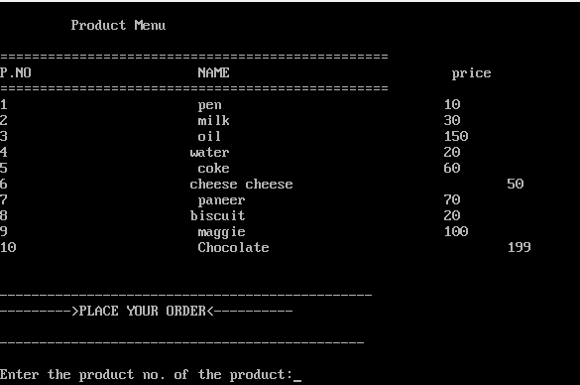

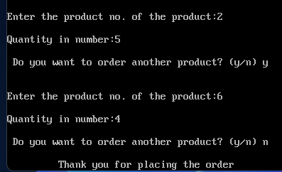

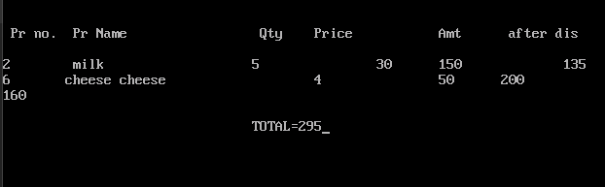

ADMINISTRATOR:

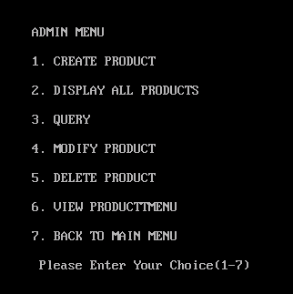

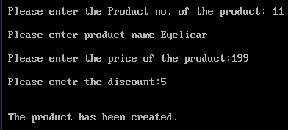

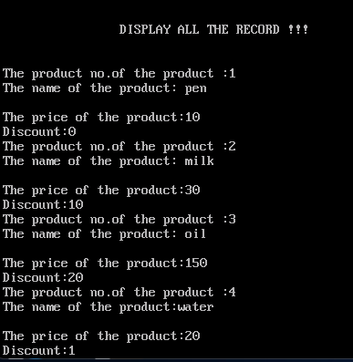

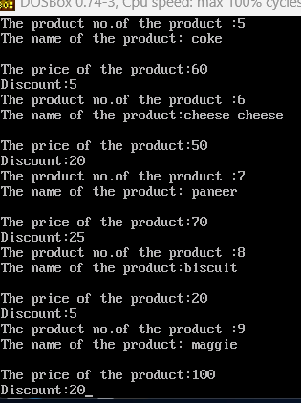

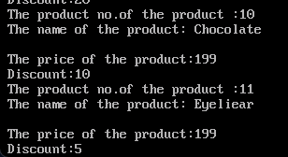

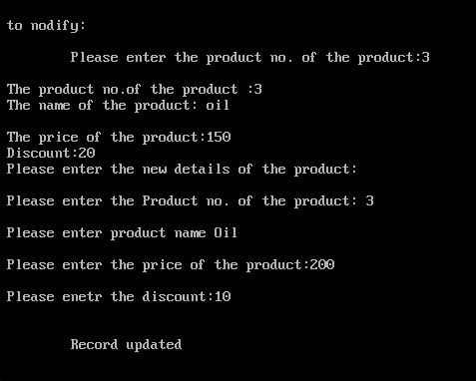

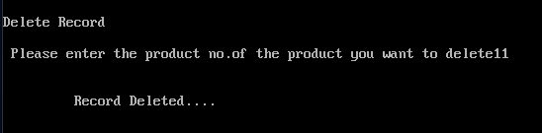

Conclusion:

In conclusion, Super Market Billing System has to do with making appropriate effort to stop the rising problem to all manual supermarket operation in order to enhance the operation of such supermarket. In this project, the software or system that can be used to aid all supermarkets that is still operating manually have been successfully developed. The software can be implementing in all types of supermarket. The software has a large memory of storing all the goods in the supermarket and also for keeping record it is highly effective and accurate.

Bibliography(REFERNCE)

* Sumita arora C++
* OOPs
* C++ programming language by Bjarne Stroustrup
* [www.google.com](http://www.google.com)
* <https://wikipedia.com>