Sri Petchiamman Thunai
D.Gunaseelan B.E , D.Hemapreetha B.E , D.Ramu
S.NO | NAME | PAGE NO
1 | Greeting Dialogue examples | 6
2 | Introducing dialogues in meeting | 8
3 | How you can introduce yourself in a meeting | 9
4 | 1000 business meeting phrases | 10
5 | Meeting and Discussion Phrases | 45
6 | DAY 1 | 77
7 | DAY 2 | 78
8 | DAY 3 | 82
9 | DAY 4 | 85
10 | DAY 5 | 88
11 | DAY 6 | 92
12 | DAY 7 | 98
13 | DAY 8 | 102
14 | DAY 9 | 106
15 | DAY 10 (Exam) | 107
16 | DAY 11 | 113
17 | DAY 12 | 115
18 | DAY 13 | 118
19 | DAY 14 | 121
20 | DAY 15 | 126
21 | DAY 16 | 130
22 | DAY 17 | 133
23 | DAY 18 | 136
24 | DAY 19 | 140
25 | DAY 20 | 142
26 | DAY 21 | 142
27 | DAY 22 (Exam) | 143
28 | DAY 23 | 154
29 | DAY 24 | 156
30 | DAY 25 | 160
31 | DAY 26 | 162
32 | DAY 27 | 162
33 | DAY 28 | 164
34 | DAY 29 | 165
35 | DAY 30 | 165
36 | DAY 31 | 165
37 | DAY 32 | 165
38 | DAY 33 | 165
39 | DAY 34 | 166
40 | DAY 35 | 167
41 | DAY 36 | 168
42 | DAY 37 | 168
43 | DAY 38 | 168
44 | DAY 39 | 168
45 | DAY 40 (Exam) | 169
46 | Basic to Advanced | 179
47 | GRAMMER | 189
48 | Conversation | 193
49 | Daily Routines | 210

Greeting Dialogue examples:
A: Hey! How have you been?
B: I’ve been good, thanks! How about you?
A: Doing well! Catch you later.
B: See you, take care!

A: Hi! What’s up?
B: Not much, just chilling. How about you?
A: Same here! Let’s chat later.
B: Sounds good, see you!

A: Hello! How are things?
B: Everything’s fine, thanks! And you?
A: I’m good too. Talk soon!
B: Bye, take care!

A: Good morning! How’s it going?
B: It’s going great! What about you?
A: Doing well! Catch you later.
B: See you, take care!

A: Hi there! How’s your day been?
B: It’s been good! And yours?
A: Pretty good! See you later.
B: Bye, take care!

A: Hey! How’s everything?
B: All good! How about you?
A: Doing well, thanks! Catch you later.
B: See you soon!

A: Hello! How are you today?
B: I’m doing great! What about you?
A: I’m good too! Talk later.
B: Take care, bye!

A: Hi! How’s life treating you?
B: Pretty good, thanks! And you?
A: Not bad! Catch you later.
B: See you, take care!

A: Hey! How have things been?
B: Everything’s been fine! How about you?
A: Doing well, thanks! Talk to you soon.
B: See you later, take care!

A: Hello! How’s your day going?
B: It’s going well! How’s yours?
A: Pretty good! Talk later.
B: Bye, I'll catch you later!

Introducing dialogues in meeting
A: Good morning, everyone! I’d like to introduce Guna, who will be joining us today to discuss the new project timeline.
B: Hi, everyone! It’s great to be here. I look forward to working with all of you.

A: Hello, team! Please meet Guna, our new software developer. Guna will be helping us with the upcoming release.
B: Thank you! I’m excited to be part of the team and to contribute to the project.

A: Before we begin, I’d like to introduce Guna, who has recently joined our department. Guna, feel free to say a few words.
B: Thanks! I’m really looking forward to collaborating with all of you and learning more about the current initiatives.
A: Everyone, this is Guna. Guna will be leading the data migration efforts. Please give him a warm welcome.
B: Hello, everyone! I’m eager to dive into the work and ensure a smooth transition for our systems.

A: I want to introduce Guna, our new team member. Guna, would you like to tell us a bit about yourself?
B: Sure! I’m Guna, and I have a background in software development. I’m really excited to get started on our next project.

A: Let me introduce you to Guna, who brings a wealth of experience in Angular development. Guna, welcome!
B: Thank you! I’m looking forward to sharing my knowledge and learning from all of you.

A: I’d like to start by introducing Guna, who will be collaborating with us on the client-side integration.
B: Hi, everyone! I’m excited to be here and to contribute to the team’s success.

A: We’re pleased to have Guna join us today. Guna will be assisting with the backend development for our project.
B: Thank you! I’m happy to be on board and ready to get started.

A: Before we dive into the agenda, I’d like to introduce Guna, who recently joined the team. Guna, would you like to say hello?
B: Hi, everyone! I’m thrilled to be part of the team and can’t wait to collaborate on the upcoming tasks.

A: Let me introduce Guna, who has joined us as a project consultant. Guna will be focusing on process improvements.
B: Hello, all! I’m excited to work with you and help streamline our workflows.

How you can introduce yourself in a meeting
You: Hi everyone! My name is Hema, and I’m excited to be part of this meeting today. I specialize in software development, and I look forward to collaborating with all of you on our upcoming projects.
You: Hello, I’m Hema. I’ve been working as a software developer, and I’m thrilled to join this team. I’m eager to contribute and learn from all of you.
You: Good morning! I’m Hema, and I’m really happy to be here. My background is in Angular and JavaScript development, and I’m excited to share ideas and collaborate.
You: Hi everyone, I’m Hema. I’ve been working in software development for a few years now. I’m looking forward to working closely with you and achieving our goals together.
You: Hello, I’m Hema, and I specialize in front-end development with Angular. I’m excited to bring my experience to this team and help drive our projects forward.
You: Good afternoon! My name is Hema, and I’m happy to be joining this meeting. I look forward to working together on solutions that help us achieve our objectives.
You: Hi, I’m Hema. I’ve recently joined the team as a software developer, and I’m eager to get started on some great projects with all of you.
You: Hello everyone, I’m Hema. My focus is on developing user-friendly applications, and I’m excited to collaborate with this talented group to create something amazing.
You: Hi all, I’m Hema. I’ve worked extensively with Angular and JavaScript, and I’m looking forward to contributing to the team’s success.
1000 business meeting phrases
Opening a Meeting
- Let's get started.
- Welcome, everyone.
- Thank you for joining us today.
- Shall we begin?
- I’d like to kick off this meeting.
- Let’s dive right in.
- Today’s agenda is quite packed.
- Let’s go through the agenda quickly.
- Before we start, does anyone have any urgent issues?
- Let’s take a look at the minutes from the last meeting.
Introducing Agenda Items
- The first item on the agenda is...
- Let’s move on to the second point.
- Our next topic of discussion is...
- I'd like to introduce the main issue for today.
- Let’s address the pressing matter at hand.
- Here’s a quick overview of what we’ll cover.
- This brings us to our next point.
- Let’s focus on the core objective of the meeting.
- We need to discuss the following items.
- We have a few key points to cover.
Asking for Opinions
- What are your thoughts on this?
- How do you feel about this proposal?
- Do you agree with this approach?
- Can I get your input on this?
- Does anyone have any comments?
- I’d like to hear everyone’s thoughts.
- Can we get your perspective on this?
- How does this look to you?
- What’s your take on this?
- Any feedback from your side?
Agreeing
- I completely agree.
- That’s an excellent point.
- I think you’re right.
- I support this decision.
- You’re absolutely correct.
- I’m on the same page.
- That makes a lot of sense.
- I’m with you on this.
- I’m in full agreement.
- I couldn’t agree more.
Disagreeing Politely
- I see your point, but I think we should reconsider.
- I understand where you're coming from, but I disagree.
- I’m not entirely convinced.
- I’m afraid I can’t agree with that.
- I have a slightly different opinion on this.
- I see it a bit differently.
- That’s an interesting perspective, but...
- I think we might need to look at it from another angle.
- I’m not sure that’s the best course of action.
- Let’s explore some alternatives.
Making Suggestions
- How about we try this approach?
- I suggest we...
- Why don’t we...
- Wouldn’t it be better to...
- Perhaps we could...
- What if we...
- Could we consider this option?
- I think we should...
- Maybe we can...
- Have you thought about doing it this way?
Clarifying
- Could you elaborate on that?
- Can you clarify what you mean?
- Just to confirm, you’re suggesting that...
- Do you mind explaining that in more detail?
- Let me make sure I understand correctly.
- Can you provide an example?
- I didn’t quite catch that. Can you repeat it?
- Are you saying that we should...
- What exactly do you mean by...?
- Let’s make sure we’re all on the same page.
Giving Updates
- Let me give you a quick update on...
- Here’s the latest information.
- As of today, the status is...
- I’d like to report on the progress.
- We’re currently at the following stage.
- I’ll briefly go over what we’ve accomplished so far.
- The project is moving forward as planned.
- So far, everything is on track.
- We’ve hit a few roadblocks, but...
- Here are the current challenges we’re facing.
Handling Questions
- Does anyone have any questions?
- Feel free to ask questions.
- I’m happy to answer any questions you might have.
- Let’s open the floor to questions.
- Are there any concerns or clarifications needed?
- I’ll take a few questions now.
- Is everything clear so far?
- Do you need any further explanation?
- What questions do you have about this?
- Can I help clarify anything?
Responding to Questions
- That’s a good question.
- Let me think about that for a moment.
- I don’t have the answer right now, but I’ll get back to you.
- I’m glad you asked.
- Let me address that.
- Here’s what I can tell you.
- That’s something we’ll need to explore further.
- I’ll need to check and get back to you.
- Let me explain.
- Yes, that’s correct.
Closing a Meeting
- Let’s wrap this up.
- I think that covers everything for today.
- Does anyone have any final thoughts?
- I’d like to conclude the meeting.
- That brings us to the end of today’s meeting.
- Let’s summarize the key takeaways.
- Before we end, let’s confirm the next steps.
- Thank you all for your contributions.
- We’ll follow up on these points in the next meeting.
- The meeting is adjourned.
Setting Next Steps
- Let’s assign action items.
- We need to outline the next steps.
- I’ll send out a summary after this.
- Can we agree on deadlines?
- Let’s make sure we have clear deliverables.
- Who will take the lead on this?
- I’ll follow up on this task.
- Let’s reconvene next week.
- We’ll keep everyone updated via email.
- Make sure to submit your updates by...
Thanking People
- I appreciate everyone’s input today.
- Thanks for your time and effort.
- Thank you for your valuable contributions.
- I really appreciate your insights.
- Thanks for bringing that up.
- I’d like to thank you all for attending.
- Thank you for the hard work.
- Your feedback is greatly appreciated.
- I’d like to acknowledge everyone’s contributions.
- Thank you for the constructive discussion.
Managing Time
- Let’s keep this brief.
- We’re running short on time.
- We need to move on to the next topic.
- Let’s stay focused on the agenda.
- We’re behind schedule, so let’s speed up.
- We’ll have to wrap this up quickly.
- Let’s try to stay within the allotted time.
- We’re going over time; let’s move forward.
- We’ll need to allocate more time for this next time.
- Let’s table this discussion for another meeting.
Delegating Tasks
- Who would like to take this on?
- Can I assign this to you?
- I think you’re the best person for this task.
- Let’s allocate this responsibility to...
- I’ll let [name] handle that.
- [Name], can you take the lead on this?
- I’d like you to manage this task.
- Would you be willing to take care of this?
- Let’s divide the workload for this project.
- Can we assign tasks to specific team members?

Postponing or Tabling Items
- We’ll revisit this next time.
- Let’s table this for now.
- We can discuss this further at our next meeting.
- We’ll need to hold off on this for now.
- Let’s come back to this later.
- Can we postpone this discussion until we have more information?
- We’ll have to put this on hold for now.
- Let’s put this on the back burner for now.
- We’ll follow up on this at a later time.
- We’ll need more time to look into this.
Reaching a Decision
- Can we all agree on this?
- Are we ready to make a decision?
- Let’s make a final decision on this.
- It seems like we have consensus.
- Can we finalize this today?
- I think we’re ready to conclude.
- It looks like we’re in agreement.
- Is everyone on board with this decision?
- I believe we’ve come to a conclusion.
- Let’s make this official.
Requesting Information
- Can you provide us with the data?
- I’d like to see more details on this.
- Can you give us an update on that?
- Do we have the latest figures?
- Can you share the results with the group?
- Let’s get the necessary information before proceeding.
- Can we gather more insights on this?
- Please send me the report by tomorrow.
- I’ll need more background information on this.
- Do we have all the facts?

Seeking Approval
- Do we have approval for this?
- I’ll need sign-off on this before moving forward.
- Is everyone okay with this?
- Can we get the green light on this?
- We’ll need management’s approval.
- Is it alright if we proceed?
- Does anyone object to moving forward?
- We’ll need authorization from the higher-ups.
- I’ll check if we can get approval today.
- Let’s ensure that this has been approved before proceeding.
Confirming Understanding
- Does that make sense?
- Are we all clear on this?
- Is everyone following along?
- Does anyone need clarification?
- Are we on the same page?
- Just to confirm, we’re all in agreement.
- Can we confirm that this is understood?
- Is there anything unclear about this?
- Everyone’s on board with this plan, right?
- Let’s make sure we all understand the next steps.
Expressing Concern
- I’m a bit concerned about this.
- I see a potential issue here.
- This might be a challenge.
- I’d like to flag a concern regarding this point.
- Do you think we might encounter any problems with this?
- I think we need to address a potential risk.
- There could be a complication with this.
- I’m worried this might delay our timeline.
- We need to keep an eye on this situation.
- Let’s address these concerns before moving forward.

Offering Support
- I’m happy to help with this.
- Let me know if you need any assistance.
- I can lend a hand if needed.
- Feel free to reach out if you need help.
- I’m available to support you on this.
- How can I assist you with this task?
- I can help you with that.
- Let’s collaborate on this.
- If you need any backup, I’m here.
- I’ll make sure to provide the necessary resources.
Requesting Deadlines
- When do you expect to have this done?
- Can you provide a timeline for this?
- What’s the deadline for this task?
- When can we expect to see results?
- Can we set a deadline for this?
- By when do you need this completed?
- What’s the time frame for this project?
- Let’s set a realistic deadline.
- When will this be ready for review?
- Do we have a target completion date?
Following Up
- I just wanted to follow up on this.
- Can you give me an update on the status?
- Have you made any progress on this?
- I’m checking in to see how things are going.
- Just a quick follow-up on our last meeting.
- Can you provide an update on where we stand?
- I’m following up to ensure we’re on track.
- Do you have any news regarding this task?
- I wanted to remind you about the upcoming deadline.
- Let’s follow up after the meeting.

Summarizing
- To summarize, here’s what we’ve discussed.
- Let me give a quick recap of the key points.
- In summary, we’ve agreed on...
- To sum it up, we need to...
- Let me wrap this up with a summary.
- Here’s a brief overview of what we’ve covered.
- The key takeaways from today’s meeting are...
- So, in conclusion, we will...
- Just to reiterate, the main points are...
- Let’s review the main conclusions.
Managing Difficult Conversations
- Let’s address this issue directly.
- I understand this is a sensitive topic.
- We need to have a difficult discussion today.
- I appreciate your honesty on this matter.
- Let’s approach this constructively.
- I understand there may be disagreements.
- It’s important we resolve this issue.
- Can we talk about what’s not working?
- I understand this is a challenging situation.
- Let’s find a way to move forward.
Problem-Solving
- Let’s brainstorm some solutions.
- How can we solve this problem?
- What’s the best way to tackle this issue?
- Let’s explore some potential options.
- How can we overcome this obstacle?
- What steps can we take to fix this?
- Let’s work through this challenge together.
- We need to find a workable solution.
- What’s the root cause of this problem?
- Let’s focus on resolving this.

Handling Interruptions
- Can I finish my point before we move on?
- I’ll get to that in a moment, but first...
- Let’s allow [name] to finish speaking.
- Please hold your questions until the end.
- Let’s try to avoid interruptions.
- Can we keep the discussion focused?
- We’ll address your point shortly.
- Let’s make sure everyone has a chance to speak.
- I’d like to finish my thought before we continue.
- Can we come back to your point in a minute?
Resolving Conflicts
- Let’s take a step back and assess the situation.
- I think we need to find some middle ground here.
- Can we find a compromise that works for everyone?
- Let’s focus on the facts rather than emotions.
- I understand both perspectives.
- Can we agree on a way forward?
- Let’s try to avoid further escalation.
- We need to settle this issue calmly and professionally.
- Can we resolve this without letting it affect our progress?
- Let’s work together to find a solution that satisfies both sides.
Giving Feedback
- I have some feedback I’d like to share.
- Can I give you some constructive feedback on this?
- Here’s what’s working well and what could be improved.
- I appreciate the effort you’ve put in, but...
- This part of the project could use some adjustments.
- Let me offer some suggestions for improvement.
- I think you did a great job on this, but there’s room for improvement.
- Could we tweak this part to make it more effective?
- Here’s how we can improve next time.
- I value your work, but there’s something I’d like to address.

Receiving Feedback
- Thank you for the feedback.
- I appreciate your honesty and insights.
- I’ll definitely take that into consideration.
- That’s helpful feedback—I’ll work on that.
- Thanks for pointing that out.
- I’ll make sure to address that.
- I’m open to any suggestions for improvement.
- I appreciate you bringing this to my attention.
- I’ll make adjustments based on your feedback.
- Your feedback is really valuable—thanks for sharing.
Scheduling Meetings
- Can we set up a meeting for next week?
- Let’s schedule a time that works for everyone.
- When are you available to meet?
- Can we book a meeting for this discussion?
- Let’s coordinate our schedules.
- How about we meet on [day] at [time]?
- Let’s arrange a meeting to go over this.
- Can we pencil in a meeting for later this week?
- What’s the best time for you to meet?
- I’ll send out a meeting invitation after this.
Providing Updates
- Let me update you on where we stand.
- Here’s the current status of the project.
- As of today, we’re on track with our deadlines.
- We’ve made significant progress since our last meeting.
- The project is going according to plan.
- I’d like to provide an update on our progress.
- Everything is moving forward as scheduled.
- There’s been a slight delay, but we’re managing it.
- I have a few updates to share.
- Here’s a brief status report.

Managing Expectations
- I just want to set some expectations here.
- Let’s be realistic about what we can achieve.
- I’d like to manage expectations around this timeline.
- We might need to adjust our goals slightly.
- Let’s make sure we’re aligned on what’s achievable.
- This might take longer than initially expected.
- We need to ensure everyone has a clear understanding of the deliverables.
- There may be some challenges we’ll need to navigate.
- I’d like to avoid any unrealistic expectations.
- Let’s establish clear expectations from the start.
Acknowledging Challenges
- We’re facing some difficulties with this.
- This has been a challenging issue to address.
- We’ve run into a few obstacles.
- There are some hurdles we need to overcome.
- We’re aware of the challenges, and we’re working through them.
- This situation is more complicated than we anticipated.
- We’re encountering some resistance.
- We’re doing our best to resolve the challenges.
- We’ve identified the key issues.
- We’ll need to put in extra effort to overcome this.
Negotiating
- Let’s negotiate the terms.
- Can we find a solution that benefits both parties?
- I think we can come to a mutually beneficial agreement.
- We may need to make some concessions here.
- Let’s work out a fair compromise.
- I’m willing to negotiate on this point.
- Can we negotiate a better deal?
- Let’s explore options that meet everyone’s needs.
- I’m open to renegotiating some aspects.
- Can we reach an agreement that works for both sides?

Expressing Urgency
- This needs to be addressed as soon as possible.
- It’s important that we act quickly.
- We’re on a tight deadline, so we need to move fast.
- Let’s prioritize this task.
- This is time-sensitive, so we need to expedite it.
- We need to get this done urgently.
- There’s no time to waste on this.
- We need to fast-track this project.
- Let’s focus on this first before anything else.
- I need an immediate response on this matter.
Proposing Alternatives
- Here’s an alternative solution we could consider.
- Let me suggest a different approach.
- We could try this instead.
- I propose we look at other options.
- What if we tried this method?
- Here’s another way to tackle the issue.
- Can we explore an alternative plan?
- Let’s consider other strategies.
- This might be a better option to pursue.
- Let’s brainstorm some alternatives to this.
Making an Apology
- I apologize for the misunderstanding.
- I’m sorry for any inconvenience this has caused.
- Please accept my apologies for the delay.
- I regret that this happened.
- I’m sorry for the confusion earlier.
- I’d like to apologize for the oversight.
- We’re sorry about the mix-up.
- I’ll make sure this doesn’t happen again.
- I apologize if there was any miscommunication.
- We’ll work on resolving this issue right away.

Ending on a Positive Note
- This has been a productive discussion.
- I’m optimistic about the next steps.
- I think we’ve made great progress today.
- Thanks to everyone for their contributions.
- We’re in a strong position moving forward.
- I feel confident about where we’re headed.
- I’m looking forward to seeing the results.
- I think we’re on the right track.
- We’ve accomplished a lot today.
- I appreciate everyone’s hard work and effort.
Handling Objections
- I understand your concerns, but...
- I see your point, however, consider this...
- That’s a valid concern, but we’ve accounted for it.
- I appreciate your feedback, but let’s look at the bigger picture.
- I hear what you’re saying, but we believe this is the best approach.
- That’s a good point, but let’s not overlook this factor.
- I respect your opinion, but we should explore all possibilities.
- I understand your hesitation, but we’ve thought this through.
- That’s a fair objection, but here’s why we believe it will work.
- I see your point, but the benefits outweigh the risks.
Encouraging Participation
- Let’s hear from some of the quieter voices in the room.
- Does anyone else have input on this?
- I’d love to hear your thoughts on this.
- Feel free to jump in if you have any ideas.
- What do you think about this, [name]?
- We welcome any additional ideas or suggestions.
- Don’t hesitate to speak up if you have something to add.
- Does anyone have a different perspective on this?
- I’d like to hear from everyone on this topic.
- We value everyone’s input, so feel free to share.

Suggesting Improvements
- Can we improve this by making a few adjustments?
- I think we could enhance this by adding...
- What if we refined this part to make it more effective?
- We could strengthen this by focusing on...
- I’d suggest fine-tuning this element.
- Let’s consider how we can optimize this process.
- We could improve efficiency by doing this differently.
- Let’s explore ways to make this even better.
- I believe we can improve on this with a few changes.
- We could benefit from a more streamlined approach.
Closing the Meeting
- Let’s wrap things up for today.
- I think we’ve covered everything for this session.
- We’ll conclude the meeting here.
- Thank you all for your time and contributions.
- That’s a wrap—thanks, everyone!
- Let’s bring the meeting to a close.
- Thanks for a productive discussion.
- We’ve reached the end of today’s agenda.
- If there are no further comments, we’ll close the meeting.
- Meeting adjourned—thanks for your input!
Planning Next Steps
- Let’s define our next steps before we leave.
- What are the next actions we need to take?
- Can we outline the follow-up tasks?
- Our next step will be to...
- Let’s assign tasks for the next phase of the project.
- We’ll regroup after completing these steps.
- Here’s what we’ll do moving forward.
- I’ll send out an email with the next steps.
- Can we prioritize what comes next?
- Let’s make sure we have a clear action plan.

Handling Technical Difficulties
- We’re experiencing some technical issues.
- Please bear with us while we sort this out.
- It looks like we’re having some connectivity problems.
- We’ll need a moment to fix this technical glitch.
- Apologies for the delay due to technical difficulties.
- Let’s pause while we resolve this issue.
- We seem to have a problem with the audio/video.
- Let’s reschedule if the issues persist.
- I’ll reconnect and try again.
- Let’s take a break while we resolve this.
Clarifying the Agenda
- Let’s review today’s agenda before we start.
- Here’s what we’ll be discussing today.
- Let’s make sure we’re clear on the agenda.
- Can we confirm the topics we’ll cover?
- I’d like to go over the main points on today’s agenda.
- Does everyone have a copy of the agenda?
- Let’s stick to the agenda to stay on track.
- I’ll be following the agenda to keep us focused.
- If we finish early, we can address any additional points.
- Please refer to the agenda throughout the meeting.
Transitioning Between Topics
- Let’s move on to the next item on the agenda.
- Now that we’ve covered that, let’s proceed to...
- I’d like to shift the discussion to the next topic.
- Let’s transition to the next point.
- Moving on, let’s discuss...
- Now, let’s address the following issue.
- With that covered, let’s turn our attention to...
- Let’s move forward with the next agenda item.
- We’ve wrapped up that discussion—next, we have...
- Can we now shift our focus to the next point?

Seeking Clarification
- Can you clarify what you mean by that?
- Could you explain that in more detail?
- I’d like a little more clarity on this point.
- Can you elaborate on that?
- Could you give us a bit more context?
- I’m not sure I fully understand—can you clarify?
- Can you walk me through that one more time?
- I just want to make sure I understand you correctly.
- Could you expand on that idea?
- Can you explain how that fits into the bigger picture?
Addressing Miscommunication
- I think there’s been a misunderstanding.
- Let’s clarify to avoid any miscommunication.
- There seems to be some confusion—let’s clear that up.
- I believe we’re not on the same page here.
- Can we take a moment to address this misunderstanding?
- It seems there’s been a miscommunication on this issue.
- Let’s realign to make sure we’re all on the same page.
- I think there’s been a mix-up—let me clarify.
- There might have been a misinterpretation of the information.
- I think we need to clear up some confusion here.
Delegating Tasks
- I’d like you to take the lead on this.
- Can you handle this task?
- Let’s assign this task to [name].
- I’ll delegate this to the appropriate team.
- Who would like to take this on?
- [Name], could you take responsibility for this?
- We’ll divide this work between the team.
- I’ll assign the task to the best person for the job.
- Can I count on you to manage this?
- I’d appreciate it if you could take care of this.

Defining Roles
- Let’s clarify who’s responsible for each part.
- [Name] will handle this aspect of the project.
- [Name] is the point of contact for this task.
- You’ll be responsible for [specific task].
- [Name] will lead this effort, and the rest of us will support.
- I’ll take ownership of this part, while [name] manages the rest.
- Let’s make sure everyone knows their role.
- [Name], could you take the lead on this?
- Let’s define clear roles for each team member.
- We’ll assign each part of the project to the right person.
Assessing Progress
- Let’s assess our progress so far.
- Where do we stand with the project?
- How are we doing in terms of meeting our goals?
- Can you provide a progress update?
- How far along are we with this task?
- Let’s evaluate our progress to date.
- Are we on track to meet our deadline?
- Can you summarize where we are at this point?
- How much progress have we made since the last meeting?
- Let’s measure our progress against our initial plan.
Requesting Approval
- Can I get approval to move forward with this?
- We need your approval before we proceed.
- Could you sign off on this decision?
- I’d like to request approval for this proposal.
- Can we get the green light to move ahead?
- I’m seeking approval from management on this.
- Once we have approval, we can proceed.
- I’ll move forward as soon as I receive approval.
- Could you authorize this plan?
- I’ll need confirmation before proceeding.

Encouraging Innovation
- Let’s think outside the box on this one.
- Feel free to propose creative solutions.
- We’re open to new and innovative ideas.
- Don’t be afraid to push the boundaries with your suggestions.
- How can we innovate in this area?
- Let’s brainstorm some groundbreaking ideas.
- I’d like to encourage bold thinking.
- Let’s look at this from a fresh perspective.
- We need some out-of-the-box ideas to solve this.
- I encourage you to challenge the current situation.
Expressing Disagreement Diplomatically
- I see your point, but I have a different perspective.
- I respectfully disagree with that approach.
- I appreciate your input, but I think we should consider another option.
- I have a different view on this matter.
- While I understand your position, I think we should go in a different direction.
- I see where you’re coming from, but I’d like to offer an alternative view.
- I’m not sure I agree with that, but I’m open to further discussion.
- Let’s explore other viewpoints before making a decision.
- I have some reservations about that idea.
- I’d like to present a different perspective.
Concluding a Decision
- It sounds like we’re all in agreement on this.
- We’ve reached a consensus on the next steps.
- It seems like we’re all aligned with this decision.
- Let’s move forward based on our agreement.
- The decision is made, and we can proceed accordingly.
- We’ve come to a final decision on this matter.
- I think we’ve reached a clear conclusion.
- We’re ready to move forward with this decision.
- It’s decided—we’ll proceed with this plan.
- This concludes the decision-making process.

Addressing Uncertainty
- There are still some unknowns that we need to address.
- We’re working with some uncertainties here.
- I’m not entirely sure about that—let me check.
- We need more information before we can move forward confidently.
- There’s some ambiguity in this area that we need to clarify.
- We’re facing some uncertainties, but we’ll manage them.
- It’s unclear at the moment, but we’re looking into it.
- We’ll need to deal with this uncertainty as we proceed.
- I’m uncertain about this part—let’s investigate further.
- We don’t have all the answers yet, but we’ll figure it out.
Acknowledging Achievements
- Great work on completing this task!
- Congratulations on reaching this milestone.
- This is a significant achievement for the team.
- Well done, everyone—we’ve accomplished a lot.
- I’m really impressed with the progress we’ve made.
- Let’s celebrate this success!
- Kudos to everyone involved in this achievement.
- You’ve done an outstanding job—thank you!
- This is a big win for the project and the team.
- I want to acknowledge all the hard work that went into this.
Encouraging Accountability
- Let’s all take responsibility for our respective tasks.
- We need to ensure accountability across the team.
- Each of us is responsible for delivering on our commitments.
- Let’s hold ourselves accountable for the project’s success.
- I expect everyone to own their part of the project.
- Accountability is key to achieving our goals.
- We’re all accountable for meeting the deadlines we set.
- Let’s make sure we follow through on our responsibilities.
- Can we each commit to our assigned tasks?
- We’re all in this together, so let’s be accountable to one another.

Handling Time Management
- Let’s make sure we’re staying on schedule.
- We need to manage our time effectively to meet the deadline.
- Can we keep an eye on the time as we move forward?
- Let’s allocate our time wisely for this meeting.
- We’re running out of time—let’s wrap this up.
- I think we need to speed things up to stay on track.
- Let’s set some time limits for each agenda item.
- We have a tight schedule, so let’s stay focused.
- Let’s avoid any delays and stick to the timeline.
- Can we make sure we finish this within the allotted time?
Addressing Budget Concerns
- We need to ensure we stay within budget for this project.
- Let’s review the budget before moving forward.
- Can we allocate more funds to this part of the project?
- How does this decision impact our overall budget?
- Let’s prioritize tasks based on our budget constraints.
- We need to find a cost-effective solution.
- Our budget is limited, so let’s use resources efficiently.
- Can we cut any costs without compromising quality?
- We’ll need to adjust the budget to accommodate this change.
- Let’s make sure we’re not overspending on this project.
Responding to Feedback
- I appreciate the feedback, and we’ll incorporate it.
- Thanks for the feedback—we’ll take that into consideration.
- That’s helpful feedback—let’s work on improving this.
- We value your input and will make the necessary adjustments.
- We’ll make the changes based on your feedback.
- Thank you for sharing your thoughts—let’s implement the suggestions.
- We’ll review the feedback and see how we can improve.
- I’ll ensure the feedback is addressed in the next iteration.
- Your feedback is noted, and we’ll act on it accordingly.
- Let’s incorporate these insights into our plan moving forward.

Managing Stakeholder Expectations
- We need to keep our stakeholders informed of any updates.
- Let’s make sure we’re meeting stakeholder expectations.
- We’ll need to manage stakeholder expectations carefully.
- Can we provide a status update to our stakeholders?
- Let’s ensure that our stakeholders are aligned with our progress.
- We need to communicate any changes to the stakeholders.
- It’s important that we set clear expectations with stakeholders.
- We’ll need to report back to the stakeholders on this issue.
- Let’s keep our stakeholders in the loop throughout the process.
- We need to manage stakeholder feedback and concerns.
Seeking Clarification on Instructions
- Can you clarify the instructions for this task?
- I’m not entirely clear on what’s expected—can you explain further?
- Could you provide more details on how to proceed?
- I just want to make sure I fully understand the instructions.
- Could you walk me through the process again?
- I need some clarification before moving forward.
- Could you elaborate on the specific requirements?
- I’d like to ensure I’m following the instructions correctly.
- Can you confirm what’s needed for this task?
- I have a few questions about the instructions—could we go over them?
Mitigating Risks
- Let’s identify any potential risks to the project.
- How can we mitigate the risks associated with this task?
- We need to have a contingency plan in case things go wrong.
- What are the biggest risks we’re facing at the moment?
- Can we assess the risk before moving forward?
- Let’s prepare for any potential obstacles.
- We need to take proactive steps to minimize risk.
- How can we reduce the likelihood of this risk occurring?
- Let’s ensure we have risk management strategies in place.
- What measures can we take to mitigate the impact of this risk?

Expressing Gratitude
- Thank you for your hard work and dedication.
- I really appreciate your contributions to this project.
- I’m grateful for the effort you’ve put in.
- Your commitment to this task hasn’t gone unnoticed—thank you!
- I just want to express my gratitude for your support.
- I really value your input and assistance.
- Thanks again for stepping up when we needed you.
- I appreciate your help in getting this done on time.
- I’m thankful for the way you handled this situation.
- I couldn’t have done this without your support—thank you!
Addressing Delays
- Unfortunately, we’re facing some delays.
- We’re running behind schedule, but we’ll make up for the lost time.
- There’s been a delay due to unforeseen circumstances.
- We’re working hard to get back on track.
- The delay was unavoidable, but we’re addressing the issue.
- We’ll need to adjust the timeline due to the delay.
- I apologize for the delay—we’re doing everything we can to expedite this.
- We’re slightly behind, but we’re confident we can recover.
- Let’s evaluate the impact of the delay and plan accordingly.
- We’re experiencing delays, but we’re actively working on a solution.
Making Recommendations
- I recommend we move forward with this plan.
- Based on the data, I’d suggest we proceed with option A.
- I believe this course of action is the best choice.
- My recommendation is to focus on this area first.
- Let me offer a recommendation for handling this issue.
- I’d suggest we prioritize this task for now.
- My advice would be to allocate more resources to this project.
- I think the best approach would be to...
- Based on our findings, I’d recommend this strategy.
- I’d advise caution before making any further decisions.

Refocusing the Conversation
- Let’s get back to the main topic of discussion.
- Can we steer the conversation back to the agenda?
- Let’s refocus on what’s most important right now.
- We’ve strayed off-topic—let’s bring it back.
- Can we return to the issue at hand?
- Let’s avoid getting sidetracked and stick to the key points.
- We need to stay focused on the task at hand.
- Let’s bring the conversation back to the main issue.
- Can we circle back to the original topic?
- We’re getting off track—let’s refocus.
Discussing Challenges
- We’re facing some challenges with this part of the project.
- Let’s address the main obstacles we’re encountering.
- There are a few difficulties we need to overcome.
- We need to find a solution to this challenge.
- What challenges are we currently dealing with?
- How can we tackle these issues more effectively?
- Let’s brainstorm ways to overcome this obstacle.
- We’re running into some roadblocks—how can we navigate them?
- This is a tough situation, but we’ll find a way through it.
- What’s the best approach for dealing with these challenges?
Proposing Solutions
- I propose we try this approach to solve the issue.
- Let’s consider this solution for the problem.
- How about we implement this strategy to address the challenge?
- One potential solution could be to...
- What if we took this approach to resolve the issue?
- We could address the problem by doing this.
- I’d like to propose a solution that might work.
- Here’s a possible fix for the current situation.
- Let’s try this method and see if it resolves the issue.
- This solution might help us overcome the challenge.

Providing Support
- How can I assist you with this task?
- I’m here to help—what do you need?
- Let me know if you need any support with this.
- I’d be happy to help with this part of the project.
- If you need assistance, feel free to reach out.
- I can provide some help if you’re feeling stuck.
- Let’s work together to get this done.
- I’ll offer my support wherever it’s needed.
- How can we provide more resources to assist the team?
- I’m available to help if you need anything.
Addressing Performance Issues
- We need to discuss some performance concerns.
- Let’s address the areas where improvement is needed.
- I’ve noticed some issues with your recent performance.
- We need to work on improving in these specific areas.
- Let’s review how we can enhance performance moving forward.
- We’re falling short in certain areas, and we need to address that.
- What steps can we take to improve your performance?
- We’ll need to put together a plan for improvement.
- Let’s identify the key areas where performance can be better.
- I’m confident we can improve with some focused effort.
Responding to Criticism
- I appreciate your feedback and will work on that.
- Thank you for pointing that out—I’ll make the necessary changes.
- I understand your concerns and will take them into account.
- I’ll address that issue and ensure it doesn’t happen again.
- Your input is valuable—I’ll make sure to improve in that area.
- I’ll work on that and get back to you with a solution.
- I appreciate the constructive criticism—thank you.
- I’ll make the necessary adjustments based on your feedback.
- Thanks for bringing that to my attention—I’ll take care of it.
- I’ll reflect on your comments and work towards improvement.

Discussing Deadlines
- Let’s confirm the deadline for this project.
- We’re approaching the deadline—how’s our progress?
- We need to make sure we meet the deadline.
- Can we extend the deadline to ensure quality?
- Are we on track to complete this by the deadline?
- Let’s set a firm deadline for this task.
- We’re working against a tight deadline, so let’s prioritize.
- How much time do we have before the deadline?
- We’ll need to push back the deadline to accommodate this.
- Let’s make sure we’re prepared to meet the deadline.
Requesting Clarification in Discussions
- Could you clarify what you mean by that point?
- I’m not sure I fully understood—can you explain further?
- Can you break that down for us?
- I have a few questions about that—could you elaborate?
- Let’s make sure we all understand the details.
- Could you provide more context for that idea?
- I think we need some clarification on this issue.
- Can you give us a clearer picture of what you’re suggesting?
- I’m a little confused—can you clarify your explanation?
- Could you explain how that fits into the overall plan?
Handling Conflicting Opinions
- It seems we have differing viewpoints on this.
- Let’s explore both perspectives before making a decision.
- We have a difference of opinion—let’s discuss it further.
- I respect your view, but I have a different take on this.
- Let’s find a way to reconcile these conflicting ideas.
- It’s important that we acknowledge differing opinions.
- We’ll need to come to a compromise on this matter.
- Can we find some common ground between these viewpoints?
- Let’s take some time to discuss the pros and cons of each perspective.
- We need to resolve this difference of opinion to move forward.

Motivating the Team
- Let’s push through and finish this strong!
- I know we can achieve this if we all give our best effort.
- We’ve come this far—let’s keep up the momentum!
- Keep up the great work, and we’ll meet our goals.
- I believe in this team’s ability to deliver excellent results.
- Let’s stay focused and finish this project successfully.
- We’ve done great so far—let’s continue the hard work.
- Keep pushing, and we’ll get this done on time.
- I’m confident we can overcome any challenges we face.
- Let’s stay motivated and maintain a positive outlook.
Discussing Potential Opportunities
- This presents a great opportunity for us.
- Let’s explore the opportunities that this opens up.
- I see an opportunity for growth here.
- This is a chance for us to expand our capabilities.
- How can we leverage this opportunity to our advantage?
- We have the opportunity to take this to the next level.
- Let’s make sure we seize this opportunity.
- This could be a great opportunity for the company’s growth.
- How can we capitalize on the opportunities presented by this project?
- We should look into the long-term opportunities this creates.
Handling Unexpected Changes
- We need to adjust to this new development.
- There’s been a change in plans—let’s discuss how to proceed.
- We’ll need to pivot due to these unforeseen circumstances.
- Let’s stay flexible and adapt to this situation.
- How can we adjust our approach to accommodate this change?
- This change was unexpected, but we’ll manage it.
- We’ll need to reassess our strategy in light of this change.
- Let’s come up with a plan to handle this sudden shift.
- How can we minimize the impact of this unexpected change?
- We’ll need to re-evaluate our next steps based on this development.

Requesting Additional Resources
- We’ll need more resources to complete this project successfully.
- Can we allocate additional resources to this task?
- We’re short on resources—what can we do to address this?
- Could we request more support to ensure this gets done on time?
- Let’s see if we can increase the budget to cover additional resources.
- We need to bring in more resources to meet the deadline.
- Can we get additional staffing for this part of the project?
- I think we’ll need more tools and materials to proceed.
- Are there any extra resources we can tap into for this?
- We need to request additional funding to support this effort.
Establishing Priorities
- Let’s prioritize the most important tasks first.
- What should be our top priority moving forward?
- We need to establish clear priorities for this project.
- Let’s focus on the highest priority items.
- Can we prioritize this task over the others?
- Our priority right now should be meeting the deadline.
- Let’s identify the key priorities for the next phase.
- We need to prioritize based on the most critical needs.
- Which task should take priority given the current situation?
- Let’s align on the top priorities before moving forward.
Confirming Understanding
- I just want to confirm that we’re all on the same page.
- Does everyone understand what’s expected here?
- Let’s make sure we all have the same understanding of the plan.
- Can you confirm that you’re clear on the next steps?
- I’d like to verify that we’re all in agreement on the details.
- Let me double-check that I understood correctly.
- Can you confirm that this is what you’re expecting from us?
- Let’s make sure we’re all aligned before moving forward.
- I just want to clarify that everyone’s clear on their responsibilities.
- Can we confirm that we all have the same understanding of the objectives?

Encouraging Collaboration
- Let’s work together to find a solution.
- We need to collaborate more effectively on this project.
- How can we improve collaboration between the teams?
- Let’s bring everyone together to work on this issue.
- Collaboration is key to achieving our goals.
- Let’s combine our efforts to get this done faster.
- We’ll get better results if we collaborate more closely.
- Let’s make sure all departments are collaborating smoothly.
- Can we brainstorm together to come up with a solution?
- I’d like to encourage more collaboration across the team.
Setting Expectations
- Let’s set some clear expectations for this project.
- Here’s what I expect from each team member.
- I want to make sure everyone knows what’s expected.
- Let’s manage expectations carefully moving forward.
- It’s important that we set realistic expectations for the outcome.
- We need to be clear about what success looks like.
- Let’s establish expectations for how we’ll measure progress.
- I expect us to hit these key milestones along the way.
- Here are the expectations I’d like to set for this task.
- We need to communicate our expectations clearly to the client.
Requesting Feedback
- I’d appreciate any feedback you have on this.
- Could you provide feedback on how we’re doing so far?
- What’s your feedback on the progress we’ve made?
- I’d like to hear your thoughts on how we can improve.
- Can you give us feedback on this approach?
- Do you have any feedback on the results so far?
- I’m open to any suggestions or feedback you might have.
- Please share any feedback that could help us improve.
- How do you feel about the direction we’re heading in?
- Let us know if you have any feedback or concerns.

Following Up
- I just wanted to follow up on our previous discussion.
- Have you had a chance to review the documents I sent?
- I’m following up to see if there’s been any progress.
- Can we follow up on this action item from last week?
- Just following up to check if there are any updates.
- I wanted to touch base on the project status.
- Let’s follow up on this after the meeting.
- Can you follow up with [name] on that issue?
- I’ll follow up with more details after this call.
- Let’s schedule a follow-up meeting to review progress.
Requesting Documentation
- Could you provide documentation for this process?
- We’ll need some documentation to support that.
- Can you send me the relevant documents?
- I’d like to request documentation on this project.
- Do we have any formal documentation on the procedure?
- Can you share the project documentation with the team?
- We need to ensure all steps are documented properly.
- Let’s make sure we have thorough documentation before proceeding.
- Could you document this process for future reference?
- I’ll follow up with the documentation you requested.
Finalizing Decisions
- Let’s finalize the decision so we can move forward.
- Are we ready to finalize this and make it official?
- It’s time to make a final decision on this matter.
- Let’s wrap up any remaining questions and finalize.
- We’ll need to finalize the details before the deadline.
- Can we finalize the agreement today?
- I think we’re ready to finalize the terms of the project.
- Let’s finalize our strategy and begin implementation.
- Once we finalize this, we can start moving forward.
- Are there any final concerns before we make a decision?

Evaluating Success
- How do we measure success for this project?
- Let’s review the key metrics for evaluating our success.
- What criteria are we using to determine if we’re successful?
- We need to assess whether we’ve met our objectives.
- Let’s analyze the results to determine our level of success.
- How do we define success for this phase of the project?
- We’ll need to evaluate the outcome against our goals.
- What’s our benchmark for considering this a success?
- Let’s compare the results to our success criteria.
- We’ve succeeded if we achieve these key outcomes.
Addressing Resource Limitations
- We’re limited by the resources available to us.
- Let’s make the most of the resources we have.
- We’ll need to work within our resource constraints.
- Our resources are stretched thin—we need to prioritize.
- Let’s be mindful of the limited resources we’re working with.
- How can we optimize our resources for better efficiency?
- We’ll need to be creative with the resources we have.
- Are there any other resources we can tap into to help?
- Let’s make sure we’re allocating resources in the most effective way.
- We’ll have to adjust our plan based on the available resources.
Encouraging Innovation
- Let’s think outside the box to come up with new ideas.
- How can we innovate to improve this process?
- We encourage creativity and fresh perspectives.
- Let’s look for innovative solutions to this challenge.
- How can we approach this differently for a better outcome?
- Let’s foster an environment that promotes innovation.
- What new ideas can we bring to the table for this project?
- We need to be bold and innovative to stand out in the market.
- Let’s brainstorm some creative solutions for this problem.
- How can we implement innovative strategies to achieve our goals?

Recognizing Contributions
- I want to acknowledge the hard work you’ve put in.
- Your contributions have made a significant impact on this project.
- Thank you for your dedication to getting this done.
- We really appreciate your efforts on this task.
- Great job on completing this ahead of schedule.
- Your attention to detail has been outstanding.
- The team’s work has been excellent, and I want to recognize that.
- I’d like to thank everyone for their valuable contributions.
- You’ve gone above and beyond, and it hasn’t gone unnoticed.
- Let’s take a moment to recognize all the effort that’s gone into this.
Resolving Miscommunication
- It seems there’s been a miscommunication—let’s clarify.
- Let’s clear up any misunderstandings before we move forward.
- I think there’s been some confusion—can we go over this again?
- We need to make sure we’re all on the same page.
- I’d like to clarify any points that may have been misinterpreted.
- There seems to be a disconnect—let’s address it.
- Let’s ensure everyone has the correct information moving forward.
- How can we improve communication to avoid this in the future?
- Let’s discuss where the misunderstanding occurred.
- We’ll need to clarify things to avoid further confusion.
Addressing Scope Creep
- It looks like the project scope is expanding—let’s address that.
- We need to avoid scope creep to stay on track.
- This request falls outside the original scope—should we re-evaluate?
- Let’s ensure that we’re sticking to the agreed-upon scope.
- We should reassess if these additional tasks are necessary.
- How can we manage scope creep while meeting expectations?
- We need to keep the scope tightly controlled to avoid delays.
- Let’s define the project scope clearly to avoid any misunderstandings.
- Are these new requirements in line with our initial scope?
- We’ll need to adjust our resources if the scope continues to expand.

Encouraging Feedback and Input
- Your input is valuable—please don’t hesitate to share your thoughts.
- I’d love to hear everyone’s feedback on this idea.
- Please feel free to speak up if you have any suggestions.
- How do you all feel about the direction we’re taking?
- I encourage everyone to contribute to this discussion.
- Your feedback will help us make better decisions—let’s hear it.
- We’d like to get your input before making a final decision.
- Please share any concerns or suggestions you might have.
- We’re open to any feedback, so don’t hold back.
- Let’s make sure everyone has a chance to provide their input.
Managing Expectations with Stakeholders
- We need to set clear expectations with our stakeholders.
- Let’s manage the stakeholders’ expectations from the beginning.
- How can we ensure our stakeholders are fully informed?
- We’ll need to communicate our progress clearly to the stakeholders.
- Let’s make sure the stakeholders are aligned with our timeline.
- We need to be transparent with our stakeholders about any delays.
- It’s important to keep the stakeholders updated on key decisions.
- Let’s set realistic expectations to avoid disappointing the stakeholders.
- How can we best manage stakeholder expectations moving forward?
- We’ll need to address any stakeholder concerns quickly.
Discussing Future Plans
- Let’s start thinking about our long-term strategy.
- What’s our plan for the next phase of this project?
- We should begin planning for the future.
- How do we want to approach this in the coming months?
- Let’s consider our future goals and how to achieve them.
- What’s the roadmap for the next year?
- We’ll need to map out a plan for future growth.
- Let’s outline the next steps for the long-term success of the project.
- How can we ensure sustained progress in the future?
- We should start laying the groundwork for future initiatives.

Handling Risk Management
- Let’s assess the risks involved with this decision.
- What are the potential risks, and how can we mitigate them?
- We need a solid risk management plan in place.
- Let’s identify the risks and create strategies to manage them.
- How can we reduce the likelihood of these risks impacting the project?
- We’ll need to continuously monitor for any emerging risks.
- Let’s ensure we have contingency plans for any risks.
- What are the biggest risks we’re facing right now?
- We need to balance the risks with the potential rewards.
- Let’s evaluate the risks before we move forward with this plan.
15 examples of positive feedback
- Great job on the project, Hema! Your dedication and attention to detail really shine through in the work you've done.
- Excellent work on the frontend, Hema! You’ve demonstrated great skills in delivering high-quality results under tight deadlines.
- Well done, Hema! Your adaptability and quick learning have made a big difference in our project’s success.
- You’ve done an outstanding job, Hema! Your creativity and commitment to quality are evident in every task you tackle.
- Fantastic work, Hema! Your ability to handle complex tasks with ease and precision is truly impressive.
- Excellent performance, Hema! Your contributions to the team have been invaluable, and your proactive attitude is appreciated.
- You’ve really excelled in this project, Hema! Your problem-solving skills and attention to detail have made a significant impact.
- Well done, Hema! Your consistent quality and ability to meet deadlines are a true asset to the team.
- I’m really impressed by how you’ve handled the frontend tasks, Hema. Your work is both efficient and precise.
- Great job on the project, Hema! Your dedication and hard work have not gone unnoticed—keep it up!
- Fantastic effort, Hema! You’ve managed to meet all the expectations with your innovative solutions and high-quality work.
- You’ve done an exceptional job, Hema! Your positive attitude and dedication to excellence make you a valuable member of the team.
- Well done on the quick turnaround, Hema! You’ve handled the challenges with ease and delivered great results.
- Amazing work, Hema! You’ve taken ownership of the project and exceeded expectations in every way.
- I’m really impressed with how you’ve progressed, Hema! Your ability to learn quickly and deliver quality results is remarkable.
15 examples of negative feedback
- Hema, while your work is progressing, there have been some inconsistencies that need to be addressed in the next phase of the project.
- I’ve noticed a few errors in your recent work, Hema. It’s important to double-check everything before submitting to ensure accuracy.
- Your speed has been good, but the quality of the frontend tasks could be improved. Let’s focus on refining the details.
- Hema, I appreciate your effort, but the recent changes need to be tested more thoroughly to avoid potential issues down the line.
- There are some recurring mistakes in your work that need attention. Let’s go over the key areas for improvement together.
- Hema, while you’re adapting quickly, I think you need more time to understand the finer details of the frontend to ensure accuracy.
- The work you’ve submitted is good, but there are some parts that still don’t fully meet the requirements. Let’s work on aligning everything more closely.
- I’ve noticed a lack of attention to detail in your recent tasks, Hema. It’s important to make sure all aspects of the project are addressed.
- While your work is fast, it lacks some necessary polish. Let’s focus on making the final output more refined next time.
- Hema, I think you need to review your work more carefully before submitting. There have been a few errors that could have been avoided.
- I’ve seen a few inconsistencies in your recent work. Let’s take the time to ensure everything is aligned with the project requirements.
- Hema, while you’re learning quickly, there are still areas where you’re missing some key details. Let’s focus on improving in these areas.
- Your speed has been great, but some parts of your work have been overlooked. Let’s focus on improving the quality alongside the pace.
- I think you could benefit from spending a bit more time on testing to ensure your work is fully functional before submitting it.
- There’s been a bit of a delay in meeting deadlines recently, Hema. Let’s work on improving time management so we stay on track moving forward.
Meeting and Discussion Phrases
- Let’s get started.
- I’d like to begin with…
- Can we touch on…?
- Before we begin, let’s review…
- Let’s circle back to this later.
- Can we move on to…?
- I’d like to open the discussion with…
- What are your thoughts on…?
- Could we go over the details of…?
- I’d like to hear your perspective on…
- Let’s take this offline.
- Can we take a break and reconvene in 15 minutes?
- We need to wrap up this discussion.
- I suggest we focus on…
- Let’s dive into…
- Does anyone have any objections?
- Can we agree on…?
- Who’s responsible for…?
- Let’s finalize this by the end of the meeting.
- I think we need more clarity on…
- Shall we move forward with…?
- Let’s make sure everyone is aligned on this.
- I’d like to propose a new approach.
- I think it’s time we address…
- Could you clarify your point?
- Can you elaborate on…?
- Let’s take a step back and reconsider…
- What’s the next step here?
- Is everyone in agreement with this approach?
- I’d like to hear your feedback on this.
Negotiation Phrases
- Let’s find a middle ground.
- What are your terms?
- Can we reach a compromise?
- I see your point, but…
- Could you meet us halfway?
- Let’s negotiate the terms of the deal.
- What’s your best offer?
- Let’s put that on the table.
- I believe we can come to an agreement.
- Let’s review the proposal.
- How flexible are you on…?
- I’m afraid that won’t work for us.
- We’re willing to be flexible if…
- Could we adjust that slightly?
- I’m open to suggestions.
- Let’s discuss the key points.
- Can we come back to this later?
- What would it take to finalize this?
- Let’s iron out the details.
- I think we’ve reached an impasse.

Giving Instructions and Delegating Tasks: (அறிவுறுத்தல்களை வழங்குதல் மற்றும் பணிகளை வழங்குதல்)
- Please make sure to…
- Could you handle…?
- I need you to take care of…
- I’d like you to focus on…
- Can you prioritize…?
- It’s important that you…
- Let’s divide the tasks as follows.
- I’ll assign this to you.
- Can you handle this on your own?
- Let me know if you need any support with…
- Could you update me on your progress?
- Please follow up on…
- Let’s delegate this task to…
- Make sure to keep me in the loop.
- Please complete this by…
- Could you give me an update on…?
- I’ll take care of this, you focus on…
- Please ensure that…
- Let’s delegate responsibilities accordingly.
- Could you confirm that…?
Requesting and Asking for Information
- Can you provide me with an update on…?
- Could you share more details about…?
- I need some clarification on…
- Would you mind elaborating on…?
- Can I get a status report on…?
- Could you give me an overview of…?
- I’d appreciate your insights on…
- Can you send me the details by…?
- Could you verify that information for me?
- Please provide a breakdown of…
- Could you confirm if…?
- Could you explain that in more detail?
- I’m looking for data on…
- Can you give me a quick summary of…?
- Could you provide some context on…?
- Let me know if you need more information.
- I’d like to understand better how…
- Do you have any updates on…?
- Could you clarify the process for…?
- Would you mind sending me the report?

Giving Feedback
- I think you did a great job on…
- I appreciate your hard work on…
- That’s a good point.
- I think there’s room for improvement in…
- Your approach to this was effective.
- I’d suggest tweaking this part of the project.
- I’m impressed with how you handled…
- Let’s focus on improving…
- You’ve made significant progress on…
- I think it’s important to reconsider…
- There are a few things to fine-tune.
- I’d recommend considering another approach.
- You’ve made some great observations.
- There’s potential for improvement in…
- We can take it to the next level by…
- I think we should refine our strategy.
- The execution was spot on.
- Keep up the good work!
- Let’s focus on optimizing…
- Your input on this was invaluable.

Problem-Solving and Decision-Making
- Let’s brainstorm some solutions.
- How can we resolve this issue?
- Let’s find a way to move forward.
- We need to assess the situation carefully.
- What’s the best course of action here?
- I think we should explore all options.
- Let’s analyze the pros and cons of this.
- How should we approach this challenge?
- Let’s tackle this problem step by step.
- I think the first step should be…
- What’s our contingency plan if…?
- We need a contingency plan for…
- Let’s weigh the risks before proceeding.
- What’s our strategy for addressing this?
- Let’s assess the potential outcomes.
- We need to prioritize this issue.
- I’d suggest we try a different approach.
- Can we make a decision on this now?
- What’s the most efficient solution here?
- Let’s come up with a viable alternative.

Expressing Agreement and Disagreement
- I completely agree with you.
- That makes sense to me.
- I’m on the same page as you.
- I think you’re absolutely right.
- I see things from your perspective.
- I understand where you’re coming from.
- I couldn’t agree more.
- That’s a great point.
- I’m in favor of this idea.
- I’m not sure I agree with that.
- I see it differently, though.
- I have a different perspective on this.
- I think we’re not aligned on this.
- I’m afraid I disagree with you here.
- I don’t think that will work.
- I’m not convinced this is the right approach.
- Let’s revisit this issue later.
- We’ll have to agree to disagree.
- I think we should reconsider that.
- I’m not sure I see the value in that.

Talking About Progress and Deadlines
- We’re on track to finish by…
- We’re ahead of schedule with…
- We’re making great progress on…
- We’re falling behind on…
- We need to speed up the process.
- We should be able to meet the deadline.
- We’re almost done with…
- I’m confident we’ll complete this on time.
- We’re currently reviewing…
- We’ll have a better idea of the timeline by…
- Let’s make sure we meet the deadline.
- We’ve hit a minor delay, but we’re still on schedule.
- The project is on track, but we need to stay focused.
- We need to prioritize meeting the deadline.
- We’ll need to adjust the timeline.
- There’s a risk of missing the deadline.
- Can we expedite this process?
- We’ve made significant headway on…
- We’re currently experiencing some delays.
- We’ll need to reassess the timeline.

Talking About Challenges and Opportunities
- We need to address the challenges in…
- There’s an opportunity for growth in…
- We can capitalize on the trends in…
- Let’s take advantage of the market potential in…
- We’re facing some challenges in…
- There’s a potential risk with…
- We need to mitigate the risks in…
- There’s a significant opportunity to…
- Let’s explore the challenges of…
- We should focus on addressing the issues related to…
- The market presents opportunities in…
- We must overcome the hurdles of…
- Let’s explore new opportunities in…
- There are several risks to consider.
- We should look into potential partnerships for…
- Let’s be proactive about mitigating risks.
- The opportunities in this market are vast.
- We should consider diversifying to minimize risks.
- This is an exciting opportunity for…
- We need to assess potential barriers to success.

Closing and Wrapping Up
- Let’s summarize the key takeaways.
- To conclude, we should…
- Before we finish, any last thoughts?
- We’ll follow up on this action item.
- I look forward to our next meeting.
- Thanks for your input today.
- To wrap up, our next steps are…
- I’ll send out the meeting notes shortly.
- Let’s schedule a follow-up for…
- Thanks for your time and contributions today.

Networking and Relationship Building
- It's great to finally meet you.
- I’d love to hear more about your experience with…
- Let’s stay in touch.
- I look forward to collaborating with you.
- Can I add you to my network?
- How have you been finding the industry recently?
- What has been your biggest challenge in…?
- It’s always a pleasure to connect with professionals like you.
- I’d like to hear your thoughts on…
- Let’s exchange ideas on this project.
- How can we help each other out moving forward?
- I’d love to learn from your expertise in…
- Would you be open to a follow-up discussion?
- I think we could benefit from working together.
- I hope we can collaborate soon.
- Let’s set up a call to discuss further.
- It was great catching up with you.
- I look forward to continuing our conversation.
- Your insights have been very helpful.
- Please feel free to reach out to me if you need anything.

Reporting and Updates
- Here's a quick update on the status of…
- I wanted to report back on…
- We’re making progress on…
- The project is moving along as planned.
- Let me update you on where we stand.
- Here's the latest update on…
- We’ve hit some roadblocks in…
- I’m happy to report that…
- The current status is…
- I’m pleased to inform you that…

- We’ve encountered some challenges with…
- I wanted to give you a quick snapshot of…
- The numbers are looking positive for…
- As of now, we are…
- I’ll keep you posted on any developments.
- We need to regroup and address…
- Here’s what we’ve accomplished so far.
- We’ve completed the first phase of…
- Our efforts have resulted in…
- I’ll make sure to send the updated report by…
Expressing Expectations and Goals
- Our goal is to achieve…
- We expect to see results by…
- We’re aiming for…
- The target completion date is…
- Our objective for this quarter is…
- We hope to reach the milestone of…
- We’re looking to expand in…
- Our primary goal is to…
- We want to ensure that we meet…
- Our focus for the upcoming months is…
- We are committed to delivering…
- The key outcome we are aiming for is…
- The goal is to improve…
- We’ll need to align our efforts toward…
- It’s essential that we achieve…
- We plan to double our efforts in…
- We should aim to reach…
- The key performance indicator (KPI) we are tracking is…
- Our main priority in the next quarter is to…
- Our target is to increase…

Clarifying and Confirming
- Just to clarify, are we all in agreement on…?
- Let me confirm that I understand your point.
- To ensure we're on the same page…
- Could you confirm that…?
- Am I right in saying that…?
- Can you give me a quick rundown on…?
- To clarify, you’re suggesting that we…
- Let me make sure I have this correct.
- Can I confirm that the deadline is…?
- Just to confirm, we are proceeding with…?
- I’d like to double-check on…
- So, just to confirm, the next step is…?
- Could you please clarify your expectations for…?
- I want to make sure we’re clear about…
- Let me make sure we all understand the situation.
- Just to be sure, the agreement is…
- I want to confirm that we are all aligned on…
- So, are we all in agreement on…?
- Can we confirm the action items for next week?
- To confirm our understanding, the key points are…
Encouraging and Motivating
- Let’s keep up the good work!
- I believe in this team’s ability to…
- We’re on the right track.
- I’m confident we’ll get through this.
- Let’s push forward and finish strong.
- Keep up the momentum!
- You’re doing a fantastic job!
- We’re making great strides.
- I’m sure we can overcome this challenge.
- With the right effort, we’ll succeed.

- Let’s stay focused and motivated.
- We’ve got this!
- Great job so far, let’s keep it up!
- We’ve made significant progress, let’s continue.
- Let’s continue working together to achieve this.
- I’m excited about where this is going.
- Our combined efforts will lead to success.
- Every step forward is progress.
- We’re almost there, just a little further.
- Together, we can achieve great things.

Handling Issues and Complaints
- I’m sorry for the inconvenience caused by…
- I understand your frustration with…
- Let me look into this for you.
- I’ll get back to you as soon as I have an update.
- I apologize for the delay in…
- We are working hard to resolve the issue.
- Let’s address this concern head-on.
- I appreciate your patience while we…
- I’ll make sure we correct this moving forward.
- We are actively working on fixing this.
- I’m happy to help resolve this situation.
- I’ll do my best to make it right.
- Thank you for bringing this to my attention.
- We are taking steps to prevent this from happening again.
- I understand the impact this has had on…
- We’ll ensure this doesn’t happen in the future.
- Let’s work together to find a solution.
- Let’s address this issue directly.
- I’ll make it a priority to resolve this.
- Please let me know if there’s anything else we can do.

Expressing Professionalism and Politeness
- Thank you for your time and attention.
- I appreciate your cooperation in this matter.
- It’s been a pleasure working with you.
- I look forward to our continued collaboration.
- I value your input on this.
- It’s a pleasure to meet you.
- I’m grateful for your assistance.
- I would appreciate it if you could…
- Please don’t hesitate to contact me if…
- I’d be happy to help with that.
- Let me know how I can assist you.
- Thank you for your understanding.
- I look forward to hearing from you.
- I appreciate your prompt response.
- Please feel free to reach out if you need anything.
- I’m happy to assist you with…
- I’m at your disposal if you need further clarification.
- It’s my pleasure to support you.
- I’m grateful for the opportunity to…
- I look forward to working closely with you.

Closing a Deal or Agreement
- We’ve come to an agreement on…
- Let’s finalize the terms.
- I think we’re ready to close the deal.
- We’ve reached a consensus on…
- The next step is to…
- I’ll send you the contract for review.
- Let’s make this official.
- We can proceed with signing the agreement.
- I’m happy to move forward with this deal.
- Let’s make this happen.

- We’ve successfully reached an agreement.
- It’s time to seal the deal.
- I think we’re all set to go ahead.
- We’re in a good place to close this.
- Let’s get the paperwork finalized.
- I’ll confirm the final details with you.
- We’re ready to move forward with the proposal.
- Everything looks good to go.
- We’ve agreed on the key terms, let’s move ahead.
- Let’s lock this in.

Expressing Success and Achievement
- We’ve achieved all of our goals for this quarter.
- This was a major win for the team.
- We’ve successfully completed the project.
- We’re ahead of schedule, which is great news.
- This was a significant accomplishment for us.
- Our efforts have paid off.
- We’ve surpassed our target by…
- This project was a success, thanks to everyone’s hard work.
- We’ve met all of our objectives.
- This is a huge milestone for the company.
- We’ve successfully navigated the challenges of…
- Our team’s collaboration led to…
- The results speak for themselves.
- We’ve exceeded expectations with…
- We’ve made remarkable progress in…
- This marks a big achievement for us.
- The team has done an outstanding job.
- We’ve reached a major breakthrough.
- I’m proud of what we’ve accomplished.
- Let’s celebrate this success.

Discussing Financial Matters
- We need to review the budget for…
- Let’s analyze the financial performance.
- The revenue for this quarter has exceeded expectations.
- The costs are higher than anticipated.
- We need to reassess our financial forecast.
- The return on investment (ROI) is looking strong.
- Let’s evaluate the profit margins for…
- We’ve allocated a significant portion of the budget to…
- The cash flow situation is healthy.
- We’ve been able to reduce operating costs by…
- The expenses are under control, but we must remain cautious.
- We’re forecasting a growth of…
- Our financial performance has been stable this year.
- We’re aiming for a 10% increase in revenue this quarter.
- The project will have a positive financial impact.
- We need to balance the books by the end of the month.
- The financial outlook looks promising for…
- The budget proposal is ready for approval.
- We should consider diversifying our revenue streams.
- Let’s review the income statement to identify any discrepancies.

Discussing Strategies and Plans
- We need to develop a clear strategy for…
- Our strategy for growth involves…
- Let’s set some strategic goals for the next quarter.
- I propose we focus on expanding our presence in…
- Let’s establish a solid plan to achieve…
- We should align our marketing strategy with…
- Our long-term vision is to…
- The strategic direction for the next year is…
- We need to evaluate our current strategy.
- I recommend revisiting the strategy for…

- Our short-term priorities are…
- We must refine our approach to…
- The action plan for next quarter is…
- The key to success will be in executing this strategy.
- Let’s focus on scalability when planning for…
- The priority is to create a sustainable strategy for…
- We need to innovate our strategy for…
- We must ensure alignment between our objectives and strategy.
- It’s important to stay agile in our strategic approach.
- Let’s keep our long-term goals in mind while working on…

Project Management Phrases
- We’re entering the final phase of the project.
- We need to set clear milestones for…
- Can we adjust the project timeline to…
- Let’s assess the risks involved in this project.
- The project is on track for completion by…
- We need to allocate additional resources to…
- The team is making steady progress.
- We’ve hit a minor setback with…
- I’ll oversee the progress to ensure we meet the deadline.
- We need to resolve this issue before proceeding.
- Can we have a project update meeting tomorrow?
- I’ll ensure all stakeholders are kept informed.
- The next milestone is scheduled for…
- I need a status report on this by…
- We need to align the timeline with available resources.
- We’re still waiting for approval before moving forward.
- The project’s scope has expanded, so we need more time.
- Let’s stay focused on completing the project on time.
- I suggest we streamline the process by…
- We’re currently reviewing the project deliverables.

Legal and Contractual Phrases
- The contract terms need to be reviewed before signing.
- Let’s ensure all the legal aspects are covered.
- I’ll get the legal team involved in this.
- We need to make sure the agreement complies with…
- The confidentiality clause should be clearly stated.
- Let’s confirm the terms of the contract.
- We need to negotiate the contract details before finalizing.
- The agreement outlines the obligations of both parties.
- We should consult with legal experts to address…
- This document requires both parties' signatures.
- Can we modify the payment terms in the contract?
- The contract stipulates that…
- Let’s ensure the terms are favorable for both sides.
- We’ll need to review the non-compete clause.
- Let’s verify that all terms are mutually agreed upon.
- We must ensure that the intellectual property rights are clear.
- The legal department will need to approve this.
- I’ll review the contract and provide feedback.
- Can you send over the final draft for approval?
- This clause is negotiable, but we’ll need to discuss it further.

Discussing Performance and Metrics
- Let’s review the KPIs for this project.
- The performance metrics show an increase in…
- We need to assess the productivity levels.
- Our team has exceeded expectations in…
- The performance results are below target.
- Let’s track the key performance indicators regularly.
- The data suggests that…
- We need to monitor the performance closely.
- I suggest we focus on improving our conversion rates.
- The quarterly performance review shows…

- We should benchmark our performance against competitors.
- Let’s analyze the success rate of our campaigns.
- The results indicate that…
- We need to implement a performance improvement plan.
- I’ll provide a detailed performance report after…
- The feedback shows that we need to focus on…
- Our sales numbers have been consistent this quarter.
- We’re falling short of the target, but we can improve by…
- We’ll need to tweak the strategy to improve performance.
- The monthly performance review is scheduled for…

Discussing Teams and Collaboration
- Let’s leverage the strengths of the team.
- We need to foster better collaboration between…
- I think this is a great opportunity to build synergy.
- The team has been working hard to achieve…
- We must ensure that everyone is on the same page.
- It’s crucial that we collaborate effectively.
- We need to communicate more efficiently across teams.
- Let’s build a cross-functional team to address…
- I think we could benefit from more collaboration with…
- It’s important that we share information across departments.
- The team has shown great initiative on…
- Let’s make sure the team is aligned with the objectives.
- I suggest we set up a collaborative meeting to…
- We need to improve our team’s communication.
- Let’s foster a culture of teamwork.
- The team is highly motivated to succeed.
- We should encourage more input from all team members.
- I’ll work closely with the team to ensure progress.
- Let’s streamline communication to improve efficiency.
- I believe this team has the potential to…

Motivating and Setting Expectations
- We are all in this together, and we’ll succeed as a team.
- Let’s take ownership of our goals.
- The key to our success is staying focused on our goals.
- Let’s maintain a positive attitude throughout this process.
- We must lead by example.
- Everyone’s contribution is valuable to our success.
- Let’s stay committed to delivering the best results.
- Our collective efforts will drive us to success.
- We need to push ourselves to achieve greatness.
- Let’s keep challenging ourselves to do better.
- Success comes from continuous improvement.
- We must stay proactive and anticipate challenges.
- Let’s set the bar high for our performance.
- I’m confident that, together, we’ll reach our goals.
- It’s important that we hold ourselves accountable for results.
- Let’s stay adaptable and open to new ideas.
- We must keep striving for excellence.
- Let’s ensure we meet our goals without compromising quality.
- Consistency is key to achieving long-term success.
- We need to maintain momentum as we move forward.

Saying I think
- In my opinion...
- From my perspective...
- In my point of view...
- I believe that…
- I feel that...
- Personally, I think...
- To my way of thinking...
- To my mind...
- I consider that...
- I assume...

- If you ask me...
- It's my belief that...
- I honestly believe that...
- As far as I'm concerned...
- The way I see things is that...
- I would say that...
- It seems to me that...
- Personally, I believe...
- I’d suggest that...
- My impression is that...

Saying You Are Welcome
- My pleasure
- It’s my pleasure
- You’re very welcome
- Don’t mention it
- Certainly
- No problem
- No worries
- Happy to help
- Always happy to help
- Not at all
- Cool
- It’s all gravy
- Glad to be of any assistance
- You got it
- Anytime
- It was nothing
- Happy to do it
- Of course
- No trouble at all
- Sure thing

Saying Well Done
- Great job
- Excellent work
- Fantastic effort
- You nailed it
- Outstanding performance
- Superb
- You're on fire
- Brilliant work
- Keep up the good work
- You’ve outdone yourself
- Impressive job
- You're doing amazing
- Hats off to you
- That's the way to do it
- You're crushing it
- Remarkable effort
- You’ve mastered it
- That's brilliant
- You're on the right track
- You've really excelled

Saying Thank You
- I really appreciate it.
- I'm so grateful.
- Much appreciated.
- I'm very thankful for your support.
- I truly appreciate your help.
- Thanks a million.
- Heartfelt thanks.
- I owe you one.
- You're a lifesaver, thank you!
- I'm deeply thankful.

- I’m really thankful for your support.
- You have my sincere thanks.
- You’ve been a big help, thank you!
- I can't express how much this means to me.
- I’m eternally grateful.
- I appreciate your kindness.
- I’m so thankful for everything.
- I’m beyond grateful.
- I truly can’t thank you enough.
- Your generosity means the world to me.

Saying Because
- Since
- As a result of
- In view of
- On account of
- Considering that
- In consideration of
- For the purpose of
- As a consequence of
- In response to
- In order to
- As per
- Owing to
- Seeing that
- As long as
- By reason of
- In light of
- In so far as
- By virtue of
- On the grounds that
- Due to the fact that

Saying No
- I’m not available.
- No thanks, I have other plans.
- Unfortunately, I can't.
- I'm sorry, I'm busy.
- It's not a good time for me.
- Not today, thank you.
- I have other commitments.
- I have prior arrangements.
- I’m going to have to decline.
- I’m not free at the moment.
- I’m tied up right now.
- I’m afraid I’m unable to.
- I'd love to, but I can't.
- I wish I could make it work.
- Maybe another time.
- I'm already booked.
- That's not going to work for me.
- That’s not going to be possible.
- I’ve got other things going on.
- I can’t make it this time.

Saying Hello
- Hey
- Greetings
- Hey there?
- What's up?
- How are ya?
- Long time no see
- How are you feeling today?
- Good to see you
- Bonjour
- Howdy?

Introducing a Topic
- Today, we are going to discuss...
- I'd like to draw your attention to...
- Recent studies have shown that...
- You may have seen recent reports in the media about...
- There is a growing trend nowadays towards...
- A rising number of people are...
- The purpose of this presentation is to...
- To begin with, let's explore...
- One of the key issues we'll focus on is...
- First, let me provide some background on...
- It's important to recognize that...
- Before we dive in, let's consider...
- What I’d like to highlight here is...
- This presentation will cover the following key points...
- Let’s start by understanding...

Shopping Dialogue Example
A: Hello, how can I help you?
B: Hello, I'm looking for a pair of red pants.
A: How much does it cost?
B: They are $50. What size do you wear?
A: I wear a medium.
B: Of course, come this way.
Shopping Dialogue => Alternative Examples:
- How much does it cost?
- How much are these?
- I want a different color.
- It’s expensive.
- It’s cheap.
- I’m just looking.
- Do you have a bigger one?
- This dress is on sale.
- We have a 20% discount.
Address directions => Alternative Examples
- I want to go to the metro station.
- Where is the metro station?
- Where is the castle?
- How can I get there?
- This is my home address.
- Turn left.
- Take the left.
- Take the second right.
- You can get there by taxi.

Ordering Food Dialogue Example
Waiter: Good evening, sir. Welcome to our restaurant!
Customer: Hi, do you have a table for five?
Waiter: Yes, sir. Please come this way.
Customer: Thank you.
Customer: I think I’ll have a glass of lemonade.
Customer: Yes, let’s also take the turkey and some salad.
Waiter: Okay, and what kind of sauces would you like on the side?

Giving arguments
- The advantages and disadvantages are as follows:
- One of the benefits/drawbacks is...
- On the one hand, there is... / On the other hand, there is...
- Those in favor of it argue that...
- Those opposed to it claim that...
- One justification often given is...
- A common misunderstanding is that...
- However, we must not forget that...

Ways to End a Conversation
- Please excuse me, I must go. I have a meeting in 30 minutes.
- I'm sorry, but I have to make an important phone call.
- I'm very sorry, but I need to speak to Mr. Guna about something.
- Excuse me, but I need to attend to something.
- I'll get in contact with you tomorrow about...
- Let's talk about this some more next week.
- Let's organize a meeting to discuss this further.
- I'd love to talk some more – when can we meet again?
- It was nice talking to you.
- It was nice meeting you.
- I'm glad we got to talk.
- I enjoyed our conversation.
- Have a nice afternoon!
- Goodbye!
- I'll see you soon!

Asking for Clarification
- Excuse me, could you explain why...?
- Sorry, does that mean...?
- I’m sorry, I don’t quite understand.
- Could you possibly give an example?
- Could you clarify what you mean by...?
- Would it be correct to conclude that...?
- Perhaps you could give an example?
- Could you elaborate on that point?
- I’m not sure I follow. Could you explain it a bit further?
- Just to clarify, are you saying that...?
- Can you help me understand what you mean by...?
- I didn’t quite catch that. Could you go over it again?
- Could you be more specific about...?
- I’d appreciate it if you could explain that in more detail.
- When you say ..., what exactly do you mean?
- Are you suggesting that...?

Agreeing
- That's exactly what I was thinking.
- I completely agree.
- I think you're absolutely right.
- That’s precisely my stance!
- I couldn't agree more.
- That’s exactly how I feel.
- Absolutely, I see it the same way.
- I totally support that view.
- You’re spot on with that.
- I’m with you 100%.
Disagreeing
- Sorry, I see things differently.
- I tend to disagree with that idea.
- That’s not right! I disagree.
- I strongly disapprove of that.
- I'm absolutely against the proposal.
- I’m afraid I don’t share that view.
- I have to disagree with you on that.
- That’s not how I see it.
- I see it in a completely different way.
- I’m not convinced by that argument.
- I’m sorry, but I can’t agree with that.
- That’s a valid point, but I have a different perspective.
- I’m not sure I can agree with that conclusion.
- With all due respect, I have to disagree.
Giving an Explanation
- Yes, the main cause/reason is...
- What I essentially mean is that...
- Let me elaborate on my explanation.
- I'll be more specific and show you.
- Yes, for instance... / For example...
- Yes, that’s absolutely correct.
- To clarify, what I’m saying is...
- Allow me to explain in more detail.
- To put it simply...
- What I’m trying to convey is...
- Let me give you a clearer picture.
- The key point here is...
- In other words, ...
- This means that...
- To break it down, ...

Ask Someone to Say Something Again
- Pardon?
- I'm sorry, I didn't hear/catch what you said.
- Would/Could you say that again, please?
- Would/Could you repeat what you said, please?
- I'm sorry, what did you say?
- What was that?
- Informal: What was that again...?
- Very informal: What? / Eh? / Mm?
- Sorry, I missed that. Could you repeat it?
- I didn’t quite catch that. Could you say it once more?
- Could you clarify that for me?
- Would you mind repeating that, please?
- I didn’t hear you clearly. Could you say that again?
- I’m sorry, could you speak a little louder?
- I didn’t quite get that. Could you explain it again?

Checking Someone Has Understood You
- Do you know what I mean?
- If you see what I mean...
- I hope that's clear.
- Do I make myself clear?
- Is that clear?
- Do you follow?
- Are you following me?
- Does that make sense?
- Am I making sense?
- You know what I mean?
- Are we on the same page?
- Do you get what I’m saying?
- Are you with me?
- Got it?
- Right?
- Got the message?
Checking have you Understood
- So
- Does that mean...?
- Do you mean...?
- If I understand correctly...
- I'm not sure I understand. Does that mean...?
- Just to confirm, does that mean...?
- Am I right in thinking that...?
- Let me make sure I understand: does that mean...?
- So, to clarify, you mean...?
- Could you explain that part again?
- Could you expand on that a bit?
- Are you suggesting that...?

Changing the Subject
- By the way...
- Before I forget...
- I nearly forgot...
- Speaking of which...
- That reminds me...
- On a different note...
- While I think of it...
- Oh, and another thing..
Don't be dumb (or) Don't be silly, ridiculous, foolish
- I'm afraid I don't know.
- I haven't a clue.
- I'm afraid I haven't got the faintest/slightest idea.
- I'm terribly sorry, but I don't understand the question.
- Sorry, I don't know what you mean.
- I'm not sure I can answer that.
- I have no idea (about) what I am expected to do.
- I wish I knew.
- I must admit, I don't know much about this problem.
- I'm sorry, but I don't know what to say.
Can you, Could you, Would you
- Repeat, please?
- Say it again, please?
- Explain it again, please?
- Spell that word, please?
- Write it on the board, please?
- Speak louder, please?
- Speak up, please?
- Speak more slowly, please?

Saying Something Another Way
- In other words...
- That means...
- What I mean is...
- That is to say...
- Or rather...
- What I'm trying to say is...
- What I'm getting at is...
- Let me think about that for a second...
- What I’m trying to say is...
- How can I explain this...
- Wait a moment, I’ll get to that...
- Give me a moment to think...
- It’s on the tip of my tongue...
- Let me gather my thoughts...
- Let me come back to that...
You want to add something
- I'd like to make another point.
- I'd also like to say...
- I’d like to add something.
- I have something to add.
- If I could just add one more thing...
- I’d like to mention...
- Another point I’d like to make is...
- I’d like to bring up something else.
- Let me add to that...
- In addition to what has been said...
- If I may add...
- Just to add to that...
- I’d like to add my perspective on this.
- I’d like to throw in my two cents.
Basic English
*You don't need to be great to start something but you have to start something to be great *
*DAY 1 *
*Today's Chapter *
Name
Place
Age
Work/study details
Family details
Hobby and
Ambition

My name is Hemapreetha.
I'm from Madurai.
I'm 28 years old.
I'm presently working as a Software Developer at Valuecoders Services LLP.
There are four members in my home. My father, my mother, my brother and me.
My hobbies are Listening music, playing any games.
My ambition is to become a Software developer.

*I am not afraid of a person who knows 10000 kicks. But I am afraid of a person who knows one kick but practices it for 10000 times. * - *Bruce Lee *

*DAY 2 *
*Today's Chapter *
*Basic terms of English. * ( *ஆங்கிலத்தின் அடிப்படை விதிமுறைகள். * )

1. *Verb * : வினை/செயல்.
Eg: go, come, play etc.

2. *Noun * : பெயர்ச்சொல்.
Eg: Ramu , Chennai, Book etc.

3. *Singular * - ஒருமை/ஒற்றை.
Eg: I, He, She, It, That

4. *Plural * - பன்மை.
Eg: You, They, We

*COMMON PRONOUNS பொதுவான பிரதிப் பெயர்ச்சொல். *
I - நான்
He - அவன்
She - அவள்
You - நீ/நீங்கள்
They - அவர்கள்
We - நாங்கள்
It - இது
That – அது

*Singular pronouns ஒருமை பிரதிப் பெயர்ச்சொல். *
I
He
She
It
That
*Plural pronouns பன்மை பிரதிப் பெயர்ச்சொல். *
We
You
They
Tenses
Present - நிகழ்காலம்
Past - இறந்த காலம்
Future – எதிர்காலம்
WH QUESTIONS - வினாச் சொற்கள்
What - என்ன
Which - எந்த
When - எப்போது
Where - எங்கே
Who - யார்
Why - ஏன்
How - எப்படி

*Today's Homework *
Nouns:
- Book (singular) - Books (plural)
- Child (singular) - Children (plural)
- Car (singular) - Cars (plural)
- City (singular) - Cities (plural)
- Mouse (singular) - Mice (plural)
Verbs:
- Run (present) - Ran (past)
- Eat (present) - Ate (past)
- Sing (present) - Sang (past)
- Write (present) - Wrote (past)
- Build (present) - Built (past)
Write 10 Nouns
- Tree
- Computer
- River
- Dog
- School
- House
- Ocean
- Table
- Phone
- Flower
Write *10 Verbs
- Run
- Jump
- Speak
- Write
- Sing
- Dance
- Eat
- Read
- Drive
- Swim
Write *10 singular nouns
- Cat
- Book
- Chair
- Tree
- Glass
- House
- Bird
- Car
- Shoe
- Pen
Write *10 plural nouns
- Cats
- Books
- Chairs
- Trees
- Glasses
- Houses
- Birds
- Cars
- Shoes
- Pens

*DAY 3 *
*Today's Chapter *
இருக்கிறது (Am, is, are + Noun)
1) I + Am
Singular + is
Plural + are
2) I + Am
3) He, she, it, that, ramu , everybody + is
4) You, they, we, ramu and guna + are
Eg:
1) I am a good student(Am) - நான் ஒரு நல்ல மாணவன்.
2) He is at home (is)-அவர் வீட்டில் இருக்கிறார்.
3) They are good players(are) - அவர்கள் நல்ல விளையாட்டு வீரர்கள்.

*அல்ல */ *இல்லை * *(Am, is, are + not+ Noun) *
i) I + Am
Singular + is
Plural + are
ii) I + Am
iii) He, she, it, that, ramu , everybody + is
iv) You, they, we, ramu and guna + are
Eg:-
1. I am not a bad student(Am)- நான் ஒரு மோசமான மாணவர் அல்ல.
2. He is not at home (is) அவர் வீட்டில் இல்லை.
3- They are not good players(are) அவர்கள் நல்ல விளையாட்டு வீரர்கள் அல்ல.

*இருக்கிறதா? *
*(Am, is, are இவைகளை SENTENCE உடைய தொடக்கத்தில் கொண்டுவர வேண்டும்.) *
Eg:-
1- Am I a good teacher? (Am) - நான் ஒரு நல்ல ஆசிரியரா?
2- Is he at home? (is) அவர் வீட்டில் இருக்கிறாரா?
3- Are they good players? (are)அவர்கள் நல்ல விளையாட்டு வீரர்களா?
Verbs | Present Verb (Tamil) | Past | Past Participle
Go | போ (போ, செல்) | went (போய், சென்று) | gone
Come | வா | came (வந்து) | come
Sit | உட்கார் | sat (உட்கார்ந்து) | sat
Stand | நில் | stood (நின்று) | stood
Look | பார் | looked (பார்த்து) | looked
Sleep | தூங்கு | slept (தூங்கி) | slept
Study | படி | studied (படித்து) | studied
Learn | கல், கற்றுக்கொள் | learnt (கற்று) | learnt
See | நோக்கு | saw (நோக்கி) | seen
Think | சிந்தனை செய் | thought (சிந்தித்து) | thought

Moral story
Four cows lived in a forest near a meadow. They were good friends and did everything together. They grazed together and stayed together, because of which no tigers or lions were able to kill them for food.
But one day, the friends fought and each cow went to graze in a different direction. A tiger and a lion saw this and decided that it was the perfect opportunity to kill the cows. They hid in the bushes and surprised the cows and killed them all, one by one.
Moral
Unity is strength.
(Meadow – புல்வெளி, grazed – மேய்ந்தது, bushes – புதர்கள்.)

Today's Homework
Write * 5 * sentence using *am + noun*
- I am a student.
- I am a teacher.
- I am an artist.
- I am a leader.
- I am a writer.
Write * 5 * sentence using *is + noun *
- She is a doctor.
- The cat is a pet.
- He is a musician.
- The car is a sports model.
- This is a book.
Write * 5 * sentence using *are + noun *
- They are teachers.
- The dogs are pets.
- We are students.
- The books are interesting.
- The children are friends.

*DAY 4 *
*Today's Chapter *
*செய்து கொண்டிருக்கிறது (AM, IS, ARE, VERB+ING) *
I + Am
Singular + is
Plural + are

Eg:-
1. I am playing football - நான் கால்பந்து விளையாடிக் கொண்டிருக்கிறேன்.
2. He is watching tv - அவன் தொலைக்காட்சி பார்த்துக் கொண்டிருக்கிறான்.
3. We are learning English - நாங்கள் ஆங்கிலம் கற்றுக் கொண்டிருக்கிறோம்.

*செய்து கொண்டிருக்கவில்லை (AM, IS, ARE + NOT + VERB +ING) *
Eg:-
1. I am not playing football - நான் கால்பந்து விளையாடிக் கொண்டிருக்கவில்லை.
2. He is not watching TV - அவர் தொலைக்காட்சிப் பார்த்துக் கொண்டிருக்கவில்லை.
3. We are not learning Hindi - நாங்கள் இந்தி கற்றுக் கொண்டிருக்கவில்லை.
*செய்துக் கொண்டிருக்கிறதா? (AM, IS, ARE இவைகளை வாக்கியத்தின் முன்பு கொண்டு வரவேண்டும். ) *
Eg:-
1. Am I teaching well? (Am) - நான் நன்றாக கற்பித்துக் கொண்டிருக்கிறேனா?
2. Is he watching TV? (Is)- அவர் தொலைக்காட்சிப் பார்த்துக் கொண்டிருக்கிறாரா?
3. Are you learning English? (Are) - நீங்கள் ஆங்கிலம் கற்றுக்கொண்டிருக்கிறீர்களா?

*WH QUESTIONS *
Eg;-
1)AM I TEACHING?
WHAT AM I TEACHING
நான் என்ன கற்பித்துக் கொண்டிருக்கிறேன்?

2)Is he watching tv?
What is he watching?
அவன் என்ன பார்த்துக் கொண்டு இருக்கிறான்?
Where is he watching tv from?
அவன் எங்கிருந்து தொலைக்காட்சியை பார்த்துக் கொண்டு இருக்கிறான்?
Who is watching tv?
யார் தொலைக்காட்சியைப் பார்த்துக் கொண்டு இருக்கிறார்கள்?
Why is he watching tv?
அவர் ஏன் தொலைக்காட்சியைப் பார்த்துக் கொண்டு இருக்கிறார்?

3)Are you playing?
What are you playing?
நீங்கள் என்ன விளையாடிக் கொண்டு இருக்கிறீர்கள்?
Which game are you playing?
நீங்கள் எந்த விளையாட்டை விளையாடிக் கொண்டு இருக்கிறீர்கள்?
Where are you playing from?
நீங்கள் எங்கிருந்து விளையாடிக் கொண்டு இருக்கிறீர்கள்?
Why are you playing?
நீங்கள் ஏன் விளையாடிக் கொண்டு இருக்கிறீர்கள்?
Day-to-day vocabulary list
*Days , Months & Seasons *
*Days * - நாட்கள்/கிழமை
1- Sunday - ஞாயிறு
2- Monday - திங்கள்
3- Tuesday - செவ்வாய்
4- Wednesday - புதன்
5- Thursday - வியாழன்
6- Friday - வெள்ளி
7- Saturday - சனி

*Months * - மாதங்கள்
- January - ஜனவரி
- February - பிப்ரவரி
- March - மார்ச்
- April - ஏப்ரல்
- May - மே
- June - ஜூன்
- July - ஜூலை
- August - ஆகஸ்ட்
- September - செப்டம்பர்
- October - அக்டோபர்
- November - நவம்பர்
- December – டிசம்பர்
*Seasons * - காலங்கள்
- Spring - 🌱🌸 வசந்தகாலம்
- Summer - ☀️கோடைகாலம்
- Autumn/fall -🍁 இலையுதிர் காலம்
- Winter - ☃️ பனிக்காலம்/குளிர் காலம்

*DAY 5 *
*Today's Chapter *
*இருந்தது *(past) *(was/were + noun) *
i) Singular + was
Plural + were
ii) I, He, She, It, That, Everybody, ramu + was
iii) You, they, we, ramu and guna + were
Eg:-
*was*
1. I was at home at this time yesterday.
நான் நேற்று இந்த நேரத்தில் வீட்டில் இருந்தேன்.
2.Pele was a great player.
பீலே ஒரு சிறந்த வீரராக இருந்தவர்.
3.It was a grand function.
இது ஒரு பெரிய நிகழ்ச்சியாக இருந்தது.

*were *
1.You were a good man before.(were)
நீங்கள் முன்பு ஒரு நல்ல மனிதராக இருந்தவர்.
2.They were excellent players.
அவர்கள் சிறந்த விளையாட்டு வீரர்களாக இருந்தவர்கள்.
3.We were friends right from our childhood.
நாங்கள் சிறுவயதிலிருந்தே நண்பர்களாக இருந்தோம்.

*இருந்ததில்லை / இருக்கவில்லை / இல்லை *(PAST) *(was/were + not + Noun ) *
Singular + was
Plural + were
Eg:-
*was*
1.I was not at home at this time yesterday.
நான் நேற்று இந்த நேரத்தில் வீட்டில் இருக்கவில்லை.
2.Pele was not a cricket player.
பீலே ஒரு மட்டைப்பந்து வீரராக இருந்தவர் இல்லை.
3.It was not a grand function.
இது ஒரு பெரிய நிகழ்ச்சியாக இருக்கவில்லை.

*were*
1.You were not a good man before.
நீங்கள் முன்பு ஒரு நல்ல மனிதராக இருந்ததில்லை.
2.They were not excellent players.
அவர்கள் சிறந்த விளையாட்டு வீரர்களாக இருந்தவர்கள் இல்லை.
3.We were not friends right from childhood.
நாங்கள் சிறுவயதிலிருந்தே நண்பர்களாக இருந்ததில்லை.

*இருந்ததா? *(PAST) *(WAS / WERE இவைகளை வாக்கியத்தின் முன்பு கொண்டு வர வேண்டும் ) *
Eg:-

*Was*
1.Was he at home at this time yesterday?
அவர் நேற்று இந்த நேரத்தில் வீட்டில் இருந்தாரா?
2.Was Pele a good player?
பீலே ஒரு நல்ல விளையாட்டு வீரராக இருந்தவரா?
3.Was it a grand function?
இது ஒரு பெரிய நிகழ்ச்சியாக இருந்ததா?

*Were*
1.Were you at college yesterday?
நீங்கள் நேற்று கல்லூரியில் இருந்தீர்களா?
2.Were they good players?
அவர்கள் சிறந்த விளையாட்டு வீரர்களாக இருந்தார்களா?

*WH questions*
Eg:-
1.What was the program in your school yesterday?
நேற்று உங்கள் பள்ளியில் என்ன நிகழ்வுகள் இருந்தது?
2.What was the problem over there?
அங்கு என்ன பிரச்சினை இருந்தது?
3.When was yesterday's class?
நேற்றைய வகுப்பு எப்பொழுது இருந்தது?
4.Who was the Chief Guest in that program?
அந்த நிகழ்வுக்கு சிறப்பு விருந்தினராக இருந்தவர் யார்?
5.Where were you yesterday?
நேற்று நீ எங்கே இருந்தாய்?

Today's ten verbs

Verbs | Present Verb (Tamil) | Past | Past Participle
Believe | நம்பு | believed | believed
Break | உடை/முறி | broke | broken
Build | கட்டு | built | built
Buy | வாங்கு | bought | bought
Call | அழை | called | called
Carry | தூக்கு | carried | carried
Change | மாற்று | changed | changed
Catch | பிடி | caught | caught
Check | சரிபார் | checked | checked
Burn | எரி | burnt | burnt
Bring | கொணர்/எடுத்து வா | brought | brought

Today's story
An old miser lived in a house with a garden. The miser hid his gold coins in a pit under some stones in the garden. Every day, before going to bed, the miser went to the stones where he hid the gold and counted the coins. He continued this routine every day, but not once did he spend the gold he saved.
One day, a thief who knew the old miser’s routine, waited for the old man to go back into his house. After it was dark, the thief went to the hiding place and took the gold. The next day, the old miser found that his treasure was missing and started crying loudly.
His neighbor heard the miser’s cries and inquired about what happened. On learning what happened, the neighbor asked, “Why didn’t you save the money inside the house? It would’ve been easier to access the money when you had to buy something!”
“Buy?”, said the miser. “I never used the gold to buy anything. I was never going to spend it.”
On hearing this, the neighbor threw a stone into the pit and said, “If that is the case, save the stone. It is as worthless as the gold you have lost”.
Moral
A possession is just as worthy of what it is used for.
*DAY 6*
*Today's Chapter *
*செய்து கொண்டிருந்தது (Was / were + verb+ ing) *
Singular + was
Plural + were
E.g:-
1.I was sleeping at this time yesterday
நான் நேற்று இந்த நேரத்தில் தூங்கிக் கொண்டிருந்தேன்
2.When I reached there, they were playing football.
நான் அங்கு சென்றடைந்தப்போது, அவர்கள் கால்பந்து விளையாடிக் கொண்டிருந்தார்கள்.
3.When I called him, he was sleeping.
நான் அவரை அழைத்தபோது, ​​அவர் தூங்கிக் கொண்டிருந்தார்.

*செய்து கொண்டு இருக்கவில்லை (Was/were + not + verb + ing) *
Singular + was
Plural + were
E.g:-
1.I was not sleeping at this time yesterday
நான் நேற்று இந்த நேரத்தில் தூங்கிக் கொண்டு இருக்கவில்லை.
2.When I reached there, they were not playing football
நான் அங்கு சென்றடைந்தபோது, அவர்கள் கால்பந்து விளையாடிக் கொண்டு இருக்கவில்லை.
3.When I called him, he was not sleeping
நான் அவரை அழைத்தபோது, ​​அவர் தூங்கிக் கொண்டு இருக்கவில்லை.

*செய்து கொண்டிருந்ததா? (WAS/WERE இவைகளை அந்த வாக்கியத்தின் முன்பு கொண்டு வர வேண்டும்) *
Singular + was
Plural + were
E.g:-
1.When you called him, was he sleeping?
நீங்கள் அவரை அழைத்தபோது, ​​அவர் தூங்கிக் கொண்டிருந்தாரா?
2.When you reached there, were they playing football?
நீங்கள் அங்கு சென்றடைந்தபோது, அவர்கள் கால்பந்து விளையாடிக் கொண்டு இருந்தார்களா?
3.When I called you, were you sleeping?
நான் உன்னை அழைத்தபோது, ​​நீ தூங்கிக் கொண்டிருந்தாயா?

*WH கேள்விகள் *
*(மேலே சொன்ன YES / NO கேள்வியுடன் WH QUESTION WORD யை சேர்க்க வேண்டும்) *
E.g.
1.When i called you, what were you playing?
நான் உங்களை அழைத்தபோது, ​​நீங்கள் என்ன விளையாடிக் கொண்டு இருந்தீர்கள்?

2.Who was speaking in that program?
அந்த நிகழ்வில் யார் பேசிக் கொண்டிருந்தார்?

3.What were you thinking about during the class time?
வகுப்பு நேரத்தில் நீங்கள் என்ன சிந்தித்துக் கொண்டிருந்தீர்கள்?

Today's ten verbs

Verbs | Present Verb (Tamil) | Past | Past Participle
Beg | யாசகம் கேள்/கெஞ்சு | begged | begged
Begin | ஆரம்பி | began | begun
Borrow | கடன் வாங்கு | borrowed | borrowed
Clean | சுத்தம் செய் | cleaned | cleaned
Open | திற | opened | opened
Close | மூடு | closed | closed
Collect | சேகரி/திரட்டு | collected | collected
Complain | குறை சொல்/புகார் செய் | complained | complained
Cook | சமையல் செய்/உணவை தயார் செய் | cooked | cooked
Count | கணக்கிடு/எண்ணு | counted | counted

Relations
🎗️Bride - மணப்பெண்
🎗️Bridegroom - மணமகன்
🎗️Fiance - வருங்கால கணவர்
🎗️Fiancee - வருங்கால மனைவி
🎗️Grandfather - தாத்தா
🎗️ Grandmother - பாட்டி
🎗️Father - அப்பா
🎗️Mother - அம்மா
🎗️Daughter - மகள்
🎗️Son - மகன்
🎗️Brother - சகோதரன்
🎗️Sister - சகோதரி
🎗️Husband - கணவர்
🎗️Wife - மனைவி
🎗️Mother- in-law - மாமியார்
🎗️Father-in-law - மாமனார்
🎗️Daughter-in-law - மருமகள்
🎗️Son-in-law - மருமகன்
🎗️Grandson - பேரன்
🎗️Grand daughter - பேத்தி
🎗️Aunt - அத்தை/சித்தி/பெரியம்மா
🎗️Cousin - ( அப்பாவின் அம்மாவின் சகோதரன் அல்லது சகோதரியின் பிள்ளைகள்)
🎗️Niece - (சகோதரன் அல்லது சகோதரியின் மகள் )
🎗️Nephew - ( சகோதரன் அல்லது சகோதரியின் மகன்)
🎗️Spouse - வாழ்க்கைத்துணை
🎗️Step child - வளர்ப்பு குழந்தை
🎗️Step brother - ( உடன் பிறவாத சகோதரன் )
🎗️Step sister - ( உடன் பிறவாத சகோதரி )
🎗️Step father - வளர்ப்பு தந்தை/ இரண்டாவது தந்தை
🎗️Step mother - வளர்ப்பு தாய்/ இரண்டாவது தாய்
🎗️Step daughter - ( கணவன் அல்லது மனைவியின் முந்தைய திருமணத்தில் உள்ள மகள் )
🎗️Step son - ( கணவன் அல்லது மனைவியின் முந்தைய திருமணத்தில் உள்ள மகன் )
🎗️Twin - இரட்டையர்கள்
🎗️Uncle - மாமா/சித்தப்பா/பெரியப்பா
🎗️Teacher - ஆசிரியர்
🎗️Widow - கணவனை இழந்தவர்
🎗️Widower - மனைவியை இழந்தவர்.

Choose the correct option
(கீழ் கொடுக்கப்பட்டுள்ள தமிழ் வாக்கியத்துக்கு ஏற்றவாறு விடையை தேர்ந்தெடுக்கவும்)
1. அவர்களை ரவி பார்ட்டிக்கு அழைத்தார்.
a) Ravi invited they to the party.
b) Ravi invited them to the party.

2. அவனை கீதாவிற்கு பிடிக்காது.
a)Geetha doesn't like his.
b)Geetha doesn't like him.

3. அவர்களின்/அவர்களுடைய பெற்றோர் இன்று காலை வீட்டிற்கு வந்தனர்.
a)Their parents came home in the morning.
b)Them parents came home in the morning.

4. நாங்கள் எங்களுடைய உணவை விடுதி மாணவர்களுக்கு அளித்தோம்.
a)We gave our food to the hostel students.
b)We gave us food to the hostel students.

5. அவன் அவனுடைய புத்தகங்களை மற்றவர்களுக்கு அளித்தான்.
a)He donated him books to others.
b)He donated his books to others.

6. இது அவளுடைய வைர மோதிரம்.
a)It is she diamond ring.
b)It is her diamond ring.

7. அவர்கள் என்னை பார்ட்டிக்கு அழைத்தனர்.
a)They called me for the party.
b)They called my for the party.

8. Paul என்னுடைய நண்பன்.
a)Paul is my friend.
b)Paul is me friend.

9. அவருடைய உரையாடல் எங்களை மிகவும் கவர்ந்தது.
a)His speech impressed us.
b)His speech impressed our.

10. நான் உன்னுடைய அம்மாவை வரும் வழியில் பார்த்தேன்.
a)I met you mother on the way.
b)I met your mother on the way.

*DAY 7 *
*Today's Chapter *
*இருக்கும் * (future) *Will be + Noun *
*(Singluar, plural என்று எந்த வித்தியாசமும் இல்லை ) *
E.g :-
1.I will be a doctor in my future.
எனது எதிர்காலத்தில் நான் ஒரு டாக்டராக இருப்பேன்.
2.We will be at college at this time tomorrow.
நாளை இந்த நேரத்தில் நாங்கள் கல்லூரியில் இருப்போம்.

*இருக்காது (future) *
*Will not be + Noun *

*(Singluar, plural என்று எந்த வித்தியாசம் இல்லை) *
E.g :-

1.I will not be a doctor in my future.
நான் எனது எதிர்காலத்தில் ஒரு மருத்துவராக இருக்கமாட்டேன்.

2.We will not be at college at this time tomorrow.
நாளை இந்த நேரத்தில் நாங்கள் கல்லூரியில் இருக்க மாட்டோம்.

*இருக்குமா? (future)*
*(Will be இன் இடையில் subject யை கொடுக்க வேண்டும்) *

*(Singular, plural எந்த வித்தியாசமும் இல்லை)*
E.g :-

1.Will you be a doctor in your future?
உங்கள் எதிர்காலத்தில் நீங்கள் ஒரு மருத்துவராக இருப்பீர்களா?

2.Will he be at college at this time tomorrow?
அவர் நாளை இந்த நேரத்தில் கல்லூரியில் இருப்பாரா?

*WH questions *
E.g :-

1.What will you be in your future?
நீங்கள் உங்கள் எதிர்காலத்தில் என்னவாக இருப்பீர்கள்?

2.Who will you be in your future?
உங்கள் எதிர்காலத்தில் நீங்கள் யாராக இருப்பீர்கள்?

3.Where will you be tomorrow?
நாளை நீங்கள் எங்கே இருப்பீர்கள்?

4.When will you be a doctor?
நீங்கள் எப்போது மருத்துவராக இருப்பீர்கள்?

Today's ten verbs

Verbs | Present Verb (Tamil) | Past | Past Participle
Behave | செயலாற்று/நடந்து கொள் | behaved | behaved
Bend | வளை/சாய் | bent | bent
Bite | கடி | bit | bitten
Bless | ஆசீர்வதி | blessed | blessed
Boil | கொதிக்க வை | boiled | boiled
Choose | தேர்ந்தெடு | chose | chose
Cry | அழு/கதறு | cried | cried
Cut | வெட்டு | cut | cut
Put | வை/போடு | put | put
Take | எடு | took | taken

Today's story 👇👇👇👇
Once upon a time, there lived a shepherd boy who was bored watching his flock of sheep on the hill. To amuse himself, he shouted, “Wolf! Wolf! The sheep are being chased by the wolf!” The villagers came running to help the boy and save the sheep. They found nothing and the boy just laughed looking at their angry faces.
“Don’t cry ‘wolf’ when there’s no wolf boy!”, they said angrily and left. The boy just laughed at them.
After a while, he got bored and cried ‘wolf!’ again, fooling the villagers a second time. The angry villagers warned the boy a second time and left. The boy continued watching the flock. After a while, he saw a real wolf and cried loudly, “Wolf! Please help! The wolf is chasing the sheep. Help!”
But this time, no one turned up to help. By evening, when the boy didn’t return home, the villagers wondered what happened to him and went up the hill. The boy sat on the hill weeping. “Why didn’t you come when I called out that there was a wolf?” he asked angrily. “The flock is scattered now”, he said.
An old villager approached him and said, “People won’t believe liars even when they tell the truth. We’ll look for your sheep tomorrow morning. Let’s go home now”.
Moral
Lying breaks trust. Nobody trusts a liar, even when he is telling the truth.

(shepherd – மேய்ப்பன், flock – மந்தை, amuse – வேடிக்கை, chased – துரத்தினார்,
weeping – அழுகை, scattered – சிதறியது, liars – பொய்யர்கள்)

*DAY 8 *
*Today's Chapter *
*செய்து கொண்டு இருக்கும் * (future)
*Will be + verb + ing *
*(Singluar, plural எந்த வித்தியாசமும் இல்லை) *
E.g :-
1.I will be travelling at this time tomorrow.
நாளை இந்த நேரத்தில் நான் பயணித்துக் கொண்டு இருப்பேன்.
2.We will be sitting in the class at this time tomorrow.
நாளை இந்த நேரத்தில் நாங்கள் வகுப்பில் அமர்ந்திருப்போம்.
3.I will be studying for my exams tomorrow evening.
நான் நாளை மாலை என் தேர்வுகளுக்காக படித்துக் கொண்டிருப்பேன்.

*செய்து கொண்டு இருக்காது (Future) *
*Will not be + verb + ing *
(Singluar, plural ஒரு வித்தியாசமும் இல்லை)
E.g :-
1. I will not be travelling at this time tomorrow.
நாளை இந்த நேரத்தில் நான் பயணித்துக் கொண்டு இருக்கமாட்டேன்.
2. We will not be sleeping at this time tomorrow.
நாளை இந்த நேரத்தில் நாங்கள் தூங்கிக் கொண்டு இருக்கமாட்டோம்.
3. I will not be attending the meeting tomorrow.
நான் நாளை கூட்டத்தில் கலந்து கொள்ளமாட்டேன்.

*செய்து கொண்டு இருக்குமா?*
*(FUTURE) *
*(Will be இன் இடையில்
"SUBJECT" யை கொடுத்த பிறகு 'Verb' உடன் "ING" சேர்த்து எழுதவேண்டும்)*
Singular/Plural என்று எந்த வித்தியாசம் இல்ல
E.g :-
1. Will you be travelling at this time tomorrow?
நாளை இந்த நேரத்தில் நீங்கள் பயணம் செய்து கொண்டு இருப்பீர்களா?
2. Will she be sleeping at this time tomorrow?
நாளை இந்த நேரத்தில் அவள் தூங்கிக் கொண்டு இருப்பாளா?
3. Will you be coming to the party tonight?
நீ இன்று இரவு பார்ட்டிக்கு வருவாயா?

*WH Questions *
E.g
1. When will you start traveling tomorrow?
நீங்கள் நாளை எப்போது பயணம் ஆரம்பிப்பீர்கள்?
2. When will you be traveling tomorrow?
நீங்கள் நாளை எப்போது பயணம் செய்ய இருக்கிறீர்கள்?
3. How will you be travelling Tomorrow?
நாளை நீங்கள் எப்படி பயணம் செய்து கொண்டு இருப்பீர்கள்?
4. Who will be travelling with you?
உங்களுடன் யார் பயணம் செய்து கொண்டு இருப்பார்கள்?
5. What will you be working there?
நீங்கள் அங்கு என்ன வேலை செய்து கொண்டு இருப்பீர்கள்?
6. Where will you be working next year?
அடுத்த ஆண்டு நீங்கள் எங்கு வேலை செய்து கொண்டு இருப்பீர்கள்?

Today's ten verbs

Verbs | Present Verb (Tamil) | Past | Past Participle
Dance | நடனம் ஆடு | danced | danced
Copy | ஒருவர் செய்வதை பார்த்து செய்தல் | copied | copied
Cost | விலை ஆகு | cost | cost
Decide | தீர்மானி | decided | decided
Defeat | தோல்வியுற செய் | defeated | defeated
Desire | ஆசைப்படு | desired | desired
Die | இறந்து போக | died | died
Do | செய் | did | done
Dream | கனவு காண் | dreamed | dreamed
Drink | குடி | drank | drunk

*Day-to-day vocabulary list *
🫀 *Internal and External organs * 👀
➡️Internal organs :
⭕Brain 🧠 - மூளை
⭕Lung 🫁- நுரையீரல்
⭕Heart 🫀- இதயம்
⭕Liver - கல்லீரல்
⭕Kidney - சிறுநீரகம்
⭕Stomach - வயிறு
⭕esophagus - உணவுக்குழாய்
⭕Large intestine - பெரு குடல்
⭕Small intestine - சிறு குடல்
➡️External organs :
⭕Skin - தோல்
⭕Eye 👀 - கண்
⭕Hand ✋🏻 - கை
⭕Leg 🦵🏻- கால்
⭕Tongue 👅 - நாக்கு
⭕Nose 👃🏻 - மூக்கு
⭕Nostrils - மூக்குத்துளை
⭕Mouth - வாய்
⭕Ear – காது
⭕Feet - பாதங்கள்
⭕Fingers – விரல்கள்
⭕Hair – முடி
⭕ Teeth - பற்கள்
⭕ Nails - விரல் நகங்கள்
⭕ Elbows – கோணங்கள்
⭕ Shoulders - தோள்கள்
⭕ Arms - கைகள்
⭕ Knees – முட்டி
⭕ Chin - கன்னம்

*DAY 9 *
*Today's Chapter *
First mid-term exam revision class

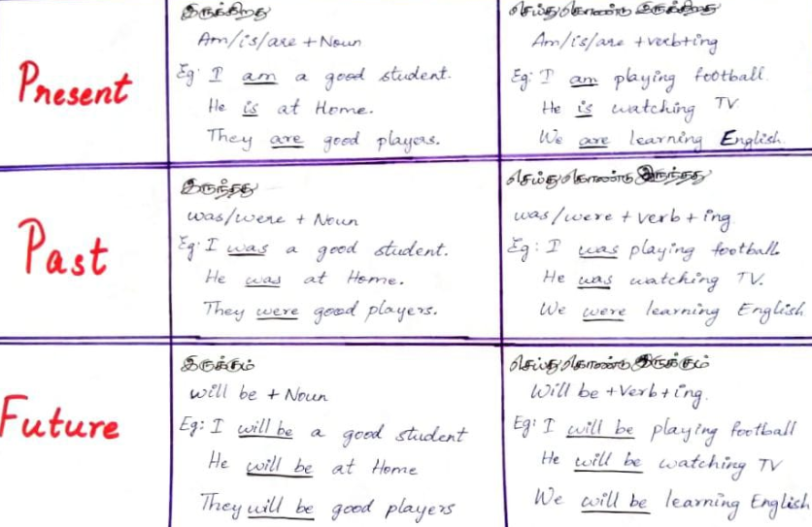

*DAY 10 *
* First mid-term examination*
* Online spoken English*
*Translate the following into English *:
1. நான் ஒரு நல்ல மாணவன்.
2. நான் வீட்டை சென்றடைந்த போது, என்னுடைய அம்மா தூங்கிக் கொண்டு இருந்தார்.
3. நீ ஒரு மருத்துவராக இருப்பாயா?
4. நீ எங்கு செல்கிறாய்?
5. அவள் இப்போது செய்தித்தாள் வாசித்துக் கொண்டு இருக்கிறாள்.
6. நேற்று இந்த நேரத்தில் நான் வீட்டில் இருந்தேன்.
7. நான் அழைத்த போது, நீ என்ன செய்து கொண்டு இருந்தாய்?
8. நாங்கள் நல்ல மாணவர்களாக இருப்போம்.
9. மெஸ்ஸி ஒரு நல்ல விளையாட்டு வீரர்.
10. நாளை இந்த நேரத்தில், நீ என்ன செய்து கொண்டு இருப்பாய்?
11. நீ அங்கு சென்றடைந்த போது, அவன் கால்பந்து விளையாடிக் கொண்டு இருந்தானா?
12. நாளை இந்த நேரம், நீ தூங்கிக் கொண்டு இருப்பாயா?
13. நரேந்திர மோடி இந்தியாவின் பிரதமர் ஆவார்.
14. நேற்று இந்த நேரம், நீ வீட்டில் இருந்தாயா?
15. நான் தமிழ்நாட்டின் முதல்வராக இருக்கமாட்டேன்.
16. அவன் என்ன நினைக்கிறான்?
17. லதா பள்ளிக்குச் சென்று கொண்டு இருக்கிறாள்.
18. நேற்று இந்த நேரம், நான் ஆங்கிலம் படித்துக் கொண்டு இருக்கவில்லை.
19. அவன் என் சேலம் செல்கிறான்?
20. நாளை இந்த நேரம், நீ வகுப்பில் இருப்பாயா?
21. நாங்கள் ஆங்கிலம் கற்றுக் கொண்டு இருக்கிறோம்.
22. நான் வந்த போது, அவள் என்ன விளையாடிக் கொண்டு இருந்தாள்?
23. நான் அழைத்தபோது, நீ தூங்கிக் கொண்டு இருந்தாயா?
24. இந்தியாவின் அடுத்த பிரதமராக இராகுல் காந்தி இருப்பார்.
25. அடுத்த வருடம், நீ எங்கே வேலை செய்து கொண்டு இருப்பாய்?
26. அவர்கள் மட்டைப்பந்து விளையாடிக் கொண்டு இருக்கிறார்கள்.
27. நான் அழைத்தபோது, நீ தொலைக்காட்சி பார்த்துக் கொண்டு இருந்தாயா?
28. ராம் ஒரு நல்ல முதல்வர் இல்லை.
29. நீங்கள் என் ஆங்கிலம் கற்றுக்கொண்டு இருக்கிறீர்கள்?
30. நேற்று இந்த நேரம், நான் பயணம் செய்து கொண்டு இருந்தேன்.
31. அவன் என்னுடைய நண்பன் இல்லை.
32. நீ வீட்டில் இருக்கிறாயா?
33. இப்போது நீ எந்த மொழி கற்றுக் கொண்டு இருகிறாய்?
34. அவள் ஒரு நல்ல பாடகி அல்ல.
35. நான் வந்தபோது, எந்த புத்தகத்தை நீ வாசித்துக் கொண்டு இருந்தாய்?

*Write down the three forms of the following verbs with meaning: *
Begin, count, bring, catch, buy, believe, break, abuse, arrive, go, come, sleep, see, think, study, borrow, beg, burn, carry, build.

First mid-term examination
Answer key
Translate the following
1. நான் ஒரு நல்ல மாணவன்.
Ans- I am a good student.
2. நான் வீட்டை சென்றடைந்த போது, என்னுடைய அம்மா தூங்கிக் கொண்டு இருந்தார்.
Ans- When I reached home, my mother/ mom was sleeping.
3. நீ ஒரு மருத்துவராக இருப்பாயா?
Ans- Will you be a doctor?
4. நீ எங்கு செல்கிறாய்?
Ans- Where are you going?
5. அவள் இப்போது செய்தித்தாள் வாசித்துக் கொண்டிருக்கிறாள்
Ans- She is reading a newspaper now.
6. நேற்று இந்த நேரத்தில் நான் வீட்டில் இருந்தேன்.
Ans- I was at home at this time yesterday.
7. நான் அழைத்த போது, நீ என்ன செய்து கொண்டிருந்தாய்?
Ans- When I called you, what were you doing?
8. நாங்கள் நல்ல மாணவர்களாக இருப்போம்.
Ans- We will be good students.
9. மெஸ்ஸி ஒரு நல்ல விளையாட்டு வீரர்.
Ans- Messi is a good player.
10. நாளை இந்த நேரத்தில், நீ என்ன செய்து கொண்டிருப்பாய்?
Ans- What will you be doing at this time tomorrow?

11. நீ அங்கு சென்றடைந்த போது, அவன் கால்பந்து விளையாடிக் கொண்டிருந்தானா?
Ans- When you reached there, was he playing football?
12. நாளை இந்த நேரம், நீ தூங்கிக் கொண்டு இருப்பாயா?
Ans- Will you be sleeping at this time tomorrow?
13. நரேந்திர மோடி இந்தியாவின் பிரதமர் ஆவார்.
Ans- Narendra Modi is the Prime minister of India.
14. நேற்று இந்த நேரம், நீ வீட்டில் இருந்தாயா?
Ans- Were you at home, by this time yesterday?
15. நான் தமிழ்நாட்டின் முதல்வராக இருக்கமாட்டேன்.
Ans- I will not be the Chief minister of Tamilnadu
16. அவன் என்ன நினைக்கிறான்?
Ans- What is he thinking?
17. லதா பள்ளிக்குச் சென்று கொண்டிருக்கிறாள்.
Ans- Latha is going to school.
18. நேற்று இந்த நேரம், நான் ஆங்கிலம் படித்துக் கொண்டிருக்கவில்லை.
Ans- I was not studying English at this time yesterday.
19. அவன் ஏன் சேலம் செல்கிறான்?
Ans- Why is he going to Salem?
20. நாளை இந்த நேரம், நீ வகுப்பில் இருப்பாயா?
Ans- Will you be at class at this time tomorrow?
21. நாங்கள் ஆங்கிலம் கற்றுக் கொண்டிருக்கிறோம்.
Ans- We are learning English.
22. நான் வந்த போது, அவள் என்ன விளையாடிக் கொண்டிருந்தாள்?
Ans- When I came, what was she playing?
23. நான் அழைத்தபோது, நீ தூங்கிக் கொண்டிருந்தாயா?
Ans- When I called you, were you sleeping?
24. இந்தியாவின் அடுத்த பிரதமராக இராகுல் காந்தி இருப்பார்.
Ans- Raghul Gandhi will be the next prime minister of India.
25. அடுத்த வருடம், நீ எங்கே வேலை செய்து கொண்டிருப்பாய்?
Ans- Where will you be working next year?
26. அவர்கள் மட்டைப்பந்து விளையாடிக் கொண்டிருக்கிறார்கள்.
Ans- They are playing cricket.
27. நான் அழைத்தபோது, நீ தொலைக்காட்சி பார்த்துக் கொண்டிருந்தாயா?
Ans- When I called you, were you watching TV?
28. ராம் ஒரு நல்ல முதல்வர் இல்லை.
Ans- Ram is not a good Chief Minister.
29. நீங்கள் ஏன் ஆங்கிலம் கற்றுக்கொண்டு இருக்கிறீர்கள்?
Ans- Why are you learning English?
30. நேற்று இந்த நேரம், நான் பயணம் செய்து கொண்டிருந்தேன்.
Ans- I was travelling at this time yesterday.
31. அவன் என்னுடைய நண்பன் இல்லை.
Ans- He is not my friend.
32. நீ வீட்டில் இருக்கிறாயா?
Ans- Are you at home?
33. இப்போது நீ எந்த மொழி கற்றுக் கொண்டு இருகிறாய்?
Ans- Which language are you learning now?
34. அவள் ஒரு நல்ல பாடகி அல்ல.
Ans- She is not a good singer.
35. நான் வந்தபோது, எந்த புத்தகத்தை நீ வாசித்துக் கொண்டிருந்தாய்?
Ans- When I came, which book were you reading?
Write down the three forms of the following verbs with meaning:

Verbs | Present Verb (Tamil) | Past | Past Participle
begin | தொடங்கு | began | begun
count | எண்ணு | counted | counted
bring | கொண்டு வா | brought | brought
catch | பிடி | caught | caught
buy | வாங்கு | bought | bought
believe | நம்பு | believed | believed
break | உடை | broke | broken
abuse | துஷ்பிரயோகம் | abused | abused
arrive | வந்து சேரும் | arrived | arrived
go | போ | went | gone
come | வா | came | come
sleep | தூங்கு | slept | slept
see | பார் | saw | seen
think | யோசி | thought | thought
study | படி | studied | studied
borrow | கடன் வாங்கு | borrowed | borrowed
beg | மன்றாடு | begged | begged
burn | எரி | burned | burned
carry | எடுத்துச்செல் | carried | carried
build | கட்டு | built | built

*DAY 11 *
*Today's Chapter *
*செய்ய முடியும்,செய்யலாம், செய்வேன். *
*Can + verb 1 *
*(Singular, plural என்று எந்த வித்தியாசம் இல்லை) *
Eg.
1. I can speak English.
என்னால் ஆங்கிலம் பேச முடியும்.
2. I can do that.
என்னால் அதைச் செய்ய முடியும்.
3. You can come in.
நீங்கள் உள்ளே வரலாம்.

*செய்ய முடியுமா?, செய்யலாமா?, செய்யவா? (Can + SUBJECT + v1)* *
*[Can என்னும் வார்த்தையை வாக்கியத்தின் முன்பு கொண்டு வர வேண்டும்] *
Eg.
1. Can you speak English?
உங்களால் ஆங்கிலம் பேச முடியுமா?
*Request: *
Can you help me?
உங்களால் எனக்கு உதவி செய்ய முடியுமா?
*Permission: *
Can I come in?
நான் உள்ளே வரலாமா?

*WH QUESTIONS of Can (Can + SUBJECT + v1)*
Eg.
1. How many languages can you speak?
எத்தனை மொழிகளை உங்களால் பேச முடியும்?
2. How can I go there?
என்னால் எப்படி அங்கு செல்ல முடியும்?

Today's ten verbs

Verbs | Present Verb (Tamil) | Past | Past Participle
Fight | சண்டையிடு | fought | fought
Find | கண்டுபிடி | found | found
Finish | தீர்த்து விடு,  பூர்த்தி செய் | finished | finished
Fly | பற | flew | flown
Forget | மற | forgot | forgotten
Gather | கூட்டமாக கூடு | gathered | gathered
Get | பெறு/ அடை | got | got
Give | கொடு | gave | given
Grow | வளரு/வளர் | grew | grown
Hate | வெறு | hated | hated

Today's story 👇👇👇
One day, king Akbar asked a question in his court that left everyone in the courtroom puzzled. As they all tried to figure out the answer, Birbal walked in and asked what the matter was. They repeated the question to him.
The question was, “How many crows are there in the city?”
Birbal immediately smiled and went up to Akbar. He announced the answer; he said there were twenty-one thousand, five hundred and twenty-three crows in the city. When asked how he knew the answer, Birbal replied, “Ask your men to count the number of crows. If there are more, then the relatives of the crows must be visiting them from nearby cities. If there are fewer, then the crows from our city must be visiting their relatives who live outside the city.” Pleased with the answer, Akbar presented Birbal with a ruby and pearl chain.

*DAY 12 *
*Today's Chapter *
*செய்ய முடிந்தது * [past of can]
*Could + v1 *
*[Singular plural என்று எந்த வித்தியாசமும் இல்லை] *
Eg.
1. I could see him yesterday.
நேற்று என்னால் அவனைப் பார்க்க முடிந்தது.
2. I could sing a song in that program.
அந்த நிகழ்வில் என்னால் ஒரு பாடலை பாட முடிந்தது.

*செய்ய முடியவில்லை *
*Could + not + verb 1 *
*Could + not = couldn't *
*(Singular, plural என்று எந்த வித்தியாசமும் இல்லை) *
Eg.
1. I could not see him yesterday.
நேற்று என்னால் அவரைப் பார்க்க முடியவில்லை.
2. I could not sing a song in that program.
அந்த நிகழ்வில் என்னால் ஒரு பாடல் பாட முடியவில்லை.

*செய்ய முடிந்ததா? *
*(Could என்னும் வார்த்தையை வாக்கியத்தின் முன்பு கொண்டு வர வேண்டும்) *
Eg.
1. Could you see him yesterday?
நேற்று அவரை உங்களால் பார்க்க முடிந்ததா?
2. Could you sing a song in that program?
அந்த நிகழ்வில் உங்களால் ஒரு பாடலை பாட முடிந்ததா?

*WH questions of could:*
*(மேலே உள்ள ஆம்/இல்லை கேள்விகளுக்கு முன்பாக அர்த்தத்துடன் பொருந்தக்கூடிய WH கேள்விச் சொற்களை கொண்டு வர வேண்டும்) *
Eg.
1. What could you see there?
உங்களால் அங்கு என்ன பார்க்க முடிந்தது?
2. How could you reach there?
உங்களால் எப்படி அங்கு சென்றடைய முடிந்தது?
Today's ten verbs

Verbs | Present Verb (Tamil) | Past | Past Participle
Keep | வைத்திரு | kept | kept
Kill | கொல்/கொலை செய் | killed | killed
Know | தெரிந்து கொள் | knew | known
Laugh | சிரி | laughed | laughed
Explain | விளக்கு/விளக்கம் கொடு | explained | explained
Learn | கற்றுக்கொள் | learned | learned
Leave | விட்டுவிடு | left | left
Let | அனுமதி | let | let
Listen | கவனி | listened | listened
Live | வாழ் | lived | lived

*DAY 13 *
*Today's Chapter *
*Today's listening session * - *Personality *
*செய்ய விரும்புகிறது *
*(Would like to + verb) *
E.g.
1. I would like to speak English
நான் ஆங்கிலம் பேச விரும்புகிறேன்
2. We would like to travel
நாங்கள் பயணம் செய்ய விரும்புகிறோம்.
*செய்ய விரும்பவில்லை *
*(Would not like to + verb) *
E.g.
1. I would not like to speak English
நான் ஆங்கிலம் பேச விரும்பவில்லை.
2. We would not like to travel.
நாங்கள் பயணம் செய்ய விரும்பவில்லை.
*செய்ய விரும்புகிறதா? *
*( Would என்னும் வார்த்தையை வாக்கியத்தின் முன்பு கொண்டு வர வேண்டும் ) *
E.g.
1. Would you like to speak English
நீங்கள் ஆங்கிலம் பேச விரும்புகிறீர்களா?
2. Would you like to travel
நீங்கள் பயணம் செய்ய விரும்புகிறீர்களா?
*WH Questions of would like to*
E.g.
1. What would you like to eat for breakfast?
காலை உணவுக்கு நீங்கள் என்ன சாப்பிட விரும்புகிறீர்கள்?
2. Where would you like to go today?
இன்று நீங்கள் எங்கு செல்ல விரும்புகிறீர்கள்?
3. Which car would you like to drive?
நீங்கள் எந்த மகிழுந்தை ஓட்ட விரும்புகிறீர்கள்?

Today's ten verbs

Verbs | Present Verb (Tamil) | Past | Past Participle
Like | விரும்பு | liked | liked
Look | பார் | looked | looked
Lose | இழந்து விடு | lost | lost
Love | நேசி | loved | loved
Make | தயார் செய்/ உருவாக்கு | made | made
Marry | திருமணம் செய் | married | married
Mean | நோக்கம், எண்ணம்/ எண்ணு | meant | meant
Meet | சந்தி/ கூடு | met | met
Melt | உருகு/ உருக்கு | melted | melted
Move | நகரு/ நகர்த்து | moved | moved

Today's story 👇👇👇
There was a girl named Asha who lived with her mother and father in a village. One day, her father assigned her a simple task. He took three vessels filled with boiling water. He placed an egg in one vessel, a potato in the second vessel, and some tea leaves in the third vessel. He asked Asha to keep an eye on the vessels for about ten to fifteen minutes while the three ingredients in three separate vessels boiled. After the said time, he asked Asha to peel the potato and egg, and strain the tea leaves. Asha was left puzzled – she understood her father was trying to explain her something, but she didn’t know what it was.
Her father explained, “All three items were put in the same circumstances. See how they’ve responded differently.” He said that the potato turned soft, the egg turned hard, and the tea leaves changed the colour and taste of the water. He further said, “We are all like one of these items. When adversity calls, we respond exactly the way they do. Now, are you a potato, an egg, or tea leaves?”

*DAY 14*
*Today's Chapter *
*Today's listening session * - *Economy *

*உள்ளது (Have/Has + Noun) *
Singular + Has
Plural + have

He, she, it, that, ramu , everybody + *Has *
I, you, they, we, ramu and guna + *have *

E.g.
*has * 👇
He has a car.
அவரிடம் ஒரு மகிழுந்து உள்ளது.
Ramu has a bike.
அருணிடம் ஒரு சக்கர வாகனம் உள்ளது.

*have * 👇
I have a mobilephone.
என்னிடம் ஒரு கைபேசி உள்ளது.
We have a good class.
எங்களுக்கு ஒரு நல்ல வகுப்பு உள்ளது.

*இல்லை (don't have / doesn't have + Noun)*
Singular + doesn't have
Plural + don't have

He, she, it, that, ramu , everybody + *doesn't have *
I, you, they, we, ramu and guna + *don't have *

E.g.
*doesn't have * 👇
He doesn't have a car.
அவரிடம் ஒரு மகிழுந்து இல்லை.
Ramu doesn't have a bike.
அருணிடம் ஒரு இரு சக்கர வாகனம் இல்லை.

*don't have * 👇
I don't have a mobilephone.
என்னிடம் ஒரு கைபேசி இல்லை.
We don't have a good class.
எங்களுக்கு ஒரு நல்ல வகுப்பு இல்லை.

*உள்ளதா? (do you have / does he have + Noun) *
Singular + does
Plural + do

He, she, it, that, ramu , everybody + *does*
I, you, they, we, ramu and guna + *do*

E.g.
*does * 👇
Does he have a car?
அவரிடம் ஒரு மகிழுந்து உள்ளதா?
Does he have a bike?
அவரிடம் ஒரு இரு சக்கர வாகனம் உள்ளதா?

*do * 👇
Do you have a mobile phone?
உங்களிடம் ஒரு கைபேசி உள்ளதா?
Do you have class today?
உங்களுக்கு இன்று வகுப்பு உள்ளதா?

WH Questions of have and has
*(Yes or No [ஆம்/ இல்லை] கேள்விகளுக்கு முன் அர்த்தமுடன் பொருந்தக்கூடிய WH கேள்வி வார்த்தைகளை கொண்டு வர வேண்டும். ) *
E.g.
When do you have class today?
இன்று உங்களுக்கு எப்போது வகுப்பு உள்ளது?
Where do you have class today?
இன்று உங்களுக்கு எங்கே வகுப்பு உள்ளது?
What does he have with him?
அவர் அவரிடம் என்ன வைத்து உள்ளார்?
Which car does she have ?
அவளிடம் எந்த மகிழுந்து உள்ளது?

Today's ten verbs
Verbs | Present Verb (Tamil) | Past | Past Participle
Have | உள்ளது | had | had
Hear | கேள் | heard | heard
Help | உதவி செய் | helped | helped
Hide | ஒளிந்து கொள் | hid | hiddden
Hold | பிடி | held | held
Hurt | காயப்படுத்து | hurt | hurt
Improve | மேம்படுத்து | improved | improved
Invite | அழை | invited | invited
Join | சேர்ந்து கொள் | joined | joined
Jump | குதி | jumped | jumped

*Day-to-day vocabulary list *
*Household Articles*
*வீட்டுப் பொருட்கள்*
◇Blender - கலக்கும் கருவி
◇Broom - துடைப்பம்🧹
◇Candle - மெழுகுவர்த்தி🕯️
◇Comb - சீப்பு
◇Cot - கட்டில்🛏️
◇Fireplace - அடுப்பு
◇Fork - முள் கரண்டி🍴
◇Key - சாவி🔑
◇Lamp - விளக்கு
◇Lantern - கண்ணாடி கூட்டு விளக்கு/ கண்ணாடி கூண்டு விளக்கு
◇Mat - பாய்
◇Mirror - கண்ணாடி🪞
◇Mortar - உரல்
◇Needle - ஊசி 🪡
◇Pestle - உலக்கை 🥢
◇Pillow - தலையணை 🛌
◇Pitcher - ஜாடி 🍯
◇Pot - குடம்/ மண்பாண்டம்🧉
◇Peeler- தோல் உரிகும் கருவி
◇Rope - கயிறு🪢
◇Sack - கோணி
◇Sewing machine - தையல் இயந்திரம்
◇Sieve - சல்லடை
◇Smokestack - புகை போக்கி
◇String - நரம்பு/ சரடு🧶
◇Umbrella - குடை⛱️
◇Wick - விளக்கு திரி 🪔

*DAY 15 *
*Today's Chapter *
*Today's listening session * - *Importance of listening *
*செய்துள்ளது - have/has + v3*

Singular + has
Plural + have

E.g.
*has * 👇
She has reached there
அவள் அங்கு வந்து சேர்ந்துள்ளாள்

*have * 👇
I have completed my homework.
எனது வீட்டுப்பாடத்தை நான் செய்து முடித்து உள்ளேன்.

*செய்யவில்லை - have/has + not + v3 *
Singular + has
Plural + have

E.g.
*has not * 👇
She has not reached there.
அவள் அங்கு வந்து சேரவில்லை.

*have not * 👇
I have not completed my homework.
எனது வீட்டுப்பாடத்தை நான் செய்து முடிக்கவில்லை.

*செய்து உள்ளதா? *
*(have/has வார்த்தைகளை வாக்கியத்தின் முன்பு கொண்டு வர வேண்டும்) *
E.g.
*has * 👇
Has she reached there?
அவள் அங்கு வந்து சேர்ந்து உள்ளாரா?

*have * 👇
Have you completed your homework?
உங்கள் வீட்டுப்பாடத்தை நீங்கள் செய்து முடித்துள்ளீர்களா?

WH Questions of have and has
*(Yes or No [ஆம் / இல்லை] கேள்விகளுக்கு முன் அர்த்தமுடன் பொருந்தக்கூடிய WH கேள்வி வார்த்தைகளை கொண்டு வர வேண்டும்.)*
He, She, It - does
I, we, you, they - do
E.g.
When do you have class today?
இன்று உங்களுக்கு எப்போது வகுப்பு உள்ளது?
Where do you have class today?
இன்று உங்களுக்கு எங்கே வகுப்பு உள்ளது?
What does he have with him?
அவர் அவரிடம் என்ன வைத்து உள்ளார்?
Which car does she have?
அவளிடம் எந்த மகிழுந்து உள்ளது?
Today's ten verbs

Verbs | Present Verb (Tamil) | Past | Past Participle
Have | உள்ளது | had | had
Hear | கேள் | heard | heard
Help | உதவி செய் | helped | helped
Hide | ஒளிந்து கொள் | hid | hidden
Hold | பிடி | held | held
Hurt | காயப்படுத்து | hurt | hurt
Improve | மேம்படுத்து | improved | improved
Invite | அழை | invited | invited
Join | சேர்ந்து கொள் | joined | joined
Jump | குதி | jumped | jumped

Today's story 👇👇👇👇
Once upon a time, three neighbours living in a village were having trouble with their crops. Each of the neighbours had one field, but the crops on their fields were infested with pests and were wilting. Every day, they would come up with different ideas to help their crops. The first one tried using a scarecrow in his field, the second used pesticides, and the third built a fence on his field, all to no avail.
One day, the village head came by and called the three farmers. He gave them each a stick and asked them to break it. The farmers could break them easily. He then gave them a bundle of three sticks, and again, asked them to break it. This time, the farmers struggled to break the sticks. The village head said, “Together, you are stronger and work better than you do it alone.” The farmers understood what the village head was saying. They pooled in their resources and got rid of the pests from their fields.

Moral of the Story
There is strength in unity.

( infested – தொற்றிக்கொண்டது, pests – பூச்சிகள், wilting – வாடுதல்,
scarecrow - பயமுறுத்தும், They pooled in their resources and got rid of the pests from their fields - அவர்கள் தங்கள் வளங்களை சேகரித்து, தங்கள் வயல்களில் இருந்து பூச்சிகளை அகற்றினர்.)

*DAY 16*
*Today's Chapter *
*Today's listening session * - *Importance of listening *
*செய்யவேண்டி உள்ளது - (have to / has to + v1) *
E.g.
I have to go to calicut today.
நான் இன்று சென்னை செல்ல வேண்டி உள்ளது.
He has to write homeworks
அவர் வீட்டுப்பாடங்களை எழுத வேண்டி உள்ளது.

*செய்ய வேண்டியதில்லை - (don't have to / doesn't have to + v1) *
E.g.
*Don't have to * 👇
I don't have to go to calicut today.
நான் இன்று சென்னைக்கு செல்ல வேண்டியதில்லை.

*doesn't have to * 👇
He doesn't have to write homeworks.
அவர் வீட்டுப்பாடங்களை எழுத வேண்டியதில்லை

*செய்யவேண்டி உள்ளதா? *
*(do (you) have to / does (he) have to + v1) *
E.g - *Do (you) have to * 👇
Do you have to go to Salem?
நீங்கள் இன்று சேலம் செல்ல வேண்டி உள்ளதா?
*does (he) have to * 👇
Does he have to write homeworks?
அவர் வீட்டுப்பாடங்களை எழுத வேண்டி உள்ளதா?

WH Questions
Where do you have to go today?
இன்று நீங்கள் எங்கு செல்ல வேண்டி உள்ளது?
When does he have to go to Chennai?
அவர் எப்போது சென்னை செல்ல வேண்டி உள்ளது?
Today's ten verbs
Verbs | Present Verb (Tamil) | Past | Past Participle
Remember | ஞாபகப்படுத்த | remembered | remembered
Reply | பதில் கூறு | replied | replied
Rest | ஓய்வு எடு | rested | rested
Return | திரும்பி வா/ திருப்பிக்கொடு | returned | returned
Ride | பயணிக்க | rode | ridden
Ring | ஒலிக்க | rang | rung
Save | சேமிக்க, காப்பாற்ற | saved | saved
Say | கூறு | said | said
See | பார் | saw | seen
Seek | தேடு | sought | sought
Day-to-day vocabulary list
Stationery
பொருளகம்/ எழுது பொருள்கள்
📍📍📍📍📍📍📍 📍📍📍📍📍📍
🔰 Glue / Gum - பசை
🔰 Ink - மை
🔰 Seal - முத்திரை
🔰 Book 📚- புத்தகம்
🔰 Thread - நூல்
🔰 Shelf - அலமாரி
🔰 Pin 🧷- குண்டூசி
🔰 Writing pad 🗒️- எழுது திண்டு/அட்டை
🔰 Folder - கோப்புறை
🔰 File 📁- கோப்பு
🔰 Bell 🔔- மணி
🔰 Paperweight - தாள் நிறுத்தி ( காகிதங்கள் பறக்காமல் இருக்க வைக்கும் எடை)
🔰 clips 🖇️- கவ்வி/பற்றி/பிடிப்பி
🔰 Lens 🔎 - கண்ணாடி வில்லை
🔰 Clipboard 📋- பிடிப்பு பலகை
🔰 Waste basket🗑️ - குப்பை கூடை
🔰 Scissors✂️ - கத்திரி
🔰 Easel - நிலைச்சட்டம்
🔰 Globe - உலக உருண்டை
🔰 Envelope ✉️- கடித உறை
*DAY 17*
*Today's Chapter *
🌿🌿"Be courageous. Challenge orthodoxy. Stand up for what you believe in. When you are in your rocking chair talking to your grandchildren many years from now, be sure you have a good story to tell." — Amal Clooney🌿🌿

*இருந்தது - ( had + noun) *
*(singular or plural எந்த வித்தியாசமும் இல்லை) *

E.g.
I had a cycle in my childhood.
என் குழந்தை பருவத்தில் என்னிடம் ஒரு மிதிவண்டி இருந்தது.
We had a program yesterday.
எங்களுக்கு நேற்று ஒரு நிகழ்வு இருந்தது.

*இருந்ததில்லை - ( didn't have + noun) *
*(singular or plural என்று எந்த வித்தியாசமும் இல்லை) *

E.g.
I didn't have a cycle in my childhood.
என் குழந்தை பருவத்தில் என்னிடம் ஒரு மிதிவண்டி இருந்ததில்லை.
We didn't have class yesterday.
எங்களுக்கு நேற்று வகுப்பு இருக்கவில்லை.

*இருந்ததா? *
*(had என்னும் வார்த்தையை வாக்கியத்தின் தொடக்கத்தில் கொண்டு வர வேண்டும்) *
E.g.
had you class yesterday?
உங்களுக்கு நேற்று வகுப்பு இருந்ததா?
Had she a program yesterday?
நேற்று அவளுக்கு ஒரு நிகழ்வு இருந்ததா?

Today's Story 👇👇
The Three Fish
There were three fish living in a pond. They were friends and practically did everything together.
One day, a fisherman came across the pond and was delighted to see the fish. He made plans to cast a net and catch them.
The wisest of the fishes made plans to find a different pond. While one of the fish agreed, the other one denied, saying that the pond was home and he shall not vacate it. The third fish further said that there had never been any danger in the pond. “I don’t see the point of leaving this pond. I think it is cowardly.”
The first two fish were unable to convince their friend, and so they decided to part ways.
The next day, when the fisherman cast his net, the first two fish escaped. However, the third one got caught. He had been unable to identify and act upon the problem and was now paying the price of neglecting danger.

(delighted – மகிழ்ச்சியடைந்தார், wisest – புத்திசாலி, vacate – காலி,
Cowardly – கோழைத்தனமான, neglecting - புறக்கணித்தல்)

Today's ten verbs

Verbs | Present Verb (Tamil) | Past | Past Participle
Select | தேந்தெடு | selected | selected
Sell | விற்க | sold | sold
Send | அனுப்பு | sent | sent
Shoot | சுடு | shot | shot
Sing | பாடு | sang | sung
Sit | உட்கார் | sat | sat
Sleep | தூங்கு/ உறங்கு | slept | slept
Speak | பேசு | spoke | spoken
Spend | செலவு செய் | spent | spent
Spread | பரப்பு | spread | spread

*DAY 18 *
*Today's Chapter *
*Today's listening session - Citizenship *
*செய்திருந்தது - (had + v3) *
*(Singular or plural என்று எந்த வித்தியாசமும் இல்லை) *

E.g.
When I reached at railway station, the train had left.
நான் தொடர்வண்டி நிலையத்தை சென்றடைந்த போது, தொடர்வண்டி சென்றிருந்தது.
When I called her, she had slept.
நான் அவளை அழைத்தபோது, அவள் தூங்கி இருந்தாள்.

*செய்திருந்ததா * ?
*(had என்னும் வார்த்தையை வாக்கியத்தின் தொடக்கத்தில் கொண்டு வர வேண்டும் ) *

E.g
When I called you, had you slept.
நான் உன்னை அழைத்தபோது, நீ தூங்கி இருந்தாயா?
Had you reached there at this time yesterday.
நேற்று இந்த நேரத்தில் நீங்கள் அங்கு சென்றடைந்து இருந்தீர்களா?

*செய்திருந்ததா * ?
*(had என்னும் வார்த்தையை வாக்கியத்தின் தொடக்கத்தில் கொண்டு வர வேண்டும் ) *
E.g
When I called you, had you slept.
நான் உன்னை அழைத்தபோது, நீ தூங்கி இருந்தாயா?
Had you reached there at this time yesterday.
நேற்று இந்த நேரத்தில் நீங்கள் அங்கு சென்றடைந்து இருந்தீர்களா?

*செய்திருக்கவில்லை - (had + not + v3) *
E.g.
When I reached at railway station the train had not left.
நான் தொடர்வண்டி நிலையத்தை சென்றடைந்த போது, தொடர்வண்டி சென்றிருக்கவில்லை.
When I called her, she had not slept.
நான் அவளை அழைத்தபோது, அவள் தூங்கி இருக்கவில்லை.

*WH Questions *
*(மேலே உள்ள ஆம்/இல்லை கேள்விகளுக்கு முன் அர்த்தத்துடன் பொருந்தக்கூடிய WH கேள்வி சொற்களை கொண்டு வர வேண்டும்) *
E.g
When had you slept yesterday?
நேற்று எப்போது நீங்கள் தூங்கி இருந்தாய்?
How had you reached there?
நீங்கள் அங்கு எப்படி சென்றடைந்து இருந்தாய்?
Today's ten verbs

Verbs | Present Verb (Tamil) | Past | Past Participle
Stand | நில் | stood | stood
Stay | தங்கு | stayed | stayed
Steal | திருடு | stole | stolen
Stop | நிறுத்து | stopped | stopped
Study | படி | studied | studied
Sweep | பெருக்கு/கூட்டு | swept | swept
Swim | நீந்து | swam | swum
Take | எடு | took | taken
Talk | பேச்சு | talked | talked
Teach | கற்பிக்க | taught | taught

Day-to-day vocabulary list
Tools - ( கருவிகள்/ ஆயுதங்கள் )
🏮Axe🪓 - கோடாரி
🏮Hammer 🔨- சுத்தியல்
🏮Mallet - மரச்சுத்தியல்
🏮Hacksaw - வெட்டும் ரம்பம்
🏮Hoe - மண்வெட்டி
🏮Hone - சானைக்கல்
🏮Knife🔪 - கத்தி
🏮Ladder 🪜- ஏணி
🏮Nail - ஆணி
🏮Spanner 🔧- திருப்பிலி/ திருகி
🏮Sickle - அரிவாள்
🏮Screw - திருகாணி/ திருகு
🏮Scraper - உளி/சீவுளி
🏮Saw - ரம்பம்
🏮Sander - மணற்பரப்பி
🏮Pulley - உருளை
🏮Rope - கயிறு
🏮Plough - கலப்பை/ஏர்
🏮Ratchet - பற்ச்சட்டம்
🏮Pliers - இடுக்கு குறடு
🏮Pickaxe⛏️ - குத்துக் கோடரி
🏮Pestle - குழவி/உலக்கை
🏮Measuring-tape - அளவு நாடா / அளக்கும் நாடா
*DAY 19 *
*Today's Chapter *
*இருக்கும் - Will have + noun*
*(singular or plural என்று எந்த வித்தியாசமும் இல்லை) *
E.g.
We will have class tomorrow.
நாளை எங்களுக்கு வகுப்பு இருக்கும்.
I will have a big house in my future.
எனது எதிர்காலத்தில் எனக்கு ஒரு பெரிய வீடு இருக்கும்.

*இருக்குமா? - (will (you) have + noun) *
E.g.
Will you have class tomorrow?
நாளை உங்களுக்கு வகுப்பு இருக்குமா?
Will he have a good future?
அவருக்கு ஒரு நல்ல எதிர்காலம் இருக்குமா?

*WH questions*
*(மேலே உள்ள Yes or No கேள்விகளுக்கு முன் அர்த்தத்துடன் பொருந்தக்கூடிய WH கேள்வி வார்த்தைகளை கொண்டு வர வேண்டும்) *
E.g.
When will you have class tomorrow?
நாளை எப்போது உங்களுக்கு வகுப்பு இருக்கும்?
Which class will you have tomorrow?
Malai உங்களுக்கு எந்த வகுப்பு இருக்கும்?
Today's ten verbs

Verbs | Present Verb (Tamil) | Past | Past Participle
Tear | கிழிக்க | tore | torn
Tell | கூற/சொல்ல | told | told
Think | நினைக்க/யோசிக்க | thought | thought
Tie | கட்டு | tied | tied
Touch | தொடு | touched | touched
Trust | நம்பு | trusted | trusted
Try | முயற்சி செய் | tried | tried
Understand | புரிந்து கொள் | understood | understood
Use | பயன்படுத்து | used | used
Wait | காத்திரு | waited | waited

Today's story 👇👇
The Elephant and Her Friends
Once upon a time, a lone elephant made her way into a strange forest. It was new to her, and she was looking to make friends. She approached a monkey and said, “Hello, monkey! Would you like to be my friend?” The monkey said, “You are too big to swing like me, so I can’t be your friend.” The elephant then went to a rabbit and asked the same question. The rabbit said, “You are too big to fit in my burrow, so I can’t be your friend.” The elephant also went to the frog in the pond and asked the same question. The frog replied, “You are too heavy to jump as high as me, so I can’t be your friend.”
The elephant was really sad because she couldn’t make friends. Then, one day, she saw all the animals running deeper into the forest, and she asked a bear what the fuss was about. The bear said, “The lion is on the loose – they are running from him to save themselves.” The elephant went up to the lion and said, “Please don’t hurt these innocent people. Please leave them alone.” The lion scoffed and asked the elephant to move aside. Then, the elephant got angry and pushed the lion with all her might, injuring him. All the other animals came out slowly and started to rejoice about the lion’s defeat. They went to the elephant and said to her, “You are just the right size to be our friend!”

*DAY 20 *
*Today's Chapter *
*Today's listening session - Kittur Rani Chennamma *
*Today's Chapter *

*செய்திருக்கும் - Will have + v3 *
*(Singular or plural என்று எந்த வித்தியாசமும் இல்லை) *
E.g.
I will have reached there by this time tomorrow.
நாளை இந்த நேரத்தில் நான் அங்கு சென்றடைந்து இருப்பேன்.
They will have completed their project by saturday.
அவர்கள் சனிக்கிழமைக்குள் தங்கள் செயல்திட்டத்தை முடித்திருப்பார்கள்.

*செய்யவேண்டி இருக்கும் / (செய்யவேண்டி வரும்) - (Will have to + v1) *
E.g.
You will have to solve this problem.
இந்த சிக்கலை நீங்கள் தீர்க்க வேண்டி இருக்கும்.

*செய்திருக்குமா? - (Will (you) have + v3) *
E.g.
Will you have reached there by this time tomorrow?
நாளை இந்த நேரத்தில் நீங்கள் அங்கு சென்றடைந்து இருப்பீர்களா?
Will you have completed your homeworks by this time tomorrow?
நாளை இந்த நேரத்தில் உங்கள் வீட்டுப்பாடங்களை நீங்கள் முடித்து இருப்பீர்களா?

*DAY 21 *
*Second mid-term exam revision class *

*DAY 22 *
*Second mid-term exam *

*Second mid-term examination *👇👇👇👇👇
Time: 1 hr Mark: 100
Translate the following sentences into English
1-எங்களுக்கு ஒரு நல்ல வகுப்பு உள்ளது.
2-நான் வீட்டிற்கு வந்தபோது என் அம்மா தூங்கி இருந்தாள்.
3-நாங்கள் நல்ல மாணவர்கள்.
4-எனக்கு நாளை வகுப்பு இருக்காது.
5-அவர் அங்கு சென்றடைந்து உள்ளார்.
6-நாங்கள் இப்போது ஆங்கிலம் கற்கிறோம்.
7-என்னுடைய சிறு வயதில் என்னிடம் ஒரு மிதிவண்டி இருந்தது.
8-நான் ஒரு போலீஸ்காரராக இருப்பேன்.
9-நாளை இந்த நேரத்தில் நாங்கள் பயணம் செய்து இருப்போம்.
10-அவள் வீட்டுப்பாடம் எழுதியுள்ளாள்.
11-நான் பேருந்து நிறுத்தத்திற்கு வந்தடைந்த போது பேருந்து போயிருந்தது.
12-நீங்கள் குளித்து உள்ளாயா?
13-நீ இப்போது டிவி பார்க்கிறாயா?
14-எங்களுக்கு நாளை வகுப்பு இருக்காது.
15-அவனிடம் ஒரு மகிழுந்து இல்லை.
16-எனக்கு நேற்று ஒரு நிகழ்வும் இருக்கவில்லை.
17-நேற்று இந்த நேரம் நான் வீட்டில் இருந்தேன்.
18-சித்ரா காலை உணவை சாப்பிட்டுள்ளார்.
19-நீங்கள் செய்தித்தாள் வாசித்து உள்ளாயா?
20-நான் அவரை அழைத்தபோது, ​​அவர் தூங்கி இருந்தார்.
21-எனது எதிர்காலத்தில், எனக்கு ஒரு பெரிய வீடு இருக்கும்.
22-நான் உங்களை அழைத்தபோது நீங்கள் தூங்கி இருந்தீர்களா?

23-அவளிடம் நல்ல பை இல்லை.
24-நீங்கள் இப்போது வகுப்பில் இருக்கிறீர்களா?
25-எனக்கு நேரமில்லை.
26-உங்களுக்கு இன்று எப்போது வகுப்பு உள்ளது?
27-நீ எப்படி அங்கு சென்றடைந்து உள்ளாய்?
28-என்னால் இந்தி பேச முடியாது.
29-நேற்று உனக்கு என்ன வகுப்பு இருந்தது?
30-நான் ஆங்கிலம் பேச விரும்புகிறேன்.
31-நாளை உனக்கு எப்போது வகுப்பு இருக்கும்?
32-உங்களால் எனக்கு உதவ முடியுமா?
33-நேற்று இந்த நேரத்தில் நீங்கள் எங்கே சென்றடைந்து இருந்தீர்கள்?
34-நீங்கள் பயணம் செய்ய விரும்புகிறீர்களா?
35-எனக்கு இன்று பள்ளிக்கு செல்ல வேண்டி உள்ளது.
36-மனிதனால் பறக்க முடியாது.
37-பறவைகள் பறக்க முடியும்.
38-நான் உங்களுடன் பயணம் செய்ய விரும்பவில்லை.
39-நாங்கள் நேற்று சேலம் செல்ல வேண்டியிருந்தது.
40-நான் உள்ளே வரலாமா?
41-நாளை உங்களுக்கு எங்கே வகுப்பு இருக்கும்?
42-நான் அங்கு ஆங்கிலம் பேச வேண்டி வரும்.
43-நேற்று எங்களுக்கு வீட்டுப்பாடம் எழுத வேண்டியிருந்தது.
44-நீ உள்ளே வரலாம்.
45-நாங்கள் எப்போதும் ஆங்கிலம் பேச விரும்புகிறோம்.
46-நான் அங்கு சென்றடைந்த போது, நிகழ்வு முடிந்திருந்தது.
47-நீ வெளிநாடு செல்ல விரும்புகிறாயா?
48-என்னால் உங்களுக்கு உதவமுடியும்.
49-உன்னிடம் எந்த மகிழுந்து உள்ளது?
50-அவர் அந்த நிகழ்வில் அழகாக நடனமாடி உள்ளார்.

*Write down three forms of the following verbs with meaning. *
Mark:20

Appear, abuse, build, catch, bring, begin, cook, count, bite, choose, take, decide, die, do, eat, fall, feel, defeat, behave, open.

*Translate the following sentences into Tamil. *
Mark:5
1- I have sent a letter to my father.
2- Have you met him?
3- When i looked into the forest, the birds were flying.
4- He has taken a good decision.
5- When i reached at home, my mother had eaten breakfast.

*Write down the meanings of the following words in Tamil *
Mark:25
Cow, together, graze, saw, opportunity, strength, farmer, refused, so, emperor, well, sold, immediately, realize, lesson,. miser, dark, treasure, loudly, thief, hid, hate, agreed, shepherd, shout.

*Second Mid-term Examination Answer.*
Time: 1 hr Mark: 100
Answer key 👇
Translate the following sentences into English - Mark 50
1-எங்களுக்கு ஒரு நல்ல வகுப்பு உள்ளது.
A- We have a good class.

2-நான் வீட்டிற்கு வந்தபோது என் அம்மா தூங்கி இருந்தாள்.
A- When I reached home, my mother had slept.

3-நாங்கள் நல்ல மாணவர்கள்.
A- We are good students.

4-எனக்கு நாளை வகுப்பு இருக்காது.
A- I will not have class tomorrow.

5-அவர் அங்கு சென்றடைந்துள்ளார்
A- He has reached there.

6-நாங்கள் இப்போது ஆங்கிலம் கற்றுக்கொண்டிருக்கிறோம்.
A- We are learning English.

7-என்னுடைய சிறு வயதில் என்னிடம் ஒரு மிதிவண்டி இருந்ததது.
A - When I was a child, I had a bicycle.

8-நான் ஒரு போலீஸ்காரராக இருப்பேன்.
A- I will be a police officer/policeman/policewoman.

9-நாளை இந்த நேரத்தில் நாங்கள் பயணம் செய்து இருப்போம்.
A- We will be travelling at this time tomorrow.

10-அவள் வீட்டுப்பாடம் எழுதியுள்ளாள்.
A- She has written the homework.

11-நான் பேருந்து நிறுத்தத்திற்கு வந்தடைந்த போது பேருந்து போயிருந்தது.
A- when I arrived at the bus stop, the bus had left/ gone.

12- நீங்கள் குளித்து உள்ளாயா?
A- Have you bathed?

13-நீ இப்போது டிவி பார்க்கிறாயா?
A- Are you watching TV now?

14--எங்களுக்கு நாளை வகுப்பு இருக்காது.
A- We will not have class tomorrow.

15-அவனிடம் ஒரு மகிழுந்து இல்லை.
A- He doesn't have a car.

16-எனக்கு நேற்று ஒரு நிகழ்வும் இருக்கவில்லை.
A- I didn't have any event yesterday.

17- நேற்று இந்த நேரம் நான் வீட்டில் இருந்தேன்.
A- I was at home, by this time yesterday.

18-சித்ரா காலை உணவை சாப்பிட்டுள்ளார்.
A- Chitra has had breakfast.

19-நீங்கள் செய்தித்தாள் வாசித்து உள்ளாயா?
A- Have you read the newspaper?

20--நான் அவரை அழைத்தபோது, அவர் தூங்கி இருந்தார்.
A- When I called him, he had slept.

21-எனது எதிர்காலத்தில், எனக்கு ஒரு பெரிய வீடு இருக்கும்.
A- I will have a big house in my future.

22-நான் உங்களை அழைத்தபோது நீங்கள் தூங்கி இருந்தீர்களா?
A- When I called you, had you slept?

23- அவளிடம் நல்ல பை இல்லை.
A- She doesn't have a good bag.

24- நீங்கள் இப்போது வகுப்பில் இருக்கிறீர்களா?
A- Are you at class?
25- எனக்கு நேரமில்லை.
A- I don't have time.

26-உங்களுக்கு இன்று எப்போது வகுப்பு உள்ளது?
A- When do you have class today?

27--நீ எப்படி அங்கு சென்றடைந்து உள்ளாய்?
A- How have you reached there?

28-என்னால் இந்தி பேச முடியாது.
A- I cannot speak Hindi.

29-நேற்று உனக்கு என்ன வகுப்பு இருந்தது?
A- Which class did you have yesterday?

30-நான் ஆங்கிலம் பேச விரும்புகிறேன்.
A- I would like to speak English.

31- நாளை உனக்கு எப்போது வகுப்பு இருக்கும்?
A- When will you have class tomorrow?

32- உங்களால் எனக்கு உதவ முடியுமா?
A- Can/could you help me?

33- நேற்று இந்த நேரத்தில் நீங்கள் எங்கே சென்றடைந்து இருந்தீர்கள்?
A- Where did you go at this time yesterday?

34- நீங்கள் பயணம் செய்ய விரும்புகிறீர்களா?
A- Would you like to travel?

35-எனக்கு இன்று பள்ளிக்கு செல்ல வேண்டி உள்ளது.
A- I have to go to school today.
36-மனிதனால் பறக்க முடியாது.
A- Man cannot fly.

37- பறவைகளால் பறக்க முடியும்.
A- Birds can fly.

38-நான் உங்களுடன் பயணம் செய்ய விரும்பவில்லை.
A- I am not willing to travel with you.(or)
I dont like to travel with you

39- . நாங்கள் நேற்று சேலம் செல்ல வேண்டியிருந்தது.
A- We had to go to Salem yesterday.

40- நான் உள்ளே வரலாமா?
A- May I come in?

41-நாளை உங்களுக்கு எங்கே வகுப்பு இருக்கும்?
A- Where will you have class tomorrow?

42- நான் அங்கு ஆங்கிலம் பேச வேண்டியிருக்கலாம் .
A- I might have to speak English there.

43- நேற்று எங்களுக்கு வீட்டுப்பாடம் எழுத வேண்டியிருந்தது.
A- We had to write homework yesterday.

44-நீ உள்ளே வரலாம்.
A- You may come in.

45-நாங்கள் எப்போதும் ஆங்கிலம் பேச விரும்புகிறோம்.
A- We always love/ like to speak English.

46. -நான் அங்கு சென்றடைந்த போது, நிகழ்வு முடிந்திருந்தது.
A- When I reached there, the event had come to an end.

47- நீ வெளிநாடு செல்ல விரும்புகிறாயா?
A- Do you like to go abroad?

48-என்னால் உங்களுக்கு உதவமுடியும்.
A- I can help you.

49- உன்னிடம் எந்த மகிழுந்து உள்ளது?
A- Which car do you have?

50-அவர் அந்த நிகழ்வில் அழகாக நடனமாடியுள்ளார் .
A- She has danced beautifully in that program.

Write down three forms of the following verbs with meaning.
Mark:20

Appear, abuse, build, catch, bring, begin, cook, count, bite, choose, take, decide, die, do, eat, fall, feel, defeat, behave, open.
Refer your notebook.

Today's ten verbs

Verbs | Present Verb (Tamil) | Past | Past Participle
Appear | தோன்று | Appeared | Appeared
Abuse | துஷ்பிரயோகம் செய் | Abused | Abused
Build | கட்டு | Built | Built
Catch | பிடி | Caught | Caught
Bring | கொண்டு வா | Brought | Brought
Begin | தொடங்கு | Began | Begun
Cook | சமையல் செய் | Cooked | Cooked
Count | எண்ணு | Counted | Counted
Bite | கடி | Bit | Bitten
Choose | தேர்வு செய் | Chose | Chosen
Take | எடுத்துக்கொள் | Took | Taken
Decide | முடிவு செய் | Decided | Decided
Die | மரணம் அடை | Died | Died
Do | செய் | Did | Done
Eat | சாப்பிடு | Ate | Eaten
Fall | விழு | Fell | Fallen
Feel | உணரு | Felt | Felt
Defeat | தோற்கடிக்க | Defeated | Defeated
Behave | நடந்து கொள் | Behaved | Behaved
Open | திற | Opened | Opened

Translate the following sentences into Tamil Mark:5
1- I have sent a letter to my father.
A- நான் எனது தந்தைக்கு ஒரு கடிதம் அனுப்பி உள்ளேன்.

2- Have you met him?
A- நீ அவனை சந்தித்து உள்ளாயா?

3- When I looked in, the birds were flying in the forest.
A- நான் காட்டை பார்த்தபோது, பறவைகள் பறந்து கொண்டு இருந்தன.

4- He has taken a good decision.
A- அவன் ஒரு நல்ல முடிவு எடுத்துள்ளான்.

5- When I reached home, my mother had had breakfast.
A- நான் வீட்டிற்கு சென்றடைந்த போது, என்னுடைய அம்மா காலை உணவை சாப்பிட்டு இருந்தார்.

Write down the meanings of the following words in Tamil - Mark:25
- Cow - பசு
- together - ஒன்று கூடி.
- graze - மேய்தல்
- saw - பார்த்தேன்
- opportunity - வாய்ப்பு.
- strength - பலம்,வலிமை.
- farmer - உழவன்,விவசாயி.
- refused - மறுத்தல்
- so - அதனால்.
- emperor - பேரரசர்.
- well - கிணறு.
- sold - விற்றது.
- immediately - உடனடியாக.
- realize - உணர்.
- lesson - பாடம்.
- miser - கஞ்சர்.
- dark - இருட்டு, இருள்.
- treasure - புதயல்.
- loudly - சத்தமாக.
- thief - திருடன்.
- hid - ஒளிந்து.
- hate - வெறுப்பு கொள் .
- agreed - ஏற்றுக்கொண்டு.
- shepherd - ஆட்டு இடையன்.
- shout - கத்து.
*DAY 23 *
*Today's Chapter *
*Today's listening session - Award Winning Speech on Forgiveness | Ashwini John | Youth ICON Awardee 2017 *
*வேண்டும் - (Want, wants + noun) *
Plural + want
Singular + wants
I, you, they, we, ramu and guna + *want *
He, she, it, that, ramu , everybody + *wants *

E.g
*want * 👇
I want a cup of water
எனக்கு ஒரு கப் தண்ணீர் வேண்டும்.

*wants * 👇
She wants a good bag
அவளுக்கு ஒரு நல்ல பை வேண்டும்.

*வேண்டாம் - (don't want, doesn't want + noun) *
Plural + don't want
Singular + doesn't want
I, you, they, we, ramu and guna + *don't want *
He, she, it, that, ramu, everybody + *doesn't want *

E.g
*don't want * 👇
I don't want a cup of water
எனக்கு ஒரு கப் தண்ணீர் வேண்டாம்.

*doesn't want * 👇
She doesn't want a good bag
அவளுக்கு நல்ல பை வேண்டாம்.

*வேண்டுமா? *
*do (you) want, does (he) want + noun *

Plural+ do
Singular + does
I, you, they, we, ramu and guna + *do*
He, she, it, that, ramu, everybody + *does*

E.g.
*do * 👇
Do you want a cup of water?
உனக்கு ஒரு கப் தண்ணீர் வேண்டுமா?
*does * 👇
Does she want a good bag?
அவளுக்கு ஒரு நல்ல பை வேண்டுமா?

*WH Questions *
*(மேலே உள்ள ஆம் அல்லது இல்லை கேள்விகளுக்கு முன் அர்த்தத்துடன் பொருந்தக்கூடிய கேள்வி வார்த்தைகளை கொண்டு வர வேண்டும்) *

E.g.
What do you want?
உனக்கு என்ன வேண்டும்?
What do you want for lunch?
மதிய உணவிற்கு உனக்கு என்ன வேண்டும்?
What does he want?
அவருக்கு என்ன வேண்டும்?
Which bag does she want?
அவளுக்கு எந்த பை வேண்டும்?

*DAY 24 *
*Today's Chapter *
*செய்யணும்,செய்யவேண்டும் *
*(Want to, wants to + v1) *
Plural + want to (I, you, they, we, ramu and guna + want to)
Singular + wants to (He, she, it, that, ramu, everybody + wants to)

E.g
*want to* 👇
I want to complete my homework.
எனக்கு en வீட்டுபாடத்தை முடிக்க வேண்டும்.
You want to speak English always.
உனக்கு எப்போதும் ஆங்கிலம் பேச வேண்டும்.
*Wants to* 👇
He wants to go to school today.
அவனுக்கு இன்று பள்ளி செல்ல வேண்டும்.
She wants to complete some kitchen works
அவளுக்கு சமையலறையில் சில வேலைகள் முடிக்க வேண்டும்.

*செய்யவேண்டாம், செய்யவேண்டியதில்லை *
*(don't want to, doesn't want to + v1) *
Plural + don't want to (I, you, they, we, ramu and guna + don't want to + v1)
Singular + doesn't want to (He, she, it, that, ramu, everybody + doesn't want to + v1)

E.g.
*don't want to * 👇
I don't want to complete my homework
எனக்கு என் வீட்டுப்பாடத்தை முடிக்க வேண்டியதில்லை,முடிக்க வேண்டாம்.
You don't want to speak English always
உனக்கு எப்போதும் ஆங்கிலம் பேச வேண்டியதில்லை, பேச வேண்டாம்.

*doesn't want to * 👇
He doesn't want to go to school today
அவனுக்கு இன்று பள்ளி செல்ல வேண்டியதில்லை, செல்ல வேண்டாம்.
She doesn't want to complete kitchen works
அவளுக்கு சமையலறையில் வேலைகள் முடிக்க வேண்டாம், முடிக்க வேண்டியதில்லை.

*செய்ய வேண்டுமா?,செய்யணுமா?. *
*do (you) want to, does (he) want to + v1 *

Plural + do (I, you, they, we, ramu and guna + do)
Singular + does (He, she, it, that, ramu, everybody + does)

E.g.
Do you want to go somewhere?
உனக்கு எங்காவது செல்ல வேண்டுமா?
Does he want to go to college?
அவனுக்கு கல்லூரி செல்ல வேண்டுமா?

*WH Questions *
*மேலே உள்ள ஆம் அல்லது இல்லை கேள்விகளுக்கு முன் அர்த்தத்துடன் பொருந்தக்கூடிய WH கேள்வி வார்த்தைகளை கொண்டு வர வேண்டும் *
E.g.
Where do you want to go?
உனக்கு எங்கு செல்ல வேண்டும்?
When does he want to reach there?
அவனுக்கு எப்போது அங்கு செல்ல வேண்டும்?

Day-to-day vocabulary list
Flowers and Plants 🪴🪴🪴🪴🪴🪴
♦️Thistle - நெருஞ்சில் மலர்
♦️Mistletoe - புள்ளுருவி
♦️Gilly flower - நந்தியாவட்டம்
♦️Daffodil - பேரரலி
♦️Bougainvillea - காகிதப்பூ
♦️Chrysanthemum or marigold - சாமந்தி / செவ்வந்திப்பூ
♦️Daisy - வெளிராதவன் / வெளிர் ஆதவப்பூ
♦️Jasmine - மல்லிகை
♦️Sun flower - சூரியகாந்தி
♦️Water lily - அல்லி, ஆம்பல்
♦️Rose - ரோஜா
♦️Orchid - மந்தாரை
♦️Touch-me-not - தொட்டாற்சினுங்கி
♦️Lotus - தாமரை
♦️Hibiscus - செம்பருத்தி
♦️Balsam - காசித்தும்பை
♦️Neem - வேம்பு

*DAY 25 *
*Today's Chapter *
*உள்ளது (ஒரு இடத்தில்) - (There is, there are) *

Singular + there is
Plural+ there are

E.g.
*there is * 👇
There is a pen on the table
மேசையின் மேல் ஒரு பேனா உள்ளது.

*there are * 👇
There are five members in my home.
என்னுடைய வீட்டில் 5 நபர்கள் உள்ளனர்.

*இல்லை (ஒரு இடத்தில்) - (There is no, there are no) *

Singular + there is no
Plural+ there are no

E.g.
*there is no* 👇
There is no a pen on the table
மேசையின் மேலே ஒரு பேனா இல்லை.

There is nobody in my home
என்னுடைய வீட்டில் யாரும் இல்லை

*there are no * 👇
There are no five members in my home
என்னுடைய வீட்டில் ஐந்து நபர்கள் இல்லை.

There are no so many people in this program.
இந்த நிகழ்வில் நிறைய பேர் இல்லை.

*உள்ளதா? - Is there, Are there *
*(IS மற்றும் ARE யை முதலில் கொண்டு வர வேண்டும்) *

E.g.
*is there * 👇
Is there a pen on the table?
மேசையின் மேலே ஒரு பேனா உள்ளதா?

Is there anybody in your home?
உன்னுடைய வீட்டில் யாராவது உள்ளார்களா?

*are there * 👇
Are there five members in your home?
உன்னுடைய வீட்டில் ஐந்து நபர்கள் உள்ளார்களா?

Are there so many people in that program?
அந்த நிகழ்வில் நிறைய பேர் உள்ளார்களா?

WH Questions
*(மேலே உள்ள ஆம் அல்லது இல்லை கேள்விகள் முன் அர்த்தத்துடன் பொருந்தக்கூடிய WH கேள்வி வார்த்தைகளை கொண்டு வர வேண்டும்) *
E.g.
What program is there in your school?
உன்னுடைய பள்ளியில் என்ன நிகழ்வு உள்ளது?
How many members are there in your home?
உன்னுடைய வீட்டில் எத்தனை நபர்கள் உள்ளனர்?

*DAY 26 *
*Today's Chapter *

We have speaking practice today
*How to Remove Negative Thoughts? Sadhguru Answers *
*Read the questions and record ur answers and send *

*DAY 27 *
*Today's Chapter *
*இருந்தது (ஒரு இடத்தில் - (there was, there were) *

Singular + there was
Plural + there were
E.g.
*there was * 👇
There was a function in my home yesterday
நேற்று என்னுடைய வீட்டில் ஒரு நிகழ்ச்சி இருந்தது.

*there were * 👇
There were so many people in that function
அந்த நிகழ்ச்சியில் நிறைய பேர் இருந்தனர்.

*இருக்கவில்லை (ஒரு இடத்தில ) - (there was no, there were no) *
Singular + there was no
Plural + there were no

E.g.
*there was no * 👇
There was no a function in my home yesterday.
நேற்று என்னுடைய வீட்டில் ஒரு நிகழ்ச்சியும் இருக்கவில்லை.

*there were no * 👇
There were no so many people in that function.
அந்த நிகழ்ச்சியில் நிறைய பேர் இருக்கவில்லை.

*இருந்ததா? (ஒரு இடத்தில்) - (Was there, were there) *
Singular: was there
Plural: were there
E.g.
*was there * 👇
Was there a function in your home yesterday?
நேற்று உங்களுடைய வீட்டில் ஒரு நிகழ்ச்சி இருந்ததா?

*were there * 👇
Were there so many people in that function?
அந்த நிகழ்ச்சியில் நிறைய பேர் இருந்தார்களா?

*WH Questions *
*(மேலே உள்ள ஆம் அல்லது இல்லை கேள்விகளுக்கு முன் அர்த்தத்துடன் பொருந்தக்கூடிய WH கேள்வி சொற்களைக் கொண்டு வர வேண்டும்) *

E.g.
What program was there in your school yesterday
நேற்று உங்களுடைய பள்ளியில் என்ன நிகழ்வு இருந்தது?
Howmany people were there in that program
அந்த நிகழ்வில் எத்தனை பேர் இருந்தார்கள்?

*DAY 28 *
*Today's Chapter *
*Today's listening tip - Travel and tourism *
We have speaking practice today
1. Your Dream Job
2. Your Family
3. This evening...
4. Your last holiday
5.Your best friend
6. Your free time
7. Yesterday....
8. This summer...
9. Something you don't like doing
10. Your favourite day of the week.
11. Your favourite food.
12. A flim that you really liked
13. Your plans for next weekend.

*DAY 29 *
*Today's Chapter *
*இருக்கும் (ஒரு இடத்தில் - there will be) *
Singular or plural என்று வித்தியாசம் இல்லை.
E.g.
There will be a program in my school tomorrow.
நாளை என்னுடைய பள்ளியில் ஒரு நிகழ்வு இருக்கும்.

*இருக்குமா? (ஒரு இடத்தில்) - will there be *
E.g.
Will there be a program in your school tomorrow?
நாளை உங்களுடைய பள்ளியில் ஒரு நிகழ்வு இருக்குமா?

*DAY 30 , 31, 32, 33 Speaking practice *

*DAY 34*
*Today's Chapter *
*செய்யாதே/செய்யக்கூடாது - (Don't + v1) *
E.g. 👇
Don't do that
அதை செய்யாதே
Don't make any noise in the class room.
வகுப்பறையில் எந்த சத்தமும் போடக்கூடாது.
Don't go there
அங்கே போகாதே
Please do not smoke in this area
தயவுசெய்து, இந்த இடத்தில் புகை பிடிக்காதே/ புகை பிடிக்கக்கூடாது.

*கட்டாயமாக செய்யவேண்டும்/ கண்டிப்பாக செய்யவேண்டும் *
*Must + verb1 *
*(ஒருமை அல்லது பன்மை வேறுபாடு இல்லை) *
E.g. 👇
You must abide by the law.
நீங்கள் கட்டாயமாக சட்டத்தை பின்பற்ற வேண்டும்
You must arrive on time; otherwise, we will leave without you.
நீ கண்டிப்பாக சரியான நேரத்தில் வந்துசேர வேண்டும். இல்லையெனில், நாங்கள் உன்னை விட்டுவிட்டு சென்றுவிடுவோம்.
You must drive very carefully.
நீங்கள் கட்டாயமாக மிகவும் கவனமாக ஓட்ட வேண்டும்.

*DAY 35*
*Today's Chapter *
*செய்ய வேண்டும் *
*Should + v1 *
(Singular or plural வேறுபாடு இல்லை )

E.g.
I should go home now.
நான் இப்போது வீட்டிற்கு செல்ல வேண்டும்.
You should write homework everyday.
நீ வீட்டுப்பாடங்களை ஒவ்வொருநாளும் எழுத வேண்டும்.
You should speak English always.
நீங்கள் எப்போதும் ஆங்கிலம் பேச வேண்டும்.

*செய்ய வேண்டாம் - Should not or shouldn't + v1 *
(Singular or plural வேறுபாடு இல்லை )
E.g. 👇
You shouldn't forget to write homework.
நீங்கள் வீட்டுபாடங்களை எழுத மறக்க வேண்டாம்.
You shouldn't smoke, because it causes for cancer.
நீங்கள் புகைபிடிக்கக்கூடாது, ஏனெனில் இது புற்றுநோயை உண்டாக்கும்.

*வாக்கியத்தின் தொடக்கத்திற்கு SHOULD கொண்டு வர வேண்டும் *
(Singular or plural வேறுபாடு இல்லை)
E.g. 👇
Should I go there?
நான் அங்கு செல்ல வேண்டுமா?
Should I write hw.
நான் வீட்டுப்பாடங்களை எழுத வேண்டுமா?

*WH Questions of should *
*மேலே உள்ள ஆம் அல்லது இல்லை கேள்விகளுக்கு முன் அர்த்தத்துடன் பொருந்தக்கூடிய WH கேள்வி வார்த்தைகளை கொண்டு வர வேண்டும் *
E.g. 👇
How should I go there?
நான் எப்படி அங்கு செல்ல வேண்டும்?
When should I submit my homework?
நான் எப்போது என் வீட்டுப்படங்களை வைக்க வேண்டும்?
What should I do next?
அடுத்து நான் என்ன செய்ய வேண்டும்?

*DAY 36,37,38,39 Speaking practice *
*Today's Chapter *

*DAY 40 Final exam*
(Total marks - 100)
I. Translate the following sentences into English
(each question carries one mark) total-35
1). இந்த கேள்விகளுக்கு நீங்கள் கட்டாயமாக பதிலளிக்க வேண்டும்.
You must answer these questions.
2). அவள் ஒரு நல்ல ஆசிரியர்.
She is a good teacher.
3)நேற்று இந்த நேரத்தில் அவன் வகுப்பில் இருந்தான்.
He was in the class at this time yesterday.
4)ஓய்வு நேரத்தில் நீங்கள் என்ன செய்ய விரும்புகிறீர்கள் ..?
What do you like to do in your free time?
5) நான் நாளை இந்த நேரத்தில் படம் பார்த்துக் கொண்டு இருப்பேன்.
I will be watching a movie at this time tomorrow.
6). நான் வீட்டிற்கு வந்தபோது, அவன் கிரிக்கெட் விளையாடிக்
கொண்டிருந்தான்
When I came home, he was playing cricket.
7). நாளை இந்த நேரத்தில், மத்திய அரசு(ஒன்றிய அரசு) உச்சநீதிமன்றத்தின் முன்பாக தடுப்பூசி விநியோகம் குறித்து விளக்கம் அளித்துக் கொண்டு இருக்கும்.
By this time tomorrow, the Central Government (Union Government) will be giving an explanation on the vaccine distribution before the Supreme Court.
8). நாளை இந்த நேரம் நீ பயணம் செய்து கொண்டு இருப்பாயா?
Will you be traveling at this time tomorrow?
9). இந்தியாவில் போதுமான ஆக்ஸிஜன் சிலிண்டர்கள் இல்லை.
India does not have enough oxygen cylinders
10). அந்த நிகழ்வில் என்னால் ஒரு பாட்டு பாட முடியவில்லை.
I couldn't sing a song at that event.
11). ஏழை மக்களுக்கு உதவ நீங்கள் விரும்புகிறீர்களா ?
Would you like to help the poor people?
12). நான் அவரை அழைக்க வேண்டுமா ...?
Should I call / invite him?
13). எங்களுக்கு இன்று பள்ளி செல்ல வேண்டாம்.
We don't want to go to school today.
14). நான் இன்றிரவு கல்லூரியில் இருப்பேன்.
I will be at the college tonight.
15). அவன் எல்லாப் பாடங்களையும் கற்றுள்ளான்.
He has learned all his lessons.
16). நேற்று இந்த நேரத்தில் தேர்தல் முடிவுகளை நாங்கள் பார்த்துக் கொண்டிருந்தோம்.
We were watching the election results at this time yesterday.
17). இன்று காலை 10 கிமீ என்னால் நடக்க முடிந்தது.
I was able to walk 10 km this morning.
18). எனக்கு வீட்டிற்கு செல்ல ஒரு இரு சக்கர வாகனம் வேண்டும்.
I want a two wheeler to go home.
19). உனக்கு என்ன வேண்டும்?
What do you want?
20). நாளை இந்த நேரம், அவள் மருத்துவமனையில் இருக்க மாட்டாள்.
She will not be in the hospital at this time tomorrow

21). மத்திய அரசு(ஒன்றிய அரசு) ஆக்ஸிஜன் கிடைக்கும் விவரங்களை நீதிமன்றத்தின் முன் விளக்க வேண்டும்.
Central Government (Union Government) has to explain the details of oxygen availability before the court.
22). அந்த சிங்கம் கரடியை தாக்கிக் கொண்டு இருந்தது.
The lion was attacking the bear.
23). என் பக்கத்து வீட்டுக்காரர் ஒரு மிகவும் தந்திரமானவர்.
My neighbor is a very cunning man.
24). அவனிடம் ஸ்கூல் பேக் உள்ளதா?
Does he have a school bag?
25). இந்த நேரம் வரை, நீங்கள் எங்கே இருந்தீர்கள்?
where have you been?
26). என்னுடைய சிறு வயதில் எனக்கு நிறைய நண்பர்கள் இருந்தன
I had many friends in my childhood.
27). இது என்னுடைய மகிழுந்து.
This is my car.
28). எனக்கு இன்று வகுப்பில் ஒரு கருத்தரங்கை வழங்க வேண்டி உள்ளது.
I need to present/give/conduct a seminar in the class today.
29). அந்த நபர் உன்னுடைய பக்கத்து வீட்டுக்காரரா?
Is that person your neighbor?
30). அந்த நிகழ்வில் எத்தனை பேர் இருந்தனர்?
How many people were there at the event?
31). நீங்கள் கட்டாயமாக இன்றே அங்கு செல்ல வேண்டும்.
You must go there today.

32). சுண்ணாம்பு துண்டுகளை வைக்க ராஜீவன் சாரிடம் ஒரு பெரிய பாக்கெட் இருந்தது.
Rajeevan sir had a big pocket to keep the pieces of lime.
33). கேரளாவில் போதுமான ஆக்ஸிஜன் சிலிண்டர்கள் இருந்தன.
Kerala had enough oxygen cylinders.
34). உனக்கு எத்தனை மொழிகள் பேச தெரியும் ...?
How many languages ​​can you speak.?
35). எதிர்காலத்தில் நான் ஒரு மருத்துவர் ஆவேன்.
I will become a doctor in future.

II. Translate the following sentences into Tamil
(each question carries one mark-total-15)
1). I want to translate these sentences into Tamil.
இந்த வாக்கியங்களை தமிழில் மொழிபெயர்க்க விரும்புகிறேன்.
2). Why are you keeping your water in his well...
நீ ஏன் அவனுடைய கிணற்றில் உன் தண்ணீரை வைக்கிறாய்
3). The leopard was very weak. So, he couldn't run behind the deer.
சிறுத்தை மிகவும் பலவீனமாக இருந்தது. அதனால், மானின் பின்னால் ஓட முடியவில்லை.
4). New zealand won the trophy in the first test world cup.
முதல் டெஸ்ட் உலகக் கோப்பையில் நியூசிலாந்து கோப்பையை வென்றது.
5). Did you have her wedding invitation...?
அவளின் திருமண அழைப்பிதழ் உங்களிடம் இருந்ததா?
6). Where will we go tomorrow...?
நாளைக்கு நாம் எங்கே போவோம்?
7). How many children does she have...?
அவளுக்கு எத்தனை குழந்தைகள் இருக்கிறார்கள்?
8). On the way to Madurai, there were police men at University.
மதுரை செல்லும் வழியில் பல்கலைக்கழகத்தில் போலீஸ்காரர்கள் இருந்தனர்.
9). My ward will be a containment zone in a few minutes.
எனது வார்டு சில நிமிடங்களில் கட்டுப்பாட்டு மண்டலமாக மாறும்.
10). Central government didn't declare a complete lockdown.
மத்திய அரசு முழுமையான பூட்டுதலை அறிவிக்கவில்லை.
11). Can you defeat the person who is stronger than you..?
உன்னை விட வலிமையானவனை வீழ்த்த முடியுமா..?
12). Are there enough covid care centres in Tamilnadu...?
தமிழகத்தில் போதுமான கோவிட் சிகிச்சை மையங்கள் உள்ளனவா?
13). Teachers don't have to go to school in this lockdown.
இந்த லாக்டவுனில் ஆசிரியர்கள் பள்ளிக்கு செல்ல வேண்டியதில்லை
14). On the way home, I had to see two people.
வீட்டிற்குச் செல்லும் வழியில், நான் இரண்டு பேரைப் பார்க்க வேண்டியிருந்தது.
15). How many students are there in Appolos...?
அப்பலோஸில் எத்தனை மாணவர்கள் உள்ளனர்?

III. Write the meaning of the words given below:
(each question carries half mark) total- 10 marks
Routine - வழக்கமான
Upset - வருத்தம்
Vessel - கப்பல், பாத்திரம்
Circumstances - சூழ்நிலைகள்
Envy - பொறாமை
Puzzle - புதிர்
Hunger - பசி
Hill - மலை
Avail- பயன் பெற
Tale - கதை
Console - பணியகம், தேற்று
Scoff - கேலி செய்
Hare - முயல்
Roming around - சுற்றித் திரி
Lone - தனிமை
Approach. - அணுகுமுறை
Miser - கஞ்சன்
Amuse - மகிழ்விக்கவும், வேடிக்கை காட்டு
Whisper - இரகசியம் பேசு
Crops – பயிர்கள்

IV. Write the meaning and three forms of the verbs given below.
(each question carries one and half mark- total 15 marks)
Welcome - Welcomed, Welcomed
Fight - Fought, Fought
Hide - Hid, Hidden
Try - Tried, Tried
Worry - Worried, Worried
Steal - Stole, Stolen
Shoot - Shot, Shot
Bring - Brought, Brought
Weep - Wept, Wept
Ride - Rode, Ridden

V. Correct the following Sentence
(each question carries half mark- total 5 marks)
1). He not have understood the lesson.
He has not understood the lesson
2). When she saw me, I were taking a autorickshaw.
When she saw me, I was hiring an auto rickshaw.
3). He want your number, give hime please.
He wants your number, give him please.
4). I have called they now.
I have called them just now.
5). How many students does he has..?
How many students does he have?
6). Shabeeb and I am going to Chennai.
Shabeeb and I are going to Chennai.
7). Will there any programs in your school tomorrow...?
Will there be any programs in your school tomorrow.?
8). How many members where there in that program...?
How many members were there in that program?
9). He have to complete his work yesterday.
He had to complete his work yesterday.
10). He have returned to Asia.
He has returned to Asia

VI. Fill in the blanks with correct form of the verb given in the bracket.
(each question carries half mark -total 4 marks)
1). She doesn't _want__ to go home now. (want)
2). When she _called_ him, he was sleeping. (call)
3). I _was_ reading 'Goat days' at this time yesterday. (was, were)
4). What are_ you doing now. (is, are)
5). He doesn't _have__ pulsar. (has, have, had)
6). He _has not_ __ attended her wedding. (has not, doesn't have)
7). He will _have_ class tomorrow. (have, has, not had)
8). He __didn't__ have cycle in his childhood. (don't, doesn't, didn't).

VII. Translate the following paragraphs into Tamil
(each one carries 1.5 mark total- 6 marks)
1). So he went to Birbal, a clever man and one of the nine courtiers of Emperor Akbar, for a solution.
எனவே அவர் பேரரசர் அக்பரின் ஒன்பது அரசவைகளில் ஒருவரும், புதிசாலியுமான பீர்பாலிடம் ஒரு தீர்வுக்காகச் சென்றார்.
2). The lion was about to eat the mouse when the mouse desperately requested the lion to set him free. “I promise you, I will be of great help to you someday if you save me.” The lion laughed at the mouse’s confidence and let him go.
தன்னை உண்ண தயாராக இருந்த சிங்கத்தை பார்த்து, நம்பிக்கை இழந்த எலி, " என்னை விட்டு விடு, உனக்கு நான் உதவியாக இருப்பேன்" என்று கெஞ்சிக் கேட்டது.
அந்த எலியின் அதீத நம்பிக்கையை எண்ணிச் சிரித்த சிங்கம், அந்த எலியை விடுவித்தது.
3). He was sitting in his room very upset, then his grandmother came and comforted him. She sat beside him and gave him a pencil. Raj looked at his grandma puzzled, and said he didn’t deserve a pencil after this performance in the test.
ராஜ் அவன் அறையில்,மிகவும் மனமுடைந்து அமர்ந்திருந்தான்.அப்போது அவனுடைய பாட்டி வந்து அவனுக்கு ஆறுதல் கூறினார். அவள், அவன் அருகில் அமர்ந்து ஒரு கரிக்கோலை /எழுதுகோலை கொடுத்தாள். ராஜ் தனது பாட்டியை குழப்பத்துடன் பார்த்தான், மேலும் சோதனையில் இந்த செயல்திறனுக்குப் பிறகு அவன் அந்த கரிக்கோலை / எழுதுகோலை பெறும் தகுதி இல்லாதவன் என்றான் .
4). The emperor called the farmer and his neighbor and asked why the man was not letting the farmer draw water from the well.
சக்கரவர்த்தி விவசாயியையும்,அவரது அண்டை வீட்டாரையும் அழைத்து, அந்த விவசாயி ஏன் கிணற்றில் தண்ணீர் எடுக்க விடவில்லை என்று கேட்டார்.

VIII. Prepare an essay not exceeding 150 words on "impact of Covid 19 on our social life"
Correct the paragraph by looking for grammar and Spelling mistakes.
(Marks - 10)
The COVID-19 pandemic significantly affected our social lives. With lockdowns, social distancing, and restrictions on gatherings, people experienced isolation and a lack of face-to-face interaction. Physical meetings, events, and celebrations were either canceled or moved online. While digital platforms allowed us to stay connected, virtual communication couldn't fully replace in-person interactions. Social anxiety and loneliness increased as people stayed home, leading to a rise in mental health concerns. On the other hand, the pandemic strengthened family bonds for some, as people spent more time at home. Communities adapted by supporting each other through volunteer work and by helping those in need. Overall, the pandemic changed how we interact, with a shift toward a more digital, distanced social life, even after restrictions were eased.

Basic to Advanced
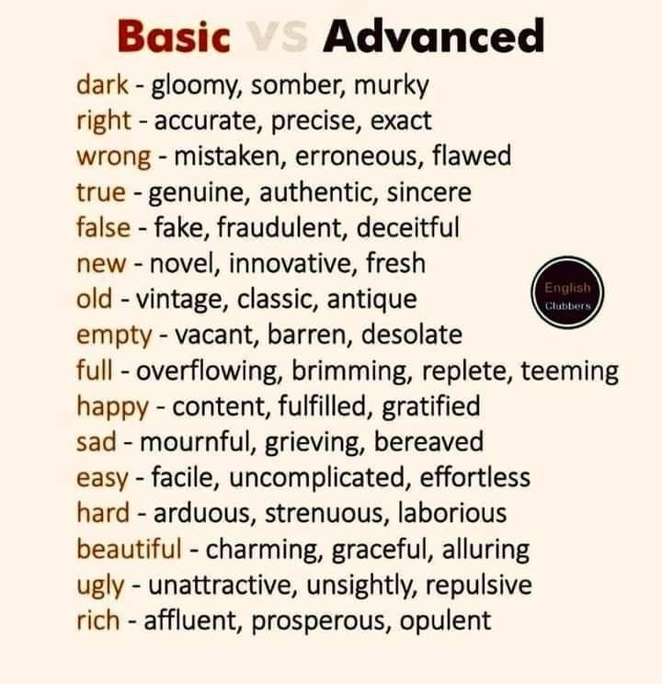

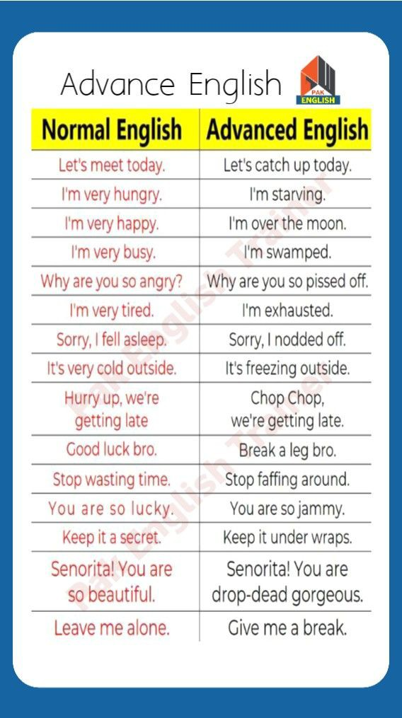
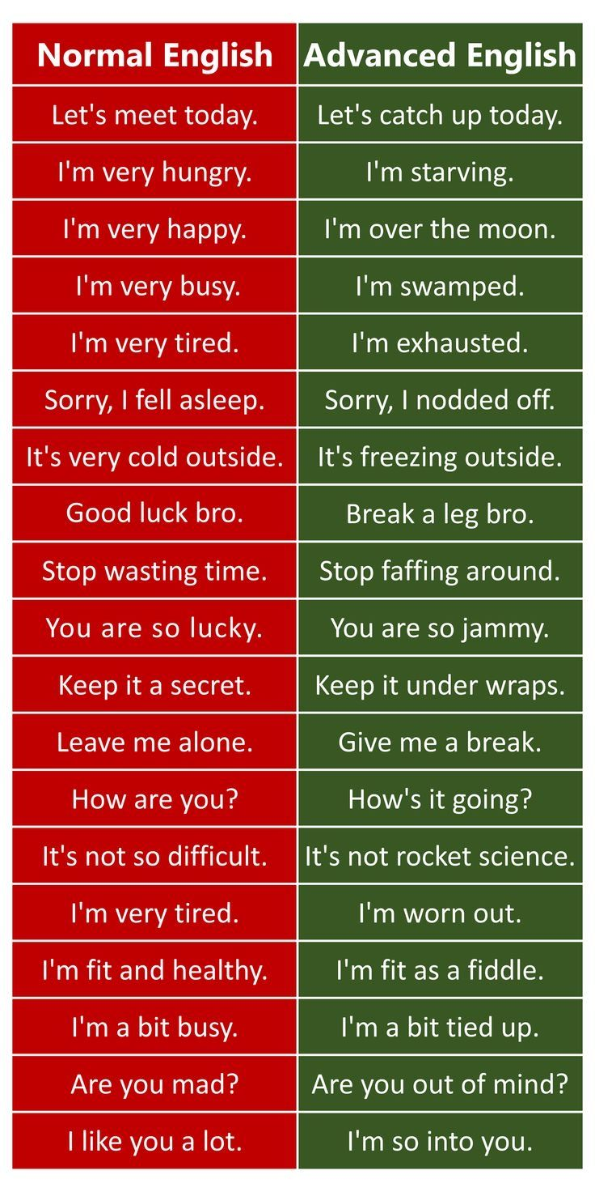
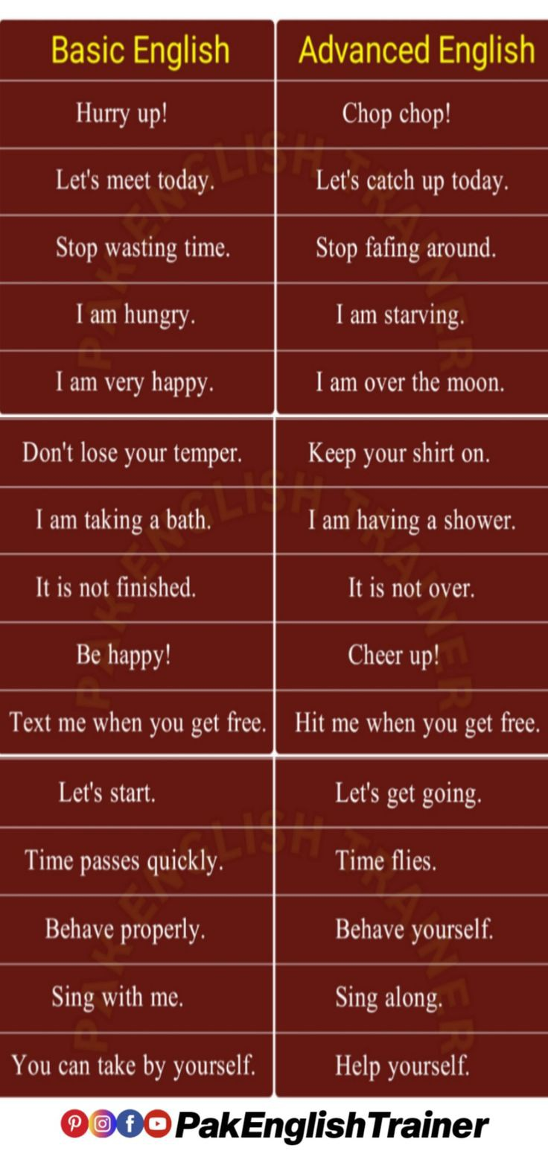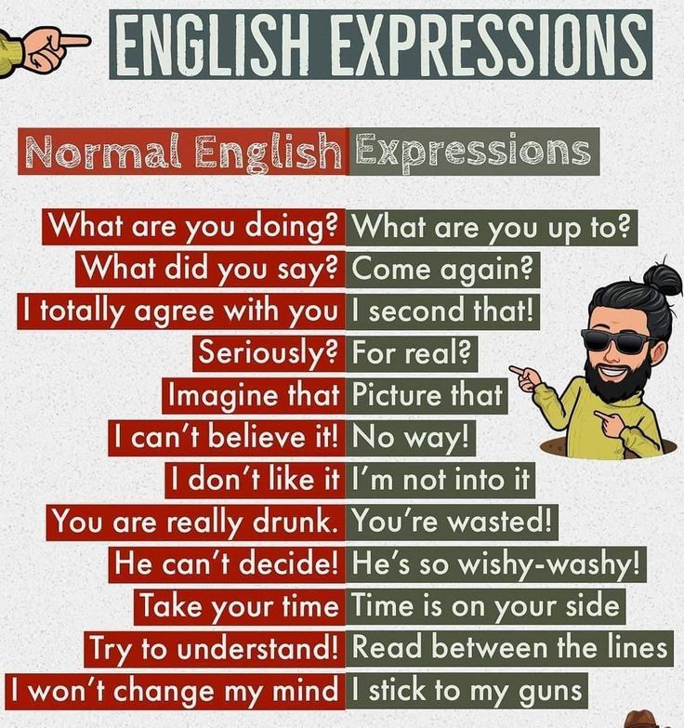

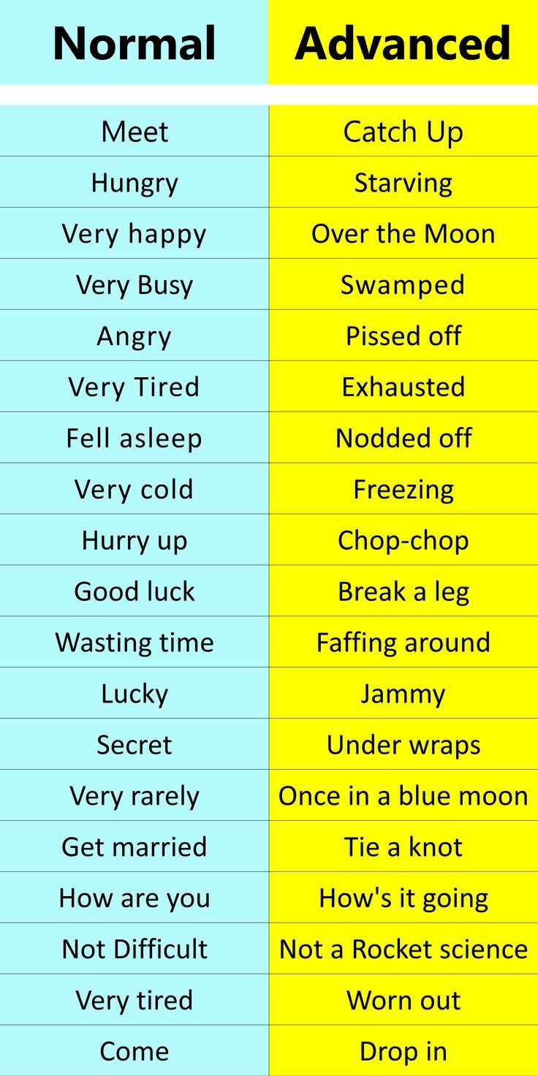
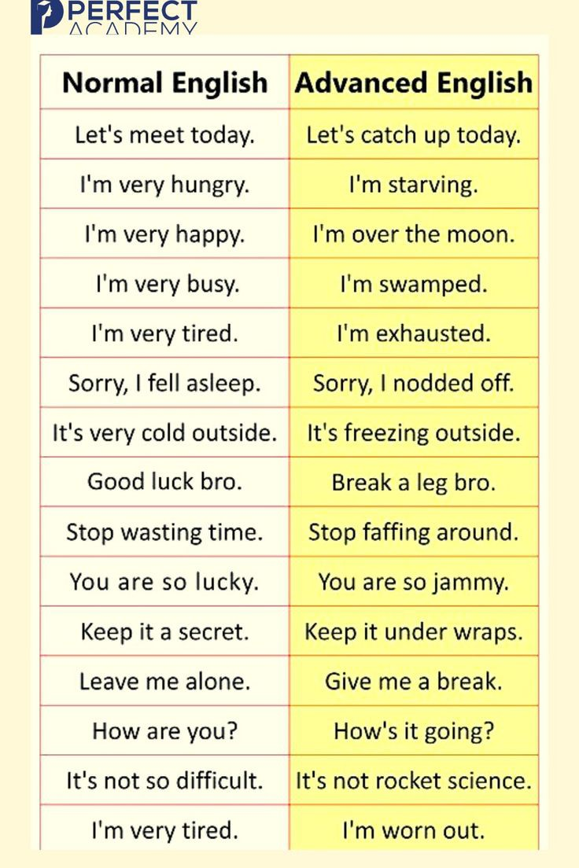
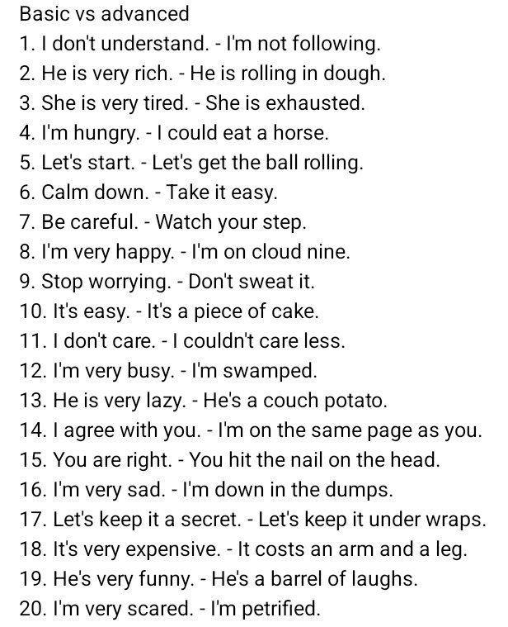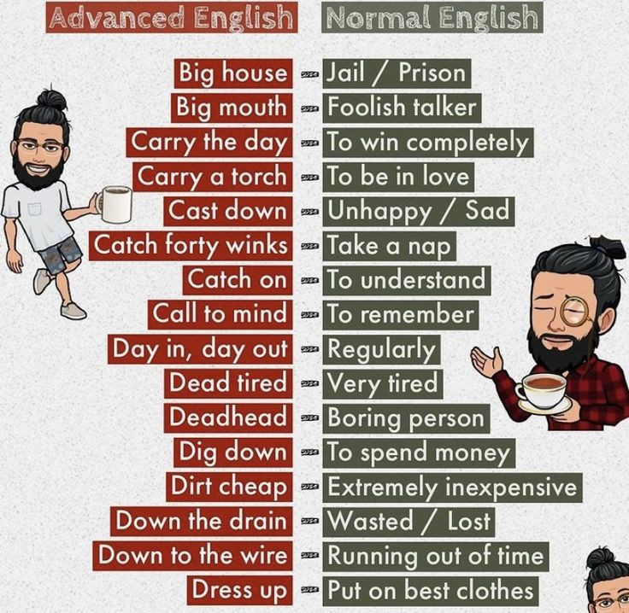

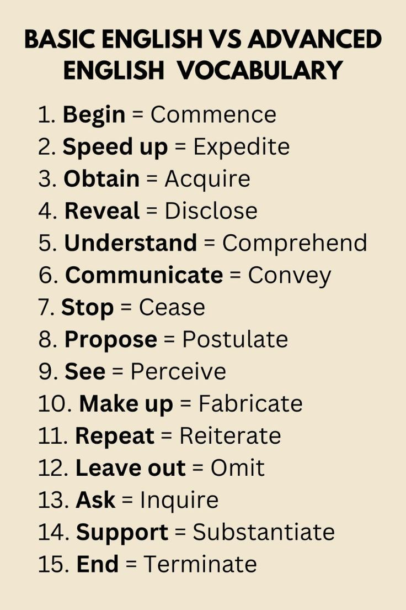
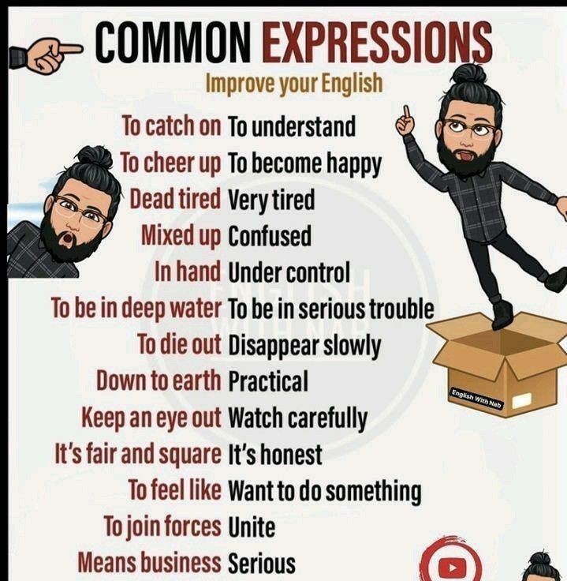

GRAMMER
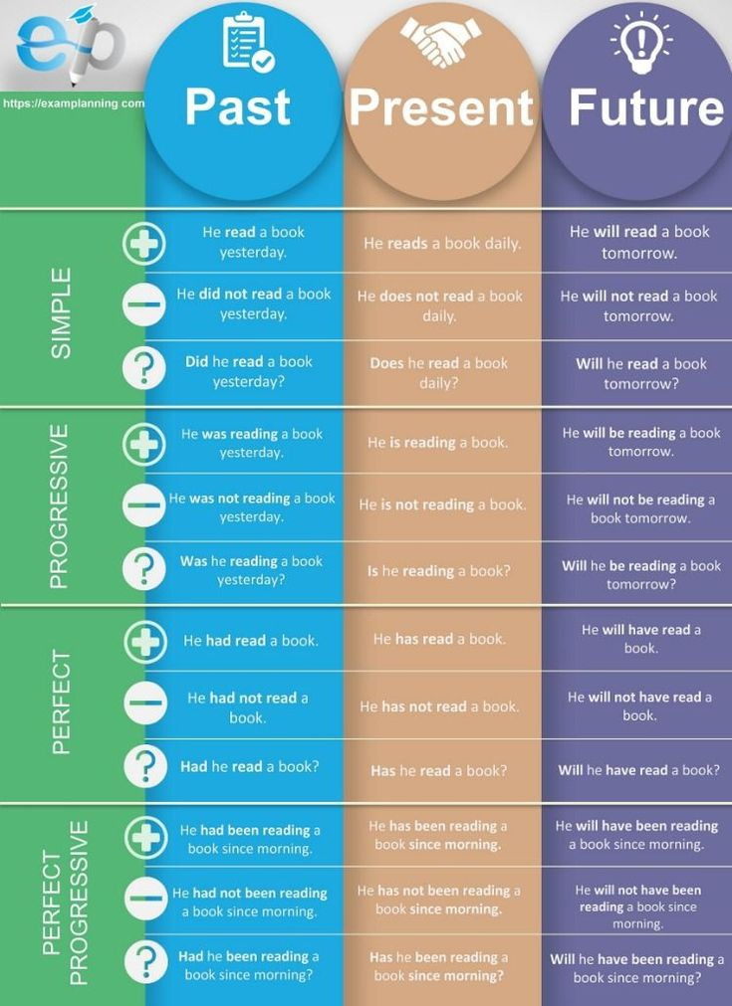
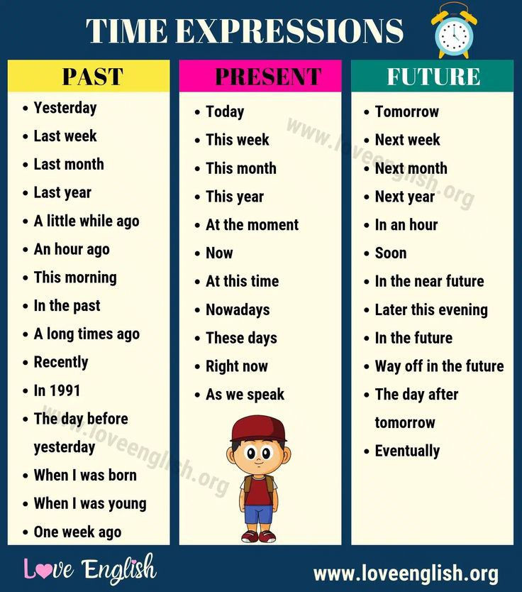

Conversation

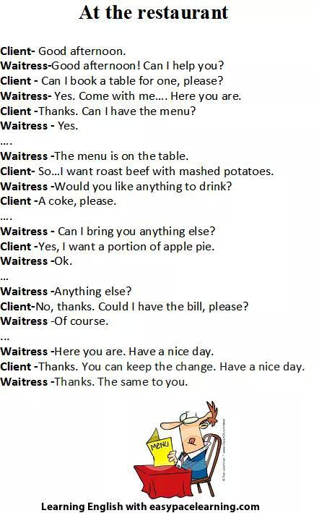

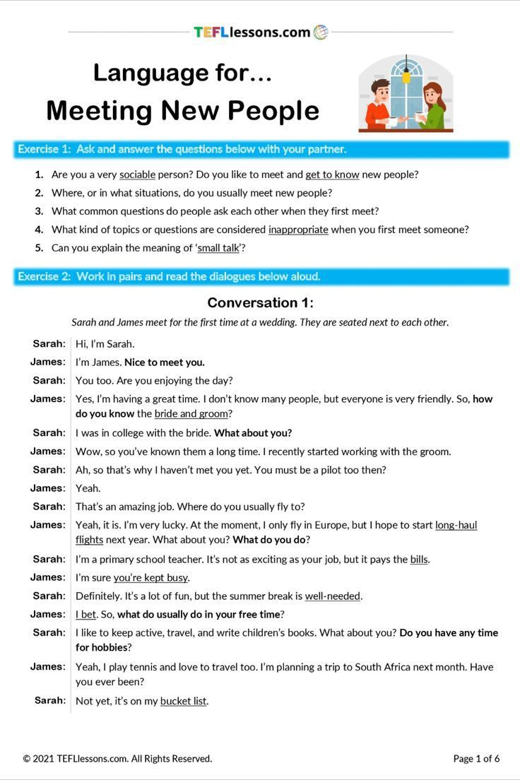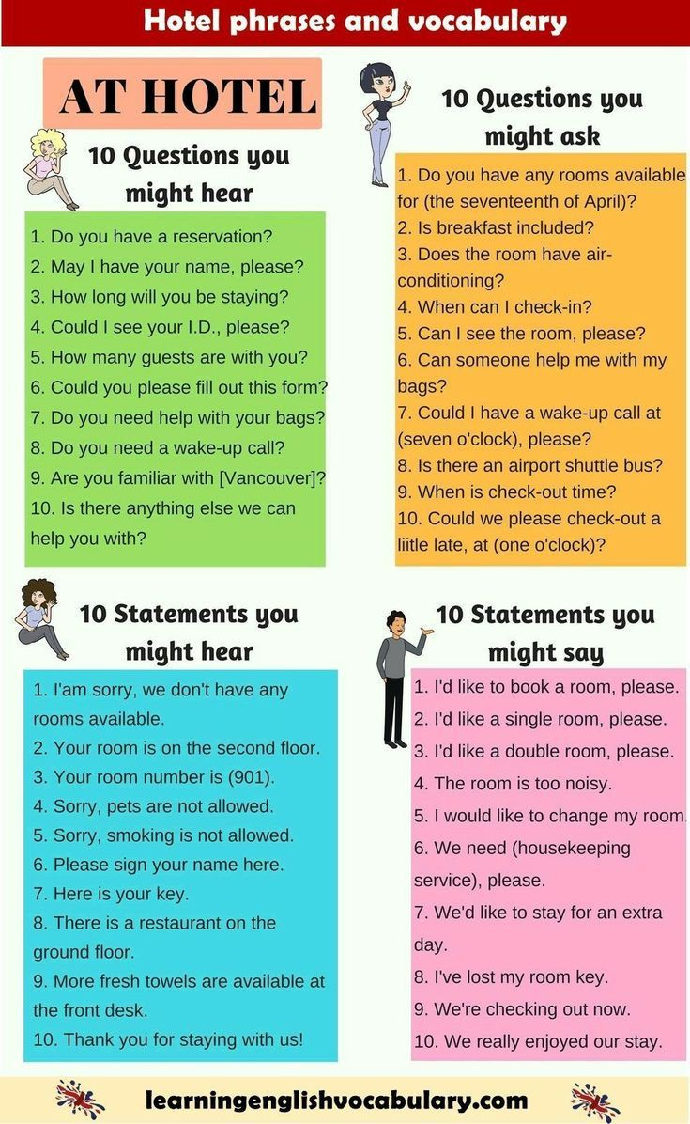
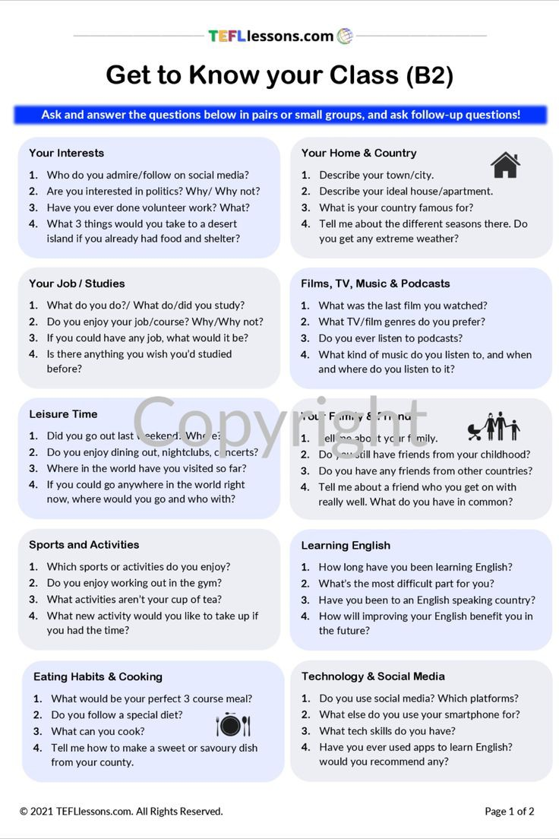
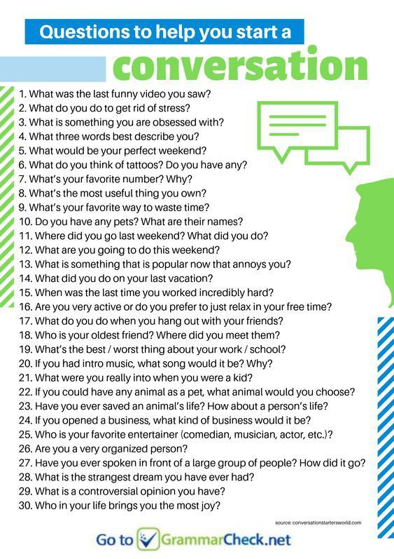

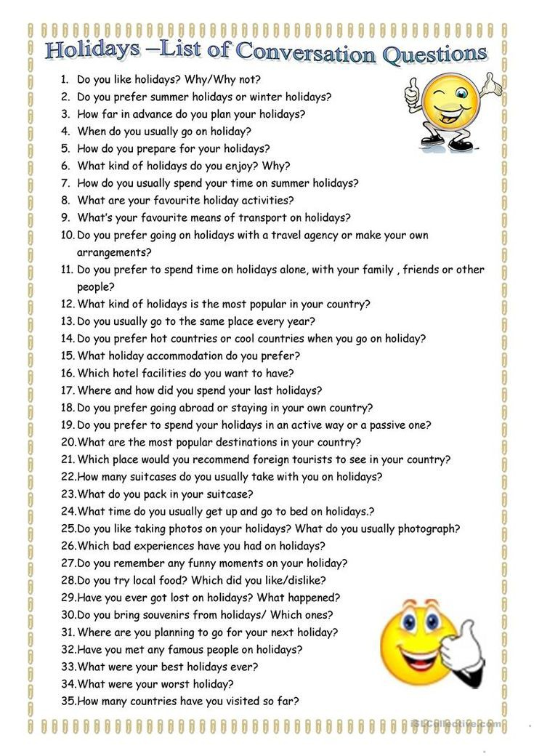
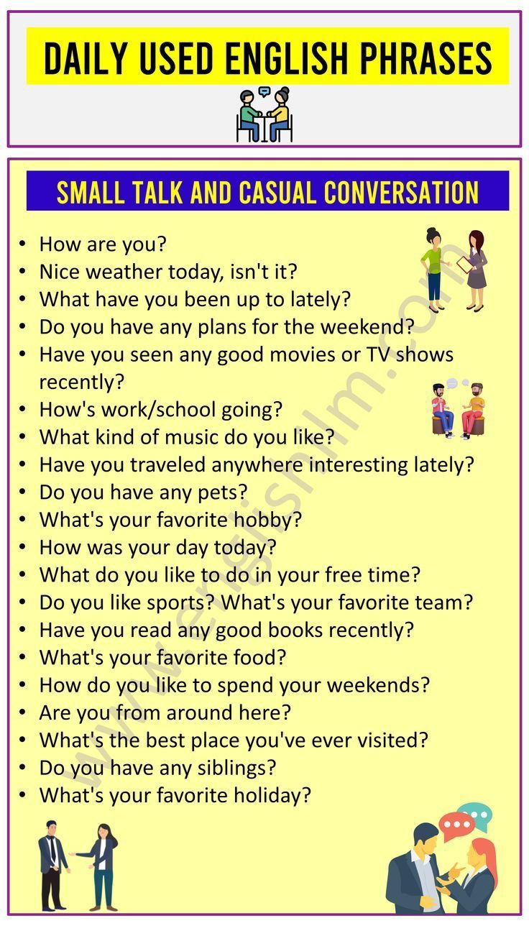
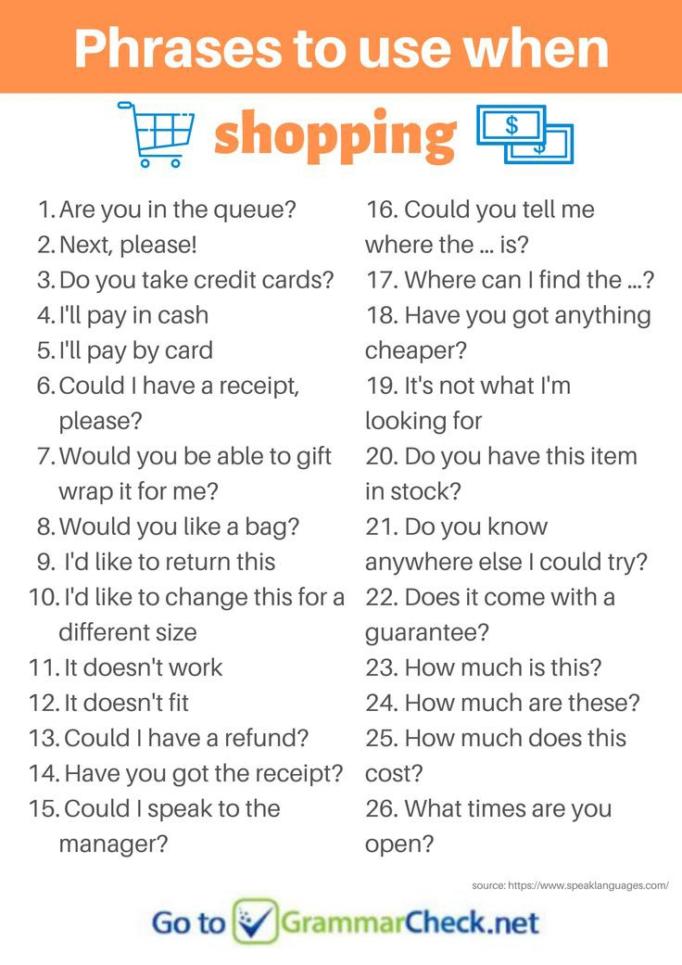
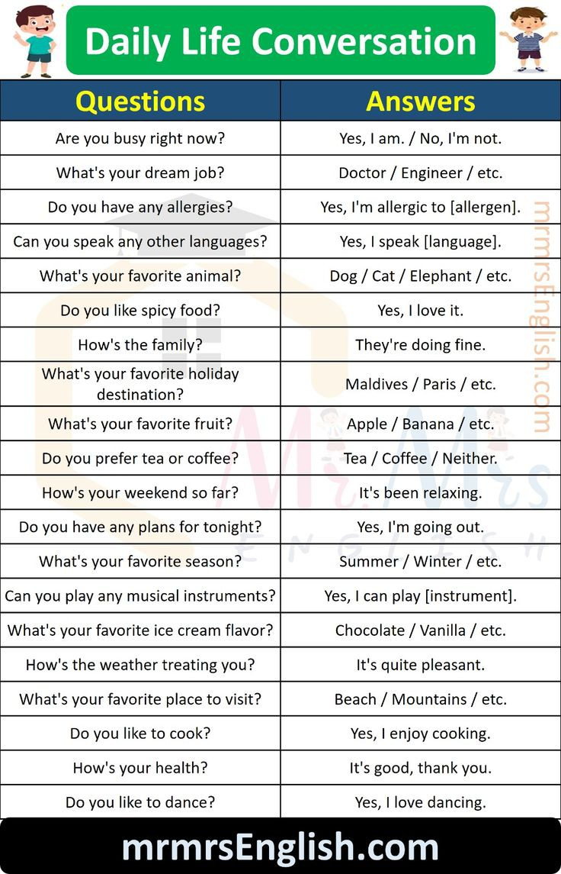
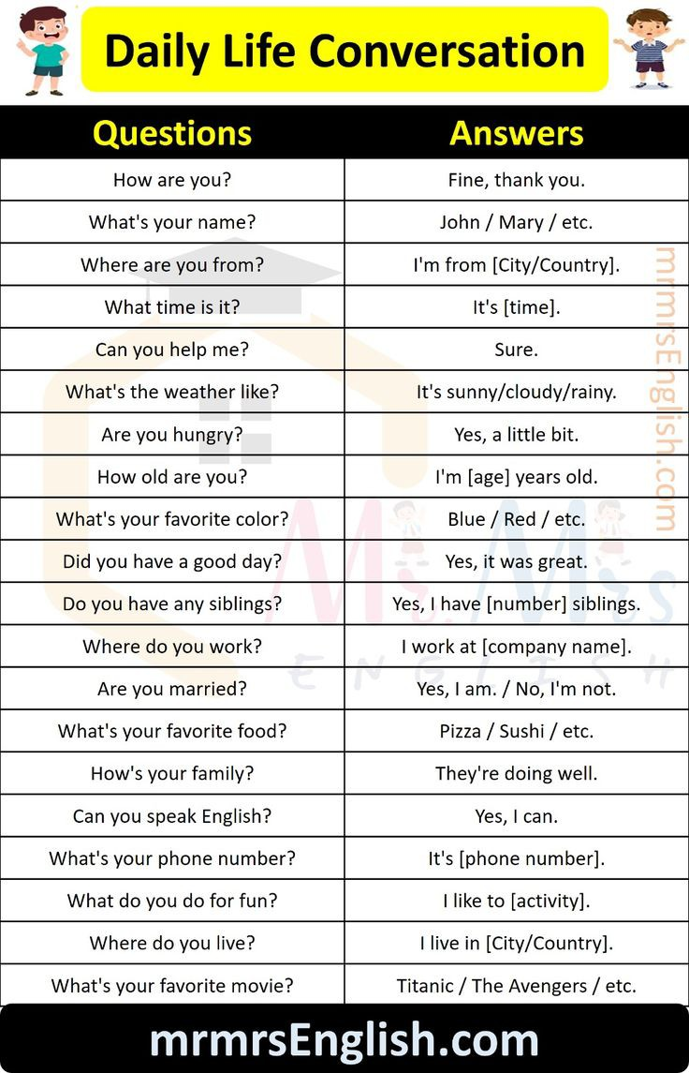
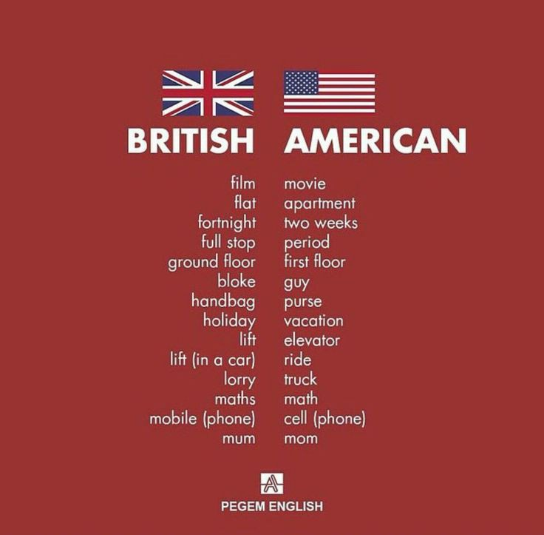

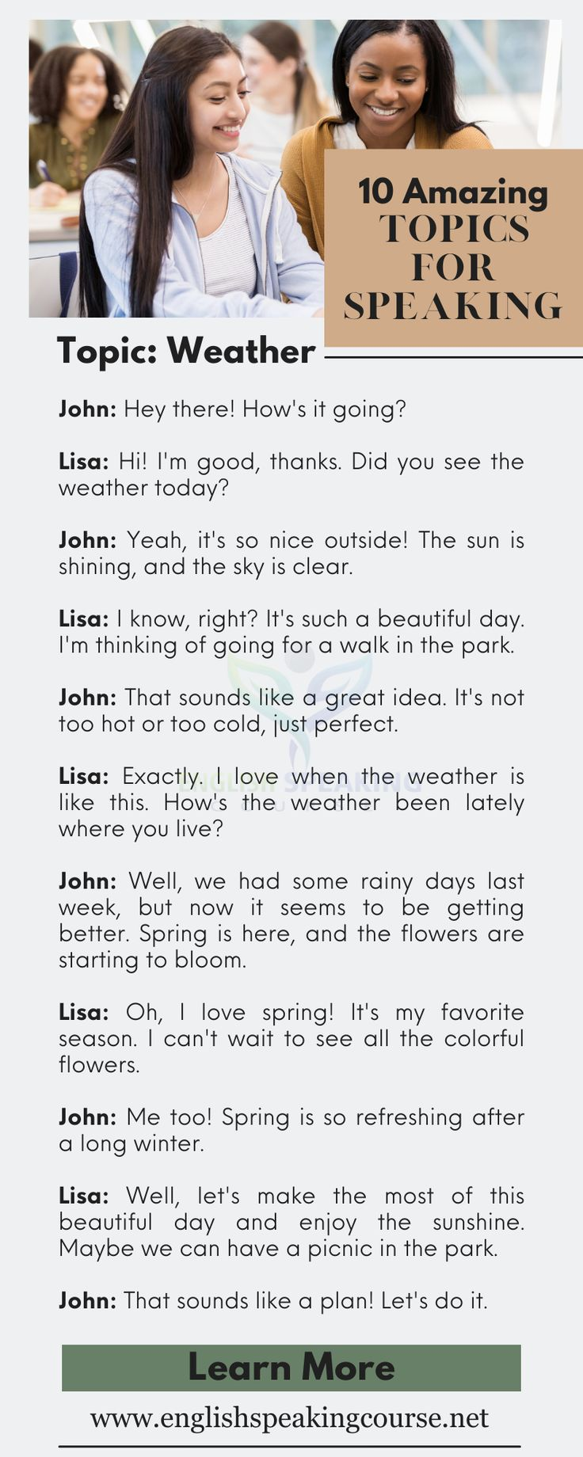
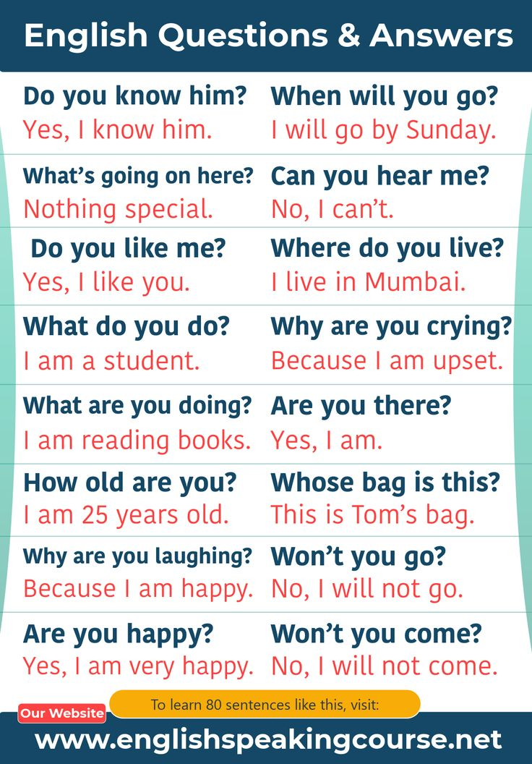
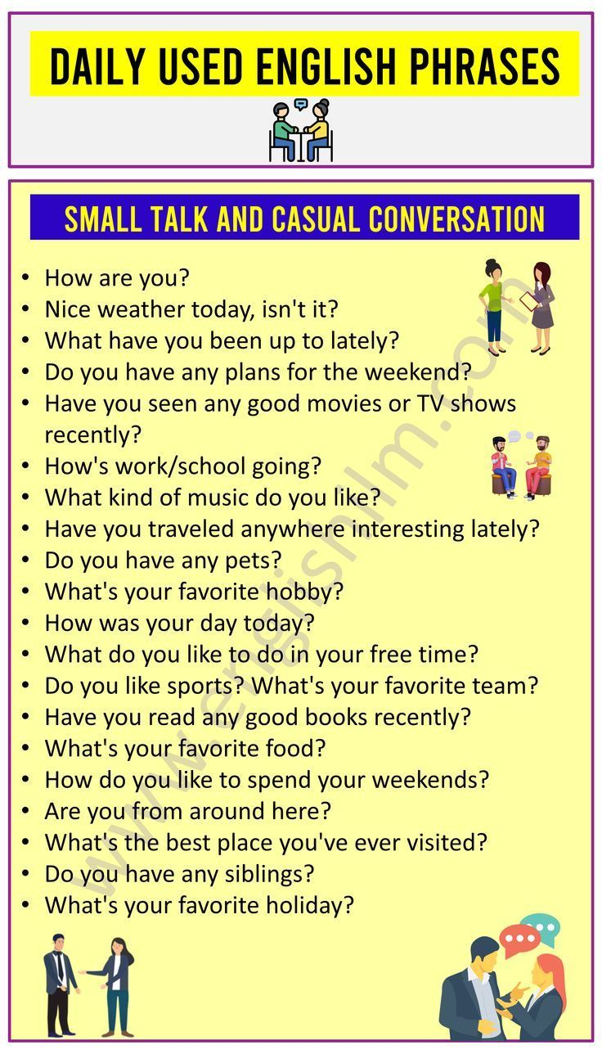
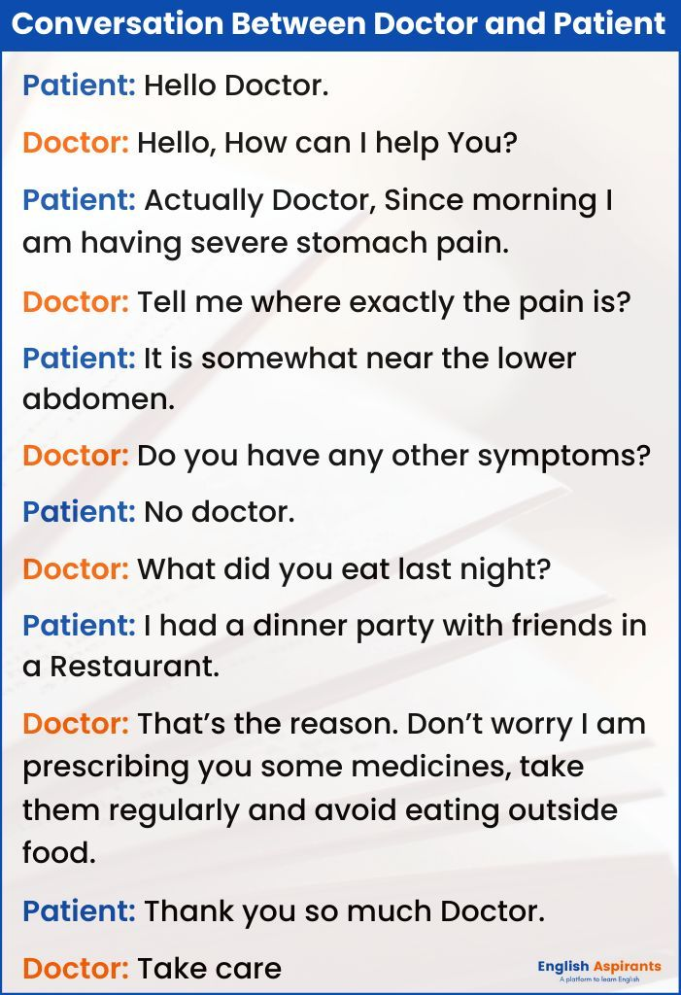
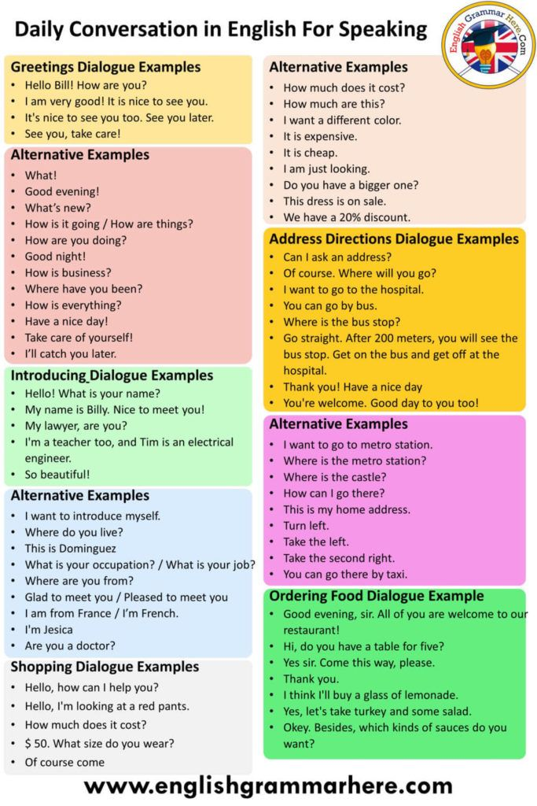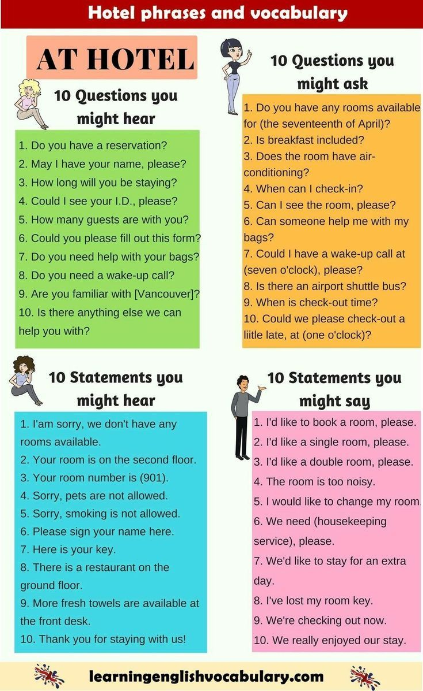
Daily Routines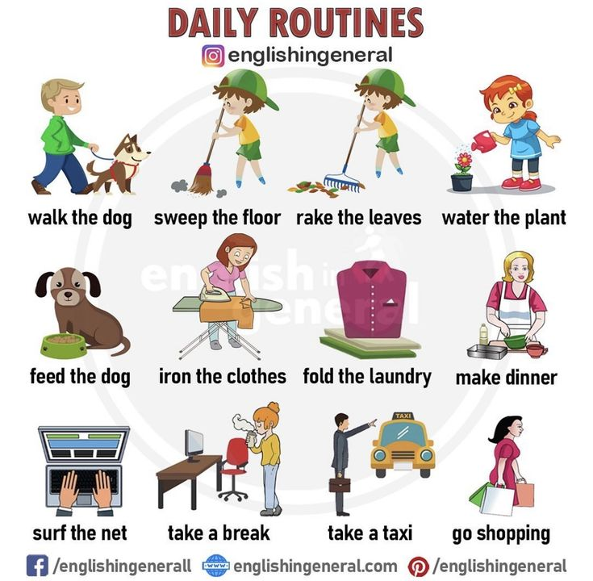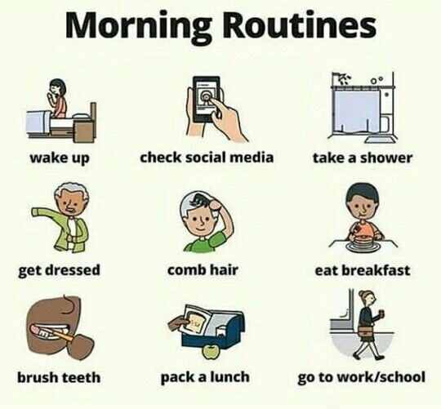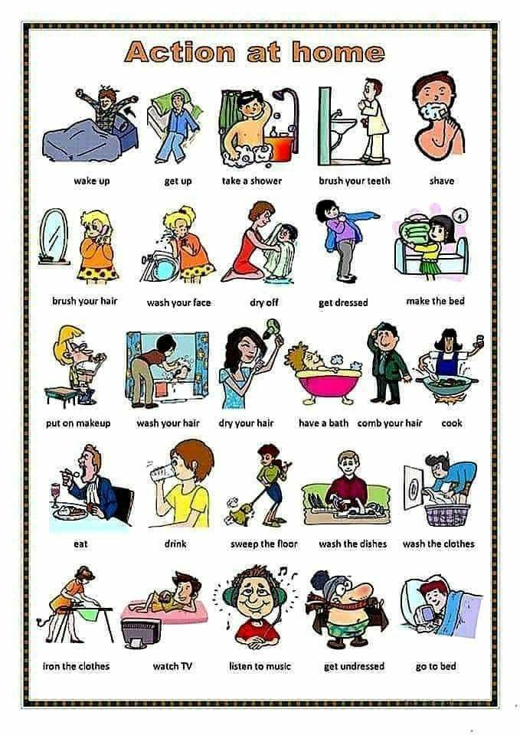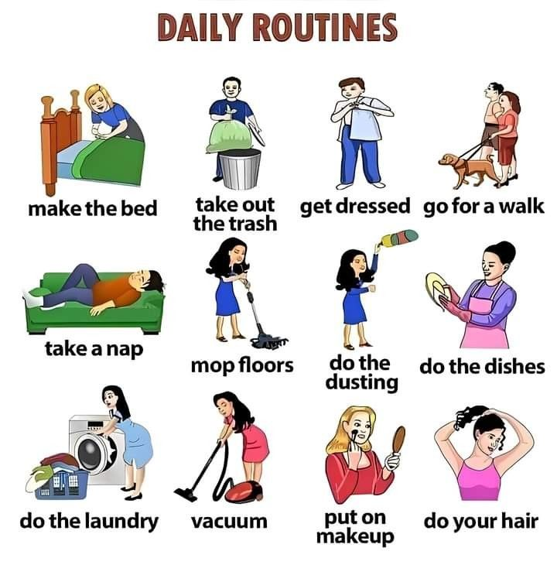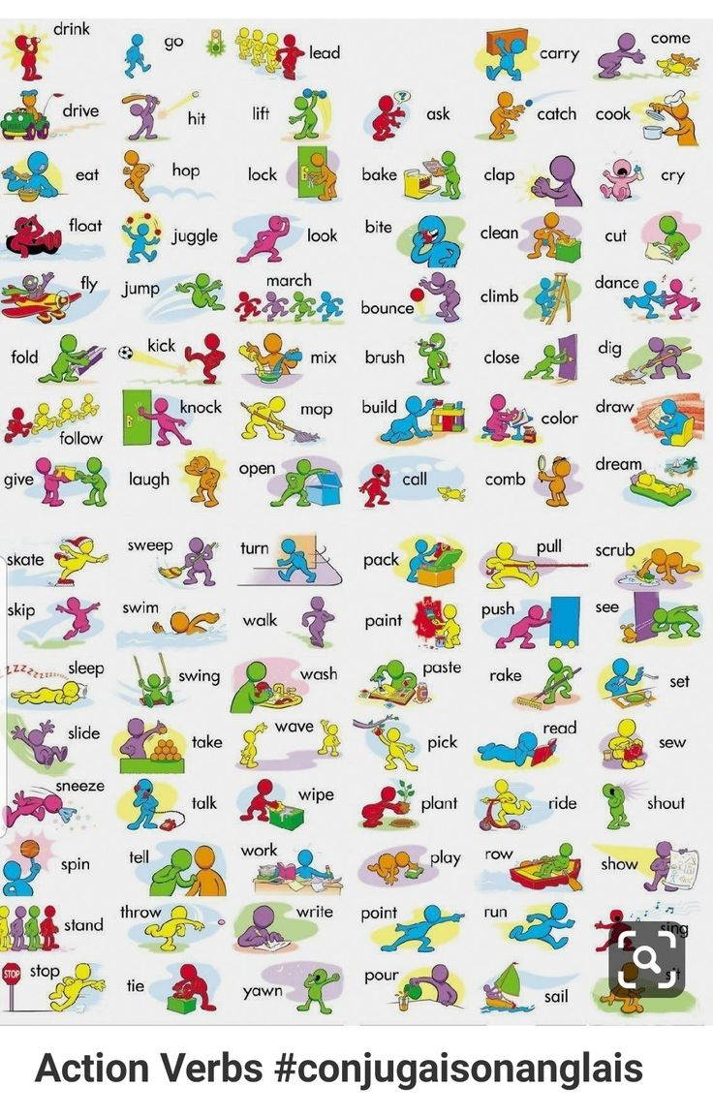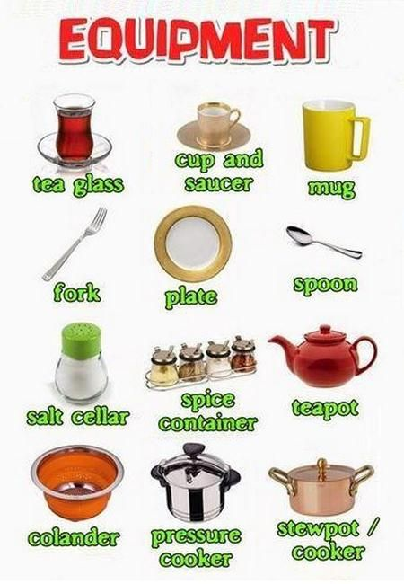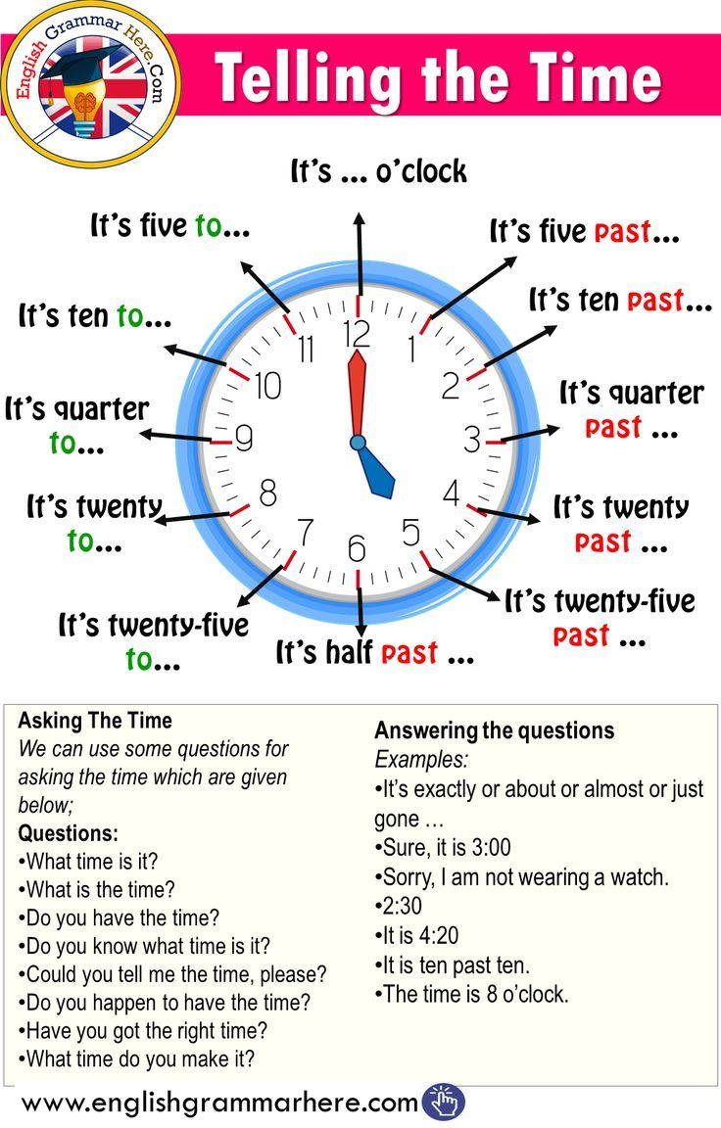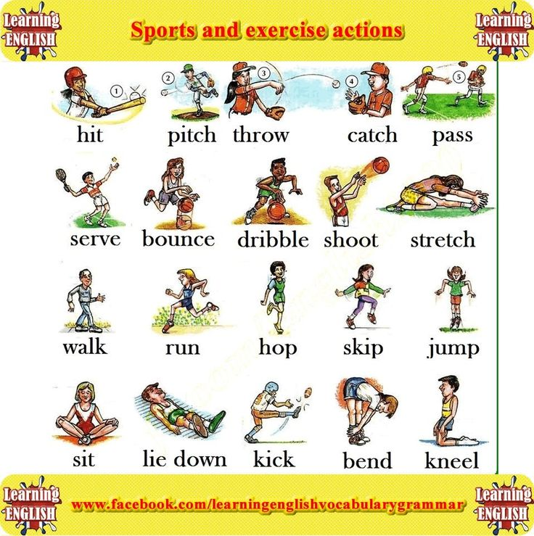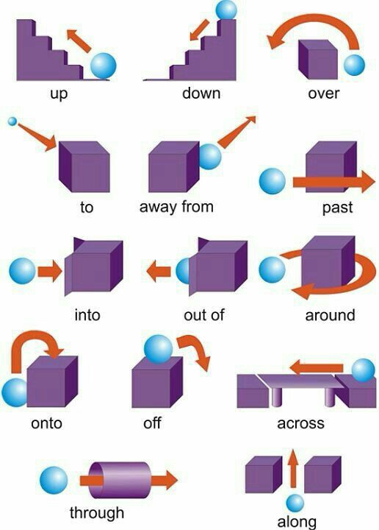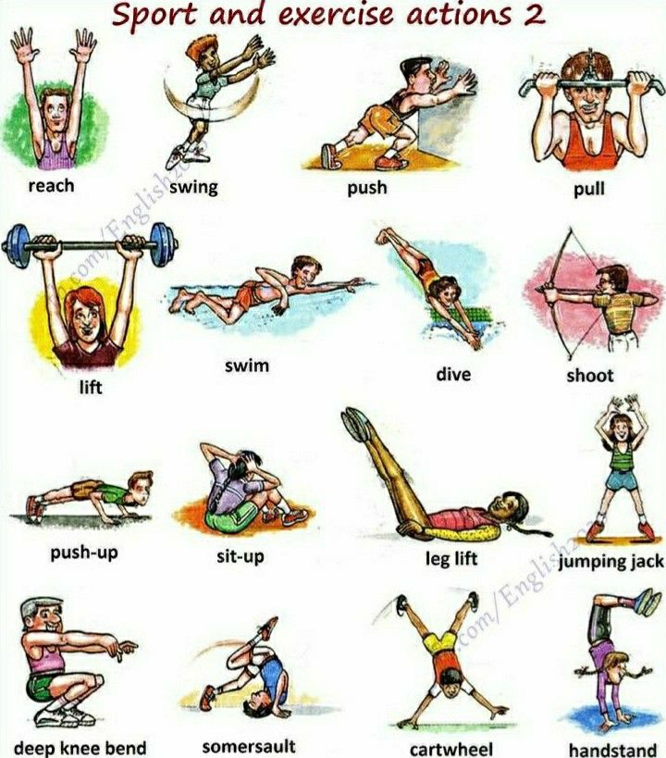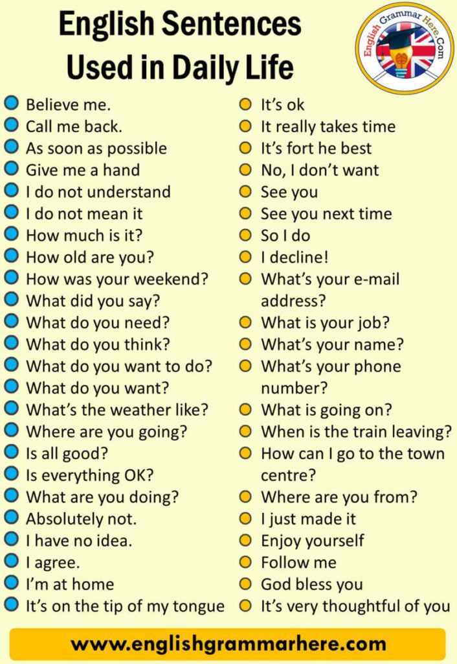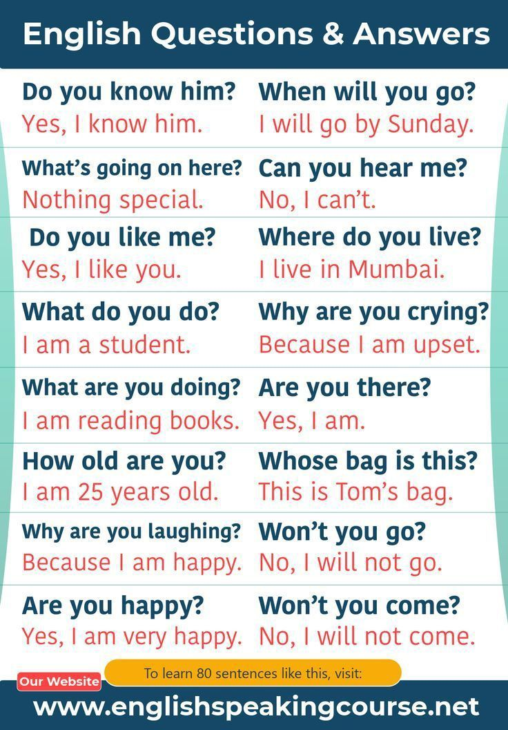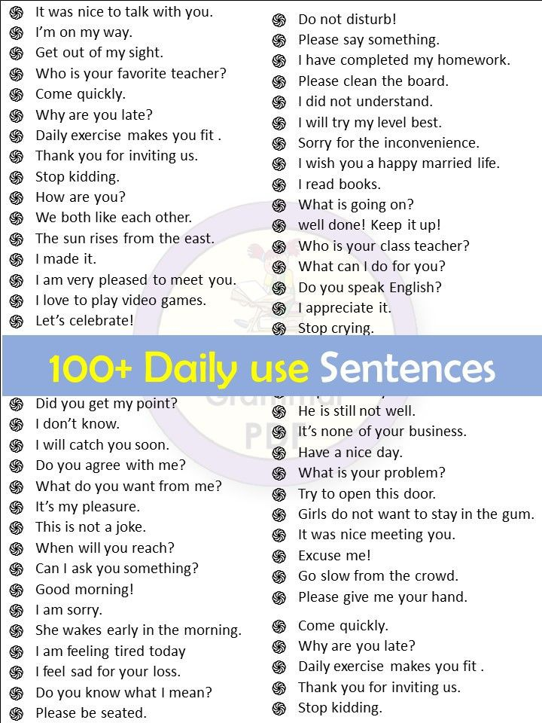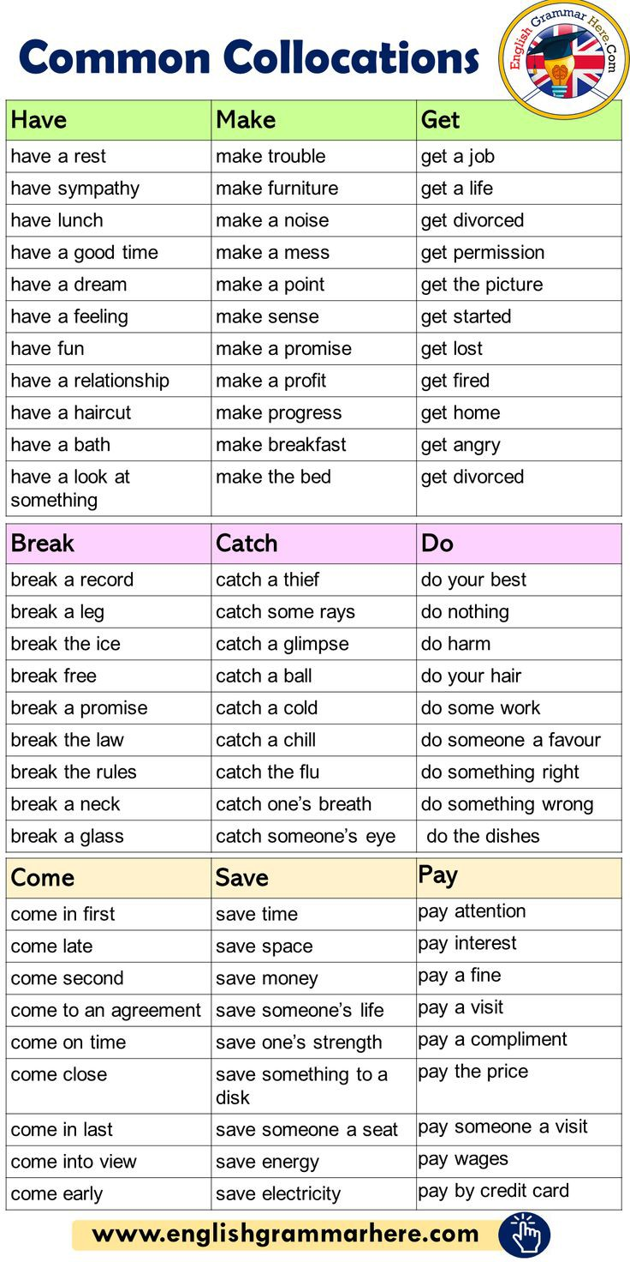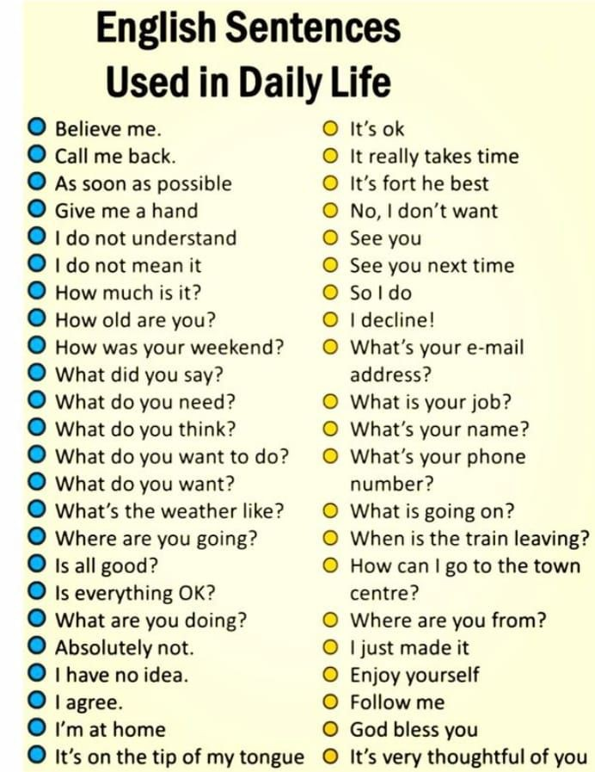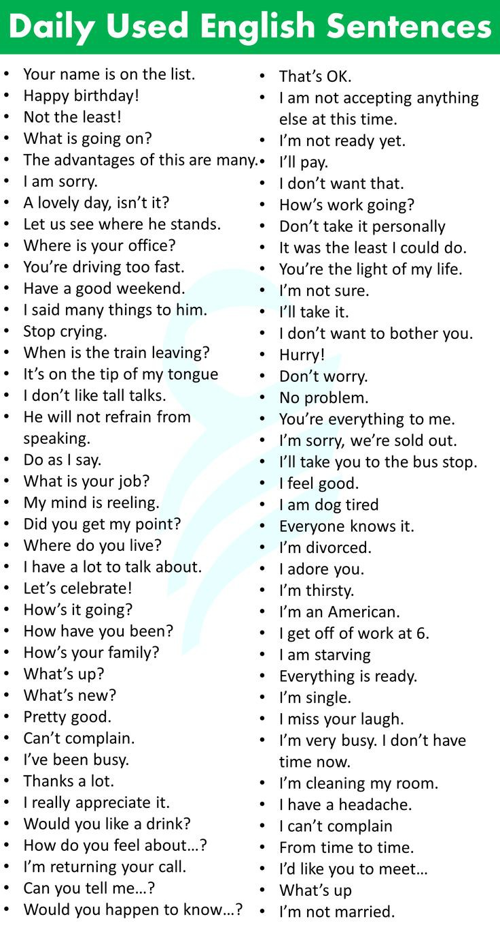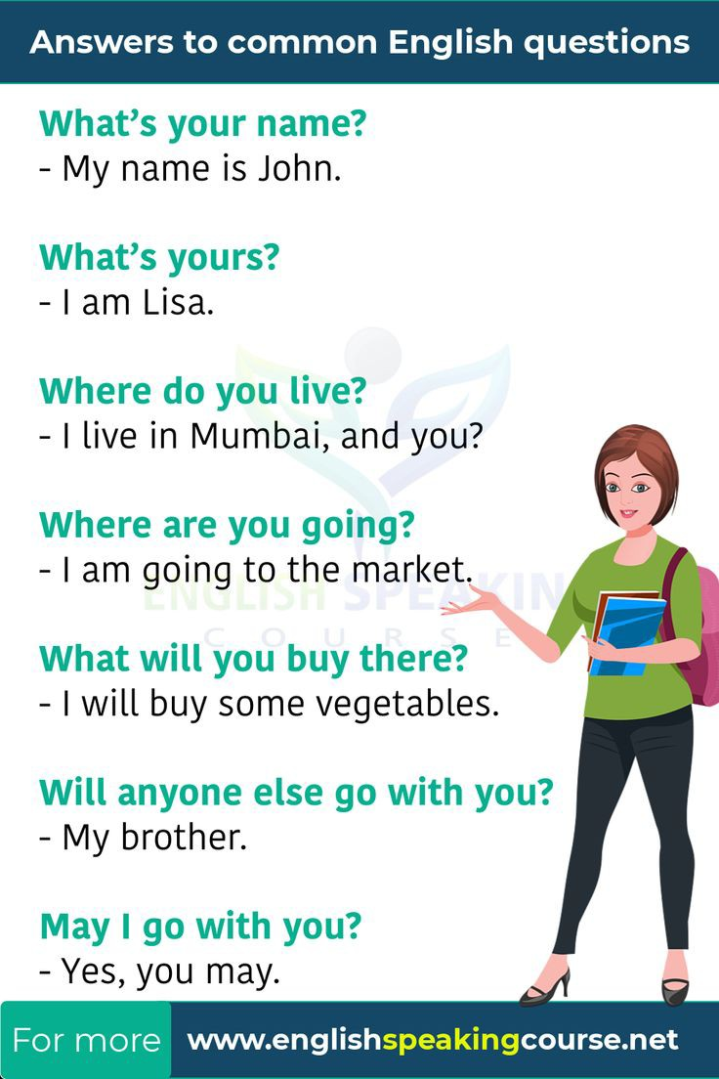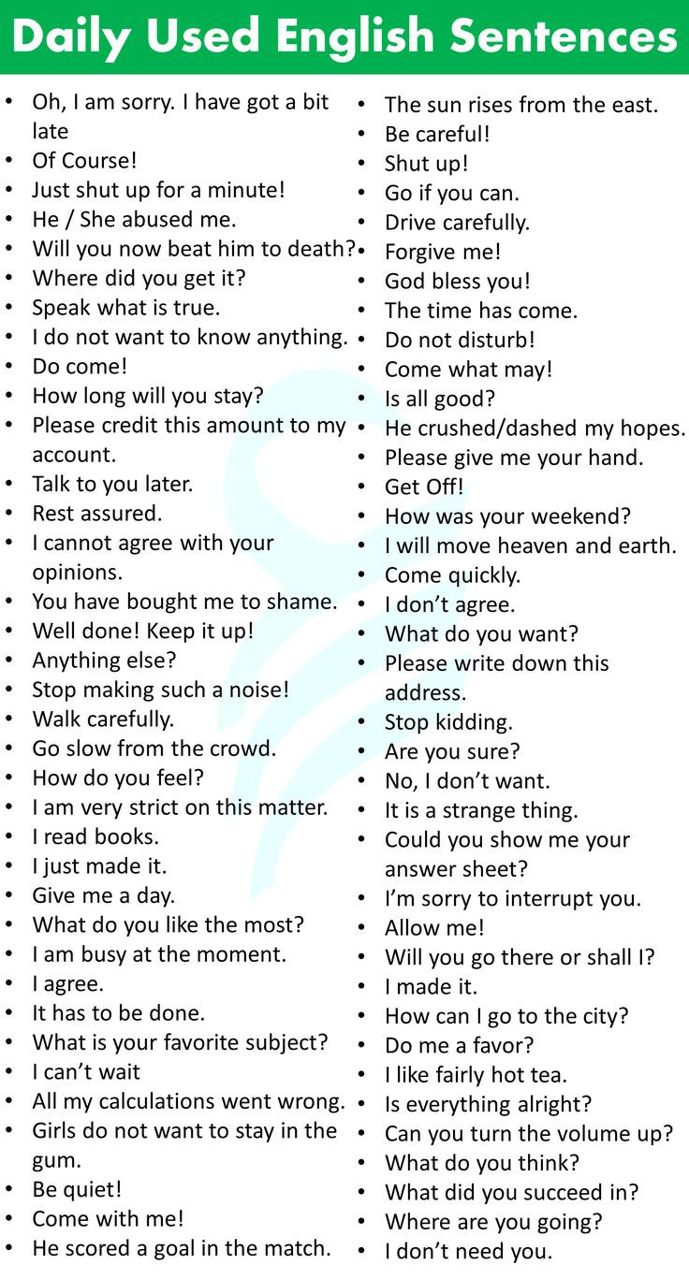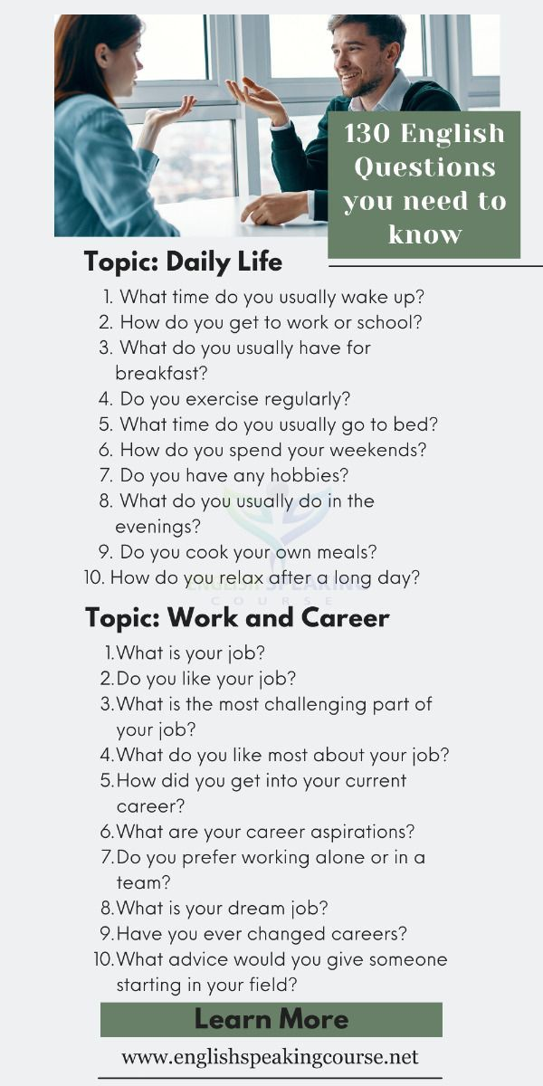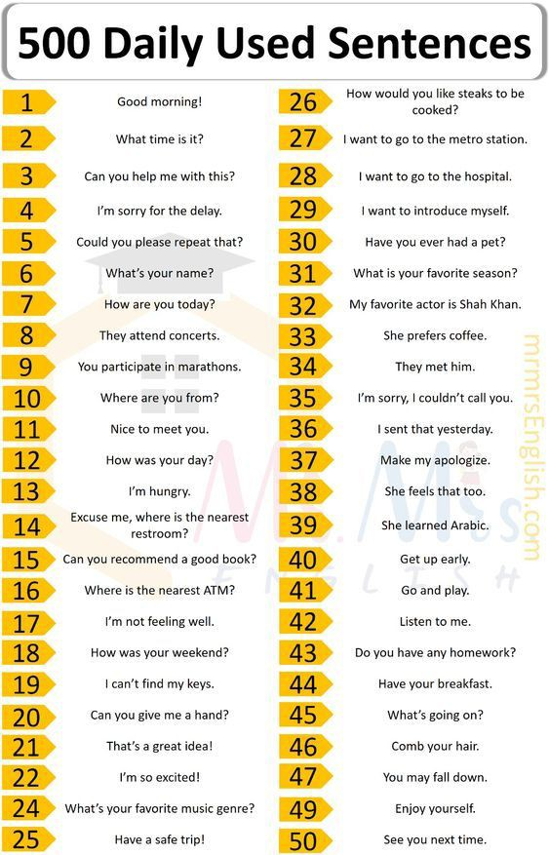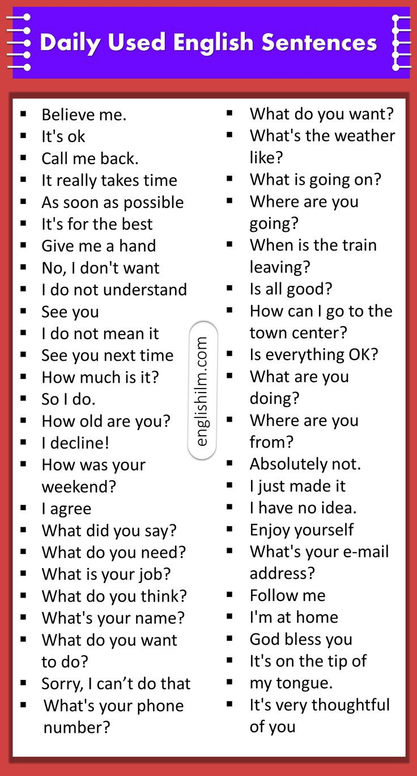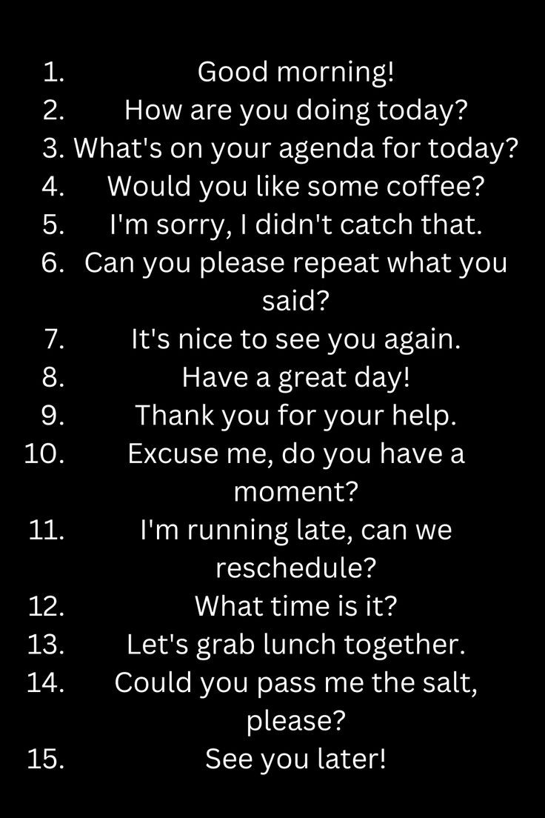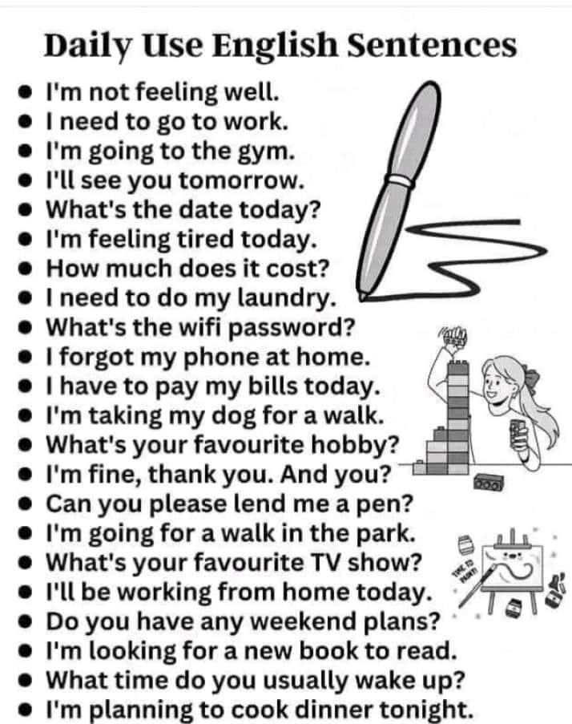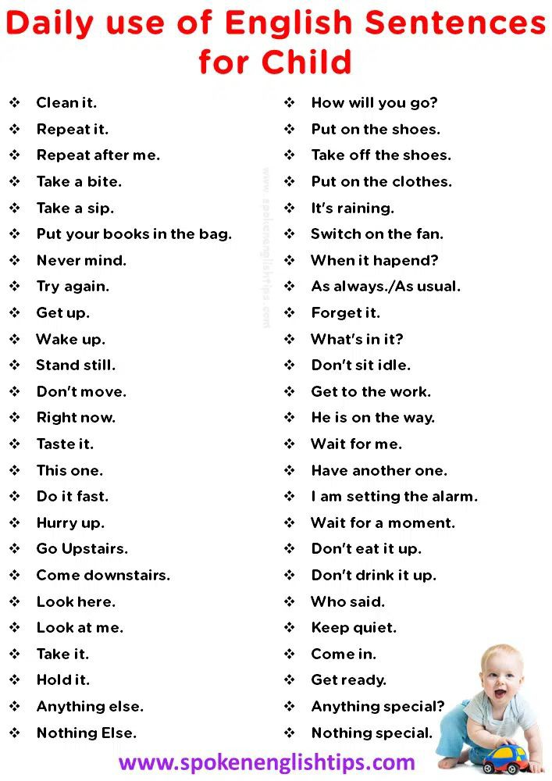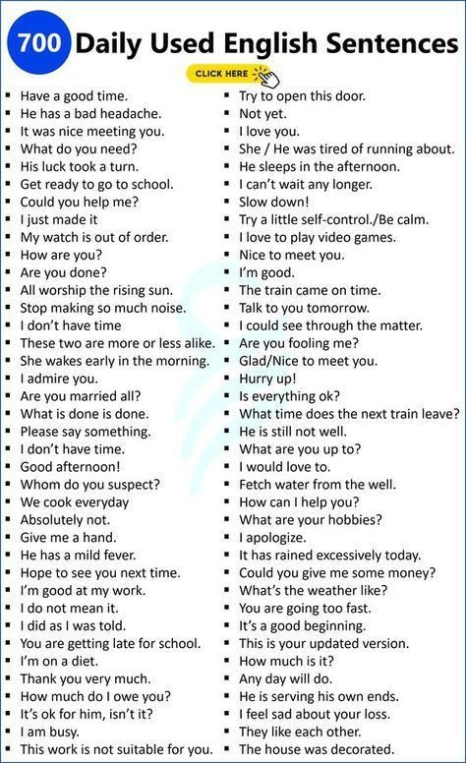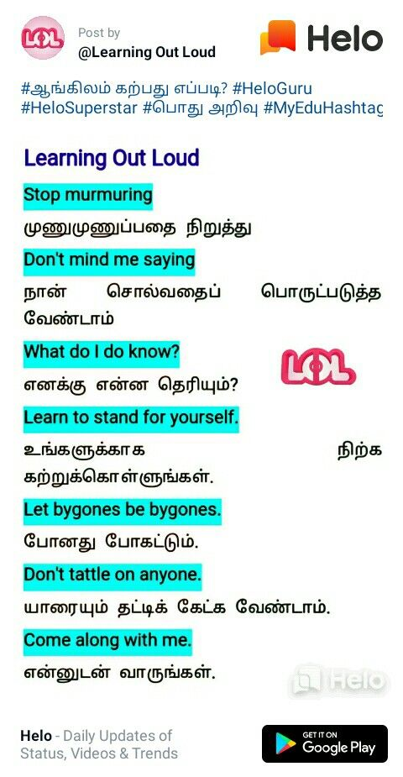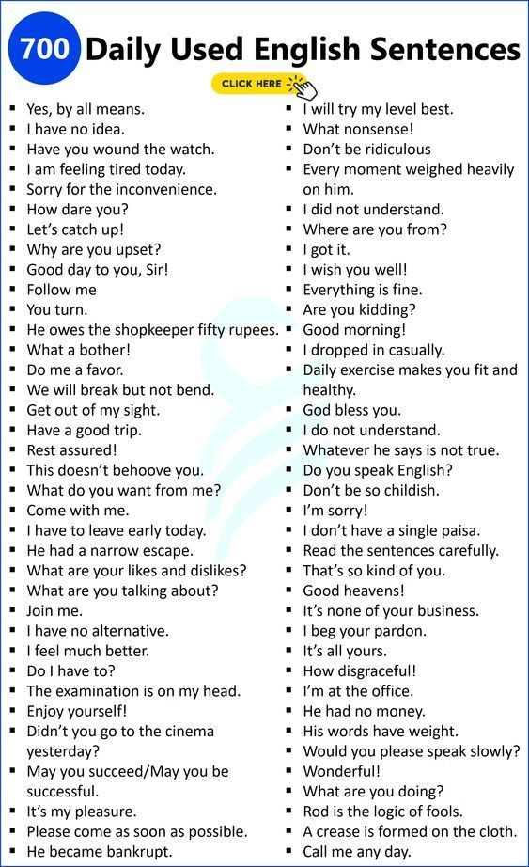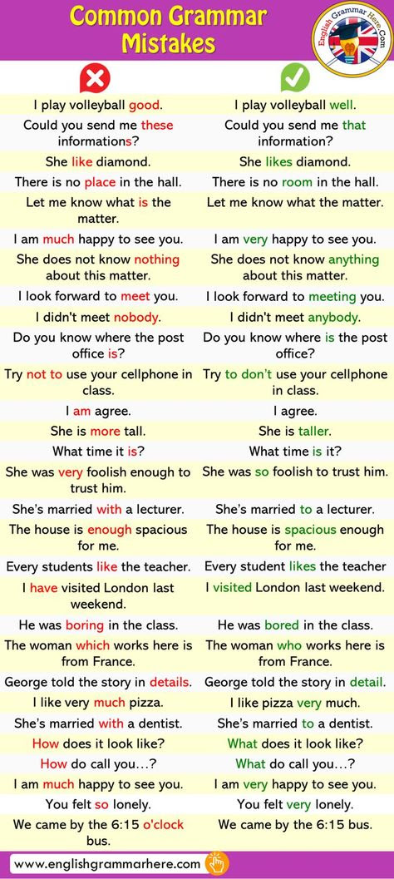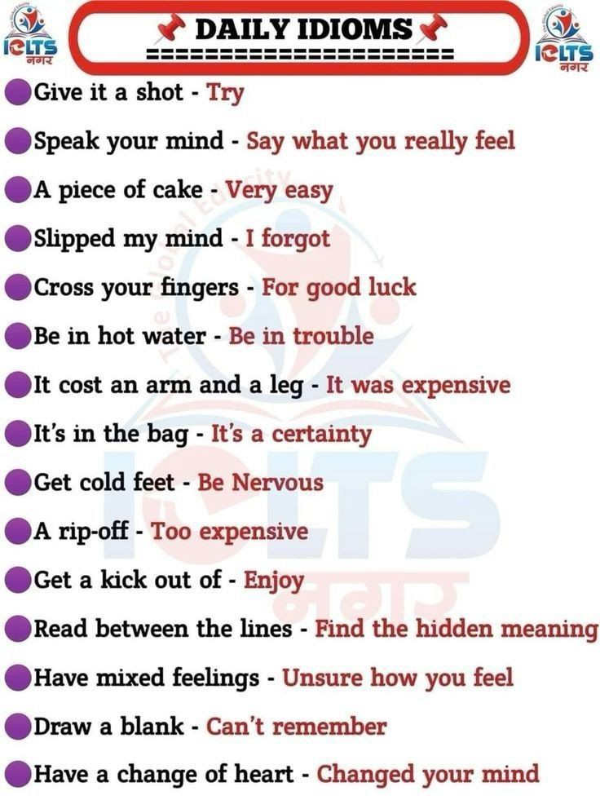

Speaking