Page 1
- Consistent margins - margins of document need to set and consistent. happy with the top, left and right margins but the bottom is too high up, adjusting it should as well release some space for us to use.
- Header (CSS: FundName) – please move this a one row down
- Fund Objective (CSS: fundobjective) – need to have one row space between header and this paragraph. Also Fund objective to be set to a maximum and then if there is not enough text in the box there will be blank space.

- Fund Information (CSS: FundInformation) – Aline the spaces and fonts between items here – to be consistent, spacing need to be the same to avoid blank we see currently.
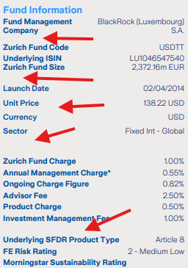
- Ratings (Morningstar Sustainability Rating; Morningstar Low Carbon Designation) – can you split the name over two lines so, it would be possible to aligned rating icons with the second row?
So, it would look like something like that?:

- Grey filed on left should be maximised to not live that big blank space
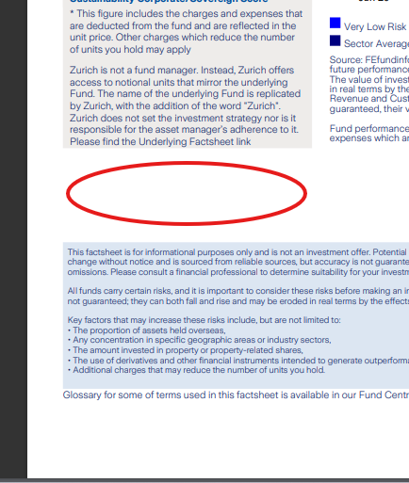
what we would like to acheve
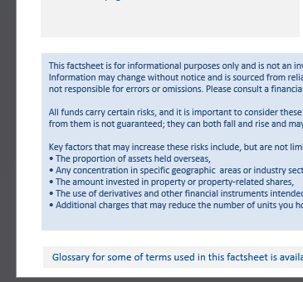
- Performance table, graph (css: Cumulative_performance, Discrete_performance, Annualised_performance, Volatility, Performance_graph) - can we reduce the size of the font only for the dates in these headers 2p down?
“Cumulative performance (as at 30/04/2025)” 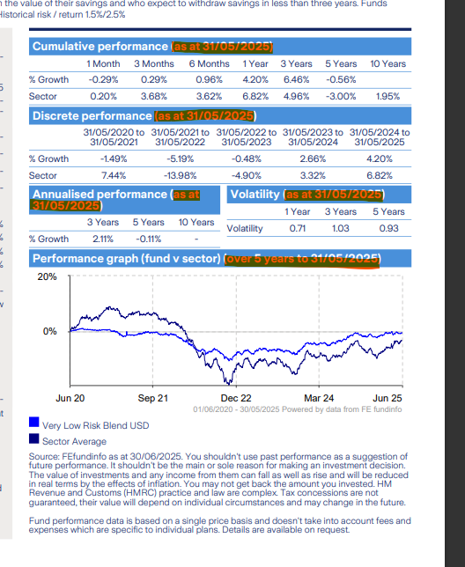
- Discrete performance (css: Discrete_performance) - can we reduce font size for date somehow?
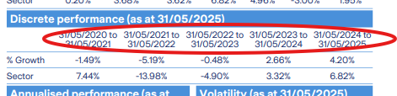
- Volatility (css: Volatility) – blue background this needs to be align with Annualised performance, they need to be the same size
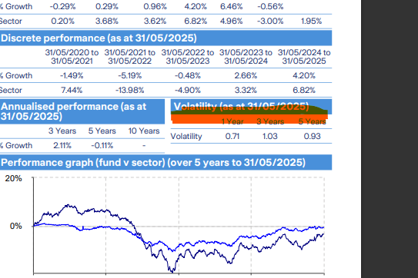

- Glossary (CSS: Glossary) - to be set in a box with a light grey colour like in attachment.
Page 2
- Consistent margins - margins of document need to set and consistent. happy with the top, left and right margins but the bottom is too high up.
- Move the log from down right cornet to top right corner
- Date in top left corner, outside of box
- Graphs on right needs to start on the same line as grey box, and end with the margin of the page 
- For the graph it is possible to add space between the header and items preferably the same size as between breakdown and the line, now it look all very squashed together
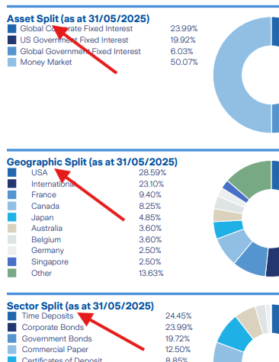
Page 3
- Consistent margins - margins of document need to set and consistent. happy with the top, left and right margins but the bottom is too high up.
- Move the log from down right cornet to top right corner
- Date shouldn’t be in the grey box

