CO5 – ASSESSMENT 1
CONSTRAINT-BASED PROBLEM SOLVING

1. Real-Time Face Recognition for Campus Security

Objective
The university requires a camera-based security system that identifies registered students and staff in real time, works under different lighting conditions, minimizes false recognition, and maintains acceptable speed on a low-cost computer.

1.1 OpenCV-Based Solution
- Image acquisition: Capture live CCTV frames using OpenCV VideoCapture. The camera is fixed at the entrance so faces are sufficiently large and visible.
- Preprocessing: Resize frames to reduce computation. Convert to grayscale for classical detection, apply Gaussian filtering for noise reduction, and use histogram equalization or CLAHE to improve contrast under poor lighting.
- Face detection: Use Haar Cascade for a lightweight CPU solution or an OpenCV DNN face detector for greater robustness. Apply minimum-size filtering to reject tiny false detections.
- Feature extraction: Crop and align each detected face, resize it to a standard size, and generate a facial feature representation such as LBPH features or a deep face embedding.
- Recognition: Compare the extracted features with registered database features using a suitable distance/similarity measure. A confidence threshold is used to decide whether the identity is accepted.
- Final identification: Display the recognized name/ID, confidence, bounding box and status. Faces below the threshold are labelled Unknown.
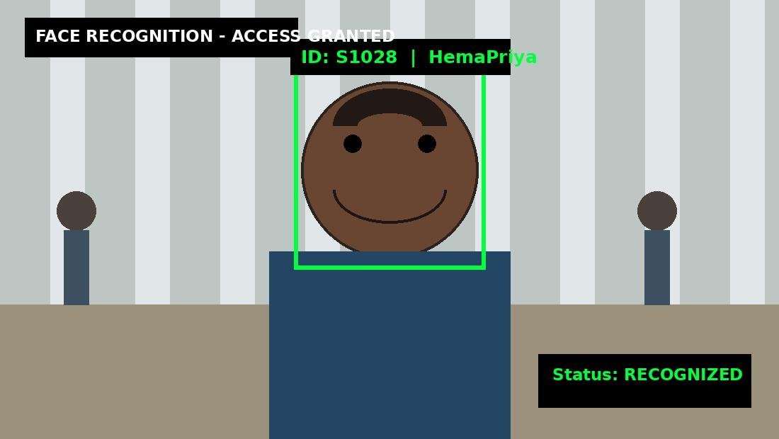
Figure 1. Example face-recognition result with bounding box, identity and recognition status.

1.2 Accuracy and Real-Time Performance
- Use several enrollment images for each person under different lighting and expressions.
- Apply face alignment and consistent preprocessing before feature extraction.
- Use a calibrated threshold and an Unknown class to reduce false recognition.
- Confirm the same identity across multiple consecutive frames before final identification.
- Process only the entrance ROI and resize frames before detection.
- Run expensive recognition less frequently and track the face between recognition operations.
- Keep registered features in memory for fast matching.
Stage | Technique | Purpose
Acquisition | OpenCV VideoCapture | Live CCTV
Preprocessing | Grayscale, CLAHE, blur | Quality improvement
Detection | Haar / DNN | Face localization
Features | LBPH / embedding | Identity representation
Recognition | Similarity + threshold | Identification
Optimization | ROI + frame skipping | Real-time speed

Conclusion: The combination of illumination preprocessing, robust face detection, suitable feature extraction, confidence thresholding and multi-frame verification provides accurate and real-time recognition while reducing false matches.

2. Intelligent Traffic Violation Detection System
Objective
The system automatically detects vehicles from roadside cameras, tracks them across frames, identifies virtual-line crossings, counts vehicles only once, and generates alerts for abnormal or unwanted movements.

2.1 OpenCV-Based Solution
- Video acquisition: Read live roadside video using OpenCV VideoCapture and define the road region of interest.
- Preprocessing: Resize frames and apply Gaussian or median filtering to reduce camera noise.
- Vehicle detection: For a fixed camera, use MOG2 background subtraction to obtain moving-object candidates. For stronger classification, an OpenCV DNN detector can identify cars, buses, trucks and motorcycles.
- Motion analysis: Apply morphological opening and closing to remove isolated noise and repair gaps in the foreground mask.
- Tracking: Assign a persistent ID to each vehicle using centroid association or a suitable OpenCV tracker.
- Line-crossing detection: Draw a virtual counting line. When a tracked vehicle centroid moves across the line, increment the count only once for that tracking ID.
- Violation detection: Compare vehicle direction with the allowed direction and check restricted ROIs for unwanted movement.
- Visualization: Display bounding boxes, vehicle IDs, count, counting line and alerts on the live video.
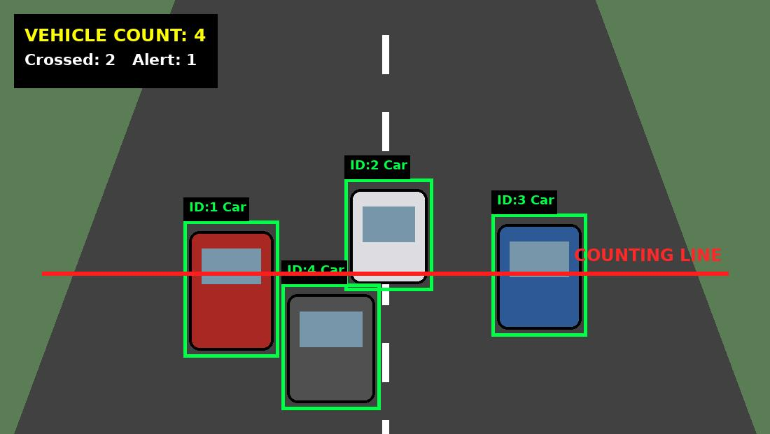
Figure 2. Example traffic-monitoring image with vehicle bounding boxes, tracking IDs and virtual counting line.

2.2 Handling Shadows, Noise and Multiple Vehicles
- Shadows: Use shadow-aware background subtraction and color/intensity analysis.
- Camera noise: Apply moderate Gaussian/median filtering.
- Dynamic backgrounds: Restrict detection to the road ROI and tune the background model.
- Occlusion: Keep tracks alive for a limited number of missed frames.
- Multiple vehicles: Give every vehicle a unique tracking ID.
- Double counting: Maintain a set of IDs already counted at the line.
- Wrong-way movement: Determine direction from consecutive centroid positions.
Conclusion: Persistent tracking IDs combined with line-crossing geometry allow accurate vehicle counting and reliable violation detection without repeatedly counting the same vehicle.

3. Automated Document Processing System
Objective
The system receives thousands of scanned documents containing blur, noise, uneven illumination and different font sizes. The objective is to enhance every document automatically and produce a clean image suitable for OCR.

3.1 OpenCV Image-Processing Pipeline
- Image acquisition: Read each scanned document using OpenCV while preserving enough resolution for small characters.
- Grayscale conversion: Convert the document to grayscale to simplify intensity processing and reduce computation.
- Denoising: Apply median filtering for salt-and-pepper noise or Gaussian filtering for general scanner noise.
- Illumination correction: Use background normalization and CLAHE when illumination is uneven.
- Thresholding: Use global thresholding for uniform pages and adaptive thresholding when illumination varies.
- Morphological operations: Use opening to remove small noise and closing to repair small gaps in text.
- Segmentation: Use contours, connected components or projection profiles to identify text regions and lines.
- Geometric correction: Correct skew and perspective using rotation and perspective transformation.
- OCR preparation: Save the cleaned, high-contrast image and pass it to the OCR engine.
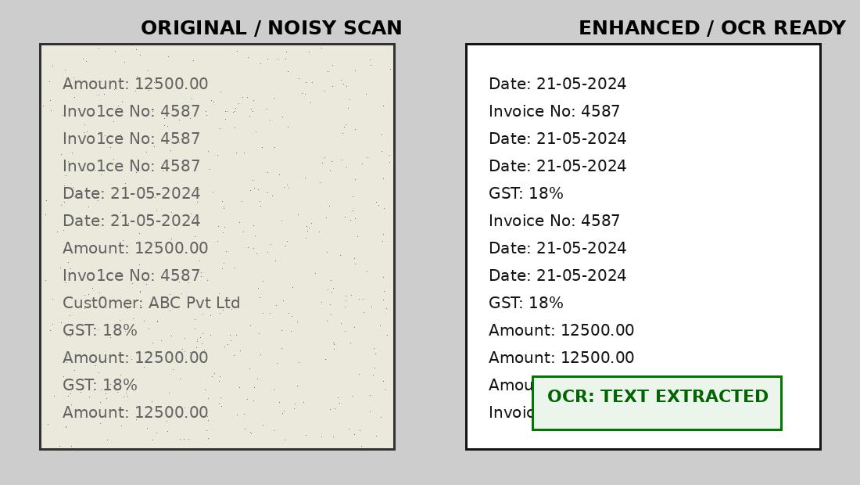
Figure 3. Example document-processing result showing noisy input, enhanced document and OCR-ready output.

3.2 Role of Each Operation
Operation | Purpose
Grayscale | Simplifies image processing
Filtering | Removes noise
Contrast enhancement | Improves faint text
Thresholding | Separates text/background
Morphology | Cleans and repairs text regions
Segmentation | Extracts text areas
Geometric correction | Corrects skew/perspective
OCR preparation | Produces readable input

3.3 Batch Processing
- Read documents from an input folder and save processed images/text to output folders.
- Use adaptive thresholding for documents with different illumination.
- Log failed pages instead of stopping the whole batch.
- Use efficient OpenCV operations and parallel processing when CPU resources allow.
Conclusion: Grayscale conversion, filtering, thresholding, morphology, segmentation and geometric correction progressively improve document quality and therefore improve OCR accuracy.

4. Real-Time Multi-Person Tracking and Attendance System
Objective
The system automatically detects multiple students, tracks them across classroom CCTV frames, recognizes registered students and marks attendance only once for each student.

4.1 Complete System Design
- Capture classroom video using OpenCV VideoCapture and restrict processing to the classroom ROI.
- Detect multiple faces using an OpenCV Haar Cascade or DNN detector.
- Crop, align, resize and normalize each detected face.
- Extract a facial feature representation and compare it with registered student features.
- Assign persistent track IDs using centroid association, optical flow or an OpenCV tracker.
- Use multi-frame verification so one blurred or partially hidden frame cannot immediately mark attendance.
- Maintain a unique student-session attendance record to prevent duplicates.
- Keep tracks alive for a limited number of missed frames so temporary face disappearance does not immediately create a new identity.
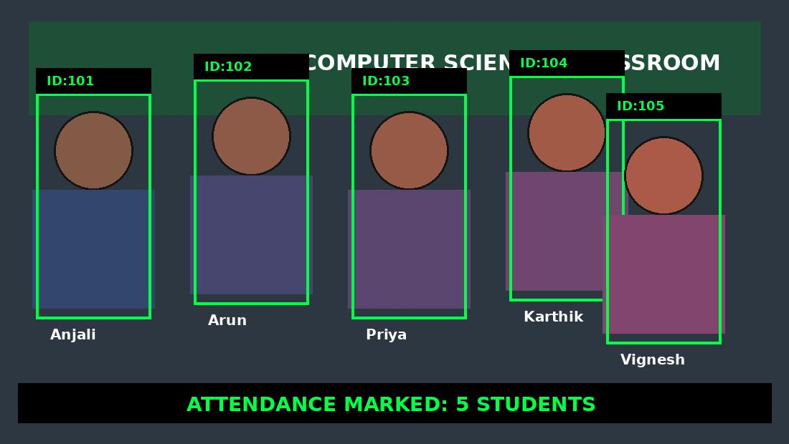
Figure 4. Example classroom attendance image showing multiple students, tracking boxes, IDs and attendance status.

4.2 Preventing False/Duplicate Attendance
- Use a minimum face-quality requirement.
- Use confidence thresholds and an Unknown label.
- Confirm identity across multiple frames.
- Use persistent tracking IDs.
- Store attendance using a unique student ID + session/date key.
- Re-run recognition after a long disappearance or major position change.
Conclusion: The combination of face recognition, persistent tracking, temporal verification and unique attendance records provides reliable automatic attendance with low duplicate and false marking.

5. Smart Home Surveillance and Intrusion Detection
Objective
The fixed-camera system must detect significant movement, reject noise and small background changes, track moving objects and generate an alert when an unauthorized person enters a predefined protected region.

5.1 OpenCV Surveillance Solution
- Camera acquisition: Capture continuous video from a fixed entrance camera and define a protected ROI.
- Background subtraction: Use MOG2 or KNN to separate moving foreground objects from the learned background.
- Filtering: Apply Gaussian blur and remove small isolated regions.
- Morphological processing: Use opening to remove noise and closing to fill small holes.
- Contour detection: Find foreground contours and reject regions below a minimum area.
- Object tracking: Track significant moving objects using bounding boxes and centroids.
- Suspicious-activity analysis: Check whether a tracked object enters the protected ROI or stays there beyond a defined duration.
- Alert generation: Display an intrusion alert and optionally save an image/video clip. Use an alert cooldown to prevent repeated alerts.
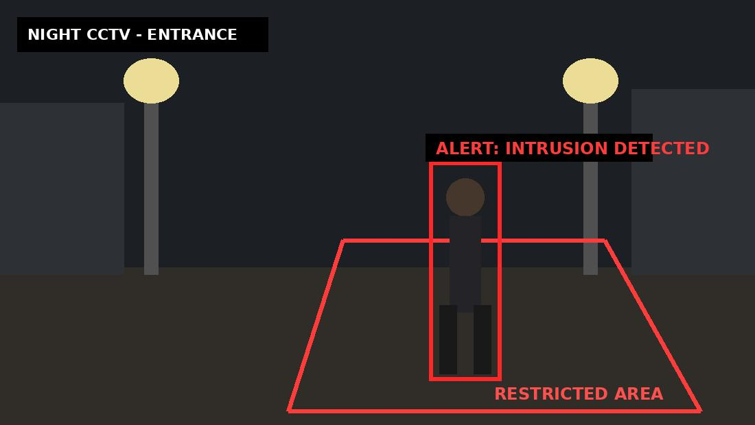
Figure 5. Example night-time CCTV intrusion detection result showing a person inside a restricted region and an alert.

5.2 Reducing False Alarms
- Shadows: Use shadow-aware background subtraction and intensity/color checks.
- Illumination changes: Use adaptive background learning.
- Trees and dynamic background objects: Restrict analysis to the entrance ROI.
- Camera noise: Use blur and minimum contour-area filtering.
- Small motion: Require minimum object area and persistence.
- Repeated alerts: Use track IDs and cooldown periods.
- Camera movement: Prefer a fixed camera; otherwise reset the background model or use motion compensation.
Conclusion: Background subtraction combined with filtering, morphology, contour analysis, tracking and ROI constraints provides a lightweight real-time intrusion detection system with fewer false alarms.

Overall Conclusion
All five systems demonstrate constraint-based computer vision using OpenCV. The main design principle is to acquire reliable frames, preprocess them, detect or segment the required objects, extract useful features, maintain temporal consistency when needed, and apply decision constraints before producing the final result.
- Face recognition focuses on robust features, confidence thresholds and multi-frame verification.
- Traffic monitoring focuses on detection, tracking IDs and virtual line-crossing.
- Document processing focuses on image enhancement and OCR preparation.
- Attendance combines recognition with tracking and one-time database recording.
- Home surveillance combines background subtraction with ROI-based intrusion rules.
These approaches are designed to handle practical constraints such as lighting changes, noise, shadows, occlusion, multiple objects, limited hardware and false detections while maintaining real-time performance.

