SIMATS ENGINEERING (SAVEETHA SCHOOL OF ENGINEERING)
Department of Computer Science and Engineering

ASSESSMENT TOOL 1 – EXPERIMENTS

Course Code: | ITA05 | Course Title: | COMPUTER VISION
CO Assessed: | CO3 – Precision (BL4) | Assessment: | Assessment Tool 1 – Experiments
Weightage: | 40% of CIA | Total Marks: | 50 (5 Questions × 10 Mark)
CO1 Statement: | Analyze and extract image features using detection and matching techniques for effective image representation and comparison.(BL4).
Student Name: | Hemapriya. J | Reg. No.: | 192425355
Section / Batch: | Hostel/2024/slot c | Date:
Code of Conduct
I _Hemapriya .J (192521431) certify that this submission is my original work and that I have adhered to the guidelines specified for this assessment. I understand that any violation of academic integrity rules will result in disciplinary action.

Signature of the Student:Hemapriya.J
Instructions
- This test contains 5 questions, each carrying 10 marks. Total: 50 Marks.
- No negative marking. Unanswered questions carry zero marks.
- No calculators or electronic devices permitted.
- Duration: 60 minutes.

Section / Topic | Focus | Q Nos | Marks
Types of Image Processing | Point, Neighborhood, Geometric Processing, Applications | 1 | 10
Image Representation | Grayscale, Binary, Color Representation | 2 | 10
Hough Transform | Line Detection, Circle Detection, Parameter Space | 3 | 10
Scale Invariant Feature Matching (SIFT) | Keypoint Detection, Feature Matching, Scale & Rotation Invariance | 4 | 10
Principal Component Analysis (PCA) | Dimensionality Reduction, Feature Selection, Data Representation | 5 | 10
GRAND TOTAL: |  | 50 Marks

Annexure A – Experiments

- Feature Descriptor Comparison (SIFT vs Harris)
Design and perform an experiment to compare Harris Corner Detection and SIFT feature extraction on the same set of images. Explain the theoretical principles behind corner detection and feature descriptors. Implement both techniques using suitable software/tools, document the detected features systematically, and analyze their performance in terms of feature quality, robustness, repeatability, and suitability for image matching applications.

- Image Enhancement for Feature Detection
Conduct an experiment to evaluate the effect of image enhancement techniques such as histogram equalization and contrast adjustment on feature detection performance. Explain the importance of image enhancement in computer vision. Apply enhancement methods followed by feature detection using appropriate tools, document the intermediate and final outputs clearly, and analyze how enhancement influences feature visibility, detection accuracy, and reliability.

- Multi-Scale Feature Detection Analysis
Design and implement an experiment to study feature detection at different image scales. Explain the concept of image scaling and scale-space representation in feature extraction. Apply feature detection methods on images of varying resolutions using suitable software/tools, document the detected features systematically, and analyze the effect of scale variations on feature stability, accuracy, and computational performance.

- Comparative Analysis of Image Filtering Techniques
Conduct an experiment to compare different image filtering techniques, such as Mean, Gaussian, and Median filtering, for preprocessing. Explain the theoretical concepts and objectives of each filtering method. Implement the filters using appropriate tools/software, document the processed images and observations clearly, and analyze their effectiveness in noise reduction while preserving important image features for subsequent feature detection.

- Complete Object Detection Workflow
Design and perform an experiment to develop an object detection workflow incorporating image preprocessing, edge detection, feature extraction, and shape detection. Explain the purpose and interaction of each processing stage in the workflow. Implement the complete pipeline using suitable software/tools, document the outputs at every stage systematically, and analyze the effectiveness of the integrated approach in achieving accurate and reliable object detection under different image conditions.

Rubrics for Calculation

Criteria | Weightage (%) | Level 4 (Exemplary) | Level 3 (Proficient) | Level 2 (Developing) | Level 1 (Beginning) | Marks
Understanding | 25 | Demonstrates | Good | Basic | Poor
of Concepts |  | thorough | understand | understandin | understanding
 |  | understanding | ing with | g; limited or | ; unable to
 |  | and effectively | proper | partial | integrate
 |  | integrates | integration | integration | concepts
 |  | multiple | of most
 |  | concepts/tech | concepts
 |  | nologies
Experimental | 30 | Well-planned, | Correct | Basic | Incorrect or
Design |  | systematic | implementa | implementati | incomplete
 |  | implementatio | tion with | on with | implementatio
 |  | n with optimal | minor | errors or | n
 |  | solution | issues | inefficiencies
Use of Tools | 20 | Effective and | Appropriate | Limited or | Incorrect or
 |  | advanced use | use of tools | inconsistent | minimal use of
 |  | of | with correct | use of tools | tools
 |  | tools/technolo | execution
 |  | gies with
 |  | proper
 |  | configuration
Analysis of | 15 | Insightful | Good | Basic | Poor or
Results |  | analysis with | analysis | analysis with | incorrect
 |  | accurate | with | limited | analysis of
 |  | interpretation | reasonable | insights | results
 |  | and validation | interpretati
 |  | of results | on
Documentation | 10 | Clear, well- | Organized | Basic | Poor or
 |  | structured | documenta | documentati | incomplete
 |  | documentation | tion with | on with | documentation
 |  | with diagrams, | necessary | missing
 |  | code, and | details | details
 |  | results

Faculty In-charge
Signature:
Date:

Feature Descriptor Comparison (SIFT vs Harris)

Aim:To compare Harris Corner Detection and SIFT feature extraction on the same image and evaluate their performance in detecting features for image processing applications.

Procedure
  - Load the input image
  - Convert the image to grayscale
  - Apply Harris Corner Detection to find corner points
  - Mark detected corners on the image
  - Apply SIFT algorithm to detect keypoints and descriptors
  - Draw SIFT keypoints on the image
  - Count number of features detected in both methods
  - Compare results visually and numerically.

Code:
import cv2
import numpy as np
img = cv2.imread('sampleinput.jpg') if img is None:
print("Error: Image not found!") exit()
gray = cv2.cvtColor(img, cv2.COLOR_BGR2GRAY) gray_float = np.float32(gray)
harris = cv2.cornerHarris(gray_float, 2, 3, 0.04) harris_img = img.copy()
harris_img[harris > 0.01 * harris.max()] = [0, 0, 255] sift = cv2.SIFT_create()
keypoints, descriptors = sift.detectAndCompute(gray, None) sift_img = cv2.drawKeypoints(img, keypoints, None) cv2.imshow("Harris", harris_img)
cv2.imshow("SIFT", sift_img) cv2.waitKey(0) cv2.destroyAllWindows()

print("Harris corners:", np.sum(harris > 0.01 * harris.max())) print("SIFT keypoints:", len(keypoints))

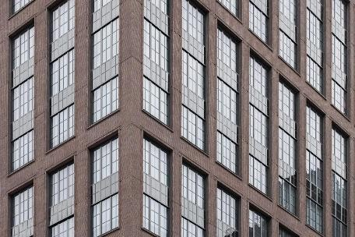
Sample Input:
Harris corners: 18778
SIFT keypoints: 6372
Sample Output:
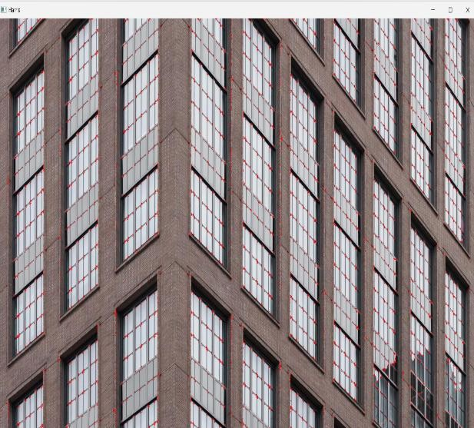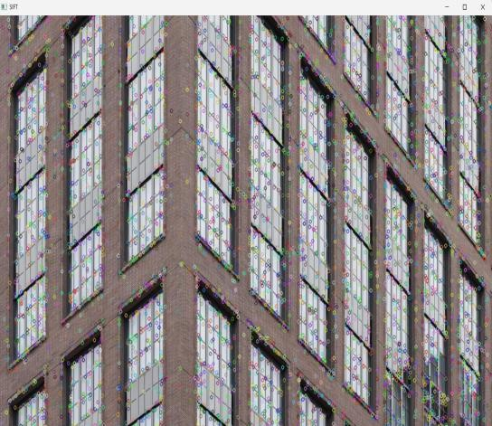
Harris Output SIFT Output

Image Enhancement for Feature Detection

Aim:To study the effect of image enhancement techniques (Histogram Equalization and Contrast Adjustment) on feature detection performance.

Procedure
  - Load the input image using an appropriate tool (e.g., OpenCV)
  - Convert the image into grayscale format
  - Apply Histogram Equalization to enhance global contrast
  - Apply Contrast Adjustment to improve brightness and intensity variation
  - Perform feature detection (SIFT/Harris) on the original image
  - Perform feature detection on the enhanced images
  - Visualize the detected features for all cases
  - Compare the number and quality of detected features
  - Analyze the effect of enhancement on feature visibility and detection performance

Code:
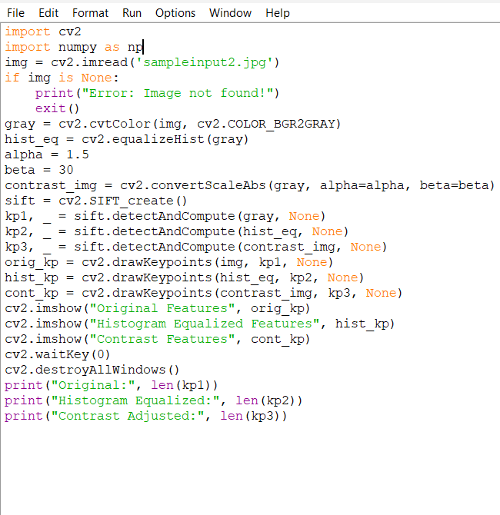

Sample Input:
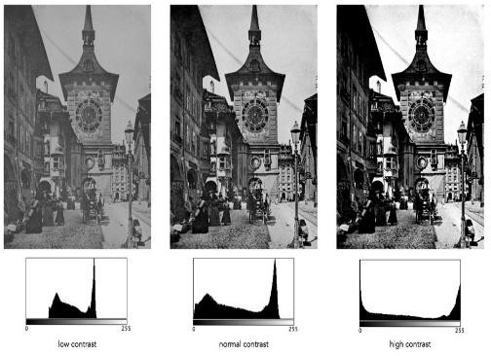

Output:
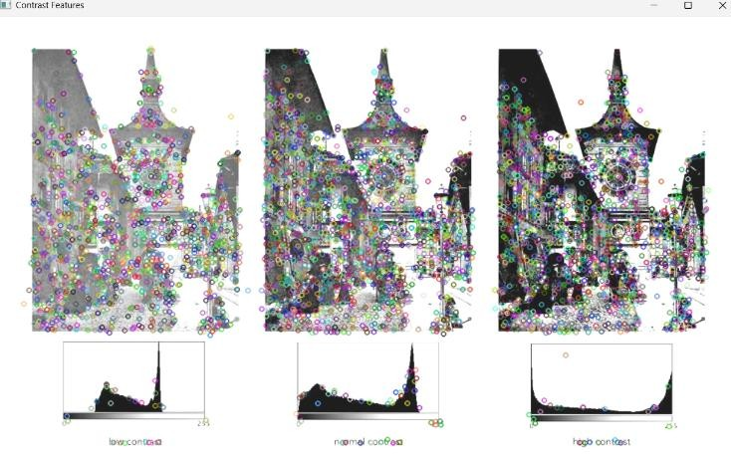
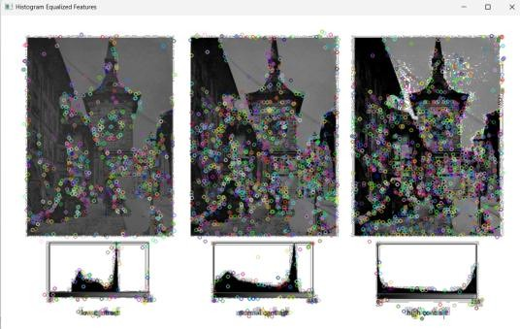

Contrast Features Histogram Equalized

- Multi-Scale Feature Detection Analysis
Aim: To design and implement an experiment to analyze how feature detection behaves at different image scales, and evaluate its effect on feature stability, accuracy, and computational performance.

Procedure:
  - Load input image.
  - Convert to grayscale.

Generate multiple scaled versions:
  - 100% (original)
  - 75%
  - 50%
  - 25%
  - Apply feature detection (SIFT or Harris) on each scale.

Record:
  - Number of detected features
  - Detection time
  - Visualize features at each scale.
  - Compare performance across scales.

Code:
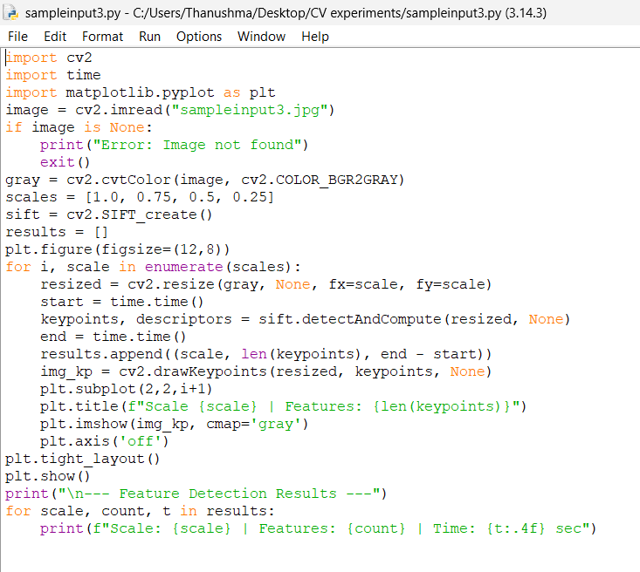

Input: Output:
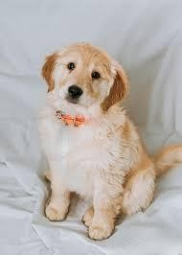
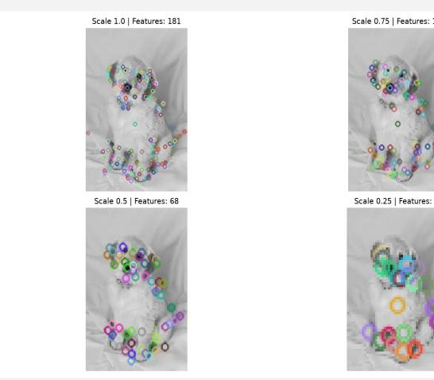

Comparative Analysis of Image Filtering Techniques
Aim: To compare Mean, Gaussian, and Median filtering techniques for image preprocessing and analyze their effectiveness in noise reduction and feature preservation.

Procedure:
- Load the input image
- Convert the image to grayscale
- Apply Mean Filter using a 3×3 or 5×5 kernel
- Apply Gaussian Filter with suitable kernel size and sigma
- Apply Median Filter with appropriate kernel size
- Display the original and filtered images
- Compare the results based on:
- Noise reduction
- Edge preservation
- Smoothness
- Analyze which filter performs better for different noise types

Code:
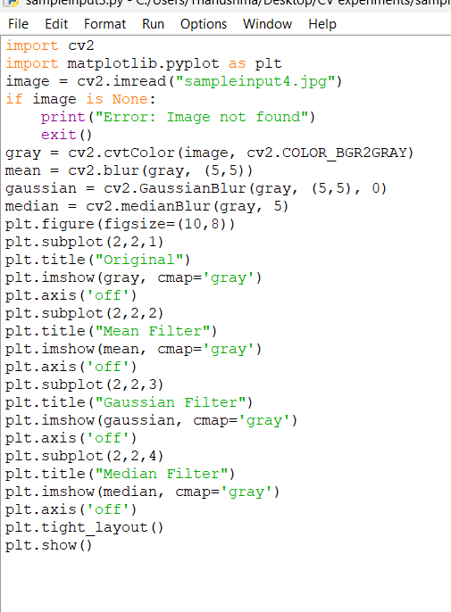

Input: Output:

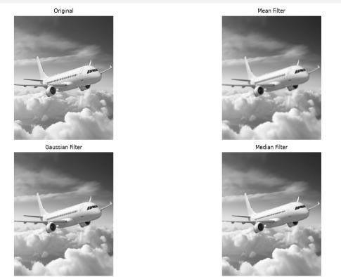

Complete Object Detection Workflow
Aim: To design and implement a complete object detection workflow using image preprocessing, edge detection, feature extraction, and shape detection, and evaluate its effectiveness under different image conditions.

Procedure:
- Load the input image
- Convert to grayscale
- Apply Gaussian blur for noise reduction
- Perform edge detection using Canny
- Extract features using SIFT
- Detect contours for shape detection
- Draw bounding boxes around detected objects

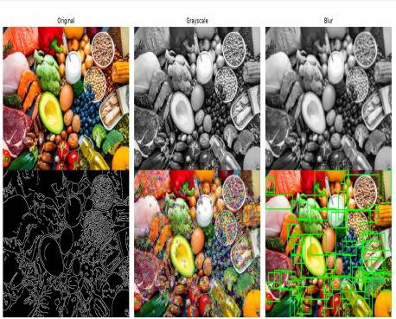
- Display outputs at each stage
Output:
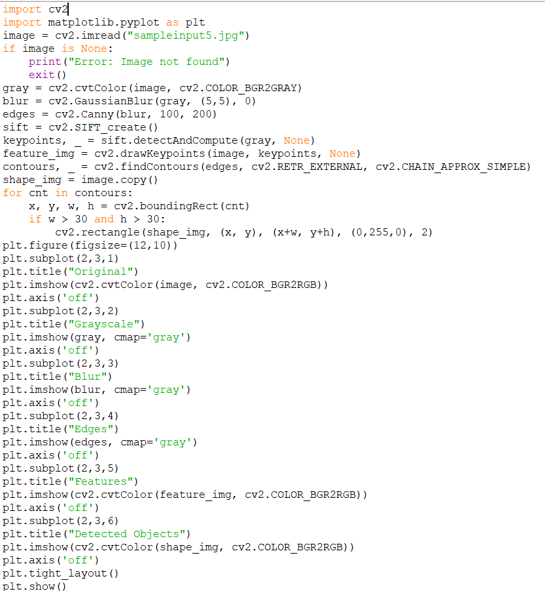
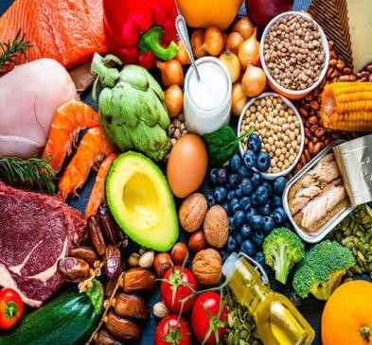
Code: Input:

