CO4 AT1 – DATA INTERPRETATION
Questions and Answers
Computer Vision / Data Interpretation

1. Real-Time Detection System
Question: A surveillance system uses the following techniques. Compare the three techniques and evaluate which method should be selected for a surveillance system operating under strict latency constraints while maintaining acceptable accuracy. Justify your decision considering deployment conditions.
Answer
The three methods are Viola-Jones, YOLO, and Deep Learning. Their accuracy and speed differ significantly.
Viola-Jones has 78% accuracy and is fast. It is suitable when very low latency is required, but its lower accuracy may result in more incorrect or missed detections.
YOLO has 92% accuracy with moderate speed. It provides a strong balance between detection accuracy and processing speed, making it suitable for practical real-time surveillance.
Deep Learning has the highest accuracy at 95%, but it is slow. Under strict latency constraints, its slower processing can reduce the responsiveness of the surveillance system.
Method | Accuracy | Speed
Viola-Jones | 78% | Fast
YOLO | 92% | Moderate
Deep Learning | 95% | Slow

Conclusion: YOLO should be selected because it provides high accuracy (92%) while maintaining moderate processing speed. It offers a better balance between accuracy and latency than Viola-Jones and Deep Learning for a real-time surveillance deployment.
Figure 1: Detection accuracy comparison
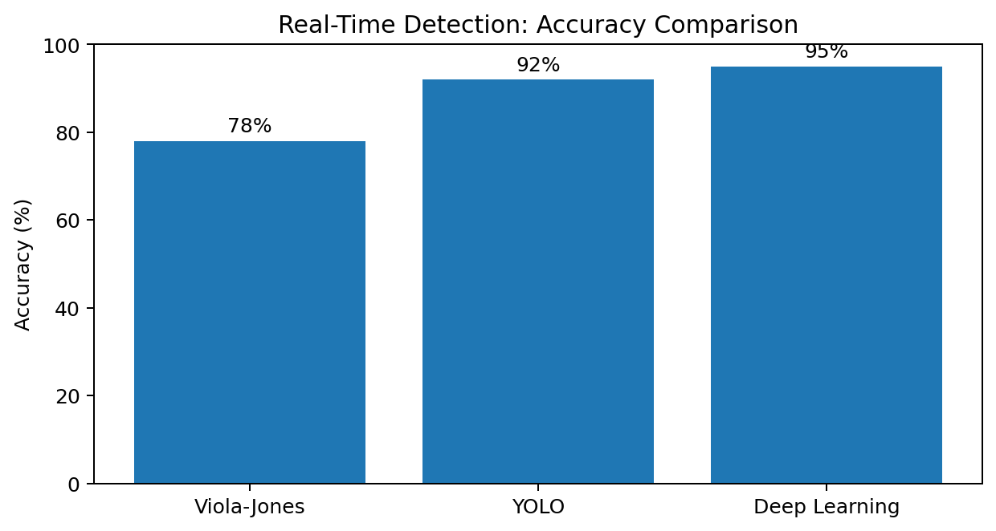
2. Robust Object Detection
Question: Compare the robustness of the three methods under normal, occluded, and low-light conditions. Evaluate which method provides the best overall performance and discuss the trade-offs involved.
Answer
The results show that Deep Learning performs best under all three conditions.
Under normal conditions, Deep Learning achieves 95%, compared with 90% for YOLO and 80% for Viola-Jones.
Under occlusion, Deep Learning maintains 85% accuracy, while YOLO achieves 75% and Viola-Jones achieves 60%. This indicates stronger robustness when parts of an object are hidden.
Under low-light conditions, Deep Learning achieves 80%, compared with 70% for YOLO and 55% for Viola-Jones.
The main trade-off is that the method with the best robustness and accuracy may require greater computational resources and processing time.
Method | Normal | Occlusion | Low Light
Viola-Jones | 80% | 60% | 55%
YOLO | 90% | 75% | 70%
Deep Learning | 95% | 85% | 80%

Conclusion: Deep Learning provides the best overall performance because it has the highest accuracy in normal, occluded, and low-light conditions. Its main trade-off is higher computational requirements compared with the other methods.
Figure 2: Robustness comparison
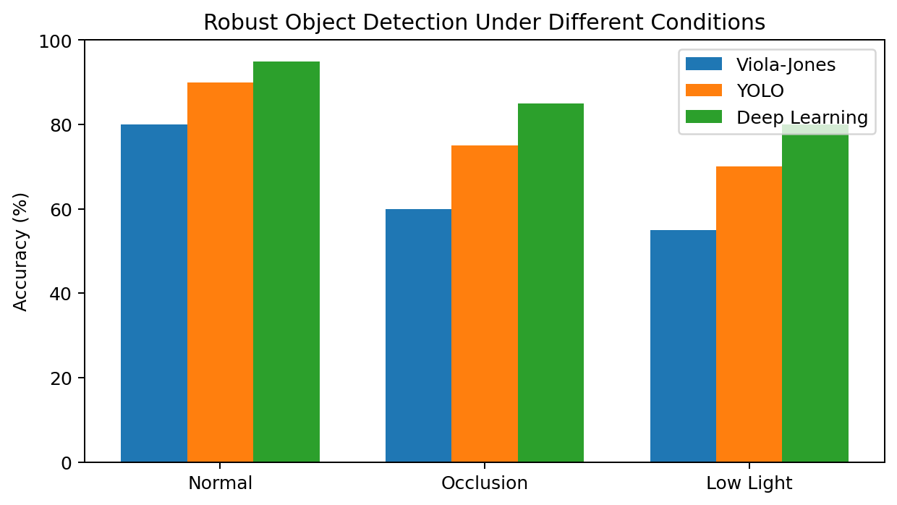
3. Optical Flow Analysis
Question: Two optical flow methods are available: Method A produces stable motion vectors but misses small motions, while Method B detects fine motion but produces noisy vectors. Compare the two methods and evaluate which method is more suitable for motion tracking in dynamic scenes. Justify your answer based on accuracy, stability, noise sensitivity, and application requirements.
Answer
Method A produces stable motion vectors and is less sensitive to noise. This makes it reliable for general motion tracking in dynamic scenes. Its limitation is that it may miss small or subtle movements.
Method B can detect fine motion more effectively, so it is useful when small movements are important. However, its noisy vectors can reduce tracking stability and may produce less reliable motion estimates.
For a dynamic scene where stable and reliable motion tracking is the main requirement, Method A is more suitable. If the application specifically requires fine-motion detection, Method B may be preferred.
Feature | Method A | Method B
Motion-vector stability | High | Low
Small-motion detection | Poor | Excellent
Noise sensitivity | Low | High
Tracking reliability | High | Moderate
Fine-motion detection | Low | High

Conclusion: Method A is the better general choice for dynamic-scene motion tracking because its stable vectors and lower noise sensitivity provide reliable tracking. Method B is preferable when detecting fine movements is the primary requirement.
Figure 3: Optical flow concept
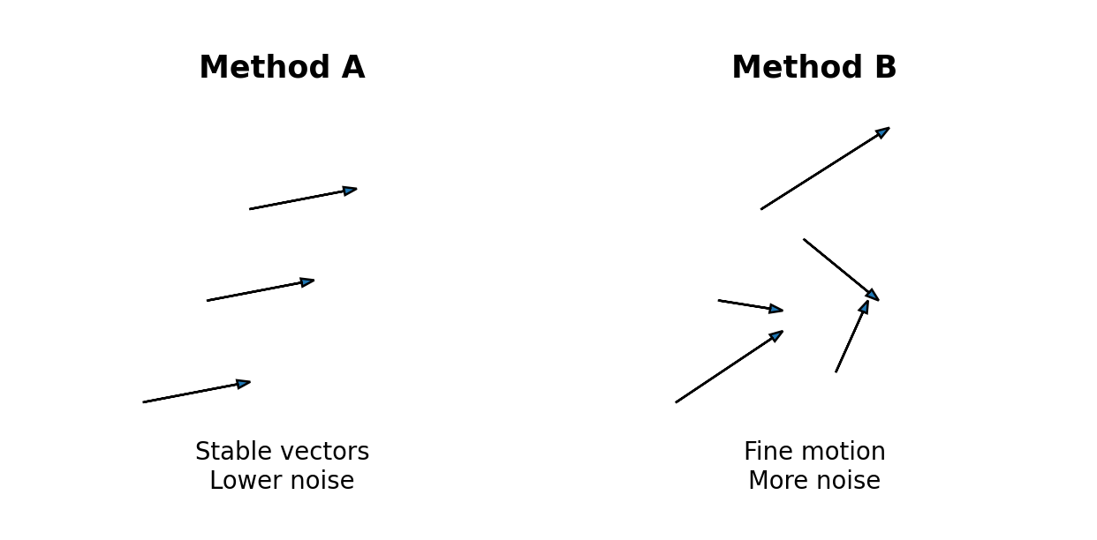
4. Model Generalization and Overfitting – 10 Marks
Question: Compare the two models and evaluate which model is more reliable for real-world deployment. Explain the generalization ability and overfitting risk of each model and justify your selection.
Answer
Model A has 98% training accuracy but only 70% testing accuracy. The 28 percentage-point difference indicates a high risk of overfitting. The model performs very well on training data but does not generalize well to unseen data.
Model B has 90% training accuracy and 88% testing accuracy. The difference is only 2 percentage points, indicating much better generalization and a lower overfitting risk.
For real-world deployment, testing performance and a small training-testing gap are important because real-world inputs are generally unseen during training.
Model | Training Accuracy | Testing Accuracy | Gap
A | 98% | 70% | 28 percentage points
B | 90% | 88% | 2 percentage points

Conclusion: Model B should be selected for real-world deployment because it has strong testing accuracy and a much smaller training-testing gap. Model A shows clear signs of overfitting.
Figure 4: Generalization and overfitting comparison
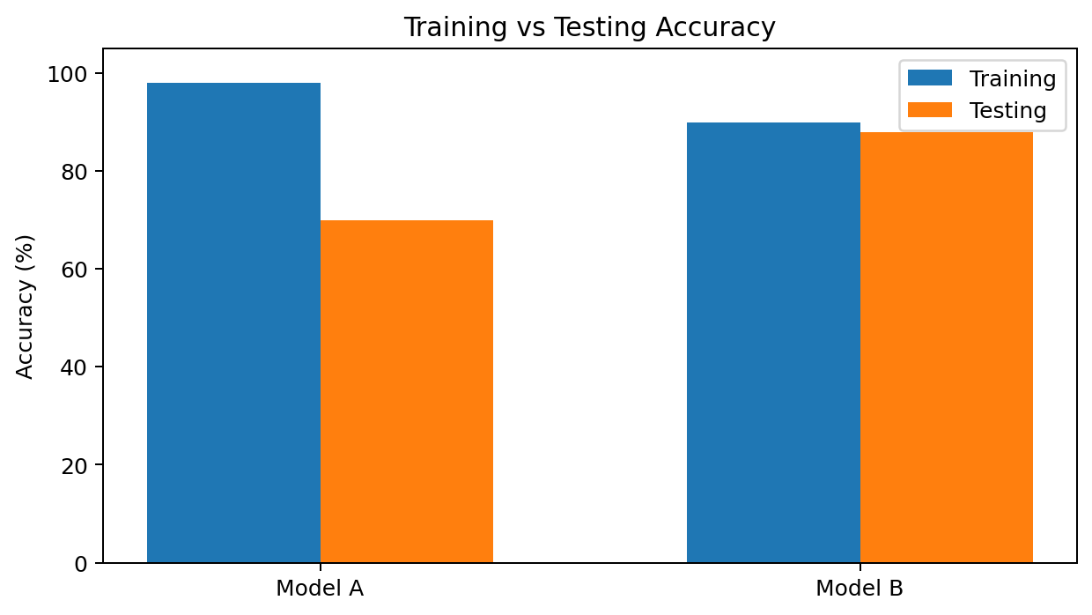
5. System Performance under Constraints
Question: Compare the three models and evaluate which model provides the best balance between accuracy, latency, and cost for a real-time application. Justify your choice considering practical deployment constraints.
Answer
Model A provides 88% accuracy, 50 ms latency, and low cost. It is the fastest and least expensive option.
Model B provides higher accuracy of 92% with 80 ms latency and moderate cost. It is a reasonable alternative when some additional accuracy is worth the extra latency and cost.
Model C has the highest accuracy of 95%, but its latency is 120 ms and its cost is high. Therefore, it may be less suitable when fast response and economical deployment are important.
For a real-time application, the best model is not necessarily the one with the highest accuracy. Latency and deployment cost must also be considered.
Model | Accuracy | Latency | Cost
A | 88% | 50 ms | Low
B | 92% | 80 ms | Moderate
C | 95% | 120 ms | High

Conclusion: Model A provides the best overall balance for a real-time application because it combines acceptable accuracy, the lowest latency, and low cost. Model B is a good alternative when higher accuracy is required, while Model C prioritizes accuracy at the expense of speed and cost.

Final Answers – Quick Reference
Question | Best Choice
1. Real-Time Detection System | YOLO
2. Robust Object Detection | Deep Learning
3. Optical Flow Analysis | Method A for stable dynamic-scene tracking
4. Model Generalization and Overfitting | Model B
5. System Performance under Constraints | Model A

