SIMATS ENGINEERING
SAVEETHA INSTITUTE OF MEDICAL AND TECHNICAL SCIENCES
NAME: K. HEMA SAI SIDDARTHA
DATE:06/10/2026
LAB EXP: 11
Reg Mo: 192325036
Course Code/ Name: DSA0601 / Data Handling and Visualization
Set 11: Product Category Analysis
Dataset: Product Categories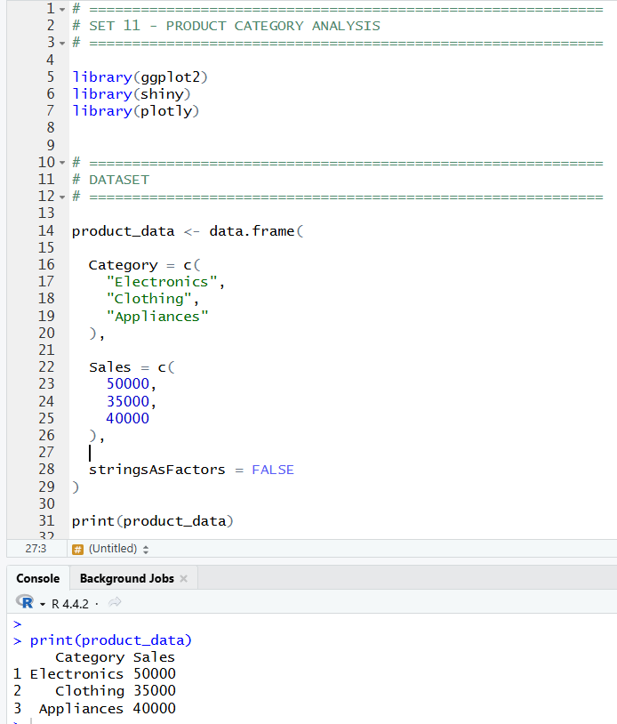
1.Generate a funnel chart to analyze the sales conversion process for each product category. Label the stages and title the chart.
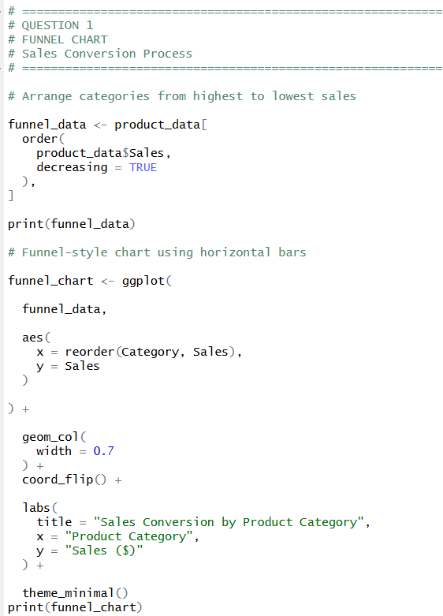
OUTPUT:
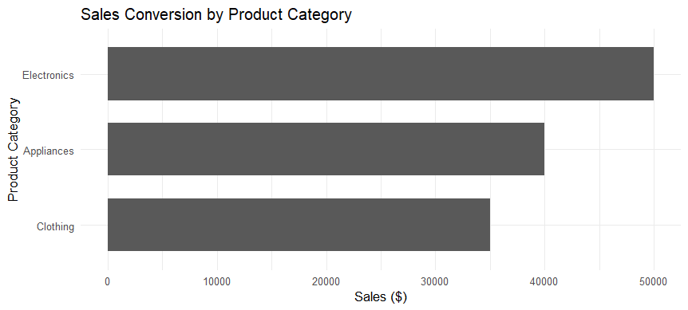
2. Build a table to display the sales data for each product category. Label the table elements.

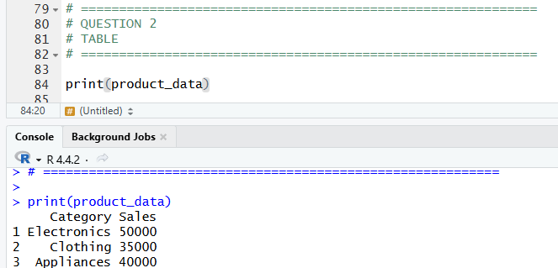

4. Create a pie chart to represent the distribution of sales across product categories. Include labels.

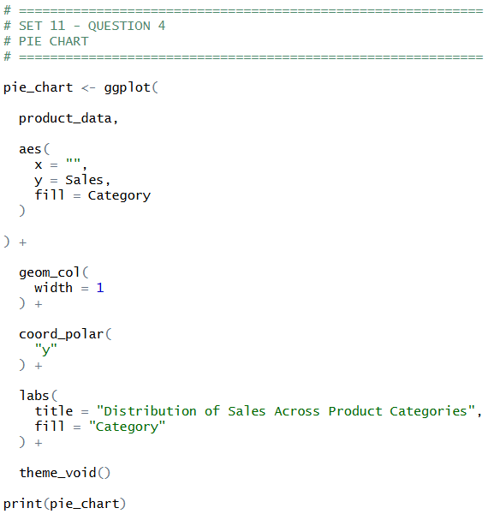
OUTPUT:

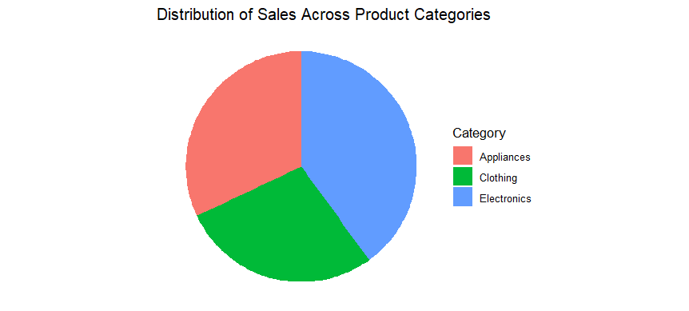

3. Develop a Tableau dashboard combining the pie chart, funnel chart, and the table for interactive exploration of product category data.
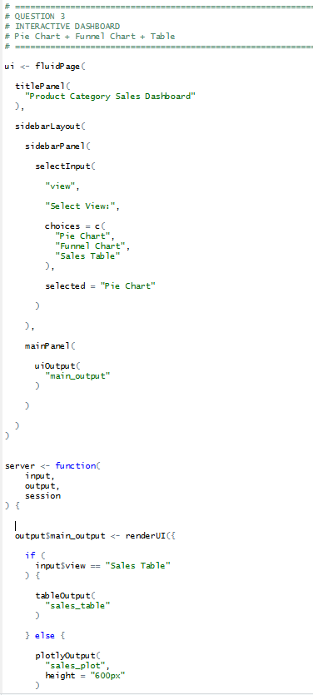

OUTPUT:
